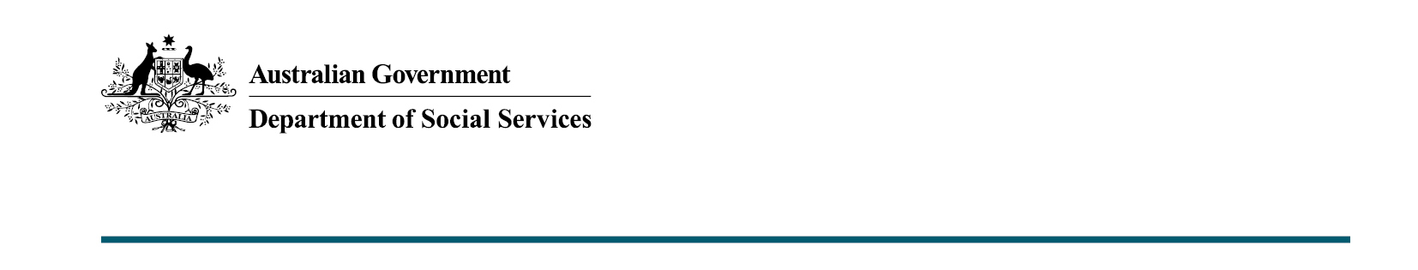

Improving payments that support young people and families
Budget 2020-21

The Australian Government is investing
$139.2 million to improve social security payments that will support vulnerable Australians through the pandemic and beyond.

What was announced in
the 2020-21 Budget?
The Australian Government will put in place three time-limited, concessional tests – for Paid Parental Leave and two relating to Youth Allowance independence criteria – in response to the impacts of the Coronavirus pandemic. The Government will also address inconsistences in the Stillborn Baby Payment to better support families while they grieve.

Concessional Work Test Arrangements for Paid Parental Leave in response to the impacts of COVID-19
The Australian Government is providing $130.4 million over three years from
2020-21 to revise the Paid Parental Leave work test period to support parents who have a history of paid work.
Under normal circumstances, to qualify for Paid Parental Leave, the primary carer must have worked at least 10 of the 13 months prior to the expected birth date of their child and worked at least 330 hours during that period.
Pending the passage of legislation expected in November 2020, the Government will temporarily extend the Paid Parental Leave work test period from 13 months to 20 months for parents who have had their employment impacted by the coronavirus pandemic.
This enables most individuals with a genuine work history pre-coronavirus pandemic to access Parental Leave Pay and Dad and Partner Pay who would otherwise fail the work test due to loss of employment or a reduction in work hours.

Key facts
- This measure is estimated to allow about 9,000 mothers to regain eligibility for Parental Leave Pay and allow a further 3,500 people to claim Dad and Partner Pay.
- This temporary change to the Paid Parental Leave work test will apply to births and adoptions between 22 March 2020 and 31 March 2021.

Addressing inconsistencies in the Stillborn Baby Payment
Stillbirth or the loss of a child is a very stressful event for families.
To support bereaved parents, the Australian Government is committing
$7.6 million to help parents cope with the personal, social and financial impacts.
Through this measure, the Stillborn Baby Payment rate structure will be replaced with a single higher payment rate, as well as improving assistance for some families who experience the loss of a child within their first year from birth.
From 1 January 2021, all eligible families who suffer a stillbirth will receive $3,606.81 regardless of whether this is their first or subsequent stillbirth.
Families not accessing Paid Parental Leave that experience a neonatal death would also receive assistance of up to $3,606.81, through Family Tax Benefit and Newborn Supplement, subject to meeting eligibility.
Families that have received a lower rate of Newborn Supplement for a second or subsequent child who later die before their first birthday would now receive a top up amount of up to $1,139.32.

Key facts
- The income testing arrangements for Stillborn Baby Payment and Family Tax Benefit, including Newborn Supplement, will not change.
- About 900 families are expected to receive additional support each year as a result of the measure.

Recognising the Impacts of Coronavirus for Youth Allowance and ABSTUDY Independence
The Australian Government is committing $25.0 million to recognise the unprecedented challenges faced this year many young people, in particular, have lost their job or have been unable to find employment.
From 1 January 2021, a six-month period between 25 March and 24 September 2020, will automatically be recognised as contributing to existing workforce independence criteria for Youth Allowance or ABSTUDY.

Key facts
- Each year about 4,000 young people meet the workforce independence criteria.
- Typically eligibility for payment and rates for young Australians aged under 22 is means tested against their parents’ income. However, young people under 22 can establish independence through their history of work, which may make them eligible for payment, or a higher rate of payment. This requires them to work 30 hours a week for 18 months over a two year period. Regional students can meet the criteria by working 15 hours a week for at least two years or earning 75 per cent of the National Training Wage Schedule for a 14 month period.
- Under this measure, regardless of their location, wage or the number of hours worked between 25 March and
24 September 2020, applicants will be considered to have demonstrated their participation in the workforce over this period.

Incentives to encourage Australians to undertake seasonal work
To support the agricultural sector and young Australians affected by the economic impact of the coronavirus pandemic, the Government committing $16.3 million to temporarily introduce a new pathway for achieving independence for the purposes of Youth Allowance (student) and ABSTUDY.
From 30 November 2020 to 31 December 2021, a person who earns $15,000 through employment in the agricultural sector will be considered independent for Youth Allowance (student) or ABSTUDY purposes.

Key facts
- This change is designed to incentivise young Australians, including school leavers, to work in the upcoming harvest season.
- People can only qualify as independent under this measure if their combined parental income is under the Parental Income Threshold of $160,000 per annum (plus $10,000 for each additional child).
- If a person does not reach the $15,000 threshold, their workforce participation can still be assessed under existing independence criteria.

More information
For more information about this measure and other Department of Social Services’ Budget measures, visit the Department of Social Services website (dss.gov.au).
For information about the Budget 2020-21, visit the Australian Government budget website (budget.gov.au).

