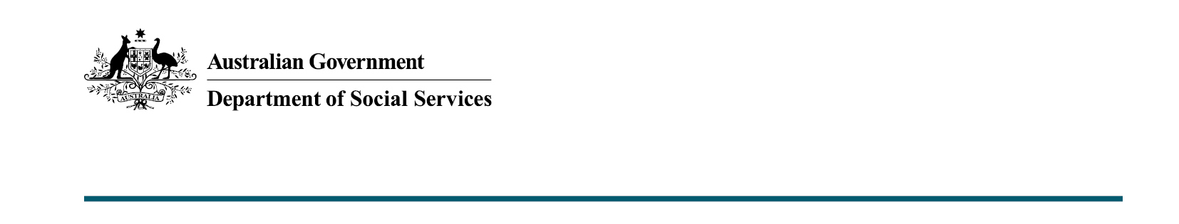

COVID-19 Response Package –further economic support payments
Budget 2020-21

The Australian Government will provide $2.6 billion in additional support to around five million payment recipients and cardholders in the lead up to Christmas and in the new year.

What was announced in the Budget 2020-21?
As part of the Australian Government’s support through the coronavirus pandemic, two additional Economic Support Payments of $250 each will be provided to eligible Australians.
Recipients must live in Australia and receive or hold one of the following payments or concession cards on 27 November 2020 and/or 26 February 2021:
- Age Pension
- Disability Support Pension
- Carer Payment
- Carer Allowance*
- Family Tax Benefit* Parts A and B
- Double Orphan Pension*
- Commonwealth Seniors Health Card
- Pensioner Concession Card*
- Certain Department of Veterans’ Affairs payments and cards.
*Not in receipt of a primary income support payment.

Key facts
- The payments will be made progressively from 30 November 2020 and 1 March 2021.
- The payments will assist households in the lead up to Christmas and in the new year.
- Recipients do not need to contact Services Australia to receive the payments.
- The payments will be non-taxable and will not count as income for social security purposes.

More information
For more information about this measure and other Department of Social Services’ Budget measures, visit the Department of Social Services website (dss.gov.au).
For information about the Budget 2020-21, visit the Australian Government budget website (budget.gov.au).

