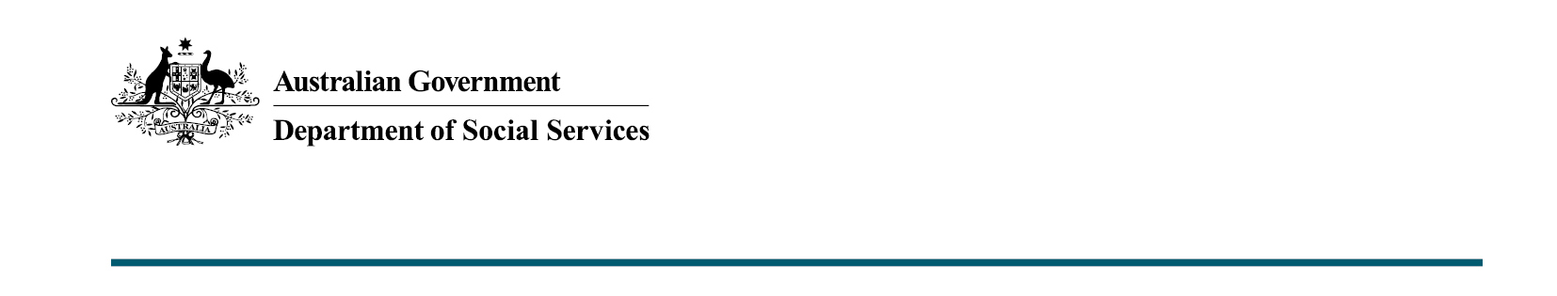

Establishment of the National Memorial for Victims and Survivors of Institutional Child Sexual Abuse
Budget 2020-21

The experiences and needs of victims and survivors of institutional child sexual abuse remain a significant national priority for the Australian Government.

What was announced in the Budget 2020-21?
The Australian Government will invest
$6.7 million from 2020-21 to establish a National Memorial for Victims and Survivors of Institutional Child Sexual Abuse (the National Memorial) in Canberra.
The funding will enable:
- a memorial design brief, which will be prepared in consultation with the National Memorial Advisory Group (NMAG) and NCA.
- a design competition to select the best proposal.
- the memorial construction.
- allocation and approval of the site in Canberra for the memorial, led by the National Capital Authority (NCA).
- a memorial dedication event, once construction is completed.
The memorial will play an important role in memorialising and acknowledging the impact of institutional child sexual abuse as a significant part of Australia’s history.
Establishing the National Memorial highlights the commitment the Australian Government places on symbolic reparation and public recognition to victims and survivors to contribute to healing, and educate future generations.

Key facts
- Establishment of the National Memorial was a recommendation of the Royal Commission into Institutional Responses to Child Sexual Abuse (Recommendation 17.6).
- There will be further consultation with victims, survivors and those affected by institutional child sexual abuse on the scope and purpose of an educative component, such as a museum.

More information
For more information about this measure and other Department of Social Services’ Budget measures, visit the Department of Social Services website (dss.gov.au).
For information about the Budget 2020-21, visit the Australian Government budget website (budget.gov.au).

