Creating a New Case Record

Disability Case Portal (DCP)
  - Autism Advisor or Better Start Information and Registration Service
This task card will take you through the process of creating a new Case record for an existing client in the Disability Case Portal (DCP).
A DCP Case record signifies an interaction between a client and a particular organisation. While an eligible child will only have one DCP Client record that may be used by multiple organisations, each organisation will also be required to create a DCP Case record that is unique to the particular service the client is accessing. You must create a Case Record for all eligible clients under the Autism or Better Start Early Intervention program that have requested assistance from you.

Portal Access:
- Access the internet and log in to Disability Case Portal (DCP) at https://portal.dss.gov.au/fofmsportal
Step | Action
 | Navigate to the Clients by clicking on the Clients tab.
Click the (Query) icon.
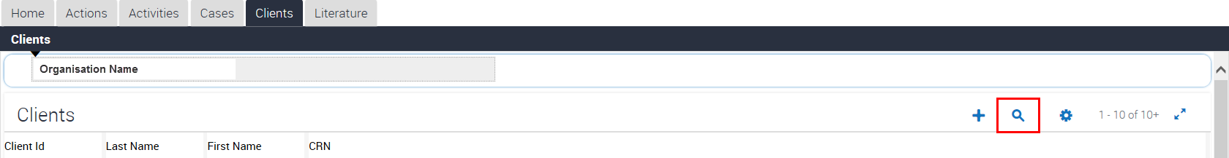
 | Enter the client’s CRN in the CRN field and click the (Go) button.
To access the client’s details, select the hyperlink on the client’s surname.
Update Client details
It is always important to keep a client’s details up to date.
For example, the client’s address details or primary contact may change.
For instructions on how to change a client’s details please see the Update an Existing Client Record that is Associated with Your Organisation task card.

 | Navigate to the Cases view tab in the bottom half of the screen.
Click the (New) icon to add a new case.
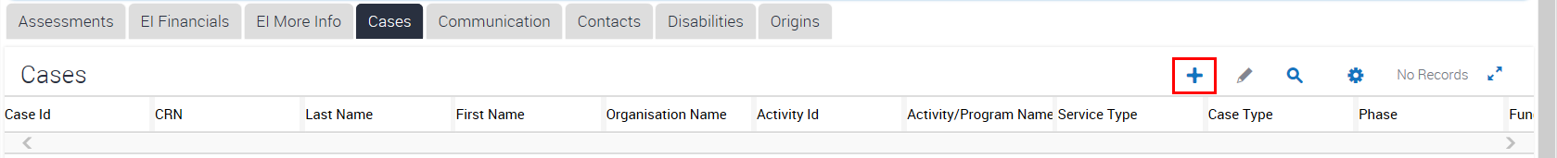
A box containing cases will appear on the screen. You can search this box to make sure there are not any existing cases for this client already. Once you are satisfied there are no other existing cases, you can select the (New) icon to continue to create a new case.
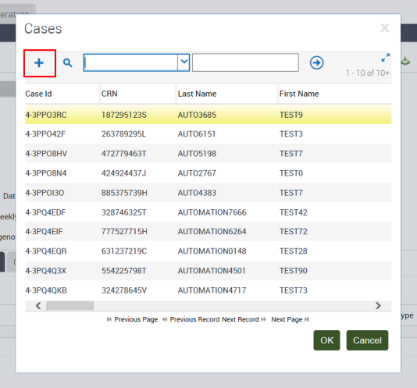
The details of the Client for which this Case is being created display in the Client Details section and include the client’s last name, first name, CRN and date of birth.
GPS also creates a unique Case Id. You should reference the Case Id in any correspondence with DSS about the client.
Click the glyph next to Activity ID.
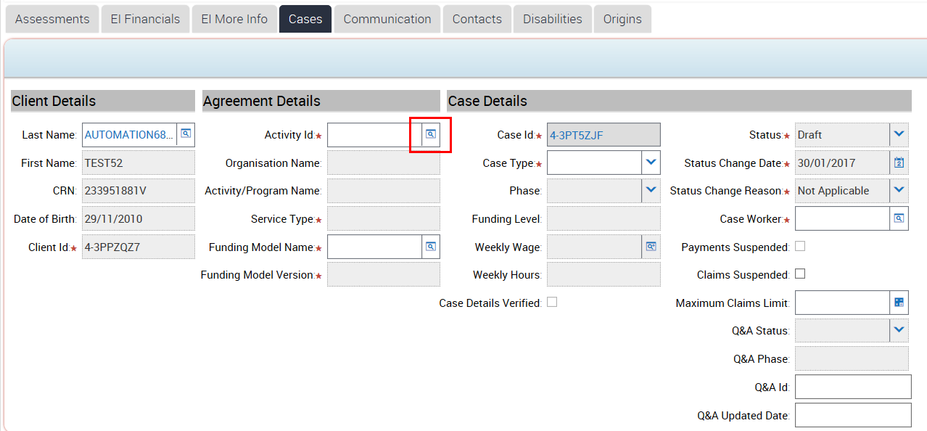
Select the relevant Activity Id from the list then click OK.
A GPS Activity outlines the type of service performed by your organisation. You select the Activity that relates directly to the service that you provide to the client.
Please make a note of your Activity Id and provide this number in any correspondence with DSS.
Click the Case Type drop-down box. For Autism select AEI, for Better Start select BSI.
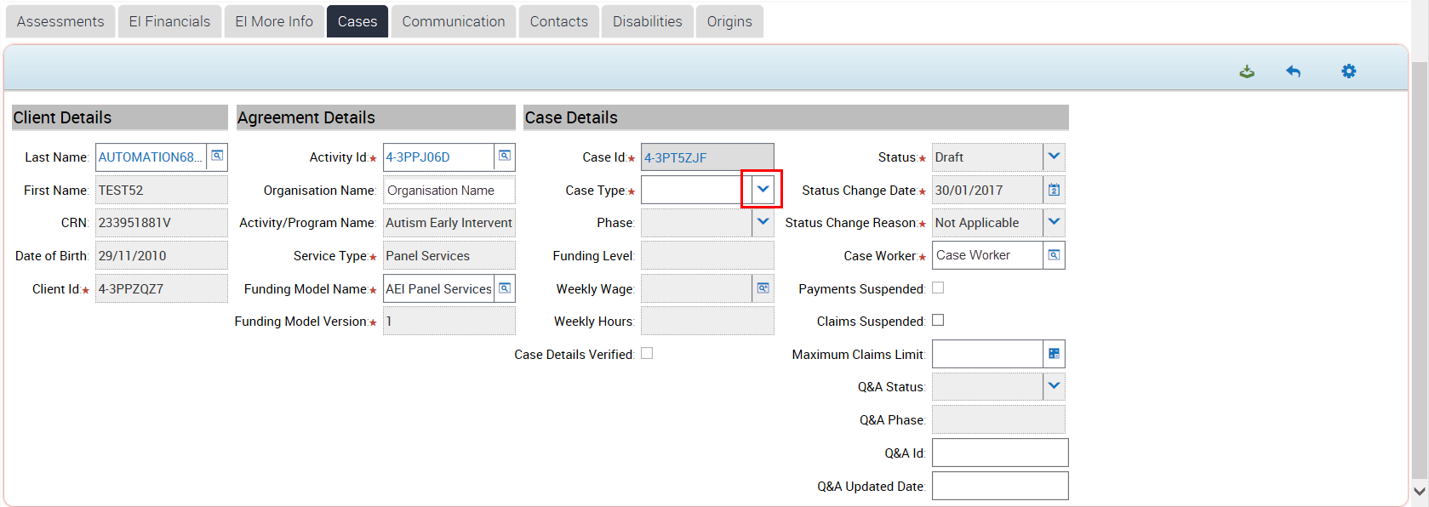
Click the glyph to find the correct Case Worker
The Case Worker refers to the person from your organisation that is entering the information for this client on in the DCP.
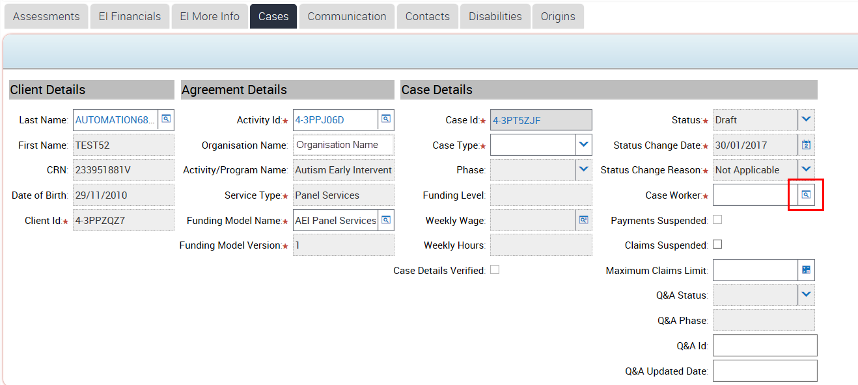
 | Highlight the appropriate Case Worker from the list and then click the OK button.
Save the record by clicking the (Save) icon.
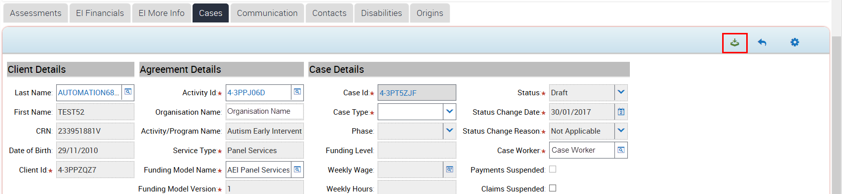
The Case record now displays in the List view.
Click the Case ID hyperlink to open the Case Record.
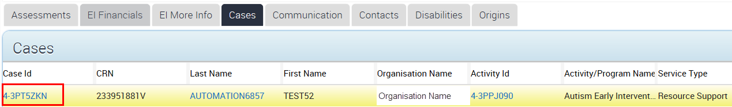
 | Click the dropdown next to Status and change the Status to Started.
 | Click the dropdown and change the Status Change Reason and select Assessed as Eligible.
Save the record by clicking into the (Menu) icon and selecting Save Record.
Please make a note of the Case Id for this client before continuing.
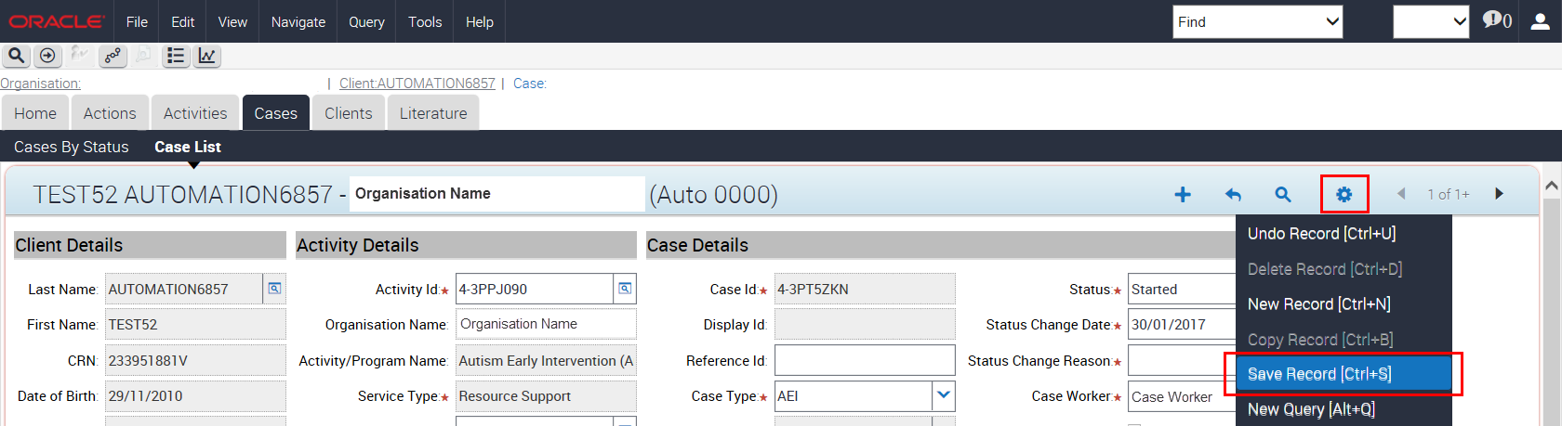
If applicable, you will now also be required to print a Letter of Introduction for the client to provide to approved Autism or Better Start Early Intervention Panel Services Providers.
For instructions on how to print a Letter of Introduction follow the task card or training video Print a Letter of Introduction.

Need Help?
For further assistance please contact the GPS Helpdesk on 1800 020 283 or email GPS.Helpdesk@communitygrants.gov.au

