  - Update a Client Record that is Associated with Your Organisation

Disability Case Portal (DCP)
  - Autism Advisor or Better Start Information and Registration Service
  - This task card will take you through the process of updating a client record associated with your organisation.
You will be shown how to:
Update a client’s residential Address
Update contact details
Portal Access:
- Access the internet and log in to DCP at https://portal.dss.gov.au/fofmsportal
Steps | Actions
Navigate to the Clients screen by clicking on the Clients tab.
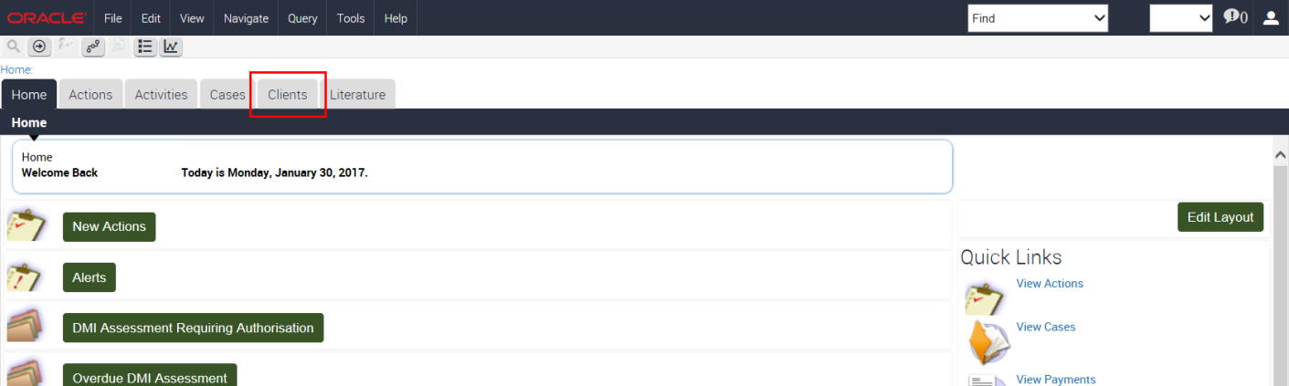
Click the (Query) icon to search for the client record you want to update.
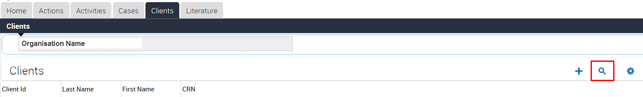
 | Enter the Customer Reference Number (CRN) then click the (Go) icon.
 | Click the Last Name hyperlink to open the client record.
To update a client’s residential address
For this example, the client’s residential address has changed and you need to create a new address record.
Note: The residential address must be the same as the address on the client’s proof of residence document, i.e. Centrelink Notification, utilities or rates invoice.

 | In the Address details section, click the glyph beside the Address field.
 | Click New to create a new address record.
Enter the client’s new address.
The software will locate and geographically code the client’s address to determine if the client resides in an outer regional or remote location.
DCP uses this information to automatically assess the client’s eligibility for the Outer Regional and Remote (OR&R) access payment.
 | Click the Find button to validate the address.
Highlight the appropriate address and select the OK button to continue.
If the address doesn’t display as expected, contact the GPS Helpdesk on 1800 020 283.

 | Select Residential from the drop down list under Type.
 | Tick the Mailing box.
You also need to deactivate and enter an end date against the previous address.
Click the previous address record.
 | Enter a date in the End Date field.
 | Click the OK button.
 | You will notice that the Address Details section updates with the new address.
You should check whether the client has become eligible for the Outer Regional and Remote Payment.
Click the EI More Info TAB. The eligible OR&R payment field will indicate eligibility.
Note: You should ask the client’s family or carer whether they have previously received the Outer Regional and Remote Payment. If not, advise them to contact their Autism Advisor or the Better Start Registration and Information Service for more information.
Each time you update a client’s address, you must also complete and authorise an AEI or BSI - Client Change of Address checklist.
Click the Assessments tab.
Click the (New) icon to add a new checklist record.
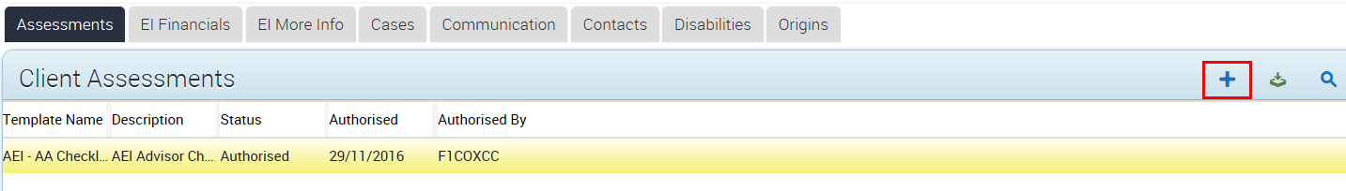
 | To access the Change of Address checklist, click the glyph beside the Template Name field.
 | Click the Change of Address template and then click the OK button.
Click the (Save) icon to save in the Assessments view.
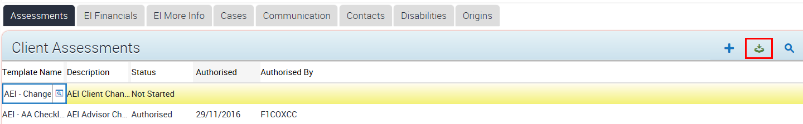
The change of address questions display. You will notice that the Status is Not Started.
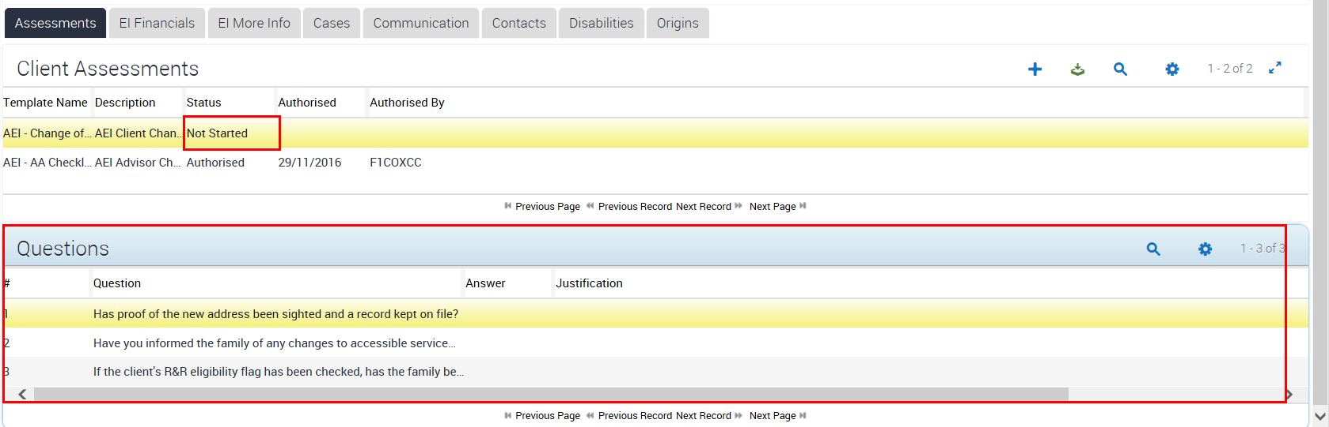
Click In Progress from the drop down list and then save the record.
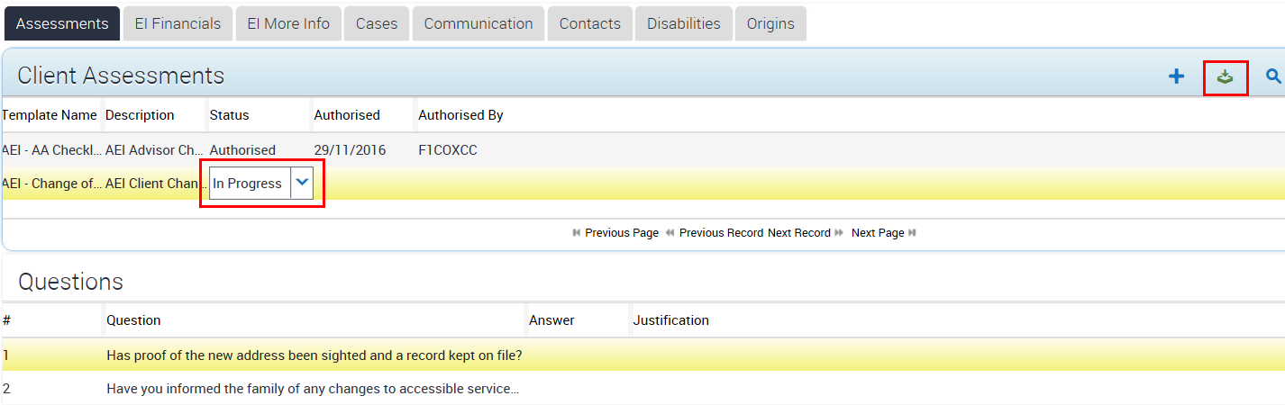
Answer each question by selecting an option from each drop down list.
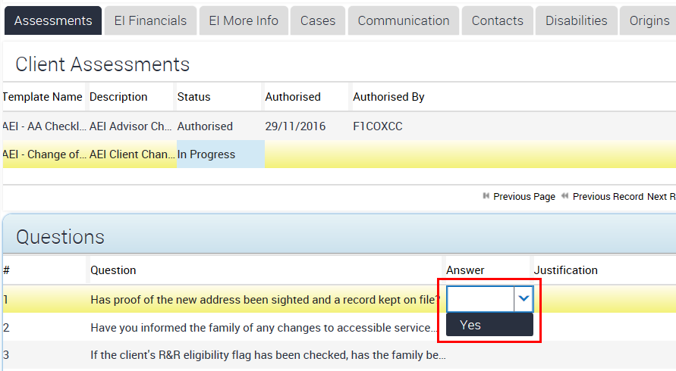
To save, click the (Menu) icon and select Save Record the Questions view.
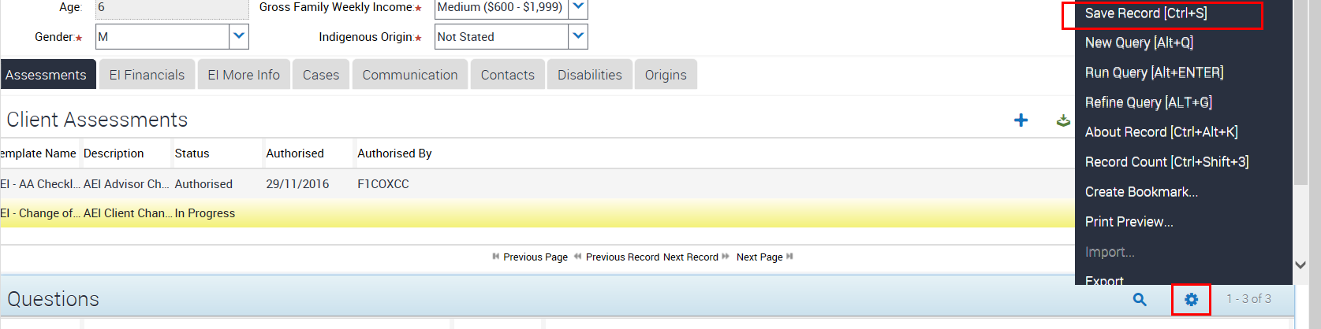
 | To complete the checklist, click Completed from the Status drop down list.
Click the (Save) icon to save the status change.
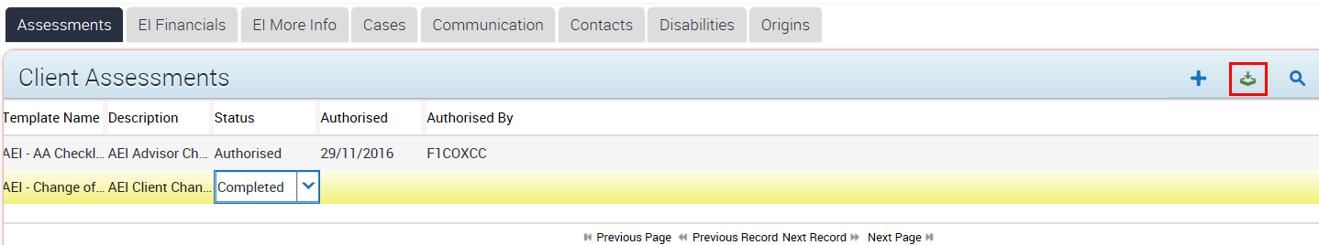
 | You now need to authorise the change of address. Select Authorised from the Status drop down list.
Click the (Save) icon to save the status change.
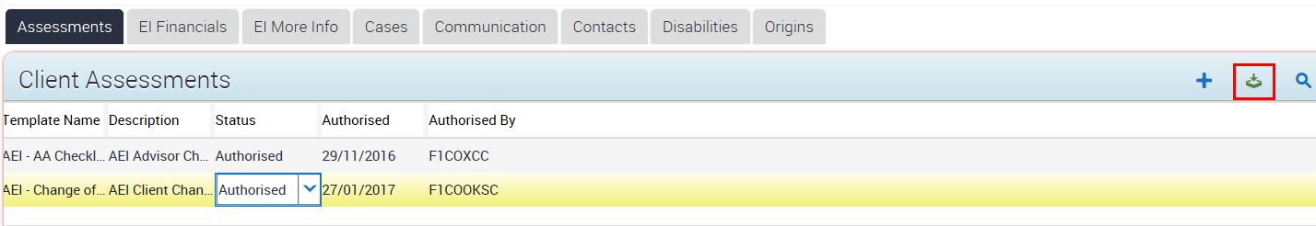
Update contact details
For this next example, the client’s primary contact notifies you that they have changed their home phone number. You need to update their phone record.

More Information
DSS provides clients with a monthly Family Activity Statement outlining claims made for services, and their remaining AEI or BSI balances.

Family Activity Statements are emailed or mailed to the person entered as the primary contact. Therefore, you need to ensure that you record a valid email or postal address for the primary contact of each client receiving services from your organisation.

 | To update the contact person of the client’s phone number, select the Contacts tab.
Click the (Edit) icon to edit the record.
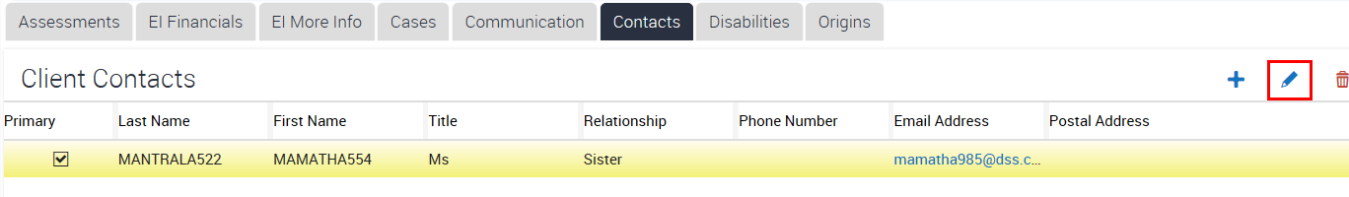
Select the glyph beside the Phone Number field.
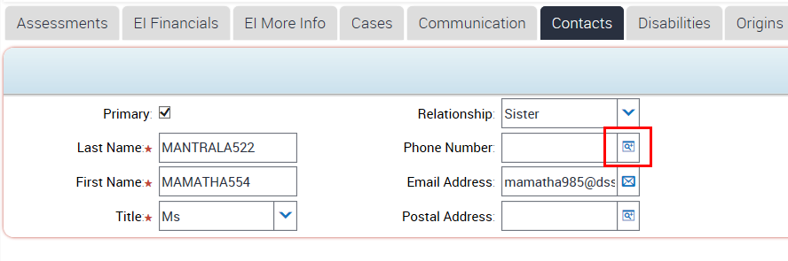
 | Click the (New) icon to create a new phone number record.
 | Type the contact’s new number in the Phone field and select the Phone Type from the drop down menu.
 | Select the (Save) icon to save the changes.
 | The new phone number will display. Check the details are correct and click OK.
The primary contact’s new phone number appears in the Phone Number field.
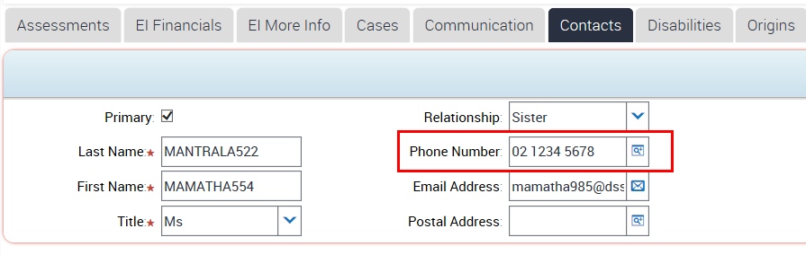
Click the (Save) icon to save the changes.
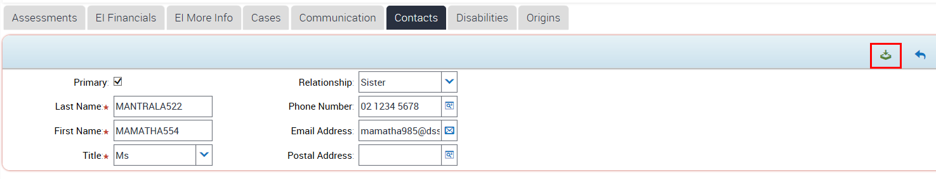
Note: If a new primary contact is required for this client you will need to make a professional judgment as to who is the primary contact with due regard to any court orders or agreements provided to you.

If you would like to change the client’s primary contact select New, enter the required information and save the record.

 | You have now finished updating the Client Record.

Need Help?
For further assistance please contact the GPS Helpdesk on 1800 020 283 or email GPS.Helpdesk@communitygrants.gov.au

