Submitting a Claim to DSS for Payment
Disability Case Portal (DCP)
Autism Advisor or Better Start Information and Registration Service
This task card will take you through the process of submitting a Claim to DSS for payment. The claim must already be created in FOFMS and have a status of Ready for Submission.

Portal Access:
Access the internet and log in to DCP at https://portal.dss.gov.au/fofmsportal

Steps | Actions
 | Navigate to the Case Claims tab and click on the (Query) icon.
 | Click the Claim Status drop-down and select Ready for Submission.Click on the (Go) icon.
 | All claims with a status of Ready for Submission will then appear in the list view. Highlight over the claim that requires submission.
4 | Check all fields are correct and then to submit the claim, click the Claim Status drop-down  and select Submitted.  .
5 | Click on the (Menu) icon and select Save Record.  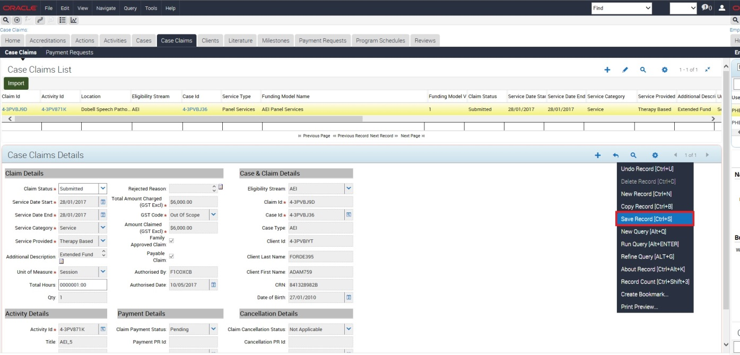

Need Help?
For further assistance please contact the GPS Helpdesk on 1800 020 283 or email GPS.Helpdesk@communitygrants.gov.au

