Printing the Letter of Introduction

Disability Case Portal (DCP)
This task card will take you through the process of printing a Letter of Introduction (LoI).
The Letter of Introduction enables Early Intervention Panel Services Providers to verify the client’s eligibility for the Autism or Better Start Early Intervention Program, and access the client’s information in DCP.
Portal Access:
- Access the internet and log in to DCP at https://portal.dss.gov.au/fofmsportal
Steps | Actions
Navigate to the Cases screen by clicking on the Cases tab.
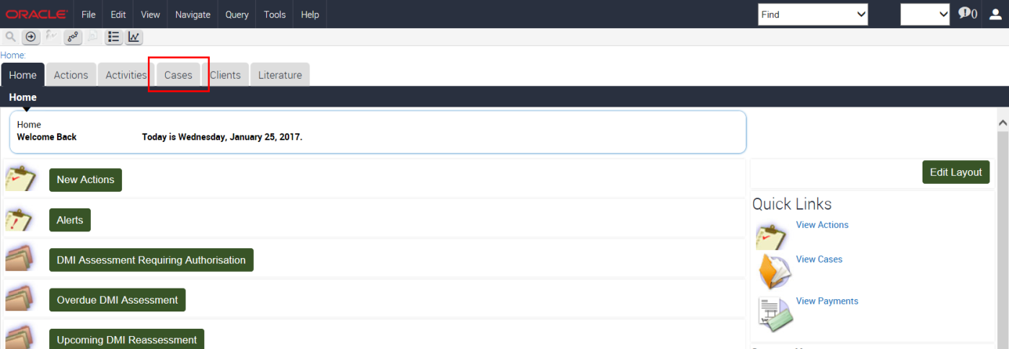
Click the button to query for the Client’s Case record.
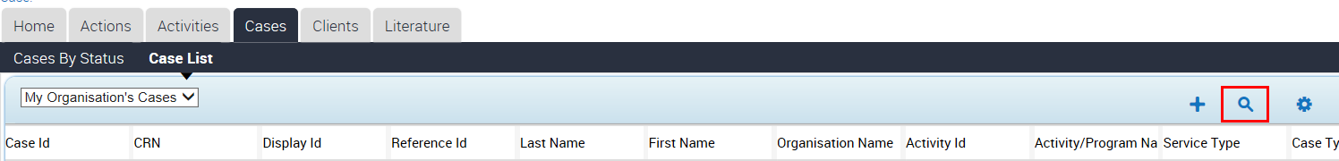

Enter the Client’s Case Id and then click the icon to execute your query.
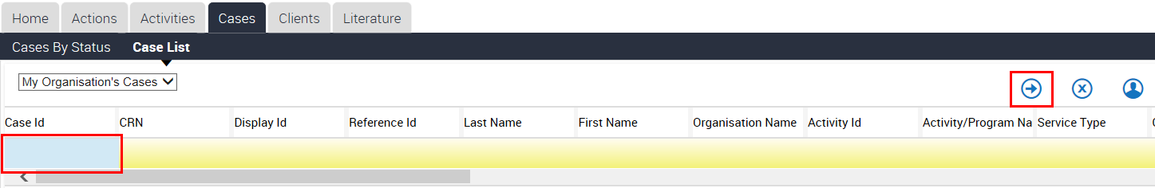
The results will return the case highlighted in yellow.
Please Note: You are only able to generate a Letter of Introduction from the Case List View.
Click the Reports icon.
The Generate Report window will display on the left hand side of the screen. Select the Submit button.
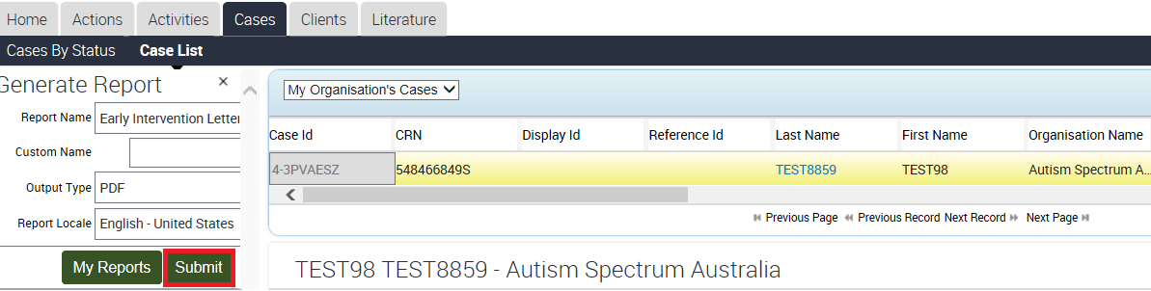

Select My Reports from the Generate Report window.
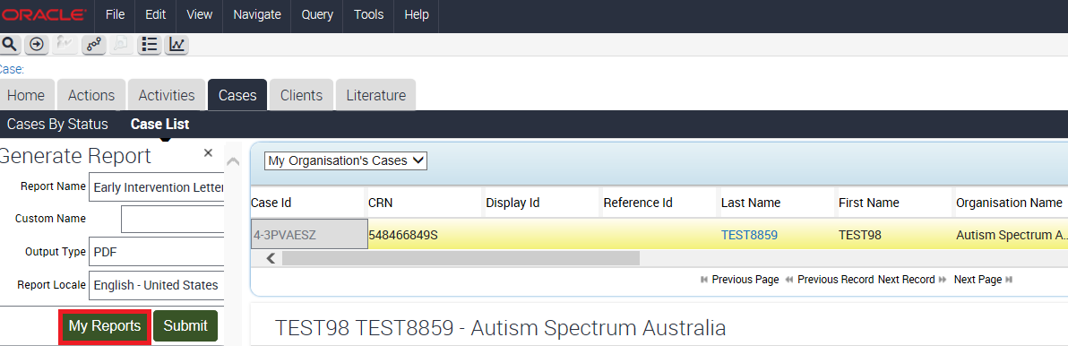
Select the relevant report from the list and click on the Report Name hyperlink.
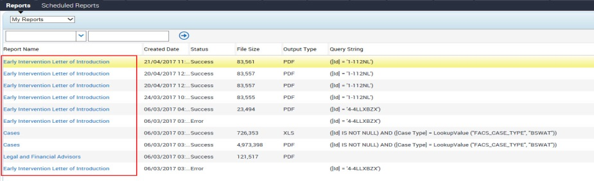
In the File Download window select Download.
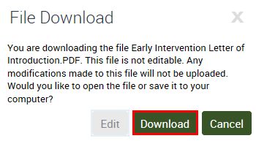
Select Open from the action bar at the bottom of the screen or select Save to save the file to a location on your hard drive and open it from there.
The Letter of Introduction will open.
The Letter of Introduction is addressed to the person identified as the client’s primary contact on the client record in DCP.
The letter contains the client’s Centrelink Customer Reference Number and their date of birth.
Early Intervention Panel Service Providers will use this information to search for the client’s record on DCP and to attach their own unique case records.
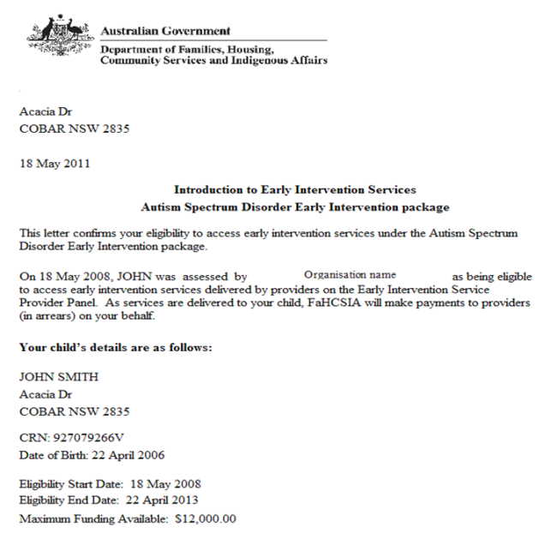
You must print a copy of this letter for the client by selecting the printer icon, and retain a copy for your own records.
Please note that you can reprint this letter at any time by following the steps outlined in this task card.
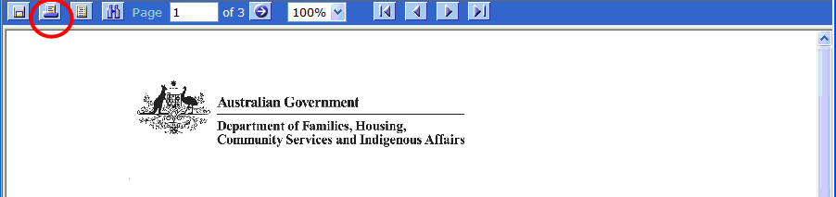
If applicable, you will now be required to create an Outer Regional and Remote (OR&R) claim.
For instructions on how to create a new OR&R claim, follow the task card for Creating a New Outer Regional and Remote (OR&R) Claim Record.

Need Help?
For further assistance please contact the GPS Helpdesk on 1800 020 283 or email GPS.Helpdesk@communitygrants.gov.au

