  - Locating and Interpreting Early Intervention (EI) Financials for Service Providers
To navigate to where a client’s EI financials are displayed, select the ‘clients’ tab on the top of the screen display.
This will return a list of the client’s for a service. Query for the client that the financials need to be viewed for. Once the required result has been located, the surname of the client (this should be hyperlinked) can be selected to bring up the client record.
Once in the client record, select the ‘EI Financials’ view tab below the client details.

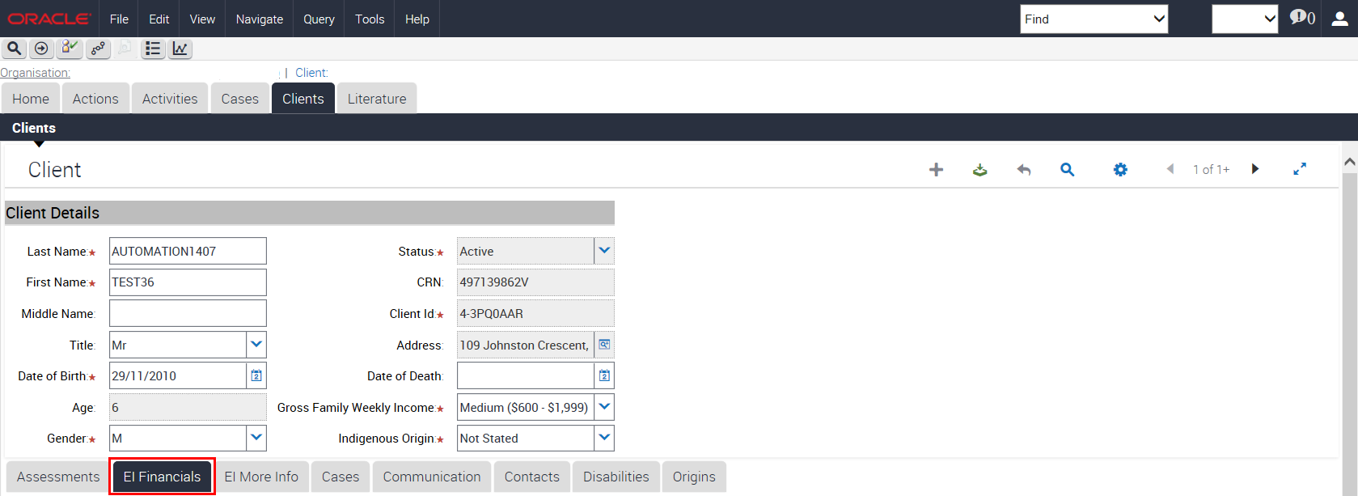

This is where the client’s funding information is stored.

Children eligible for Autism (AEI) or Better Start (BSI) packages get a total of $12,000 to spend on services and resources until they turn 7 years old, or the funding runs out. Each child can only spend a maximum of $6,000 each financial year, and can only spend $2,100 of that each financial year on resources. Only $4,200 (35%) of the overall funding can be spent on resources. A client can spend the total amount of funding on services; however they can only spend funding on resources if there is funding available in the Most Recent Period Balance. If a child is eligible for Outer Regional and Remote payments (OR&R) they are granted an extra $2,000 to assist with the cost of transportation to and from services. OR&R can only be claimed once and the eligibility for this funding is determined on a case by case basis.
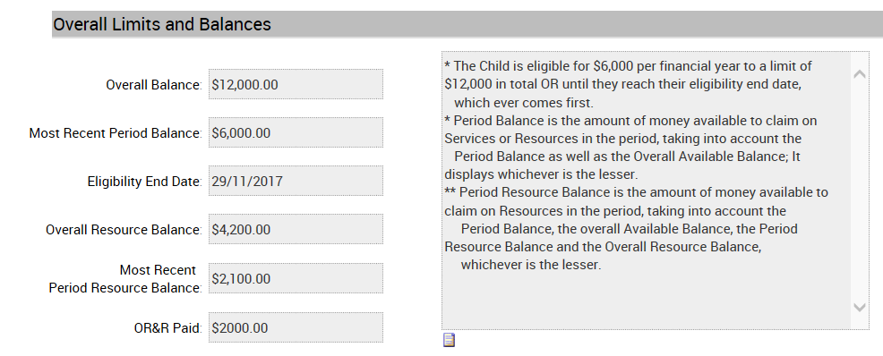
Overall Balance: Displays the child’s available balance until their 7th birthday
Most Recent Period Balance: Displays the child’s available balance for the duration of the current financial year
Eligibility End Date: Displays the child’s seventh birthday. Claims cannot be processed with a service date falling outside the eligibility start and end date
Overall Resource Balance: Displays the child’s available resource balance until their 7th birthday
Most Recent Period Balance: Displays the child’s available resource balance for the duration of the current financial year. This funding can only be spent if there is sufficient funding available in the Most Recent Period Balance.

OR&R Paid: N/A: Not applicable, client is not eligible for OR&R payment
Blank: Client has $2000 available for OR&R payment
$2,000: Client has spent OR&R payment
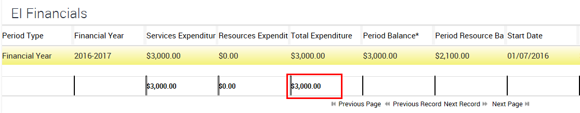
Financial Year Line:
The EI Financials display the child’s expenditure across all financial years that they have been eligible for funding to date.
A new financial line will appear for each new financial year that the child is eligible for funding. The financial line may not appear until the first claim has been submitted for that financial year. If a new financial year does automatically create, the AEI and BSI helpdesk will need to manually create one.
Total balance spent for all years is displayed at the bottom of the page as shown by the red arrow in the above screen shot.

Need Help?
For further assistance please contact the GPS Helpdesk on 1800 020 283 or email GPS.Helpdesk@communitygrants.gov.au

