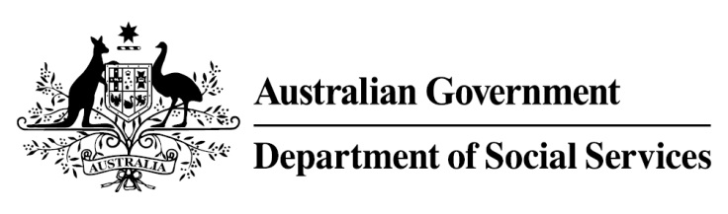

Try, Test and Learn Fund

  - Train and Care
Using insights from the Priority Investment Approach, the $96.1 million Try, Test and Learn Fund is trialling new and innovative approaches to assist groups of people at risk of long-term welfare dependence.
The Try, Test and Learn Fund will help achieve the objectives of welfare reform—that is, to develop a modern welfare system that increases the capacity of individuals, reduces the risk of welfare dependency and maintains a strong welfare safety net.

What does the evidence tell us?

Fast facts
Priority group: Young parents
Recipient numbers: 135
Location: Western Sydney and regional New South Wales
Trial period: 24 months
Total funding: $1.2 million
Co-designers: Apprenticeships R Us, and Mission Australia
Service providers:
Apprenticeships R Us
Potential future saving: The purpose of these initiatives is to test whether an intervention works to reduce long-term reliance on welfare. It is not possible to predict success rates in advance—this is the purpose of testing new approaches. If 14 per cent of participants (19) take up some work when they would not otherwise have done so, the savings to the welfare system are likely to outweigh the costs.
- In 2016, there were 3,760 young parents in Australia aged 18 or under receiving Parenting Payment. On average, all current young parents are expected to be on income support for around 48 years over their future lifetime.
- If nothing changes for these young parents, 79 per cent will be receiving income support payments in 10 years, and 57 per cent will be receiving income support payments in 20 years.
- In addition, analysis shows, around 620 current young parents will remain on income support for the rest of their lives.

What is Train and Care?
Young parents will be offered 7 to 8 weeks of practical training to equip them with the skills expected in entry-level positions in a range of industries. The trainers will offer flexible hours to accommodate family commitments. The young parents will also be offered a permanent child care placement, in a convenient location (depending on availability of child care places) as close as possible to home or the training location.
Once training is complete, the young parents will be offered entry-level work placements that could lead to a job.
During the training and work placement period, financial assistance will be available to cover all out-of-pocket child care costs.

What are we trying to achieve?
Help young parents transition to work by combining training and child care support.
A smoother transition to work is more likely to result in positive, long-term outcomes.

How is this initiative new and innovative?
The initiative’s innovation is in providing a practical workplace-training program and work experience, and at the same time supporting participation by removing the barriers faced by young parents relating to child care access and affordability.

How will this initiative be evaluated?
This initiative will be tracked using a range of evaluation methods, such as surveys, participant interviews and actuarial analysis.

