eNewsletter, Issue 8, October 2016

A message from Australian Government Minister for Social Services, Christian Porter
Today we mark an important milestone in our mission to help women and their children live free from violence, with the launch of the Third Action Plan of the National Plan to Reduce Violence against Women and their Children 2010-2022.
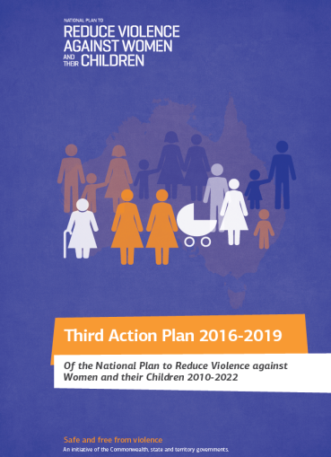
The Third Action Plan 2016-2019 was presented at the Council of Australian Governments’ National Summit in Brisbane, where all governments, experts and key stakeholders came together to connect, review progress and encourage an integrated response to reduce violence against women and their children.

We are at the halfway point of a 12-year roadmap for generational change.

The Third Action Plan includes a suite of practical actions under six priority areas, ranging from prevention to responding to emerging issues such as technology-facilitated abuse.

It identifies the need to provide additional support for frontline services, outlines how we’ll meet the needs of vulnerable communities and for the first time, prioritises how we’ll assist children to feel safe and recover.

The Third Action Plan is backed by $100 million in Australian Government funding, on top of the $100 million for the Women’s Safety Package, plus ongoing funding of around $25 million a year to implement the National Plan.

We’re building on the foundations of six years of dedication and hard work by individuals, communities, businesses, non-government organisations and my state and territory colleagues.

Together we have kept the issue of domestic, family and sexual violence on the national agenda, and consequently, there is now an unprecedented level of community awareness on the issue.

I want to thank all of those who have given their time and expertise to make the Third Action Plan a reality.

We are making progress, but there is more to be done.

The true impact of domestic violence – how it affects victims, their families, friends, workmates, and our whole community – is impossible to measure.

It’s up to each of us to play a part in efforts to stop the violence.

Sincerely,
The Hon. Christian Porter MP Australian Government Minister for Social Services.
Table of Contents
A message from Australian Government Minister for Social Services, Christian Porter 1
Feature stories 3
1800RESPECT 3
Our Watch Awards 2016 3
Beginning a Life in Australia is now online 4
Release of national data on police-recorded victims of family and domestic violence 4
Department of Immigration and Border Protection 4
eSafety Women – Empowering women to take control online 5
Updates from around the country 6
Western Australia 6
Highlights from New South Wales 6
Highlights from South Australia 8
Highlights from Victoria 9
Highlights from Tasmania 9
Highlights from Queensland 11
Have your say! 13
Do you need help? 13

Feature stories

1800RESPECT
1800RESPECT is running a campaign to encourage frontline workers across Australia to learn how they can increase the safety, support and wellbeing of people impacted by sexual assault, domestic and family violence.

On Monday 21 November representatives of 16 different sectors will join Rosie Batty to pledge their support for women and their children who are affected by domestic and family violence.

As part of this event they will encourage their organisations and frontline workers in their sector to learn how they can make a difference and encourage them to download the 2016 1800RESPECT Frontline Workers Toolkit.

The 16 represented sectors include: domestic and family violence, education, local government, not-for-profits, LGBTI, Aboriginal and Torres Strait Islander, multicultural, legal services, sport, media, youth, mental health, disability, police, emergency services and corporate.

The Toolkit is equipped with tools and information to help workers identify signs, offer knowledge-based support, and connect women to the most appropriate services. Developed in consultation with experts and funded by the Department of Social Services, the 1800RESPECT online toolkit has key information on good practice, educational videos with specialists, webinars, tools and resources, and apps.

The toolkit can be downloaded at 1800respect.org.au/toolkit.

The campaign coincides with the 16 Days of Action campaign – a global campaign to end violence against women that runs from 25 November to 10 December 2016.

To find out how you can get involved in the campaign please contact Kelli Browne on kelli@1800respect.orgau or Catherine Watt on Catherine@1800respect.org.au.

Our Watch Awards 2016
On 14 September the second Our Watch Awards were held to celebrate media excellence in reporting on violence against women.

Lauren Novak and Sheradyn Holderhead won the 2016 Our Watch Gold Award for their campaign in the Sunday Mail and The Advertiser, “Knowing what we’re up against”. Our Watch judges said: “The ‘Knowing what we’re up against’ campaign demonstrated a clear objective - to know the extent of the issue of family violence so as to stop it."

Columnist and broadcaster Tracey Spicer spoke with the winners about how high quality reporting can contribute to a deeper understanding of violence against women including its drivers and prevention.

The event, was hosted by Julia Zemiro, and saw more than 200 journalists, industry, media identities and survivor advocates gathered at Sydney’s Doltone House, Hyde Park.

The Awards were delivered in partnership with The Walkley Foundation, and funded by the Department of Social Services.

You can view all the winning entries here.

Beginning a Life in Australia is now online
The newly-updated Beginning a Life in Australia booklet (BaLIA) – a settlement guide to services available in Australia – is now available from the Department of Social Service website.

The booklet contains detailed national and state/territory specific information about education, employment, health, housing, money and transport for migrants and the community.

Families escaping violence, for instance, will find emergency services contact numbers and crisis accommodation information useful.

BaLIA also provides information on topics such as domestic violence and offers support for new arrivals who may be unfamiliar with Australian laws and way of life.

BaLIA contains over 1500 links, so it is best viewed online.

BaLIA will be available in 39 community language translations. Audio options may also be available in some languages.

To find out more, go to the Department of Social Service website.

Release of national data on police-recorded victims of family and domestic violence
On 13 July 2016 the Australian Bureau of Statistics (ABS) released the second edition of statistics on victims of family and domestic violence recorded by police nationally.

Statistics were published for victims of Homicide, Assault, Sexual Assault and Kidnapping/abduction, for a range of characteristics such as sex, age, Indigenous status, location, weapon use and relationship of offender to victim.

This project was funded by the Department of Social Services to build a stronger evidence base for family, domestic and sexual violence.

This data release is a component of Recorded Crime - Victims, 2015 (cat. no. 4510.0).
It contains national, state and territory totals.

To view and download the latest data, go to the ABS website.

Department of Immigration and Border Protection
The Department of Immigration and Border Protection is strengthening its response to domestic and family violence. As part of this, Rape and Domestic Violence Services Australia were engaged to provide a pilot training programme for staff earlier this year and in November 2016 the department is aiming to launch a three year strategy to guide its responses to both clients and staff experiencing domestic or family violence.

eSafety Women – Empowering women to take control online
In April 2016 the Australia Government launched eSafety Women. The new resources aim to empower Australian women to take control of their online lives.

Most women who experience abuse from a current or former partner will also experience online abuse from that person. This means they may be cyberstalked, have intimate images shared, have their banking access restricted, or, more commonly, receive multiple abusive and threatening messages.

The eSafety Women portal:

- provides practical tools to equip all women to protect themselves, and their loved ones, against all forms of online abuse, such as real stories from women to help raise awareness of what abuse looks like.

- trains frontline staff who work directly with women at risk to help equip those women to protect themselves, and their children, online. To date over 70 face to face workshops have been held nationally with social workers, counsellors, and legal workers attending the training.

- increases awareness and understanding of online abuse, so that all women can identify it and respond safely through resources such as ‘how to’ videos that show how to use online safety settings.

This initiative forms part of the Australian Government’s $100 million Women’s Safety Package.

For more information go to the eSafety Women website.

Updates from around the country

Western Australia

Silent Domestic Violence Memorial March
The 2016 Annual Silent Domestic Violence Memorial March will be held on Friday 25 November in Western Australia.

The event remembers those whose lives have been lost as a result of family and domestic violence, and to convey the message that one death is too many.

The event commences at 10:30am with free morning tea, information stalls and guest speakers, and the march through the city starts at 12 noon.

It is hosted by the Women’s Council for Domestic and Family Violence Services WA in partnership with the WA Department for Child Protection and Family Support.

For more information about the march see the Women’s Council for Family and Domestic Violence Services website or see the Silent Domestic Violence Memorial March Facebook page.

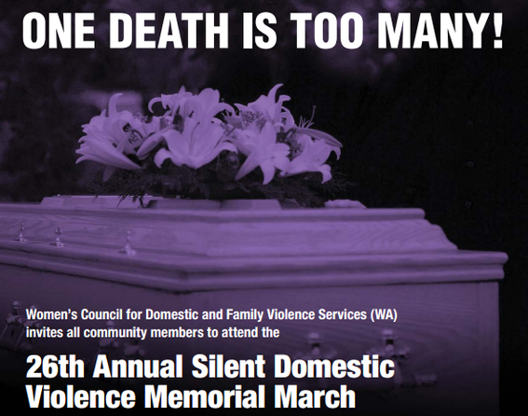

New Child Protection Practice Guidance and Tools
On 1 July 2016 the Department for Child Protection and Family Support launched new practice guidance for responding to family and domestic violence.

The practice guidance which includes new policy, procedures, toolkits and other resources aims to promote child and adult victim safety through improved engagement and intervention with perpetrators.

This package builds on Western Australia’s commitment to protecting child and adult victims of family and domestic violence by holding perpetrators to account. It is also In line with recent amendments to WA’s child protection legislation.

For more information or to download the documents visit the website.

Highlights from New South Wales

Launch of Domestic and Family Violence Blueprint for Reform 2016 - 2021
On 24 August 2016, the Minister for the Prevention of Domestic Violence and Sexual Assault, the Hon Pru Goward MP launched the Domestic and Family Violence Blueprint for Reform 2016 – 2021: Safer lives for Women, Men and Children.

The Blueprint is a key NSW Government reform that responds to domestic and family violence. It is the result of extensive consultation with victims of domestic and family violence, non-government services working with victims, peak organisations and government agencies.

The Blueprint provides a response to the feedback received in consultations by setting out six key outcomes:
- Preventing domestic and family violence
- Intervening early with vulnerable communities
- Supporting victims
- Holding perpetrators accountable
- Delivering quality services
- Improving the system.

The NSW Government will work in partnership with non-government organisations, the private sector and the broader community over the next five years to implement the Blueprint.

For more information on the Blueprint, visit the website.

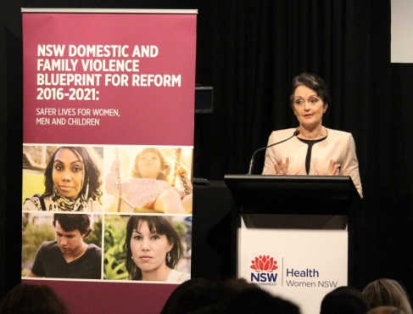

Increased Investment in Domestic Violence Services and Initiatives
To support the implementation of the Blueprint, the NSW Government has doubled its investment in specialist domestic violence services and initiatives to more than $300 million. This is up from $148.5 million in the 2015-16 Budget.

Key initiatives in the 2016-17 Budget include:
- $53 million for a state-wide roll out of Safer Pathway, which ensures high-risk victims receive a consistent and integrated multi agency response. This is subject to the successful evaluation of pilot sites.
- $43 million for housing supports through Start Safely, providing short to medium-term financial help for people escaping domestic and family violence who are at risk of homelessness.
- $34 million for the Women’s Domestic Violence and Court Advocacy Program, and an additional $6.3 million to meet unmet demand to respond to police referrals. This investment will ensure victims and their families can continue to receive comprehensive support through the justice system.
- $25 million for Staying Home Leaving Violence, so women and children can stay safely in their own home or a home of their choice.
- $20 million for a Domestic and Family Violence Innovation Fund for prevention, early intervention and crisis responses that support the efforts of specialist domestic and family violence services and refuges.
- $15 million for NGO-led community based perpetrator interventions, including $8 million in new funding, to change behaviour.
- $13 million for Victims Services to pilot new responses for male victims, such as gay men, or fathers and sons suffering family violence, through expert NGO support.

Highlights from South Australia

Domestic Violence and Problem Gambling
In March 2016, the Office for Women (OFW) and Office for Problem Gambling (OPG) hosted a Share Space event attended by 45 South Australian practitioners from the domestic violence and gambling help services sector.

Many domestic and family violence services are currently dealing with a similar cohort of clients – in some cases, individuals and families are accessing both domestic violence and problem gambling services.

At the event, participants agreed that a new policy framework to deal with cases of problem gambling and domestic and family violence should be developed.

It was agreed this should be informed by a public health approach and service responses should be sustainable and outcome driven. Agreements between funding bodies and services should reflect this approach in addressing the two issues.

A working group of key stakeholders will progress the two most significant elements out of the Share Space event - the state wide mapping of services and the creation of a common risk assessment tool, which recognises the link between problem gambling and domestic and family violence.

Innovative education program wins State Award
An education program for women affected by domestic violence, Pathways to Education, is the South Australian 2016 Adult Learning Program of the Year. It was recognised for its outstanding contribution to adult learning in the face of adversity.

The pilot program was designed to help women affected by domestic and family violence achieve both learning and personal development goals. The women studied in a safe and confidential learning environment, with a domestic violence caseworker available for support.

All 17 women involved in the pilot graduated from the program, with many now enrolled in further education.

The Pathways to Education program was funded by the South Australian Government’s Office for Women and delivered through a collaboration between the Central and Limestone Coast Domestic Violence Services and TAFE SA Women’s Education.

Young People and Domestic and Family Violence and Sexual Assault
For young Australians, domestic and family violence and relationship breakdown is a key reason for seeking assistance from specialist homelessness services.

The South Australian Department for Communities and Social Inclusion is convening a series of workshops in October and November 2016 to bring key players from the community sector together to consider the response required to reduce the impact of violence on young people in SA. The outcomes will inform the development of a South Australian Youth Safety Strategy.

This work is driven by a collaboration between the Office for Youth, the Office for Women, Housing SA, SA Health, Uniting Communities and Multicultural Youth SA.

Highlights from Victoria

Take Action, Go Orange
In November, the Victorian Government is calling on the whole Victorian community to ‘Take Action and Go Orange’ as part of the second Victoria Against Violence 16 Days of Activism campaign.

Now in its second year, Victoria Against Violence will again coincide with the United Nations' 16 Days of Activism against Gender-Based Violence campaign – commencing on International Day for the Elimination of Violence against Women (25 November) and concluding on International Human Rights Day (10 December).

Building on the momentum and success of last year’s inaugural campaign, Victoria Against Violence will seek to turn the Victorian community’s attention to the devastating impact that family violence has on the lives of so many. It will highlight the link between gender inequality and family violence, and encourage every Victorian to join the global ‘Go Orange’ movement.

Orange is the colour designated by the UN Secretary-General’s UNiTE to End Violence against Women campaign. As a bright and optimistic colour, orange represents a future free from violence against women and girls.

From 25 November, Victoria Against Violence invites individuals, families organisations, businesses, students and all levels of government to stand together to prevent family and gender violence. Further information about the 16 Days of Activism and how the community can get involved is available online.

Victoria Against Violence sends a clear message that every Victorian has a role to play in preventing family violence.

For information and ideas about how to get involved visit the website.

Highlights from Tasmania

Launch of the Safe Families Coordination Unit
On 4 July 2016, the Premier, the Hon Will Hodgman MP officially opened the Safe Families Coordination Unit (the Unit) - the flagship initiative of Safe Homes, Safe Families: Tasmania’s Family Violence Action Plan 2015-2020 (Safe Homes, Safe Families).

The Unit brings together staff from across Tasmanian Government agencies who for the first time, are co-located. This enables the Unit to share information to help identify those families at risk of family violence and to support them as early as possible.

The Unit is focussing on addressing priority family violence perpetrators through dedicated information gathering and intelligence development activities. Collecting evidence from across government about perpetrators will aid in the prosecution of offenders.

The Unit’s work builds on, and complements, Safe At Home, Tasmania’s whole-of-government criminal justice response and intervention system which has been in place since 2004 and other non-government services.

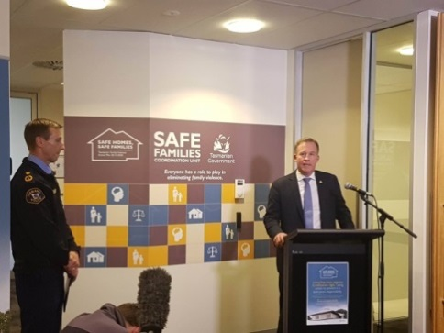
Image: The Premier launches the SFCU with Tasmania Police Commissioner Darren Hine APM

Supporting families affected by violence
In May 2016, CatholicCare Tasmania was announced as the successful provider of the new Safe Choices service with the service commencing operations in June 2016.

Safe Choices is providing an alternative pathway for people in or wanting to leave violent relationships to seek practical, non-crisis support including information, advice and referral. Safe Choices is initially being trialled in southern Tasmania in 2016-17 and will then be rolled out to other regions.

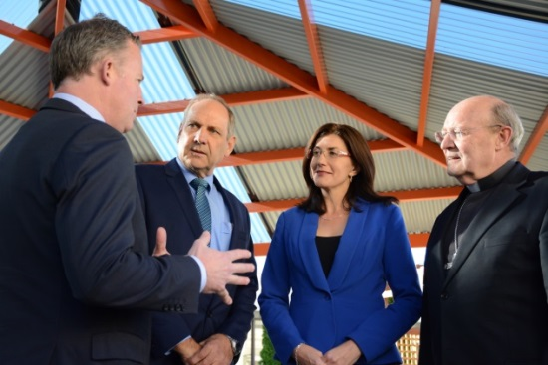
Image: The Premier and Minister for Women announce CatholicCare as the Safe Choices provider
Forensic examination of family violence victims
In April 2016 a pilot program offering forensic medical examination and documentation of injuries to adult victims of family violence commenced at the Royal Hobart Hospital.

The medical exams, undertaken by a specialist forensic nurse examiner, provide victims of family violence with another option for care and advice as they can help victims find the most appropriate support services.

It also gives police and the justice system the best possible chance of convicting perpetrators of family violence, as the forensic nurse examiner can be called as an expert witness or supply a medico-legal report as evidence.

Commissioner for Children and Young People’s Report on Family Violence
On 20 September 2016, the Premier, the Hon Will Hodgman MP launched the Tasmanian Commissioner for Children and Young People’s Report: Family Violence and Children and Young People in Tasmania.

The launch was also attended by 2015 Australian of the Year Rosie Batty, and young women from Project O.

The Report contains 26 findings and highlights that children can be victims of family violence in their own right. The findings provide guidance on what further actions can be taken to improve the outcomes for Tasmanian children and young people experiencing the effects of family violence.

The Tasmanian Government will make a formal response to the Report and will consider the findings as its ongoing response to family violence in Tasmania.

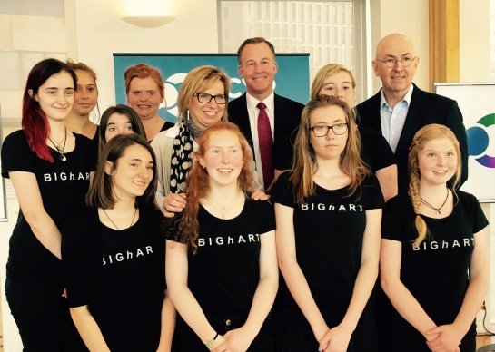
Image: Premier, Commissioner, Rosie Batty and Project O participants
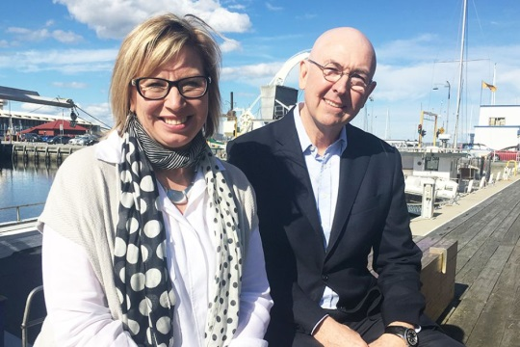
Image: Rosie Batty and Commissioner for Children and Young People Mark Morriseey

Highlights from Queensland

First Domestic and Family Violence Implementation Council Report
On 30 August the Domestic and Family Violence Implementation Council, Chaired by Dame Quentin Bryce, tabled their first six-month progress report.

The Council was established to monitor and champion the implementation of the recommendations from the Not Now, Not Ever: Putting an End to Domestic and Family Violence in Queensland report and the Queensland Domestic and Family Violence Prevention Strategy.

The report showed that from December 2015 to May 2016, significant progress had been made. The report noted that of the 121 recommendations for government action, 32 had been completed, work had started on 77 recommendations, and 12 have been scheduled for the future action plan.

Key achievements noted in the report include:
- release of the 10-Year Domestic and Family Violence Prevention Strategy
- opening of 72-hour crisis shelters in Brisbane and Townsville
- the trial of a specialist domestic and family violence court at Southport
- a suite of laws including amendments to the Penalties and Sentences Act 1992 to make domestic violence an aggravating factor and laws to make non-fatal strangulation a separate offence
- development of the Respectful Relationships education program for all Queensland schools to counter attitudes and behaviours that underpin violence later in life.

More information about the Council and the report can be viewed here.

Investment package to boost domestic and family violence services over five years
The Queensland Government has committed $198.2 million over five years to implement recommendations of the Not Now, Not Ever: Putting an End to Domestic and Family Violence in Queensland report.

This funding is part of the 2016-17 State Budget and includes:
- $42.4 million to roll out specialist courts, building on learnings from a trial at Southport
- $43.1 million for additional or enhanced domestic and family violence services to support victims
- $26.3 million for eight specialist teams to prioritise victims and their safety
- $10.3 million for additional perpetrator interventions to help protect victims
- $9.6 million for a communication and engagement program to change attitudes and behaviours towards domestic and family violence
- $8.7 million for two new shelters to support women and children escaping domestic and family violence.

More information about the Queensland 2016-17 budget commitment can be found here.

Strengthening Domestic and Family Violence Legislation
On 11 October 2016, the Domestic and Family Violence Protection and Other Legislation Amendment Bill 2016 was passed by the Queensland Parliament.

The Bill implements the outcomes of an overarching review of the Domestic and Family Violence Protection Act 2012 and makes important improvements to better protect victims and their families.

The amendments allow police to act more quickly to protect women and children fleeing violence. They also facilitate information sharing between key government and non-government entities, and extend the default duration of a protection order to five years.

The amendments build on priority legislative changes already enacted and constitutes the next stage of legislative reforms to implement the Queensland Government’s response to the Not Now, Not Ever report.

More information on the Bill is available here.

Have your say!
We would love to hear from you! If you have content you’d like included in future editions of this e-Newsletter, or have other questions, comments or ideas, please email us at NPSecretariat@dss.gov.au.

Do you need help?
If you or someone you know is experiencing domestic and family violence or sexual assault, get help by calling:
- 000 if you, a child, or another person is in immediate danger
- 1800RESPECT – 1800 737 732
- Relationships Australia – 1300 364 277
- Mensline – 1300 789 978
- You can ask for a free interpreter if needed.

National Relay Service
- TTY users - phone 133 677 then ask for the phone number you wish to contact
- Speak and Listen (speech-to-speech relay) users - phone 1300 555 727 then ask for the phone number you wish to contact
- Internet relay users - visit the National Relay Service website and ask for the phone number you wish to contact.

