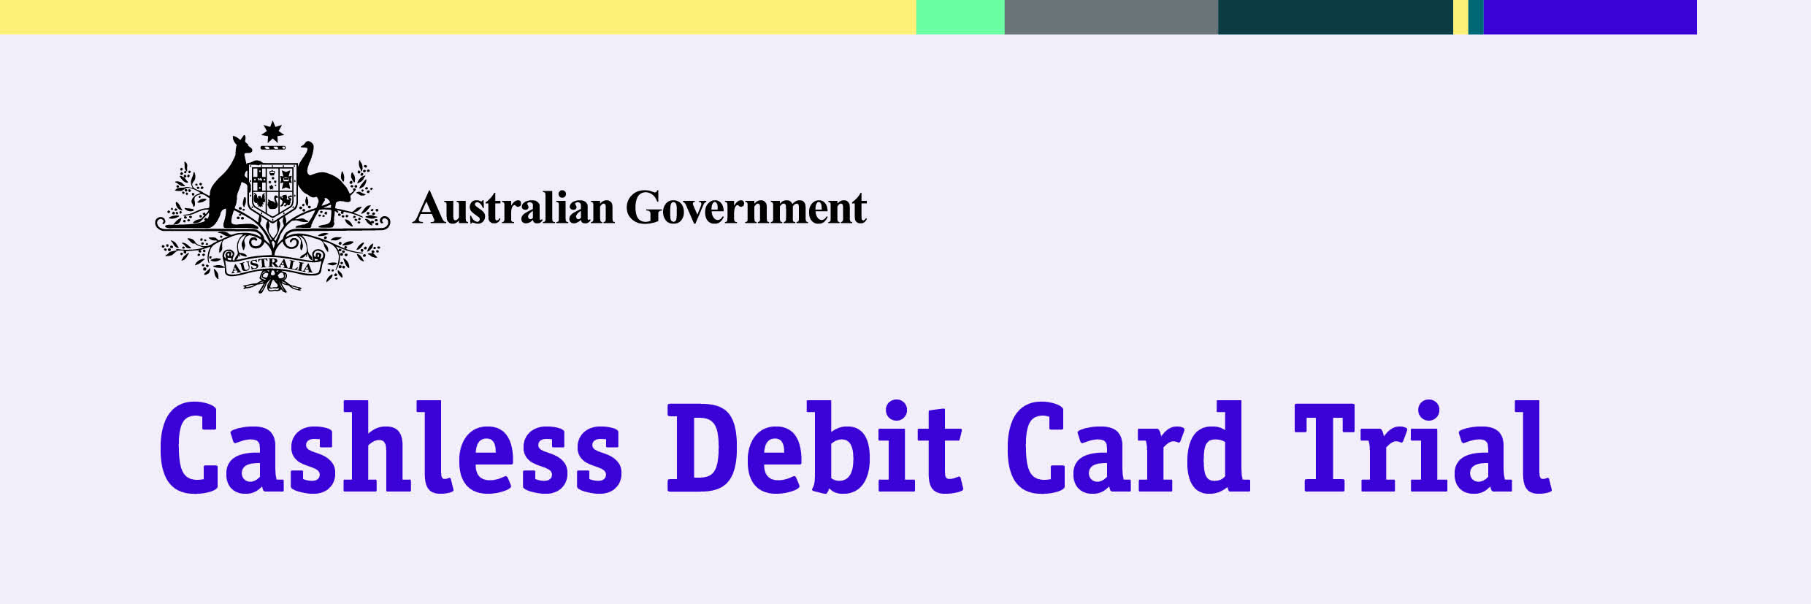
Community Panel - Questions and Answers

What is the panel?

The Community Panel for the Ceduna region is part of the Cashless Debit Card trial. The panel aims to encourage people to do the right thing for their community. You can apply to the panel to increase the cash amount of your Centrelink payments.

How does it work?

The panel members make a decision using the information on your application form and their own knowledge of the community.

The panel may also get extra information about you from the local school, health centre, housing, police, or child protection services. You are also encouraged to provide additional information, including why you need access to more cash from your welfare payment.
If approved, the panel can reduce the restricted percentage on your cashless debit card from 80 to 50 per cent. The panel cannot exit you from the trial.

How do I apply?

Applications are available at:
- Your Local Partner

Ceduna Aboriginal Corporation, 39 McKenzie St, Ceduna

Koonibba Community Aboriginal Corporation, Main Office, 3 Mickey Free Laurie Drive, Koonibba

Oak Valley Maralinga Aboriginal Corporation, Eyre Highway, Oak Valley

Scotdesco Aboriginal Corporation, Scotdesco Main Office, Eyre Highway, Bookabie

Yalata Community Incorporated, Eyre Highway, Yalata

Complete Personnel, Shop 4, Syprys Mall, Ceduna
- Department of Social Services – Panel Administrator

Corner of Merghiny and East Terrace, Ceduna
- Online from: www.dss.gov.au/cashlessdebitcard

Completed application forms can be returned:
- By email – communitypanel.ceduna@dss.gov.au
- By post – PO Box 396, Ceduna SA 5690
- In person – you can give your form to your Local Partner, or to the Panel Administrator.

Where can I find out more? Visit www.dss.gov.au/cashlessdebitcard
Or contact the Department of Social Services on 1800 252 604 or at communitypanel.ceduna@dss.gov.au

Community Panel - Questions and Answers

How long will the application take?

The timing of a decision will depend on the panel members’ local knowledge, and the time it takes to have information verified by different services. This could take up to several weeks.

The panel administrator will send you a letter and tell you the outcome. If your application to change your restricted percentage is successful then the information in the “Your details” section of the application form will be provided to the Department of Human Services to assist them to reduce your restricted percentage.

Why do I have to give permission for my personal information to be shared with other agencies?

When you apply to change the restricted percentage of your welfare payment, you are asked if it is okay for the panel administrator to share your personal information, such as your name, date of birth and address, with agencies so they can check if the information provided on your application is correct.
The extra information provided by agencies such as housing, police or health, will be used by the panel to assist them in making a decision to change your restricted percentage.

You can choose not to share your personal information but this means the panel may not accept your application to change your restricted percentage.

How is my personal information used?

Your personal information is protected by law, under the Privacy Act 1988, and won’t be shown to anyone unless you give permission. You can see the Department of Social Services privacy policy at www.dss.gov.au/privacy-policy.

Information may be used to help with the work of the trial but it won’t identify you.

Can I appeal the decision made by the panel?

If your application is not successful, or you did not receive the restricted percentage you applied for, you will have 21 days to ask for a review of the decision.

You will have to give more information to help your application before the panel makes a final decision.

If your situation changes you can also put in a new application.

What does the question, ‘agree that if legislation varies the restricted portion of my payment to an amount that is lower than the amount decided by the panel, my restricted portion will be the lower amount determined by legislation’ mean?

If legislation is changed and the restricted percentage (currently 80%) is lowered below a restricted percentage decided by the panel, then your restricted percentage will be the lower amount.
For example if the panel changes your restricted percentage to 70%, but legislation is approved to change the restricted percentage from 80% to 60% for all trial participants, then your new restricted percentage would be 60%.
Where can I find out more? Visit www.dss.gov.au/cashlessdebitcard
Or contact the Department of Social Services on 1800 252 604 or at communitypanel.ceduna@dss.gov

