Community panel

Application to change restricted amount or reconsider a previous decision

Your details:
Full name
Date of birth
Customer Reference Number
Residential address
Postal or email address to send reply to
Phone number
Requested restricted amount between 50-80%
Reconsideration of previous Applications:
Would you like the panel to reconsider a previous decision? If so, please provide additional information in the section on page 2.
Please answer the following questions:
Answering ‘yes’ to any of these questions will not automatically result in your application being rejected. Please include any comments to support your application in the additional information section on page 2. These comments provide important context and support for your application. Please circle your response.
Have you been convicted of an offence where alcohol, drugs or domestic violence were a factor in the past 12 months?
Have there been any substantiated child protection issues against you in the last 12 months?
Have you been evicted by Housing SA from your public housing tenancy in the previous 12 months?
Have you been removed from the Ceduna Transitional Accommodation Centre in the previous two months?
Are you currently suspended from staying at the Ceduna Transitional Accommodation Centre?
Do you have any current Housing SA rental debts that are not being repaid?
Have you received any health assistance in the last 12 months as a result of substance use? If yes, please provide details in the additional information section on page 2.
Last term, did your child/ren miss more than one day a week of school on average?
In the additional information section on page 2, please list your child/ren’s full name, date of birth and name of school where they are enrolled.

Additional Information

Please provide details of children: Please list your child/ren’s full name, date of birth and name of school they are enrolled at below. This may include your own children and any other children for which you are the primary carer.
Full name of child | Date of Birth | School attended (if school age)
Supporting Statement: the Panel encourages you to provide additional information to support your application to change the restricted amount on your Cashless Debit Card (please attach a separate page if more space is needed).

Consent Form
I, (your name)
please tick:
declare that the information I have provided in this application is true
give my consent to the panel administrator collecting the personal information I have provided in this form
give my consent to the panel administrator disclosing my personal information to one or more of the SA Police, Housing SA, SA Health, Department of Education and Child Development, Tullawon Health and the Ceduna Koonibba Aboriginal Health Service Aboriginal Corporation for the purpose of confirming whether the information I have provided in this form is correct
give my consent to the SA Police, Housing SA, SA Health, Department of Education and Child Development, Tullawon Health and the Ceduna Koonibba Aboriginal Health Service Aboriginal Corporation disclosing this information to the panel administrator
give my consent to the panel administrator providing the community panel with my personal information received from the above agencies
give my consent to the panel administrator notifying the Department of Human Services (DHS) to change the restricted amount of my payment to the amount decided by the panel, understanding that the panel will take into account my requested amount
agree that if legislation varies the restricted portion of my payment to an amount that is lower than the amount decided by the panel, my restricted portion will be the lower amount determined by legislation
understand that the minimal amount of my personal information will be provided to DHS to allow for essential programme operations, such as the reduction of the restricted amount of my payment and that de-identified and summarised information may be used for the purpose of administration
Signed
Name
Date
Optional: If you would like a nominee to help you:
If you are unable to fill out this form, you can ask a trusted friend, family member or support service worker to help you. If they help you to fill out this form, they should fill in the details below as your nominee. By signing below, they accept responsibility for ensuring that you understand what this form means.
Signed
Name
Date
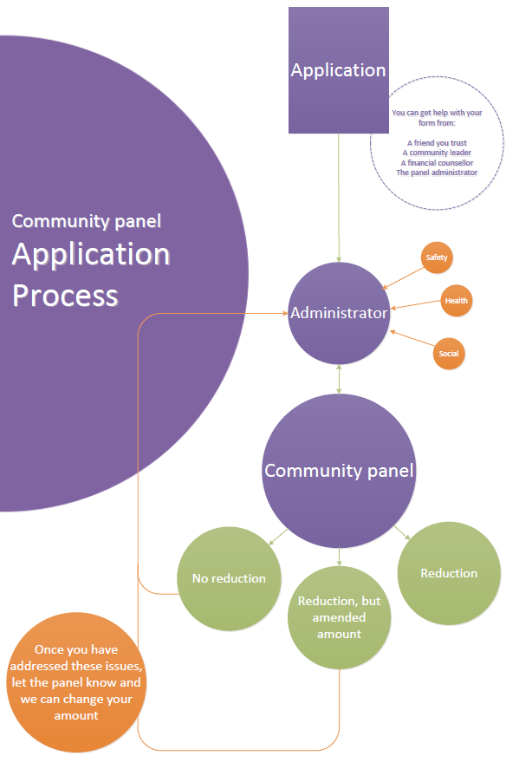
Where can I find out more? Visit www.dss.gov.au/cashlessdebitcard
Or contact the Department of Social Services on 1800 252 604 or at communitypanel.ceduna@dss.gov.au

