Safe Places

Emergency Accommodation Program

Inclusion Round

Consultation Findings

Acknowledgement of country
In the spirit of reconciliation, the Department of Social Services acknowledges the Traditional Custodians of country throughout Australia and their connections to land, sea and community. We pay our respect to their Elders past and present and extend that respect to all Aboriginal and Torres Strait Islander peoples today.

Help and Support
Violence against women and children can be hard to discuss and reading this document may cause distress.
Help is available. If you or someone you know is experiencing or at risk of experiencing domestic, family or sexual violence, call 1800RESPECT on 1800 737 732 or visit 1800RESPECT.org.au.
If you or someone close to you is in distress or immediate danger, please call 000.

Table of Contents
Acknowledgement of country 2
Help and Support 2
1 Introduction 4
1.1 Overview of the Inclusion Round 4
1.2 Overview of consultation activities 5
1.3 Additional housing support for women and children experiencing FDV 5
2 Key findings 7
2.1 Definitions of emergency accommodation and ‘safe place’ 8
2.1.1 Definition of emergency accommodation, including length of stay 8
2.1.2 Definition of safe place 9
2.2 Design of emergency accommodation 10
2.2.1 Livable Housing Design Guidelines: 12
2.2.2 Additional design features 13
2.3 Supporting the priority groups 14
2.3.1 First Nations women and children 15
2.3.2 CALD women and children 16
2.3.3 Women and children with disability 17
2.4 Building and construction sector challenges and mitigations 18
2.5 Eligibility and assessment criteria 19
2.5.1 Eligibility criteria 19
2.5.2 Assessment criteria 20
2.6 Support for applicants 26
2.6.1 Development period 27
2.6.2 ‘Expression of Interest’ process and length of submission period 28
2.6.3 Resources for smaller organisations to develop proposals 29
2.6.4 Apportioning funds to Aboriginal and Torres Strait Islander organisations, particularly ACCOs, in line with Priority Reform Two (Building the community-controlled sector) of the National Agreement on Closing the Gap. 29
2.6.5 Advice, templates and checklists to assist applicants 30
2.7 Program funding and funding approach 31
2.7.1 Mixed-use proposals 31
2.7.2 Milestone payments 31
2.8 Designated use period 32
3 Conclusion 32

Introduction
Family and domestic violence (FDV) is one of the leading causes of homelessness for women and children. The National Plan to End Violence against Women and Children 2022--2032 (the National Plan) recognises housing is essential to ending gender-based violence.
Under the National Plan, the Australian Government is providing $100 million over 5 years (2022-23 to 2026-27) for the Department of Social Services (the department) to continue the Safe Places Emergency Accommodation (Safe Places) program through the Safe Places Inclusion Round (the Inclusion Round). Of this, up to $90.9 million is available for grants over four years (2023-24 to 2026-27). The Inclusion Round builds on the $72.6 million investment in the Safe Places program across 2020-21 to 2024-25.
From November 2022 to June 2023, the department undertook a range of consultation activities to inform the design of the Inclusion Round. This Consultation Findings Report (the Report) provides an overview of the key themes and findings from these activities.
The intent of the Report is to provide a resource for stakeholders to inform the development of emergency accommodation, including organisations who are interested in applying for funding under the Inclusion Round and/or applying for relevant state and territory government opportunities.

Overview of the Inclusion Round
The Inclusion Round will provide capital work grants to fund the building, renovation or purchase of new or expanded emergency accommodation to assist women and children experiencing FDV.
The Inclusion Round will focus on improving access to appropriate emergency accommodation for First Nations women and children, women and children from culturally and linguistically diverse (CALD) backgrounds, and women and children with disability. This includes those who experience the intersection of racism, ableism and sexism.
The $100 million commitment to the Inclusion Round is part of the Australian Government’s investment to support the delivery of the National Plan with a strong focus on prevention, early intervention, response and supporting victim-survivors to recover and heal. It also contributes to reducing all forms of violence against Aboriginal and Torres Strait Islander women and children by 50 per cent, in line with Target 13 of Closing the Gap.
The Inclusion Round is being delivered via a competitive grant round on GrantConnect.

Overview of consultation activities
From November 2022 to June 2023, the department consulted with 145 organisations and individuals to inform the design of the Inclusion Round. This included national peak bodies and state and territory service organisations across the housing and homelessness and FDV sectors. The department also consulted with current Safe Places grantees and organisations with expertise relating to First Nations women and children, women and children from CALD backgrounds, and women and children with disability, who are the focus of the Inclusion Round.
Consultation activities included:
- Releasing a Discussion Paper for public consultation on Engage from 30 January to 10 March 2023, with 37 submissions received
- Facilitating workshops in each state and territory capital city and Townsville, as well as 2 virtual workshops in March 2023
- A Roundtable discussion with sector stakeholders and the Minister for Social Services, the Hon Amanda Rishworth MP, held on 6 June 2023
- Ongoing engagement with state and territory governments.
In addition, the department engaged Cultural and Indigenous Research Centre Australia (CIRCA) to facilitate:
- Specialist sector workshops with organisations working with and/or advocating for the priority groups, which were held from February to March 2023
- Interviews with victim-survivors of FDV with lived experience of emergency accommodation, which were held from May to June 2023.
Dedicated engagement with victim-survivors who have lived experience of emergency accommodation services aligns with the cross-cutting principle of the National Plan to centre victim-survivors. The National Plan commits to working with victim survivors and recognises the value of lived experience in informing appropriate and effective initiatives.
This Report captures the key findings from these consultation activities.
CIRCA has also developed separate detailed reports on findings from the specialist sector workshops and interviews with victim-survivors. The full reports are available on the department’s website and published alongside the Inclusion Round grant opportunity on GrantConnect (www.grants.gov.au).

Additional housing support for women and children experiencing FDV
The Government has committed to a comprehensive housing agenda to address the issues Australians are facing in securing appropriate accommodation, including women and children experiencing FDV.
Women and children experiencing FDV will benefit from a range of housing initiatives, including the $10 billion Housing Australia Future Fund (HAFF), which will build 30,000 new social and affordable housing properties in its first 5 years. In addition to supporting women in general through the increased number of secure housing properties available, a minimum of 4,000 of these dwellings will be allocated to women and children impacted by FDV and older women at risk of homelessness.
The Australian Government has also committed $100 million from the HAFF in its first 5 years to deliver crisis and transitional housing options for women and children experiencing FDV and older women at risk of homelessness. Establishment of the HAFF requires passage of legislation through Parliament. These measures complement the additional $100 million committed to the Inclusion Round grant opportunity.
In addition, the Keeping Women Safe in their Homes (KWSITH) program funded under the National Plan supports women and their children experiencing FDV to stay in their own home, or a home of their choice, where it is safe and appropriate to do so. The Australian Government has committed $76.57 million from 2022-23 to 2026-27 to deliver KWSITH, including $41.7 million through the 2022-23 October Budget.

Key findings
During consultations, several common themes emerged.
In recognition of client diversity, there was broad agreement that the proposed definition of emergency accommodation should include stays up to 12 months, with flexibility for longer stays where applicants demonstrate why they are taking a custom approach.
Stakeholders called for consideration of additional design features, such as prayer or faith rooms and space for yarning circles, in order to meet the needs of the priority groups, as well as communal areas such as gardens, recreation rooms and rooms for outreach services. Stakeholders felt that value for money assessments should factor in additional design features to ensure projects including such features at an additional cost are not disadvantaged.
Another common theme when determining the suitability of an applicant was a demonstrated understanding of, and ability to embed, the needs of women and children in the design of emergency accommodation and delivery of services. Stakeholders raised the importance of applicants demonstrating genuine, meaningful and ongoing engagement with local communities in developing proposals and designing emergency accommodation. This includes engagement with First Nations, CALD and disability communities, as well as people with lived experience of FDV and emergency accommodation.
Stakeholders also highlighted the importance of building the capacity and capability of smaller organisations. Stakeholders emphasised these applicants may have more suitable expertise providing appropriate emergency accommodation services to Inclusion Round priority groups.
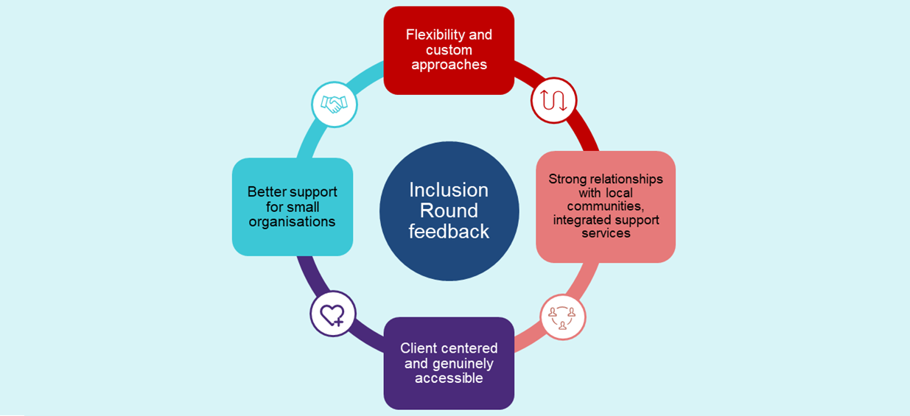
The following sections capture the key consultation findings and explain how they have been embedded in the Inclusion Round grant opportunity.

Definitions of emergency accommodation and ‘safe place’

Definition of emergency accommodation, including length of stay
As part of the Inclusion Round consultation, the department sought feedback on the proposal to define emergency accommodation as short-term accommodation for less than 12 months. This definition includes refuges and crisis shelters, and incorporates emergency accommodation options (excluding hotels and boarding houses) as described by the Australian Institute of Health and Welfare (AIHW).
In recognition of client diversity and different models of emergency accommodation across jurisdictions, the department has proposed considering longer stays where applicants demonstrate the need, suitability, tenancy timelines and referral pathways relevant to their custom approach.
Overall, stakeholders supported the proposed definition of emergency accommodation. The department heard flexibility for custom approaches was important to allow providers to respond to the individual needs of women and children experiencing FDV, and provide time to begin the healing process. Stakeholders noted this flexibility was particularly important to meet the diverse needs of victim-survivors from the priority groups, noting some First Nations and CALD women and children experiencing FDV face the additional impact of separating from family or community, or may need longer to build trust with service providers.
Stakeholders were particularly pleased to see custom approaches available as a potential avenue to support women on temporary visas experiencing FDV. These women may face additional barriers seeking and receiving services and supports, such as social security payments and social or public housing.
Stakeholders also recognised that having access to safe and stable accommodation plays a major role in recovery and healing for victim-survivors. This is a highly individualised process, and some women and children have complex needs requiring greater and longer-term support. Stakeholders also noted it can take multiple attempts for victim-survivors to leave violent situations, and it is important to support them in accessing safe and supportive accommodation and services on every occasion.
However, stakeholders also acknowledged when women and children spend longer periods of time in emergency accommodation, this reduces the system’s capacity to meet ongoing demand. It is important to note the guidelines for length of stay of up to 12 months are not mandatory for every client using emergency accommodation. The Inclusion Round grant opportunity recognises service providers need to apply the guidelines at their own discretion and according to the circumstances of each client.
Stakeholders reported challenges in supporting women and children to access transitional or long-term housing in the current market, particularly in regional and remote areas. The department heard there can be delays in transitioning women and children out of emergency accommodation due to increasing housing costs, low rental vacancy rates and long social housing wait lists. Due to these challenges, there was support for the requirement for applicants to provide a tenancy management policy, including exit pathways for clients moving into longer-term accommodation.
There were also calls for the Inclusion Round to be complemented with an increase in transitional and longer-term housing options. The Government has committed to a comprehensive housing agenda to address the issues facing Australians, including women and children experiencing FDV (see Section 1.3 Additional housing support for women and children experiencing FDV). The $100 million committed to the Inclusion Round complements this agenda.

Definition of safe place
As part of the Inclusion Round consultation, the department sought feedback on the proposed definition of a ‘safe place’.
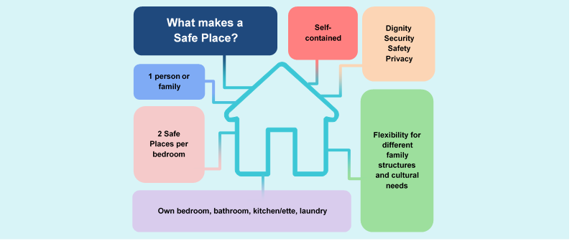
Dwellings eligible for funding under the Inclusion Round must provide dignity, security, safety and privacy in a self-contained living space, including bedroom/s, bathroom, kitchen/kitchenette, and laundry, for the sole use of one person or family group. The department proposed dormitory-style accommodation would not be eligible for funding under the Inclusion Round, as it does not provide the appropriate level of privacy or dignity for women and children experiencing FDV. Stakeholders largely agreed with this definition.
Stakeholders acknowledged it is important to accommodate the needs of both women without children and with larger families. They noted the size and structure of families can vary significantly, and it is important to build in flexibility to accommodate older children, female family members such as mothers or sisters, particularly for First Nations or CALD women, and carers and/or support workers for women and children with disability. Suggestions included dual lock doors, which could allow the joining of 2 self-contained living spaces, or proposals with a mix of different size dwellings to accommodate various family structures.
In determining the number of ‘safe places’ (i.e. the maximum number of women/children supported at any one time) for assessment and reporting purposes, the department proposed using the calculation of 2 persons per bedroom. For example, a 2-bedroom house accommodating one family unit will equal 4 safe places.
The calculation for the number of safe places is consistent with the definition of overcrowding accepted by the Australian Bureau of Statistics and AIHW, noting there may be individual circumstances where it is appropriate for emergency accommodation to be provided in a way that does not meet the definition.
The department heard a need for flexibility with assessing the acceptable number of safe places as, in some circumstances, having 2 family members sharing a bedroom may be inappropriate. Equally, some stakeholders noted a quota of 2 people per bedroom may limit true accessibility and inclusivity, as it is common for women, particularly First Nations and CALD women, to have more than one child in their care who they may wish to sleep in the same room as them.
The department will apply this definition of safe places to all Inclusion Round applications. The department will calculate the cost to the Commonwealth of each application based on the cost per dwelling and per safe place.
It is important to note the method for determining the number of safe places will only be used for assessment and reporting purposes, to ensure consistency when calculating the number of safe places offered by each application. There is no requirement for grantees to enforce the calculation of two persons per bedroom. Determining the appropriate number of persons per bedroom for emergency accommodation funded under the Inclusion Round is an operational matter for grantees, and should be based on the preferences and needs of women and children on a case-by-case basis.

Design of emergency accommodation
Stakeholders highlighted the importance of safe places being homely, welcoming and clean. They also noted a need for safe places to be functional in design, rather than clinical. Practical suggestions to create a cosy and comfortable space included:
- using soft furnishings,
- ensuring there is natural light and sufficient storage, and
- providing new bedding and linen.
Stakeholders also noted a full kitchen, rather than a kitchenette, is more practical and accessible, enabling women to cook nutritious and cost effective meals. Access to the internet and/or a computer was also considered important to allow women and children to maintain contact with their friends and family, send emails and access online services.

Stakeholders noted it was important for emergency accommodation to make women and children feel safe and secure. Suggestions included:
- sound proofing,
- alarms,
- cameras,
- crim safe screens,
- front door stoppers,
- presence of onsite staff,
- not having visible house numbers on the dwelling,
- secure and high fencing, and
- discreet parking close the dwelling where cars cannot be seen from the street.
It was noted high quality applications should demonstrate an understanding of the most appropriate security design features, taking into account the location of the emergency accommodation. Stakeholders suggested that, where possible, security features should be individualised based on the preferences of clients.
Stakeholders also noted high quality proposals would consider sensory needs and trauma-informed design principles. This may include consideration of the Design Guide for Refuge Accommodation for women and children developed by Sam Donnelly from the University of Technology Sydney, which contains design principles for trauma-informed emergency accommodation.
Some stakeholders also encouraged the department to favourably view proposals that consider environmental sustainability and energy efficiency, such as using local resources and materials, renewable energy options such as solar panels and batteries, and water efficiency. These were considered beneficial to help reduce ongoing costs, such as electricity bills. In some locations, stakeholders noted it was also important to include air conditioners, and consider the impact of extreme weather events, such as floods, bushfires and cyclones.

Livable Housing Design Guidelines:
As part of the Inclusion Round consultation, the department sought feedback on what standard of the Livable Housing Design Guidelines in the National Construction Code should be met for emergency accommodation delivered under the Inclusion Round. The guidelines describe livable design elements and what is required to achieve a Livable Housing Australia (LHA) Silver-, Gold- or Platinum-level accreditation. Certification of homes against the guidelines provides assurance that homes are easier to access, navigate and live in, and are cost-effective to adapt as life circumstances change.
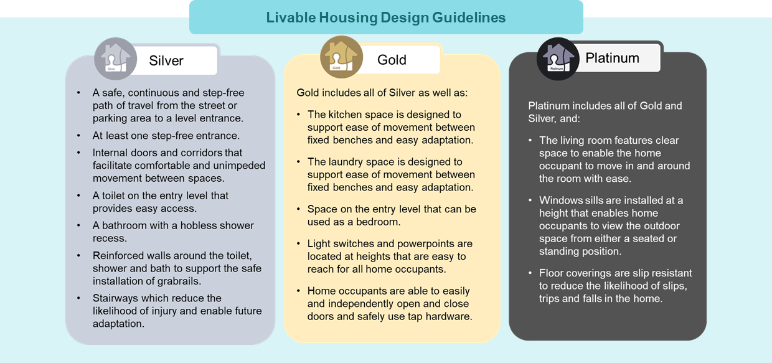
There was broad agreement for new builds to meet LHA Silver-level accreditation at a minimum, with stakeholders emphasising the importance of creating physically accessible emergency accommodation. Stakeholders agreed with the department’s proposal to consider favourably proposals meeting LHA Gold or Platinum level accreditation to promote a higher degree of accessibility, noting this is a requirement in some states.
For renovations and purchases, stakeholders noted challenges with retrofitting existing structures to meet accessibility standards, including increased costs and difficulties obtaining approval. Stakeholders considered preference should be given to renovations and purchases meeting a minimum LHA Silver-level accreditation, but it should not be a requirement.
Feedback indicated proposals with multiple dwellings should include at least one safe place meeting LHA Gold or Platinum level accreditation to increase access for women and children with disability. Stakeholders also noted that high quality applications would also align with any accessible design standards recommended or required by their state and/or local government. The Inclusion Round grant opportunity factors in this feedback.

Additional design features
Stakeholders highlighted the importance of additional design features that meet the specific needs of the priority groups, noting they contribute to the creation of a place that feels safe.
The department heard high quality projects would include features that facilitate connections to faith. Examples included sufficient space within dwellings for private prayer, clean and discrete communal prayer or faith rooms, and connections to local religious institutions.
Stakeholders also noted the importance of funding projects designed for First Nations women and children that consider and accommodate their unique needs, connection to the land, and cultural practices, such as spaces for yarning circles. Incorporating cultural activities, ceremonies and traditional healing practices into emergency accommodation was also highlighted.
In order to provide women and children with dignity, the department heard high quality projects may include additional design features such as a backyard or garden. Where self-contained dwellings are co-located, stakeholders considered it important to have communal areas such as child-friendly gardens, playgrounds and play areas, recreation rooms, gyms, and rooms for outreach services. Communal areas were considered particularly important for those who have a much stronger or recent experience of living in a collective culture.
Stakeholders noted outdoor areas are important to support women and children experiencing FDV with pets, including assistance animals, which can play an important therapeutic function. Stakeholders suggested favourably considering applications with animal inclusive emergency accommodation, including protocols for animal intake, partnerships with animal welfare organisations, support services for pet owners, and animal free zones and procedures to ensure other residents’ boundaries are respected.
Stakeholders acknowledged projects with additional features would likely attract higher costs, noting it may reduce the overall number of safe places delivered. The assessment of a project’s value for money incorporates this feedback.
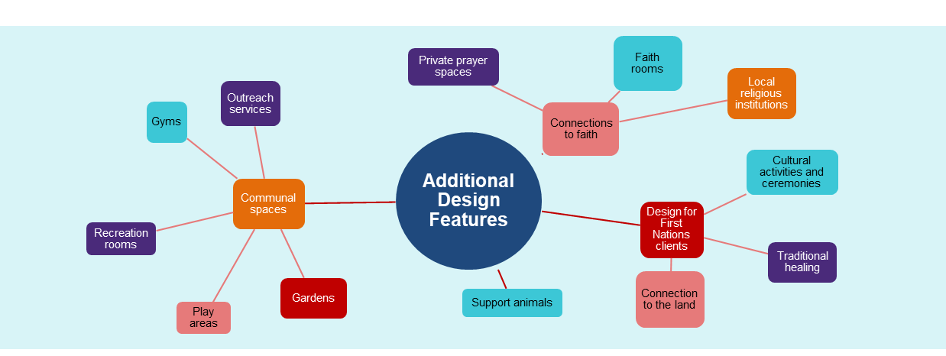

Supporting the priority groups
In addition to consultation undertaken by the department, CIRCA was engaged to facilitate:
- Specialist sector workshops with organisations working with, and/or advocating for, the priority groups
- Interviews with victim-survivors of FDV who have lived experience of emergency accommodation, including First Nations women, women from CALD backgrounds, and women with disability.
CIRCA has developed separate detailed reports on findings from the specialist sector workshops and interviews with victim-survivors. These are available on the department’s website, and published alongside the Inclusion Round grant opportunity on GrantConnect. While there are commonalities between the consultation undertaken by CIRCA and the department, this section of the Report primarily focuses on stakeholder feedback regarding how best to support the priority groups provided during department-led engagement activities.
A common theme in consultation was how best to ensure an applicant has the desired specialist knowledge, skills and competencies relevant to the priority group(s) whose access to accommodation and services they are seeking to improve. Stakeholders considered applicants could demonstrate their suitability through:
- Community engagement, including connection with the priority groups within their region (see 2.5.3 Consultation with local community and priority groups).
- Expertise working with and delivering services to First Nations women and children, women and children from CALD backgrounds, and/or women and children with disability, or a partnering provider who has this expertise.
- Evidence of appropriate, accessible and culturally sensitive referral pathways to additional specialist services.
- Cultural competency, including a service model that demonstrates a commitment to staff sensitivity to cultural practices, traditions and values, and an ability to communicate effectively with First Nations women and children, women and children from CALD backgrounds, and women and children with disability. This includes an understanding of the unique needs of clients, the different forms of FDV they may experience and the impact it may have on their lives. This may include training in cultural competency, cultural supervision, disability awareness, disability-specific practice approaches, intersectionality and accessibility, including refresher courses.
- Direct employment of First Nations staff, CALD staff, or staff with disability, including any policies to enhance the employment rate of these groups.
- Reconciliation, Diversity, and Disability Action Plans or Strategies, including review processes.

Stakeholders were also pleased to see consideration of intersectionality within the Inclusion Round, noting the impact compounding forms of oppression or inequality may have for women and children experiencing FDV. However, some stakeholders noted the nature of intersectionality may reduce consideration of specific needs, and that high-quality applications would acknowledge and demonstrate how they would overcome this.
The following section outlines some of the specific indicators raised by stakeholders to determine an applicant’s suitability to meet the needs of each priority group.

First Nations women and children
Stakeholders emphasised the importance of projects proposing to provide emergency accommodation for First Nations women and children to be led by, or work in conjunction with, Aboriginal Controlled Community Organisations (ACCOs). Stakeholders considered access to workers from a similar cultural background to be a key contributor to feelings of safety for First Nations women and children.
The Inclusion Round grant opportunity guidelines specify that applications from Aboriginal and Torres Strait Islander organisations, including ACCOs, will be considered favourably.
Other measures raised by stakeholders to determine the suitability of applicants to meet the needs of First Nations women and children included:
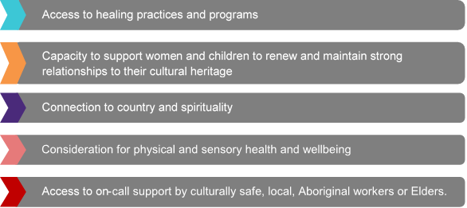

Stakeholders also noted the lack of after-hours emergency accommodation support in regional and remote areas is an additional barrier faced by First Nations women and children. They noted presenting to police was often the only choice available after-hours, which can deter women from seeking help, including due to the lack of privacy in small towns. Stakeholders suggested high quality applications for emergency accommodation in regional and remote areas that may service First Nations women and children would demonstrate how they would provide after-hours support.

CALD women and children
For women and children from CALD backgrounds, stakeholders noted high-quality applications would demonstrate how they would meet clients’ communication needs and provide language support. Suggestions included:
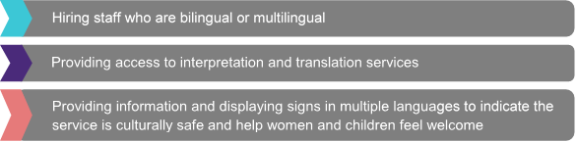
The importance of safe places catering to religious and cultural needs was also raised. This includes access to a culturally safe prayer room, kitchen policies that respect cultural needs, and cooking facilities and food suitable for a diverse range of cultural and religious groups, such as halal, kosher and vegetarian options.
Stakeholders highlighted the importance of applicants being able to cater to the specific needs of non-Australian citizens, including women on temporary visas. This includes ensuring eligibility for income support or residency is not a barrier to accessing emergency accommodation. Some stakeholders also noted a preference for emergency accommodation for women and children from CALD backgrounds to be located in an area with good public transport options to assist those who do not have a drivers licence.

Women and children with disability
In addition to meeting a minimum LHA Silver-level accreditation, stakeholders noted a commitment to providing an accessible service that allows clients to maintain independence is a key indicator of an applicant’s suitability to meet the needs of women and children with disability. This includes:
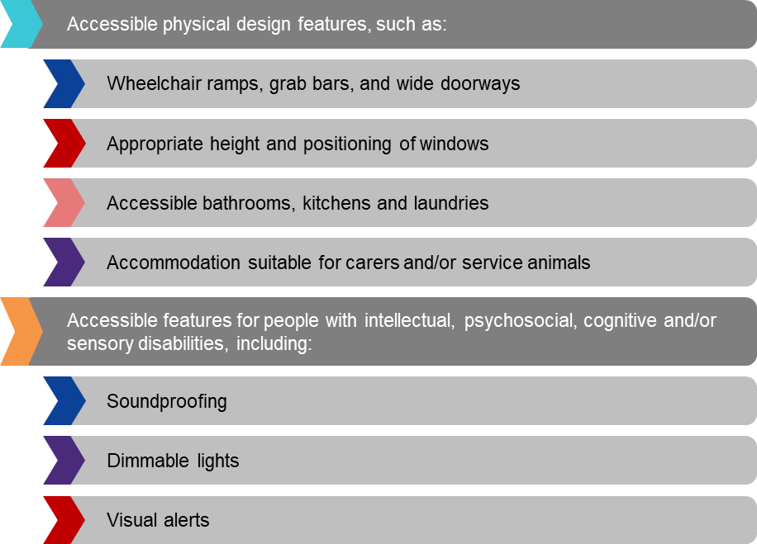
Stakeholders also highlighted the importance of informational and attitudinal accessibility. Stakeholders considered it important to employ staff who have specialised skills to support the diverse and individual needs of women and children with disability and an understanding of accessibility issues. This includes the ability to explain expectations, rules and procedures to clients so they know what to expect while living in emergency accommodation.
An understanding of accessible information formats, such as closed captioning, assistive technologies and sign language, was also considered an indicator of a high quality application. In addition, demonstrating staff could respond to the varying needs of clients and work collaboratively with other service providers and health professionals was considered favourable.

Building and construction sector challenges and mitigations
Stakeholders also raised challenges with timeframes for planning and development approval, which can affect project timelines, resulting in increased construction costs.
The department heard there is a need for the Inclusion Round to consider potential additional costs due to delays, inflation and increasing construction costs. There was broad agreement high quality applications would include cost contingency, with the department establishing clear processes and procedures to allow successful grantees to access contingency funds if the need arises.
Stakeholders recommended applicants include and demonstrate the appropriateness of contingency funds as part of their proposal, noting it may vary considerably between locations. For example, the department heard freight and transport costs may necessitate a higher level of contingency funds for projects in regional and remote areas.
Stakeholders suggested engaging suitably qualified consultants, in particular a dedicated project manager, is also an effective risk mitigation strategy. The procurement of a quantity surveyor report was also considered valuable. Stakeholders suggested it would be helpful for the department to facilitate an information seminar focused on construction market risk and mitigation to support applicants in minimising risks associated with capital works projects.
Some stakeholders suggested turnkey or pre-fabrication projects as another strategy to reduce the impact of challenges in the current building and construction sector. However, others cautioned against relying too heavily on turnkey or pre-fabrication projects as many projects are not fit for purpose and may not improve access to emergency accommodation for the priority groups.
In response to this feedback, the Inclusion Round grant opportunity will include a mandatory Capital Works Project Plan and Budget template with guidance to assist applicants in addressing these challenges. Applicants will also be strongly encouraged to seek grant funding amounts that include contingency funding for unexpected expenses, such as capital works costs that might increase in the future.

Eligibility and assessment criteria

Eligibility criteria
As part of the Inclusion Round consultation, the department sought feedback on potential eligibility criteria, including:
- Which entity types should be eligible and ineligible.
- The requirement for projects to provide new (additional) safe places for FDV emergency accommodation.
- The requirement the applicant or partnering service provider is a suitable FDV specialist services provider.
- Confirmation the applicant and partnering services providers will agree to reporting and evaluation requirements of the department.
- Confirmation of compliance with all relevant Australian Government, state, and local government regulations, including implementation and compliance with the National Principles for Child Safe Organisation, with compliance evidenced on an annual basis through the designated use period.
Stakeholders also called for funding to support the refurbishment of existing emergency accommodation, such as communal, dormitory style accommodation, to make it inclusive, accessible and fit for purpose, self-contained accommodation. While modifications and renovations are eligible for funding under the Inclusion Round, all projects must result in the creation of new (additional) safe places.

Other communities of victim-survivors
While stakeholders expressed support for the focus on improving access to emergency accommodation for the priority groups, some stakeholders raised concerns over barriers for other communities of victim-survivors. This included victim-survivors from LGBTQIA+ communities, older women, and young people who present to emergency accommodation on their own. Some called for consideration of these communities as additional priority groups in the Inclusion Round, or in intersection with the priority groups.
Women and children who need to access emergency accommodation delivered under the Inclusion Round will be assessed based on need, regardless of whether they are part of a priority group. All women and children, regardless of identity, must be provided with accommodation or referral. Referral should be made only if accommodation is unavailable or a provider has security or safety concerns for the presenting women and children, staff or existing residents. To support this, applicants are strongly encouraged to demonstrate appropriate referral pathways to specialised support services as part of the application process. This may include providing optional attachments such as referral policies.

Other models of emergency accommodation
Stakeholders also raised interest in accommodation models that support women and children to remain in their home.

The KWSITH program is an alternative to emergency accommodation. The program helps women and their children who have experienced FDV to remain in their homes or a home of their choosing, when it is safe and appropriate to do so. This means women and children can continue to have access to their usual support networks, such as workplaces and schools.
It supports women through risk assessments, safety planning, home security audits and upgrades, and case management. The home security upgrades can vary across the different providers, but can include alarms, security screens and locks, and the use of technologies such as monitored personal safety devices, surveillance cameras, dashboard cameras, and electronic sweeping and de-bugging of homes and cars.
The KWSITH program can help to prevent homelessness by offering greater housing stability for women experiencing violence, and providing an alternative to homeless shelters and emergency accommodation. This can also help to reduce the strain on emergency accommodation.

Assessment criteria
As part of consultation, the department proposed assessing Inclusion Round applications against 4 criteria:
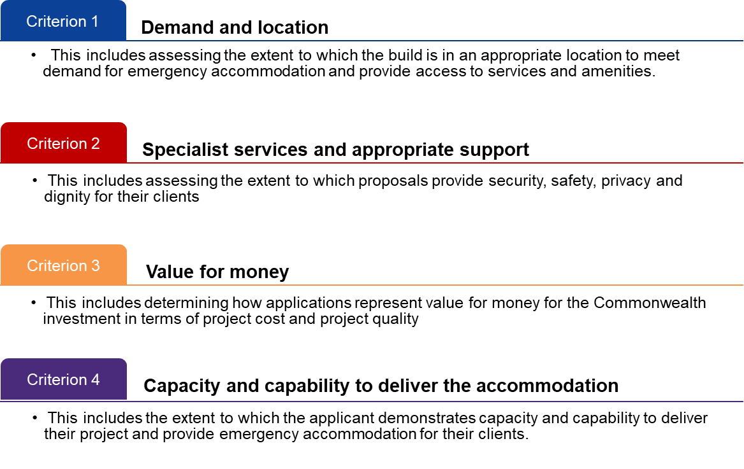
Stakeholders were broadly supportive of the proposed criteria. A key piece of feedback around the proposed assessment criteria was needing a stronger focus on the importance of applicants demonstrating genuine, meaningful and ongoing engagement with local communities in developing proposals. This was considered particularly important given the focus of the Inclusion Round on increasing access to appropriate emergency accommodation for First Nations women and children, women and children from CALD backgrounds, and women and children with disability. Some stakeholders also suggested adding an additional criterion to assess the community impact the proposed project would have.

Criterion 1: Demand and location
Stakeholders were largely supportive of proposed Criterion 1: Demand and location. The department heard this criterion should not be overly restrictive to enable applicants to demonstrate the suitability of a variety of different types of projects for their particular circumstances.

Addressing access and location issues
It was noted women and children in greatest need of appropriate and accessible emergency accommodation options often experience compounding forms of oppression or inequality and are small in number, which should be considered when assessing this criterion.
Similarly, the department heard it is important to consider that for many culturally diverse community members experiencing FDV, there can be limited knowledge of, or willingness to access formal services outside of their cultural community. It was noted these clients may be more likely to seek support from informal networks and resources, including seeking advice and guidance from trusted members of their community.
In terms of the location of emergency accommodation, stakeholders considered it important to be close to services and amenities such as public transport, schools, community groups, childcare, police stations, employment services, shops and medical services. However, stakeholders noted there should be some room for judgement in the assessment process so proposals to create new emergency accommodation in rural and remote locations are not disadvantaged due to reduced proximity to services and amenities. Some stakeholders noted locating emergency accommodation away from central hubs was important to provide privacy and security, particularly in regional and remote locations.
It was also suggested that scattering emergency accommodation throughout the community may assist women and children feel like they are part of the community and reduce stigma, as dwellings are not specifically identifiable as emergency accommodation. However, the department also heard models that co-locate dwellings (e.g. town houses, apartments or units) can be beneficial for healing and recovery as they provide an extra sense of security and a sense of community, particularly for First Nations women and children.

Demonstrating demand in the Inclusion Round
The Inclusion Round grant opportunity factors in feedback on criterion 1: demand and location. Applicants are required to demonstrate the appropriateness of their proposed location, taking into consideration the needs of potential clients in that area, including any priority groups they are proposing to increase access for.

As part of the Inclusion Round grant opportunity the department released factsheets indicating local levels of unmet demand for emergency accommodation for women and children experiencing FDV, based on state and territory Specialist Homelessness Services data.
Applicants are able to supplement this data with any additional quantitative or qualitative data they may have on unmet demand. This may include waiting lists, qualitative evidence such as reports of women and children accessing informal supports and resources, or localised evidence and knowledge, including the distance to the next emergency accommodation location. This acknowledges women and children experiencing compounding forms of oppression or inequality do not always present to formal support services to seek help, and therefore may not be captured by official data sources. It also acknowledges stakeholder feedback that women and children experiencing FDV sometimes travel out of area to access emergency accommodation, which may also be better represented through an applicant’s own data.

Criterion 2: Specialist services and appropriate support
Stakeholders agreed the proposed criterion 2: specialist services and appropriate support was important. Stakeholders suggested the ability to provide specialist services and appropriate support is key in determining an applicant’s capacity to deliver services over the 15-year designated use period. Applying this criterion should include considering intake and assessment processes, risk assessments and mitigations, and harm minimisation policies and procedures.

Connecting with a range of specialist supports
Stakeholders reiterated the importance of applicants demonstrating an ability to provide and link clients with a range of specialist support services. This includes immediate supports, such as counselling, psychological and mental health support, sexual violence specialist services, financial counselling, case management services, translation services, and legal services and court support, including migration lawyers.
Stakeholders noted the importance of cultural services, such as healing programs and spiritual and religious services, for First Nations and CALD women and children, and specialised disability supports for women and children with disability. They also highlighted the importance of employing workers who have the skills and capability to support children as victim-survivors in their own right, such as appropriate counsellors and play therapists.
The department also heard women and children using emergency accommodation need assistance accessing general services such as health and medical services, including general practitioners, dentists, occupational therapists and pathologists, Centrelink, alcohol and drug services, employment services, parenting support and childcare.
The importance of proposals demonstrating service delivery scope and practice, including partnerships, linkages and referral pathways with local service providers, was emphasised, acknowledging it is not reasonable to expect a service to be capable of delivering all specialist expertise.

Best practices for helping victim-survivors of FDV
Stakeholders noted having external service providers attending emergency accommodation to deliver services on-site where possible and appropriate is preferable as it helps reduce fatigue and re-traumatisation for victim-survivors. They suggested high quality applications would incorporate a core and cluster model, or include a centralised hub where services provide wrap-around supports.
Stakeholders also suggested high quality applications would provide women and children with caseworkers, case management or advocate support. The department heard caseworkers play an important role in reducing the administrative burden for clients by assisting them to access and navigate services, and reduce the need to retell their story to multiple services. This included practical support, such as assistance obtaining a new Medicare card, bank account, identity card and accessing social security payments.
Stakeholders noted the importance of applicants adopting a trauma-informed and culturally appropriate approach, providing clients with safety, trust, choice, collaboration and empowerment. This included demonstrating how they would provide clients with dignity and autonomy, such as consulting with women and children on services available to them and presenting them with options, rather than making decisions on their behalf.
Stakeholders also emphasised the importance of specialist services aligning with relevant FDV best practice and regulatory frameworks, including risk and safety planning, codes of practice or guidelines and relevant quality standards. However, it was acknowledged this assessment may be challenging as some states do not have codes of practice or guidelines specifying minimum standards for FDV service delivery. Some stakeholders indicated meeting the Australian Women Against Violence Alliance (AWAVA) Good Practice Principles in Addressing Sexual and Gender-Based Violence may be a strong indicator of suitability for organisations in states with no minimum requirements.

Ensuring suitability of specialist services
The department has established arrangements with states to enable them to provide advice on applications within their jurisdiction, including the suitability of specialist services. The purpose of these arrangements is to determine whether states will support projects on an ongoing basis.
The department will assess the suitability of services by requesting intake assessment and safety plan templates as well as an outline of the organisation’s service capabilities, whether that be through referral pathways, partnerships with other organisations, or in house service delivery.
Successful applicants will need to submit further documentation as evidence of their service model as part of the grant agreement. This may include, for example, policies for diversity and inclusion, privacy, and rent setting. Grantees will also complete a declaration which states compliance with relevant Commonwealth and State/Territory legislation relating to service delivery, such as background checks for working with children and vulnerable people.

Criterion 3: Value for Money
Stakeholders agreed the project cost criteria should consider:
- Local construction/real estate costs, to ensure high cost locations will not be disadvantaged in the assessment process
- Additional costs associated with higher build quality in assessing value for money, to ensure LHA Gold- or Platinum-level accredited dwellings that accommodate women and children with disability will not be disadvantaged.
Stakeholders also noted it was important to consider costs associated with additional design features, particularly those that meet the needs of the priority groups. For example, costs associated with building prayer or faith rooms, spaces for yarning circles, and/or communal areas such as gardens, recreation rooms and rooms for outreach services.
The Inclusion Round grant opportunity factors in this feedback. The department has also procured the development of a value for money tool to inform the assessment of value for money, which will consider factors such as local construction/real estate costs, and costs associated with LHA accreditation and additional design features.
The Inclusion Round is a partnership model emphasising co-investment arrangements for the capital works component of projects. However, the department also heard considering co-contributions from the applicant, private and philanthropic sources, and state and/or local governments in assessing the project cost criteria may disadvantage smaller organisations. For example, stakeholders reiterated smaller organisations often face additional resourcing barriers, and noted some applicants may not be familiar with corporations such as the National Housing Finance and Investment Corporation (NHFIC).
To address this feedback, the department has developed an Application Pack, to be released alongside the Inclusion Round grant opportunity. This pack provides guidance on other sources of potential funding, including details on known upcoming funding opportunities across states and territories, as well as how to apply for NHFIC funding.

Operational funding
Some stakeholders have highlighted challenges securing operational funding from private, state or local government sources to support the delivery of services and dwelling maintenance over the 15 year designated use period.
Issues include coordinating capital works and operational funding from multiple sources or funding opportunities, which may not align in terms of timing, eligibility criteria and reporting requirements. Stakeholders suggested this creates a barrier for organisations applying for the Inclusion Round grant opportunity, with many smaller organisations unable to fund delivery of FDV services. Some stakeholders also suggested evidence of operational funding over a shorter period, such as 3 to 5 years, is more realistic to align with state service funding models.

The department heard there is a need for greater alignment between Commonwealth and state funding opportunities, and has been working in partnership with state counterparts to increase support for the Inclusion Round and grantees. This includes establishing arrangements for states to provide advice on applications within their jurisdiction (see Ensuring suitability of specialist services).
In addition, the department has been working with New South Wales state departments to align arrangements for both the Core and Cluster Tranche 3 Procurement and Safe Places Inclusion Round grant opportunity. Applicants who are invited to apply for the Request For Tender for Core and Cluster may also choose to apply for capital funding as part of the Safe Places Inclusion Round. If successful, applicants could receive capital funding from the Commonwealth Safe Places Inclusion Round and service delivery funding from the Core and Cluster Tranche 3 funding round.
Under the National Plan, the Government is also providing $159.0 million over 2 years from 2023-24 for the National Partnership on Family, Domestic and Sexual Violence Responses (FDSV National Partnership) with states to support frontline family, domestic and sexual violence services.
This investment builds on the builds on the $270.7 million provided over 2-years from 2021-22 under the FDSV National Partnership and the $169.4 million committed in the October 2022-23 Budget to generate 500 new jobs for community organisations nationally, by funding frontline service and community sector workers to support those experiencing family, domestic and sexual violence.
Allocation of this funding to specific services, including Safe Places, would be a matter for state and territory governments.

Criterion 4: Capacity and capability to deliver the accommodation
Stakeholders were broadly supportive of proposed criterion 4: capacity and capability to deliver the accommodation. Stakeholders emphasised the importance of applicants demonstrating experience delivering similar projects or a partnership with an organisation who has this expertise.
Stakeholders agreed with the proposal for high quality applications to demonstrate ongoing housing pathways, length of stay policies and experience in tenancy and asset management. In particular, stakeholders highlighted the importance of expertise in assisting clients to secure safe, suitable and stable longer-term accommodation, including transitional accommodation, social housing or the private market.
Some stakeholders suggested high quality applications would demonstrate specific experience and expertise providing tenancy management services to women and children experiencing FDV, as well as any groups the applicant is proposing to target. Some also suggested the lead applicant should be a Community Housing Provider, or at a minimum, demonstrate a partnership with a Community Housing Provider to support exit pathways.

2.5.3 Consultation with local community and priority groups
Stakeholders suggested amending the assessment criteria to reflect the importance of applicants demonstrating genuine, meaningful and ongoing engagement with local communities in developing proposals. This includes engagement with First Nations, CALD and disability communities. The importance of engaging with people with lived experience of FDV was also emphasised, particularly those who have experiences with emergency accommodation.
Stakeholders highlighted the importance of community engagement to understand and meet the specific needs of women and children, and ensure the design of emergency accommodation is appropriate for the local area, culturally safe, accessible and trauma informed. The department heard good community engagement should include discussing the proposed design and location of the new emergency accommodation, as well as plans for ongoing consultation throughout the project. This may include ensuring the project is not developed and/or delivered in a location of cultural importance, and co-designing the emergency accommodation so it is culturally sensitive and accessible, and supports recovery and healing.
Suggestions on how applicants could demonstrate community engagement included a community strategy document, support from local organisations, including Aboriginal medical or legal services who work with and know communities clients may come from, and local advisory groups and committees. However, some stakeholders also acknowledged it is important to have realistic expectations on community engagement, noting it can be difficult to build deep and trusting connections with sensitive communities.
This feedback has been incorporated into the process of designing application requirements for the Inclusion Round grant opportunity. High quality responses will demonstrate how applicants have embedded the needs and perspectives of women and children with lived experience and engagement with local communities into the design and location of the emergency accommodation. Applicants are also encouraged to give details of their ongoing relationships with local communities through the Community Engagement Plan developed by the department. This is an optional template that forms part of the Application Pack, though applicants should also aim to demonstrate community engagement in other parts of their application where relevant.

Support for applicants
As part of the Inclusion Round consultation, the department invited feedback on the best ways to support applicants to develop quality proposals, particularly smaller organisations.
Proposals put forward by the department as part of consultation included:
- A development period of up to 6 months for organisations with viable proposals who may require additional time to develop a high-quality and competitive application. The proposed awarding of development periods was subject to funding availability following the assessment of fully developed grant proposals.
- Releasing factsheets detailing priority locations to assist applicants to determine locations with high-unmet demand for emergency accommodation, with the ability for applicants to supplement this data with any additional data they may have.
- Publishing a Forecast Opportunity on GrantConnect advertising the estimated opening date so applicants have sufficient time to prepare in advance.
- Holding information sessions ahead of the opening of the Inclusion Round grant opportunity to provide prospective applicants the opportunity to ask questions.
- Publishing an Application Pack, including guidance documents, a checklist of mandatory and desirable attachments for assessment purposes, and templates.
During consultation, stakeholders acknowledged there are barriers for smaller organisations applying for grants, including ethnic and multicultural community organisations and ACCOs. Stakeholders agreed the importance of supporting and building the capacity and capability of smaller organisations. Stakeholders also emphasised the suitability of smaller organisations to deliver appropriate emergency accommodation, particularly specialist community organisations with expertise relating to the priority groups.

Development period
Stakeholders were supportive of the proposal to award development periods, noting preparing a high-quality competitive grant application can be a significant piece of work, particularly for smaller organisations. Stakeholders agreed some organisations might need longer than the 2-month submission period to strengthen their proposal, including obtaining local Council approval and undertaking further planning and consultation to develop a high quality application, compounded by difficulties in obtaining land in a competitive market.
Some stakeholders considered a development period of up to 6 months would be sufficient, particularly for applicants with existing partnerships with community housing organisations and specialist FDV services. Others suggested a longer development period of up to 12 months would be more realistic for smaller organisations.
While stakeholders noted the importance of the grant opportunity providing pathways to support projects ready to commence as soon as possible, it was also seen as important to support projects from organisations requiring more time to develop competitive proposals. Stakeholders encouraged removing the requirement for development periods to be subject to funding availability following the awarding of fully developed grant proposals. It was noted this may deter organisations with otherwise viable proposals from applying, particularly smaller organisations, as there is no guarantee funding will be available following the awarding of fully developed proposals. As an alternative, stakeholders suggested allocating a portion of funding specifically for development period recipients.
The department acknowledges some applicants might require more time than offered by the Inclusion Round grant opportunity to prepare high-quality capital works proposals and secure development approval. To achieve an overall mix of grants that meets the objectives of the Inclusion Round grant opportunity effectively, the decision maker may invite applicants with provisionally suitable applications requiring further development to future grant opportunities that are restricted, targeted or ad hoc.
Applicants invited to future grant opportunities will have up to 12 months to develop competitive proposals. Invitations to apply for future grant opportunities will not be subject to funding availability following the assessment of fully developed grant proposals, with the decision maker having flexibility to invite applicants with provisionally suitable proposals to apply for future grant opportunities as they see fit.

The decision maker will only invite applicants to future grant opportunities if their applications meet the requirements listed at section 9.2 ‘Further grant opportunities’ of the Inclusion Round Grant Opportunity Guidelines. These requirements are:
- Eligible and compliant for the Inclusion Round grant opportunity
- Meets assessment criteria 1 and 2, and partially meets assessment criteria 3 and 4.
- Meets all minimum requirements for capital works proposals as listed in Table 1 at section 6.1 of the Inclusion Round Grant Opportunity Guidelines
- Recommended by the Selection Advisory Panel as provisionally suitable for a grant, subject to further development of the capital works proposal to address areas for improvement.

‘Expression of Interest’ process and length of submission period
Some stakeholders noted competitive grants processes discourage organisations from working with each other and create barriers to establishing partnerships. There were also calls for the grant opportunity to be open for applications for longer than 2 months to provide additional time to build relationships and develop an application. However, other stakeholders expressed a preference to proceed with the 2-month submission period to allow them to commence projects and start delivering new emergency accommodation as soon as possible.
One suggestion was delivering the Inclusion Round via a two-stage process that includes:
- An Expression of Interest stage, where applicants submit a high level description of their proposal, including proposed location and demand
- A Request for Tender stage, where applicants submit a finalised competitive application with full designs and approvals.
The Inclusion Round grant opportunity has maintained the awarding of grants on a competitive basis to maximise the benefits of the $90.9 million available for grants. The 2-month submission period has also been retained as a longer submission period would delay the assessment of applications and delivery of emergency accommodation, particularly for those organisations who have projects ready to commence.
The department considers inviting applicants to apply for future grant opportunities that are restricted, targeted or ad hoc is a suitable option for organisations with a viable proposal who need additional time to fully develop a competitive proposal. This allows fully developed proposals to commence and start delivering new emergency accommodation as soon as possible.
To provide organisations with additional time to start preparing an application, on 16 August 2023 the department published a Forecast Opportunity on GrantConnect advertising the estimated opening date. The intent of the Forecast Opportunity was to provide organisations with advance notice of the Inclusion Round grant opportunity and additional time to start preparing an application, including helping smaller organisations allocate resources and undertake forward planning.

Resources for smaller organisations to develop proposals
Stakeholders also suggested establishing a process to grant smaller organisations seed funding of up to $50,000 on a case-by-case basis. The intent of seed funding would be to assist with capacity building and sector development, as well as support the development of high quality, competitive proposals during the development period.
Stakeholders considered this would help reduce resourcing challenges, which may limit the ability of smaller organisations to develop a competitive application and absorb upfront costs. This includes costs associated with progressing development approval applications, obtaining a quantity surveyor report or recruiting a dedicated project manager.
Stakeholders noted providing resourcing support to smaller organisations would also assist with capacity building and allow recipients to engage professionals who have the expertise to develop a high-quality capital works application. This may include expertise in architectural design, engineering and building codes, and soil and other environmental analysis, as well as preparing council applications and navigating approval processes. Stakeholders also suggested seed funding may provide a pathway for smaller organisations to recruit an experienced grant writer, noting administrative staff often undertake this task.
Stakeholders suggested targeting the provision of resourcing support to smaller organisations in genuine need, in particular those with expertise relating to the priority groups. Suggested criteria to determine suitability for resourcing support included community connectedness and a history of service delivery in the community.
The Inclusion Round grant opportunity factors in this feedback, with the decision maker having discretion to invite applicants with provisionally suitable proposals to apply for future grant opportunities. This may include inviting applicants to apply for ad hoc grant opportunities to receive funding of up to $50,000 to support further development of their proposals. The decision maker may then invite these applicants to a restricted or targeted grant opportunity to submit their fully developed applications for full grants.

Apportioning funds to Aboriginal and Torres Strait Islander organisations, particularly ACCOs, in line with Priority Reform Two (Building the community-controlled sector) of the National Agreement on Closing the Gap.
Some stakeholders also recommended quarantining a specific amount of funding for ACCOs as part of the Inclusion Round grant opportunity. Stakeholders considered this would support the National Agreement on Closing the Gap and recognise ACCOs are best placed to provide services to their communities.
The Inclusion Round grant opportunity assessment process gives preference to applications led by ACCOs, including those in rural and regional areas, to help build and empower the community controlled sector. This recognises the expertise of ACCOs to provide culturally safe and appropriate emergency accommodation to First Nations women and children.

Advice, templates and checklists to assist applicants
The department heard the following supports provided by the department would assist applicants to develop high quality proposals:
- Datasets or statistical information to help applicants provide supporting evidence of unmet demand for emergency accommodation within the proposed location.
- Holding information sessions shortly after the opening of the grant opportunity, rather than ahead of the grant opportunity opening, to allow prospective applicants to review the Grant Opportunity Guidelines and ask more targeted questions.
- Providing information in an accessible manner, including Easy Read versions and formats that are compatible with screen readers.
- Having dedicated staff available to provide information, guidance and feedback to prospective applicants without in-house capital works or grant writing expertise.
- Providing templates for financial information required to be submitted as part of an application, including budgets.
- Providing completed examples of templates that applicants are required to complete.
- Defining key terms used in Grant Opportunity Guidelines, such as ‘client-centred’, ‘trauma-informed’, ‘culturally appropriate’ and ‘accessible’ to assist applicants to determine how best to demonstrate these criteria.
- Establishing a register of community organisations to facilitate collaboration and partnerships, and allow the sharing of expertise, including from registered Community Housing Providers.
As part of the Inclusion Round grant opportunity, the department released the proposed factsheets, which include a quantitative description of unmet demand for emergency accommodation for women and children experiencing FDV based on state and territory Specialist Homelessness Services data. The data used in these factsheets has been provided by the Australian Institute of Health and Welfare.
The department has also moved the information sessions to occur about two weeks after the opening of the Grant Opportunity. The information sessions will provide prospective applicants with guidance on the grant opportunity guidelines, specifically eligibility and assessment criteria, and an opportunity to ask questions regarding the grants process. Prospective applicants can register for an information session on the GrantConnect.
EasyRead versions of this Report, including a version compatible with assistive technology, were also released.
The department released an Application Pack, which includes guidance and explanatory text to assist in the preparation of a complete and high quality application. The Application Pack includes:
- Mandatory templates, such as the Capital Works Project Plan and Budget document,
- Optional templates, such as the Community Engagement Plan, and
- Reference documents such as the State and Territory Alignment List, which provides details on current and upcoming funding opportunities.
Documents in the Application Pack also provide links to further resources that applicants may find helpful in developing their applications. The department has also included definitions for key terms used in the Grant Opportunity Guidelines.

Program funding and funding approach
Inclusion Round consultation has proposed providing grant funding of between $500,000 and $8 million per project to allow for both small-scale, emergency accommodation only projects, as well as mixed-use projects where emergency accommodation is combined with longer-term social and community housing.
Stakeholders broadly agreed with the suitability of these funding amounts. However, some stakeholders recommended building in some flexibility in the event a high-quality and worthwhile application is received that either exceeds the upper limit or is less than the minimum funding amount.
Some stakeholders encouraged reducing or eliminating the minimum funding amount of $500,000 to ensure small-scale local projects that would have a positive impact are eligible. This included projects in regional areas where there may be limited demand or capacity for large-scale projects, or smaller building or renovation projects.
Some stakeholders also considered the maximum grant amount of $8 million insufficient for larger scale projects, noting the increasing cost of property and land in a highly competitive market.

Mixed-use proposals
As part of the Inclusion Round consultation, the department invited views on whether applications for mixed-use proposals should be required to secure funding for the long-term housing aspects of their proposal prior to seeking Inclusion Round funding. This may include funding or financing by states, NHFIC or third parties (e.g. non-government organisations, philanthropic and private sectors).
Stakeholders had mixed views on whether this was appropriate, with most suggesting this should not be a prerequisite for mixed-use proposals as timelines may not align across funding opportunities. Stakeholders considered evidence of an application for funding, or details on how funding would be secured for the longer-term housing aspects of a proposal to be sufficient. The Inclusion Round grant opportunity factors in this feedback.

Milestone payments
The Inclusion Round grant funding will be released by milestones, with payments made on completion of key project milestones. Consultation sought feedback on a proposed milestone structure of:
- Signing of Grant Agreement – 20 per cent initial payment
- Base and Frame – 50 per cent payment
- Lock-up – 20 per cent payment
- Occupancy Permit and confirmation of FDV wrap-around service access for clients – final 10 per cent payment.
Stakeholders largely considered the proposed milestone schedule, including the 20 per cent initial payment on signing of a Grant Agreement, was appropriate. Some stakeholders noted this would serve as a potential mitigation to some of the ongoing challenges across the building and construction sector, which pose financial risks and challenges, particularly for smaller and not-for-profit organisations.
The Inclusion Round grant opportunity is also open to and may require tailored funding arrangements where projects require more flexibility.

Designated use period
As part of the Inclusion Round consultation, the department invited feedback on the suitability of the 15 year proposed designated use period. During the designated use period, applicants are responsible for securing funding for FDV and other specialist services for clients, funding the ongoing maintenance of dwellings, annual reporting on the use of the emergency accommodation, and providing evidence of compliance with all relevant Australian Government, state, and local government regulations on an annual basis.
Stakeholders agreed the 15 year designated use period is appropriate. Some stakeholders noted it is important for applicants to demonstrate how they will maintain the adequacy of the emergency accommodation over the designated use period. Some also encouraged the department to give preference to applications that commit to retaining the accommodation to meet social, affordable or acute housing needs beyond the 15 year designated use period.
Stakeholders noted it is important to have clear expectations of grantees during the designated use period so applicants are aware of what they are potentially committing to. The Inclusion Round grant opportunity reflects this feedback.

Conclusion
Consultation on the Inclusion Round highlighted the importance of all applicants demonstrating expertise working with and delivering relevant services to the group(s) whose access to emergency accommodation they are seeking to improve. This includes their capacity and capability to meet cultural, communication and accessibility needs, such as access to healing programs and interpreters, and designing emergency accommodation that is physically and attitudinally accessible. Stakeholders noted other indicators that an applicant is suited to meeting the needs of the priority groups included direct employment of First Nations, CALD or staff with disability, and the implementation of Reconciliation, Diversity and Disability Action Plans or Strategies, including review processes.
Stakeholders also discussed the importance of applicants demonstrating genuine, meaningful and ongoing community engagement, including with the priority groups and people with lived experience of FDV. They highlighted the significance of community engagement to ensure the design and location of emergency accommodation is culturally sensitive and accessible, and provides clients with security, safety, privacy and dignity. This may include additional design features, such as a prayer or faith room, space for yarning circles, gardens, recreation rooms and rooms for outreach services.
Stakeholders also suggested the Inclusion Round grant opportunity should include pathways that provide smaller organisations with additional time to develop a high-quality and competitive application, and seed funding on a case-by-case basis.
The Inclusion Round grant opportunity and assessment processes factor in this feedback, as well as the findings from specialist sector workshops and interviews with victim-survivors undertaken by CIRCA. Separate detailed reports on these consultation activities are available on the department’s website and published alongside the Inclusion Round grant opportunity on GrantConnect.
If you have any further questions about this paper or the Inclusion Round grant opportunity, please contact us at SafePlaces@dss.gov.au.

https://www.dss.gov.au/ending-violence
www.grants.gov.au
https://engage.dss.gov.au
Safe Places Emergency Accommodation (Safe Places) Program | Department of Social Services, Australian Government (dss.gov.au).
AIHW, Specialist homelessness services annual report 2021-22, see Technical notes; Glossary.
Canadian National Occupancy Standard (aihw.gov.au)
This includes the more detailed parameters for overcrowding relating to the age and gender of children for permanent housing.
Design guide for refuge accommodation for women and children (apo.org.au).
Design guidelines (livablehousingaustralia.org.au)
Safe Places Emergency Accommodation (Safe Places) Program | Department of Social Services, Australian Government (dss.gov.au).
National Principles for Child Safe Organisations | National Office for Child Safety
Keeping Women Safe in their Homes | Department of Social Services, Australian Government (dss.gov.au)
https://awava.org.au/2020/12/09/research-and-reports/good-practice-principles-in-addressing-sexual-and-gender-based-violence
Safe Places Emergency Accommodation (Safe Places) Program | Department of Social Services, Australian Government (dss.gov.au).

