Executive Summary
National Plan to
End Violence against
Women and Children
2022–2032

A joint Australian, state and territory government initiative.
Ending gender-based violence in one generation.
Contents
Acknowledgements 3
Dedication 3
Help and support 4
Other support 4
The ripple effects of violence against women and children 6
Our vision – Ending violence in one generation 8
About the National Plan 9
How this National Plan was developed 9
National Plan – At a glance 9
Violence impacts people in different ways 11
Key areas of focus for addressing gender-based violence in the Australian Government 13
Addressing structural barriers to achieving change 13
Cross-cutting principles 18
Advance gender equality 18
The diverse lived experiences of victim-survivors are informing policies and solutions 18
Closing the Gap 19
Person-Centred coordination and integration 20
Intersectionality 21
People who choose to use violence are held accountable 24
Focus areas across the continuum 25
Domains 25
Approach to monitoring and evaluation 27
Key terminology and definitions: Working towards national consistency 28
Notes 30

Acknowledgements

We acknowledge and pay respects to all Aboriginal and Torres Strait Islander peoples across Australia, who are the Traditional Owners and Custodians of the land and waters and of the oldest continuous living culture on Earth. We pay respects to Elders past and present. We acknowledge the positive legacy left by ancestors – which is lore and strength of culture.
We thank the Aboriginal and Torres Strait Islander Advisory Council on family, domestic and sexual violence which has worked in partnership with government to inform the development of this plan and is leading the development of the underpinning Aboriginal and Torres Strait Islander Action Plan. We would also like to thank members of the National Plan Advisory Group for their input to the development of this plan and their participation in the consultation activities that informed its design.

Dedication

The National Plan is dedicated to each and every victim and survivor of gender-based violence. We acknowledge their resistance and resilience.
We thank the victim-survivors who have spoken out and shared their stories. Their work to share their experiences continues to inspire us and drive us to do more.
We mourn those who have been murdered and the children we will not see grow up. We recognise those with lived experience who continue to recover from violence and manage the life-long impacts of trauma. We acknowledge the life-long disabilities and impairments that many live with as a direct result of violence against women.
We acknowledge and thank all the people and organisations who work tirelessly every day to prevent and respond to all forms of violence against women and children, and whose advice and advocacy have informed this plan.

Help and support

Violence against women and children can be hard to discuss and reading this document may cause distress. Help is available.
If you or someone close to you is in distress or immediate danger, please call 000.
For information, support and counselling, you can contact:
1800RESPECT | National sexual assault, domestic and family violence counselling, information and support service. | 1800 737 732  www.1800respect.org.au
Well Mob | Social, emotional and cultural well-being online resources for Aboriginal and Torres Strait Islander peoples. | www.wellmob.org.au
Full Stop Australia | National trauma counselling and recovery service for people of all ages and genders experiencing sexual, domestic and family violence. | 1800 943 539  www.fullstop.org.au
MensLine Australia | A telephone and online counselling service offering support for Australian men. | 1300 78 99 78
Kids Helpline | Free, confidential online and phone counselling service for young people aged 5 to 25. | 1800 551 800

Other support
Translating and Interpreting Service (TIS National) | Provides access to phone and on site interpreting services in over 150 languages. | 131 450  www.tisnational.gov.au
Aboriginal Interpreter Service | Helps to address language barriers faced by Indigenous people in the Northern Territory. | (08) 8999 8353 (24 hours)  Fax (08) 8923 7621  Email ais@nt.gov.au  Voice relay number  1300 555 727
National Relay Service (NRS) | Allows people who cannot hear or do not use their voice to communicate with a hearing person over the phone. | TTY number 133 677  SMS relay number  0423 677 767

Further help and support services are available through the DSS website:
https://www.dss.gov.au/our-responsibilities/women/programs-services/reducing-violence/help-and-support

The ripple effects of violence against women and children

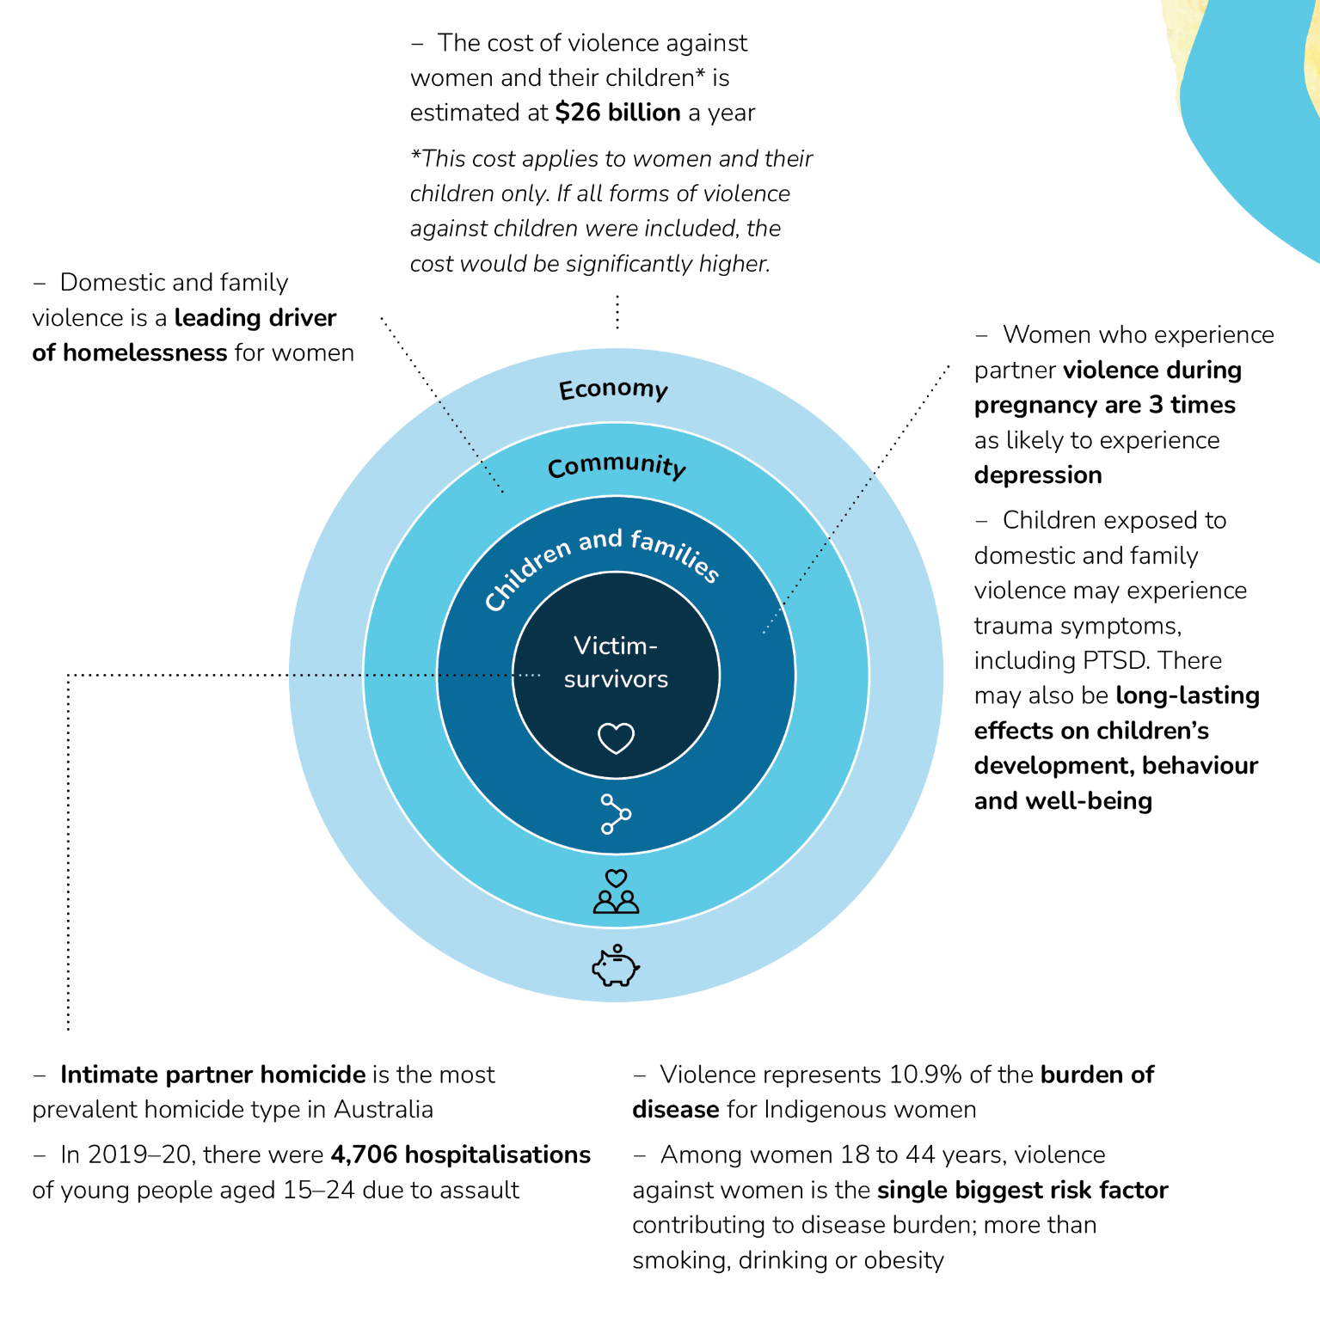Example impacts
The infographic above details the ripple effects of violence against women and children.
From the centre of the ripple effect and extending outwards, are:
Victim survivors
- Intimate partner homicide is the most prevalent homicide type in Australia
- In 2019-20, there were 4,706 hospitalisations of young people aged 15-24 due to assault.
- Violence represents 10.9% of the burden of disease for Indigenous women
- Among women 18 to 44 years, violence against women is the single biggest risk factor contributing to the disease burden; more than drinking, smoking or obesity
Children families
- Women who experience partner violence during pregnancy are 3 times as likely to experience depression
- Children exposed to domestic and family violence may experience trauma symptoms, including PTSD. There may also be long-lasting effects on children’s development, behaviour and well-being. There may also be long-lasting effects on children’s development, behaviour and well-being
Community
- Domestic and family violence is a leading driver of homelessness for women
Economy
- The cost of violence against women and their children* is estimated at $26 billion a year

*This cost applies to women and their children only. If all forms of violence were included, the cost would be significantly higher.

Our vision – Ending violence in one generation

This National Plan is our commitment to a country free of gender-based violence – where all people live free from fear and violence and are safe at home, at work, at school, in the community and online. This is a human right for all people and we commit to ending violence against women and children in Australia in one generation.
Violence against women and children is a problem of epidemic proportions in Australia. One in 3 women has experienced physical violence since the age of 15, and one in 5 has experienced sexual violence. On average, a woman is killed by an intimate partner every 10 days. Rates of violence are even higher for certain groups, such as Aboriginal and Torres Strait Islander women. A woman is also more likely to experience violence at particular life stages, such as while pregnant or while separating from a relationship. In 2021, girls aged 10 to 17 made up 42% of female sexual assault victims. These are not just statistics. They represent the stories of real people, and everyday realities.
Violence against women and children is not inevitable. By addressing the social, cultural, political and economic factors that drive this gendered violence,we can end it in one generation. While our focus for this National Plan is the next 10 years, we know that we will need to continue to prioritise ending violence against women and children as we strive to build a community that is safe for all.
This is an ambitious vision, yet we can achieve it, if we all work together.
If we address gender inequality, rigid gender norms, and discrimination, we can prevent this kind of violence. Gender inequality, compounded by other forms of discrimination including racism, is at the heart of the problem. Advancing gender equality must be central to the solution. Everyone has a meaningful role to play – as families, friends, work colleagues, employers, businesses, sporting organisations, media, educational institutions, service providers, community organisations, service systems and governments.
It is vital if we are to end violence against women and children that the Commonwealth, states and territories are all pulling in the same direction and are united in our vision to achieve this within a generation.

About the National Plan

The National Plan puts in place a national policy framework to guide the work of governments, policy makers, businesses and workplaces, specialist organisations and family, domestic and sexual violence organisations and workers in addressing, preventing and responding to gender-based violence in Australia.
The National Plan will be implemented through 2 five-year Action Plans. These will detail specific Commonwealth, state and territory government actions and investment to implement the objectives across each of the 4 domains: prevention, early intervention, response, and recovery and healing.
In the longer-term, a standalone First Nations National Plan will be developed to address the unacceptably high rates of violence Aboriginal and Torres Strait Islander women and children experience. This violence happens alongside the multiple, intersecting and layered forms of discrimination and disadvantage affecting the safety of Aboriginal and Torres Strait Islander families and communities. A deliverable under this National Plan is a dedicated action plan for Aboriginal and Torres Strait Islander family safety, which will provide the foundations for the future standalone First Nations National Plan.
This National Plan builds upon lessons learned from the previous National Plan to Reduce Violence against Women and Children 2010-2022. It recognises there is more work to do and incorporates feedback from victim-survivors, advocates, research and data experts, and family, domestic and sexual violence service providers.

How this National Plan was developed
The National Plan has been developed and agreed by Commonwealth, state and territory ministers with responsibility for women’s safety. It is the culmination over 2 years of extensive consultation with victim survivors, advocacy groups, frontline services, family, domestic and sexual violence organisations, research and data experts and the public. The voices of victim-survivors have been at the centre of the development of the National Plan. We will continue to listen to them and learn from their experiences to support the implementation of the National Plan. The Government also established the National Plan Advisory Group and the Aboriginal and Torres Strait Islander Advisory Council on family, domestic and sexual violence to provide expert guidance and advice on the development of the National Plan.

National Plan – At a glance

Our vision is to end gender-based violence in one generation.
Violence against women and children is a problem of epidemic proportions in Australia.
This National Plan is our commitment to a country free of gender-based violence with our vision of ending violence against women and children in Australia in one generation. The National Plan puts in place a national policy framework to guide the work of governments, policy makers, businesses and workplaces, specialist organisations and family, domestic and sexual violence organisations and workers in addressing, preventing and responding to gender-based violence in Australia.
The National Plan takes a holistic and multi-sectoral approach and builds upon the progress made, and lessons learned over the last 12 years.
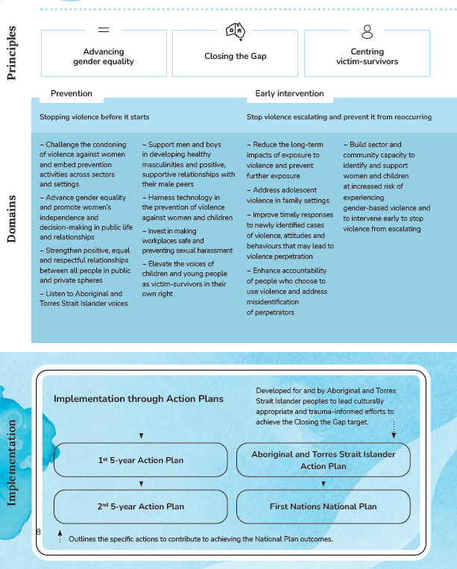
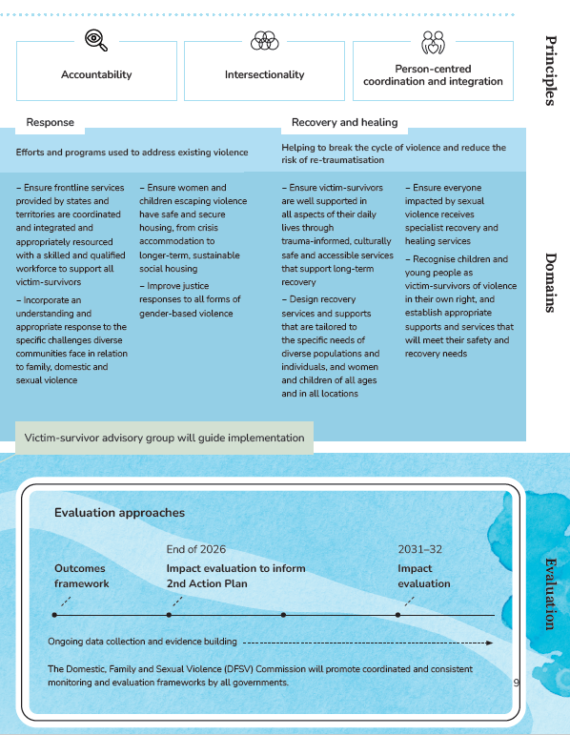

The infographics above summarise the cross-cutting principles, domains for action, implementation plan and evaluation strategy for the National Plan.

Principles
- Advancing gender equality
- Closing the Gap
- Centring victim-survivors
- Accountability
- Intersectionality
- Person-centred coordination and integration

Domains
- Prevention – Stopping violence before it starts
  - Challenge the condoning of violence against women and embed prevention activities across sectors and settings
  - Advance gender equality and promote women’s independence and decision-making in public life and relationships
  - Strengthen positive, equal and respectful relationships between all people in public and private spheres
  - Listen to Aboriginal and Torres Strait Islander voices
  - Support men and boys in developing healthy masculinities and positive, supportive relationships with their male peers
  - Harness technology in the prevention of violence against women and children
  - Invest in making workplaces safe and preventing sexual harassment
  - Elevate the voices of children and young people as victim-survivors in their own right

- Early intervention – Stop violence escalating and prevent it from reoccurring
  - Reduce the long-term impacts of exposure to violence and prevent further exposure
  - Address adolescent violence in family settings
  - Improve timely responses to newly identified cases of violence, attitudes and behaviours that may lead to violence perpetration
  - Enhance accountability of people who choose to use violence and address misidentification of perpetrators
  - Build sector and community capacity to identify and support women and children at increased risk of experiencing gender-based violence and to intervene early to stop violence from escalating

- Response – Efforts and programs used to address existing violence
  - Ensure frontline services provided by states and territories are coordinated and integrated and appropriately resourced with a skilled and qualified workforce to support all victim-survivors
  - Incorporate an understanding and appropriate response to the specific challenges diverse communities face in relation to family, domestic and sexual violence
  - Ensure women and children escaping violence have safe and secure housing, from crisis accommodation to longer-term, sustainable social housing
  - Improve justice responses to all forms of gender-based violence

- Recovery and healing – Helping to break the cycle of violence and reduce the risk of re-traumatisation
  - Ensure victim-survivors are well supported in all aspects of their daily lives through trauma-informed, culturally safe and accessible services that support long-term recovery
  - Design recovery services and supports that are tailored to the specific needs of diverse populations and individuals, and women and children of all ages and in all locations
  - Ensure everyone impacted by sexual violence receives specialist recovery and healing services
  - Recognise children and young people as victim-survivors of violence in their own right, and establish appropriate supports and services that will meet their safety and recovery needs

Victim-survivor group will guide implementation

Implementation

Implementation through Action Plans
The Action Plans outline specific actions to contribute to achieving the National Plan outcomes.
- 1st 5-year Action Plan → 2nd 5-year Action Plan
- Aboriginal and Torres Strait Islander Action Plan* → First Nations National Plan
*developed for and by Aboriginal and Torres Strait Islander peoples to lead culturally appropriate and trauma-informed efforts to achieve the Closing the Gap target

Evaluation
- Ongoing data collection and evidence building
- Outcomes Framework
- Impact evaluation to inform 2nd Action Plan (end of 2026)
- Impact evaluation (2031-32)
The Domestic, Family and Sexual Violence (DFSV) Commission will promote coordinated and consistent monitoring and evaluation frameworks by all governments.

Violence impacts people in different ways

No two women’s or children’s experiences of violence are the same. Violence against women and children can be exacerbated in certain settings and where gender inequality intersects with other forms of disadvantage and discrimination. Violence is less visible and less understood for some groups in the community.
The common impacts of violence against women and children can include:
- Poorer health
- Mental health issues such as depressive and anxiety disorders
- Early pregnancy loss
- Alcohol use disorders
- Economic insecurity
- Reduced capacity to study
- Poorer language skills

While all experiences of violence, abuse or harassment are unique, evidence clearly shows most perpetrators of gender-based violence are men, and most victims and survivors are women. Times of stress can see an increase in men’s violence against women and children. As well as health and economic crises like the pandemic, natural disasters and their aftermaths are times when women and children can face a greater risk of violence, displacement, injury, and death.
Women of all ages experience gender-based violence, including sexual abuse and harassment and technology-facilitated abuse, in every setting. Girls and younger women can experience gender-based violence in the same way as adult women.
Children can witness violence but children can also experience violence directly. A child’s worldview is shaped by the violence they see, hear and experience each day. These experiences affect their perception and understanding of the world, which can have long-term and ongoing impacts. The National Plan acknowledges children, including LGBTIQA+ children and young people, as victims of gender-based violence in their own right.
Many older women experience the compounding negative effects of taking on multiple unpaid caring roles, which can affect their employment and economic security and mean they have limited control over finances and decision-making.

Violence affects women at every life stage (not an exclusive list)
Childhood
- Infanticide
- Female genital mutilation
- Forced marriage
- Sexual harassment at school
- Technology-facilitated abuse
- Child sexual abuse
Adulthood
- Dating violence
- Sexual violence
- Intimate partner violence
- Forced marriage
- Sexual harassment at work, in public, and university
- Technology-facilitated abuse
- Economic abuse
- Intimate partner homicide
Older age
- Sexual violence
- Economic abuse
- Physical violence
- Violence in institutions
- Violence perpetrated by intimate partners, family members and carers

For Aboriginal and Torres Strait Islander women, family violence, sexual assault and abuse is a major cause of personal harm, family and community breakdown, and social fragmentation. This violence is compounded by the ongoing effects of colonisation and racism, for example from non-Aboriginal and Torres Strait Islander partners and their families, and is perpetrated by men of all cultural backgrounds.
Violence against women and girls with disability tends to occur more frequently, over a longer period of time and across a wider range of settings. It can also be perpetrated by a greater range of people than violence against women and girls without disability, including by carers, guardians and support workers, in both home and institutional settings. In addition, women with intellectual or cognitive disability can also be particularly susceptible to various types of technology-facilitated abuse.
Women and children from diverse cultural, ethnical, religious and linguistic backgrounds and migrant and refugee women and children, including those on temporary visas, can face specific challenges. These include the impact of their visa status (for example, depending on partners for residency in Australia and having restricted eligibility criteria for access to government support and services); the absence of trusted social networks or families in Australia and linguistic and cultural barriers in seeking help and reporting violence.
LGBTIQA+ people experience violence within their intimate partner relationships at similar levels to those in cisgender heterosexual relationships. LGBTIQA+ people also experience significant violence within their families of origin, particularly as children and young people.
The National Plan seeks to explicitly include LGBTIQA+ people and children as part of Australia’s commitment to ending all forms of gender-based violence.

Key areas of focus for addressing gender-based violence in the Australian Government
- Coercive control: Coercive control is characterised by a pattern of behaviours used by a perpetrator over time that has the effect of creating and maintaining power and dominance over another person or persons.
- Intimate partner homicide: Intimate partner homicide is also the most prevalent type of domestic homicide in Australia, accounting for 45 deaths in 2019–20. On average, one woman is killed by an intimate partner every 10 days.
- Sexual violence and harassment: Sexual assault is a crime that also contributes to major health and welfare issues in Australia and worldwide. For many victim-survivors, the effects can be wide-ranging and lifelong. Sexual harassment is part of the continuum of sexual violence and abuse.
- Pornography: With pornography now overwhelmingly consumed online and viamobile devices, it is both prevalent and pervasive, perpetuating sexist, misogynistic and degrading views about women. This is a serious concern in addressing the drivers of violence against women and children.
- Economic abuse including financial abuse: Economic abuse involves a pattern of control, exploitation or sabotage of money and finances and economic resources, which affects a person’s ability to obtain, use or maintain economic resources, threatening their economic security and potential for self-sufficiency and independence.
- Technology-facilitated abuse: Technology-facilitated abuse is widespread and increasing, often taking the form of stalking, surveillance, tracking, threats, harassment and the non-consensual sharing of intimate images.

Addressing structural barriers to achieving change

Strengthening the sector, building the workforce
To end violence against women and children in one generation, multiple sectors need to work together in areas of prevention, early intervention, response, and recovery and healing. Across these domains, there must be a workforce comprised of people with the skills to prevent and respond to gender-based violence.
Having a workforce that is adequately skilled to respond to violence is just one side of the coin. There must also be an expert workforce to prevent gender-based violence. Like the response workforce, the prevention workforce needs to be multidisciplinary. It requires technical and content experts whose focus is on systems change, and sector-based professionals who tailor and deliver prevention initiatives within their organisations. To end gender-based violence in one generation, prevention needs to be embedded in every setting and sector.

Housing is essential to ending gender-based violence in a generation
Domestic and family violence is the main reason women and children leave their homes in Australia and is the leading cause of homelessness for children. Inadequate housing options limit women’s and children’s ability to leave violent situations and present barriers to accessing help and support. Housing is central to personal safety and its role in policy responses must be considered across the continuum, from prevention to recovery and healing.
Improving housing outcomes for women and children experiencing violence requires both an increase in housing stock and better access to housing options. While improving pathways to long-term affordable and appropriate housing is central to supporting the long-term recovery of victim-survivors, it is critical to implement and expand programs that support women and children to remain safely in their own homes if that is their wish.

Addressing barriers to create safety for victim-survivors
Leaving a violent intimate partner relationship is the most dangerous time for a victim-survivor and their children. Work on addressing barriers should include an emphasis on providing safe and affordable housing. This should include transitional housing to support women and children moving from crisis accommodation, and those who are recently separated. Other ways to remove barriers include providing:
- paid domestic and family violence leave, so women do not have to choose between their personal safety and their economic security
- affordable local public transport, so women and children can travel to safety and access services, employment and their social networks
- affordable childcare, to support women’s economic security and social inclusion, and remove a significant obstacle to seeking help.

Improving service systems and eliminating systems abuse
Systems abuse refers to the manipulation of legal and other systems by perpetrators of family violence, done so in order to exert control over, threaten and/or harass a current or former partner. The existing system has largely prioritised crisis, legal responses and mainstream responses to violence. However, systems, legislation and services can unintentionally promote women’s dependency on men and perpetuate discrimination.

Social security
Australia’s social security system supports victims and survivors to not only leave a violent relationship, but also to establish a life free from violence. Examples of support include:
- Crisis Payment, which is available to victims of family and domestic violence up to 4 times a year
- Rent Assistance
- Higher single rates of social security payments.
Further, there a number of policy settings in place to ensure the social security system is designed to support victim-survivors, including exemptions from mutual obligation requirements and assets tests. The Australian Government will continue to ensure the needs of women and children experiencing family and domestic violence are taken into account in the delivery of government services.

Improving the family law system
While states and territories share responsibility for addressing family and domestic violence, the Commonwealth is responsible for the federal family law system. It is critical that the system protects those at risk of violence – including children and young people – who are victims and survivors of family violence in their own right. The community continues to look to its legal systems to provide accessible and efficient processes when a decision has been made to dissolve a partnership. These systems also need to provide assurances of safety during those processes, particularly where children are involved. While much has been done, work will continue to help more separating families resolve disputes in a timely and safe manner, so that litigation is a last resort.
Guided by the recommendations of 2 recent comprehensive reviews of the family law system, more will be done to make the family law system, safer and easier to use, and to ensure safer outcomes for women and children.

Improving criminal justice responses
Under our federal system of government, each jurisdiction is responsible for administering its own criminal justice system, including criminal laws, policing, courts and corrections. This includes the determination of domestic, family and sexual violence crimes and the provision of police and court ordered intervention orders. While state and territory governments are primarily responsible for criminal justice responses to family, domestic and sexual violence, the scale and prevalence of this violence, and the associated barriers to justice, make it an issue that requires national collaboration.
Key areas for improvement throughout the life of the National Plan include enhancing access to equitable justice outcomes for all victim-survivors; identifying and removing barriers to reporting violence and engaging with the criminal justice process; investigating and prosecuting violence against women and children including sexual violence; ensuring police and prosecutors have the tools and training they need to respond effectively to the use of violence; and strengthening our responses to perpetrators of violence. Capacity building for legal services, including Women’s Legal Services and Aboriginal and Torres Strait Islander Women’s Legal Services, police, the judiciary and community corrections is also a priority.

Access to justice for different communities
Currently, many communities do not have safe and equitable access to justice. There have been some initiatives to overcome these barriers to access, such as family violence specialist courts, virtual outreach legal services and intermediary schemes for victim-survivors and witnesses. To improve equitable access to justice, more needs to be done to ensure justice systems are safe, accessible and easy for victim-survivors to navigate.

Journey through the justice response
Alternative approaches, such as restorative justice, family dispute resolution, roundtable conferencing and community courts (such as the Koori courts and Murri courts), also need to be available and accessible. In addition to providing culturally safe approaches, access to justice involves making sure that systems are culturally, linguistically, physically and geographically accessible to diverse communities – for example, migrant and refugee women including those on temporary visas, who may have a first language other than English, and victim-survivors living in remote areas.
These systems should be equally responsive and accessible to people with disability and older women, which may involve providing outreach to institutions and aged care facilities. Justice responses should also seek to accommodate the different needs and interests of victim-survivors and employ, where appropriate and safe to do so, different forms of accountability for perpetrators. These might include community sanctions and restorative 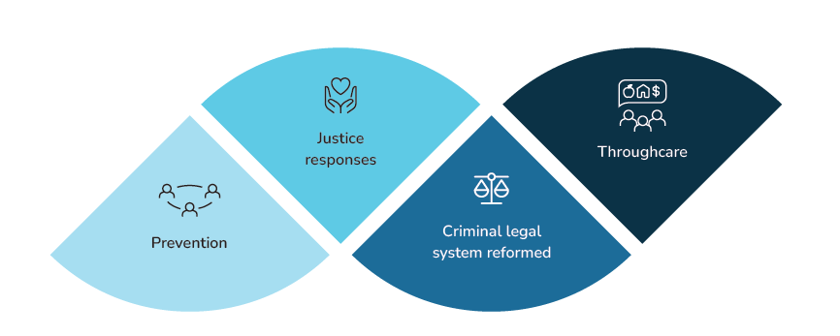processes, alongside legal sanctions and perpetrator interventions.

Cross-cutting principles

Advance gender equality
Everyone, regardless of gender, identity, ability, race and sexuality, has the right to live and work free from violence and harassment. To achieve this, we must address gender inequality and other forms of discrimination, because these create the social context in which violence against women and children occurs. Evidence shows that higher levels of violence against women are consistently associated with lower levels of gender equality in both public life and personal relationships.
Gender inequality is present when unequal value is afforded to women and men and there is an unequal distribution of power, resources and opportunity between them. While progress has been made through policies and laws to support women’s rights and opportunities, there is more work to be done to advance gender equality in Australia.
Gender inequality is maintained through:
- social norms such as rigid gender norms and stereotypes
- systems and institutions such as policies that limit women’s economic participation
- differences in child-rearing practices for boys and girls
- structures and practices that limit women’s participation in the workforce and perpetuate the gender pay gap and the superannuation gap.
Gender inequality does not exist in isolation. It intersects with other forms of structural and systemic discrimination. This means that some women face higher rates of violence, are at a heightened risk of experiencing or being exposed to certain forms of harassment, and can experience greater barriers to accessing support and recovery.
The National Plan will intersect with and be complemented by a National Gender Equality Strategy as well as with existing state and territory strategies on gender equality.

The diverse lived experiences of victim-survivors are informing policies and solutions
No effective solutions can be developed without the people most affected by them, and whom this National Plan intends to serve. Victim-survivors must be at the heart of solutions. Victim-survivors have specific and contextual expertise that comes from lived experience of abuse and violence. They have intimate firsthand knowledge of services, systems, and structures that are meant to support them but have sometimes failed them. They know from experience the weaknesses and strengths of interventions in practice.
The National Plan commits to working with victim-survivors and recognises the value of lived experience in informing appropriate and effective initiatives. To achieve this the Domestic, Family and Sexual Violence Commission will establish a formal mechanism for embedding victim-survivor engagement at the national level.
This will mean:
- making sure the diverse views and perspectives of victim-survivors are central in developing the Action Plans that will underpin this National Plan
- setting up mechanisms for ongoing engagement and consultation with victim- survivors to support implementation of the National Plan and its Action Plans
- supporting victim-survivor led advocacy groups to contribute to policy development and implementation
- recognising trauma as a normal response to abuse and as an injury of gender-based violence. Trauma recovery and actions to redress the lifelong impacts of violence and abuse on victim-survivors are embedded in the Action Plans.

Closing the Gap
The National Agreement on Closing the Gap (Closing the Gap) is an agreement by all Australian governments and the Coalition of Aboriginal and Torres Strait Islander Peak Organisations. The objective of Closing the Gap is to enable Aboriginal and Torres Strait Islander peoples and governments to work together to overcome the inequality experienced by Aboriginal and Torres Strait Islander peoples, so they achieve life outcomes equal to those of all Australians.
In addressing violence against Aboriginal and Torres Strait Islander women and children, it is vital to recognise the continuing trauma and intergenerational effects of colonisation. It is also essential to make sure responses to violence address these ongoing effects.
The National Plan will reinforce and support the Closing the Gap framework by taking a strengths-based approach to working with Aboriginal and Torres Strait Islander communities.
Further, it will align with the Priority Reforms:
- formal partnerships and shared decision-making
- building the community controlled sector
- transforming government organisations
- shared access to data and information at a regional level.
In alignment with Closing the Gap, the National Plan supports measures designed to achieve Closing the Gap Target 13: By 2031, the rate of all forms of family violence and abuse against Aboriginal and Torres Strait Islander women and children is reduced at least by 50%, as progress towards zero.
The National Plan also directly and indirectly supports Closing the Gap Targets contributing to addressing over-representation in the justice and out-of-home care systems and reducing suicide (Targets 9, 10, 11, 12 and 14).
Putting Aboriginal and Torres Strait Islander peoples at the forefront of the National Plan is critical to achieving real change. This will mean:
- measuring and reporting on how the National Plan is contributing to the achievement of Closing the Gap Target 13
- developing solutions with and led by Aboriginal and Torres Strait Islander peoples, Elders and communities
- Aboriginal organisations delivering family, domestic and sexual violence services, healing, men and boys services and recovery services to their communities
- ensuring there are mechanisms and genuine partnerships to make sure mainstream services embed cultural safety at their core and meet the needs of Aboriginal and Torres Strait Islander peoples
- establishing prevention-focused services that support and strengthen families, and recognising trauma-informed responses for children impacted by violence
- ensuring specialist programs and services are designed with, by and for Aboriginal and Torres Strait Islander peoples and communities
- developing the Aboriginal and Torres Strait Islander workforce and prioritising opportunities for Indigenous workers to build their capacity
- organisations, businesses, and governments collaborating and sharing with Aboriginal and Torres Strait Islander peoples and communities in a process of two-way learning to deliver localised best-practice responses
- ensuring Aboriginal and Torres Strait Islander communities retain ownership of their cultural knowledge and intellectual property, and integrating mechanisms to promote data sovereignty into the underpinning Action Plans and future standalone First Nations National Plan.

Person-Centred coordination and integration
Ending violence against women and children requires a holistic multi-sectoral and culturally informed approach and the coordinated efforts of multiple stakeholders.
A cross-cutting focus of the National Plan is to ensure that all stakeholders, from governments right through to locally based specialist service organisations, communicate effectively and share information.
Mechanisms are needed that enable coordination and collaboration across jurisdictions, sectors and settings, and promote consistency between legislative and policy reforms, programs, and other response and prevention efforts. These mechanisms respond to and manage risk, and provide a pathway for victim-survivors to aid their recovery.
This may include:
- establishing safety and security – for example, through access to police, shelters and transitional housing
- providing health care and treatment – for example, through hospitals and general practitioners, and through socio-emotional support
- holding people who choose to use violence accountable – for example, through perpetrator interventions, legal responses and child protection
- providing additional and ongoing support – for example, through case management, advocacy and long-term housing
- establishing referral pathways to make sure the victim-survivor receives follow-up and ongoing support
- making sure follow-up responses acknowledge and manage potential ongoing risk to victim-survivors.
A person-centred service system is timely, safe, inclusive, tailored and accessible, and it delivers integrated specialised services that reinforce the need to work together to end gender-based violence.

Intersectionality
Women and children are not a homogenous group. They have many and varied personal identities, backgrounds, experiences and social positions. The National Plan takes an intersectional approach to addressing men’s violence against women, children and LGBTIQA+ people because it is critical to success across all efforts.
This approach recognises that violence and gender inequality exist in relation to multiple and intersecting structural and systemic forms of discrimination, such as racism, colonialism, ableism, homophobia, biphobia and transphobia and ageism. Class discrimination and poverty also compromise the health and safety of women and children. These affect the prevalence, dynamics and severity of violence against women.
Not only do these systemic and structural intersections affect women’s experiences of violence, both as individuals and as groups, but they also have an impact on how gender and gender inequality are constructed and experienced. They can also limit or undermine the consequences perpetrators face for choosing to use violence.
While gender inequality and gendered drivers of violence are always relevant in explaining its use against women, they may not be the most significant factors in every context. The probability of experiencing violence (or particular forms of violence) is higher for some women. This is not because some women are inherently ‘vulnerable’. Rather, it is because of the intersections between the social, political and economic processes of gender inequality and other forms of systemic and structural inequality.
Some examples of intersections are as follows:
- Aboriginal and Torres Strait Islander women and children face complex barriers that are compounded by the ongoing legacies of colonisation including racism, systemic barriers, social and economic disadvantage resulting from intergenerational and ongoing experiences of trauma and culturally unsafe service provision.
- Refugees and migrants, including those on temporary visas and in particular those of colour, experience racism, sexism and other specific forms of discrimination that intersect to drive increased levels of violence against women from these groups – violence that is both gendered and racialised. Women from migrant and refugee backgrounds are less likely to report violence against them due to language barriers, cultural stigma, concerns about visa and residency status, and financial insecurity.
- Migrant women, including those on temporary visas, also face structural barriers other women do not, such as the impact ending a relationship has on their visa status and eligibility for social security. Granting migrant women access to support services, regardless of their visa status, will help ensure they are not left out.
- Sexism and ableism intersect and compound to drive high levels of violence, and particular forms of violence, against women and children with disability. For example, family members and/or carers and guardians may control the decision-making for and limit the independence of women with disability, making it difficult for them to access help when they need it. They are further excluded when services are not designed with accessibility in mind.
- Cisgenderism and heteronormativity, including rigid gender norms, drive and normalise violence against LGBTIQA+ people of all genders.
- The systems and structures of military service and the deeply held cultural views relating to veterans in Australian society mean veterans and their families can be isolated and face complex barriers to help, both as victim-survivors and perpetrators – during and after military service has ended.
The National Plan promotes actions across the domains of prevention through to recovery and healing that respond to the diversity of women and children, while addressing the underlying drivers of gender-based violence.

Violence against women is tragically common across all Australian communities
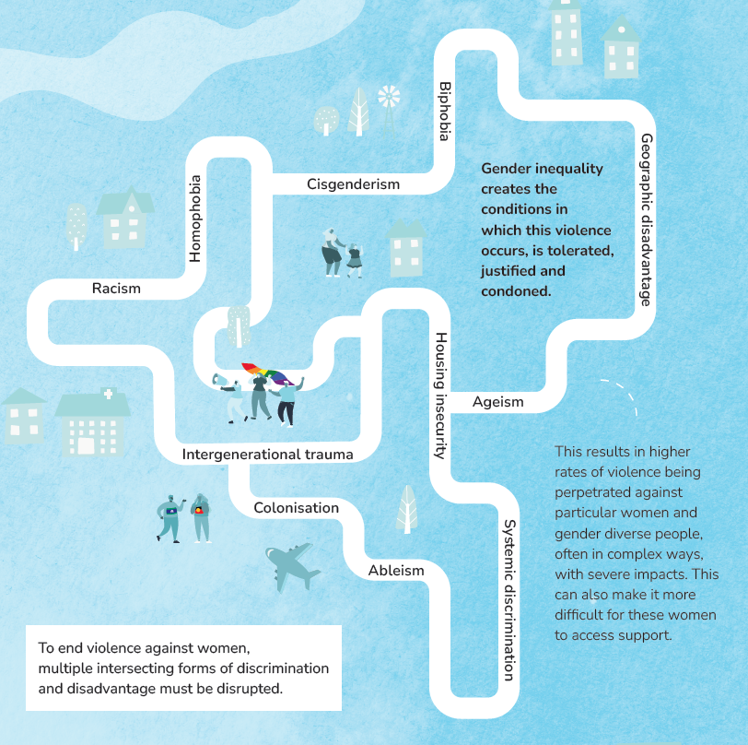
The graphic above depicts the multiple intersecting forms of discrimination and disadvantage that must be disrupted to end violence against women, including:
- Racism
- Intergenerational trauma
- Colonisation
- Ableism
- Systemic discrimination
- Housing insecurity
- Ageism
- Geographic disadvantage
- Cisgenderism
- Homophobia
- Biphobia
Gender inequality creates the conditions in which this violence occurs, is tolerated, justified and condoned. This results in higher rates of violence being perpetrated against particular women, often in complex ways, with severe impacts. This can also make it more difficult for these women to access support.
Driver 1. Condoning of men’s violence against women
Driver 2. Men’s control of decision-making and limits to women’s independence in public and private life
Driver 3. Dominant forms of masculinity and rigid gender stereotyping
Driver 4. Male peer relations and cultures of masculinity that emphasise aggression, dominance and control

People who choose to use violence are held accountable
Violence against women and children will not end without a clear and sustained focus on perpetration. Victim-survivors are never responsible for the violence they experience, yet too often the public and institutional response to women experiencing violence is “Why doesn’t she just leave?”.
Holding people who choose to use violence accountable means the responsibility to stop using violence belongs to the person using it.

What does accountability mean?
To focus attention and expectations on the actions of people who choose to use violence, we need a better understanding of accountability.
It is critical that tailored and culturally safe services and system responses are available to people who seek to address their use of violence.
Accountability can take different forms and can involve:
- victim-survivors being heard and believed, and the person who committed the violence facing appropriate consequences
- victim-survivors never being held responsible for addressing the violence they face
- people who have used violence taking personal responsibility for their violence and choosing to change their behaviour
- people who have used violence understanding what they have done, working towards changing their behaviour and repairing the harm caused
- people who have used violence face legal, justice or other consequences
- services and systems correctly identify the primary perpetrator
- improved community understanding of gender-based violence
- social and societal accountability for people who use violence.

Focus areas across the continuum

The National Plan takes a holistic and multi-sectoral approach to ending violence against women and children in one generation. This builds upon the progress made, and lessons learned over the last 12 years. We acknowledge where we have come from and where we have more work to do.
The priority areas for action are evidence-based and span the continuum of prevention, early intervention, response, and recovery and healing. The priorities are interconnected, with each action reinforcing the effectiveness of others. For example, recovery and healing from childhood trauma contributes to long-term prevention by addressing one of the factors that reinforce violence against women. High-quality and accessible response services hold perpetrators accountable, and in turn reduce the recurrence of violence.

Domains

Prevention
Our national vision is a country free from violence against women and children. The only way to achieve this is to stop violence from happening before it starts, through prevention efforts. Prevention is a long-term national priority, and focuses on ending violence in one generation.
Prevention means stopping violence against women from occurring in the first place by addressing its underlying drivers. This requires changing the social conditions that give rise to this violence; reforming the institutions and systems that excuse, justify or even promote such violence.
Effective prevention required integrated and cohesive work that builds mutually reinforcing action at all levels, together with clearly defined and well-supported implementation.
Comprehensive prevention aims to influence laws, policies, and the practices and behaviours of organisations, groups and individuals. This whole-of-society approach engages people of all ages in all the places they live, work, learn, socialise and play.
It includes a broad range of activities such as:
- Employer-led workplace initiatives to embed respect and gender equality in organisational structures, policies and cultures
- Efforts to encourage more respectful and informed reporting on violence against women in the media
- Respectful relationships and consent education in schools
- Gender-responsive policy analysis and development processes to identify ways to address the gendered drivers of violence in public policy

Early intervention
Early intervention is an important part of a holistic approach to ending men’s violence against women and children. It is vital in stopping violence from escalating and protecting victim-survivors from both immediate and long-term harm.
Early intervention, also known as ‘secondary prevention’, aims to identify and support individuals and families experiencing, or at risk of, gender-based violence in order to stop violence from escalating, protect victim-survivors from harm and prevent violence from reoccurring.

Response
A comprehensive and person-centred response system is essential for holding perpetrators to account, helping to keep women and children safe and reducing the reoccurrence of violence.
Response refers to efforts and programs used to address existing violence – for example, services such as crisis counselling, financial, housing or medical assistance as well as police and justice responses including family law services and perpetrator interventions. Also known as ‘tertiary prevention’, these efforts aim to prevent the reoccurrence of violence by holding perpetrators of violence to account and supporting victim-survivors.

Recovery and healing
Victim-survivors of violence experience a range of physical impacts, sometimes permanent disability, as well as trauma-related mental health problems, financial hardship and social isolation. Recovery is an essential component of the holistic approach under the National Plan as it recognises that victim-survivors need additional, often lifelong, supports to recover and heal from trauma and the physical, mental, emotional and economic impacts of violence.
Recovery is an ongoing process that enables victim-survivors to be safe, healthy and resilient and to have economic security and post-traumatic growth. Victim-survivors require support to recover from the financial, social, psychological, emotional and physical impacts of violence. Recovery also includes addressing the short-term, long-term and lifelong health impacts for victim-survivors, which may include physical injuries, reproductive and sexual health issues and poor mental health.
Recovery also relates to the rebuilding of a victim-survivor’s life, their ability to return to the workplace and community, as well as obtaining financial independence and economic security. However, it must be acknowledged that victim survivors recover and heal in different ways, with some people being unable to return to work and requiring access to ongoing support.
In cases of gender-based violence, the victim-survivor may still be in contact or live with the perpetrator. In these situations, the family as a whole may need support to recover. Moreover, in some cases, people are both victim-survivors and perpetrators of violence – for example, some adolescents using violence. People in this situation must be supported to both recover from their experiences of violence and address their own use of violence to prevent further harm.

Working together to create change
The 2010–2022 National Plan saw the establishment of key national organisations that form the foundational infrastructure for Australia’s response to family, domestic and sexual violence – Our Watch, ANROWS and 1800RESPECT. Since their establishment, they have played crucial and interlocking roles using investment from Commonwealth, state and territory governments to provide a consistent, national focus on family, domestic and sexual violence.
In recognition that we are all responsible for understanding family, domestic and sexual violence, these organisations share expertise and support across governments, business, the family, domestic and sexual violence sector and the broader public, to promote change. Their work will continue under this National Plan, and be augmented by the work of the Domestic, Family and Sexual Violence Commission, which will have a strong focus on accountability and ensuring activities and initiatives are appropriately aligned and collaborative.

Approach to monitoring and evaluation

Specific and Measurable Targets
Data is crucial to understanding the problem of gender-based violence, measuring our progress towards ending it, and informing decisions about funding, service design and delivery.
To ensure accountability, the National Plan requires ambitious and measurable targets to demonstrate progress over time towards ending gender-based violence.
Continuing to build a strong evidence base is central to the success of the National Plan. Our ability to provide quality responses to victim-survivors, hold perpetrators accountable and keep women and children safe is predicated on addressing data gaps and building strong data-sharing mechanisms. Recognising that data is complex and there are differences between jurisdictions, a key focus of the National Plan is to improve data collection, coordination and consistency.

Outcomes Framework
The National Plan will be supported by an Outcomes Framework that will increase our ability to track, monitor and report change over the life of the National Plan. It will help us continuously improve our work and respond to new or emerging areas of need.
The Outcomes Framework will include 4 outcome levels, recognising the importance of action at the individual level, the service level, the system level and the community level. By including these 4 levels, the framework represents relevant, meaningful and effective outcomes for a broad range of stakeholders who will be impacted by or involved with the National Plan.
There is still more data and evidence development work to be done to measure sustained population level changes in attitudes about gender-based violence.
That is why, in addition to continuing support for key national survey collections, we are implementing new data collections and data development projects.
The Domestic, Family and Sexual Violence Commission will work with Commonwealth agencies, states, territories and community organisations to promote coordinated and consistent monitoring and evaluation frameworks by all governments.

Key terminology and definitions: Working towards national consistency
Definitions of gender-based violence are a whole-of-system issue. Nationally consistent definitions should be used to inform and support program design, public and private sector policies, as well as legislation across states and territories to ensure that all people in Australia have equal access to support and justice. They can also inform everyday working and social experiences as this consistent understanding is applied to workplaces and community, online and government settings.
The National Plan uses the following terms that form the basis for national discussion on consistent definitions:
Intimate partner violence, also commonly referred to as ‘domestic violence’, refers to any behaviour within an intimate relationship (including current or past marriages, domestic partnerships or dates) that causes physical, sexual or psychological harm. This is the most common form of violence against women. Intimate partner violence can also occur outside of a domestic setting, such as in public and between 2 people who do not live together.
Family violence is a broader term than domestic violence, as it refers not only to violence between intimate partners but also to violence perpetrated by parents (and guardians) against children, between other family members and in family-like settings. This includes for example elder abuse, violence perpetrated by children or young people against parents, guardians or siblings, and violence perpetrated by other family members such as parents-in-law.
Family violence is also the term Aboriginal and Torres Strait Islander peoples prefer because of the ways violence occurs across extended family networks. Family violence can also constitute forms of modern slavery, such as forced marriage and servitude.
Coercive control is often a significant part of a victim-survivor’s experience of family and domestic violence. It describes someone’s use of a pattern of abusive behaviours against another person over time, with the effect of establishing and maintaining power and dominance over them.
Abusive behaviours that perpetrators can use as part of their pattern of abuse include physical abuse (including sexual abuse), monitoring a victim-survivor’s actions, restricting a victim-survivors freedom or independence, social abuse, using threats and intimidation, emotional or psychological abuse (including spiritual and religious abuse), financial abuse, sexual coercion, reproductive coercion, lateral violence, systems abuse, technology-facilitated abuse and animal abuse.
Sexual violence refers to sexual activity that happens where consent is not freely given or obtained, is withdrawn or the person is unable to consent due to their age or other factors. It occurs any time a person is forced, coerced or manipulated into any sexual activity. Such activity can be sexualised touching, sexual abuse, sexual assault, rape, sexual harassment and intimidation and forced or coerced watching or engaging in pornography. Sexual violence can be non-physical and include unwanted sexualised comments, intrusive sexualised questions or harassment of a sexual nature. Forms of modern slavery, such as forced marriage, servitude or trafficking in persons may involve sexual violence.
Consent is where a person freely and voluntarily agrees to participate in an interaction. While consent applies to a broad range of issues, in this context it is most often physical or sexual in nature. Consent requires ongoing and mutual communication and decision-making, and can be withdrawn at any point. Legal definitions of sexual consent vary between states and territories, with reforms occurring in a number of jurisdictions to amend the legal definitions of consent, for example, to adopt an affirmative model of consent that requires a person to take active steps to say or do something to find out whether the other person consents to the sexual activity. While the age of consent differs between jurisdictions, children under the age of consent cannot consent to sex or sexual acts. A person must also have the cognitive capacity to consent to the sexual activity at the time and must not be:
- misled about the nature or purpose of the sexual activity
- influenced by someone abusing their position of authority, trust, or dependency
- in the context of forced marriage, a person does not freely or fully consent to the marriage because of threats, deception or coercion, or because they are incapable of understanding the nature and effect of the marriage ceremony, or the individual is under the age of 16 years.

Notes

Australian Bureau of Statistics (ABS), 2016 Personal Safety Survey (PSS), ABS, Australian Government, 2017.
B Serpell, T Sullivan and L Doherty, Homicide in Australia 2019–20, Statistical Report no. 39, Australian Institute of Criminology (AIC), 2022, doi:10.52922/sr78511.
Australian Institute of Health and Welfare (AIHW), Family, domestic and sexual violence in Australia, 2018, catalogue number FDV 2, AIHW, Australian Government, 2018, doi:10.25816/5ebcc144fa7e6.
RL Burch and G Gallup, ‘Pregnancy as a stimulus for domestic violence’, Journal of Family Violence, 2004, 19(4):243–7, doi:10.1023/B:JOFV.0000032634.40840.48.
ABS, Recorded Crime – Victims, 2021, ABS website, 2022.
AIHW, Family, domestic and sexual violence in Australia: continuing the national story 2019, AIHW, Australian Government, doi:10.25816/5ebcc837fa7ea.
Victorian Government and The Equality Institute, Family violence primary prevention: building a knowledge base and identifying gaps for all manifestations of family violence, The Equality Institute, 2017.
LC Potter, R Morris, K Hegarty, C García Moreno and G Feder, ‘Categories and health impacts of intimate partner violence in the World Health Organization multi country study on women’s health and domestic violence’, International Journal of Epidemiology, 2021, 50(2):652–662, doi:10.1093/ije/dyaa220; S Brown, D Gartland, H Woolhouse H and R Giallo, Maternal health study policy brief no. 2: health consequences of family violence, Murdoch Children’s Research Institute, Melbourne, 2015; 136 A Morgan and H Boxall, Economic insecurity and intimate partner violence in Australia during the COVID 19 pandemic, Research report 02/2022, ANROWS, 2022; L Nisbet, G Halse, E van Esbroek, W Heywood, A Powell and P Myers, National student safety survey: qualitative research on experiences of sexual harassment and sexual assault among university students in 2021, The Social Research Centre, 2022; LJ Conway, F Cook, P Cahir, S Brown, S Reilly, D Gartland, F Mensah and R Giallo, ‘Children’s language abilities at age 10 and exposure to intimate partner violence in early childhood: results of an Australian prospective pregnancy cohort study’, Child Abuse & Neglect, 2021, 111:104794, doi:10.1016/j.chiabu.2020.104794.
ABS, 2016 PSS
Our Watch, Change the Story: A shared framework for the primary prevention of violence against women in Australia, 2nd edn, Our Watch, 2021.
Our Watch, Preventing intimate partner violence against older women, Our Watch, 2022.
L Dowse, K Soldatic, A Didi, C Frohmader and G van Toorn, Stop the violence: addressing violence against women and girls with disabilities in Australia, Background Paper, Women with Disabilities Australia, 2013.
Dowse et al., Stop the violence.
eSafety Commissioner, ‘For my safety’: Experiences of technology-facilitated abuse among women with intellectual disability or cognitive disability, eSafety, 2021.
Harmony Alliance, Migrant and refugee women in the COVID-19 pandemic: Impact, resilience and the way forward – National consultation report, Harmony Alliance, 2021.
B Serpell et al, Homicide in Australia 2019–20.
B Serpell et al, Homicide in Australia 2019–20.
R Glenn and J Kutin, Economic abuse in Australia: Perceptions and experience, Centre for Women’s Economic Safety, 2021.
D Woodlock, ReCharge: Women’s technology safety, legal resources, research and training, national study findings, Women’s Legal Service NSW, Domestic Violence Resource Centre Victoria and WESNET, 2015.
Australian Housing and Urban Research Institute (AHURI), ‘Housing, homelessness and domestic and family violence’, AHURI website, 2021.
Australian Law Reform Commission (ALRC), Family Law for the Future: An Inquiry into the Family Law System Final Report, ALRC Report 135, ALRC, 2019; Joint Select Committee on Australia’s Family Law System
Our Watch, Change the story.
Australian Government, Closing the Gap Report 2020, Australian Government, 2020.
Australian Government, National Agreement on Closing the Gap, Australian Government, 2020.
Our Watch, Change the story.
Our Watch, Changing the picture: A national resource to support the prevention of violence against Aboriginal and Torres Strait Islander women and their children, Our Watch, 2018.
M Segrave, R Wickes and C Keel, Migrant and refugee women in Australia: The safety and security study, Monash University, 2021, doi:10.26180/14863872.
K Hegarty, L Tarzia, S Rees, A Fooks, K Forsdike, D Woodlock, L Simpson, C McCormack and S Amanatidis, Women’s Input into a Trauma informedystems model of care in Health settings (The WITH Study) Final report, ANROWS Horizons 02/2017, ANROWS, 2017; J Ayre, M Lum On, K Webster, M Gourley and L Moon, Examination of the burden of disease of intimate partner violence against women in 2011: Final report, ANROWS Horizons 06/2016, ANROWS, 2016. More information You can find out more and read the full National Plan on the National Plan website at www.dss.gov.au/ending-violence.

