Enhanced Income Management - Stakeholder post

Support available
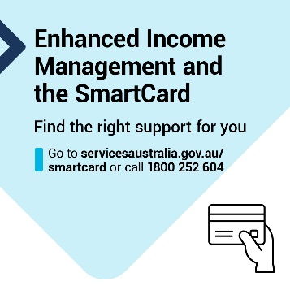
Post words
If you’re on Income Management, you can choose to move to enhanced Income Management and get a SmartCard.
You can use the SmartCard for online shopping, at most EFTPOS terminals, to ‘tap to pay’ in store, or pay your bills over the phone or online.
If you’re in the Northern Territory, you can choose to have your account and SmartCard managed through Services Australia or the Traditional Credit Union. [remove section if outside of the NT]
If you need help managing your money, free financial support is available to you. Find local support by visiting dss.gov.au/supportservices
Services Australia can also help you find the right support.
Visit servicesaustralia.gov.au/smartcard or call the SmartCard eIM hotline on 1800 252 604 to find out more.
If you need an interpreter, they will arrange one for free.
If you are a person with disability and need other support, visit the Disability Gateway disabilitygateway.gov.au or call 1800 643 787.

