Enhanced Income Management - Stakeholder post

About enhanced Income Management
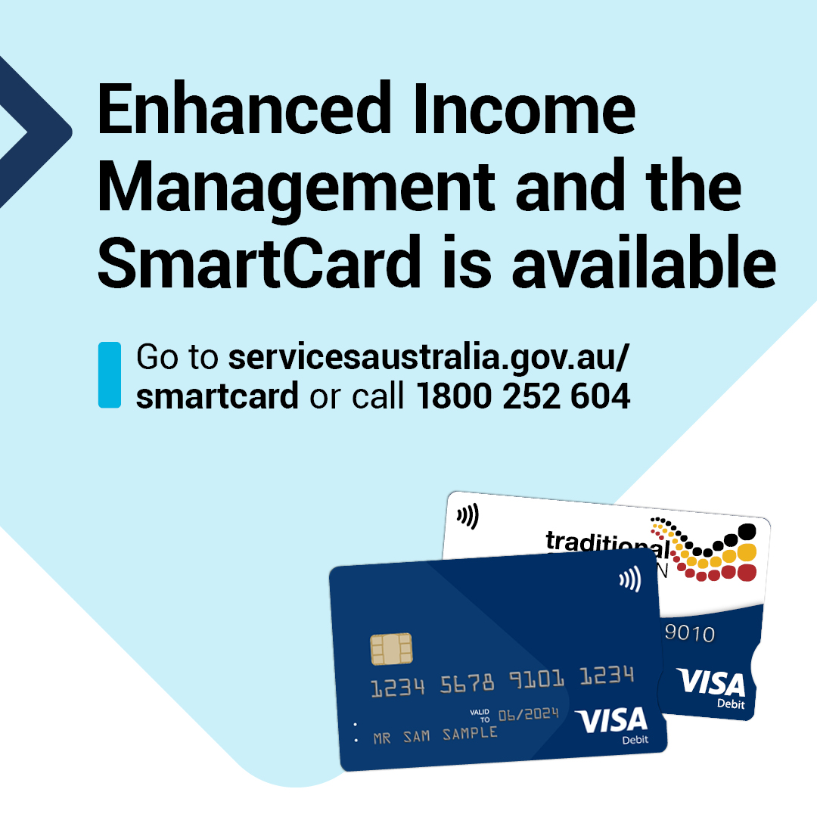
Post words
Enhanced Income Management and the SmartCard is available for people on Income Management.
You can use the SmartCard at most shops across Australia using enabled ‘tap to pay’ options. You can also use it for online shopping or to pay bills over the phone or online.
If you choose to move to enhanced Income Management, you’ll get support from Services Australia to help you manage your account and SmartCard.
If you live in the Northern Territory you can choose to have your account and SmartCard managed through Services Australia or the Traditional Credit Union. [remove Traditional Credit Union mention if outside of the NT]
If you choose to move to enhanced Income Management, the amount of money you get will not change.
Find out what this means for you by visiting servicesaustralia.gov.au/smartcard or calling the SmartCard eIM hotline on 1800 252 604.
If you need an interpreter, they will arrange one for free.
If you are a person with disability and need other support, visit the Disability Gateway disabilitygateway.gov.au or call 1800 643 787.

