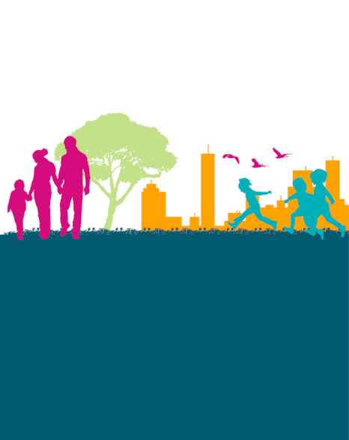
Welcome to the inaugural Families and Children (FaC) Activity newsletter.
The purpose of this newsletter is to highlight important news and information for service providers delivering grant activities under the FaC Activity. The Department of Social Services encourages providers to circulate this newsletter to their staff.
The department intends to send this newsletter to service providers several times each year, as necessary. Providers will be able to access all issues of the newsletter on the Families and Children Activity webpage.
The department is open to feedback on the regularity, format and content of the newsletter. Please contact your Funding Arrangement Manager if you have suggestions.
This issue focuses on:
- Update on the FaC Activity service improvements
- New resources on the Families and Children Activity webpage
- Information and guidance on using the Data Exchange
- Helpful resources on outcomes measurement available on the
Australian Institute of Families’ (AIFS) website.

What is in this issue?

Families and Children Activity Newsletter

Issue 1 | August 2021
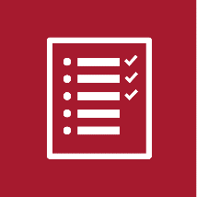
Progress to date
- A summary of feedback from the Supporting Improvements to the Families and Children Activity consultations conducted in the first half of 2021 has been released on DSS Engage.
- Following the consultation, the department issued new grant agreements with requirements related to the Data Exchange Partnership Approach, program logics and theories of change, and a review point (five-year grant agreements only). The department also published operational guidelines for each program, including a draft outcomes framework for the FaC Activity.
Further consultation
- Following positive feedback, the department is reconvening the advisory groups in early September 2021 to gather feedback on the implementation of key reforms including the outcomes framework and the program logic and theory of change template.
- Later this year, the department will continue consultation with providers on better integrating Budget Based Funded services and Children and Parenting Support services with Communities for Children Facilitating Partners.
Operational guidelines
- The department has published updated versions of operational guidelines on the FaC Activity webpage. These guidelines will be updated over time as required.
Outcomes framework
- The department is finalising the FaC Activity outcomes framework in consultation with AIFS and the advisory groups. The department will publish the final version in all operational guidelines later in 2021.
Program logic and theory of change template
- The department is finalising the program logic and theory of change template in consultation with AIFS and the advisory groups. The department aims to publish a link to the final version on the FaC Activity webpage later in 2021.

Update on FaC service improvements
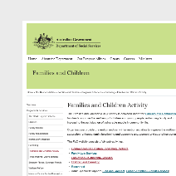
The FaC Activity webpage now includes links to:
- draft operational guidelines for each grant program
- fact sheets on new requirements for service providers from 1 July 2021
- new Activity Work Plan templates.
Please note service providers and service delivery staff must deliver grant activities in accordance with relevant operational guidelines from 1 July 2021.

Families and Children Activity webpage
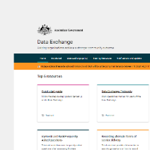
Updated guidance on reporting data
- The department has updated its Program-specific guidance for Commonwealth Agencies in the Data Exchange.
- The document sets out reporting requirements and recommendations for each grant program under the FaC Activity.
- Service providers must report data in accordance with the requirements for their grant programs.
Extended demographics data
- Service providers are not required to collect any extended demographics from clients. Refer to Appendix A for further information.
Translating outcomes measurement tools into SCORE
- The department publishes a SCORE Translation Matrix. The matrix lists validated outcomes measurement tools that have been translated into SCORE, and provides templates for providers to translate their own outcomes measurement tools into SCORE.
How the department uses DEX data and why this data is important
- The department uses DEX data to monitor and report the effectiveness of grant programs and inform future policy and decisions of the Australian Government.
- DEX data help the department understand what is being done, how well it is being done and whether the department and service providers are meeting expectations.
- For service providers, DEX data indicates the performance and impact of their grant activities. Providers can use this data to inform best practice and evaluations, and gather evidence on the effectiveness of their activities.
How to grant DEX access to staff
- The department has published a guide on how providers grant DEX access to staff. Please contact the Data Exchange Helpdesk if you require further assistance.
Online DEX training modules
- The department has published two online DEX training modules for service providers, each of which takes about 20 minutes to complete:
  - Adding a client, case and session in the Data Exchange
  - Recording outcomes using SCORE
DEX training and support
- The department publishes DEX training resources online.
- To supplement these resources, the department intends to deliver a series of webinars from October 2021, survey the sector in early 2022 to identify further needs, and circulate important information via this newsletter as necessary.

Data Exchange
The following resources may be useful to service providers developing or reviewing ways of measuring client outcomes:
- How to choose an outcomes measurement tool
- Outcomes measurement tools for particular outcomes (please read this webpage in conjunction with the explanatory notes)
- Outcomes measurement tools for playgroups
- Collecting data from parents and children for the purpose of evaluation: Issues for child and family services in disadvantaged communities
- Measuring outcomes in programs for Aboriginal and/or Torres Strait Islander families and communities
- Evaluating the outcomes of programs for Indigenous families and communities
- Demonstrating community-wide outcomes: Exploring the issues for child and family services
AIFS publishes these resources via Child Family Community Australia (CFCA). CFCA is an information exchange on the AIFS website that offers service providers evidence-based information and resources on a range of topics.
AIFS offers a range of information and support for service providers. The department will publish more detail about these resources in future newsletters.

Measuring outcomes

Appendix A – Data Exchange reporting requirements for service providers

Providers are required to record the following data in DEX:
- Name
- Date of birth
- Gender
- Suburb/Town
- State
- Postcode
- Country of birth
- Main language spoken at home
- Whether a client identifies as Aboriginal or Torres Strait Islander
- Whether a client has one or more impairments, conditions or disabilities
- Session dates and services (i.e., what type of service a client receives and when)
- SCORE data (i.e., measures of client circumstances, goals or satisfaction).

Providers are not required to record any extended demographics data, such as:
- Homelessness indicator
- Household composition
- Highest level of education/qualification
- Employment status
- Main source of income
- Approximate gross income and income frequency
- Time of first arrival in Australia
- Visa type
- Ancestry
- Whether a client is a carer
- NDIS eligibility
A note on privacy
The Data Exchange ensures clients’ personal information is protected through strict protocols that comply with the requirements of the Social Security (Administration) Act 1999, Privacy Act 1988, including the Australian Privacy Principals, and other relevant legislation. Strict IT security rules prevent DSS staff from accessing personal information.
Data Exchange data is not shared for compliance purposes, or to track whether individuals are providing the correct information to the Australian Government. Data Exchange data is not provided to Centrelink and a client’s payment status will not be impacted by information reported through the Data Exchange.
For further information on the Data Exchange’s governance around confidentiality, anonymity and privacy, please visit the Data Exchange website and read the Data Exchange protocols.

