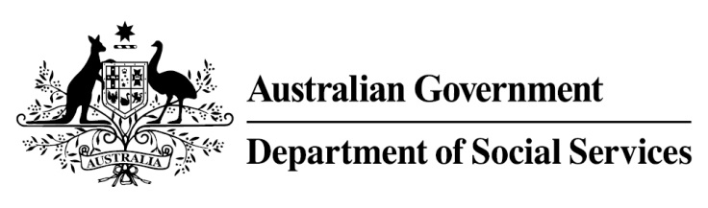

Try, Test and Learn Fund

Initiative: Work Work

Location: Sydney, New South Wales and Melbourne, Victoria

What are we trying to achieve?

Fast facts
Priority group: Older unemployed
Participant numbers: 48
Location: Sydney and Melbourne
Trial period: 18 months
Total funding: $0.8 million
Service provider: Two Good Foundation Ltd
Potential future saving: If around 13 per cent of participants move off income support because of this project, the savings to the welfare system are likely to outweigh the costs of the project.

Create employment pathways for women aged 50 and over who are unemployed, and living in a homeless refuge or are at-risk of becoming homeless, to increase their likelihood of gaining financial independence.
What is Work Work?
Participants complete 16 weeks of paid on-the-job training as kitchen assistants with Two Good Foundation, producing meals that are distributed to refuges in Sydney or Melbourne.
Participants also complete accredited training in vocational and hospitality skills, a six-month paid work placement within the hospitality industry, and support to find ongoing work.
Coaches guide participants onto their career pathways by providing training in resume writing and interviewing, for example. Social workers support participants to resolve any work-related psychosocial issues that may arise, and provide referrals to services they may require (for example, housing support).
An important element of the project is ensuring participants feel supported within the workplaces they are in, by promoting a trauma-informed understanding of the participants’ journeys to independence. This is promoted within Two Good Foundation and within the workplaces where participants are placed.

What does the evidence tell us?
- Many older Australians want to work but find it difficult to get work.

- Australians are on average living into their 80s, and older jobseekers may draw on income support payments for many years.

- If nothing changes, 75 per cent of this group will be receiving income support payments in 10 years, and 74 per cent will be receiving income support payments in 20 years.

How is this initiative new and innovative?

This initiative will test the scalability of a unique partnership model that provides a safe and supported environment for a disadvantaged group of older women, and importantly, partners with employers early in the project’s life.
Using insights from the Priority Investment Approach, the $96.1 million Try, Test and Learn Fund is gathering evidence on new or innovative approaches to addressing barriers to work.
The Try, Test and Learn Fund will help achieve the objectives of welfare reform—that is, to develop a modern welfare system that increases the capacity of individuals, reduces the risk of welfare dependency and maintains a strong welfare safety net.

