Australian Priority Investment
Approach to Welfare – Overview

The Priority Investment Approach is a new way of looking at the welfare system. It uses data analysis to provide insights into how the system is working and uses those insights to find innovative ways of helping more Australians live independently of welfare.

Why is this important?
Australia has a new, detailed and transparent profile of our welfare system, which will guide us in helping people to become independent of welfare through employment.
The future lifetime cost of welfare payments for all Australians is estimated to be $4,764 billion ($4.8 trillion) as at 30 June 2015.

What have we learnt so far?
More than one third of Australia’s population receive welfare payments.
Around 10 per cent of Australians not currently receiving payments are expected to start receiving welfare over the next five years.
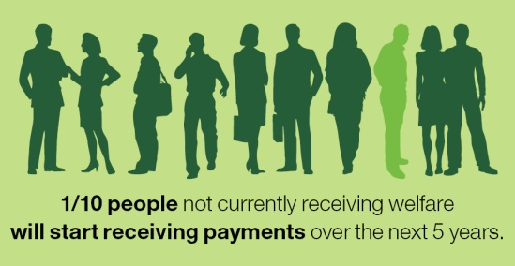
The data has revealed that more than one third of Australia’s population is currently receiving welfare payments and of those not currently in the welfare system, 88 per cent are expected to receive some type of welfare payment at some point in their lifetime.

The longer people stay out of the welfare system—especially if it is over three years—the lower their chance of receiving a welfare payment in the future.
Age Pension is the most expensive part of our welfare system. This is because we are living healthier, longer lives.

Why are we doing this?
The welfare system ensures our most vulnerable will always have help, and by intervening early we will be able to give those with capacity the opportunity to develop life skills and to participate economically and socially through work.
Employment has significant health and social benefits. Having a job also helps individuals build financial independence, and reduces welfare costs.
The Priority Investment Approach allows us to realistically look into the future and see where we are headed. Investing in early intervention will help people from being trapped in the welfare system.

This is current as at 30 June 2015.

