eNewsletter, Issue 5, September 2015

Welcome to the fifth issue of the National Plan e-Newsletter.

This edition has a focus on improving perpetrator interventions/justice responses.

All Australian governments are committed to keeping women and their children safe from violence. To keep women and their children safe we must hold perpetrators to account. How we hold perpetrators of domestic, family and sexual violence to account can change the future for women and their children.

In this issue, you will hear from the Hon. Gail Gago, MLC, Minister for the Status of Women, South Australia, find an article about the National Roundtable and get updates about the Family Law Council, National Data Collection and Reporting Framework and the National Partnership Agreement on Legal Assistance Services. You will also see updates from governments around the country about work they are doing in 2015 to reduce violence against women and their children.

We would like to thank everyone for their support of the National Plan and ongoing efforts to ensure Australian women and their children can live free from violence.

Table of Contents
Message from the Hon. Gail Gago MLC, Minister for the Status of Women, South Australia 3
What has been happening? 5
Feature stories 5
Australian Government announces Women’s Safety Package to Stop the Violence 5
National Roundtable – Responding to Violence against Culturally and Linguistically Diverse (CALD) Women and their Children 6
Our Watch media awards 6
Attorney-General’s Department supports the National Community Legal Centres Conference 8
Victims of family violence a priority under new legal assistance agreement 9
Families with complex needs and the intersection of the family law and child protection systems 9
Update on the progress of the National Family Violence Bench Book 10
‘Help improve the national evidence base for family and domestic violence’ 10
First release of experimental Family and Domestic Violence statistics 11
National Outcome Standards for Perpetrator Interventions 11
National campaign to reduce violence against women 12
Updates from around the country 12
Safe Homes, Safe Families: Tasmania’s Family Violence Action Plan 2015-2020 12
Highlights from South Australia 14
Highlights from Western Australia 15
Highlights from New South Wales 17
Highlights from Queensland 18
Dates for your diary 20
Have your say! 21

Message from the Hon. Gail Gago MLC, Minister for the Status of Women, South Australia

On 30 July 2015 I proudly launched Achieving Women’s Equality, South Australia’s Women’s Policy.

South Australia has a strong history of promoting women’s rights and leading in a way that recognises and celebrates the cultural, social, and economic diversity of women’s lives and contributions to our community.

In December 1894, South Australia became the first Australian state to allow women to vote in state elections and the first state to allow women to stand for State Parliament. Following the recent 120th anniversary of women’s suffrage in South Australia it is fitting Achieving Women’s Equality generates ambitious aspirations that will create enduring positive change for South Australian women and girls.

Achieving Women’s Equality provides a framework to achieve gender equality across all facets of state government and in partnership with non-government organisations, business, local government and community groups.

The policy draws together existing state government programs that positively impact women to support three key priorities:
- improving women’s economic status
- increasing women’s leadership and participation
- improving women’s safety and wellbeing.
The policy documents sets out our recent activities. We have done much to improve women’s economic status, increase opportunities for women’s leadership, and improve the safety and wellbeing of women.

The South Australian Government takes very seriously the effects of domestic violence on women and their children and is strongly committed to the National Plan to Reduce Violence against Women and their Children. South Australia has led the way with developing specialist services to help victims, identify offenders and promote attitudinal change regarding respect and gender equality.

One new initiative announced at the launch of Achieving Women’s Equality is South Australian Government funding for the development of a new pilot program offering education pathways to women affected by domestic and family violence. The program will be led by Central Domestic Violence Service and will support women to engage in education and move toward confident engagement, participation and financial security.

While today we enjoy the benefits of the significant progress made by our women’s rights pioneers, we still have work to do.

For more information about the South Australian Women’s Policy Achieving Women’s Equality, and other initiatives, visit officeforwomen.sa.gov.au
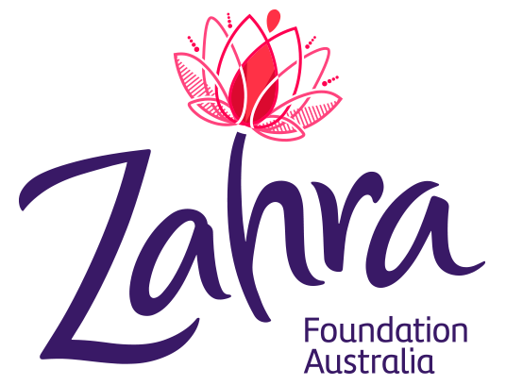

I was honoured to attend the official launch of the Zahra Foundation Australia on 5 September 2015. The establishment of the Zahra Foundation has been initiated by Zahra Abrahmizadeh’s children in memory of their mother who was stabbed to death by her estranged husband at a community function in 2010.

In partnership with Central Domestic Violence Service, the Zahra Foundation has been established as a trust
fund to be used for all women in South Australia to build their economic and financial independence and help women to break the cycle of poverty and violence. zahrafoundation.org.au

What has been happening?

30 July Hearing her voice – Report from the kitchen table conversations with culturally and linguistically diverse women on violence against women and their children was released.

July/August The Royal Commission into Family Violence (Victoria) public hearings.

7 August Meeting of Commonwealth, state and territory Ministers responsible for the implementation of the National Plan to Reduce Violence against Women and their Children 2010-2022.

7 August National Roundtable – Responding to Violence against Culturally and Linguistically Diverse (CALD) Women and their Children.

13 August Launch of Safe Homes, Safe Families, Tasmania’s Family Violence Action Plan 2015-2020.

20 August Senate Inquiry into Domestic Violence in Australia – final report released.

25-27 August The 36th National Community Legal Centres Conference.

3 September Australian of the Year, Rosie Batty, launched the updated Daisy app, featuring information translated into 28 different languages and text to voice for those with vision impairment.

7 September Launch of the Freedom from Fear Action Plan 2015: Working towards the elimination of family and domestic violence in Western Australia.

Feature stories

Australian Government announces Women’s Safety Package to Stop the Violence

On 24 September 2015, the Australian Government announced increased funding to address domestic and family violence through the Women’s Safety Package. The $100 million package contains practical measures to help keep women safe, deliver better frontline support and services, and provide resources to help parents, teachers and students change young people’s attitudes to violence so we don’t perpetuate this problem in the next generation.

The Women’s Safety Package is a set of immediate interim actions to respond to recent escalating tragedies and help keep women and their children safe. The funding is in addition to the Australian Government’s $101 million investment in the Second Action Plan of the National Plan to Reduce Violence Against Women and their Children 2010-2022, and the $30 million national campaign to reduce violence against women and their children, which is being jointly funded with states and territories. Further structural work will be laid down under the Third Action Plan, due for release in 2016.

This package responds to the initial advice of COAG’s Advisory Panel on Reducing Violence against Women and their Children – chaired by Ken Lay and deputy chaired by Rosie Batty and Heather Nancarrow.

Follow this link to view the full media release.

National Roundtable – Responding to Violence against Culturally and Linguistically Diverse (CALD) Women and their Children

The first ever National Roundtable on responding to violence against CALD women and their children was held on 7 August 2015 and has been described as a breakthrough day. Over 85 participants attended the Roundtable, as well as Commonwealth and state and territory Ministers responsible for reducing violence against women and their children, and senior officials from each jurisdiction. Three CALD women spoke of their personal and professional experiences with domestic violence, forced marriage and female genital mutilation in CALD communities.

The National Roundtable was a commitment under the Second Action Plan of the National Plan to Reduce Violence against Women and their Children 2010-2022. It brought together CALD women leaders, community and business leaders, academics, specialists from domestic violence and sexual assault services and other key stakeholders from around Australia to discuss this issue. A report from the National Roundtable will be released in November 2015. This will help build on existing work, support implementation of the Second Action Plan, enhance the understanding of diverse forms of violence, and assist policy and programme development going forward.

A report from the kitchen table conversations held with CALD women in every state and territory between October 2014 and March 2015 was released at the Roundtable. The report, Hearing Her Voice, can be found online.

Our Watch media awards

Jess Hill was named the inaugural winner of the 2015 Our Watch Gold Award for her series on domestic violence at a ceremony in Sydney on 10 September. Her award winning work appeared in The Monthly, the Guardian and on the ABC investigative Background Briefing program.
The judges said, “Through quality journalism, she raised awareness of the complexities of domestic violence and its prevention. Her dedication, deep research and directness of style produced a series of reports which are both comprehensive and accessible.”
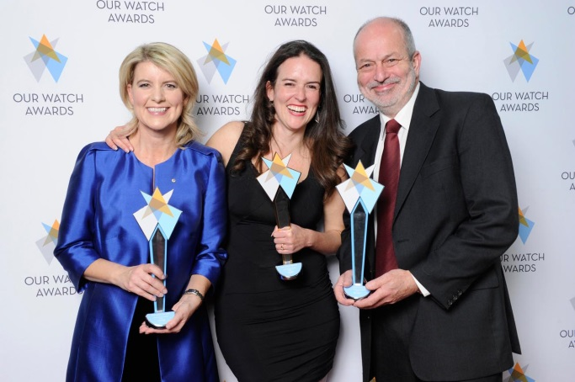
When handing out the Gold Award, Today Show host and Walkley Advisory Board member Lisa Wilkinson said her work, ‘set a benchmark for all’.
Our Watch Chair Natasha Stott Despoja, Gold Award winner Jess Hill and Our Watch CEO Paul Linossier

Our Watch developed the new national media awards scheme, administered by the industry-leading Walkley Foundation, to recognise and reward exemplary reporting to end violence against women, in particular reporting that highlights the causes of violence and what we as a society can do to prevent it.
The Our Watch Awards is an initiative under the National Plan to Reduce Violence against Women and their Children 2010-2022. It is part of the broader Our Watch National Media Engagement Project, which includes the development of reporting guidelines to help inform improved media reporting.
Welcoming more than 200 leading figures from the media, women’s sector, business, sports and survivor advocates, Our Watch Chair Natasha acknowledged the role of the media in helping shape the national conversation around this important social issue.
She said the 177 entries heralded a ‘positive new era’:
“We are seeing a significant change in the public’s understanding of the drivers of violence against women and there is a growing collective commitment to prevent such violence”.
Jess Hill won three awards in total, including best longform, best series or special and the overall Gold Award. Best use of social media was awarded to Destroy the Joint team, and Jayne Margetts and the ABC News Team won best news coverage. Best local/community journalism went to Simon Mann, Bec Zajac and Ania Dutka from The Citizen.
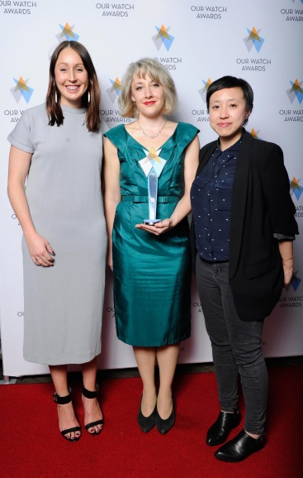
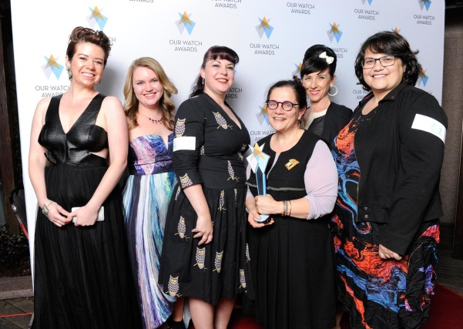
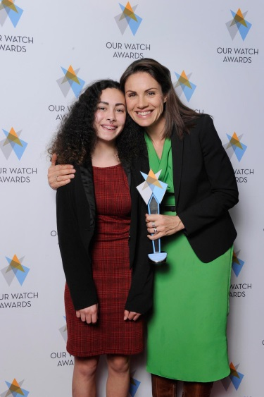
Fairfax Media
Destroy the Joint
Jayne Margetts of the ABC

Attorney-General’s Department supports the National Community Legal Centres Conference

The 36th National Community Legal Centres Conference was held from 25-27 August 2015, in Melbourne, Victoria. The Attorney-General’s Department supports the conference to help the community legal sector to come together, learn from each other and develop important professional networks. The conference theme was “Unless…” Storytelling in CLCs work - reasons, roles and risks. Over 600 delegates attended and shared stories of front-line service delivery, with a particular focus on legal assistance for those experiencing family violence.

The first session included deeply personal accounts from two women who had experienced family violence, and who continue to deal with the devastating effects on their lives and those of their children. These stories highlighted the many difficulties faced by both victims of domestic violence and their families when navigating the legal system.

Australian of the Year and family violence advocate, Rosie Batty, presented with Dr Chris Atmore (Senior Policy Adviser, Federation of Community Legal Centres, Victoria) and expressed her ongoing commitment to be a catalyst for social policy and political change on family violence issues.

Other sessions focused on incorporating the voices of Aboriginal and Torres Strait Islander women into the work of the Victorian Royal Commission into Family Violence. The conference showcased the important role that community legal centres and, in particular, Women’s Legal Services, play in offering innovative and practical legal assistance to their clients.

The Attorney-General, Senator the Hon. George Brandis QC, delivered the closing address, praising the commitment and professionalism of community legal centre staff who provide vulnerable and disadvantaged people with meaningful access to the justice system.

Victims of family violence a priority under new legal assistance agreement

The National Partnership Agreement on Legal Assistance Services (NPA), which commenced on 1 July 2015, directs the most intensive services to financially disadvantaged people. One of its key priorities is maximising the availability of legal assistance to people experiencing, or at risk of, family violence. A person is considered financially disadvantaged if they are experiencing family violence and temporarily have no access to their finances. This allows someone in a crisis situation to seek legal assistance when they need it most.

The NPA encourages innovative service delivery models that seek to address barriers that vulnerable people may face in accessing justice. Great examples include Skype outreach services to victims of family violence in isolated areas, and co-location of health and legal services to provide holistic support. The NPA encourages the sector to provide better, more integrated support to people affected by family violence.

The NPA’s focus on family violence will help vulnerable people access assistance and will ultimately lead to better outcomes for people experiencing family violence. You can view the NPA here.

Families with complex needs and the intersection of the family law and child protection systems

The Family Law Council is currently forming its views on terms of reference issued by the Attorney-General. The reference is to consider ways in which parenting disputes could be better addressed through the assistance of relationship support services and/or court processes that can cut across the child care and protection and family law systems.

Council’s views on the first two terms of reference were provided to the Attorney-General in an interim report on 30 June 2015.

The Council is currently seeking submissions from key stakeholders to help form its views on the opportunities for enhancing collaboration and information sharing:
- within the family law system, such as between the family courts and family relationship services
- between the family law system and other support services such as child protection, mental health, family violence, drug and alcohol, Aboriginal and Torres Strait Islander and migrant settlement services
- any limitations in the data currently available to inform these terms of reference.
The Council is due to report to the Attorney-General by 30 June 2016. If you or your organisation would like to make a submission regarding these issues, please email it as a Word document to flcreference@ag.gov.au by 30 October 2015.

Update on the progress of the National Family Violence Bench Book

Work is well underway on the National Family Violence Bench Book to be published in June 2017. The Australasian Institute of Judicial Administration is supporting the project and has appointed Professor Heather Douglas, of the TC Beirne School of Law at The University of Queensland, to lead the project.

The project team has been liaising with others who have produced bench books on this subject, including Professor Linda Neilson who developed the Canadian Bench Book on Domestic and Family Violence.

Professor Douglas describes the Bench Book as a huge undertaking that has already garnered the interest and support of judicial officers, lawyers and service providers around the country. She says, “if judicial officers in city, regional and country Australia are using the Bench Book in their courtrooms, it will have done the best part of its job”.

‘Help improve the national evidence base for family and domestic violence’

Whether you are a service provider, policy analyst or program manager, you can help to improve the national evidence base for family and domestic violence.

The National Data Collection and Reporting Framework (DCRF) provides a systematic way of organising data about family and domestic violence. This paves the way for nationally consistent and comparable data, facilitating a shared understanding of family and domestic violence and improving the current evidence base.

The DCRF recognises that organisations share common information practices and needs.
It can assist organisations’ reporting processes, allow comparisons with similar organisations, identify better practice approaches and support evidence based business/funding cases. Consistent data collection can inform interventions across all aspects of family and domestic violence.

The DCRF can assist organisations to create data which enables them to better understand client characteristics, needs and service demand.

The full details of the DCRF can be accessed here.

First release of experimental Family and Domestic Violence statistics

For the first time, experimental information about victims of family and domestic violence related offences will be released by the ABS. This release, catalogue number 4510.0, supplements the Recorded Crime Victims statistics with information on whether the incident was determined by police officers to be family and domestic violence related.

These statistics will be available from mid-day on 23 September 2015 at ABS website.

National Outcome Standards for Perpetrator Interventions

Commonwealth, state and territory governments are working together to co-design a set of National Outcome Standards for Perpetrator Interventions (the National Standards) for COAG consideration at its final meeting of 2015. The National Standards will guide Australian governments and their community partners as they work towards improving the way we intervene with men who use violence against women in order to stop their violence now and prevent it in the future.
We need to place men’s violence in the spotlight and keep men who use violence firmly in view of our systems so the right people can intervene at the right time to hold perpetrators accountable.

In order to remove the burden from victims to protect themselves and place the responsibility for their safety firmly back onto the systems and services, all parts of the system that intervenes with perpetrators must be part of the solution, including our police, courts, corrections, and community services.

The Australian Government has funded Australia’s National Research Organisation for Women’s Safety (ANROWS) $3 million to establish a dedicated Perpetrator Interventions Research Stream to strengthen the evidence base on perpetrator interventions in Australia and support the implementation of the National Standards.

ANROWS is finalising a ‘State of Knowledge’ paper to identify existing research on perpetrator interventions across Australia. As such research in Australia is an emerging field, this paper will help build the evidence base for further research and inform policy development. The ‘State of Knowledge’ paper will be released by ANROWS later in 2015.

ANROWS will also be releasing its perpetrator research priorities later in 2015 to support the implementation of the National Standards and the priorities of the National Plan. They will subsequently call for applications for research grants in the priority areas. General information about ANROWS’ grants process can be found on the ANROWS website.

National campaign to reduce violence against women

On 4 March 2015, the Australian Government announced it would work with state and territory governments to develop a national campaign focused on reducing violence against women and their children.

The Department of Social Services undertook comprehensive desktop research which recommended that developmental research be undertaken to inform a primary prevention campaign, focussed on developing respectful relationships and positive gender equality attitudes by young people.

Qualitative and quantitative developmental research has recently been conducted, which will inform the development of the campaign strategy, including messaging and approach.

Updates from around the country

Safe Homes, Safe Families: Tasmania’s Family Violence Action Plan 2015-2020

On 13 August 2015, the Premier, Will Hodgman MP, launched Safe Homes, Safe Families: Tasmania’s Family Violence Action Plan 2015-2020. This is the Tasmanian Government’s new, coordinated, whole-of-government action plan to respond to family violence.

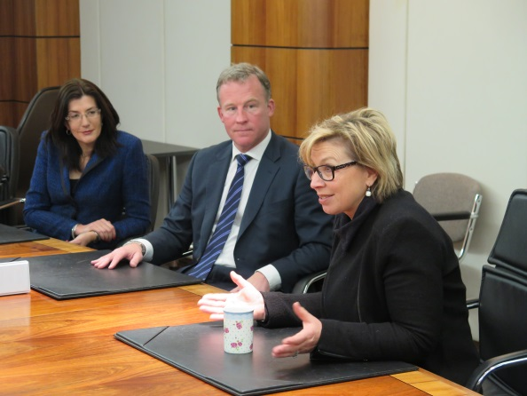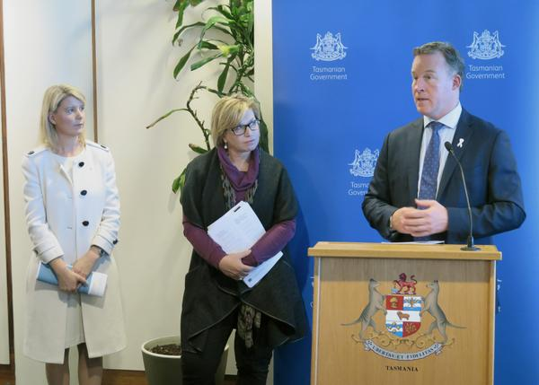

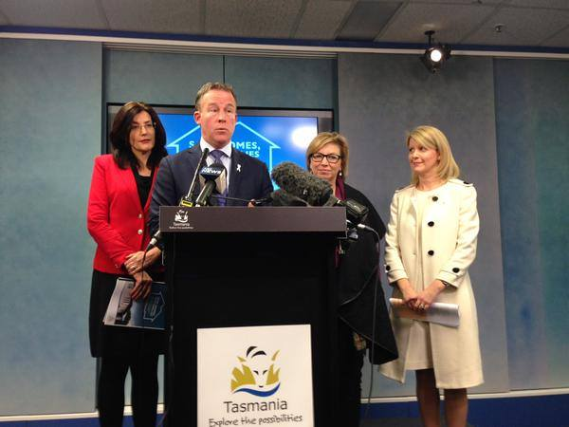
Photos: Launch of Safe Homes, Safe Families: Tasmania’s Family Violence Action Plan 2015-2020
The Premier was joined for the launch by the Tasmanian Minister for Women, the Hon. Jacquie Petrusma MP, Our Watch Chair and Australia’s Ambassador for Women and Girls Natasha Stott Despoja AM and 2015 Australian of the Year, Rosie Batty.

Safe Homes, Safe Families has been very well received by the community, garnering widespread praise and endorsement.

The actions contained in Safe Homes, Safe Families were informed by stakeholders and the community during the consultation process, and the best available research and evidence.
Safe Homes, Safe Families focuses on these priority areas for action:
- changing attitudes and behaviours that lead to family violence
- supporting families affected by violence
- strengthening our legal responses.
Through Safe Homes, Safe Families, an additional $25.57 million has been committed to new and direct action over the next four years. This includes:
- $8 million to establish Safe Families Tasmania – bringing together government agencies in a statewide collaborative unit to coordinate support services for victims and hold perpetrators to account
- $685,000 to actions which will change the attitudes and behaviours that lead to family violence
- $12 million in practical programs and services to address the immediate needs of families affected by family violence
- $4.75 million to strengthen legal responses to hold perpetrators to account and better support victims through the legal system – through strengthening the legislative framework, appointing more specialist police prosecutors, supporting early intervention perpetrator programs for low to medium risk offenders, and additional legal assistance to people experiencing family violence.
Safe Homes, Safe Families is available for download.

Highlights from South Australia

Residential Tenancies Act South Australia
The South Australian Government has proposed amendments to tenancy laws that will provide specific protection for victims of domestic violence.

Minister for Status of Women and Business Services and Consumers, the Hon. Gail Gago, MLC, says “These changes aim to support victims of domestic violence to leave a hostile environment or remove the perpetrator from the environment without incurring further expenses caused by the perpetrator.”

“It would allow victims to have their name removed from a joint lease without the consent of the other party, and would keep their personal information from being listed on a residential database.

“All in all, the amendments are about ensuring victims are not subject to ongoing undue hardship - whether financially or by having to deal with the perpetrator on matters such as lease arrangements and finalising bond”. For further information.

Intervention Orders – Domestic Violence Abuse Prevention Program
The South Australian Intervention Orders (Prevention of Abuse) Act 2009 is supported by an across government intervention response model. This model provides the basis for intervention responses within the context of intimate partner relationships.

As part of the legislation, one of the conditions that the court can put in place is mandating that defendants attend a 24-week Domestic Violence Abuse Prevention Program, which is facilitated by Offenders Aid and Rehabilitation Services (OARS).

OARS also provide a 12-week program designed to accommodate men from CALD backgrounds or with literacy issues. One-on-one counselling is also available for people who are unable to participate in a group setting. Interpreters are used if language is a major barrier to participation.

The Domestic Violence Abuse Prevention Program works in collaboration with the Women’s Safety Contact Program (WSCP). This program is delivered by Central Domestic Violence Service (CDVS) with the aim to increase the safety of female protected persons who:
- have experienced domestic or Aboriginal family violence
- are not otherwise engaged with a women’s domestic violence
- have a partner (or ex-partner) involved in the prevention programs.

The ongoing collaboration between OARS and WSCP is a crucial element of the intervention response model. Up to date information about the progress and interaction of the perpetrators assigned to the programs is critical for ensuring women’s ongoing safety.

Women’s Domestic Violence Court Assistance Service
The South Australian Government announced not-for-profit organisation Victim Support Service will deliver a critical new service to directly assist victims of domestic violence in legal matters, including Intervention Orders.

Establishing the Women’s Domestic Violence Court Assistance Service was a commitment made in Taking a Stand - the State Government’s response to the Coroner’s findings in the Zahra Abrahimzadeh case.

Minister for the Status of Women, the Hon. Gail Gago, MLC, said the free, confidential service would provide a greater level of support within the court system for victims of violence.

In addition to providing direct services to women, the service will provide education and resources on intervention orders to the domestic violence sector in South Australia, increasing its capacity to advocate for women in these matters.

From 1 July 2015 women can access the service from anywhere in South Australia using the free phone telephone number 1800 VICTIM (842846) or via the VSS website Victim Support Service SA website

For further information.

Highlights from Western Australia

Western Australia launches the Freedom from Fear Action Plan 2015
The Freedom from Fear Action Plan 2015: Working towards the elimination of family and domestic violence in Western Australia (the Action Plan) was launched Monday 7 September.
The Action Plan focuses on engaging and responding to perpetrators of family and domestic violence and sets out 20 actions under the following five priority areas:
- promote understanding and awareness about family and domestic violence;
- target communities and populations at greatest risk;
- trial and evaluate innovative approaches to perpetrator intervention;
- promote consistent quality practice in engaging and responding to men who use violence; and
- increase the capacity and authority of the service system to stop perpetrators of family and domestic violence when they are identified.
The Action Plan was developed in consultation with government and community sector stakeholders and was endorsed by Cabinet on 24 August 2015.
Launch of updated family and domestic violence website pages

Aligning with the launch of the Freedom from Fear Action Plan, resources, links and webpages on the WA Department for Child Protection and Family Support’s website have been updated.

Pages have been refreshed to present the range of initiatives and strategies underway, while reinforcing key messages in the National Plan.

A number of actions included in the Action Plan will be launched during October, November and December 2015, these include:

Safer Families, Safer Communities: Kimberley Family Violence Regional Plan 2015-2020

Following extensive consultation and information analysis, an across government and community sector plan for responding to family violence in the Kimberley region has been developed. The Safer Families, Safer Communities: Kimberley Family Violence Regional Plan 2015-2020 (Kimberley Plan) focuses on responding to the high incidence of family violence within Aboriginal communities and the over-representation of Aboriginal women and children as victims of family violence.

The Kimberley Plan outlines a whole of community response including improved access to, and effectiveness of, existing service responses. This includes civil and criminal justice processes, and working alongside Aboriginal people, families and communities to develop and/or strengthen local responses to family violence. The anticipated launch date for the Kimberley Plan is early October 2015.

Youth Say No

Youth Say No is an awareness campaign developed in consultation with, and for, young people. It includes information and resources about family and domestic violence, lesson plans for teachers, interactive components and linkages to other social media platforms. Resources to support schools and other educational institutions to implement Respectful Relationships Education Programs will be available on the new Youth Say No website to be launched on 25 November 2015 (White Ribbon Day).

Minimum Standards for Men's Behaviour Change Programs

Minimum Standards of Practice (Minimum Standards) have been developed to support agencies and organisations to respond to men who use violence in a way which holds them accountable and provides them with the opportunity to take responsibility for their behaviour. The Minimum Standards establish key components of program governance, design, delivery, review and evaluation which all men's behaviour change programs must adhere to. The Minimum Standards will be launched on 1 December 2015 (during the 16 Days of Activism Against Gender Violence).

Family and Domestic Violence Common Risk Assessment Risk Management Framework (CRARMF) second edition

The second edition of CRARMF will be officially launched on 27 November 2015. It will extend the original Framework and focus on:
  - updating the policy context for the Framework in Western Australia
  - incorporating recommendations from the 2013 evaluation, including developing information and resources to strengthen information sharing, referral pathways and collaborative case management
  - increasing the awareness and understanding about the role of the Framework in supporting an ‘integrated response’
  - strengthening practice guidance about engaging and responding to perpetrators for the purpose of assessing and managing risk
  - modifying the risk assessment tool to better align with the risk assessment process, with provision made for the recording of the victim’s assessment of the level of risk and professional judgement.

Highlights from New South Wales

NSW pilots new community-based men’s behaviour change interventions

The NSW Government has released targeted funding to pilot new community-based Men’s Behaviour Change Programs. The $5.28 million investment over three years was announced by Australia’s first Minister for the Prevention of Domestic Violence and Sexual Assault, the Hon. Pru Goward.

Men’s Behaviour Change Programs are community-based domestic and family violence perpetrator programs for men who want to stop using violent and controlling behaviour towards a current or former partner, children or other family member. Programs involve individual and group therapy to enable men to reflect on the impact of their violence, take responsibility for their behaviour, and commit to making change. Central to these programs is the support provided to partners and children.

Chair of the Men’s Behaviour Change Network NSW, Diane Coleman, commended the NSW Government on this targeted approach.

“Focusing on the safety of women and children, these programs hold men accountable for their violence and provide them the opportunity to take responsibility for their actions and develop non-abusive and non-controlling behaviours of equality and respect to their current or former partners,” Ms Coleman said.

For further information.

NSW – Tackling Violence

The 2015 Tackling Violence community service announcement featuring NSW Coach Laurie Daley, former South Sydney Rabbitoh’s legend Nathan Merritt and players from 19 grassroots rugby league clubs delivering anti domestic violence messages is being broadcast across regional NSW TV and Government, NRL and other social media platforms. The announcement takes the anti-domestic violence message from the clubhouse to the wider community, asking viewers “whose team are you on?” See the ad here.

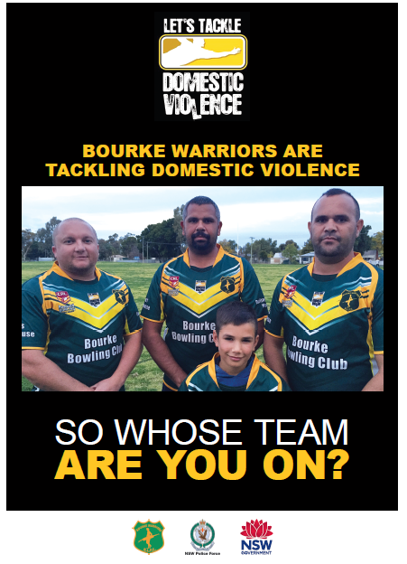
In 2015, over 800 rugby league players and officials have signed a code of conduct that penalises them for domestic violence offences, attended a domestic violence workshop led by Tackling Violence Ambassadors and NRL greats, David Peachey, Alan Tongue and Nathan Merritt and participated in awareness raising “domestic violence rounds” to get the message out that violence against women will not be tolerated.

Tackling Violence is a NSW Government program currently managed by Women NSW. The program has been operating for six years and has worked with 37 grassroots rugby league clubs across regional NSW in communities with significant rates of domestic violence assault. The program has been evaluated by Eva Cox AO and Jumbunna House of Indigenous Learning, University of Technology Sydney who recommended the program continue and expand.

A short film of a Tackling Violence workshop with clubs graduating the program after five years sponsorship can be watched here.

Change Your Ways - Australian Men Talk about Domestic Violence, developed by Tackling Violence and featuring Australian rugby league legend Gordon Tallis and Newcastle Knights Clint Newton can be watched here.

Highlights from Queensland

Queensland Government Response to Bryce Report

On 18 August, the Queensland Government released its response to the Report of the Domestic and Family Violence Taskforce, Not Now, Not Ever: Putting an End to Domestic and Family Violence in Queensland accepting all 121 recommendations relating to government agencies and supporting the remaining 19 recommendations related at non-government bodies. Funding of $31.3 million over four years will be invested to implement the high priority initiatives in the report to tackle domestic and family violence. An audit of domestic and family violence services will inform a long term funding and investment model to inform future investment in the domestic and family violence service system.

The recent devastating deaths of two women and a child have led the Queensland Government to act fast and take immediate action to implement key recommendations in the Taskforce Report to eliminate this violence. Dame Quentin Bryce will chair a new council to oversee implementation, including progressing key legislative changes, establishing a Domestic and Family Violence Death Review and Advisory Board to identify gaps in the support available for victims, strengthening police responses and evidence gathering, and the trial of an integrated response model in Beenleigh and Logan.

The Queensland Government will be consulting on the draft Domestic and Family Violence Prevention Strategy across the state though community forums and roundtables in October and November. Details will be announced soon on the Queensland Government End Domestic and Family Violence website.

In recognising that domestic and family violence is just one form of violence disproportionately experienced by women, the Minister for Communities, Women and Youth has also committed to developing a Queensland Violence Against Women Prevention Plan which will look at the causes, forms and impacts of violence against women more broadly. Community engagement and consultation will be undertaken throughout the remainder of 2015.

Domestic and Family Violence Magistrates Court trial on Gold Coast

A specialist court dealing exclusively with domestic and family violence matters is being trialled on the Gold Coast as part of the Queensland Government's response to the Bryce Taskforce Report, Not Now, Not Ever.
The six-month trial, based at Southport, is aimed at providing victims with consistent, coordinated and timely access to justice. With a specialist court, a dedicated magistrate will have expertise in domestic and family violence issues, and integrated support services will be on hand to help participants navigate through the complex legal processes.

The trial has incorporated key elements from successful Australian and International specialist domestic violence court models, such as:
- Duty lawyers to support both parties
- Access to support, information and referral for victims
- Specialist staff training
- Enforcement and prosecution of breaches of domestic violence orders
- Access to domestic and family violence perpetrator programs
- Coordination of the justice system response and coordination of service providers; and
- Monitoring and evaluation systems.
The outcomes of the trial will inform future work in developing a specialist approach to the way domestic and family violence proceedings are dealt with by the courts across Queensland.

Southport was chosen as the location for the trial as it deals with the highest proportion of domestic violence proceedings in the State (in 2014-15, 2,681 lodgements or 10.02% of lodgements state-wide). From 1 to 23 September, 291 new applications for protection orders were lodged at the specialist court.

Dates for your diary

12 September White Balloon Day – protecting children from sexual assault.

2 October International Day of Non-Violence.

26-27 October 2015 Family Violence Has No Boundaries Conference - this inaugural conference will be exploring the theme of cultural diversity and prevention and will look at all aspects of family and domestic violence.

25 November White Ribbon Day – to register or attend an event, please visit whiteribbon.org.au

25 November to 10 December Sixteen Days of Activism to Stop Violence Against Women.

3 December International Day of People with Disability – to register or attend an event, please visit idpwd.com.au

10 December International Human Rights Day.

Have your say!
We would love to hear from you! If you’d like your event included in this e-Newsletter, or have other questions, comments or ideas, please email us.
If you’ve not done so already, please subscribe to receive this e-Newsletter.

Do you need help?
If you or someone you know is experiencing domestic and family violence or sexual assault, get help by calling:
- 000 if you, a child, or another person is in immediate danger
- 1800RESPECT – 1800 737 732
- Relationships Australia – 1300 364 277
- Mensline – 1300 789 978
- You can ask for a free interpreter if needed.

National Relay Service
- TTY users - phone 133 677 then ask for the phone number you wish to contact
- Speak and Listen (speech-to-speech relay) users - phone 1300 555 727 then ask for the phone number you wish to contact
- Internet relay users - visit the National Relay Service website and ask for the phone number you wish to contact.

