Data highlight: No.1/2014

Financial Hardship in Australia
Laura Bennetts Kneebone
‘Severe poverty amplifies the experienced effects of other misfortunes of life … illness is much worse for the very poor than for those who are more comfortable’ (Kahneman 2011, ch.37) . Poverty cannot be measured simply by assessing income. How far a person’s income will stretch depends upon many factors, including where they live, how many dependants they have, how much debt they are in and the level of their financial management skills. Poverty, or financial hardship, can perhaps be better measured by asking a few questions about being short of money.
Financial hardship is measured in at least four different longitudinal surveys in Australia. The Household, Income and Labour Dynamics in Australia (HILDA) Survey collects data from a random sample of Australian households; Growing Up in Australia: the Longitudinal Study of Australian Children (LSAC) is a cohort study of Australian children in urban and regional households; Footprints in Time: the Longitudinal Study of Indigenous Children (LSIC) is a cohort study of Aboriginal and Torres Strait Islander families in urban, regional and remote households; and Building a New Life in Australia: the Longitudinal Study of Humanitarian Migrants (BNLA) is a survey of new humanitarian migrants to Australia, approximately half of whom arrive with children.
These surveys are not directly comparable in many ways, but they give us an insight into the experiences of these populations, each with its own characteristics. Often the same set of questions is used in each survey, enabling direct comparison, as is the case with the financial hardship questions. These comparisons need to be treated with some caution, because the sample characteristics and methodology differ; they can, however, be considered generally indicative.
Financial hardship is measured by asking survey participants (or their parents, in the case of LSAC and LSIC) whether any of a list of events has occurred in the past 12 months because people were short of money (see Table 1). These events are not all of equal severity. Struggling to pay bills on time may indicate short-term cash flow problems, as when several large bills arrive at once, whereas going without meals is more likely to indicate that a family is experiencing severe financial distress.
Table 1: Financial hardship in 2012/2013*
Measure of Disadvantage | BNLA | LSIC | LSAC | HILDA
Sought assistance from a welfare or community organisation | 15% | 19% | 3% | 3%
Pawned or sold something because needed cash | 7% | 13% | 3% | 4%
Were unable to heat (or cool) home | 24% | 9% | 2% | 3%
Went without meals | 9% | 10% | 2% | 3%
Could not pay the mortgage or rent payments in time | 13% | 11% | 6% | 6%
Could not pay gas, electricity or telephone bills on time | 19% | 33% | 16% | 12%
*Data sources: Weighted data collected from HILDA wave 12 (2012), BNLA wave 1 (2013), both cohorts of LSAC wave 5 (2012) and unweighted data from LSIC wave 5 (2012).
The percentage of people in each survey who experienced multiple types of financial hardship is shown in Figure 1. More than 80 per cent of Australian households (as surveyed in HILDA and LSAC) experienced no financial hardship, while the remainder experienced one or more types of financial hardship. Levels of financial hardship were much higher in the LSIC and BNLA populations: only 55 per cent of families with Indigenous children (LSIC), and 60 per cent of new humanitarian migrants (BNLA) experienced no financial hardship. To establish a baseline to enable comparison with the general population, we can look at the HILDA data. In Australian households generally, 12 per cent struggled with bills, 3 per cent sought assistance from a welfare or community organisation and 3 per cent went without meals at some point. Looking at LSAC data, we see that young families are a little more likely to have trouble paying bills on time (16 per cent), but only 3 per cent sought assistance and 2 per cent went without meals.
Figure 1: Households experiencing multiple types of financial hardship*
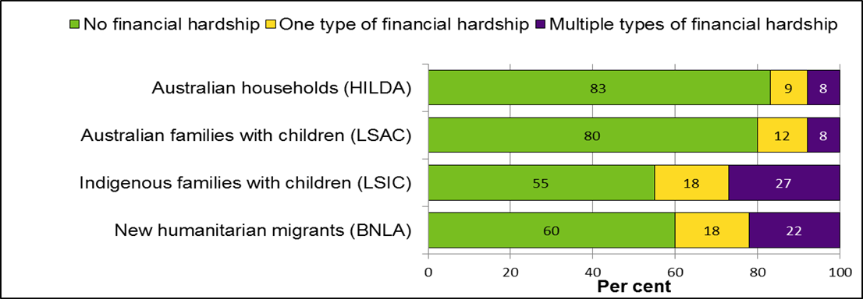
Households experiencing multiple types of financial hardship
 | No financial hardship | One type of financial hardship | Multiple types of financial hardship
Australian households (HILDA) | 83% | 9% | 8%
Australian families with children (LSAC) | 80% | 12% | 8%
Indigenous families with children (LSIC) | 55% | 18% | 27%
New humanitarian migrants (BNLA) | 60% | 18% | 22%
*Data sources: Weighted data collected from HILDA wave 12 (2012), BNLA wave 1 (2013), both cohorts of LSAC wave 5 (2012) and unweighted data from LSIC wave 5 (2012).

The Indigenous families in LSIC are quite closely comparable to the LSAC sample, with the qualification that the children in the study are a few years younger, and their mothers were on average younger at first birth. There is also a larger proportion of single-parent families in LSIC. Thirty-three per cent of Indigenous families struggled to pay bills on time (double the figure for LSAC), 19 per cent sought assistance from a welfare or community organisation and 10 per cent went without meals because they were short of money. New humanitarian migrants in BNLA were asked to report only whether these things had occurred since their arrival in Australia (the median time in Australia was between four and five months). All these migrants had visas enabling them to work and access government benefits. Nineteen per cent reported having difficulty paying bills on time. Fifteen per cent sought assistance from a welfare or community organisation and 9 per cent went without meals in that period.

These figures suggest that Indigenous families and new humanitarian migrants experience significantly higher levels of multiple financial disadvantage than other Australians. They are twice as likely to struggle with housing payments and more than three times as likely to go without meals.

Key Statistics

- 22 per cent of new humanitarian migrants, and 27 per cent of Indigenous families experience multiple types of financial hardship.
- 10 per cent of Indigenous families went without meals; 13 per cent of new humanitarian migrants could not afford housing payments in time.
- More than 12 per cent of all Australians have trouble paying utility bills on time because they are short of money.

References
Kahneman, D. (2011). Thinking, Fast and Slow, Penguin Books

