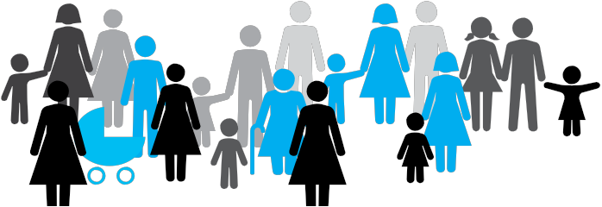
National Plan to Reduce Violence against Women and their Children 2010-2022
Second Action Plan 2013-2016, Moving Ahead
Safe and free from violence
An initiative of the Commonwealth, state and territory governments.
What is the National Plan to Reduce Violence against Women and their Children?
Domestic and family violence and sexual assault are crimes that must be stopped. In Australia, around one in three women has experienced physical violence, and almost one in five has experienced sexual violence since the age of 15.
That is why the Commonwealth, state and territory governments worked with the community to develop a 12-year National Plan to Reduce Violence against Women and their Children 2010-2022 (the National Plan).
Released in 2011, the National Plan explains what we are doing to reduce violence against women and their children. Its vision is that:
Australian women and their children live free from violence in safe communities.
The National Plan is made up of four Action Plans that build on each other over time so that we can learn from what we’ve done in the past and make changes for the future.
Over the first three years, we’ve laid a strong foundation to reduce violence against women and their children.
What is the Second Action Plan?
The Second Action Plan is an important next step for the National Plan. It focuses on moving ahead and building on the foundations set in the First Action Plan. It runs from 2013 to 2016 and describes 26 practical actions that all governments have agreed are important to reduce violence against women and their children.
Through these 26 actions, we are doing more work to:
- Get the whole community involved to stop violence from happening in the first place.
- Learn about and stop violence against Indigenous women, women from culturally and linguistically diverse backgrounds and women with disability.
- Improve how systems like the police, courts and legal system work together and with services that support women who have experienced violence and with men who commit violence.
- Improve programmes for men who commit violence so that women are safe.
- Find out more about what works well in stopping violent behaviour and supporting women who need help.
You can find out more about the Second Action Plan and its actions by going to www.dss.gov.au/NationalPlan.
How was the Second Action Plan developed?
To develop the Second Action Plan, national roundtables were held in February 2014, attended by around 100 experts and organisations. We also received over 50 written submissions.
In 2013, we consulted with a lot of people about particular actions under the National Plan, including: Our WATCh; Australia’s National Research Organisation for Women’s Safety (ANROWS); and work around perpetrators of violence.

How can I support the Second Action Plan?
Reducing violence against women and their children is everyone’s responsibility and a long-term challenge. By working together and challenging the attitudes and behaviours that allow violence to occur, we can create real and lasting change in our communities. There are different ways you can get involved. You can:
- encourage gender equality and speak out against violence against women and their children in your family, community, workplace or sporting group
- volunteer or donate to your local women’s service, youth group, homeless shelter, Indigenous or multicultural group or get involved with community or local government organisations
- check out www.theline.gov.au and promote respectful relationships in your family and community
- connect with Our WATCh www.ourwatch.org.au
- follow White Ribbon on Facebook (/WhiteRibbonAustralia) or Twitter (@WhiteRibbonAust)
- connect with the National Women’s Alliances www.dpmc.gov.au/women/news/2013/six- national-women-s-alliances.cfm
- learn about Australia’s National Research Organisation for Women’s Safety www.anrows.org.au
- look at key statistics, including from the Personal Safety Survey and the National Survey on Community Attitudes towards Violence against Women
- look out for the National Plan Communications Strategy that will be released next year. It will tell you more about how you can get involved.
The four Action Plans under the National Plan are:
- The First Action Plan: Building a strong foundation (2010-2013)
- The Second Action Plan: Moving ahead (2013-2016)
- The Third Action Plan: Promising results (2016-2019)
- The Fourth Action Plan: Turning the corner (2019-2022)
How can I find out more?
To find out more about the National Plan and the Second Action Plan, go to www.dss.gov.au/NationalPlan
An Easy Read version of the National Plan is on the website too.

Do you need help?
If you or someone you know is experiencing domestic and family violence or sexual assault, get help by calling:
- 000 if you, a child, or another person is in immediate danger
- 1800 RESPECT – 1800 737 732
- Relationships Australia – 1300 364 277
- Mensline – 1300 789 978

