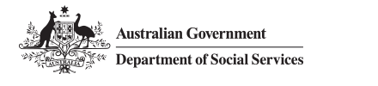

Translated Script

Enhanced Income Management and the SmartCard
- Enhanced Income Management can help you manage your money and pay for your essential needs such as rent, food and clothing.
- You can use your enhanced Income Management account to set up direct debits for bills like rent, electricity and water.
- You can transfer money to other people’s enhanced Income Management accounts.
- You will use a SmartCard to access your enhanced Income Management account.
- To get a SmartCard, you need to visit a Services Australia service centre, participating Agent, or a Traditional Credit Union (TCU) branch if you are a TCU customer.

