Yenn’s story
Being able to find and navigate supports is important. Many autistic people find it hard to seek out and receive appropriate help – including mental health support.
Yenn’s story shows why a new National Autism Strategy is needed so that autistic people can be supported to live the lives they want and deserve. Their story shares the importance of having autistic voices, ideas and experiences at the centre of the National Autism Strategy.
Yenn is a successful author, blogger, public speaker, advocate and public servant. They are also autistic, have ADHD and schizophrenia, and are gender non-binary and asexual. They love their cat Sunflower who keeps them company when working from home.
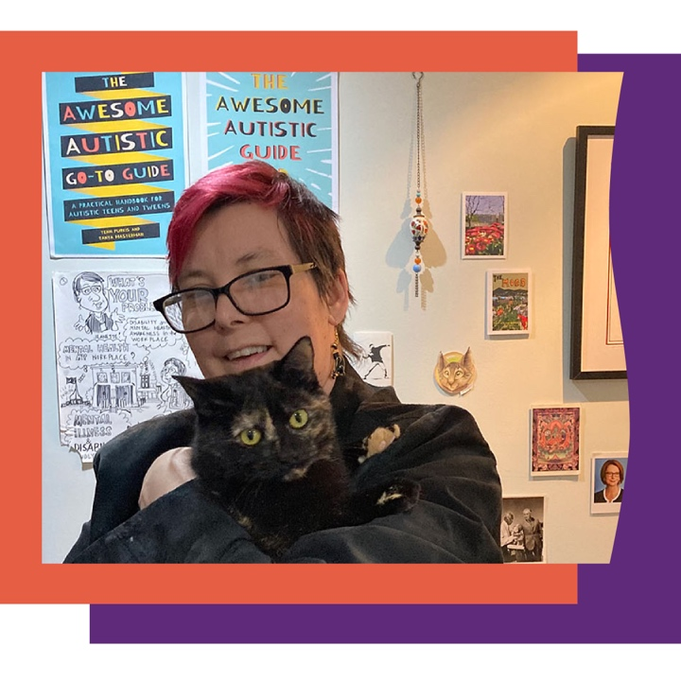
Yenn is excited about a National Autism Strategy driven by and developed with autistic people. They’re hopeful the Strategy will break down barriers that autistic people face in living the lives they want and deserve.
In their previous experiences with mental health clinicians, Yenn has received poor treatment and been discriminated against. “It’s hard to ask for help, when half of the times you have, have been really negative,” said Yenn.
For Yenn, development of a National Autism Strategy is a chance to educate clinicians. If clinicians have a better understanding of autism, that means autistic people can receive the mental health support needed.
Yenn also feels strongly that having a National Autism Strategy validates the autistic experience – and that it will be a place to go to learn from other autistic people.
Yenn says that developing a National Autism Strategy shows that the Government is committed to supporting and including autistic people. They look forward to a Strategy that brings together information, best practice and objectives across key areas in a consistent and coherent way. Yenn hopes it will be useful for autistic people, their families, carers and the wider community.
‘It’s so important that autistic people are front and centre with the development of the National Autism Strategy.’
‘Representation is so important. Without it, the Strategy is meaningless. We need autistic people with different backgrounds and identities to share their ideas and experiences so that the National Autism Strategy supports as many of us as possible.’
Help shape the change. Visit dss.gov.au/National-Autism Strategy to see how you can have your say on the National Autism Strategy.

