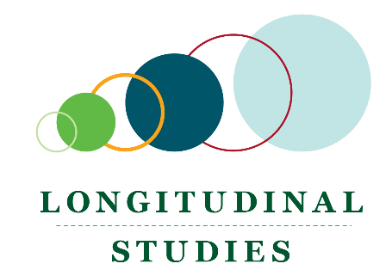
Longitudinal Studies
  - Building a New Life in Australia: The Longitudinal Study of Humanitarian Migrants

Overview
Building a New Life in Australia (BNLA) is a comprehensive study of how humanitarian migrants settle into a new life in Australia.
This longitudinal study commenced in 2013, spanning the participants’ early months in Australia, through to their eligibility for citizenship. The BNLA collection is managed by the Australian Institute of Family Studies (AIFS), with fieldwork conducted by Kantar Public and Multicultural Marketing and Management (MMM).

Purpose of the study
The BNLA study aims to:
- Better understand factors that either help or hinder the successful settlement of humanitarian migrants
- Provide an evidence base to inform policy and program development
- Evaluate changes reflected in policy and program outcomes.

Study participants
The study cohort comprises more than 1,500 migrating units1, approximately 2,400 individuals, who were granted a permanent humanitarian visa in the six months between May and December 2013. Most study participants live in Melbourne and Sydney.
The migrant group have diverse backgrounds and experiences. They come from 35 different countries, with varied cultural backgrounds, and speak close to 50 different languages. At commencement, ages ranged from 15 to 83 years. Almost all had arrived in Australia in 2013 to start a new life, escaping trauma and persecution before their arrival.

Key research questions
More information about DSS longitudinal surveys is available at: www.dss.gov.au/longitudinal-studies
Data access - you can apply via the Australian Data Archive - dataverse.ada.edu.au/dataverse/bnla
Releases include a data user guide, a data dictionary and questionnaires with data labels.
Ad hoc data requests are available for small requirements. Please email your request to: LongitudinalStudies@dss.gov.au
Bibliographic research repository for longitudinal analysis using DSS datasets: see flosse.dss.gov.au

The broad research questions that guide the study are:
- What are the settlement outcomes of humanitarian migrants?
- How does access to and use of government and non-government services and welfare benefits contribute to humanitarian migrants’ successful settlement?
Do the settlement experiences and outcomes of humanitarian migrants vary according to the differing migration pathways taken?

Data collection
Information was collected annually from 2013–2014 to 2017–2018. Alternating waves of home visits (waves 1, 3 and 5) and telephone interviews in (waves 2 and 4) were conducted between October and March each year.
In wave 1, the survey and participant materials were translated from English into 14 different languages, with around 90% of participants completing the survey in a language other than English. The most common languages were Arabic and Persian.

COVID-19
The scheduled annual collections for the BNLA were paused during the COVID-19 pandemic over 2020 and 2021. The BNLA will resume in 2022 as Australia emerges from COVID-19 isolation and lockdowns.
___________
1 A migrating unit is the grantee of a humanitarian visa plus others — typically immediate family members — accompanying the visa holder to Australia.

Study content overview

Housing and neighbourhood
- Assistance in finding housing
- Number of times moved home
- Tenure type
- Quality of housing
- Number of bedrooms
- Neighbourhood characteristics

English language proficiency
- Languages spoken at home
- English language proficiency
- Whether attending English language classes
- Use and helpfulness of interpreting services

Employment and income
- Current employment status
- Employment characteristics
- Prior occupation and work experience before coming to Australia
- Experience of unemployment in Australia
- Income and government benefits received
- Financial strain

Health
- Physical and mental health
- Life stressors and coping

Self-sufficiency
- Experiences and ease of accessing services
- Information and transport
- Barriers to service use

Community support
- Levels of support from national, religious and other community group
- Involvement in community activities
- Ease of making friends
- Sense of belonging in Australia
- Social networks available upon arrival

Child-specific elements
- Use of English and language of family
- School enrolment and year level
- School absenteeism
- Delinquent behaviour
- Awards/recognition/academic achievement
- Parental warmth and discipline.

Personal resources and life satisfaction
- Satisfaction with current life and situation
- Self-concept
- Self-efficacy
- Levels of trust in different community groups and organisations
- Experience of discrimination

Family composition and demographics
- Age
- Gender of family members
- Country of birth
- Marital status

Education and training
- Highest level of education achieved
- Current education and training undertaken
- Educational aspirations
- Previous qualifications gained prior to arrival in Australia
- Whether previous qualifications have been recognised

Life before Australia
- Life before settling in Australia including countries resided in prior to arrival
- The experience of deprivation or trauma
- Time spent and type of services accessed in refugee camps, Australian detention centres or community detention
- Reasons for migrating to Australia
- Immigration experience

Life in Australia
- Expectations of life in Australia before arrival
- Factors promoting or hindering settlement
- Ease of settling in Australia

