For further assistance, please contact [nrasithelpdesk@dss.gov.au](mailto:nrasithelpdesk@dss.gov.au)

## National Rental Affordability Scheme (NRAS) Portal

## Quick Reference Guide

Lodge a market rent valuation

This Quick Reference Guide (QRG) will take you through the steps to lodge a market rent valuation in the NRAS Portal.

Access Required:

* Participant Read Write User; or Participant Claims User.

Please note all MRVs must be accompanied by a signed MRV Checklist

Warning Do not use the navigation buttons on your web browser while working in the portal. Using the back, forward or refresh buttons on your browser will cause you to lose the information you have entered.

Use the **Back** and **Continue** buttons to move through the different sections.

1. Log in to the [NRAS Portal](https://nras.dss.gov.au/nrasportal/).
2. At the Disclaimer, click **I Agree**.
3. There are two ways to navigate to the Search Dwellings screen from the main page: through the Dwellings tile (see step 4) or the dropdown menu (see step 5).
4. Click the **Dwellings** tile. A list of Dwellings will be returned, then select the **Search Dwelling** button.

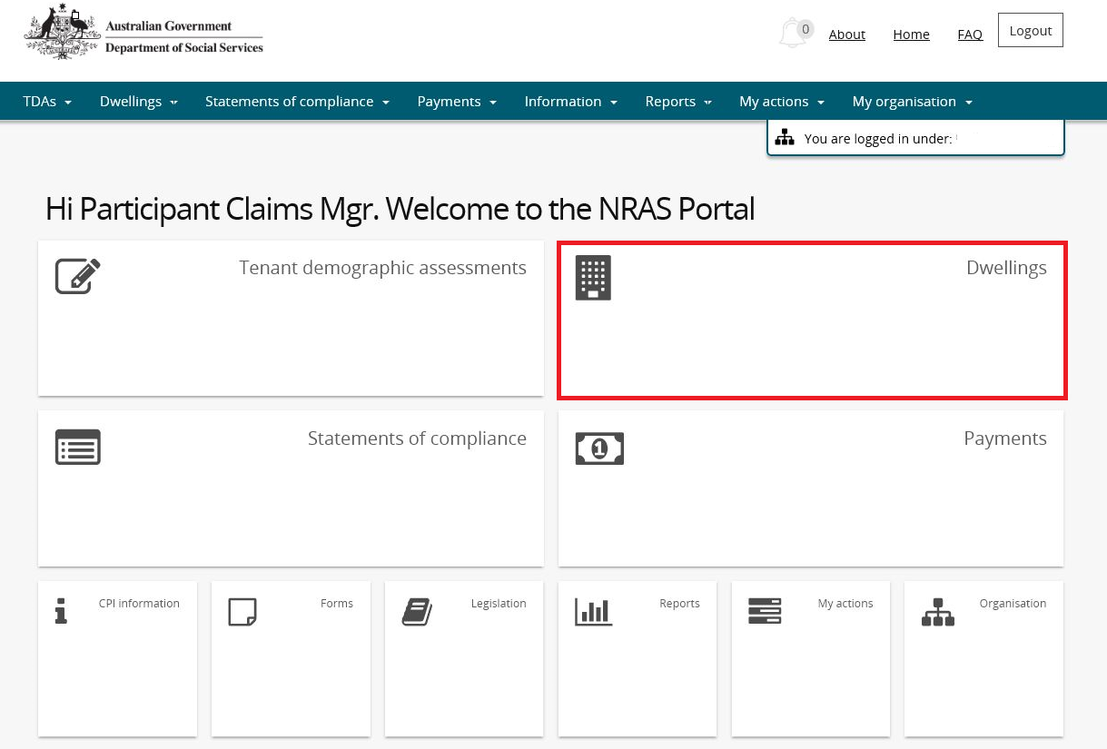

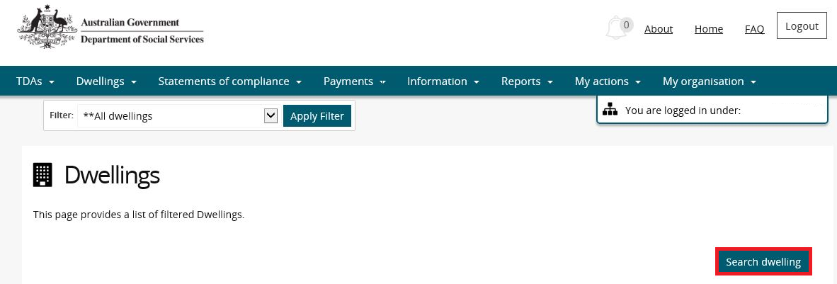

**OR**

1. At the **Welcome** screen, select **Dwellings>Search dwelling**.

Dwellings

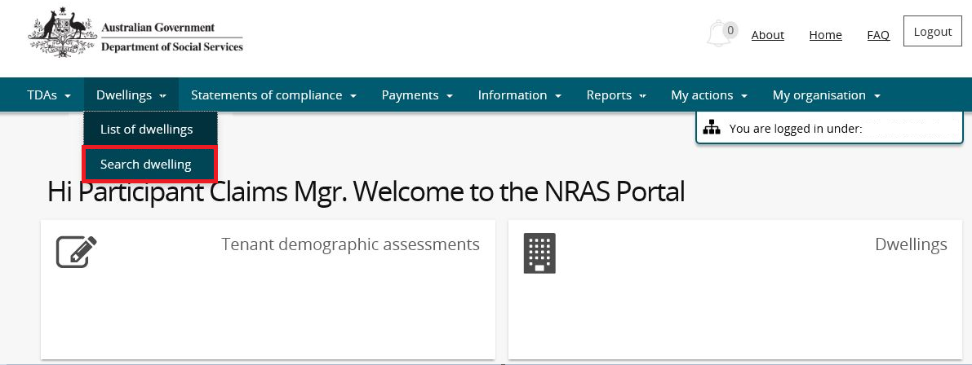

1. Enter required search criteria, then select the **Run Search** button.

Note icon.Click **Advanced** to display additional search fields.

Note icon. Search for a dwelling using any of the available search fields. All fields on the **Search dwellings** page are not case sensitive for searching. If you wish to view all dwellings you have access to, leave the Dwelling search fields blank.

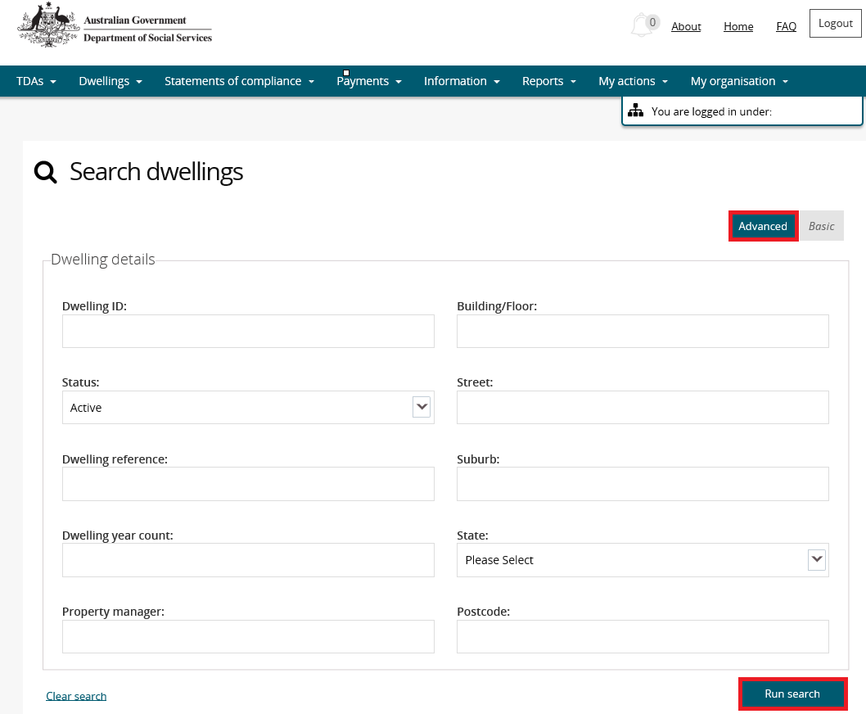

1. Results matching your entered search criteria will be returned.
2. Select the **View dwelling** button.

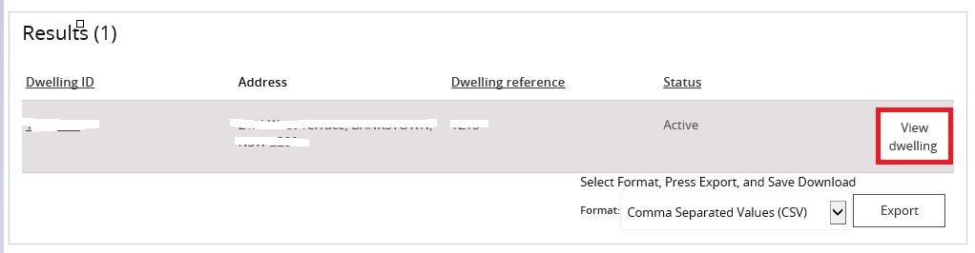

1. On the **View dwelling** page, select the **Market rent** link from the menu bar.

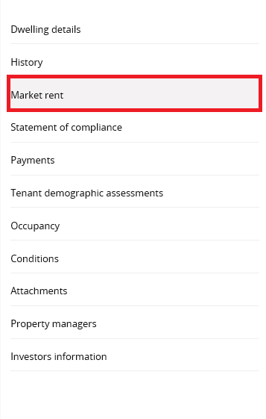

Note icon. As per the NRAS Regulations, you will only be able to add Market rent valuations for dwellings 91 days before the due date of the Market Rent Valuation. The ‘Add market rent’ button will only be available once this period is met. The button will be greyed out all other times.

Note icon. An ‘Action’ record will be created alerting you to any Market rent valuations which are due. Please see the QRG #15 How to view and complete Actions.

1. The Market rent page displays. Click the **Add market rent** button. The **Create market rent** page will be displayed.

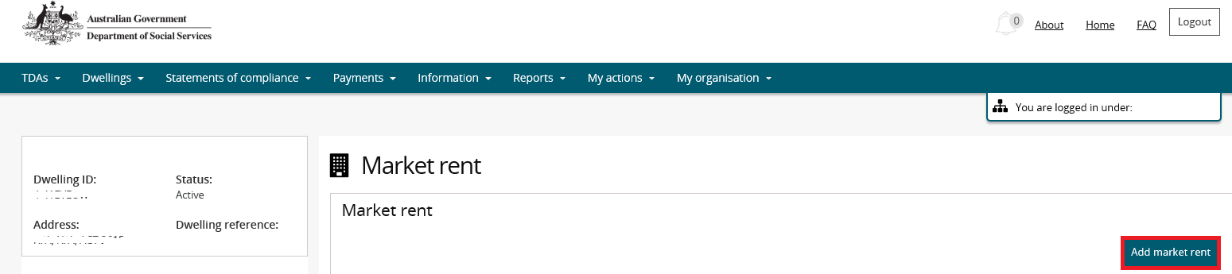

1. Read the conditions listed on the page and then enter the Market rent value.
2. Select the **Add attachment** button and select the file you wish to upload.

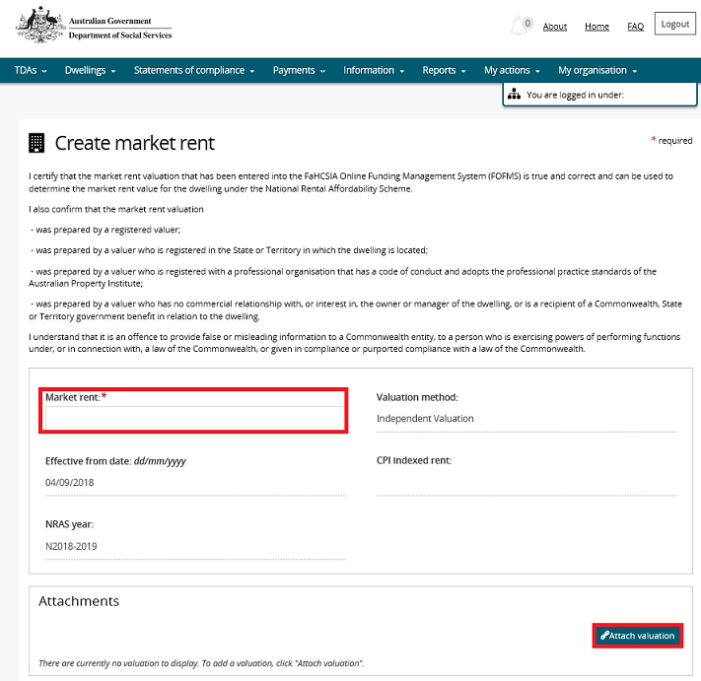

1. On the **Manage attachment details** screen, edit the file name (if required) and select an Attachment type.

Note icon. The Name and Attachment type fields are mandatory. The Attachment type field will default to the Market Rent Value Year you are adding. (E.g. Year 1, Year 5 or Year 8 Market Rent Valuation).

As per the NRAS Regulations, an **MRV checklist** **must** also be completed by the approved participant or their authorised agent and uploaded to the Attachments Tab along with the Market Rent Valuation.

Note icon.You can also enter any comments on the Manage attachment details screen.

1. Select the **Save and return** button.

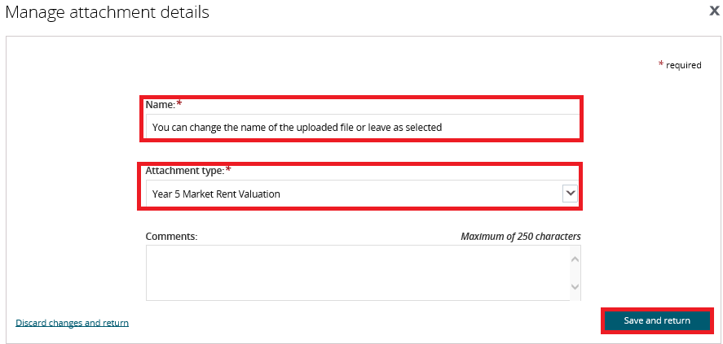

1. The **Create market rent** page will be returned, select the **Save and return** button on the Create market rent page.

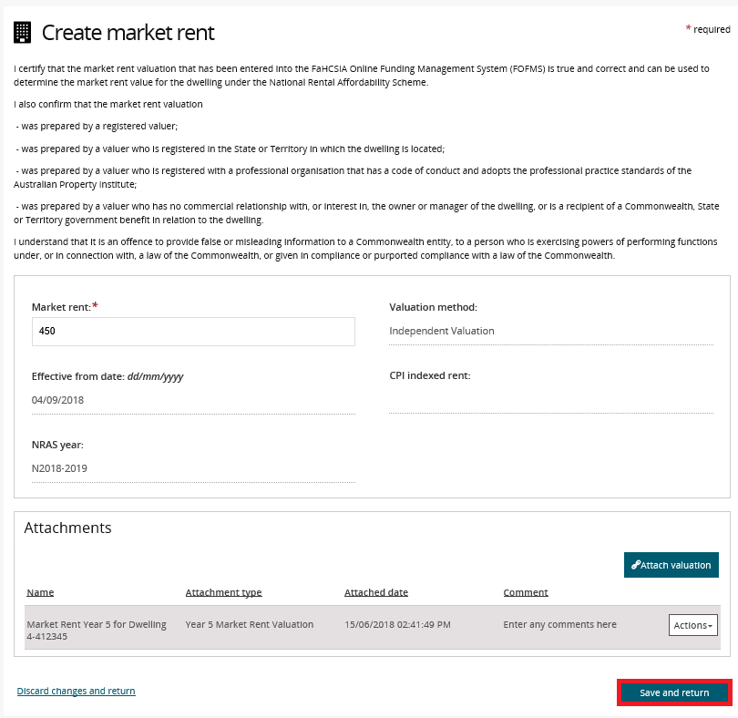

1. The Market rent record will be added for the Dwelling.

Note icon.The Compliance Team will receive a notification of the lodgement of the Market Rent Valuation.

Logging out of the NRAS Portal

1. To log out of the NRAS Portal click **Logout**.

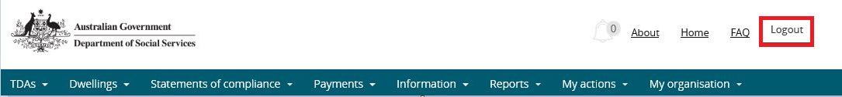

Note icon. For technical support enquiries, please contact [nrasithelpdesk@dss.gov.au](mailto:nrasithelpdesk@dss.gov.au) or 1300 911 235.