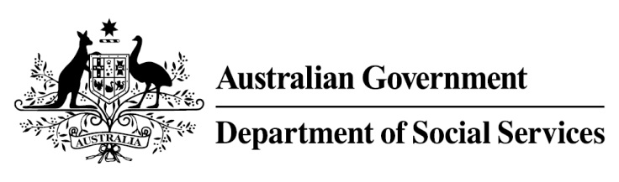

Try, Test and Learn Fund

Initiative: Career Skills for New Jobs

Location: South-Western Sydney, New South Wales

What are we trying to achieve?
To support older jobseekers to re-enter and stay in the workforce, by equipping them with the skills and confidence they need to self-manage their own careers. The project also seeks to engage employers to understand their challenges with recruiting and retaining older jobseekers.

Fast facts
Priority group: Older unemployed
Participant numbers: 250
Locations: South-Western Sydney, NSW covering six statistical areas: Bankstown, Canterbury, Fairfield, Hurstville, Kogarah-Rockdale, and Liverpool. This includes localities such as Bankstown, Cabramatta, Campbelltown, Campsie, Fairfield, Hurstville, Kogarah, Lakemba, Liverpool, Prestons, Punchbowl, and Rockdale.
Trial period: 13 months
Total funding: $3 million
Service provider:
PricewaterhouseCoopers with EML, ReadyTech and Esher House
Potential future saving: If around nine per cent of participants move off income support because of this project, the savings to the welfare system are likely to outweigh the costs of the project.

What is Career Skills for New Jobs?

Participants are referred to this project through jobactive providers. Participants are linked to a career practitioner. Using diagnostic tools specifically designed for this cohort, the career practitioner works one-on-one with each participant to help them understand their existing skillset and gain awareness of potential future career pathways. The career practitioner will also provide one-on-one assistance on how to effectively search for jobs and guidance on interview techniques.

Using an online career management tool, participants will receive guidance on how they manage their own career trajectory. This could include developing their CV, receiving information on local employment and training opportunities, or other services to improve their health, wellbeing and financial literacy. Engagement with local employers, employer and advocacy groups will help to identify the in-demand skills, knowledge and experience, and will help raise awareness of the benefits of older employees.

What does the evidence tell us?
- Many unemployed older Australians want to work but struggle to find or stay in work.
- Australians are on average living into their 80s, and older jobseekers may draw on income support payments for many years.
- If nothing changes, 75 per cent of this group will be receiving income support payments in 10 years, and 74 per cent will be receiving income support payments in 20 years.

How is this initiative new and innovative?
This project combines personalised, career coaching and guidance with access to an online Career Management Tool —to help older jobseekers build the skills and confidence to self-manage their career, and connect them to a network of existing tools, information and resources to help them find and stay in work.
Using insights from the Priority Investment Approach, the $96.1 million Try, Test and Learn Fund is gathering evidence on new or innovative approaches to addressing barriers to work.
The Try, Test and Learn Fund will help achieve the objectives of welfare reform—that is, to develop a modern welfare system that increases the capacity of individuals, reduces the risk of welfare dependency and maintains a strong welfare safety net.

