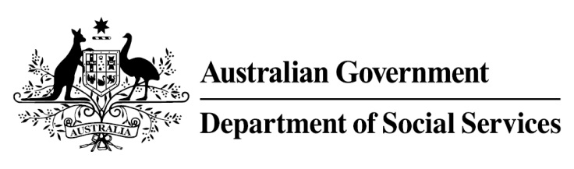

Try, Test and Learn Fund

Initiative: Building Bridges for Mature Jobseekers

Location: North-West Tasmania

What are we trying to achieve?

This project aims to improve employment opportunities and outcomes for older jobseekers in the Burnie region by building networks between participants and local employers who are looking for workers.

Fast facts
Priority group: Older unemployed
Participant numbers: 150
Locations: Burnie region, Tasmania
Trial period: 24 months
Total funding: $250,000
Service provider: Burnie City Council
Potential future saving: If around one per cent of participants move off income support because of this project, the savings to the welfare system are likely to outweigh the costs of the project.

What is Building Bridges for Mature Jobseekers?

This place-based initiative was co-developed with the Burnie City Council, local employers, services and older jobseekers. It leverages Burnie City Council’s well-developed connections to its local community. It will deliver a series of activities that:

link local employers with local older jobseekers through networking events. These will involve employer presentations, speed-interviewing of participants, and other networking opportunities.

connect older jobseekers with other relevant local services including local providers of employment services and complementary programs.

raise community awareness of the benefits of employing older jobseekers.

What does the evidence tell us?
- Many unemployed older Australians want to work but find it difficult to get work.

- Australians are on average living into their 80s, and older jobseekers may draw on income support payments for many years.

- If nothing changes, 75 per cent of this group will be receiving income support payments in 10 years, and 74 per cent will be receiving income support payments in 20 years.

How is this initiative new and innovative?
This initiative is a local response to a locally identified issue. Insights indicated that jobs in this regional community are often secured through informal social networks, and this project aims to bridge the social networking gap.
Using insights from the Priority Investment Approach, the $96.1 million Try, Test and Learn Fund is gathering evidence on new or innovative approaches to addressing barriers to work.
The Try, Test and Learn Fund will help achieve the objectives of welfare reform—that is, to develop a modern welfare system that increases the capacity of individuals, reduces the risk of welfare dependency and maintains a strong welfare safety net.

