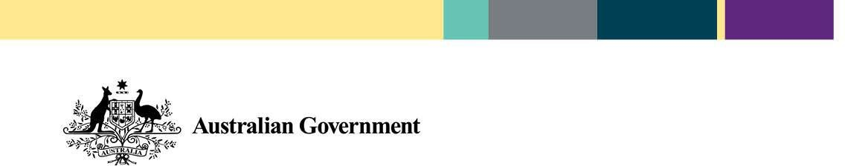
Cashless Debit Card
Paying bills and shopping

How do I pay bills, including existing direct debits, with my new account?
The Cashless Debit Card is designed to support a range of payment options for regular bills. This includes, BPAY, some direct debit arrangements, or setting up recurring deductions.

To use BPAY or to set up recurring payments
To pay bills you can log in to your Cashless Debit Card account at www.cdc.indue.com.au and use the ‘Transfers and BPAY’ link.

Direct debits
To arrange direct debits you will need to provide your biller with your BSB and account number, which can be found on the back of your card.

How can I pay rent?
There are a number of ways you can pay rent including Centrepay, the Rent Deduction Scheme and BPAY.

Centrepay and the Rent Deduction Scheme are available for everyone who is receiving welfare payments. Centrepay and the Rent Deduction Scheme are paid before your payments are sent to your Cashless Debit Card.

Please contact Centrelink if you have any questions about your Centrelink payments, Centrepay or the Rent Deduction Scheme.

You may also be able to pay your rent using direct debit, BPAY or eftpos. If you have existing direct debit or transfer arrangements with your regular bank account, you may need to change them so they come out of your Cashless Debit Card.

If you cannot use the above options, you should contact the Cashless Debit Card Hotline on 1800 252 604 to discuss alternative options including setting up transfers to your landlord’s account or your unrestricted account.

Can the card be used in any shop or business including online shopping?
You can use the card to make purchases online from approved online retailers and at shops or businesses that accept eftpos. However, there are restrictions in place for businesses that sell alcohol or have gambling activities available such as casinos.

For help making purchases online, contact the Cashless Debit Card Hotline on 1800 252 604.
Will I still have access to cash for places that do not have EFTPOS such as op shops and local markets?
Yes. You will have access to 20 per cent of your welfare payment that you can withdraw as cash to use in circumstances where only cash is accepted, for example at school canteens, fetes, and farmers markets.

Most businesses in your community have eftpos facilities and will accept payments from the Cashless Debit Card. However, the Department of Social Services is working closely with merchants that do not currently have eftpos facilities.

Can the card be used at a place that mostly sells food but some alcohol, like a café?
Yes, most cafés will accept the card for the purchase of food.

Can the card be used at a place that mostly sells alcohol and some food, such as pubs?
You may be able to use the card at places that mostly sell alcohol and some food, like pubs. However, you will only be able to purchase food and not alcohol at these places.

Still need help?
In situations where it is not possible to pay for bills or purchase goods with the Cashless Debit Card, contact the Cashless Debit Card Hotline on 1800 252 604 for assistance.

-Where can I find out more? Go to dss.gov.au/cashlessdebitcard
Or contact the Department of Social Services on 1800 252 604 or at cashlessdebitcard@dss.gov.au
The information contained in this fact sheet is intended as a guide only. The information is accurate as at June 2019.

