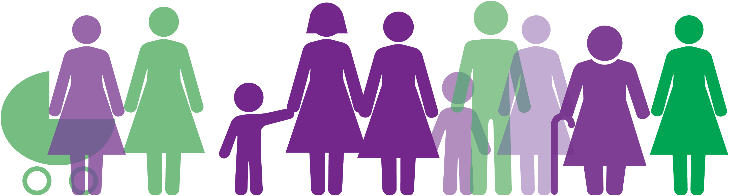
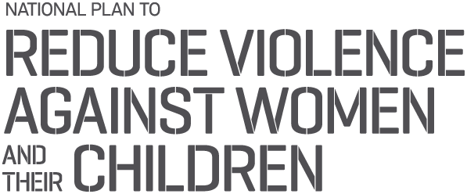

2017–18 ANNUAL PROGRESS REPORT
Third Action Plan 2016–2019 under the National Plan to Reduce Violence against Women and their Children 2010–2022
  - Safe and free from violence
An initiative of the Australian, state and territory governments.
© Commonwealth of Australia 2019
ISBN: 978–1–925318–83–8
Copyright notice — 2019
This document, the 2017–18 Annual Progress Report of the Third Action Plan 2016–2019 of the National Plan to Reduce Violence against Women and their Children 2010–2022, is licensed under the Creative Commons Attribution 4.0 International Licence.
License URL:
https://creativecommons.org/licenses/by/4.0/legalcode
Please attribute:
© Commonwealth of Australia (Department of Social Services) 2019
Notice:
- If you create a derivative of this document, the Department of Social Services requests the following notice be placed on your derivative: Based on Commonwealth of Australia (Department of Social Services) data.
- Inquiries regarding this licence or any other use of this document are welcome.
Please contact:
Branch Manager
Communication and Media Branch, Department of Social Services
Phone: 1300 653 227
Email: communications@dss.gov.au
If you are deaf or have a hearing or speech impairment, you can use the National Relay Service to contact any of the Department of Social Services listed phone numbers.
TTY users — phone 133 677 and ask for the phone number you wish to contact.
Speak and Listen users — phone 1300 555 727 and ask for the phone number you wish to contact.
Internet relay users — visit the National Relay Service at http://relayservice.gov.au
Contents
Introduction 4
The National Plan to Reduce Violence against Women and their Children 2010–2022 5
2017–18 Annual Progress Report 5
Investments 6
Australian Government 6
Australian Capital Territory 6
New South Wales 6
Northern Territory 7
Queensland 7
South Australia 7
Tasmania 8
Victoria 8
Western Australia 9
Third Action Plan highlights in 2017–18 10
National Plan performance over time 11
Australian attitudes to violence against women: Results from the 2017 National Community Attitudes towards Violence against Women Survey 11
Extent of violence: Results from the 2016 Personal Safety Survey 12
Indicators and measures 14
Examples of progress against the Third Action Plan’s national priority areas in 2017–18 17
National Priority Area 1: Prevention and early intervention 17
National Priority Area 2: Aboriginal and Torres Strait Islander women and their children 24
National Priority Area 3: Greater support and choice 28
National Priority Area 4: Sexual violence 32
National Priority Area 5: Responding to children living with violence 34
National Priority Area 6: Keeping perpetrators accountable across all systems 38
Key website links 42

Introduction
Under the National Plan to Reduce Violence against Women and their Children 2010–2022 (the National Plan), the Australian and state and territory governments have been working together to reduce violence against women and their children.
The Australian Government sets the national policy agenda and provides support for people impacted by domestic, family and sexual violence through family law (including legal assistance), social security (including income support and crisis payments), and a wide range of services targeted to supporting vulnerable Australians, including homelessness services. National programs that support people impacted by domestic, family and sexual violence include the 24‑hour counselling service for victims, 1800RESPECT, and training community frontline workers through DV alert.
The Australian Government also plays a key role in prevention of violence against women and their children. State and territory governments work with the Australian Government and provide co-funding for national initiatives such as the National ‘Stop it at the Start’ Campaign, and base funding for Our Watch. This complements the work conducted by jurisdictions, collectively driving national change in attitudes towards violence.
State and territory governments support the national policy agenda by delivering a range of services and support, including justice, policing, crisis accommodation, and legal assistance for victims and perpetrators. They also fund and coordinate services provided by the non‑government sector.
The Australian and state and territory governments invest in research to build the evidence base to inform policy related to domestic and family violence and sexual violence. The delivery of national research and data collection initiatives such as the National Community Attitudes towards Violence against Women survey and the Australian Bureau of Statistics’ Personal Safety Survey provides evidence to support policy development and contributes to the development and delivery of support services and primary prevention activities.
The Australian Government promotes human rights internationally and contributes to Australia’s international obligations under conventions including the United Nations Convention on the Elimination of Discrimination Against Women (CEDAW) and United Nations Convention on the Rights of the Child through national policy, including the National Plan.

The National Plan to Reduce Violence against Women and their Children 2010–2022
The National Plan brings together the efforts of governments across the nation to make a real and sustained reduction in the levels of violence against women. The National Plan is a key framework that also connects the important work being done by not-for-profit organisations and the broader community to work towards the vision that ‘Australian women and their children live free from violence in safe communities’.
The National Plan is underpinned by four three-year Action Plans to drive practical change at all levels of government and respond to emerging priorities over the course of the National Plan. The first two Action Plans laid the foundation for the National Plan and were important in building the national infrastructure and capability to support victims of domestic, family and sexual violence.
The Third Action Plan 2016–19 was developed during a time of heightened attention and significant work nationally around domestic and family violence. This included a number of state and territory-based inquiries and reports, as well as the final report of the Council of Australian Governments (COAG) Advisory Panel on Reducing Violence against Women and their Children. The Third Action Plan was informed by this work, as well as progress made under the first two Action Plans and extensive stakeholder consultation in 2016.
For the National Plan to be successful in achieving its long-term goals, a solid national evidence base is required. The National Plan is built on the existing evidence and continues to invest in new research and in strengthening existing data collections to track progress.

2017–18 Annual Progress Report
This report reinforces the commitment of all governments to work together, learn from combined experience and continue to work towards a significant and sustained reduction in violence against women, including sexual assault. All governments are committed to annual reporting on the progress of the National Plan. The 2017–18 Annual Progress Report is the second report for the Third Action Plan and builds on the activities reported in the 2016–17 Annual Progress Report. Both reports demonstrate the collective effort by Australian, state and territory governments each year to reduce violence against women and their children.
The 2017–18 report provides a selection of activities undertaken between July 2017 and June 2018 that contribute to the six National Priority Areas and provides an indication of investment by jurisdictions during this time. It also tracks the nature and extent of violence against women between 2005 and 2016, based on data from the Australian Bureau of Statistics’ Personal Safety Survey as well as measuring people’s understanding of and attitudes towards gender equality and violence against women through the National Community Attitudes towards Violence against Women Survey.

Investments

Australian Government
To support the Third Action Plan 2016–19, the Australian Government has invested $100 million over three years, comprising:
- $30 million to frontline legal assistance and family law services
- $25 million to assist Indigenous communities
- $20 million for prevention and early intervention initiatives
- $15 million for frontline services
- $10 million to respond to and prevent sexual violence, and to conduct research.
This builds on:
- ongoing funding of around $25 million per year that underpins the National Plan to support national partners and key services such as 1800RESPECT, DV-Alert, Our Watch, White Ribbon Australia and Australia’s National Research Organisation for Women’s Safety (ANROWS)
- the $100 million Women’s Safety Package announced by former Prime Minister, the Hon Malcolm Turnbull MP in September 2015
- a $30 million national Stop it at the Start campaign, jointly funded by the Australian, state and territory governments.

Australian Capital Territory
The 2017–18 Budget allocated an additional $2.2 million over four years to the Safer Families Initiatives, announced in the 2016–17 Budget, to help address family violence. This brings the total Safer Families package for the 2017–18 Budget to $23.5 million over four years. The focus of the package is for a more integrated response to individuals and families affected by domestic and family violence.

New South Wales
From 2016–17, the New South Wales Government has invested more than $300 million over four years in the specialist domestic and family violence response, more than doubling the investment in specialist services and initiatives. This investment, which will deliver a more effective response to domestic and family violence across the state, supports the implementation of the NSW Domestic and Family Violence Blueprint for Reform 2016–2021: Safer Lives for Women, Men and Children. In the 2018–19 NSW Budget this commitment is being extended to $390 million over four years.
The 2017–18 NSW Budget provided:
- $25 million for the Start Safely private rental subsidy to help people escaping violence move from homelessness into stable housing in the private rental market
- $13 million for Safer Pathway to continue the state-wide implementation of the multi-agency response to high-risk victims, with 15 new sites in the next 12 months
- $10 million for Women’s Domestic Violence Court Advocacy Service to support victims through the criminal justice system
- $10 million for behaviour change interventions for high-risk offenders
- $6.2 million for Staying Home Leaving Violence to support women and their children to remain safely at home
- $5.1 million for police high-risk offender teams, including the roll-out of two new teams in 2017–18
- $4.9 million for NGO-led community-based perpetrator interventions to support people to change their behaviour.

Northern Territory
The Northern Territory Government invested $36 million in 2017–18 in the prevention and reduction of domestic, family and sexual violence in the Northern Territory across all contributing agencies.
This investment includes funding for 36 crisis accommodation services and specialist counselling and outreach services. Funded services included safe accommodation services for women and their children escaping domestic, family and sexual violence; outreach services delivering crisis, advocacy and case management support to women and their children; and specialist children’s services operated by Darwin Aboriginal and Islander Women’s Shelter and Dawn House. The Northern Territory Families also funded Tangentyere Council Aboriginal Corporation to deliver men’s outreach and referral services and men’s behaviour change programs designed to respond to and reduce domestic violence.

Queensland
The Queensland Government continues to demonstrate its commitment to the Domestic and Family Violence Prevention Strategy 2016–2026 (and its associated action plans) by investing $328.9 million over six years to implement and build on recommendations from the Special Taskforce on Domestic and Family Violence in Queensland report, Not Now, Not Ever. The 2017–18 Budget committed $78.5 million over four years to support whole-of-government domestic and family violence reforms, including allocating $3.4 million to establish two new women’s crisis shelters in areas of high demand in South East Queensland. Since the Not Now, Not Ever report, the Queensland Government has committed to establishing seven new shelters across the state, including in regional and remote areas.
The Queensland Government has supported the health and wellbeing of women who have experienced sexual violence, with investment increasing from $6.1 million per annum across 19 sexual assault service outlets in 2015 to $8.9 million across 29 service outlets in 2017–18. This represents an increase of $2.9 million per annum, or 47 per cent, since 2015.

South Australia
In March 2018, a new government was elected in South Australia. During the lead up to the election the new South Australian Government committed to address domestic and family violence with a series of election commitments. In the 2018-19 budget the Government committed $11.9 million over four years to implement these commitments.

Tasmania
Following on from the $26 million in additional funding allocated over four years in August 2015 through Safe Homes, Safe Families: Tasmania’s Family Violence Action Plan 2015–2020, the 2017–18 state Budget committed $5.5 million for initiatives to further enhance the response to family violence. This included:
- $1.7 million over four years for a Director of Public Prosecutions Family Violence and Sexual Assault Unit
- $3.4 million over four years to roll out body-worn cameras for all frontline police officers
- $0.4 million over two years to support the Eligible Persons Register.
Safe Homes, Safe Families also introduced a new budget model for the Tasmanian Government: a funding pool for actions delivered across five different agencies, managed through a central agency across multiple years.
This model has meant that savings from one agency are not automatically reinvested into that agency but become available to fund jointly agreed priorities approved by Cabinet. This has allowed for savings in the first year of implementation to be reallocated to expand existing actions (that is, to meet increased service demand) and to support new actions across years two to four (for example, investment in an innovative electronic monitoring trial for family violence offenders).
This innovative finance model also provides agencies with a degree of flexibility between projected and actual expenditure over each year of implementation. This contributes to the success of the cross-agency model by removing the need for agencies to completely expend allocated funds within the financial year (or risk losing the funding). Where projected expenditure is revised, the secretariat works closely with agencies to negotiate the reallocation of budget across the life of the action. Where true savings are identified, a joint agreement will result in funds being returned to the central pool — in an innovative and collaborative approach to funding.

Victoria
Victoria has made significant investments in responding to and preventing family violence. In May 2017, the Victorian Government announced an unprecedented $1.9 billion in investment to implement all 227 recommendations of the Royal Commission into Family Violence. The budget included $448.1 million to establish 17 Support and Safety Hubs as crucial contact and referral points that link victim survivors and their children to the support and services they need. The first hubs, known as ‘the Orange Door’, were launched in Barwon, Bayside Peninsula, Inner Gippsland, Mallee and North-East Melbourne regions.
The package also includes:
- $270.8 million for victim assistance, after-hours crisis support, counselling and therapy, including for children
- $269.4 million to enhance the response of Victoria’s legal system to family violence. This includes implementing the specialist Family Violence Courts model in several locations across the state, expanding legal assistance services for victim survivors and a new case management system for courts
- $133.2 million for housing, to rebuild family violence refuges and introduce new Aboriginal family violence refuges, lease more private rental properties for victims, and provide additional public housing
- $95.4 million to strengthen the family violence workforce, which includes new workers in mental health and alcohol and drug services, expanded training across a wide range of services, and initiatives to recruit the next generation of workers
- $76.9 million to hold perpetrators of family violence to account and to change perpetrator behaviour
- $164.7 million to expand flexible support packages
- $33.5 million to provide greater support for Aboriginal Victorians and Aboriginal organisations and communities, including through prevention and early intervention programs and support for victim survivors.
This budget also invested $50.7 million for prevention activities by establishing a dedicated Prevention Agency, and $29.2 million to expand the Family Services program to assist vulnerable children and their families. A further $131.9 million was dedicated to expanding child protection services and placements for children who are unable to live safely with their families.
In May 2018, the Victorian Budget announced that it would be providing additional funding to build on this important work. It included $49.9 million to ensure victim survivors have access to the support they need to recover, including the provision of flexible support packages. The budget also provided $27.7 million for improved refuge responses for victims, and $24 million for campaigns to change behaviour and prevent family violence before it starts. Finally, a further $5 million was provided for initiatives under the Industry Plan for Family Violence Protection and Response.
The Victorian Government also announced investment in the safety of children and families, with $226 million to expand the child protection workforce and continue after-hours emergency services and specialist intervention.

Western Australia
The Western Australian Government has committed to developing a 10‑year strategy for reducing family and domestic violence. In early June 2018, a Family and Domestic Violence policy consortium was convened, comprising representatives from government, community sector services, Aboriginal Community Controlled Organisations and academia, to develop a comprehensive project plan to develop a 10-year across-government strategy to reduce family and domestic violence.
Informed by community and sector consultation, the strategy will identify opportunities and set the direction to align reform agendas, build on current initiatives, and enable a more integrated across-government approach to addressing family and domestic violence.

Third Action Plan highlights in 2017–18

2017
JUL – In its 2017–18 budget, the New South Wales Government provided $13 million to expand Safer Pathway across NSW to 43 sites to provide increased safety supports to victims of domestic and family violence.
AUG – The Australian Government announced the new panel approach to delivering 1800RESPECT, partnering with the specialist trauma providers DV Connect (Queensland), Safe Steps (Victoria) and Women’s Safety Services (South Australia).
OCT – The Office of the eSafety Commissioner launched its image-based abuse portal — the world’s first, government-led initiative of its kind.
NOV – Tasmania’s Safe Homes, Safe Families was recognised with two awards in the 2017 Institute of Public Administration Australia Prime Minister’s Awards for Excellence.
DEC – The Northern Territory Government launched its Domestic, Family and Sexual Violence Reduction Strategy 2018–2028 — Safe, Respected and Free from Violence.

2018
FEB–MAR – Queensland established two new Integrated Service Response trial sites, in addition to the three already in operation across the state. All five are trialling the evidence-based Common Risk Assessment and Safety Framework and utilise strengthened information-sharing provisions to assess risk and develop safety plans to help keep victims and their families safe.
MAR – The Victorian Government announced the development of a new family violence prevention organisation, alongside another behaviour change campaign. The new prevention organisation, Respect Victoria, will be a statutory authority enshrined in legislation that will work to change the attitudes, social norms and culture that lead to family violence and violence against women.
APR – South Australia’s First Domestic Violence Roundtable provided an opportunity for non-government organisations working in the domestic, family and sexual violence sectors and broader community services to communicate directly with government.
The Tasmanian Government commenced the Family Violence Service System Review (including Safe Homes, Safe Families) to inform the next family violence action plan, to be launched in July 2019.
MAY – The Australian Capital Territory Family Safety Hub was launched following an 18-month co-design process.
JUN – Western Australia established a Family and Domestic Violence policy consortium to take a new, innovative and collaborative approach, bringing together representatives from government, community sector services and academia to create a comprehensive project plan for the development of the Family and Domestic Violence 10-Year Strategy.

National Plan performance over time
Under the National Plan, the Australian Government has made significant investments in research and data to track performance over time. This work highlights the extent of the problem and Australians’ views on violence. It also informs responses to victims and perpetrators of violence, including for women in culturally and linguistically diverse communities, women with a disability, and Aboriginal and Torres Strait Islander women.

Australian attitudes to violence against women: Results from the 2017 National Community Attitudes towards Violence against Women Survey
The 2017 National Community Attitudes towards Violence against Women Survey (NCAS) was a $3.1 million investment by the Australian Government. It tells us about people’s understanding of, and attitudes towards, violence against women; about their attitudes towards gender equality; and whether there has been a change over time. The 2017 NCAS has delivered some encouraging results:
- Most Australians have an accurate knowledge of violence against women, do not endorse this violence, and are more supportive of gender equality than in previous NCAS surveys. Figure 1 shows the results, over time, of how respondents to the NCAS scored their understanding of, and attitudes to, violence and their support for gender equality.
- Australians are now more likely to understand that violence against women involves more than just physical violence and less likely to hold attitudes supportive of violence against women (compared with 2013 and 2009).
- Australians are also strongly inclined to act in response to violence, and believe that they would have support to act. For example, if confronted by a male friend verbally abusing his female partner, most respondents say they would be bothered (98%), would act (70%) and would feel they would have the support of all or most of their friends if they did act (69%).
While these results provide some optimism for the National Plan’s performance over time, further action is still required. The 2017 NCAS also highlighted some concerning results, including:
- a decline in the number of Australians who understand that men are more likely than women to perpetrate domestic violence (in contrast to the evidence that men are more likely to be perpetrators).
- a concerning proportion of Australians believing that gender inequality is exaggerated or no longer a problem and a high proportion of people believing that women use claims of violence to gain tactical advantage in their relationships with men.

Mean score of selected attitudes, Australia 2009–2017
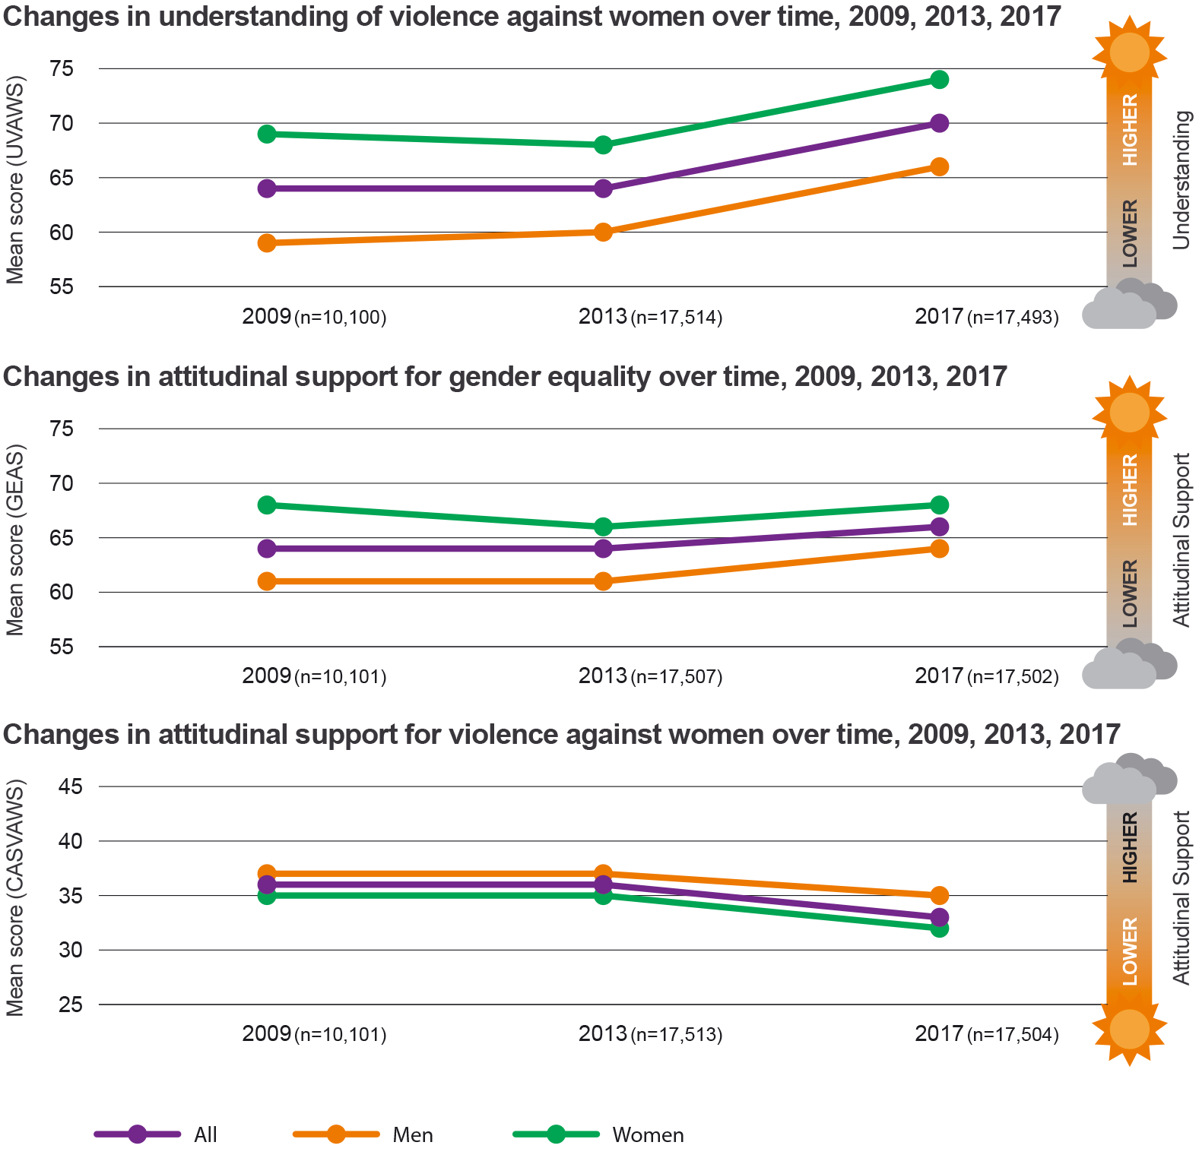
Source: 2017 National Community Attitudes towards Violence against Women Survey, Australia’s National Research Organisation for Women’s Safety

Extent of violence: Results from the 2016 Personal Safety Survey
The 2016 Personal Safety Survey (PSS) is a $12.3 million investment by the Australian Government that measures the prevalence of violence against women in Australia. Top-level results show that, while the long-term trend of a decline in physical violence against women has continued through to 2016, there has been no reduction in either partner violence or sexual violence against women in Australia between 2005 and 2016, as shown in Figure 2.
Proportion of women who experienced physical, sexual, and partner violence, during the last 12 months, changes over time, Australia
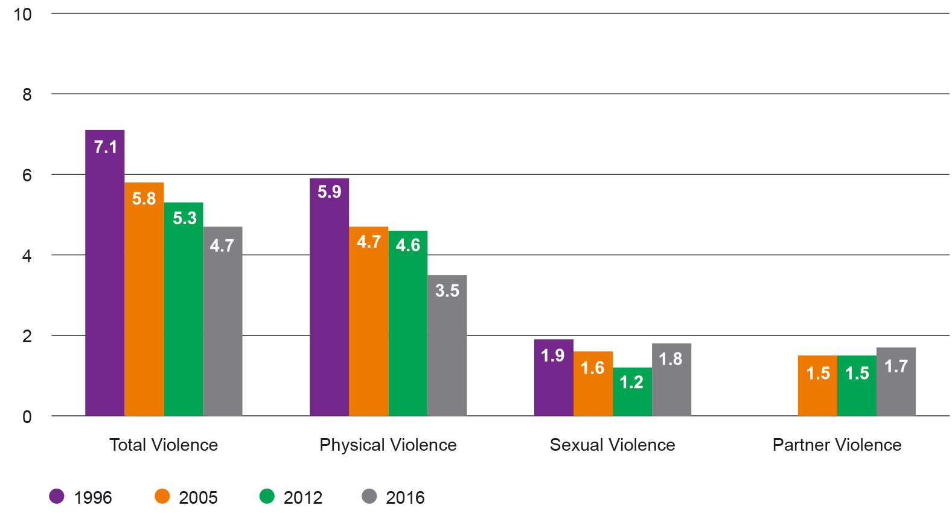
Source: 2016 Personal Safety Survey, Australian Bureau of Statistics
Prevalence of intimate partner violence against women since the age of 15 years is unacceptably high, with one in four women having experienced it since the age of 15 years.
Proportions of women and men who have experienced partner violence and women who have experienced sexual violence since the age of 15 years, Australia
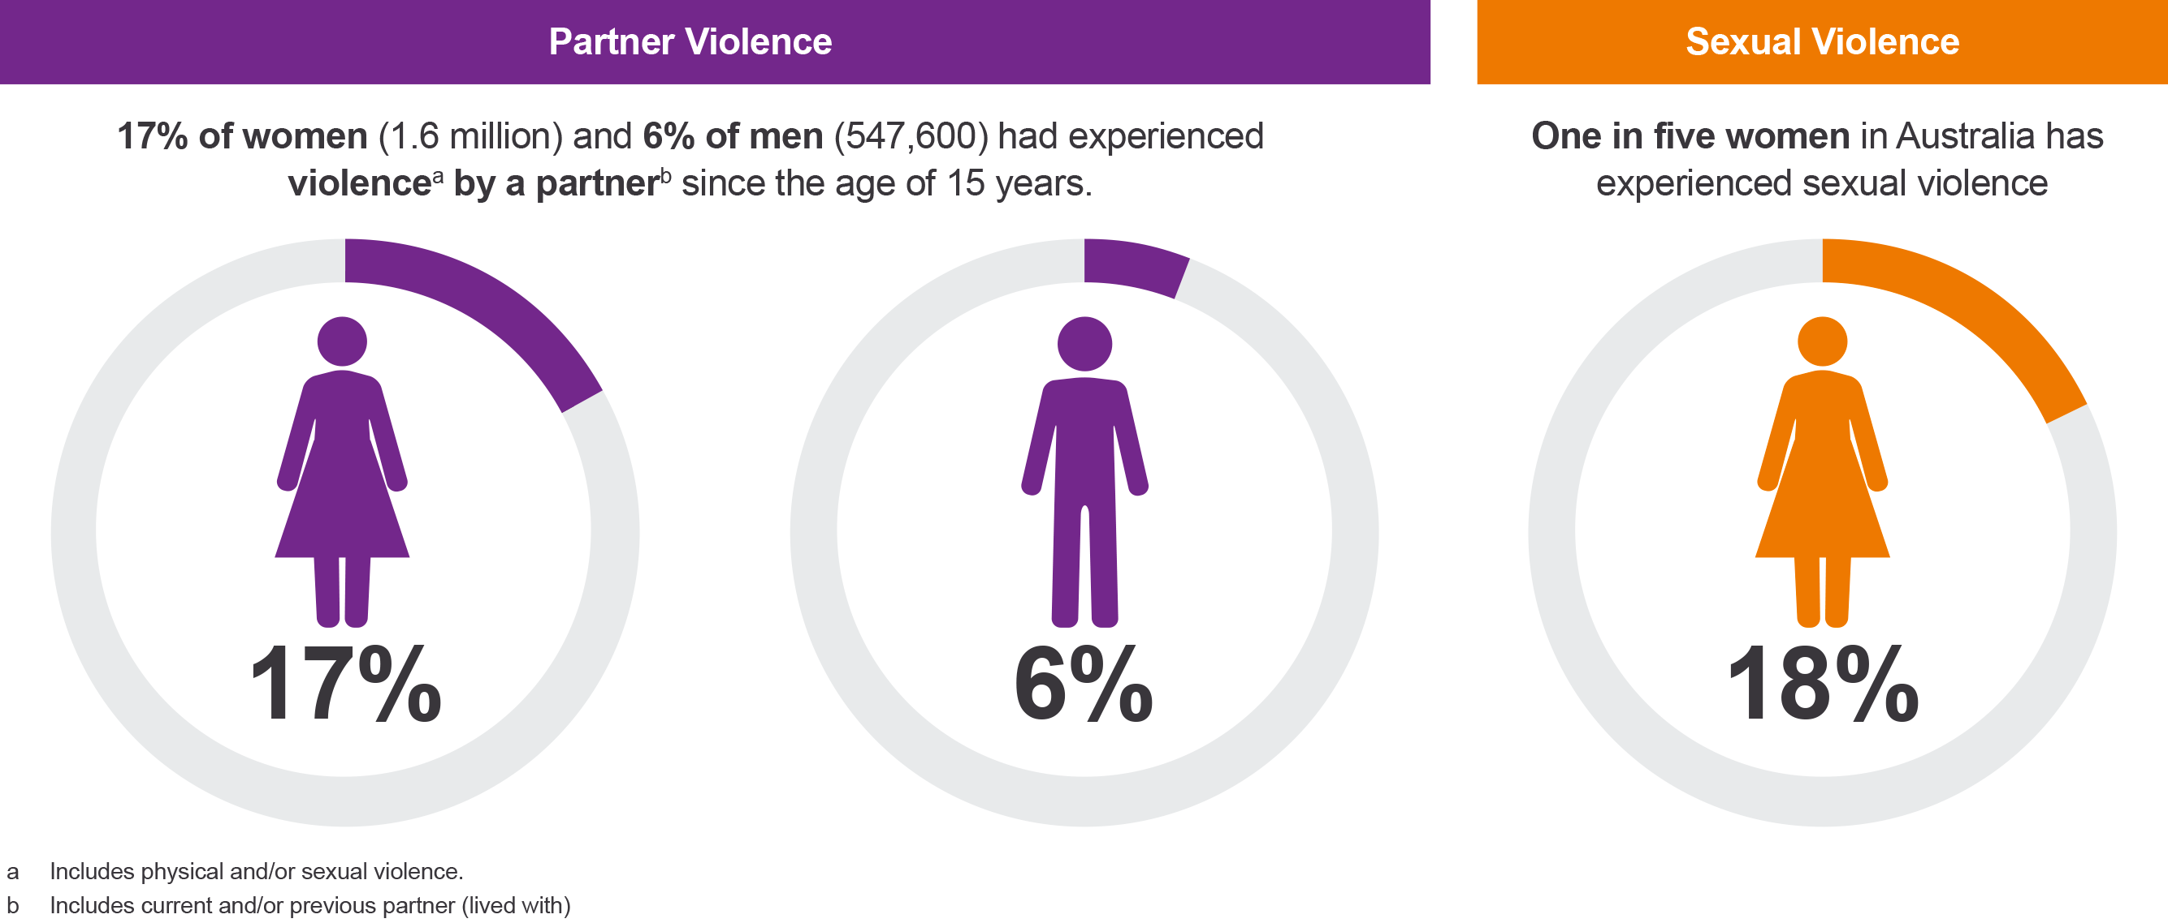
Source: 2016 Personal Safety Survey, Australian Bureau of Statistics
The 2016 PSS was funded by the Department of Social Services in the National Plan to Reduce Violence Against Women and their Children 2010–2022.

Indicators and measures
The overall objective of the National Plan is to achieve a significant and sustained reduction in violence against women and their children. This is the long-term goal. A set of indicators, identified in the National Plan, support tracking this long-term goal. Progress on these indicators is shown in the table below.
Focus area | Indicator/measure | Assessment
National prevalence | Reduced prevalence of domestic violence and sexual assault  Source: 2016 Personal Safety Survey | The estimated prevalence of partner violence against women has remained relatively stable since 2005. The trend in sexual assault against women is on a slight upward trajectory. See figure 2.  In 2005, 1.5 per cent of women were estimated to have experienced violence in the 12 months prior to the survey, compared with 1.7 per cent in 2016.  In 2016, it was estimated that 1.8 per cent of women (171,600) experienced sexual violence in the 12 months prior to the survey.
 | Increased proportion of women who feel safe in their communities  Source: 2016 Personal Safety Survey | Women are reporting that they are increasingly feeling safer in private and in community settings in Australia. In particular, women are feeling much safer at home alone after dark. In 1996, more than 20 per cent of women indicated they felt unsafe in this setting. In 2016, this proportion halved to 10 per cent.
 | Reduced deaths related to domestic violence and sexual assault  Sources:  National Homicide Monitoring Program  ABS Recorded Crime - Victims 2015, 2016 and 2017 | The number of female deaths in Australia related to domestic violence and sexual assault increased between 2010–12 and 2012–14. For female deaths perpetrated by an intimate partner, the number rose from 83 in 2010–12 to 99 in 2012–14.  In 2015, 105 women were killed in a family and domestic violence related incident. In 2016, 94 women were killed, and in 2017, 72 women were killed in a family and domestic violence related incident.
 | Reduced proportion of children exposed to their mother’s or carer’s experience of domestic violence  Source: 2016 Personal Safety Survey | The proportion of children exposed to their mother’s or carer’s experience of violence, by either a current partner or previous partner, remained relatively stable between 2012 and 2016.  An estimated 50 per cent of women (60,300) who had children in their care when they experienced violence by a current partner reported that the children had seen or heard the violence.  An estimated 68 per cent of women (418,200) who had children in their care when they experienced violence by a previous partner reported that the children had seen or heard the violence.
 | A decrease in repeated partner victimisation  Source: 2016 Personal Safety Survey | The 2016 Personal Safety Survey gives a mixed result for tracking repeated partner victimisation. There was a decrease in the proportion of women who experienced repeated violence by a previous partner between 2012 and 2016, but no change in repeated violence by a current partner.
Attitudinal change | Increased intolerance of violence against women  Source: 2017 National Community Attitudes towards Violence Against Women Survey | There are some promising trends, which highlight increased intolerance of violence against women in Australia. Most Australians, for example, do not endorse violence against women, support for gender equality is rising, and Australians are less likely to hold attitudes supportive of violence in 2017 than they were in 2009 and 2013.  Australia is a world leader in tracking attitudes to violence against women. With three waves of the NCAS now complete, the Australian Government has committed to undertaking a further NCAS in 2021, which will add to the growing body of knowledge of trends in attitudes towards violence against women.
 | Improved knowledge, skills, and behaviour of respectful relationships by young people  Source: 2017 National Community Attitudes towards Violence Against Women Survey | Young people (aged 16-24 years) were more likely in 2017 than they were in 2013 to recognise that controlling, abusive and intimidating behaviours in a relationship are forms of violence against women. They were also less likely in 2017 to endorse attitudes supportive of violence against women overall and more likely to endorse equal and respectful relationships between women and men overall.
Indigenous women | Reduced proportion of Indigenous women consider family violence, assault and sexual assault are community and neighbourhood problems  Source: National Aboriginal and Torres Strait Islander Social Survey 2014–15 | The proportion of Indigenous women who consider family violence, assault and sexual assault to be community and neighbourhood problems remained mostly stable between 2008 and 2014–15.
 | Increased proportion of Indigenous women are able to have their say within community on important issues including violence  Sources:  National Aboriginal and Torres Strait Islander Social Survey 2014–15  Family and Community Safety for Aboriginal and Torres Strait Islander Peoples Study ANU 2019 | The proportion of Indigenous Australians (men and women) who feel able to have their say within the community on important issues including violence, all of the time or most of the time, remained mostly stable between 2008 and 2014–15. Women who had experienced family and domestic violence were just as likely as those who had not experienced any physical violence to feel like they could have a say within the community on important issues.  - Around two in 10 women in both groups felt they could have a say most or all of the time (21 per cent and 25 per cent respectively)  - Around five in 10 in both groups felt they could have a say a little or none of the time (56 per cent and 50 per cent respectively)  The Third Action Plan has created opportunities for Aboriginal and Torres Strait islander women to have their say on violence in communities. For example, the Australian National University is undertaking a comprehensive study on family, domestic and sexual violence in 18 Indigenous communities. The study includes focus groups in communities.
Access to services | Increased access to and responsiveness of services for victims of domestic/family violence and sexual assault  Source: 2016 Personal Safety Survey | The proportion of female victims of partner violence seeking advice or support remained relatively stable between the 2012 and 2016 waves of the PSS.  Key services have increased their access for users and their responsiveness. For example, 1800RESPECT has met a 54 per cent increase in demand between 2016–17 and 2017–18.  The majority of women did seek advice or support about the most recent incident. (In 2016, an estimated 62 per cent of women who experienced physical assault by a male had sought advice or support (659,000). Of these women, approximately 63 per cent sought advice or support from a friend or family member (417,500).)  (In 2016, half of all women who experienced sexual assault by a male sought advice or support about the most recent incident (50 per cent or 316,900). Of these women, 71 per cent sought advice or support from a friend or family member (224,500).)
 | Increased rates of women reporting domestic violence and sexual assault to police  Sources:  2016 Personal Safety Survey  Australian Bureau of Statistics 2018, Recorded Crime, Victims publication | Rates of women in Australia reporting physical assault and sexual assault to police, where the perpetrator was a partner, remained relatively stable between 2005 and 2016.  In 2012, an estimated 28 per cent of women reported their most recent incident of physical assault by a male to police, compared to 29 per cent in 2016.  In 2012, an estimated 17 per cent of women reported their most recent incident of sexual assault by a male to police, compared to 15 per cent in 2016.  A dedicated family, domestic and sexual violence chapter in the ABS Recorded Crime (Victims and Offenders) shows that the number of sexual assault victims increased by 8 per cent across Australia from 2016, with more than four in five victims being female and at least two of five assaults recorded during 2017 being FDV-related.

Examples of progress against the Third Action Plan’s national priority areas in 2017–18

National Priority Area 1: Prevention and early intervention

National, states and territories:

National ‘Stop it at the Start’ Campaign
Stop it at the Start is a multi-award-winning, primary prevention campaign jointly funded by the Commonwealth, states and territories through the Council of Australian Governments.
The campaign was informed by extensive research which found that we often don’t realise that the cycle of violence can start with the beliefs and attitudes boys and girls develop from a young age. When thinking about our own reactions, we might be surprised to recognise some of the most common ways we excuse disrespectful and aggressive behaviour.
- We play down disrespectful or aggressive behaviour (‘Don’t worry, it wasn’t that bad’).
- We accept aggression as just part of being a boy (‘Boys will be boys’).
- We blame girls (‘What was she wearing?’).
- We raise girls to accept disrespect (‘It’s okay, he probably did it because he likes you’).
When we make these excuses, we’re allowing disrespectful behaviour to become a normal part of growing up. As adults, we need to recognise and reconcile our role as important influencers of the next generation.
With this in mind, the Stop it at the Start campaign looks to help parents, family members, teachers, coaches, employers and other role models to look at their own attitudes, and start a conversation about respect with the young people in their lives.
Phase 1 was launched in April 2016. It included a range of activities such as multiple advertising bursts in March and November 2017, and ongoing public relations and community engagement. The response was overwhelming, and far exceeded expectations. The television advertisements were viewed more than 43 million times online and had more than 464,000 shares on social media, promoting extensive online conversation. There were also more than 761,000 page views on the website and more than 40,000 downloads of campaign resources.
While cultural change takes time, evaluation research shows that the first phase successfully helped people make the link between disrespect and violence, and start to change some of their deeply held attitudes. Seventy-nine per cent of those surveyed agreed that violence against women starts with disrespect towards women — up from 68 per cent before the campaign began. The evaluation showed that almost half of all influencers saw the campaign and started changing some of their deeply held attitudes.
Phase 2 advertising ran from 7 October 2018 to the end of November 2018. Phase 2 looked to move the conversation forward, with new advertising and supporting activities.

1800RESPECT
1800RESPECT has been funded by the Australian Government since 2010 as part of the National Plan. It provides a free, confidential and interactive online and telephone counselling, information and referral service for anyone affected by domestic and family violence and sexual assault.
On 29 October 2017, a panel of three highly experienced and qualified not-for-profit organisations began delivering the trauma specialist counselling component of 1800RESPECT. The panel comprises Women’s Safety Services in South Australia, DV Connect in Queensland and safe steps Family Violence Response Centre in Victoria.
The panel arrangement builds on improvements made with the 2016 implementation of the first response triage model. Under this model, all calls are answered by qualified and experienced first-response counsellors. Anyone who is assessed as needing additional in-depth trauma specialist counselling, or who requests this support, is then warm-transferred to a trauma specialist counsellor.
The panel has increased the capacity of the trauma specialist component of the service, meaning more people can now receive specialist support when they need it. In 2017–18 trauma specialist counsellors answered 27,968 calls referred to them following an initial assessment by a first-response counsellor. This is a 102 per cent increase in the number of calls answered compared to 2016–17 prior to the establishment of the panel.
The panel and first-response triage model have enabled 1800RESPECT to respond to increases in demand, such as that experienced in 2017–18 following #MeToo and several high-profile sexual assault, domestic and family violence incidents. In 2017–18, first-response counsellors answered 98,466 telephone and online contacts, a 54 per cent increase from the previous year. Despite the significant increase in demand, wait times have continued to remain low (49 seconds for calls and 126 seconds for online counselling in 2017–18), enabling people to access high-quality support when they need it.
In additional to providing high-quality counselling, in March 2018 1800RESPECT launched a new trauma-informed website, with an up-to-date service referral database to ensure people have access to current and reliable information online. 1800RESPECT has also worked with stakeholders on a number of projects to increase the accessibility and appropriateness of the service for women with disability. This includes progressing the development of a mobile phone app, researching the viability of video counselling and improving service responses and referral pathways for women with disability.

New South Wales:

Innovation Fund
Prevention and early intervention are two key components of the NSW Government’s Domestic and Family Violence Blueprint for Reform. To help achieve this, with the 2016–17 Budget the NSW Government announced the establishment of a $20 million Domestic and Family Violence Innovation Fund over four years.
In 2017, after a supported development process and competitive appraisal, the NSW Government funded the following seven projects in the first round of funding:
Leaving Prison/Leaving Violence (Community Restorative Centre) — Provides genuine alternative pathways for women leaving prison or court who are at risk of returning to a violent situation.
Safe Families (RSPCA) — Builds capability in domestic violence shelters to accommodate pets. This assists victims to not be separated from their animals. It creates a ‘package’ that will enable refuges to accommodate humans and pets together on-site.
Linking Communities Education Van (Linking Communities Network) — Brings domestic and family violence education to rural, isolated communities through an interactive, non-intrusive ‘pop-up’ framework to address a lack of services in isolated communities.
Respectful Relationships Peer Educators (People with Disability Australia) — Provides sex and relationship education for women and girls with intellectual disability by women with intellectual disability.
Building Access for Women with Disability (People with Disability Australia) — Improves disability inclusion capability for domestic violence shelters and community of practice and helps develop disability inclusion action plans.
Toolbox Talks (Sutherland Shire Family Services) — Delivers domestic and family violence education sessions to the mining and construction industry.
Kalypi Paaka Mirika Healing Program (Maari Ma) — Creates a healing program that incorporates therapies and skills to manage causes of domestic and family violence in a localised Aboriginal cultural framework to prevent domestic and family violence.
Following the success of the first round of funding, the NSW Government opened the second round in September 2017 and, in August 2018, announced almost $12 million for 13 new innovative projects.
New South Wales case study: Linking Communities Education Van
The Linking Communities Education Van, operated by Linking Communities Network, is an Innovation Fund project that highlights the importance of not only education about domestic and family violence in rural and isolated communities but also the incidental benefits of travelling to and through these communities.
Anna (not her real name) left her home in the Philippines after she married an Australian man and they started their life together on an Australian farm. However, she was not allowed to talk to anyone that came onto the farm and did not have access to a landline or mobile telephone. She did not leave the farm for 15 months after arriving in Australia and experienced aggression and physical violence.
Anna fell pregnant but was allowed to see a doctor in town only at 25 weeks gestation. She was too scared to talk to the doctor because her husband had threatened to kill her. Anna’s daughter was born and they returned to the farm and this abusive behaviour continued for five years towards both Anna and her daughter.
On a few occasions Anna accompanied her husband on trips to town and was left alone while he went to the pub. On one occasion she saw the Education Van stopped at a petrol station. Anna approached the Education Van driver who agreed to help her.
They organised to meet again, where they took Anna and her daughter to a refuge and organised support services for her to leave her husband, contact her family and establish an independent life.
If it wasn’t for the Education Van going through that town on that particular day, Anna and her daughter would still be living with domestic violence and would never have received the support and empowerment Anna needed to escape the relationship.

Northern Territory:

Safe, Respected and Free from Violence Prevention Fund
In May 2018, the Northern Territory Government launched the Safe, Respected and Free from Violence Prevention Fund, providing $0.3 million per year for locally driven, community-informed violence prevention activities, including those focusing on supporting children and young people to engage in healthy, respectful relationships.
Six projects were supported in the first round of the fund:
- Alice Springs Women’s Shelter for the program ‘Talking Pictures, Talking Respect’
- North Australia Aboriginal Justice Agency for the program ‘Kunga’s Stopping Violence on Social Media’
- Danila Dilba Health Service for the program ‘Healthy Relationship Resources for Young People’
- Tangentyere Council Aboriginal Corporation for the ‘Mums Can, Dads Can Project’
- World Vision Australia for the program ‘Channels of Hope for Gender — Lajamanu’
- Miwatj Health Aboriginal Corporation for the program ‘Let’s Talk About It: Consent and Respectful Relationships’.

South Australia:

Domestic violence roundtables
During the March 2018 South Australian election campaign, the then South Australian Opposition released its election policy ‘Addressing Domestic and Family Violence’, which outlined a series of commitments and proposed reforms in relation to domestic and family violence. The policy committed to meeting with non-government stakeholders within 30 days of the election to discuss the proposed reforms.
The first domestic violence roundtable, held in Adelaide in April 2018, provided an opportunity for non-government organisations working in the domestic and family violence sector to communicate directly with government. Government representatives were present on the day, including the Minister for Human Services, with portfolio responsibility for the status of women, the Attorney-General, the Minister for Police, and the newly appointed Assistant Minister for Domestic and Family Violence Prevention. The government representatives took an observational role, allowing robust discussion on programs the non-government organisations considered to be working and where the new government could make a difference for women and their children. Initiatives announced during the election campaign and discussed at roundtables included:
- funding the Women’s Safety Service Crisis Hotline to operate 24 hours a day
- increasing the availability and quality of crisis accommodation
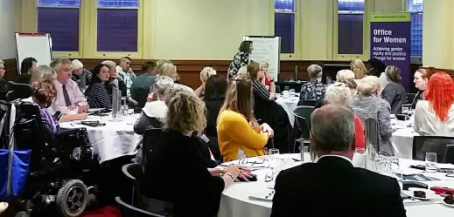
Domestic violence roundtable, Adelaide, April 2018
- enabling people at risk to seek information about a current or former partner’s violent offending history in certain circumstances (domestic violence disclosure scheme)
- improving data collection and communication across government and non-government sectors
- providing peak body funding for the Coalition of Women’s Domestic Violence Services
- providing more targeted rehabilitation for perpetrators
- co-locating services in ‘safety hubs’ across the state
- developing a personal protection app to link at-risk individuals directly to South Australia Police and women’s services
- implementing legislative reforms to support women’s safety, including ones relating to intervention orders.
A key theme that emerged during the discussion was the importance of primary prevention and early intervention. Prevention, it was said, must be a key part of targeted work with perpetrators of domestic and family violence, and of universal education programs within workplaces, schools and learning institutions.
When discussing early intervention, attendees noted that there are several critical points at which responses could be better implemented, such as when an intervention order is put in place; when there is court involvement; after separation; before and after release from prison; and with the families and children of victims or those identified as being at risk.
The success of the initial roundtable has led to a series of regional roundtables being held to enable non-metropolitan stakeholders to provide feedback on how policies and programs can best support local communities, and specifically women living in regional and remote South Australia.

Victoria:

Workplace Equality and Respect Program
Workplaces are an important site for family violence prevention and response strategies. Workplace settings provide significant opportunity to reach large sections of the population, and unique potential to reach and support vulnerable or isolated groups. There is opportunity for workplaces to play a key role in building capacity to challenge sexist, discriminatory and bullying behaviours and cultures.
In 2016–17, the Victorian Government funded Our Watch to develop and pilot workplace resources to facilitate primary prevention activities within workplaces through continuous dialogue, reflection and action. They were piloted in four Victorian workplaces, and were then refined on the basis of the pilot findings and additional stakeholder consultations.
In 2017–18, the Workplace Equality and Respect evidence-based tools were trialled across the Victorian public sector to enable them to build respectful and gender-equitable cultures; ensure that they have suitable policies for FV victims; provide adequate responses to and not allow for collusion with family violence perpetrators; and build skills and support staff in taking bystander action. Program models, tool kits, training resources and packages will be made available for use in all workplaces. The government will also review and report on options for using existing regulatory frameworks and government procurement policies to support all Victorian employers in implementing best-practice family violence policies.
Queensland case study: Creating a violence free future — Developing and evaluating a whole-school approach to respectful relationships in a primary school setting
The Queensland Department of Education is partnering with Our Watch to develop and trial a transferable whole-school approach to respectful relationships education in a primary school setting. Ten state primary schools in the South East region of Queensland have opted to be part of this innovative project.
The pilot focuses on implementing and evaluating a whole-school approach to respectful relationships education. This approach involves professional development for staff, auditing current policies and processes and engaging parents to reinforce messages regarding respect and equality received at school. Ten hours of curriculum instruction for students in years 1 and 2 is also being implemented and evaluated.
Deakin University is overseeing the evaluation of the pilot, comprehensively measuring the impact and effectiveness of the approach. The evidence generated from this pilot will inform national and international approaches to the primary prevention of gender-based violence through school settings.
One of the 10 schools participating in the pilot is Kingston State School. Kingston State School has a student population of approximately 590. Approximately 19 per cent of students identify as either Aboriginal or Torres Strait Islander and there are a large number of students from the Pacific Islands. Across its community, Kingston State School builds a strong culture of achieving personal excellence and learning, reinforced through their Vision, Mission and Values.
Kingston State School is proud to be involved with the Our Watch respectful relationships pilot in Queensland. Since starting with the pilot the school has:
- participated in data collection activities to determine where the attitudes and beliefs of the school community sit towards gender equality
- engaged in professional development for leaders to support them to lead a whole-school approach to respectful relationships education
- engaged in professional development for teachers to implement respectful relationships education
- ensured the knowledge and understanding gained by leading staff from professional development experiences has been shared with the whole teaching staff, leading to rigorous discourse, specifically around the notion of gender equality in the context of teaching and learning
- commenced curriculum instruction for Year 1 and 2 students, delivered by the school’s specialist Health teacher, with ongoing planning, consultation and reflection supported by the school’s Head of Curriculum and Guidance Officer
- provided ongoing dissemination of respectful relationships information and resources for the school and wider community through the school newsletter, social media and staff notice platforms
- engaged the wider community through an awareness-raising and information session delivered at the Family and Child Chapter for Logan Together, a collective impact project
- continued to acknowledge the critical need for respectful relationships education for the primary prevention of domestic and family violence with the Guidance Officer and Principal providing crisis support for families impacted by domestic and family violence.

National Priority Area 2: Aboriginal and Torres Strait Islander women and their children

National:

Indigenous-specific initiatives
Under this national priority area, the Commonwealth, through the Department of the Prime Minister and Cabinet (PM&C), committed $25 million for Indigenous-specific activities to address family violence against Aboriginal and Torres Strait Islander people. Across Australia, 14 Indigenous service providers have been engaged to deliver:
- trauma-informed therapeutic services for Indigenous children affected by family violence to break the cycle of intergenerational violence
- services for perpetrators to encourage behaviour change and prevent future offending
- additional holistic, case-managed crisis support to Indigenous women and children experiencing family violence through increasing the capacity of Family Violence Prevention Legal Services (FVPLS)
- intensive family-focused case management to address behaviours that lead to family violence.
Following a successful co-design process in 2016–17, led by the Indigenous business Inside Policy, the service providers continued to refine their service models and began to recruit staff. An important element of this process was establishing internal processes and referral pathways into and out of their programs, along with developing documentation such as program manuals and case note templates. The documentation will provide guidance for staff and support delivery of services that adhere closely to the evidence-based models that were developed in partnership with Inside Policy.
In 2017–18, the majority of providers commenced service delivery, although this was delayed in several organisations because of challenges with recruitment. Inside Policy provided implementation support to providers throughout 2017–18, conducting site visits and working closely with those providers that needed additional support. Inside Policy also facilitated peer-to-peer learning sessions for providers, engaging with staff from CEO level through to those working directly with clients. One of the Third Action Plan providers, the Victorian Aboriginal Child Care Agency, delivered a series of webinars on conducting risk assessments and case planning in the context of family and domestic violence. Ongoing support was also provided by PM&C, through its regional network, and will ensure providers continue to deliver high-quality services through 2018–19.
In addition to the services described above, We Al-li Pty Ltd, a specialist Indigenous organisation, was engaged to develop and deliver trauma-informed training to all 14 FVPLS providers across Australia. Through this project, FVPLS are being supported to build their workforce capacity to provide trauma-informed legal assistance and victim support services to their clients. In 2017–18, We Al-li delivered the trauma training workshops to most FVPLS providers and supported them to operationalise trauma-informed approaches by identifying Trauma Champions in each organisation. These Trauma Champions will play an integral role in ensuring that the FVPLS organisations continue to implement trauma-informed practices.

Queensland:

‘Safe at Home’ solutions for Aboriginal and Torres Strait Islander women and their children in remote areas
Following from the Doomadgee community co-design activity, the Queensland Government returned to Doomadgee in June 2018 to reaffirm the community-led decision to establish and equip a Strong Women’s Group to drive change and address domestic and family violence in the community.
The Strong Women’s Group is tasked with making safe spaces for people to go to avoid violence and to feel good, proud and strong through connecting with their culture and kin, and for community to meet and speak about culturally safe ways of addressing domestic and family violence with stakeholders and service providers.
The Doomadgee Strong Women’s Group will draw on the strengths of the Doomadgee community and incorporate the Winangali and Ipsos research learnings to drive change in community. These are that any reform in Indigenous communities should be community-led, involve the community working collectively, encourage local capacity-building and support community-owned organisations.
The Queensland Government’s response to the Queensland Productivity Commission report on its inquiry into Service delivery in Queensland’s remote and discrete Aboriginal and Torres Strait Islander communities recently affirmed these findings and made a commitment to develop improved ways of working together that are responsive to the needs of local Indigenous people and to support longer-term developmental objectives.
It is anticipated that this collective action will provide momentum and further support the Doomadgee community to identify and address gaps and optimise their success, so that, over time, the healing and the formation of respectful relationships will help to break the cycle of domestic and family violence and people will feel safe in their homes and community.
The Queensland Government respects the importance of the community-led project to drive change and address family violence in Doomadgee and will continue to work with Aboriginal and Torres Strait Islander communities through mutual respect and understanding.

Tasmania:

Aboriginal Family Safety Workers
The Aboriginal Family Safety Worker Initiative was announced by the Tasmanian Government in March 2017 under Safe Homes, Safe Families: Tasmania’s Family Violence Action Plan 2015–2020, with the objective of improving the quality and accessibility of culturally appropriate services to Aboriginal women and children affected by family violence.
Exposure to family violence has been identified as a serious risk factor to children’s development, and the wellbeing outcomes for both mothers and children. The Aboriginal Family Safety Worker Initiative responds to this evidence and to feedback from the community for enhanced frontline service responses led by Aboriginal family violence workers.
In September 2017, three Aboriginal Family Safety Workers commenced work in Child and Family Centres located in Ravenswood (North), Burnie (North West) and at tagari lia in Bridgewater (South). Aboriginal Family Safety Workers work with families and children from birth to four years (including older children within the family), accessing Child and Family Centres run by the Department of Education. They provide a protective factor for families in the Child and Family Centres community, supporting and promoting family safety while addressing the impacts of family violence on children.
Aboriginal Family Safety Workers support families by:
- facilitating referral pathways between Aboriginal community organisations and Child and Family Centres, to ensure Aboriginal families experiencing or affected by family violence are supported as they navigate the service system (including Child Safety Services)
- utilising services in their region and supporting parents to attend appointments (both specialised family violence and other wrap-around community services)
- supporting families to develop safety plans
- engaging with children in activities that model safe and secure attachment and healthy relationships
- being alert to signs of developmental delay and identifying when social/emotional/physical early intervention is needed
- collecting data that demonstrates the effectiveness of the role of community place-based intervention
- providing culturally specific advice relating to family engagement and the development of support strategies that improve the safety of Aboriginal families (including pregnant women) in the Child and Family Centres environment
- developing and building on existing networks in the Child and Family Centres and with other service partners to provide peer support specifically related to experiences encountered with family safety and family violence issues.
A Peer Reflection Action Research Model is being used to evaluate the Aboriginal Family Safety Workers Initiative to capture, analyse and document the new understandings and learnings from the establishment of the three positions and test the questions: ‘What has changed since workers have been in the community?’ and ‘What has been the impact of the role in the community?’ This model provides a process for Aboriginal Family Safety Workers to critically reflect and support ongoing qualitative research on the Initiative.
South Australia case study: Ceduna and Yalata State Aboriginal Women’s Gatherings
Ceduna Building Resilience was a joint project funded by the Australian Government Department of Social Services and the South Australian Government. The national Building Resilience initiatives aim to achieve positive outcomes for families, women and their children by working across sectors to improve the safety and wellbeing of children, advancing gender equality and reducing family violence.
To continue the work of the project, which began in 2015–16 and continued in 2016–17, the South Australian Government held two State Aboriginal Women’s Gatherings in June 2018, with a focus on supporting women and their children who have experienced domestic and family violence. A gathering was held in Yalata on 18 June and another in Ceduna on 19 June.
The South Australian Government partnered with local services to provide a safe and culturally sensitive space for Aboriginal women to come together and discuss local issues and priorities. Local services attending the gatherings included Save the Children, Women’s Safety Services South Australia, Aboriginal Advocacy and Elder Abuse, Centacare, and Drug and Alcohol Services South Australia (a South Australian Government agency). Each service led a discussion to hear from a local point of view how services and support programs are delivered in remote locations and what can be improved.
A key theme of both gatherings was the need to consult with local communities about how programs and policies affect women and their children in remote areas. In recognition of this key theme, the South Australian Government is convening a series of domestic violence roundtables to consult directly with sector stakeholders.
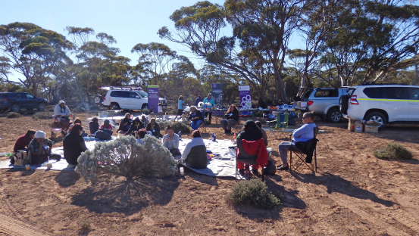
State Aboriginal Women’s Gathering, Yalata, June 2018
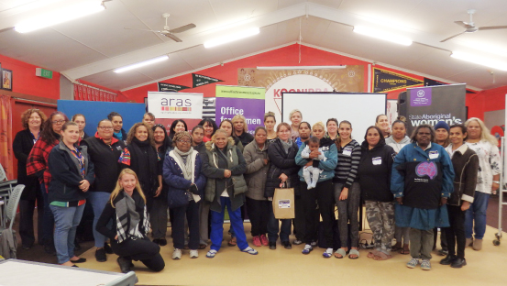
State Aboriginal Women’s Gathering, Ceduna, June 2018

National Priority Area 3: Greater support and choice

National:

Specialist Domestic Violence Units and Health Justice Partnerships
The Australian Government is providing $23.8 million over four years (2015–16 to 2018–19) to 17 legal assistance providers for the delivery of Specialist Domestic Violence Units (DVUs) and the establishment of Health Justice Partnerships (HJPs). This includes $4.9 million provided under the Third Action Plan to extend this national pilot program by one year, from 30 June 2018 until 30 June 2019. Total payments made to specialist DVUs and HJPs in 2017–18 were $6.12 million.
With this funding, specialist DVUs and HJPs have delivered a range of legal assistance services and other support to vulnerable and at-risk women, including legal advice, legal representation, duty lawyer services, case management, accommodation assistance, safety planning, counselling, financial advice and other practical assistance.
These services are located in areas of high need across Australia, covering a mix of metropolitan, regional and remote areas.
Preliminary feedback from providers, the sector and the community has been positive. Statistics gathered throughout 2017–18 indicate that the funded DVUs/HJPs have provided approximately 2700 legal services and 860 non-legal support services to around 2700 individual clients across all providers.
The funded units aim to provide short and longer-term benefits to women experiencing family violence through the delivery of tailored, wrap-around legal and support services in collaboration with partner organisations. Benefits include:
- increased legal access, literacy and positive legal outcomes
- positive outcomes with non-legal issues
- improved safety, and
- improved wellbeing through feeling respected and empowered.
Case study
Through a strategy of flexible service delivery tailored to local needs, the units are able to deliver these benefits to people such as ‘Carol’, an Indigenous woman who separated from her partner after suffering high-risk domestic violence for more than 14 years. When Carol met with her ex-partner to pass the kids into his care, he physically assaulted her in front of the kids. Carol applied for a Domestic Violence Order but was denied. Then Carol’s local DVU stepped in and helped her to successfully appeal the court’s decision and lock in a final Domestic Violence Order for five years.

Australian Capital Territory:

Family Safety Hub
As part of the Safer Families package announced in the 2016–17 Budget, and supplemented in the 2017–18 Budget, the Australian Capital Territory Government invested $23.5 million in a family violence package to address domestic and family violence in the territory. A component of this package is the Family Safety Hub.
The Family Safety Hub was originally envisaged as an integrated service approach. After the community, frontline service workers and the Australian Capital Territory Government undertook an 18-month co-design process, the Family Safety Hub was shaped into something different in 2017–18.
The Family Safety Hub is a catalyst for change, officially launched in May 2018. It serves as a completely new approach to domestic and family violence in the territory — one that works with the community to tackle one problem at a time and generate fresh ideas that we can use to make real changes for the better. The Family Safety Hub brings the right people together to co-design, pilot and scale up innovative solutions to challenges in domestic and family violence. This helps to better address people’s needs and build shared understanding and capability across the system. With each challenge, the aim is to solve some of the toughest problems contributing to domestic and family violence.
Initial challenge topics were established based on research insights to better understand issues facing the territory community — and the changes required for better preventing, intervening in and supporting recovery from domestic and family violence.
The first challenge focused on ‘early intervention opportunities for pregnant women and new parents experiencing or at risk of domestic and family violence’ and commenced in May 2018. Bringing together frontline workers and cross-disciplinary professionals resulted in four ideas to be developed further to tackle this challenge:
- free legal advice in hospitals and child and family centres
- a campaign focusing on reducing stigma for seeking help
- involving fathers
- addressing reproductive coercion.
Through intensive co-design, research and development, these ideas are being refined to develop prototypes and pilot tests. An evidence-based evaluation is used across the entire process to build a business case for scaling up. The advantage of this approach is that it enables ideas to be learned and improved quickly, creating new services developed by and for the community.

Northern Territory:

Redevelopment of the Alice Springs Women’s Shelter
The Northern Territory Government is strongly committed to reducing the significant rates of domestic and family violence across the Northern Territory. This requires an effective and sustainable domestic and family violence service and support system, including women’s shelters.
In 2017, the Northern Territory Government awarded a $6 million capital works grant to help the Alice Springs Women’s Shelter redevelop its facility to better service the needs of the victims of domestic and family violence in Alice Springs.
The current 30-bed facility consists of a number of buildings that have grown piecemeal over the past 30 years. Some of the buildings are flood-affected and the type of accommodation available is not suited for women and children recovering from domestic violence. The redevelopment will provide the same number of beds but will be reconfigured to provide greater flexibility, and capacity for more suitable grouping arrangements.

Tasmania:

Safe Choices
Safe Choices is a free non-crisis service that delivers ongoing practical and positive support and assistance to Tasmanians affected by family violence. Safe Choices was established in June 2016 as an action under Safe Homes, Safe Families and is delivered by CatholicCare Tasmania. Safe Choices provides statewide information, advice and referrals to everyone who contacts the program. Safe Choices understands the different forms that family violence can take and works with all members of the Tasmanian community, including women, men, lesbian, gay, bisexual, transgender, and intersex people, people from the Cultural and Linguistically Diverse community, and the Aboriginal community.
“I was referred to Safe Choices by Child Protection … I had been in an abusive marriage for 13 years. I am so thankful that I now have support. [The Safe Choices team] have listened, validated and empowered me to take the steps needed for our safety.”
Safe Choices offers an alternative pathway into safety planning, exit planning, assistance and support for those who may choose not to use the justice response to family violence.
Using a case management model, Safe Choices is able to offer longer-term support to families to help them rebuild their support and social networks and re-engage with the community.
“Safe Choices helped me at a time when I was most helpless and vulnerable. They have taught me life skills and given me my independence and autonomy back.”
Following a staged roll-out, Safe Choices now has a reach across the whole of Tasmania, with offices in Burnie, Hobart and Launceston, and regularly provides a presence to remote communities such as Queenstown, Rosebery and Smithton.
Through its 1800 phone line, Safe Choices provides information about what family violence is, and information on the services available to community members, self-referral to service providers, and potential referring agencies. The 1800 line is diverted to either the northern office or the southern office and provides advice and information, assessments and intakes.
The program also operates an outreach service and has connections to Neighbourhood Houses, community centres and Child and Family Centres where workers are able to meet with clients in a safe and understanding environment.
Support to clients includes:
- family violence education
- safety planning
- identifying support needs
- referrals to relevant services
- support with navigating legal issues
- emotional support
- support with navigating the justice system.
“[Safe Choices] came to me when I never knew if I could keep on going [and] helped me see I could make a life again.”
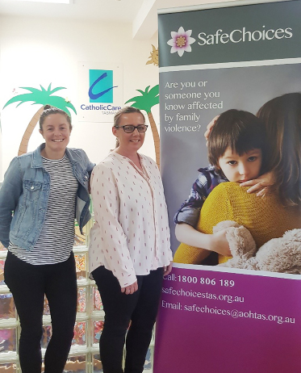
Safe Choices Launceston workers
Western Australia case study: Pets in Crisis
In July 2017, the Royal Society for the Prevention of Cruelty to Animals (WA), in partnership with the Department for Communities, established the Pets in Crisis program. The initiative supports the National Plan to Reduce Violence against Women and their Children 2010–2022 and the Western Australia Government’s Stopping Family Violence policy by providing greater support and choice for families affected by violence.
Pets in Crisis provides a temporary home and foster care of pets for up to three months for families affected by domestic violence, until the family can arrange permanent, safe accommodation. Pets in Crisis collaborates with women’s refuges across the Perth metropolitan area and establishes an easy pathway for victims’ pets to be safely accommodated away from perpetrators of violence. Pets are provided with veterinary and animal health care, rehabilitation, behaviour training services and after-care support. All pets are required to be sterilised, vaccinated and microchipped or this is arranged with the families at a reduced cost. Pets in Crisis has the capacity to care for 30 pets at any one time. Pets in Crisis is a free service and accessible by referral only.
Pets in Crisis is assisted by Vet West and the Women’s Council for Domestic and Family Violence Services (WA). Pets in Crisis has had a great start, with positive feedback from families that the program has provided valuable support and assurance in knowing their pets are loved and cared for while they are re-establishing their lives following family and domestic violence.

National Priority Area 4: Sexual violence

National:

Office of the eSafety Commissioner — image-based abuse
One in four Australian women has experienced emotional abuse from a current or former partner, and one in six has experienced physical abuse. In almost all of these cases, technology played a role — in the abuse, control and stalking of women. Image-based abuse, or the sharing of intimate images without consent, is a form of technology-facilitated abuse, with one in 10 adult Australians having a nude or sexual photo or video posted or shared online without their consent.
In response to this issue, the eSafety Office launched its image-based abuse portal in October 2017, for Australians to report the abuse and seek its removal online. It also offers practical advice, resources and access to support services to help victims manage the devastating impacts of this abuse.
At 30 June 2018, the Office had received 259 reports, relating to 401 separate URLs and/or locations, with material being available across 130 different platforms. To date, the Office has been able to remove images reported to it in around 80 per cent of cases — despite the fact that most websites are hosted overseas.
No two reports are alike, but behavioural trends observed from reports include anonymous sharing, sextortion, threatened sharing of intimate images, and image-based abuse as a manifestation of coercive control in the context of domestic or family violence. The Office’s experience is that victims are mainly female, and the primary concern of most victims is for quick removal of the material.
The Office responds to reports quickly to ensure victims are safe and supported and works with them to have the images removed. The report resolution approach focuses on:
- taking action — seeking rapid removal of material
- ensuring the victim is safe — if a victim’s personal safety is at risk, the Office will refer them immediately to police
- providing support — distressed victims receive an immediate referral to an appropriate expert counselling service.
The Australian Government’s Enhancing Online Safety (Non-Consensual Sharing of Intimate Images) Bill 2017 was introduced to the Senate on 6 December 2017. The legislation would increase the Office’s effectiveness in having image-based abuse material removed by strengthening its powers to apply pressure on website owners, hosting providers, social media services and perpetrators.
It is also critical to provide domestic and family violence frontline workers with the skills and knowledge they need to assist their clients who may be experiencing image-based abuse. The recently launched eSafetyWomen—online training for frontline workers program incorporates a dedicated module covering this important issue.
Case study
A woman who had been in an abusive relationship reported to the Office after her ex-partner took control of her social media accounts and posted intimate images and videos of her online. The Office was successful in having the material removed. The woman had a protection order in place, which included a provision prohibiting her ex-partner from posting images and video of her. With the woman’s consent, the Office provided information to the police, at their request, which assisted the police in charging the woman’s ex-partner for a number of offences, including breaching the protection order.

Developing laws to penalise the non‑consensual sharing of intimate images
On 23 November 2016, the Minister for Communications and the then Minister for Women, Senator the Hon. Michaelia Cash, announced that the Australian Government would conduct a public consultation process on a proposed civil penalty regime for the non-consensual sharing of intimate images (colloquially known as ‘revenge porn’ or image-based abuse). As part of that process, the Department of Communications and the Arts released a discussion paper in May 2017 and held face-to-face public workshops in July 2017. Feedback from stakeholders informed the development of the Enhancing Online Safety (Non-consensual Sharing of Intimate Images) Bill 2018, which was introduced in the Senate on 6 December 2017. On 14 February 2018, the Bill was passed in the Senate, with amendments.
The Bill will amend the existing Enhancing Online Safety Act 2015 to introduce a civil penalty regime to combat the non-consensual sharing of intimate images. The primary amendments will:
- prohibit the non-consensual posting of, or threatening to post, an intimate image on a ‘social media service’, ‘relevant electronic service’, (e.g. email and SMS/MMS), or a ‘designated internet service’ (e.g. websites and peer-to-peer file services)
- establish a complaints and objections system, to be administered by the eSafety Commissioner, where victims, or a person authorised on behalf of a victim, will be able to lodge a complaint directly with the eSafety Commissioner where there is reason to believe that an intimate image has been posted (or threatened to be posted) without consent
- facilitate the removal of an image where a person initially consented to an image being posted and then changed their mind and now wishes to have the image removed, by enabling them to give the eSafety Commissioner an ‘objection notice’
- introduce a civil penalty regime to be enforced by the eSafety Commissioner, who will have the power to use a graduated range of responses against both perpetrators and content hosts.
The Bill complements current criminal laws and the online complaints portal pilot, which was launched by the eSafety Commissioner on 16 October 2017. The Bill has since been passed by Parliament.

Northern Territory:

Sexual Violence Prevention Framework
The Northern Territory Government is currently developing a Sexual Violence Prevention Framework in response to the recommendations of both the Northern Territory Royal Commission and the Royal Commission into Institutional Responses to Child Sexual Abuse.
This strategy is a key commitment under the Northern Territory Domestic, Family and Sexual Violence Reduction Framework 2018–2028 Safe, respected and free from violence.

National Priority Area 5: Responding to children living with violence

national:

Family Law Amendment (Family Violence and Other Measures) Act 2018
The Family Law Amendment (Family Violence and Other Measures) Act 2018 commenced operation on 1 September 2018. The Act expands and clarifies the conferral of family law jurisdiction on state and territory courts, including by allowing state and territory children’s courts to be prescribed to have parenting jurisdiction under Part VII of the Family Law Act 1975. The intent is to enable children’s courts to make appropriate orders under the Family Law Act where there are existing proceedings before the court, particularly in child protection matters.
In the 2017–18 Mid-Year Economic and Fiscal Outlook, the Australian Government announced that it would provide $0.5 million over two years to pilot the increased exercise of family law jurisdiction under the Act in selected state and territory courts in up to three jurisdictions. The Attorney-General’s Department (AGD) has negotiated a grant agreement with the Northern Territory to support a pilot of enhanced parenting jurisdiction in the Family Matters Division of the Darwin Local Court. The pilot is due to commence in March 2019, subject to the making of relevant regulations. AGD is also conducting formal negotiations with other jurisdictions about potential participation in a pilot. The pilots will allow participating jurisdictions to demonstrate and measure the benefits of state and territory courts exercising family law jurisdiction when hearing related state or territory matters, particularly where vulnerable families are experiencing family violence. The pilots will also gather data on the potential resourcing impacts and system efficiencies for courts and other parts of the justice system, including, where relevant, the child protection system. They will run until 30 June 2020 and will be independently evaluated to inform the future implementation of the Act in all states and territories.
Following the completion of the National Domestic and Family Violence Bench Book (a national online resource for judicial officers) in June 2017, AGD updated its content in 2018. AGD also funded the National Judicial College of Australia (NJCA) to develop and deliver family violence training for judicial officers in all jurisdictions (federal family law, state and territory) that preside over matters involving family violence. This training program was delivered through 13 sessions to 323 judicial officers from across Australia. AGD has also funded the NJCA to develop and deliver family law training for state and territory judicial officers. This training is currently being rolled out across Australia. AGD has also funded Legal Aid NSW (on behalf of National Legal Aid) to redevelop the National Training Program for Independent Children’s Lawyers.

Service system responses to the needs of children to keep them safe from violence
The Commonwealth is funding the Australian Catholic University to analyse what happens in practice to children and their families where there is domestic and family violence and reports have been made to child protection authorities. This project provides a clearer empirical picture of the nature of families that seek and either succeed or fail to engage with the child protection and family violence system, as well as their experiences of this process. This has helped to facilitate effective collaboration and information sharing between the family law, family violence and child protection systems.
The study:
- identifies how the domestic and family violence and child protection service systems respond to the needs of children and keep them safe from violence
- assesses how these service interventions impact on women who are experiencing family and domestic violence
- identifies the challenges and risks of policies and service responses for children exposed to domestic and family violence and the child protection system.
The study has used data-gathering techniques to:
- develop a profile of the children and families reported to child protection with issues of domestic and family violence
- identify and map service responses, including the use of safety plans and other actions taken, such as referral
- make recommendations on how community-based and government services should recognise and respond to violence.
The Australian Catholic University has drafted a research report identifying services gaps between child protection and family violence systems and possible benefits of collaborative service models. It has also drafted a ‘Research to Practice’ publication to aid the implementation of the research.

Victoria:

Reform to the child and family services sector
Victoria’s establishment of Support and Safety Hubs provides women, children and families with quick and simple access to the support and safety that they need. Significant reform to the child and family services sector focuses on identifying and addressing issues earlier and improving the way services work together to better meet the needs of vulnerable children and families. This aligns with efforts to target services towards early intervention and prevention through the Roadmap for Reform: strong families, safe children.
This work will be complemented by more diverse and accessible crisis and longer-term accommodation options for victims of family violence and their families, as well as flexible support packages and greater access to therapeutic support to assist people in their recovery and to live safe, stable and independent lives into the future.
The Victorian Government has acted to ensure that services that work with children and families can better identify and support women and children who have experienced family violence. This includes providing:
- $81.1 million to strengthen the Maternal and Child Health service. This investment will better support children’s development in the early years of life and enable earlier identification and interventions for families experiencing vulnerability. This includes strengthening the Maternal and Child Health response to family violence through workforce training and additional Maternal and Child Health visits for at-risk families
- $38.4 million to provide an enhanced role for universal services providers, in keeping with the Royal Commission’s recommendation to implement a whole-of-hospital model to put in place an enduring and integrated system response to family violence across public hospitals.
To better support vulnerable children and families to recover and thrive, the Victorian Government invested $29.2 million in family services to assist an additional 1229 families and expand the supports available, particularly for families requiring intensive assistance. To improve family services and align with the roll-out of the Support and Safety Hubs, over 2017 a new model of family services was developed with the community sector. This will ensure that family services are equipped to span the continuum of risk — both to prevent escalation into crisis and to remain with families experiencing complex difficulties and support them to transition away from the system. This process will also break down many of the existing program barriers.
Further action by the Victorian Government to keep children safe included:
- embedding practice change so that child protection practitioners can better identify and assess family violence risk, implementing several recommendations of the Royal Commission
- placing community-based child protection practitioners in the Support and Safety Hubs to provide expert advice on the safety and wellbeing of children and provide access to any history of assessment and intervention by Child Protection
- investing $71.1 million to employ more than 450 additional child protection practitioners, who will be able to spend more time working closely with the families and children that need it most. The funding will also provide additional capacity in after-hours emergency child protection services and ensure continuation of the Specialist Intervention Unit, which provides practice guidance to Child Protection service teams
- refocusing Child Protection on its core, statutory functions to free up the time of highly skilled practitioners to focus on managing the risks to children and helping families to provide a safe home for their children
- investing $59.6 million to support children and young people who are unable to live safely at home, including:
  - continuing to fund approximately 120 lapsing targeted care packages and funding approximately 100 new ones to continue to reduce placements in residential care and provide supports tailored to a child’s or young person’s circumstances and needs
  - delivering an additional 1982 home-based care placements for children who are unable to live at home, rather than having them enter residential care.
The Victorian Government has worked closely with Aboriginal communities to improve the safety and wellbeing of Aboriginal children in, or at risk of entering, the child protection and out-of-home care systems. As part of the government’s commitment to Aboriginal self-determination and self-management, the Victorian Government invested $1.1 million to further expand the number of Aboriginal Community Controlled Organisations assuming legal guardianship for the welfare of Aboriginal children subject to a Children’s Court protection order, allowing community-led, culturally appropriate decisions regarding Aboriginal children, which we know leads to better outcomes.

Northern Territory:

Safe, Thriving and Connected: Generational Change for Children and Families 2018–2023
Safe, Thriving and Connected: Generational Change for Children and Families 2018–2023 is the Northern Territory’s plan to implement reforms to better support children, young people and families experiencing vulnerability and to deliver the recommendations of the Royal Commission into the Protection and Detention of Children in the Northern Territory. To address the impact of domestic and family violence on young children, and in recognition of the link between child safety and domestic and family violence, the Northern Territory Government will reform the family support service system to better support children and families at risk of or experiencing domestic and family violence.

Queensland:

Stop the Hurting — End Domestic Violence Youth Campaign
The report of the Special Taskforce on Domestic and Family Violence — Not Now, Not Ever: Putting an End to Domestic Violence in Queensland — identified the need for a comprehensive communication strategy to challenge community attitudes and increase awareness and understanding of and action in response to domestic and family violence.
Central to the Queensland Government response is the Domestic and Family Violence Prevention Engagement and Communication Strategy 2016–2026. The strategy comprises several campaigns targeting specific population groups (for example, youth, bystanders and the LGBTIQ community) over three years.
The goal of the first communication campaign, Stop the Hurting — End Domestic Violence, was to influence behaviour and attitudes of 12- to 17-year-old Queenslanders to help break the intergenerational cycle of domestic and family violence.
Youth were targeted in this first campaign, as research shows that early adulthood is a life stage during which prospects for prevention are particularly strong. Educating children and young people is also key to breaking the intergenerational cycle of behaviours and attitudes on domestic and family violence.
The campaign’s objectives were to: begin removing the sense of ‘shame’ associated with domestic and family violence and challenging the current behaviour of keeping the issue behind ‘closed doors’; increase awareness that domestic and family violence is unhealthy behaviour, and not just physical (for example, economic and psychological abuse); and provide help-seeking information.
The campaign was co-designed with young people from Aboriginal and Torres Strait Islander communities and tested with non-Indigenous youth. Extensive research was also undertaken to better understand the youth target group (including behaviours, media habits, how to reach them and how to get their attention).
The campaign commenced in June 2017 with a multi-pronged media approach including: a music slam competition (hip-hop), youth music workshops (urban and regional), a youth advertisement campaign (television, cinema, out-of-home and digital media) and a social media campaign.
The campaign was evaluated using a range of data collected during and after the campaign. The evaluation analysed the campaign reach, impact and delivery modes, as well as youth attitudes towards domestic and family violence and the campaign. It found that there was generally a high awareness of the campaign among youth (for example, more than 163,000 teenagers reached through Facebook and Instagram posts, and more than 1.7 million unique views of display and video activity on platforms such as YouTube and Snapchat). The campaign was found to have had a positive impact in changing the knowledge and attitudes of young people towards domestic and family violence, and their willingness to take action. For example, a large majority (80%) of teenagers recalled seeing advertising about domestic and family violence without prompting, and almost all (95%) indicated that they would feel more comfortable taking action in response to domestic and family violence as a result of seeing the campaign. It was evident that digital and social media are the most effective channels to reach the audience.
The campaign was recognised at the Annual Brisbane Advertising Awards in September 2017, receiving two silver medals and four bronze medals across various creative excellence categories.

National Priority Area 6: Keeping perpetrators accountable across all systems

Victoria:

Risk Assessment and Management Panels
Following two successful pilots, 18 Risk Assessment and Management Panels (RAMPs) were rolled out across the state from June 2016. RAMPs are formally convened monthly meetings, held at local level, of representatives from key agencies and organisations that contribute to the safety of women and children experiencing serious and imminent threat from family violence. By working together, they can better facilitate the safety of family violence victim survivors, and focus on men who pose a serious and imminent threat, to prevent them from perpetrating harm and to hold them accountable for their actions. RAMPs provide a response to women and their children at critical levels of risk, who require a comprehensive, multi-agency risk assessment and management action plan.
Following the roll-out of the RAMPs, work has continued to embed the new operational practice, provide continued workforce development and address system barriers so that the RAMPs can operate as effectively as possible. An Information Usage Arrangement issued by the Commissioner for Privacy and Data Protection, is in place to enable the RAMPs to share the information required to make appropriate decisions for risk assessment and management. This supports the operation of RAMPs prior to broader information-sharing legislative reform being implemented, as recommended by the Royal Commission into Family Violence.
In June 2017, the Victorian Parliament passed the Government’s legislation to create a specific family violence information-sharing regime. The implementation of new information-sharing arrangements will support the continued operation of the RAMP model and create a more permissive information-sharing environment.
Comprehensive RAMP training sessions are delivered by the Statewide RAMP Coordinator (through the Domestic Violence Resource Centre Victoria). This training, along with detailed operational guidelines, ensures that RAMP members are well placed to contribute to the RAMP process and understand the model and their own roles and responsibilities.
The RAMP Information Sharing System has been rolled out across the state to support better information sharing and promote the consistent delivery of the RAMP program. The operation of RAMPs will be reviewed after the delivery of other key initiatives (such as the redeveloped Family Violence Risk Assessment and Risk Management Framework, the new information-sharing regime and the Support and Safety Hubs) to ensure there is consistency across these operations.

New South Wales:

Expansion of the Men’s Behaviour Change Network
The Men’s Behaviour Change Programs (MBCPs) are a specialist service for men who use violence and abuse in their intimate, domestic and family relationships. The MBCPs aim to help men take responsibility for and to stop perpetrating violent, controlling and abusive behaviours, and also provide contact, safety planning and support for women and their children while the women’s current or former male partners attend the MBCP. The underlying premise of MBCPs is that men are accountable and responsible for their actions, and programs are responsive to the needs of women and children and prioritise their safety.
In 2017–18, the New South Wales Government expanded community-based men’s behaviour change interventions, with a particular focus of commencing new programs in previously unserviced areas, including rural and remote areas and areas with high rates of domestic and family violence reoffending. In 2018–19, the New South Wales Government will invest $4.5 million in non-government organisations to lead community-based perpetrator interventions (men’s behaviour change programs) and build the capacity and capability of the sector.
New South Wales case study: Men’s Behaviour Change Network – perpetrator interventions
George has been married to Martha for 11 years and they have two children aged 10 and five years. George contacted the Men’s Behaviour Change Program at the urging of his wife, who was unhappy with their relationship and with George’s parenting of the children.
After two intake interviews, George was accepted into the Men’s Behaviour Change (MBC) Group and attended the full 32-week program. Martha was referred to Partner Support.
Martha was initially reluctant to engage with Partner Support, but agreed to regular phone calls from the Partner Support Worker. After a few weeks, Martha disclosed that George was regularly physically and sexually abusive and that she was continually frightened of him. She wanted to end the relationship but was concerned about George’s response. Martha was supported to understand the dynamics of abuse, develop safety strategies for her and the children, and create a stronger sense of choice and agency.
George regularly attended the MBC group, but the facilitators noted that George frequently avoided discussions of personal responsibility. They decided to increase the intervention with George, so that he would also begin weekly one-to-one sessions. These sessions helped George to reflect on the physical abuse George used in his family; the way he exerted control over the behaviour of his wife and children; and his avoidance of responsibility in the MBC group. As the one-to-one sessions progressed, George’s engagement in the MBC group increased.
George completed all 32 weeks of the MBC program. In his exit interview, George noted that he was finding his internal adjustment of values difficult but that he was beginning to understand the idea of entitlement and responsibility, and that committing to non-violence and the safety of others was a never-ending process of awareness and monitoring. George refused the offer of further one-to-one support.
Martha continued with Partner Support for a further six months. During that time she and George separated, George left the house and they negotiated child care arrangements.
Three months later George decided to take up the offer of regular one-to-one support. This support is ongoing.

Western Australia case study: Good practice approaches
In 2017, the Western Australia Department of Communities contracted Stopping Family Violence Inc. (SFV) to support phase two of the Implementation of Good Practice Approaches in Responding to Perpetrators of Family and Domestic Violence.
SFV continues to represent an important link between policy, research and practice in perpetrator responses at both state and national levels. SFV aims to cultivate expertise and foster positive collaborative relationships by facilitating the Men’s Behaviour Change Program Network and other stakeholder activities and events. These are important forums to promote information dissemination, collaborative practice, discussion and debate, and drive a cohesive research and development agenda. SFV is also an active member of various advisory, reference and strategic groups that provide expert advice and support to perpetrator response related projects.
A critical area of work in 2017–18 has been the development of a monitoring and quality assurance framework for the implementation of Practice Standards. This has entailed engaging with key stakeholders to increase awareness of the importance of a quality accreditation process for the sector in Western Australia. SFV also developed a comprehensive training package to support Men’s Behaviour Change Program practitioners in Western Australia to gain the skills required for their work, consistent with the National Outcome Standards for Perpetrator Interventions and the Western Australia Practice Standards for Perpetrator Intervention: Engaging and Responding to Men who are Perpetrators of Family and Domestic Violence. SFV continues to work across jurisdictions, engaging with service providers, supporting program evaluation and continuous improvement, and helping to develop a comprehensive evaluation framework for the Western Australia context. SFV has prepared a discussion paper that aims to help develop and pilot an outcomes framework for the Men’s Behaviour Change Program sector. SFV will officially launch this discussion paper in late 2018.
SFV has recognised the need to develop an evidence base that underpins practice when responding to perpetrators. The family and domestic violence sector has a limited research base, which SFV has helped to build through its involvement in three national research projects in collaboration with ANROWS. These projects aim to gain a greater understanding of the Australian perpetrator interventions, analyse current pathways and practice, identify gaps in practice, and offer evidence-based solutions through the establishment of practice guidelines and policy.
SFV has begun working on an integrated men’s behaviour change and alcohol and other drug intervention project with a specific focus on Aboriginal perpetrators in the Kimberley. The project aims to pilot a response to family and domestic violence perpetrators with alcohol and other drug issues, reduce family and domestic violence and improve community safety. SFV has also become an official partner of the Safe and Together Institute and provides Safe and Together training to a wide range of stakeholders seeking to become more informed about domestic violence in their work.

Queensland:

Specialist domestic and family violence courts
The report of the Special Taskforce on Domestic and Family Violence — Not Now, Not Ever: Putting an End to Domestic Violence in Queensland — identified the critical role of the justice system in responding to domestic and family violence, to keep victims safe and hold perpetrators to account. The report called for a specialist court approach to dealing with domestic and family violence matters. In response to the taskforce’s recommendations, the Queensland Government commenced a trial of a specialist domestic and family violence court in Southport in September 2015. The trial involved both civil applications for protection orders and criminal matters related to domestic and family violence. Following the success of the trial and an evaluation conducted by Griffith Criminology Institute, the Queensland Government committed funding of $69.5 million over four years in the 2017–18 Budget to:
- roll out specialist domestic and family violence courts in Beenleigh and Townsville, with circuits to Mount Isa and Palm Island
- establish the Southport specialist domestic and family violence court as a permanent court.
The specialist domestic and family violence court model is multidisciplinary and collaborative. It is acknowledged that the court process is a touchpoint for service delivery, enhancing victim safety and ensuring perpetrator accountability. This includes giving perpetrators strong encouragement to stop using violence as well as appropriate sanctions.
An important outcome of the specialist court, both medium-term and long-term, is increasing perpetrator accountability. Compared to a court that does not operate a specialist domestic and family violence court:
- victim participants at specialist domestic and family violence courts report higher levels of agreement that the wrongfulness of the behaviour had been communicated in the courtroom
- victim assessments that the perpetrator had been held to account by the specialist domestic and family violence court Magistrate are slightly higher
- perpetrator participants at specialist domestic and family violence courts are significantly more likely to agree that their behaviour needs to change
- stakeholders working at specialist domestic and family violence courts have a strong sense that the specialist nature of the court contributes to offender accountability
- enhanced police practices (evidence-gathering, the internal review of charge decisions, the active filing of substantial criminal charges where there is sufficient evidence) as well as specialist police prosecutors were seen as contributing to perpetrator accountability within the specialist criminal jurisdiction.
The Southport specialist domestic and family violence court trial received two awards at the Prime Minister’s 2017 Awards for Excellence in Public Sector Management.

Key website links
For more information on initiatives being delivered under the National Plan and the Third Action Plan:
www.plan4womenssafety.dss.gov.au
https://www.dss.gov.au/women/programs-services/reducing-violence/the-national-plan-to-reduce-violence-against-women-and-their-children-2010-2022
For more information on programs funded under the Third Action Plan:

1800RESPECT
www.1800respect.org.au
www.1800respect.org.au/daisy

DV-alert
www.dvalert.org.au

ANROWS
www.anrows.org.au

Our Watch
www.ourwatch.org.au

Stop it at the Start Campaign
www.respect.gov.au

The Line
www.theline.org.au

White Ribbon Australia
www.whiteribbon.org.au

eSafetyWomen
www.esafety.gov.au/women

Australian Capital Territory initiatives
Safer Families
www.women.act.gov.au
http://www.communityservices.act.gov.au/safer-families

New South Wales initiatives
www.facs.nsw.gov.au/domestic-violence
NSW Domestic and Family Violence Prevention and Early Intervention Strategy 2017–2021
www.women.nsw.gov.au/violence_prevention/dfv-prevention-intervention-strategy
Women’s Strategy
https://www.women.nsw.gov.au/women_and_work/womens_strategy
Sexual Assault Strategy
https://www.women.nsw.gov.au/violence_prevention/nsw-sexual-assault-strategy
2017–18 NSW budget summary — domestic and family violence
https://www.facs.nsw.gov.au/__data/assets/pdf_file/0004/417910/2017-18-NSW-Budget-Domestic-and-Family-Violence.pdf
Innovation Fund
https://www.women.nsw.gov.au/violence_prevention/innovation-fund
The NSW Domestic and Family Violence Blueprint for Reform 2016–2021: Safer Lives for Women, Men and Children.
https://www.women.nsw.gov.au/violence_prevention/blueprint

Northern Territory initiatives
The Northern Territory’s Domestic, Family and Sexual Violence Reduction Strategy 2018–2028 — Safe, Respected and Free from Violence
https://territoryfamilies.nt.gov.au/domestic-violence/domestic-and-family-violence-reduction-strategy
Safe, Thriving and Connected: Generational Change for Children and Families 2018–2023
https://rmo.nt.gov.au/

Queensland initiatives
Queensland Domestic and Family Violence Prevention Strategy 2016–2026 and Action Plans
https://www.csyw.qld.gov.au/campaign/end-domestic-family-violence/dfvp-strategy
Queensland Violence Against Women Prevention Plan 2016–2022
https://www.csyw.qld.gov.au/violence-prevention/violence-against-women-prevention-plan–2016–22
Service delivery in Queensland’s remote and discrete Indigenous Communities
https://www.qpc.qld.gov.au/inquiries/service-delivery-in-queenslands-remote-and-discrete-indigenous-communities/
https://stopthehurting.initiatives.qld.gov.au/
Queensland Courts – Specialist Domestic and Family Violence Court
https://www.courts.qld.gov.au/courts/domestic-and-family-violence-court

South Australia initiatives
www.officeforwomen.sa.gov.au

Tasmania initiatives
www.dpac.tas.gov.au/safehomessafefamilies
Responding and Reporting — Progress report on Safe Homes, Safe Families: Tasmania’s Family Violence Action Plan 2015–2020
http://www.dpac.tas.gov.au/__data/assets/pdf_file/0006/266073/Safe_Homes_Safe_Families_-_Action_plan.pdf

Victoria initiatives
https://www.vic.gov.au/familyviolence.html
Free from violence: Victoria’s strategy to prevent family violence and all forms of violence against women
https://www.vic.gov.au/familyviolence/prevention-strategy.html
https://www.vic.gov.au/women.html
Safe and Strong: A Victorian Gender Equality Strategy
https://www.vic.gov.au/women/gender-equality/a-victorian-gender-equality-strategy.html

Western Australia initiatives
http://www.parliament.wa.gov.au/publications/tabledpapers.nsf

The Prevention of Family Violence Bill 2018 (the Bill) was introduced to the Victorian Parliament on 20 June 2018. The Bill was passed on 23 August 2018, and a minor amendment made by the Legislative Council on 5 September 2018, effectively enshrined Respect Victoria in law.
Note: UVAWS = Understanding of Violence Against Women Score; GEAS = Gender Equality Attitudinal Score; CASVAWS = Changes in Attitudinal Support for Violence Against Women Score
Note the partner violence infographic in Figure 3 relates to violence by a cohabiting partner; see the Australian Bureau of Statistics website for further details.
This means the initial counsellor provides the trauma-specialist counsellor with the information, with the caller still on the line, to avoid the caller needing to re-tell their story.
Australian Bureau of Statistics 2017, Cat. No. 4906.0 — Personal Safety, Australia, 2016
Office of the eSafety Commissioner 2017, Image-based abuse — National survey: Summary report
This case study is an aggregation of various similar reports received and has been de-identified to protect the victim’s confidentiality.
The Bill was passed by Parliament on 23 August 2018 and commenced on 1 September 2018.

