Eligibility, Referral and Commencement Guidelines

V1.2
Disclaimer
This document is not a stand-alone document and does not contain the entirety of Disability Employment Services Programme Providers' obligations. It should be read in conjunction with the Disability Employment Services Deed and any relevant Guidelines or reference material issued by the Department of Social Services under or in connection with the Disability Employment Services Deed.

Contents
Eligibility, Referral and Commencement Guidelines 3
Document Change History: 3
Disability Employment Services Deed Clauses: 4
Additional Clauses: 4
Reference documents relevant to these Guidelines: 4
Explanatory Note: 4
Eligibility 5
Overview 5
Eligibility requirements for DES 5
Specific job seeker groups 6
Employment Benchmark hours 7
Requirement to complete the Disability Employment Services Privacy Consent Form 7
Flow Chart - Disability Employment Services - Determining Eligibility 8
Referral and Commencement 9
Background 9
Provider Choice 9
Direct Registration 9
Flow Chart - Creating Sessions in the Electronic Diary 10
Creating Appointments to receive Referrals to Programme Services using the Department’s IT Systems: 12
Flow Chart - Referrals to Programme Services and conducting an Initial Interview 15
Disability Employment Services Privacy Consent Form 20

Eligibility, Referral and Commencement Guidelines

Document Change History:

Version | Start Date | Effective Date | End Date | Change & Location
1.2 | 12 September 2015 | 12 September 2015 |  | Update of terminology
1.1 | 29 June 2015 | 29 June 2015 | 11 September 2015 | Removed content related to Section 23.
1.0 | 17 Dec 2014 | 9 Mar 2015 |  | Original version of guidelines

These Guidelines specify a Disability Employment Services (DES) Programme Provider’s (hereon referredto as ‘DES Provider’) responsibilities and required actions for confirming eligibility, receiving Referrals and Commencing a job seeker in DES.

Disability Employment Services Deed Clauses:
Clause 81 – Referrals
Clause 87 – Appointments with Participants
Clause 88 – Initial contacts
Clause 89 – Contact services

Additional Clauses:
Clause 18 – Business level expectations
Clause 59 – Transition Out
Clause 132 – the Department may reduce the number of Referrals to the Provider

Reference documents relevant to these Guidelines:
Direct Registration Guidelines
Referral for an Employment Services Assessment Guidelines
Eligible School Leaver Guidelines
Job in Jeopardy Guidelines
Disability Management Service – Special Class Clients Guidelines
Disability Support Pension Recipients Under 35 Years in DES Guidelines
Disability Management Service Participants Not Receiving Income Support Guidelines
Providing Disability Employment Services to Pre-release Prisoners Guidelines
Service Fees Guidelines
Contacts Guidelines
Period of Service Guidelines
Programme Review Guidelines
Transfer Guidelines
Records Management Instructions Guidelines Documentary Evidence for Claims for Payment Guidelines Job Seeker Classification Instrument Guidelines
Funding Level Tool Guidelines

Explanatory Note:
- All capitalised terms have the same meaning as in the Disability Employment Services Deed (the Deed).
- In this document, ‘must’ means that compliance is mandatory and ‘should’ means that compliance represents best practice.
- Shaded areas in the flow charts denote activities that are undertaken by the Participant, the Department or Centrelink.

Eligibility

Overview
This section of the Eligibility, Referral and Commencement Guidelines provides an overview of eligibility criteria for Disability Employment Services (DES). It explains general eligibility criteria, as well as eligibility criteria for specific job seeker groups. It also outlines the role of the Employment Services Assessment (ESAt) or Job Capacity Assessment (JCA) in determining job seeker eligibility and provides eligibility criteria for ESAt/JCA exempt groups.

Role of the ESAt/JCA in determining eligibility
In most cases, job seekers will be Referred to DES Providers following an ESAt or JCA. The ESAt or JCA will determine which service a person is Referred to based on the nature of their disability, injury or health condition. With the exception of ESAt/JCA exempt job seekers, job seekers who are Referred to DES must have a valid ESAt/JCA with a recommended referral of either DES – Employment Support Service (DES-ESS) or DES - Disability Management Service (DES-DMS).

Note: A DES Provider can only Commence a job seeker who has a valid ESAt/JCA with a recommended referral for the service which the DES Provider is contracted to deliver.

ESAt/JCA Exempt Job Seekers
While most job seekers will be referred to an ESAt or JCA Assessor to determine their eligibility for DES, specific job seeker groups can Directly Register with a DES Provider and are not required to undertake an ESAt or JCA. The job seeker groups that are eligible to commence in DES without an ESAt or JCA are:
- Eligible School Leavers (ESL) – refer to the Eligible School Leaver Guidelines;
- Special Class Clients (SCC) – eligible for DES-DMS only (refer to the Disability Management Service – Special Class Clients Guidelines); and
- Job in Jeopardy (JiJ) Participants - refer to the Job in Jeopardy Guidelines.
These job seekers can be immediately Commenced in DES provided that they meet general DES eligibility requirements and the specific eligibility requirements set out in the relevant guidelines.

Specialist Service Providers
DES Providers contracted as Specialist Service Providers assist a self-defined group of job seekers (for example, job seekers with hearing impairment, intellectual disability or youth). In accordance with the DES Deed Clause 78.2, Specialist Service Providers must not Commence a Participant who is not a member of the relevant Specialist Service Group for which the Provider is contracted to deliver Programme Services.

Eligibility requirements for DES
General Eligibility
A job seeker is eligible for Disability Employment Services if they:
- have a disability, injury or health condition;
- are aged at least 14 but have not yet attained 65 years of age;
- are at or above the minimum legal working age in their State or Territory;
- have a future work capacity with intervention of at least 8 hours per week;
- are an Australian resident (see information below);
- are not studying full time (unless the job seeker is an Eligible School Leaver); and
- are not working at or above their Employment Benchmark hours (not applicable for Job in Jeopardy Participants).

Australian Resident
To be eligible for DES a job seeker must be an Australian resident. The only exception to this requirement is where a job seeker is a Temporary Protection Visa (TPV) holder (see Note 2 below for more information).

An Australian resident is a person who resides in Australia and is one of the following:
- an Australian citizen;
- the holder of a permanent resident visa; or
- a special category visa holder (SCV) who is a protected SCV holder (see Note 1).

Note 1: New Zealand citizens living in Australia who have not been granted permanent residency are generally holders of protected or non-protected SCVs. Only New Zealand citizens who hold protected SCVs are eligible for DES. A New Zealand citizen who is a protected SCV holder is someone who:
- was in Australia on 26 February 2001 as a SCV holder
- was outside Australia on 26 February 2001, but was in Australia as a SCV holder for a total of 12 months in the two years prior to that date, and subsequently returned to Australia
- has a certificate issued under the Social Security Act 1991 stating that they were residing in Australia on a particular date. (These certificates are no longer issued)
New Zealand citizens who do not meet these requirements eg. they are arrived in Australia after 26 February 2001, are non-protected visa holders and are ineligible for DES.

Note 2: From 1 July 2014 eligible job seekers who are not permanent residents but who hold a current TPV, can access DES - ESS. TPV holders are not eligible for DES – DMS.

Specific job seeker groups
Workers Compensation Recipients
Job seekers who are receiving workers compensation payments are generally considered to be employed and are therefore ineligible for DES unless they are required to participate in DES as a condition of receiving income support payments from Centrelink.

Job seekers who are working
Job seekers who are working may be eligible for DES, as long as they are not working at or above their Employment Benchmark hours at the time of Commencement. When determining whether a job seeker is working at or above their Employment Benchmark hours, the DES Provider should consider the hours that the Participant normally works in their job, discounting periods of leave or recently reduced/increased hours. Please note - a DES Provider should keep documentary evidence to support their decision.

Job seekers who are studying
Full-time students are ineligible to Commence in DES, with the exception of Eligible School Leavers (ESL). Job seekers who are undertaking part-time study may be eligible to Commence in DES provided they are looking for work and meet all other eligibility criteria.

Participants turning 65 and/or transferring to the Age Pension
If a job seeker is already in DES and turns 65 and/or transfers to the Age Pension, they can choose to remain in DES. If they are working toward an outcome, the DES Provider is still eligible for outcome fees due. However, once exited, they will no longer be eligible to Commence in DES.

Pre-release Prisoners
Pre-release Prisoners may be referred by a State or Territory Corrective Service to a DES Provider. Pre-release Prisoners may be Directly Registered by DES Providers and will be referred for an ESAt to determine the appropriate employment service. Refer to the Providing Disability Employment Services to Pre-release Prisoners Guidelines.

Employment Benchmark hours
Employment Benchmark hours are the number of hours that a Participant must work each week, on average, to achieve a Full Outcome. Participants will have an Employment Benchmark of 0, 8, 15 or 30 hours per week. The Employment Benchmark is determined by the Department’s IT Systems and is generally based on a Participant’s work capacity as assessed through the ESAt or JCA. Refer to the Outcome Guidelines for further information.

Requirement to complete the Disability Employment Services Privacy Consent Form
Where a job seeker is referred to a DES Provider by Centrelink a Disability Employment Services Privacy Consent Form (Attachment A) must be completed and signed by both the job seeker and the DES Provider prior to Commencing the job seeker in DES. The purpose of the Form is to advise the job seeker about privacy arrangements in relation to their personal information and to gain the job seeker’s consent for the DES Provider to share this information with other parties including other government organisations and employment services Providers. The Disability Employment Services Privacy Consent Form does not need to be completed for job seekers who are directly registered as privacy information is included in the DES Direct Registration Form which must be signed by both the job seeker and the DES Provider.

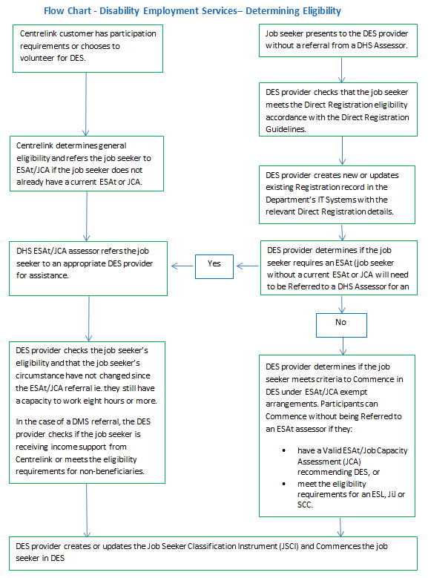

Referral and Commencement

Background
This section of the Eligibility, Referral and Commencement Guidelines specifies a DES Provider’s responsibilities and required actions for receiving Referrals of and Commencing eligible job seekers.

While ESAt Assessors or JCA Assessors will generally determine the programme for which a Referred job seeker is eligible, DES Providers must undertake some checks of a job seeker’s eligibility for DES once a job seeker is Referred (refer to the DES Direct Registration Guidelines for more information).

Job seekers are not required to be in receipt of an Income Support Payment to be eligible for DES. However, where a job seeker is Referred to DES – DMS who is not receiving Income Support Payments from Centrelink, the job seeker must meet the income test for non-beneficiaries or belong to one of the other cohorts to be eligible (refer to Disability Management Service Participants Not Receiving Income Support Guidelines).

Provider Choice
In most cases a job seeker will be Referred to DES by a Department of Human Services (DHS) ESAt or JCA Assessor. Referrals can also be made by Centrelink, the Department, jobactive Providers or by another DES Provider.

Job seekers can choose a DES Provider from the list of available Providers in their Employment Services Area (ESA) (subject to the Disability Employment Services Deed), at the time of initial Referral. To inform this choice, Centrelink provides information about the services available in the job seeker’s local area including the Provider’s Star Rating. DES Providers also provide information about their services to Centrelink and DHS ESAt and JCA Assessors.

Job seekers will be Referred to a DES Provider who is contracted to deliver services in the ESA in which they reside. In certain circumstances, job seekers may choose to go to a DES Provider from outside the ESA in which they reside eg. where a job seeker chooses to go to a Specialist DES Provider. In this circumstance, the job seeker may select a Specialist DES Provider who delivers services to a defined Specialist Service Group, provided that the job seeker is a member of that defined group. Please refer to the DES Direct Registration Guidelines for more information about the requirements for servicing job seekers who do not reside in a DES Provider’s ESA including specific requirements for ESL and JiJ Participants.

If the job seeker does not select a DES Provider, the Department’s IT Systems will randomly allocate them a generalist DES Provider.

Direct Registration
DES Providers can register job seekers who approach them directly for services. This is known as Direct Registration. Where a job seeker has a Valid ESAt or JCA, a DES Provider may Commence a job seeker in DES after they Directly Register the job seeker without referring them for an ESAt. Where a job seeker does not have a Valid ESAt or JCA, a DES Provider will generally refer the job seeker to a DHS Assessor. Refer to the DES Direct Registration Guidelines for more information.

Creating Sessions in the Electronic Diary
The DES Provider must ensure that sessions are available in the Electronic Diary to receive Appointments.

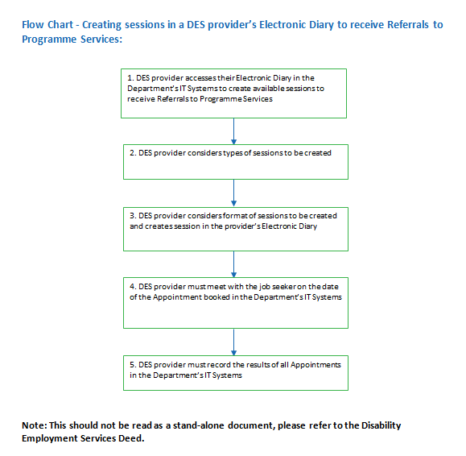

Creating Appointments to receive Referrals to Programme Services using the Department’s IT Systems:

Who is Responsible: | What is Required:
1. The DES Provider  DES Provider accesses their Electronic Diary on the Department’s IT Systems to create available sessions to receive Referrals to Programme Services. | DES Providers must ensure that they have the correct access levels and security levels to create sessions in their Electronic Diary on the Department’s IT Systems.  DES Providers should consider the following when deciding on how many sessions to create:  - the organisation’s market share within the specified ESA;  - the programmes which have been identified by the DES Provider to be delivered at that Site; and  - any subcontracting arrangements the DES Provider may have in place.
2. The DES Provider  DES Provider considers types of sessions to be created. | DES Providers must ensure that their Electronic Diary has the following types of sessions:  - Initial Interview;  - Re-engagement (including for the purpose of Reconnection); and  - Contacts, which may be booked by Centrelink and ESAt Assessors, following a Change of Circumstance Reassessment or a Programmes Review by an ESAt Assessor.  DES Providers must ensure that their Electronic Diary always has available Appointments for all of the above session types within the next two Business Days, unless otherwise agreed with the Department.
3. The DES Provider  DES Provider considers format of sessions to be created and creates session in the DES Provider’s Electronic Diary. | When deciding on the format of the session the DES Provider should consider whether it is an individual or a group session.  Note: All sessions will be automatically available to all DES programmes delivered at that Site. The session format will default to an individual session.
4. The DES Provider  DES Provider must meet with the job seeker on the date of the Appointment booked in the Department’s IT Systems. | The DES Provider must meet with the job seeker and conduct the Contact, Initial Interview or Re-engagement Appointment at the Appointment time (date) as recorded in the Department’s IT Systems.
5. The DES Provider  DES Provider must record the results of all Appointments in the Department’s IT Systems. | Appointment results must be recorded on the same day as the Appointment (or as soon as possible thereafter). Appointment results cannot be recorded as ‘attended’ until the job seeker has presented at the time of the Appointment.  - End of Process.

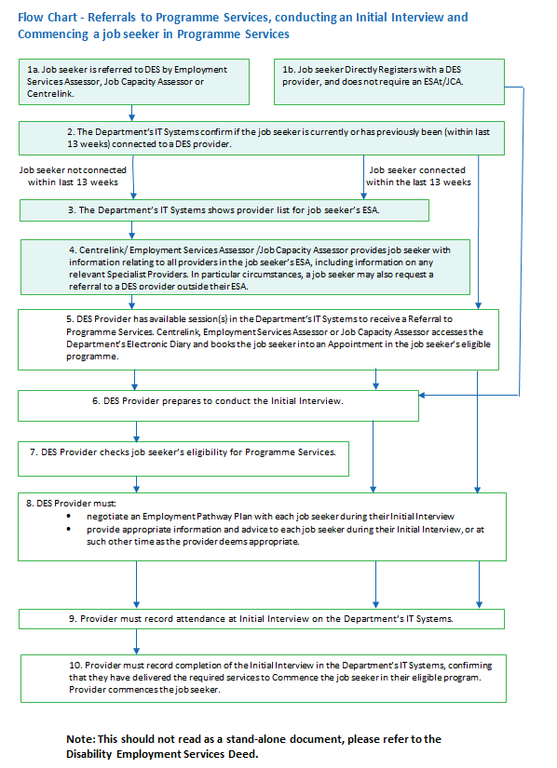

Referrals to Programme Services and conducting an Initial Interview

Who is Responsible: | What is Required:
1a. Job seeker  Job seeker is Referred to DES by an Employment Services Assessment or Job Capacity Assessment. | A job seeker has attended Centrelink or an ESAt/JCA and is Referred to a DES Provider.  Note: If the referral is the result of a Change of Circumstances Reassessment or a Programme Review for the job seeker the DES Provider will be required to make an Appointment after receiving notification of the assessment outcome.
1b. Job seeker  Job seeker Direct Registers with a DES Provider. | Job seeker Direct Registers with a DES Provider in accordance with the Direct Registration Guidelines.
2. The Department  The Department’s IT Systems confirm if the job seeker is currently or has previously been (within last 13 weeks) connected to a Disability Employment Services Provider. | The Department’s IT Systems will check the job seeker’s record and determine if the job seeker is connected with a DES Provider, or has been connected with a DES Provider within the last 13 weeks.  - If the job seeker has not been connected with a DES Provider in the last 13 weeks, Proceed to Step 3  - If the job seeker is currently connected with a DES Provider, or has been within the previous 13 weeks, the job seeker must remain with that DES Provider, unless the Provider does not deliver the Programme Services required, Proceed to Step 5  - If the job seeker has been connected with a DES Provider in the previous 13 weeks, but that Provider does not offer the Programme Services required (as a result of a new ESAt/JCA or Ongoing Support Assessment), Proceed to Step 3
3. The Department  The Department’s IT Systems shows DES Provider list for job seeker’s ESA. | The Department’s IT Systems will display a list of all DES Providers servicing the job seeker’s ESA and eligible Programme Service to Centrelink and the Employment Services Assessor/Employment Services Assessor.  In some circumstances Job seekers may also specifically request to be Referred to a DES Provider out of their ESA, such as a Specialist Provider which services the job seeker’s particular characteristics.
4. Employment Services Assessor/Job Capacity Assessor  Employment Services Assessor/Job Capacity Assessor provides job seeker with information relating to all DES Providers in the job seeker’s ESA, including information on Specialist Service Providers, if any. | To enable job seeker choice, Centrelink, Employment Services Assessors and Job Capacity Assessors will supply, where available, the following information about DES Providers, with available market share, to assist the Participant to make an informed choice:  - Performance Ratings for Disability Employment Services;  - Specialist Service Providers;  - location;  - assistance provided by DES Providers; and  - any information provided under local arrangements for job seekers’ information (this may include organisational pamphlets, Fact Sheets, or other information that related to the Services they deliver).  If a job seeker selects a DES Provider they will be Referred to that Provider. If the job seeker elects not to select a DES Provider they will be allocated a generalist DES Provider based on a Provider’s ESA Business Share and available Appointments.
5. The DES Provider  DES Provider has available session(s) in the Department’s IT Systems to receive a Referral to DES. Centrelink, books the job seeker into an appointment in the job seeker’s eligible Programme. | It is the responsibility of DES Providers to create sessions at the site level in the Department’s Electronic Diary to receive Referrals for a job seeker’s Programme.  The job seeker selects a DES Provider from the list of Providers and Centrelink, the Employment Services Assessor or Job Capacity Assessor books an Appointment for the job seeker from the selected Appointments in the DES Provider’s Electronic Diary. Centrelink, the Employment Services Assessor or the Job Capacity Assessor then notifies the job seeker of the appointment details.
6. The DES Provider  DES Provider prepares to conduct the Initial Interview. | DES Providers will be alerted to Referrals via booked Appointments in their Electronic Diary.  Where the job seeker is being Directly Registered and is identified as being ESAt/JCA exempt, or already has a current and valid ESAt/JCA with a recommended referral of Disability Employment Services, the DES Provider may proceed to the Initial Interview (refer to the Direct Registration Guidelines) without having to arrange an ESAt for the job seeker.  DES Providers should complete the following pre-interview checks:  - checking that an ESAt/JCA report has been submitted (if one was needed to determine eligibility);  - attempting to contact the Participant to confirm the appointment via the Participant’s preferred contact method. The Department’s IT Systems will automatically send an Appointment reminder via mobile phone or email, if that is the preferred method of contact. Note: reminder messages are sent as a service to assist Participants – they are not a notification for the purposes of compliance action;  - making arrangements to cater for a job seeker’s special needs, if required. If needed, the DES Provider is to contact the job seeker to reschedule for a time when the special needs arrangements are available; and  - checking previous participation, any ESAt/JCA information, Comprehensive Compliance Assessments, and previous Employment Pathway Plans.  Note: Centrelink will only book Appointments with a DES Provider for a time after they expect to have submitted the ESAt /JCA report.  DES Providers are required to cater to a Participant’s special needs and should consider whether any of the following apply to the Participant:  - the need for an interpreter service  - a Job Seeker Incident Report (JSIR);  - a vulnerability; or  - whether the job seeker has a disability requiring assistance (e.g. wheelchair access).
7. The DES Provider  DES Provider must check job seeker’s eligibility for Programme Services. | DES Provider must check that the job seeker meets the eligibility criteria including:  - is aged between 14 and 65 years of age;  - is an Australian resident or is a TPV holder;  - is not studying full time (unless the job seeker is an Eligible School Leaver); and  - is not working at or above their employment benchmark hours (not applicable for Job in Jeopardy Participants).  In addition, for a DES-DMS Participant who is not in receipt of an Income Support Payment, before Commencing the job seeker the DES Provider must first check that the job seeker meets the non-beneficiary income test or belongs to one of the other cohorts in accordance with the Disability Management Service Participants Not Receiving Income Support Guidelines.  Checking information in the Job Seeker Classification Instrument (JSCI)  Information from the JSCI, in conjunction with information from Centrelink and the Job Capacity Assessment, is used to determine the Funding Level for Participants in the Employment Support Service.  For DES-ESS Participants it is important that DES Providers check to ensure all JSCI information is completed in order that the correct Funding Level is calculated for each Participant.  Some updates to the JSCI are able to be undertaken directly by the DES Provider. Please see the Job Seeker Classification Instrument Guidelines and Funding Level Tool Guidelines for more information.
8. The DES Provider  DES Provider must provide the specific information and services to all job seekers, regardless of their Programme.  Document References:  Employment Pathway Plan Guidelines | At the Initial Interview, the DES Provider must:  - check that they are talking to the correct Participant  - explain the types of services that may be provided in the relevant Programme;  - explain the relevant Service Guarantee and the Code of Practice;  - explain to an Activity Tested job seeker their rights and obligations under Social Security Law and the consequences of not meeting their obligations; and  - explain to a Disability Support Pension (DSP) recipient under 35 years of age, who is subject to participation requirements, their rights and obligations regarding compulsory activities.  During the Initial interview the DES Provider must negotiate an Employment Pathway Plan with each Participant, which includes any Interventions required at that point.  DES Providers may choose to complete the appropriate résumé summary fields in the Department’s IT Systems.
9. The DES Provider  DES Provider must record attendance at Initial Interview on the Department’s IT Systems. | DES Provider confirms attendance at the Initial Interview by recording that the Initial Interview was ‘attended’ by the job seeker in the Electronic Diary in the Department’s IT Systems.
10. The DES Provider  DES Provider must record completion of the Initial Interview in the Department’s IT Systems, confirming that they have delivered the required services to Commence the Participant in their eligible Programme. | DES Providers will be asked to confirm they have delivered all services and information to the Participant required under clause 88 of the Deed.  The Department will confirm that all requirements for Commencement in DEShave been met ¹. Ideally the Participant will be Commenced at the Initial Interview. If not, the Participant must be Commenced in their Programme within 5 working days of Referral or Direct Registration ². The Participant’s Period of Service starts at this point.  Note 1: If the DES Provider has not delivered all services and information to the Participant, the DES Provider should not select the confirmation in the Department’s IT Systems. The Participant must not be Commenced in their eligible Programme until all of the required services have been delivered. The DES Provider can go back to this confirmation at a later date, once they have delivered all of the required services and information to the Participant.  Note 2: Every endeavour must be made to Commence the Participant within 5 working days. For those Participants who Directly Register and must be referred to an ESAt before Commencement, every endeavour must be made to Commence the Participant within 5 working days of the ESAt being submitted.  If, however, under exceptional circumstances, Commencement within 5 working days is not possible, the DES Provider must keep adequate documentary evidence for the reason/s.

Attachment A

Disability Employment Services Privacy Consent Form

Privacy and Your Personal Information

The personal information collected by your Disability Employment Services (DES) Provider, on behalf of the Department of Social Services (the Department), is subject to restrictions imposed on its disclosure, collection and use by the Privacy Act 1988 (Cth) (Privacy Act). DES Providers are obliged, in accordance with the terms of their funding agreements, to comply with the Privacy Act when collecting, using and disclosing the personal information of customers.
Your personal information is collected for the provision of employment services to:
- determine your eligibility for participation in DES, which is delivered by DES Providers
- provide you with employment and training opportunities
- evaluate and monitor outcomes, programmes and services provided by DES Providers
- facilitate resolution of complaints made by you or your DES Provider, and
- allow for inclusion of your name in surveys conducted by the Department or on behalf of the Department.
The consequence of not providing some or all of your personal information is that the Department cannot ensure that you are provided with suitable employment assistance.

Your personal information may be passed on to: the Department of Social Services, the Department of Human Services; the Department of Education and Training; the Department of Immigration and Border Protection, the Department of Employment and the Department of the Prime Minister and Cabinet and their respective contracted service Providers for the purpose of employment-related services where those agencies are involved in delivering employment-related services related to you. Your personal information may also be disclosed between DES Providers in the event your existing Provider cannot provide services to you and you are transferred to another Provider.

Limited personal information will be provided to Call Centre operators, who are under contract to the Department to enable them to re-issue passwords for access to your personal page on JobSearch.
Your personal information may also be used by the Department or given to other parties where you have agreed or it is required or authorised by or under an Australian law or a court/tribunal order.

The Department’s Privacy Policy contains more information about the way it will manage your personal information, including information about how you may access your personal information held by your DES Provider and or the Department and seek correction of such information. This Privacy Policy also contains information on how you can complain about a breach of your privacy rights and how the Department will deal with such a complaint. Click here to obtain a copy of the Department's Privacy Policy or you request a copy from the Department at DSSfeedback@dss.gov.au.

Declaration by Disability Employment Services Participant:

By signing below:

I give consent for the Disability Employment Service Provider providing me with employment assistance to use on my behalf, and disclose as required to the Australian Government, some or all of my personal information for the purposes of employment-related services.

I acknowledge that my personal information may be transferred to a new Disability Employment Service Provider in the event that my existing Disability Employment service Provider cannot provide services for any reason.

I acknowledge that the disclosure of some or all of my personal information to the Australian Government will occur strictly for the purposes of assisting the Australian Government and agencies to improve employment and related services.

Name: _____________________________

Address: _____________________________

Date of Birth: _____________________________

Job Seeker ID: _____________________________

Signed: _____________________________

Date: _____________________________

Declaration by Disability Employment Services Provider:

By signing below, I declare that I have explained to the Disability Employment Service Participant that:

Personal information the Disability Employment Services Participant is asked to provide, is collected for the purposes of providing Disability Employment Services.

The Disability Employment Service Provider may be required from time to time, to pass some or all of the Disability Employment Service Participant’s personal information to the Australian Government, for the purposes of improving employment and related services or to a new Provider in the event that the Disability Employment Service Participants’ existing Provider cannot provide services for any reason. This Disability Employment Service Provider may not yet have a contract for the delivery of Disability Employment Services in place.

Name: _____________________________

Address: _____________________________

Signed: _____________________________

Date: _____________________________

