The National Plan to Reduce Violence against Women and their Children
Easy Read version
How to use this document
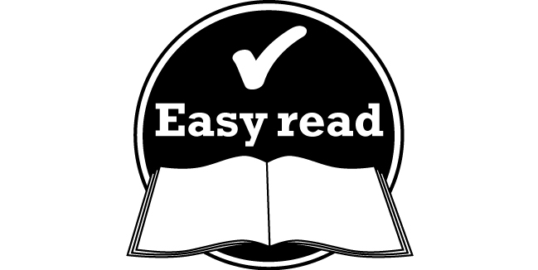 This information is written in an 'easy to read' way.
We use pictures to explain some ideas.
Some words are written in bold. We have explained what these words mean. There is also a list of these words on page 18.
This document is a summary of a longer document.
You can find the original document on the Department of Social Services website.
Please contact us if you would like to receive this information in other formats. Our contact details are:
Email: npsecretariat@dss.gov.au

If you are experiencing problems with domestic violence or sexual assault, please call 1800RESPECT on 1800 737 732.
Contents
What is violence? 4
What is domestic and family violence? 4
What is sexual assault? 4
Why do we need a National Plan? 6
What we are going to do 8
What we will do 9
How we will know we are making a difference 10
Encouraging respectful relationships 11
Strengthening Indigenous communities 13
Making sure that services meet the needs of women and children 15
Making sure that the legal system meets the needs of women and children 16
Working with people to stop them from hurting others 18
Making sure the plan is working 19
Word list 20

What is violence?
This document is about reducing violence in our community.
Violence is an act that hurts you or another person. It may be:
- physical – hurting your body
- emotional – hurting your feelings
- sexual – making you do sexual things you don’t want to do
- mental – threatening you, putting you down, trying to control you or harming your mind.

What is domestic and family violence?
Domestic violence is a problem that occurs between people who are in a relationship.
It is abusive.
It is threatening.
Domestic violence usually occurs at home.
And it often occurs between family members. This is also called family violence.
Domestic violence is often about power. It occurs when one person tries to have more power than another in a relationship.

What is sexual assault?
Sexual assault is when a person hurts another person in a sexual way.
This might include:
- rape, or being made to have sex with someone you don’t want to have sex with
- being hurt with an object
- being made to watch sex or pornography, including movies and images of people having sex .
In Australia today, 1 in 3 women has experienced physical violence. 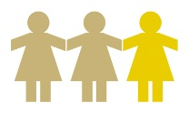
Almost 1 in 5 has experienced sexual violence. 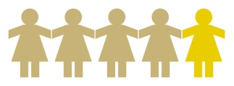
Almost all Australians understand that violence is a crime.
In some communities, violence is worse than in others. For example, Indigenous women and girls are 35 times more likely to end up in hospital because of family violence than other Australian women and girls.
Violence affects all kinds of women, including:
- women who come from a range of cultures
- women living in rural and remote areas
- older women.
Violence also affects children.
Men experience violence too. However, they are more likely to experience violence from strangers and in public. Women are more likely to experience violence at home or in the family.
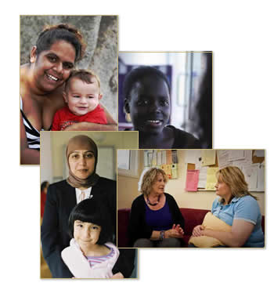

Why do we need a National Plan?
We can all work together to reduce violence against women and their children.
Governments from all around Australia will work with the community to reduce violence against women and their children.
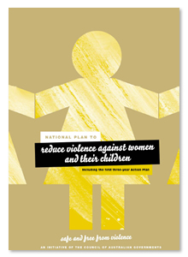
The National Plan to Reduce Violence against Women and their Children is our way of doing this.
We are focusing on these types of violence:
- domestic and family violence
- sexual assault.
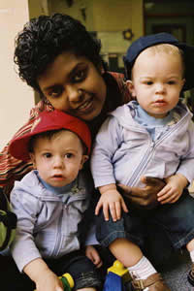
We want to make improvements that will last for a long time, such as:
- building respectful relationships
- encouraging men and women to treat each other as equals
- preventing violence from happening in the first place
- making sure that people who hurt others are held responsible for their actions
- offering more services to people who hurt others to help them stop using violence.

What we are going to do
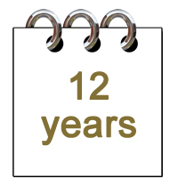 We want Australian women and their children to live free from violence in safe communities.
Our Plan is for the next 12 years.
There are 4 stages to our Plan:
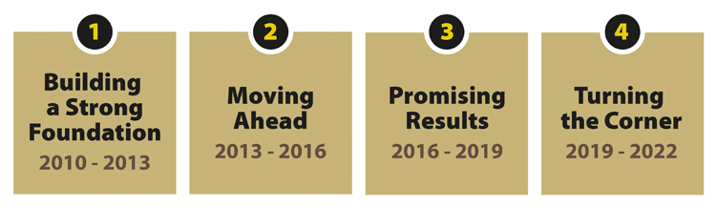
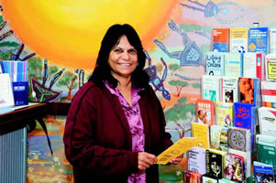Over this time, we will:
- reduce violence against women and their children in the community
- increase the number of women who feel safe in the community
- reduce the number of people who die because of domestic violence or sexual assault
- reduce the number of children who see violence in the home.
Making sure that communities are safe and free from violence
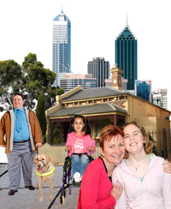 We want our communities to be safe places to live.
We want women and children to feel safe.
To do this, we need to change the way some people think about women.
We need to encourage equality between men and women.
We want people in our community to learn that violence is not acceptable and that women have the right to feel safe.

What we will do
We will work to change the way people think. We will do this by:
- providing information
- working with the media to improve the way they talk about violence
- providing grants for communities to help prevent violence
- improving the way we work in all areas where violence can be prevented.
For example, we currently have a great website called The Line. This website is for young people and it helps them understand that violence is wrong and that there are things that can be done about it.
And soon we will ask people questions with two surveys – the Personal Safety Survey and the National Survey on Community Attitudes towards Violence against Women. This will help us to understand what people think about violence in our community.

How we will know we are making a difference
We will know that we are making difference when more people in the community say that violence is wrong.

Encouraging respectful relationships
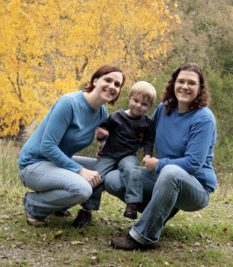 We want to encourage people to treat each other with respect.
And we want to help people to have healthy relationships.
This is an important part of life for children and young people. If adults behave with respect, children and young people will learn from them.

What we will do
We will do the following things:
- provide information about healthy relationships through schools
- run programs about healthy relationships
- support adults to behave with respect
- encourage men to lead happy, healthy lives that are free of violence.
We will continue to run the following programs:
- Respectful Relationships education projects across Australia
- White Ribbon Day – a campaign that supports men who don’t accept violence against women
- Mensline – a national phone number that men and boys can call for help and advice: 1300 789 978
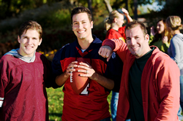 Here’s a great example of the work being done in Respectful Relationships education programs. The ‘Sex and Ethics’ program is run by the University of New South Wales and the University of Western Sydney. They are working with under 16 and under 18 rugby players to help these young men develop respectful relationships.
Here are some quotes from young men who took part in the program:
“One of my mates was trying to take advantage of a drunk girl and my girlfriend and I put the drunk girl in a cab and sent her home.”
“I was at a party, and my mate wanted to have sex with a girl who was drunk.
I told him he shouldn’t, told him what could happen.”
“There are many forms of sexual assault.”
“Treat women with respect.”

How we will know we are making a difference
We will know that we are making difference when more people treat each other with respect – especially young people.

Strengthening Indigenous communities
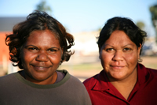 We want to support Indigenous communities to reduce violence against women and children.
We want women in these communities to have a say about how we can make things better.
And we want to work together – with communities and with all areas of government – to improve things for Indigenous people.

What we will do
We will do the following things:
- provide local programs
- build skills
- provide education
- respond quickly to areas where there are urgent needs for improvement
- work with communities to reduce drug, alcohol and substance abuse
- improve police responses
- develop community safety plans
- improve support services.
Examples include:
- continuing the Indigenous Family Safety Program
- providing training about domestic and family violence to nurses and health workers.

How we will know we are making a difference
We will know that we are making difference when:
- Indigenous women can have more of a say about what is happening in their communities
- the amount of violence in Indigenous communities is reduced.

Making sure that services meet the needs of women and children
There are many services in the community to help women and children who are victims of domestic violence or sexual assault.
We want to improve these services. And we want to help all the different services work together.
This way, we can make sure that women get the right services at the right time.

What we will do
We will do the following things:
- expand counselling services
- support services who are helping women and children
- encourage other services in the community – such as health services – to show women the right way to get support.
A good example of the work we are doing is the 1800RESPECT Domestic and Sexual Violence National Counselling Service. People can ring this service on 1800 737 732 for help and advice. We want to expand this service and make it better.

How we will know we are making a difference
We will know that we are making difference when more women have access to services.

Making sure that the legal system meets the needs of women and children
Domestic violence and sexual assault are crimes.
This means that they are against the law – the set of rules that we all must follow.
In our community, there are people who are responsible for making sure that we all follow the law. These people are:
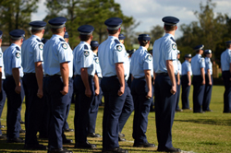 police
the people who work in the courts, such as lawyers and judges
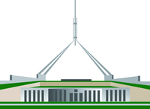 governments.
Together, these people make up the legal system.
We would like women to know that they can tell people who work in the legal system if they have been hurt.
And we would like to support women as they deal with the legal system.

What we will do
We will do the following things:
- Improve the ways that women can find legal services and use the legal system.
- Encourage people in the legal system to understand and stand up against violence.
- Help the legal system to work with other services in the community to help reduce domestic violence and sexual assault.
- Make changes to the law to help victims of family violence.
- Make improvements to domestic or family violence orders. These are the rules and instructions that the courts give to people who have acted violently. We want to make sure that these orders are recognised all around Australia.

How we will know we are making a difference
We will know that we are making difference when more women are reporting domestic violence and sexual assault.
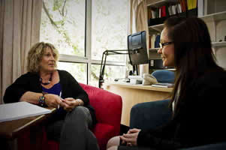

Working with people to stop them from hurting others
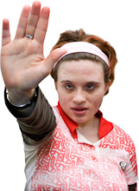 People need to know that violence is not acceptable.
We want to help people who hurt others.
We want to help them to change their behaviour.
We want to stop them from behaving that way again.

What we will do
We will do the following things:
- Research ways that we can help people who hurt others to stop using violent behaviour.
- Support states and territories to run good programs for people who hurt others. We want to make sure that these programs work well and are getting good results.
- Improve the way that the legal system supports people.

How we will know we are making a difference
We will know that we are making a difference when less people hurt others or use violent behaviours.

Making sure the plan is working
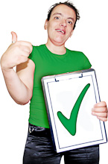 It’s important for us to regularly check that the plan is working.
We will do the following things:
- Create a National Centre of Excellence where work and research will take place.
- Gather more information about violence in our community. The more we know about what is happening, the more we can do. We will run 2 surveys:
- the Personal Safety Survey
- the National Survey on Community Attitudes towards Violence against Women.
These surveys will give us a better idea about the way people think about violence.
They will also help us to understand the amount of violence that is taking place in our community.
Over time, we hope to see less and less violence.
- Work together with state and territory governments.
- Provide a progress report to the Government every 3 years.
- Provide a final report after 12 years.

Word list
Domestic or family violence orders
The rules and instructions that the courts give to people who have acted violently. They may apply to domestic or family violence.
Domestic violence
This is a problem that occurs between people who are in a relationship. It is abusive. It is threatening.
Domestic violence usually occurs at home. And it often occurs between family members. This is also called family violence.
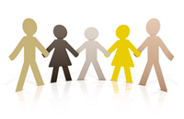
Equality
When people are treated the same, as equals.
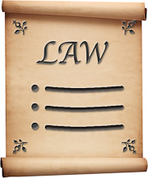
Law
The law is the set of rules that we all must follow.
Legal system
The legal system is made up of:
- police
- the courts
- governments.
Together, these people make sure we are all following the law.
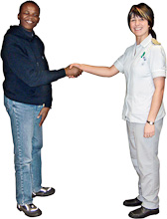
Respect
Treating someone with fairness, kindness and dignity.
Sexual assault
Sexual assault is when a person hurts another person in a sexual way.
This might include:
- rape, or being made to have sex with someone you don’t want to have sex with
- being hurt with an object
- being made to watch sex or pornography, including movies and images of people having sex .
Violence
An act that hurts another person. It may be:
- physical – hurting your body
- emotional – hurting your feelings
- sexual – making you do sexual things you don’t want to do
- mental – threatening you, putting you down, trying to control you or harming your mind.
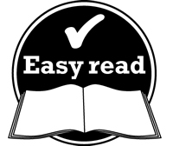
This Easy Read document was created by the Information Access Group using PhotoSymbols, stock photography and custom images.

