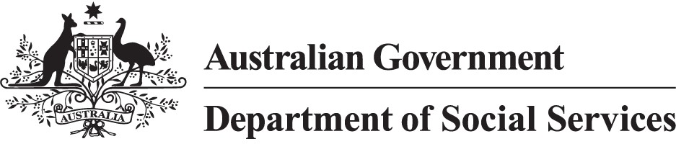
This directory is limited to program, and services funded by Department of Social Services, National Indigenous Australians Agency and Department of Health and Aged Care.
For more information about enhanced Income Management and the SmartCard visit servicesaustralia.gov.au/smartcard or call the SmartCard eIM hotline on 1800 252 604.

Support Services Summary

Directory – Doomadgee
July 2023

Support Services Summary Directory – Doomadgee
This directory provides an overview of contacts for available support services.

Managing money

Name | Contact details
The Uniting Church in Australia Property Trust | 1800 007 007
Financial Counselling Australia Ltd | (07) 4051 1224

Food and emergency relief

Name | Contact details
The Salvation Army (New South Wales) Property Trust | 1800 007 007
St Vincent de Paul Society Queensland | 1800 846 643
Mount Isa Family Support Service and Neighbourhood Centre Inc. | (07) 4743 4506
SecondBite | 1800 263 283
Foodbank Australia Limited | (08) 8947 3669
Oz Harvest Limited | 1800 108 006

Alcohol and other drug support and treatment services

Name | Contact details
North and West Remote Health Ltd | 1800 799 244  (07) 4742 9300
Lives Lived Well Limited | 1300 727 957

Name | Contact details
Gindaja Treatment and Healing Indigenous Corporation | 207 Back Beach, Road Yarrabah  General: (07) 4056 9000  Residential: (07) 4056 0800
Goldbridge Rehabilitation Services | 10 Garden Street, Southport (07) 5503 1255
The Salvation Army (Qld) Property Trust | 13 72 58
Cape York Family Centre | 7 Flaggy Road, Cooktown Mon – Fri: 9:00am to 4:00pm (07) 4082 2420
We Help Ourselves | 404 Image Flat Road,  Nambour  (07) 5476 0877
Pharmaceutical Rehabilitation services | 10/82 City Road, Beenleigh Mon, Wed and Fri, 8:00am to 4:30pm  Tues and Thurs, 8:00am to 7:00pm  Sat, 8:00am to 12:00pm (07) 3059 1301
Mission Australia | (07) 3394 8100
St Vincent de Paul QLD | 1800 846 643

Gambling addiction

Name | Contact details
The Uniting Church in Australia Property Trust (Q.) | 1800 007 007

Mental health/emotional support

Name | Contact details
Apunipima Cape York Health Council | (07) 4037 7100

Nationally Available Services
This section provides an overview of national support services available

Organisation | Description | Contact details
Alcohol and Drug Information Service (ADIS) NSW | For free and confidential 24/7 counselling helpline for people concerned around alcohol and/or drug misuse. | 1800 250 015
Lifeline 13YARN | 13YARN (Thirteen YARN) is the first national crisis support line for First Nations people who are feeling overwhelmed or having difficulty coping. The service offers a confidential one-on- one opportunity with a Lifeline-trained First Nations Crisis Support Worker who can provide crisis support 24/7. 13YARN  empowers the community with the opportunity to talk without judgement and provide a culturally safe space to speak about their needs, worries or concerns. | 13YARN (13 92 76)
Australian National University (e- hub Assist) | Online self-help mental health programs. | e-hub Assist - Home (ehubhealth.com)

Black Dog Institute | Online self-help programs, psychoeducation and positive psychology. | Black Dog Institute | Science. Compassion. Action.
Blue Knot Foundation | Information and support line for anyone | Blue Knot Helpline and Redress Support Service 1300
 | affected by complex | 657 380
 | trauma. | Mon - Sun, 9am to 5pm
 |  | National Counselling and
 |  | Referral Service – Disability
 |  | 1800 421 468 or 02 6146
 |  | 1468
 |  | Mon-Fri, 9am to 6pm
 |  | Sat-Sun and public holidays,
 |  | 9am to 5pm
Butterfly Foundation | Telephone, online counselling, referral and online support groups for eating disorders and body image issues. | 1800 33 4673  Mon-Sun, 8am to midnight
Lifeline Australia | 24/7 crisis support and telephone counselling. | 13 11 14
Alcoholics Anonymous | Alcoholics Anonymous is a fellowship of people who share their experience, strength and hope with each other that they may solve their common problem and help others to recover from alcoholism. | 1300 222 222
Beyond Blue | 24/7 online and email counselling and moderated forums. | 1300 22 4636
ReachOut | 24/7 online support for people aged 12 to 25. | A Safe Place to Chat Anonymously, Get Support & Feel Better | ReachOut Australia

 |  | (02) 8029 7777
National Debt Helpline | Provides help to sort out your money (budget). | 1800 007 007  Mon-Fri, 9:30am to 4:30pm
Mob Strong Debt Helpline | Provides help to sort out your money (budget). | 1800 808 488  Mon-Fri, 9:30am to 4:30pm
Salvation Army | Provides help with food and bills. | 13 72 58
St Vincent de Paul Society | Provides help with food and bills. | 13 18 12
1800RESPECT | 24/7 Domestic or family violence counselling. | 1800 737 732
Family Drug Support Australia | 24/7 Alcohol or other drug use counselling. | 1300 368 186
National Gambling Helpline | 24/7 Support for anyone affected by gambling. | 1800 858 858
Narcotics Anonymous | Narcotics Anonymous is a non-profit fellowship or society of men and women for whom drugs had become a major problem. | 1300 652 820
Hearing Assessment Program – Early Ears | The program provides free, safe and simple hearing checks to children aged 0 - 6 years who do not yet attend full time school and on-going advice and support to parents and carers. | 134 432

Qlife Provides online chat or
phone counselling for lesbian, gay, bisexual, transgender and intersex (LGBTIQ+) people.
1800 184 527
Mon – Sun 3:00pm to midnight

Head to Health An online resource from the Australian
Government, designed to connect Australians to trusted mental health and wellbeing support services and information. Products and services available on Head to Health can be accessible via phone, online/digital formats, and/or face- to-face physical locations.
Home | Head to Health

