Department of Social Services
Co-design report: National early childhood program for children with disability or developmental concerns (NECP) - Summary
December 2021

Table of contents
Background 2
Methodology 2
Findings 3
Context 3
What information and support do parents and carers want? 3
Ideal program characteristics from the perspective of professionals 4
Implications for the NECP 4
Next steps 4
Appendix 5
Appendix A - What information and support do parents and carers want? 5
Appendix B - Program core competencies 5
Appendix C - Program audience 5

Background
The Australian Government (the Government) is committed to improving lifelong outcomes for children with disability or developmental concerns. In the 2021-22 Federal Budget, the government committed $17.9 million over four years (to 2024-25) to establish and deliver the National early childhood program for children with disability or developmental concerns (NECP) for children 0-8 years.
Over the past decade, the government has delivered information and community-based supports to children with disability and developmental delay and their parents and carers under, the Helping Children with Autism (HCWA) and the Better Start for Children with Disability (Better Start) programs, which are scheduled to cease on 30 June 2022, in line with the NDIS transition. These program components include:
- HCWA PlayConnect Playgroups – which has supported over 500 young children with autism through 42 individual supported playgroups across Australia,
- HCWA and Better Start Early Days Workshops – which has delivered information, referral and peer networking opportunities to over 3,200 families through more than 450 workshops,
- HCWA and Better Start disability and autism online content – which has developed and maintained over 300 publicly available evidence-based disability online resources on the Raising Children Network (RCN) website.
The NECP will build on this investment and complement continuing programs and supports delivered by the government. Further requirements of the NECP are to:
- assist in meeting the Closing the Gap Target 4 (Aboriginal and Torres Strait Islander children thrive in their early years), noting these children are underrepresented in the uptake of disability services, and
- align with Australia’s Disability Strategy 2021-2031, including the Early Childhood Targeted Action Plan.
Many of the challenges outlined in this report, were also identified through the Early Childhood Early Intervention (ECEI) implementation reset conducted by the National Disability Insurance Agency (NDIA), which focused on improving the operations of the Early Childhood (EC) Approach. While the NDIA is working hard to improve support for families engaged with the EC approach and the reach of EC Partners, there are many families who have not yet engaged with formal disability supports. Supporting these families requires a different point of access and a focus on group or community-based services. The findings from this consultation have highlighted a clear desire for families to also connect with informal information and peer support mechanisms, while also potentially engaging with EC Partners for tailored support.

Methodology
The Department of Social Services (the Department) commissioned Whereto to conduct a co-design of the NECP by engaging with various stakeholders to meet the following aims of the NECP:
- enable parents and carers to access information on their child’s development and capacity building supports
- help prepare children with disability or developmental concerns for school and other learning environments
- develop the skills and confidence of parents and carers to support their child’s learning and development and connect with services, including the NDIS, if appropriate.
The co-design process involved an evidence scan, interviews, group workshops with parents and carers and early childhood and disability peak bodies, service providers and academic experts, and an online survey with parents and carers. In all, 503 parents and carers, who had at least one child aged 0-8, with a diagnosed disability or developmental concerns and 91 professionals were involved. Participants came from capital cities and rural or remote locations, and represented a range of cultural and linguistic backgrounds. Some were navigating NDIS plans, whilst others were paying privately for disability supports due to NDIS ineligibility. Many had no access to services, and little understanding of what resources are currently available.

Findings

Context
This design process has highlighted the current state of rapid change in supports for children with disability and developmental concerns. More young children are receiving funded services through the NDIS than prior to its existence, however, increased access to funded services for children with disability and developmental delay has also been associated with some unintended consequences. These include: a shift away from family centred-practice, a focus on intervention services delivered in clinical settings rather than natural learning environments, difficulties and delays in accessing funding or supports, and a lack of options for those ineligible for the NDIS.
Discussions with parents and carers revealed a number of common themes in their experiences, such as:
- inconsistency in the information and advice they received from health/education professionals and family
- significant wait times to access services and supports, even amongst those who have access to funding
- a sense of being overwhelmed and isolated, particularly for those who have been unable to access support
- an appetite to learn more about how they can best support their child and family
- a desire to connect and learn from others, including other families in similar situations.
It was also clear from our discussions, that parents’ and carers’ experiences and information and support needs could vary substantially, and were influenced by a number of factors, including:

- where parents/carers ‘are at’ in their journey
- age of their child
- their physical location (metro, regional, remote)
- cultural safety and engagement needs
- confidence and capacity to navigate the system
- their child’s disability or developmental concern
This context suggests that the NECP should:
- ensure that a gap is not created once HWCA and Better Start programs cease operation on 30 June 2022
- avoid significant duplication or overlap with existing services, including those provided by EC Partners
- complement and amplify existing resources, where possible, to target audiences
- focus on informal support approaches to audiences/groups rather than individualised support
- focus on those who are newly identified as having a disability or developmental concerns, and their families.

What information and support do parents and carers want?
Whilst the co-design engaged a diverse sample of parents and carers, there was remarkable consistency in the benefits and features desired in early childhood supports. In essence, their requirements were for emotional and social support, enabling capabilities to improve confidence and capacity of families to facilitate participation and access to information (Appendix A). These high-level suggestions can be seen as minimum attributes for successful program delivery, and are also likely to be attributes of other early childhood programs. These attributes could result in different activities within the NECP, for example for remote vs metro, for specific cultural groups, and for specific disabilities. While the NECP may be targeted at children with disability or developmental concerns, there is clear demand for supports for parents and carers themselves.
It just makes a big difference to even just get ideas from other people about how to handle situations you're going through and just to have a chat. Sometimes all you need to do is just offload to someone that understands because they're going through the same thing - Parent

Ideal program characteristics from the perspective of professionals
Professionals identified a number of key enablers that should be incorporated into the NECP design or be elevated within community-based supports. These enablers include:

- family-centred and strengths-focused approach
- increased use of digital tools and technology
- linkages with existing services and EC Partners
- enhanced universal workforce capacity
- use of trained peer workers and community workers

We’ve had parents crying in gratitude because there’s been nothing else for them in Arabic. And even if people have a little bit of English, the language of autism can be very inaccessible. And you need to realise there can be great shame and stigma in some communities around disability - Professional

Implications for the NECP

Families at the beginning of their journey, who have questions about their child’s development, or are awaiting medical assessment, can feel particularly isolated. There is an opportunity for the NECP to target those early in their journey and before they engage with more formal disability supports through EC Partners. The NECP components (Appendix B) and activities delivered should work to facilitate:
- improving access to information on early childhood development, disability and developmental concerns
- visibility of support options and pathways for families, highlighting those outside formal disability supports
- information for families on how to support their child when there is concern about development or disability
- opportunities for families to share experiences, gain emotional and social support by interacting with peers.
Families across the disability journey and socioeconomic spectrum told us of distressing experiences, loneliness, service confusion, and a desire to be better supported emotionally in supporting their children and accessing supports and services. We heard that parents are seeking practical supports they can implement straight away and are facing challenges in navigating the wide range of information. This need to improve navigation of existing supports and access emotional support is experienced universally and activities should be widely available to people seeking this support. Some Aboriginal and Torres Strait Islander and culturally and linguistically diverse children and families are experiencing greater barriers to accessing support, and may require tailored services to provide culturally safe supports. The NECP should address the needs of these communities through a separate priority audience service offering (Appendix C).
Activities delivered under the NECP should be:
- community-based: in-person activities embedded in local communities, utilising existing facilities and groups, and working with local peers, cultural and community leaders to enhance access for families
- delivered to groups rather than individuals: activities are designed to create opportunities for engagement with other families, information is publicly available and publicly shared
- flexible in delivery: can be tailored to meet audience needs in duration, format, location, structure, etc.
- flexible in content: core content that can be tailored to meet the specific needs of targeted groups, including disability type, such as autism, to maximise relevance, engagement and impact
- delivered through a range of channels: options for engaging in-person or online channels
- enabling connections: range of entry points into program activities and subsequent connections to other community-based supports and services as relevant
- building on existing mechanisms: leverage current services and networks to maximise reach and efficiency.

Next steps
Once advice has been provided to government and a decision sought, the department will undertake grant processes to select providers to implement the NECP. A review of the NECP is scheduled after two years of operation to ensure the program is meeting its aims and is still required in the early childhood landscape.

Appendix

Appendix A - What information and support do parents and carers want?
 | Ambition | Elements | Example activities
Emotional and social benefits | Reduce isolation and parental stress, increase wellbeing, affinity and connection to other families. | Safe, non-judgemental, inclusive spaces  Learning from and identifying with others’ lived experiences | Workshops for parents and carers of children with disability or developmental concerns  Supported playgroups for children with disability or developmental concerns
Enabling capabilities | Build capability and confidence of families to support their child at home and when interacting with services and systems | Practical parenting strategies/skills  Understanding how to better support their child, including through specific disability activities,  Understanding how to navigate information, systems (health/education) and the service landscape | Information and resources on early childhood disability and developmental concerns accessible through websites  Parenting workshops for universal and targeted audiences  Autism specific workshops
Functional attributes | Reduce barriers to participation and improve access to support and information | Practical resources and tools in accessible language  Facilitated connection (in and out) as part of an ecosystem of soft supports | Information and resources in easy English and other languages  Tailored delivery of activities for priority audiences, for example culturally appropriate workshops, playgroups, camps  Peer and community workers

Appendix B - Program core competencies
The recommended program activities are aligned with three core competencies, which define what the NECP will do for its audiences. The combination of these competencies and the way in which they are delivered should differentiate the NECP from others and are inherent in the program aim.
Information: | Provide accurate, credible, and up to date information relevant for families, with tailored information for program audiences | For example, information and resources provided through websites in accessible language
Capacity building: | Enhance confidence and capacity of families to support their child’s development, particularly those in vulnerable community segments, and support children to prepare for learning environments through child-focused activities. | For example, through workshops for parents and carers; and supported playgroups for children with disability or developmental concerns
Connection: | Enable families to make connections with supports in their communities, including other early childhood services and local families/peers. | For example, providing emotional and social support through parenting workshops and supported playgroups

Appendix C - Program audience
It is recommended that the focus of the NECP is targeted to key needs, and specific demographic groups. The key needs identified in this consultation were increased access to information and informal or community-based support. Additionally, the focus for this program should be on families who are early in their journey, especially those who have not engaged with formal disability supports. Program activities will be distinguished on the basis of being universal or community-level activities with an equity focus (focused on priority audiences). The diagram below is an overview of the recommended activities across the two audience streams, the universal audience, and priority audiences:

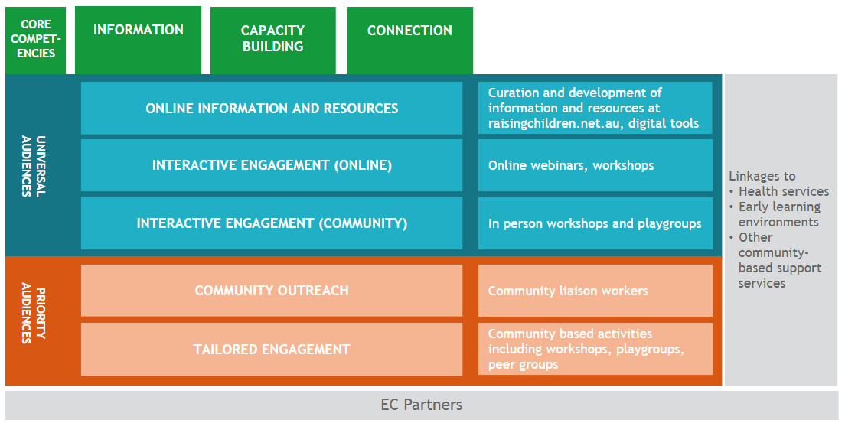
The suggested priority audiences are as follows:
 | Universal audience | Priority audiences
Description | Families with children aged under 9 years with concerns about their child’s development, or where a child has a diagnosed disability  Focus on those who are early in their journey of seeking information and support and/or have not engaged with formal disability supports | Aboriginal and Torres Strait Islander families, and culturally and linguistically diverse families with children aged under 9 years where there are concerns about development, a developmental delay or disability  Vulnerable families which may include those experiencing illness or disability (parent / carer), family violence, homelessness, family breakdown, alcohol, and drug use
Rationale | Early detection and family-centred intervention is shown to impact positively on child development  Potential to support gap between infant support services and when child enters early learning environment  Soft support of peers is highly valued and can enhance parent confidence and capacity | As at left and additionally:  Significant barriers to accessing and receiving universal community-based support  Need for culturally safe activities to optimise participation and outcomes
Stage in support seeking journey | Exploring concern about development  Seeking or waiting for medical assessment  Not diagnosed, seeking support options  Predominantly not engaged with formal disabiltiy supports | Any stage including identified developmental delay or diagnosed disability
Aim | Providing parents and carers with options for supporting their child outside formal disability supports and to introduce parenting strategies to support child development at home as early as possible helping them to:  understand developmental milestones and identify developmental differences,  build capacity to implement practical in-home parenting strategies to support development  identify and connect to other community-based supports and early childhood services  understand where to seek help with respect to accessing diagnoses  build informal opportunities for emotional and social support with other families | As at left, but with the additional aims of:  increasing access to community-based support and early childhood services for children with disability or developmental delay  providing culturally safe opportunities for children and families to interact to support child development and help with transition to learning environments  connecting directly with other families and children
Program setting | Universal program activities – predominantly web-based information, resources, and interactive engagement | Targeted program activities at grass-roots level – predominately face to face delivery

- Programs include the Positive Partnerships Program, administered through the Department of Education, Skills and Employment, the HCWA and Better Start Medicare Benefits Schedule items, administered through the Department of Health, MyTime Peer Support Groups administered by the department, the NDIS Early Childhood (EC) approach and services delivered by the NDIA EC Partners, early childhood grants in the Information, Linkages and Capacity Building (ILC) Program, administered by the department.

