For further assistance please contact [nrasithelpdesk@dss.gov.au](mailto:nrasithelpdesk@dss.gov.au)

National Rental Affordability Scheme (NRAS) Portal

Quick Reference Guide

## Updating submitted TDAs

This Quick Reference Guide (QRG) will take you through the process of updating TDAs that have been submitted to NRAS.

Warning TDAs can only be updated where the status of the TDA is ‘Submitted’ and no claims have been submitted for the NRAS year associated to the TDA.

Access Required:

* Participant Read Only User, Read Write User or Participant Claims User.

Warning Do not use the navigation buttons on your web browser while working in the portal. Using the back, forward or refresh buttons on your browser will cause you to lose the information you have entered.

Use the **Back** and **Continue** buttons to move through the different sections.

Updating a submitted TDA

Additional Information Note Any field with a star/asterisk is a mandatory field and must be completed to move through the TDA.

1. Log in to the [NRAS Portal](https://nras.dss.gov.au/nrasportal/).
2. At the Disclaimer, click **I Agree**.
3. There are two ways to navigate to the Search TDA screen from the main page: through the Tenant demographic assessments tile (see step 4) or through the drop down menu (see step 6).
4. Clickthe **Tenant demographic assessments** tile. A list of all TDAs will be displayed, then select the **Search TDAs** button.

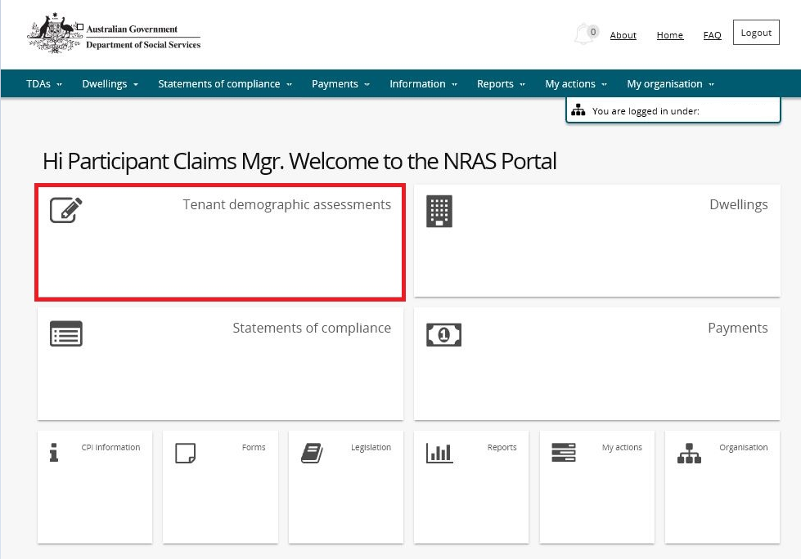

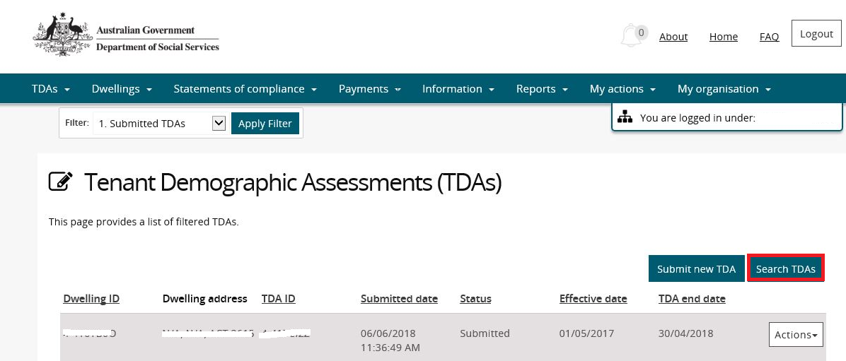

**OR**

1. At the **Welcome screen**, select **TDAs>Search TDAs**.

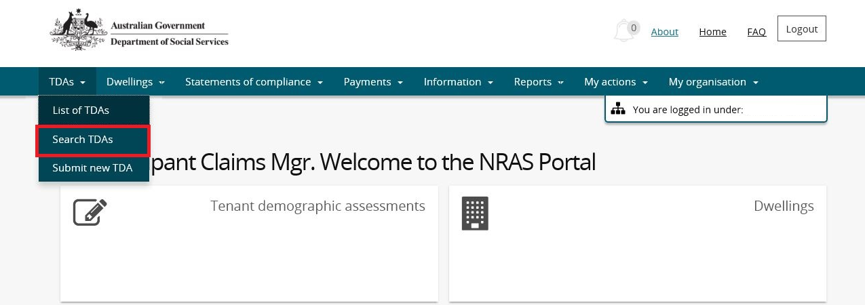

1. Enter required search criteria, then select the **Run Search** button. Results matching your entered search criteria will be returned.

Note icon.Click **Advanced** to display additional search fields.

Additional Information Note Only TDAs with a status of submitted can be updated. Also, if a TDA has an incentive claim attached to it that has been processed, the TDA will not be able to be edited.

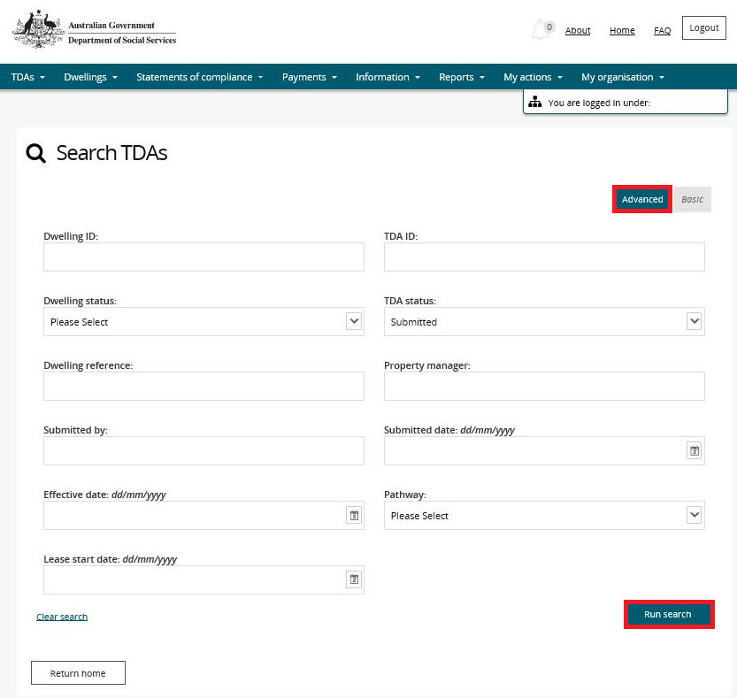

1. On the Results section of the screen, select **Actions>View TDA** for the TDA.

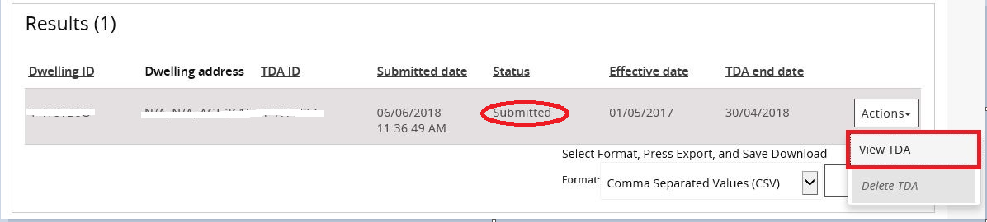

1. On the Lease and TDA details screen, select the **Update** button for the TDA.

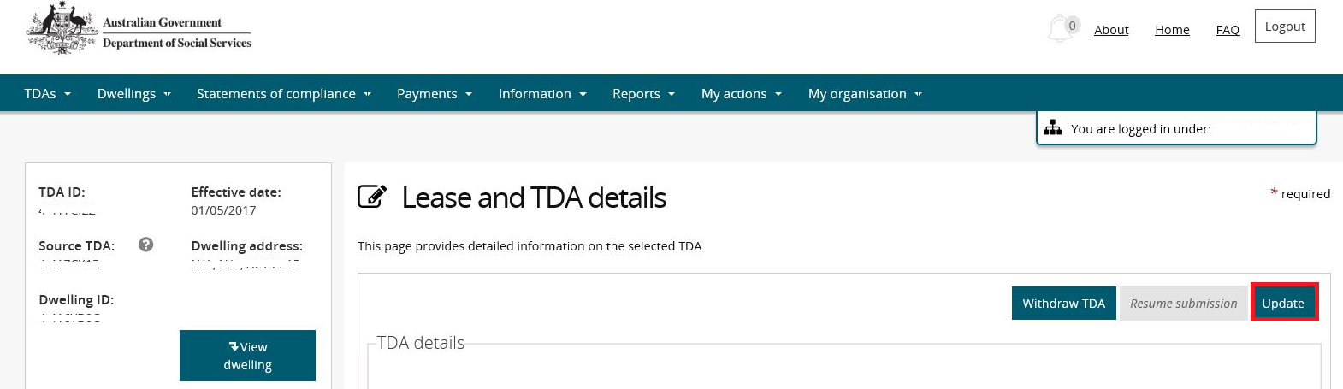

1. The **Rent details** page will be displayed.

Additional Information NoteYou will now enter the same path as the submission/resume submission of a TDA process and you are able to update the same fields that were available when the TDA was originally submitted.

Note icon. If you need to update lease start and end dates, refer to the Updating or deleting a lease section of QRG #5 Withdrawing a TDA and Lease.

Additional Information Note For more assistance creating TDAs refer to Quick Reference Guides.

1. Continue submission of the TDA to the **Finish** screen.
2. Click **Finish**. The Tenant Demographic Assessments (TDAs) screen is displayed.

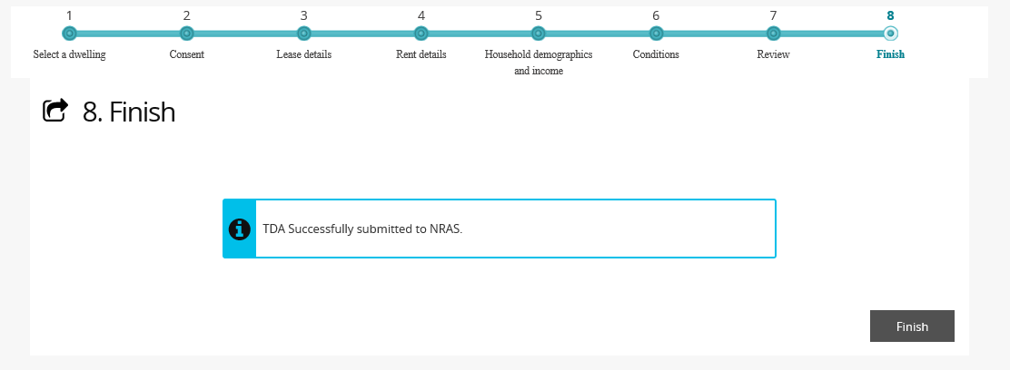

Logging out of the NRAS Portal

1. To log out of the NRAS Portal click **Logout**.

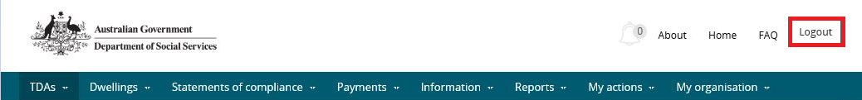

Note icon. For technical support enquiries, please contact [nrasithelpdesk@dss.gov.au](mailto:nrasithelpdesk@dss.gov.au) or 1300 911 235.