For further assistance, please contact [nrasithelpdesk@dss.gov.au](mailto:nrasithelpdesk@dss.gov.au)

## National Rental Affordability Scheme (NRAS) Portal

## Quick Reference Guide

Submit a Vacancy

This Quick Reference Guide (QRG) will take you through the steps to submit a vacancy for a dwelling.

Access Required:

* Participant Read Write User or Participant Claims User.

Warning Do not use the navigation buttons on your web browser while working in the portal. Using the back, forward or refresh buttons on your browser will cause you to lose the information you have entered.

Use the **Back** and **Continue** buttons to move through the different sections.

1. Log in to the [NRAS Portal](https://nras.dss.gov.au/nrasportal/).
2. At the Disclaimer, click **I Agree**.
3. There are two ways to navigate to the Search Dwellings screen from the main page: through the Dwellings tile (see step 4) or through the dropdown menu (see step 5).
4. Click the **Dwellings** tile. A list of Dwellings will be returned, then select the **Search Dwelling** button.

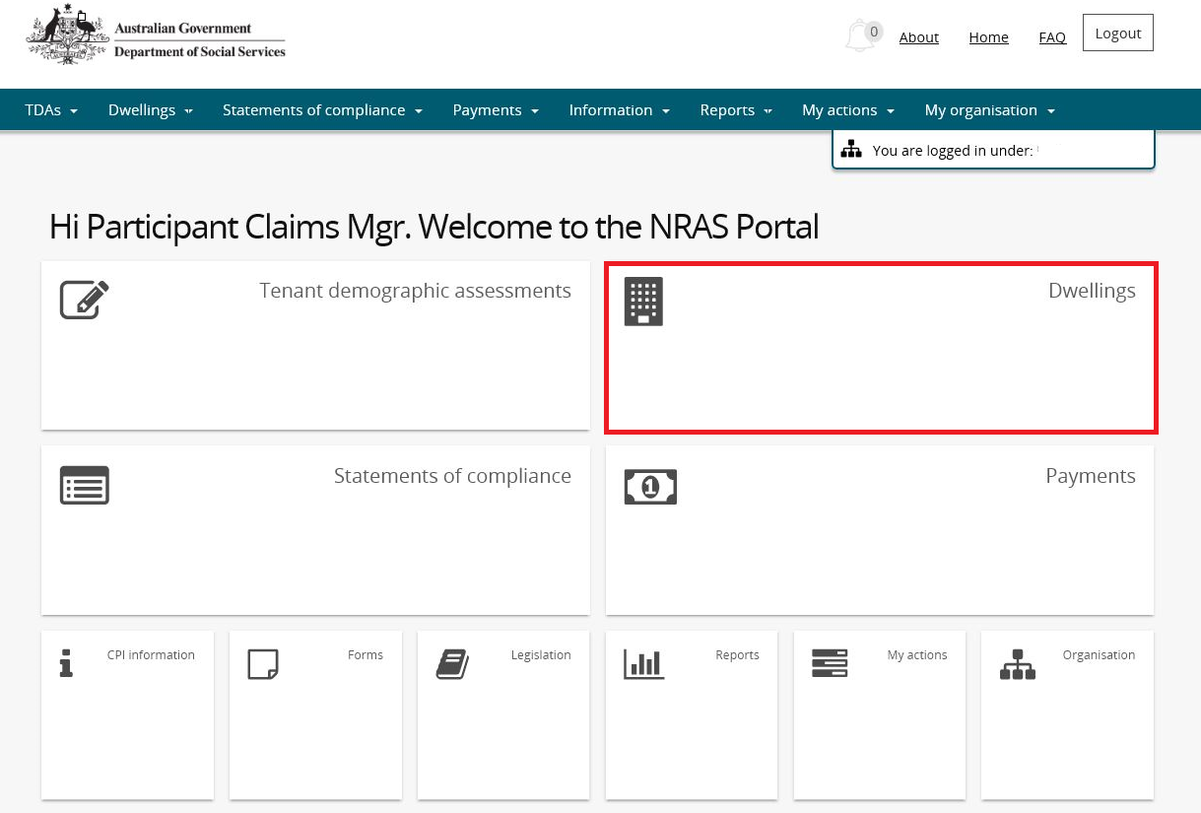

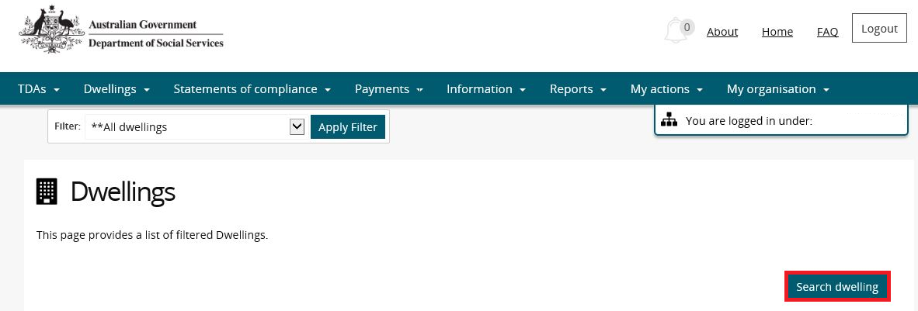

**OR**

1. At the **Welcome** screen, select **Dwellings>Search dwelling**.

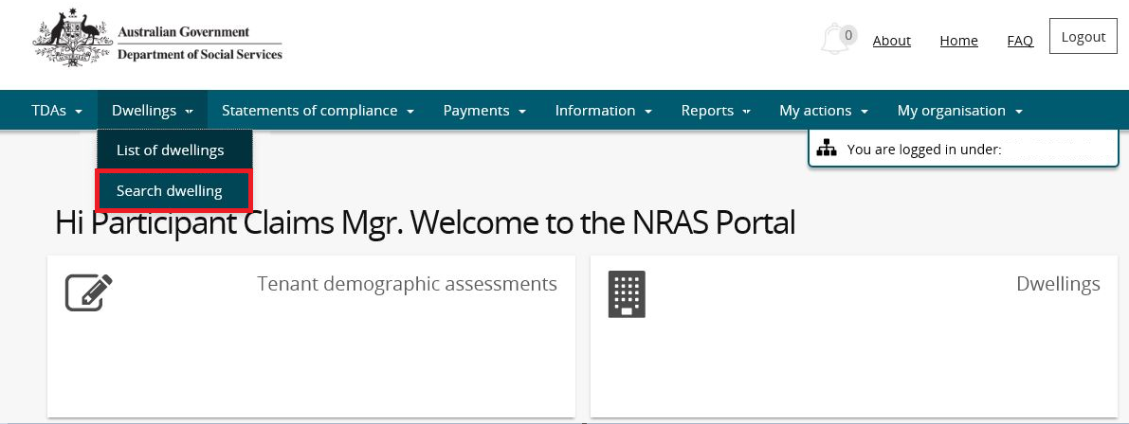

1. Enter required search criteria, then select the **Run Search** button.

Note icon.Click **Advanced** to display additional search fields.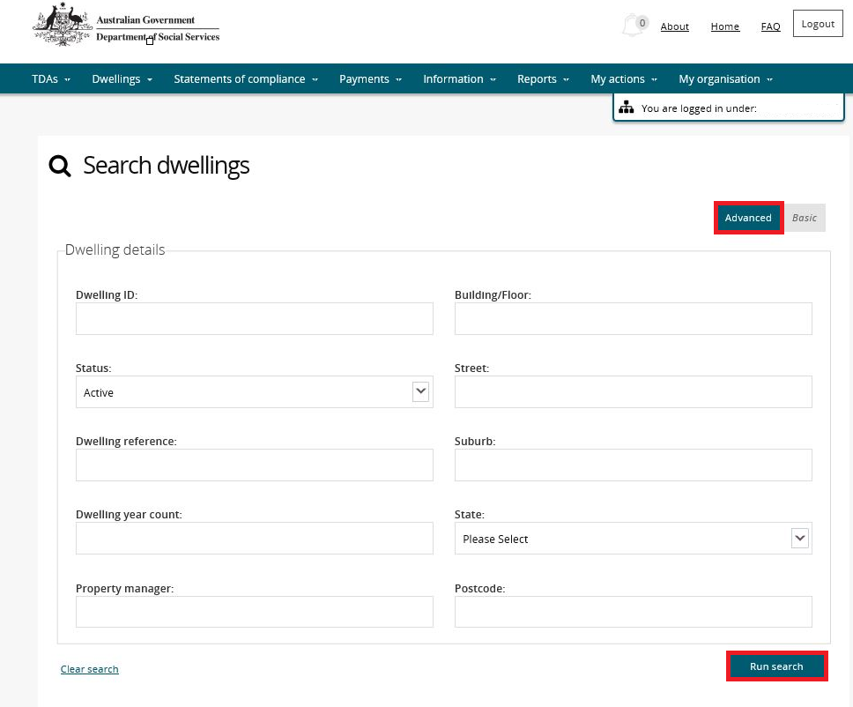

1. Results matching your entered search criteria will be returned.
2. Select the **View dwelling** button.

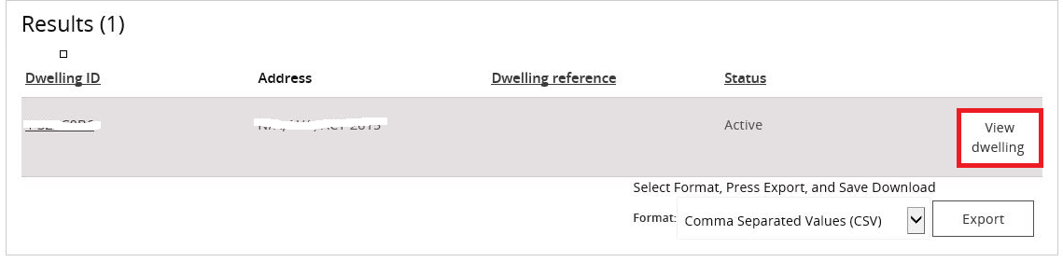

1. Select the **Occupancy** menu item on the Dwelling details page.

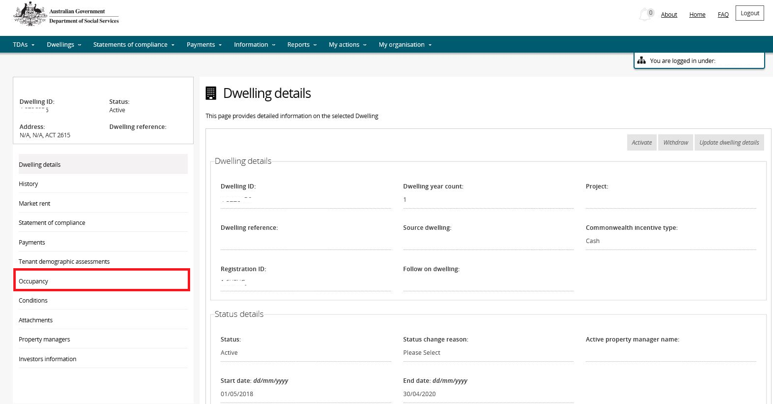

1. Any existing lease or vacancy records will be displayed. To add a Vacancy record, select the **Add vacancy** button on the **Occupancy** page.

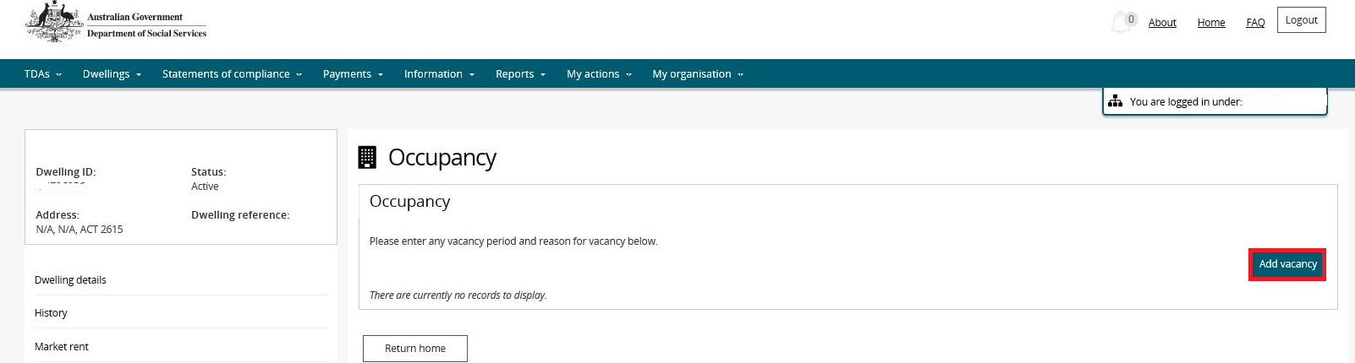

1. Enter the **Vacancy Start and End dates and Vacancy reason** on the Manage occupancy page and then select **Save** and **Return home**.

Warning The Vacancy Start, End and Reason fields are mandatory.

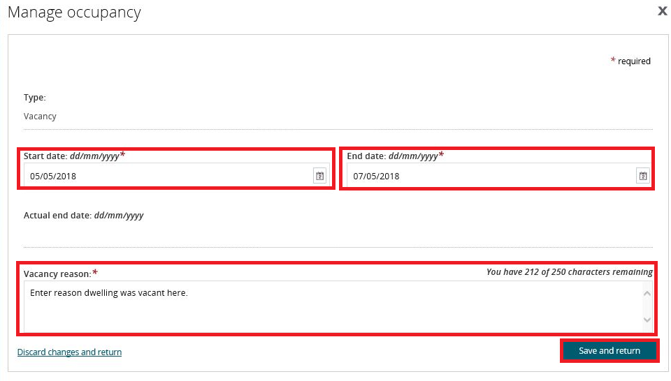

1. The Vacancy will appear on the **Occupancy** page.

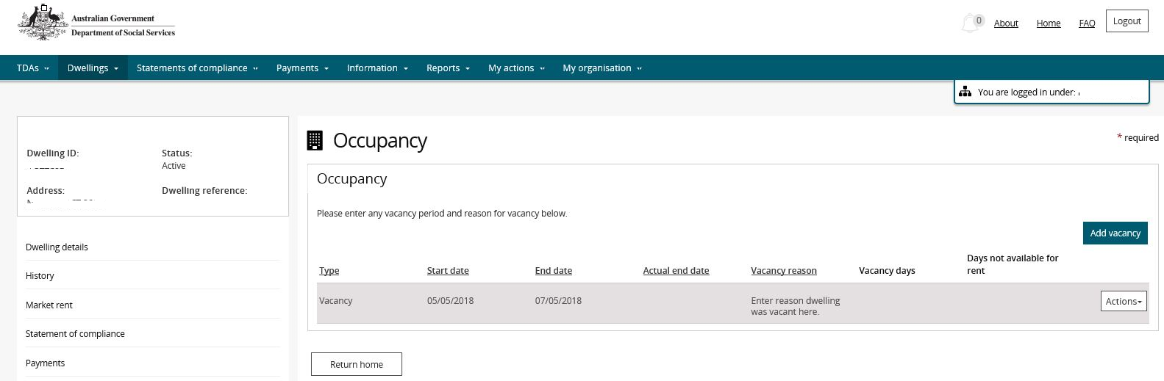

Additional Information NoteYou are able to Update or Delete the vacancy if the **Action>Update** or **Action>Delete** buttons are available and/or there is not an existing claim for the associated NRAS Year.

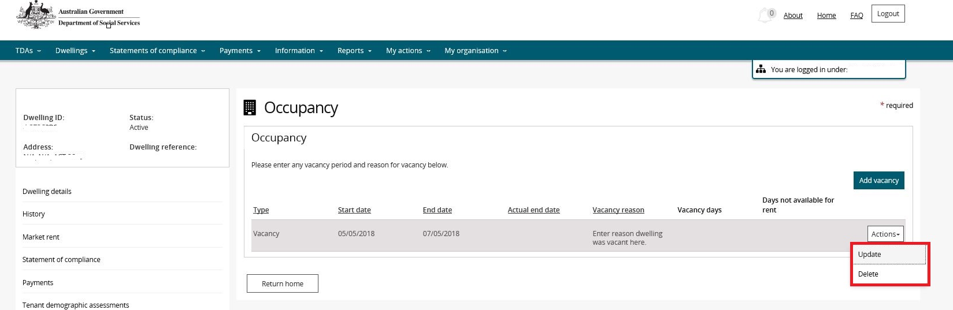

Additional Information NoteYou are also able to add a new vacancy or update/delete existing vacancies during submission of a TDA.

Additional Information Note For more assistance refer to Quick Reference Guides #2 to #4 for submitting TDAs.

Logging out of the NRAS Portal

1. To log out of the NRAS Portal click **Logout**.

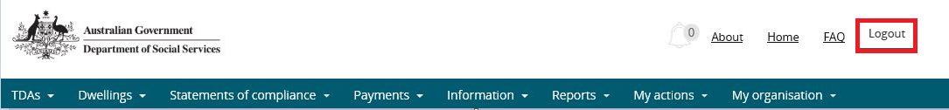

Note icon. For technical support enquiries, please contact [nrasithelpdesk@dss.gov.au](mailto:nrasithelpdesk@dss.gov.au) or 1300 911 235.