For further assistance, please contact [nrasithelpdesk@dss.gov.au](mailto:nrasithelpdesk@dss.gov.au)

## National Rental Affordability Scheme (NRAS) Portal

## Quick Reference Guide

Delete a draft TDA

This Quick Reference Guide (QRG) will take you through the steps to delete a draft TDA in the NRAS Portal.

Access Required:

* Participant Read Write User; or Participant Claims User.

Warning Do not use the navigation buttons on your web browser while working in the portal. Using the back, forward or refresh buttons on your browser will cause you to lose the information you have entered.

Use the **Back** and **Continue** buttons to move through the different sections.

1. Log in to the [NRAS Portal](https://nras.dss.gov.au/nrasportal/).
2. At the Disclaimer, click **I Agree**.
3. There are two ways to navigate to the Search TDA screen from the main page: through the Tenant demographic assessments tile (see steps 4 to 5) or through the drop down menu (see step 6).
4. Clickthe **Tenant demographic assessments** tile. A list of all TDAs will be displayed, then select the **Search TDAs** button.

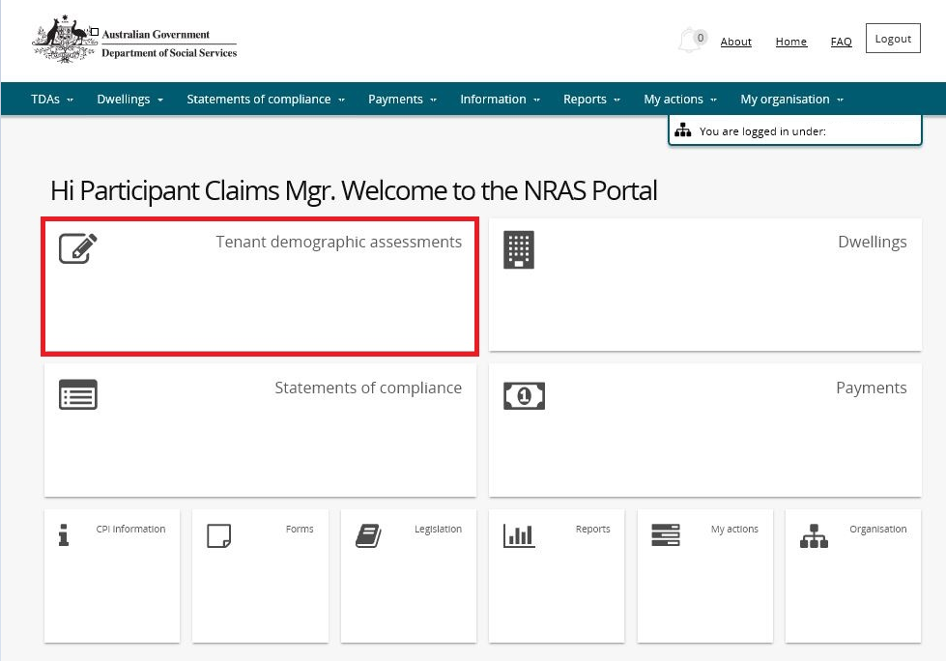

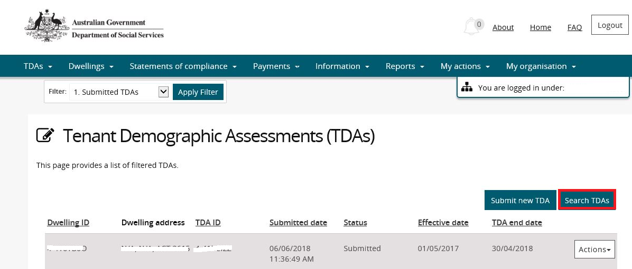

**OR**

1. At the **Welcome screen**, select **TDAs>Search TDAs**.

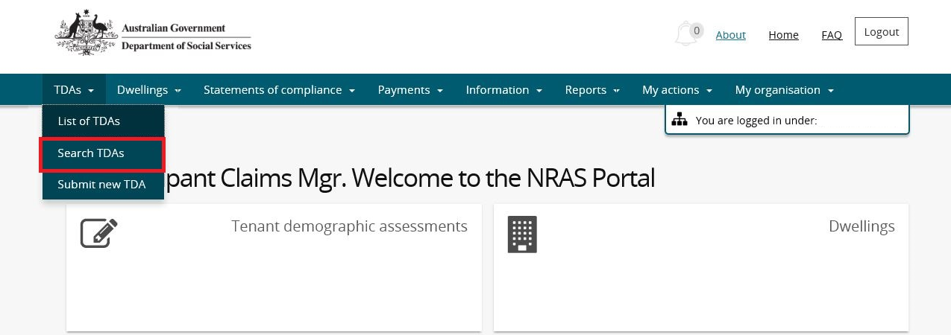

1. Enter required search criteria, then select the **Run Search** button. Results matching your entered search criteria will be returned.

Note icon. The Dwelling ID and TDA ID search fields on the **Search TDAs** page are both case insensitive. If you do not have the Dwelling or TDA details or you wish to view all TDAs you have access to, leave the all search criteria blank.

Note icon.Click **Advanced** to display additional search fields.

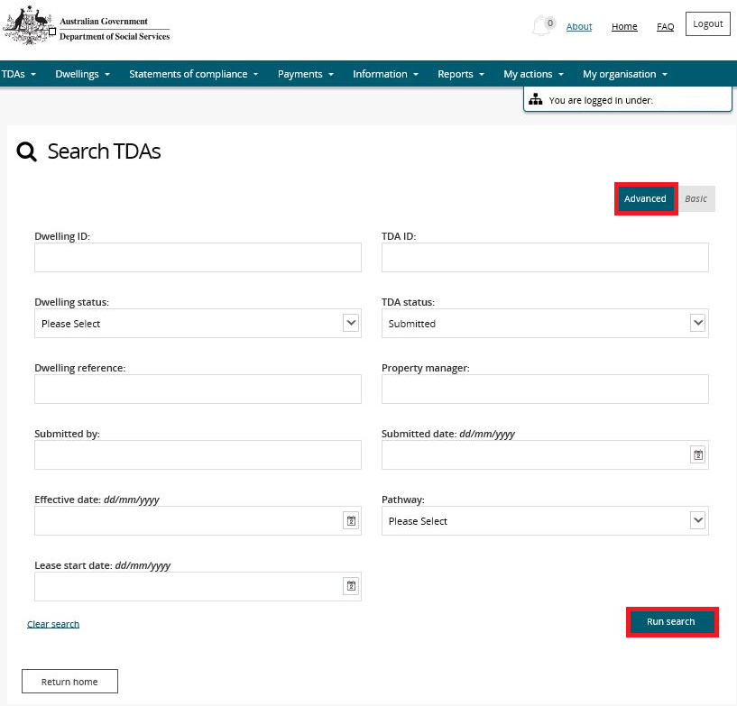

1. Results matching the entered search criteria will be returned.

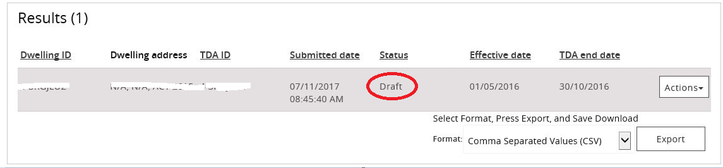

1. On the Results section of the screen, select **Actions>Delete TDA** for the TDA.

De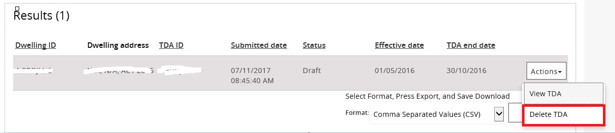

1. A message will be displayed ‘‘Are you sure you want to delete the selected record in ‘All TDA’s’’’.

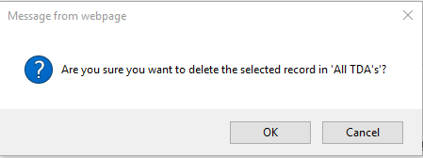

1. Select the **OK** button.
2. The TDA will be deleted.

Additional Information Note For more assistance creating TDAs refer to Quick Reference Guides.

Logging out of the NRAS Portal

1. To log out of the NRAS Portal click **Logout**.

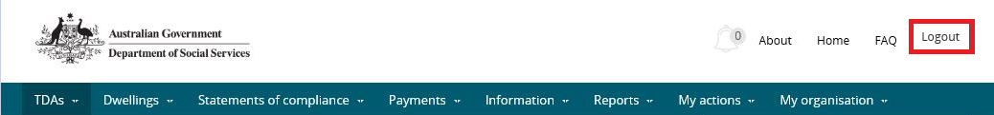

Note icon. For technical support enquiries, please contact [nrasithelpdesk@dss.gov.au](mailto:nrasithelpdesk@dss.gov.au) or 1300 911 235.