For further assistance please contact [nrasithelpdesk@dss.gov.au](mailto:nrasithelpdesk@dss.gov.au)

National Rental Affordability Scheme (NRAS) Portal

Quick Reference Guide

## Saving, Finding and resuming submission of Draft TDAs.

This Quick Reference Guide (QRG) will take you through the process of saving a TDA as Draft, finding a Draft TDA and resubmission of a Draft TDA in the NRAS Portal.

Access Required:

* Participant Read Only User, Read Write User or Participant Claims User.

Warning Do not use the navigation buttons on your web browser while working in the portal. Using the back, forward or refresh buttons on your browser will cause you to lose the information you have entered.

Use the **Back** and **Continue** buttons to move through the different sections.

Saving a TDA as Draft

Additional Information Note Any field with a star/asterisk is a mandatory field and must be completed to move through the TDA.

1. Log in to the NRAS Portal.
2. At the Disclaimer, click **I Agree**.
3. There are two ways to navigate to the Submit a TDA screen from the main page: through the Tenant demographic assessments tile (see steps 4 to 5) or through the drop down menu (see step 6).
4. Clickthe **Tenant demographic assessments** tile. A list of all TDAs will be displayed.

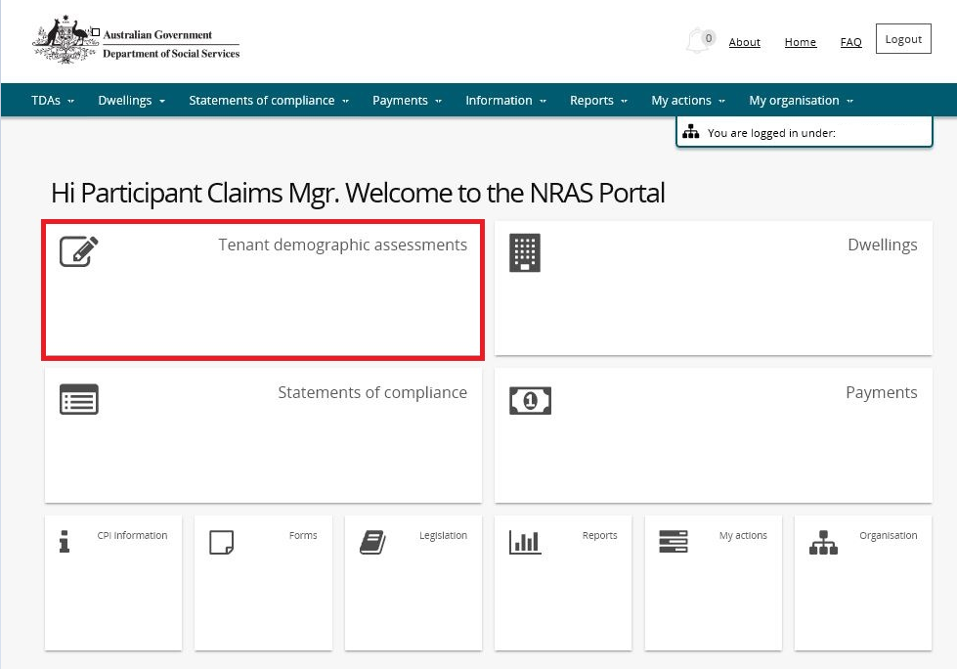

1. Select the **Submit new TDA** button.

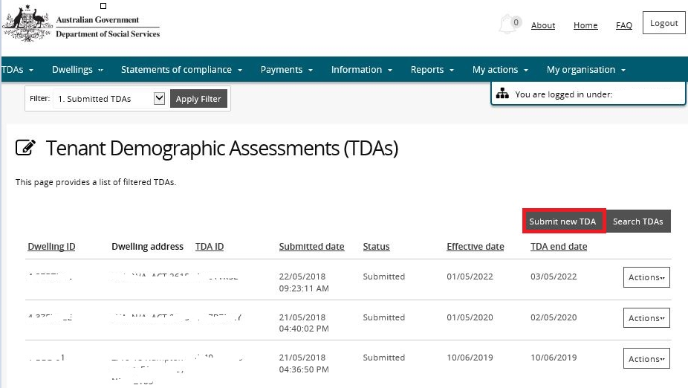

**OR**

1. At the **Welcome screen**, select **TDAs>Submit new TDA**. 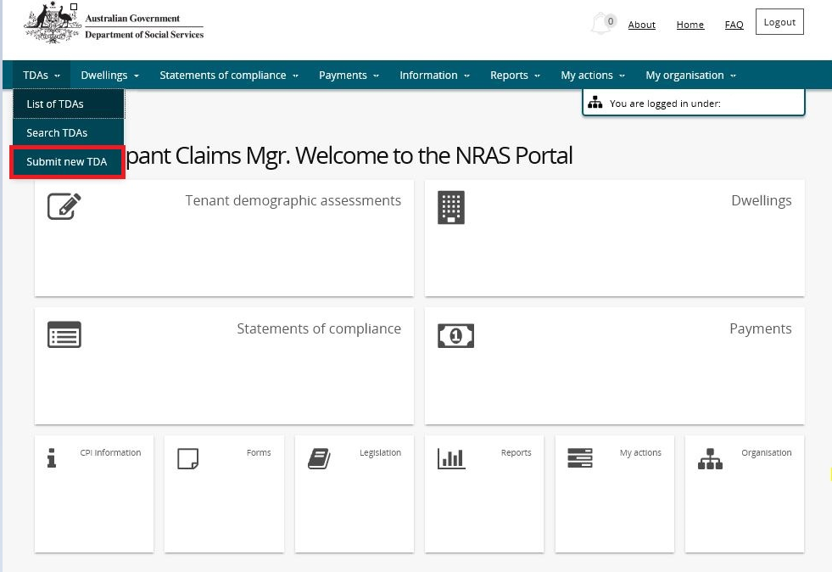
2. Select:
   1. **New lease With New Tenants** if the tenants were not living in this dwelling in a previous lease or this is the first time you are tenanting the dwelling.
   2. **New lease With Same Tenants** if the same tenants are renewing the previous lease.
   3. **Same Lease** if the same tenants are continuing their previous lease and there is a change in household composition, income or rent charged.
3. Select the **Start** button.

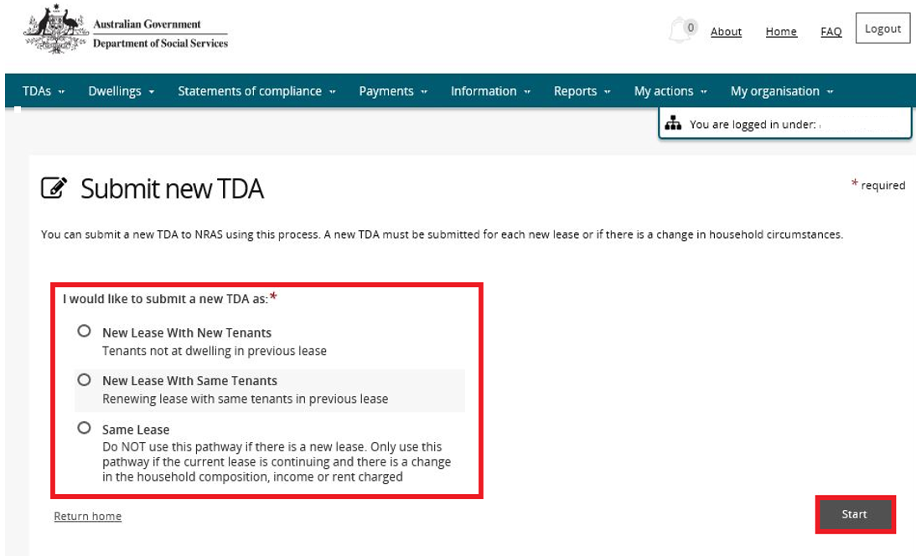

1. To search for a dwelling, enter the **Dwelling details**.

Note icon. The Dwelling ID search field on the ‘Select a Dwelling’ page is not case sensitive. If you do not have the Dwelling Id or you wish to view all Dwellings you have access to, leave the search details blank.

Note icon. Click **Advanced** to display additional search fields.

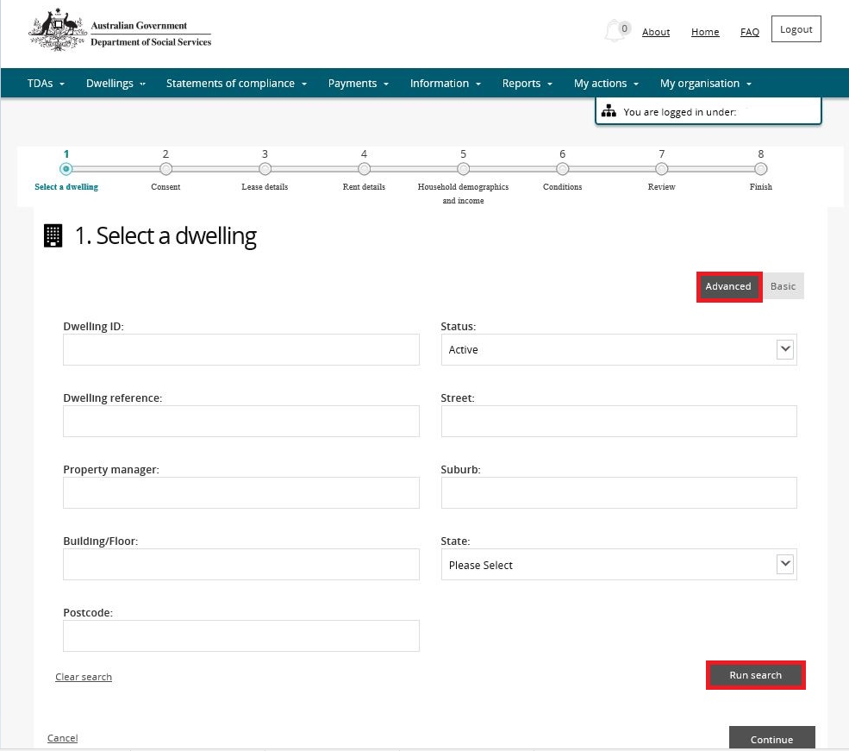

1. Click **Run search**.
2. Dwellings matching the entered search criteria will be returned.
3. Scroll down and select the dwelling.

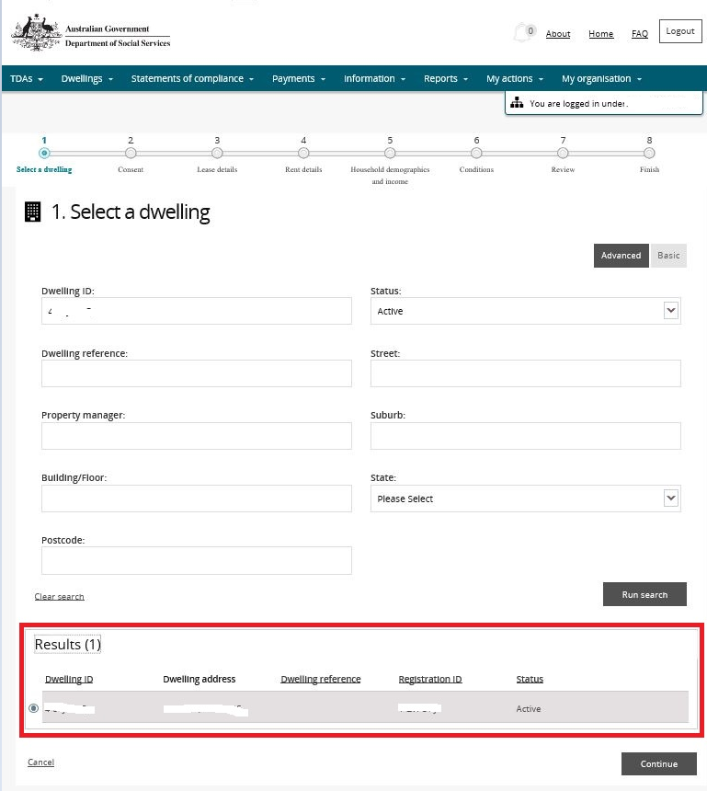

1. Click **Continue**.
2. Select **Yes** or **No** on the Consent screen.

Additional Information Note Tenant consent must be obtained to create a TDA. If you choose No, you will need to begin the process again after you have received tenant consent.

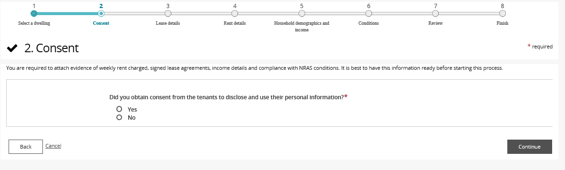

1. Click **Continue**.
2. The **Lease details** screen displays.

Additional Information NoteThe Lease details screen will display any existing leases for the dwelling.

1. Select the **New lease** button (for New Lease New Tenant or New Lease Same Tenant pathways).

Additional Information Note For more assistance submitting new TDAs refer to Quick Reference Guide #2 to #4.

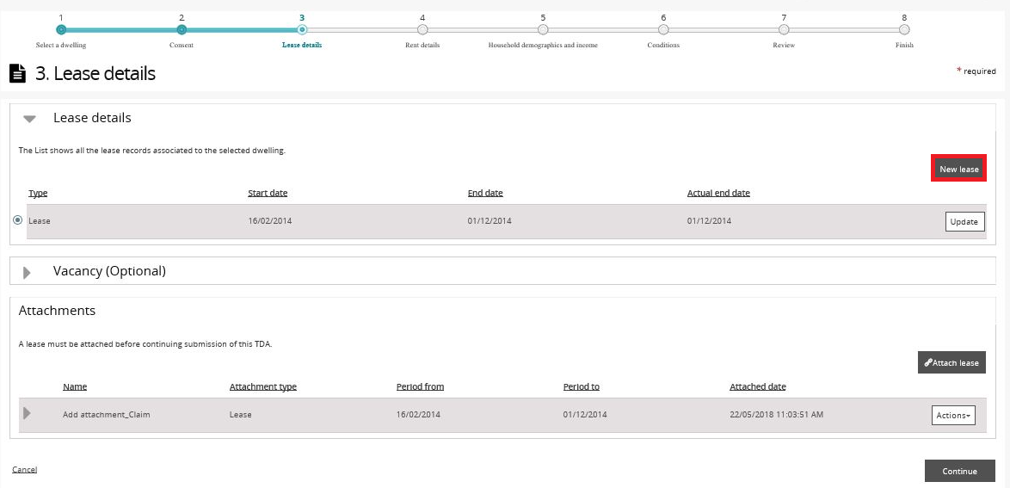

1. For New lease new tenants or New lease same tenants pathways, on the **New lease** screen enter a start and end date for the lease then select the **Save and return** button.

Additional Information Note If a previous lease exists the ‘Start date’ will default to the previous leases end date plus one day.

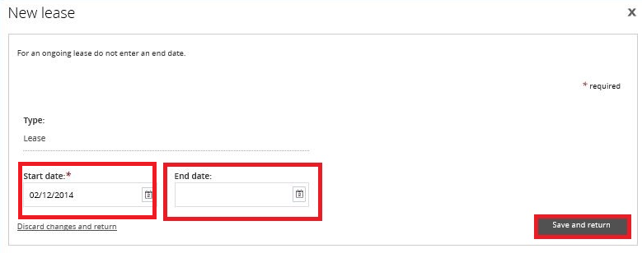

Additional Information Note You can either use the date picker or directly enter a date.

Additional Information Note For an ongoing lease, do not enter an end date.

Additional Information Note For more assistance creating TDAs refer to Quick Reference Guide #2 to #4.

1. The **Lease details** screen will be redisplayed.
2. For New lease new tenants or New lease same tenant pathways and if required, enter a vacancy period by expanding the **Vacancy (Optional)** section and selecting the **Add** **Vacancy** button.

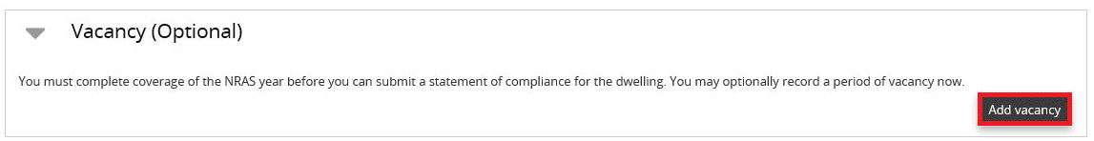

1. Enter **Start date, End date** and **Reason** and then select **Save and return** button.

Additional Information Note Start date, End date and Reason are mandatory fields when entering a Vacancy.

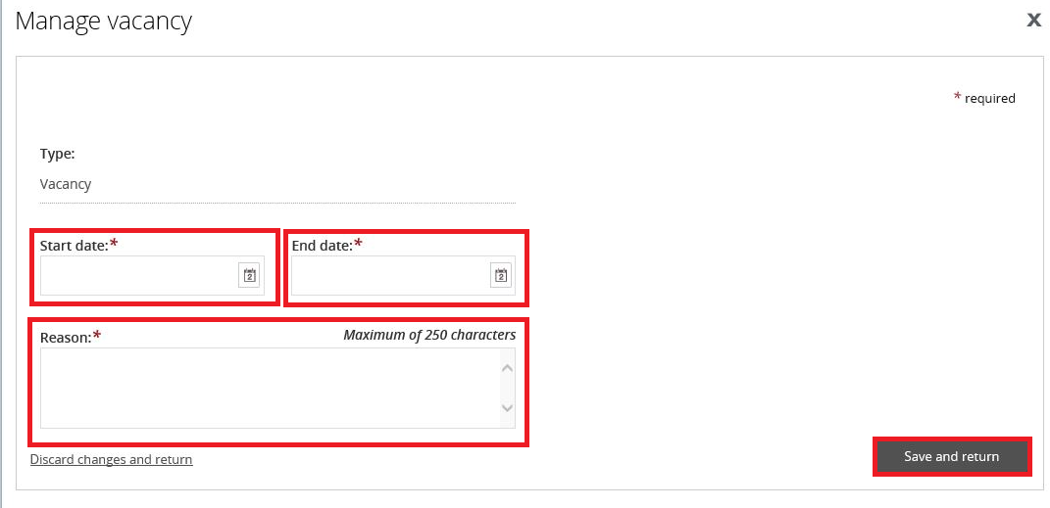

1. The attachment of a Lease document is mandatory for New lease new tenant and New lease same tenant pathways. To attach the lease, click **Attach Lease**.
2. On the **Manage attachment details** screen select a filethen enter the Lease period date and any comments.
3. Select the **Save** **and** **return** button.

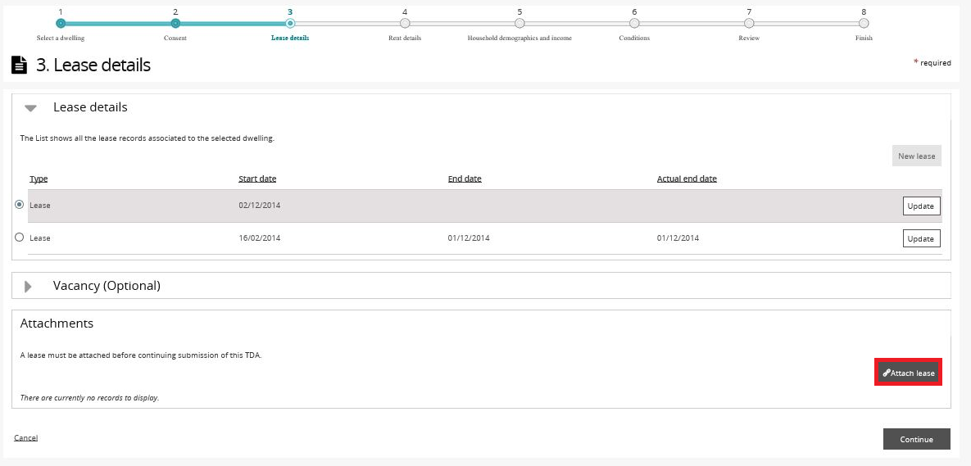

Additional Information Note The **Period** **from** date will default to the Lease start date from Step 18 (above). The ‘Period to’ and ‘Comments’ fields are not mandatory.

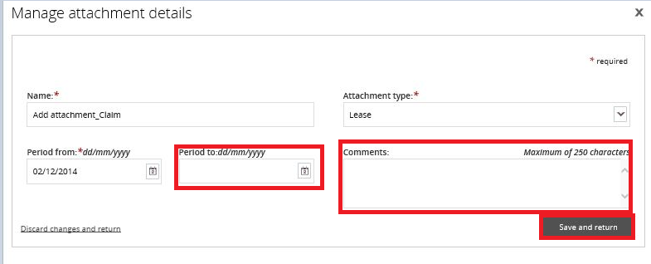

1. The document will appear in the **Attachments** section of the **Lease** **details** screen.

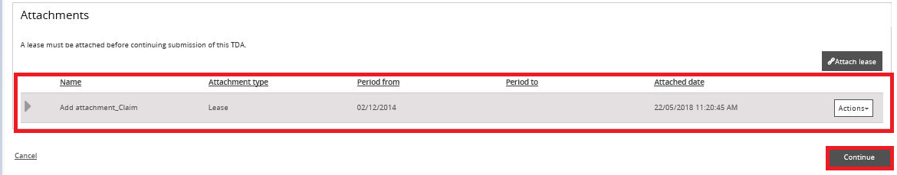

1. Select the **Continue** button.
2. The **Rent** **details** screen is displayed.

Additional Information Note The **What date do changes to the TDA start from** field will default to the Lease start date.

1. Enter a **TDA end date** into the **to** field.

Additional Information Note You are now able to create multiple TDAs by entering a TDA end date that is after the NRAS year end date. This will create multiple ‘split’ TDAs based on the TDA Start and End dates entered. These additional TDAs will be created with the ‘Same Lease’ pathway.

1. Enter the current rent charged in the **What is the current rent being charged?** field.

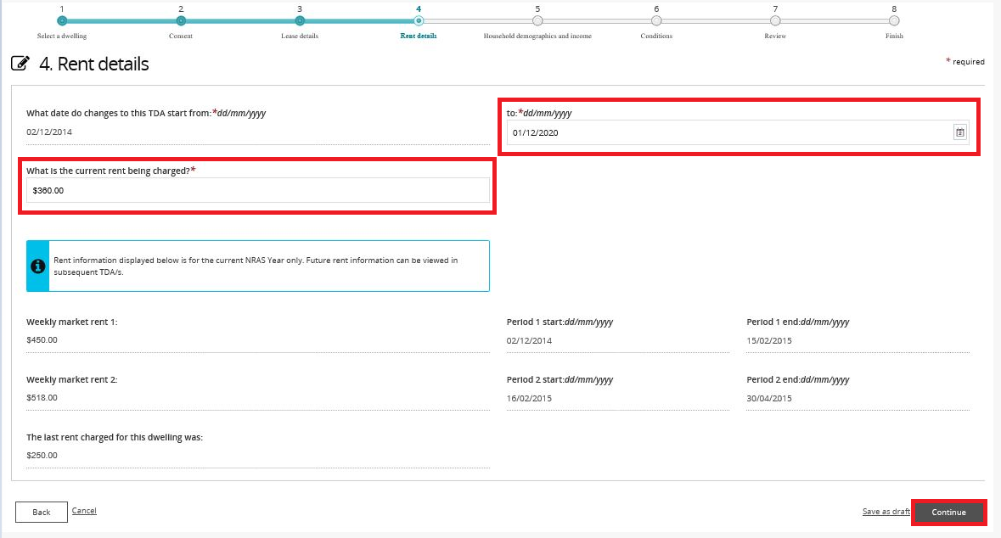

Additional Information Note The **Rent details** screen is the first opportunity to save the TDA as a draft. Clicking **Save as Draft** will exit you from the TDA process. You can return to the draft and complete it at a later date. All screens from this point onward will provide the **Save as Draft** functionality.

Additional Information NoteYou will find the **Save as draft** option at the bottom of each of the following screens:

* Rent
* Household Demographics and Income
* Conditions
* Review.

Additional Information NoteMandatory fields must be completed on each page before the TDA can be saved as a draft.

Additional Information Note For more assistance creating TDAs refer to Quick Reference Guides.

1. Ensuring all mandatory fields have been entered, select **Save as draft**. The TDA will be saved with a status of **Draft**.

Finding a Draft TDA

1. There are two ways to navigate to the Search TDAs screen from the main page: through the Tenant demographic assessments tile (see steps 2 to 4) or through the dropdown menu (see step 4).
2. Clickthe **Tenant demographic assessments** tile. A list of all TDAs will be displayed.



1. On the **Tenant Demographic (TDAs)** screen, select **Search TDAs**.

**OR**

1. At the **Welcome screen** select **TDAs>Search TDAs**.

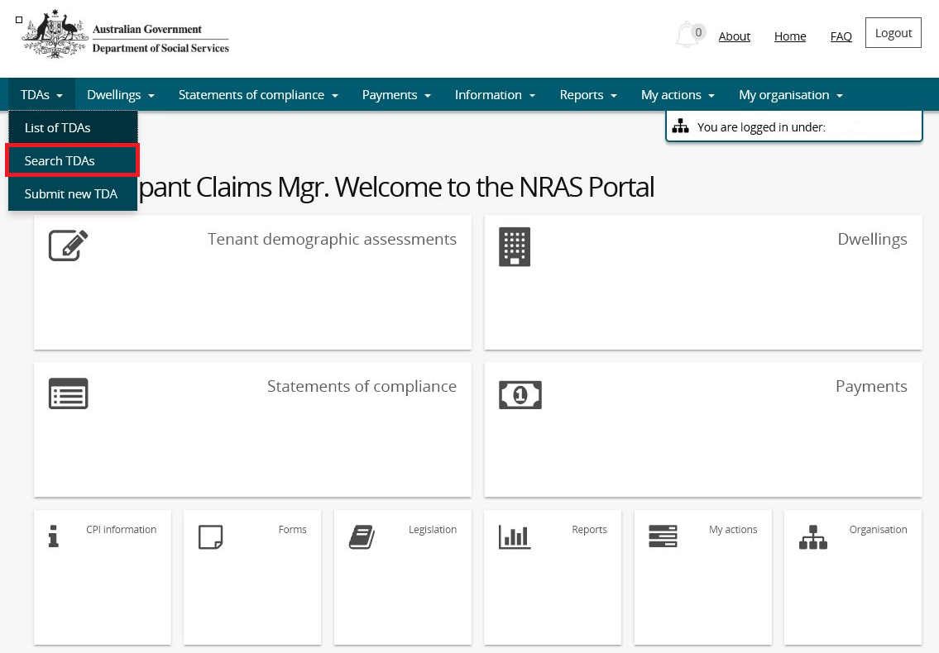

1. The **Search TDAs** screen will be returned.

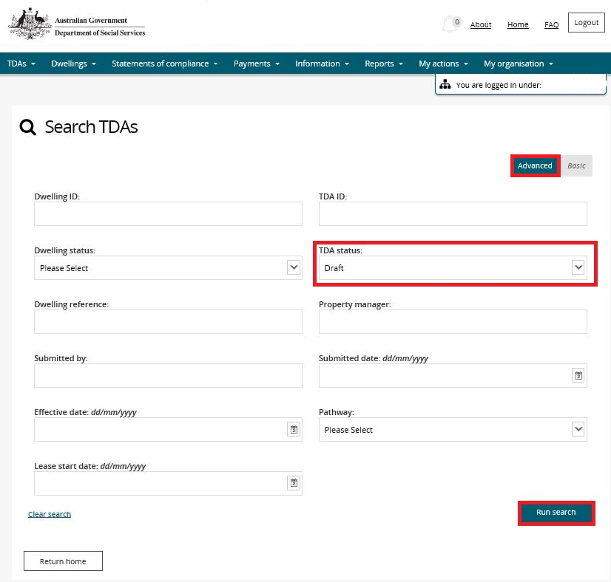

Note icon. The Dwelling ID and TDA ID search fields on the ‘Search TDAs’ page are both case insensitive. If you do not have the Dwelling or TDA details or you wish to view all TDAs you have access to, leave the all search criteria blank.

Note icon.Click **Advanced** to display additional search fields.

1. Enter search criteria and select **Draft** in the **TDA status** field.
2. The TDA is returned in the search results.
3. Select **Actions>View TDA** for the relevant TDA.

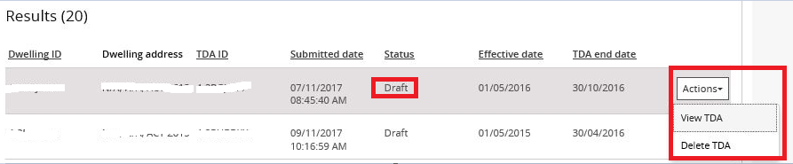

1. The Lease and TDA details screen will be returned with the **Resume submssion** button enabled.

Resuming submission of a draft TDA

Following on from Step 9 in the **Finding a Draft TDA** section above.

1. Select the **Resume submission** button.

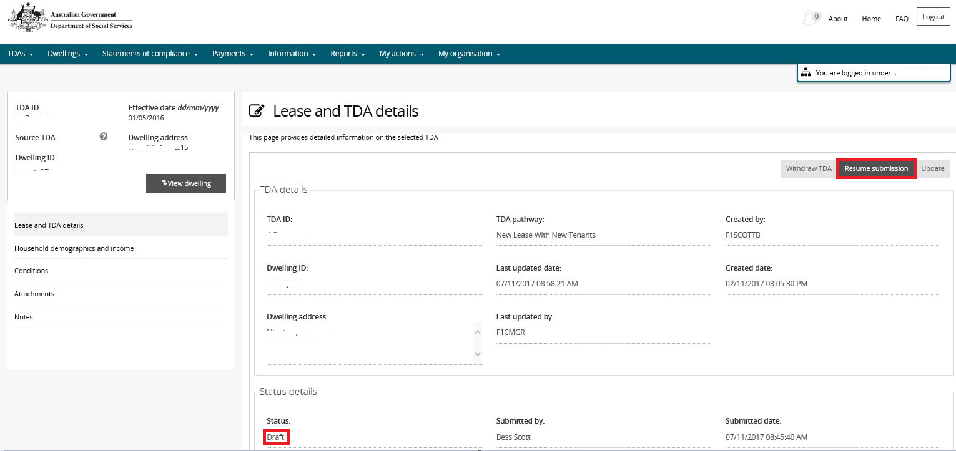

1. The **Rent details** page will be displayed.

Note icon. If you need to update lease start and end dates, refer to the Updating or deleting a lease section of QRG #5 Withdrawing a TDA and Lease.

1. Continue submission of the TDA to the **Finish** screen.
2. Click **Finish**. The Tenant Demographic Assessments (TDAs) screen is displayed.

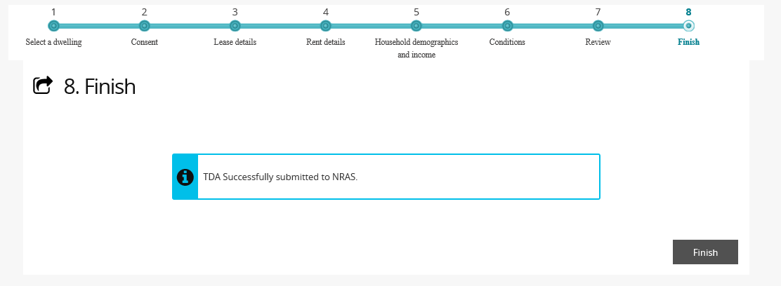

Additional Information Note For more assistance creating TDAs refer to Quick Reference Guides.

Logging out of the NRAS Portal

1. To log out of the NRAS Portal click **Logout.**

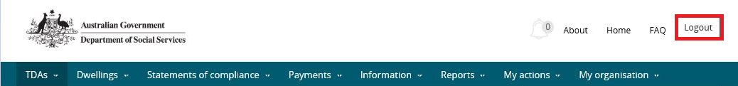

Note icon. For technical support enquiries, please contact [nrasithelpdesk@dss.gov.au](mailto:nrasithelpdesk@dss.gov.au) or 1300 911 235.