For further assistance, please contact [nrasithelpdesk@dss.gov.au](mailto:nrasithelpdesk@dss.gov.au)

## National Rental Affordability Scheme (NRAS) Portal

## Quick Reference Guide

Exporting Data from the Portal

This Quick Reference Guide (QRG) will take you through how to export data from the lists of Dwellings, Tenant Demographic Assessments (TDAs), Statements of Compliance (SoC) or Payments.

Access Required:

* Participant Read Only User; Participant Read Write User; or Participant Claims User.

Warning Do not use the navigation buttons on your web browser while working in the portal. Using the back, forward or refresh buttons on your browser will cause you to lose the information you have entered.

Use the **Back** and **Continue** buttons to move through the different sections.

1. Log in to the [NRAS Portal](https://nras.dss.gov.au/nrasportal/).
2. At the Disclaimer, click **I Agree**.
3. You are able to export data from various areas of the Portal where it contains a lists of dwellings, TDAs, SoCs, or Payments. Click on the appropriate area where you want to visit. For example, click the **Tenant demographic assessments** tile or use the navigation menu to select “List of TDAs” or “List of Dwellings”, etc.

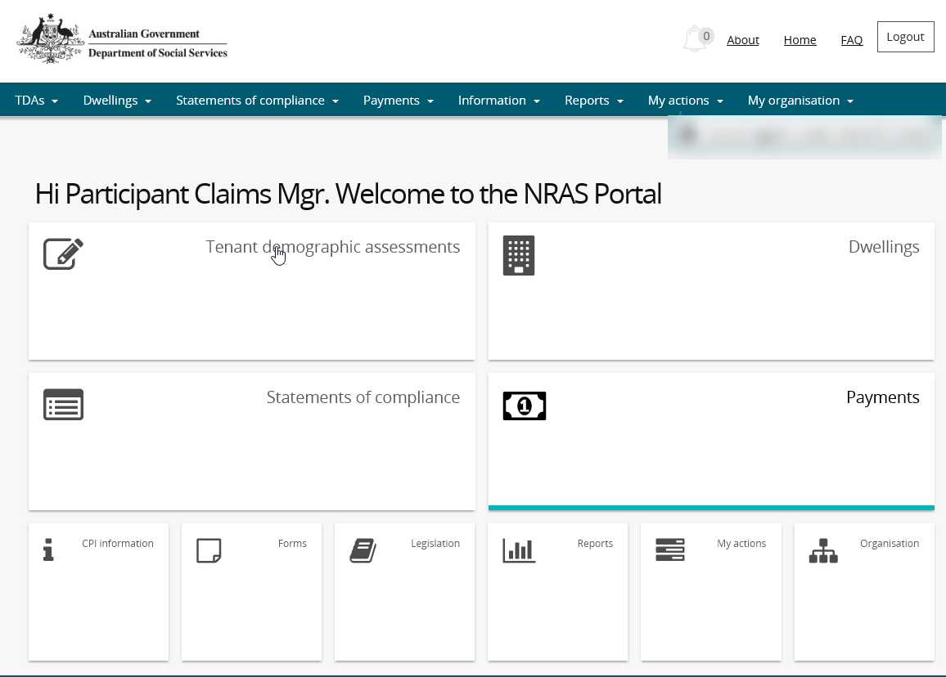

OR

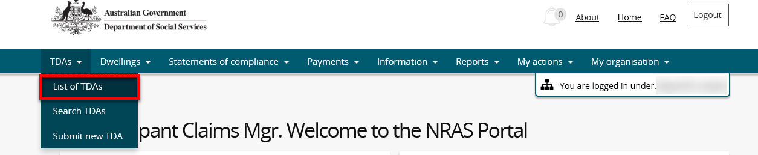

1. The page with the list of data (TDA/Dwelling/SoCs/Payments – depending on what data you would like to export) opens.

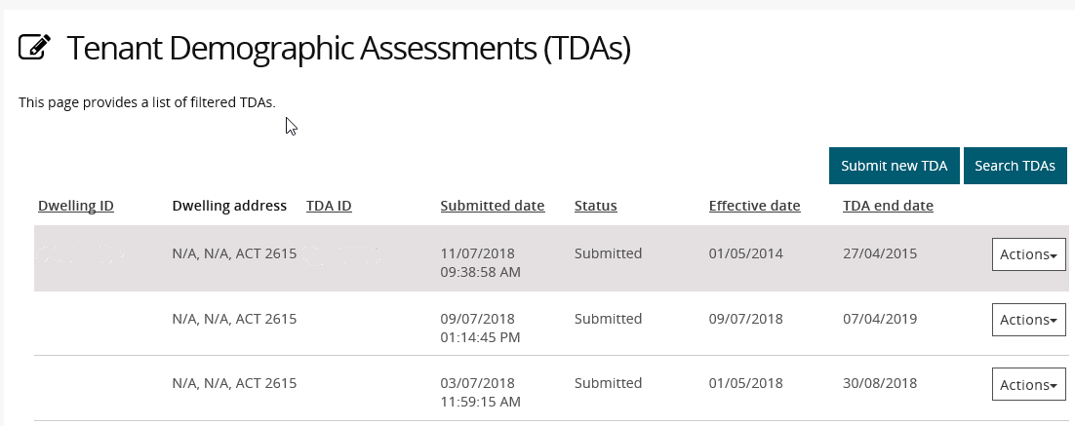

1. To **Export**, navigate to the bottom right of the page, select the type of file and then select **Export**. The recommended format is Tab Separated Values (TSV).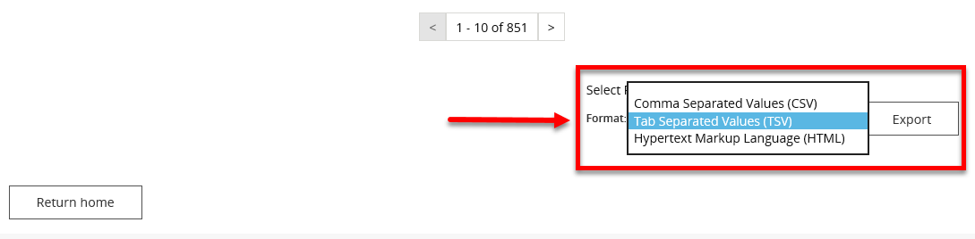
2. Where you are exporting data for more than one item, please allow the system time to process the request. Do not click **Export** again as this will override the request and only extract one line of data. To check if the export request is working the text on the browser tab changes to **Export**.

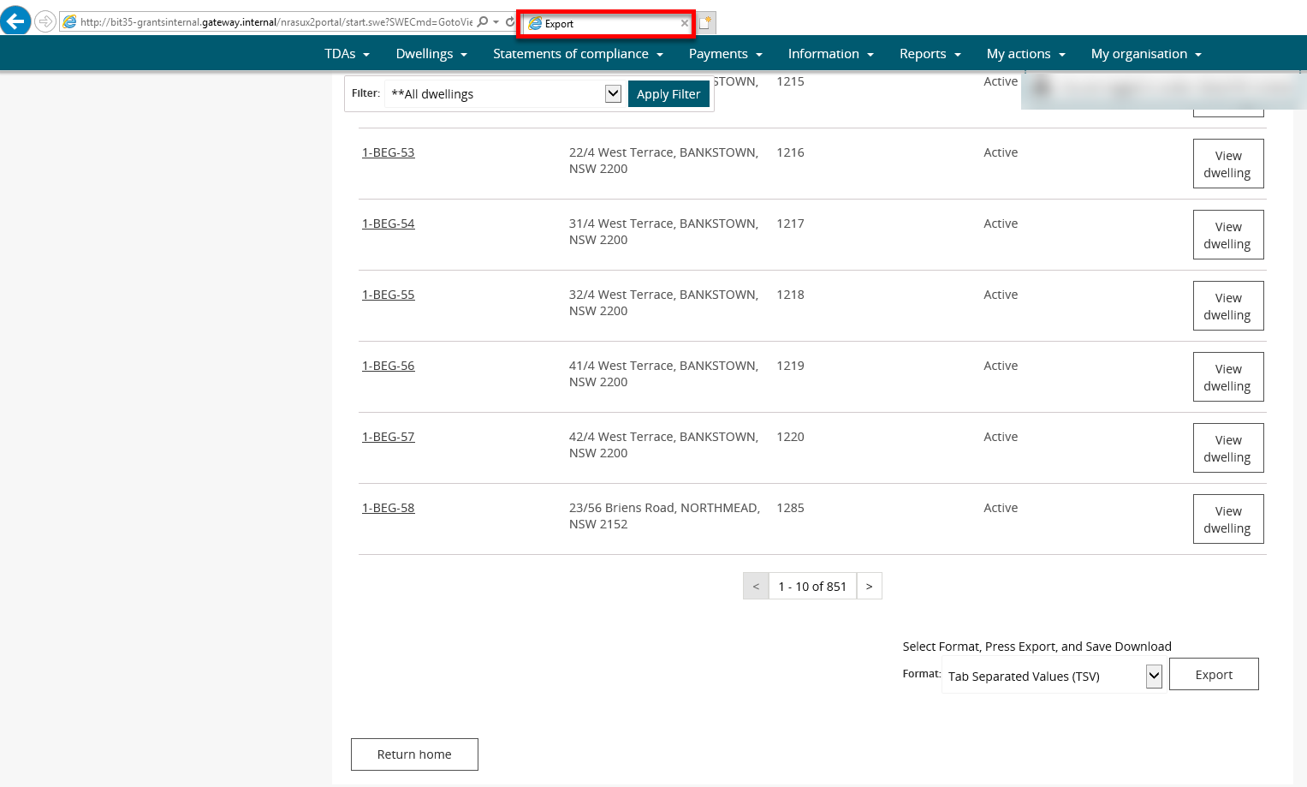

1. Once the Export process is complete, you will be prompted to either **Open** or **Save** the report.

Prompt for Open or Save the report - select Open or Save

1. Your Report will either be opened or saved to the specified location.

Additional Information Note All records in the report will be displayed or saved.

Logging out of the NRAS Portal

1. To log out of the NRAS Portal click **Logout**.

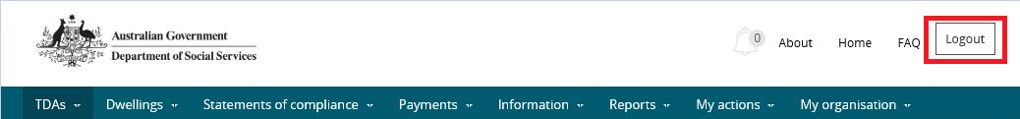

Additional Information NoteFor technical support enquiries, please contact [nrasithelpdesk@dss.gov.au](mailto:nrasithelpdesk@dss.gov.au) or 1300 911 235.