For further assistance, please contact [nrasithelpdesk@dss.gov.au](mailto:nrasithelpdesk@dss.gov.au)

## National Rental Affordability Scheme (NRAS) Portal

## Quick Reference Guide

Run a “Dwellings without a Valid Statement of Compliance Report”

This Quick Reference Guide (QRG) will take you through the steps to run a Dwellings without a Valid Statement of Compliance (SoC) Report.

Access Required:

* Participant Read Write User; or Participant Claims User.

Warning Do not use the navigation buttons on your web browser while working in the portal. Using the back, forward or refresh buttons on your browser will cause you to lose the information you have entered.

Use the **Back** and **Continue** buttons to move through the different sections.

1. Log in to the [NRAS Portal](https://nras.dss.gov.au/nrasportal/).
2. At the Disclaimer, click **I Agree**.
3. Click **Reports** or **Reports>Generate a report**.

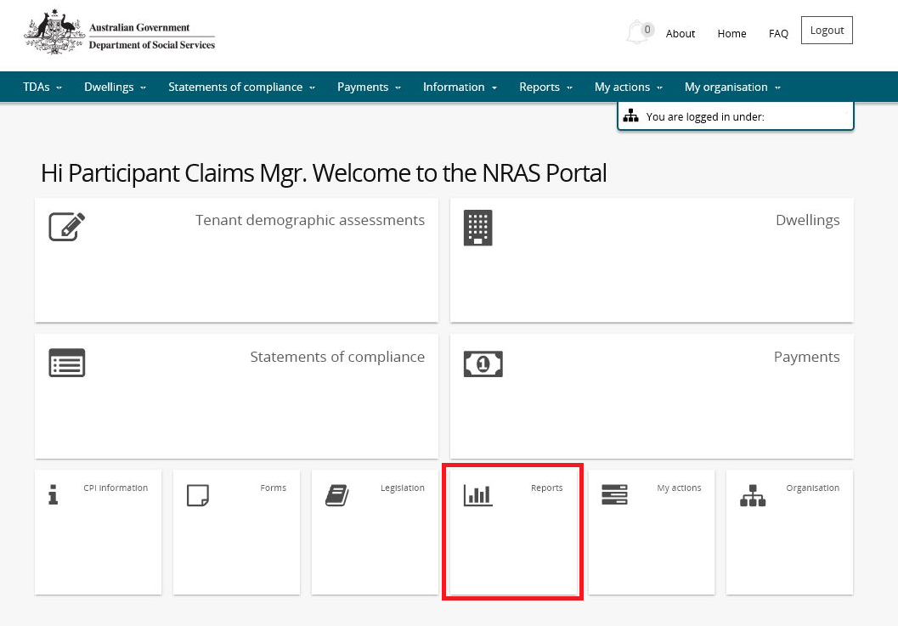

OR

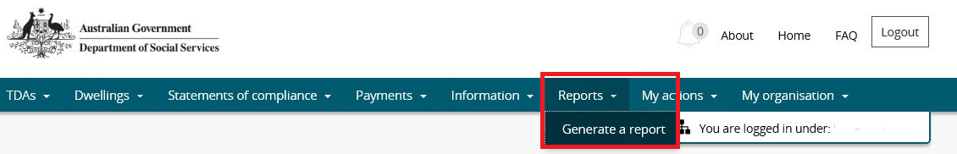

1. At **Generate a report,** select **Dwellings Without a Valid SoC**.
2. At NRAS year, select the **NRAS year**.
3. Click **Generate report**.

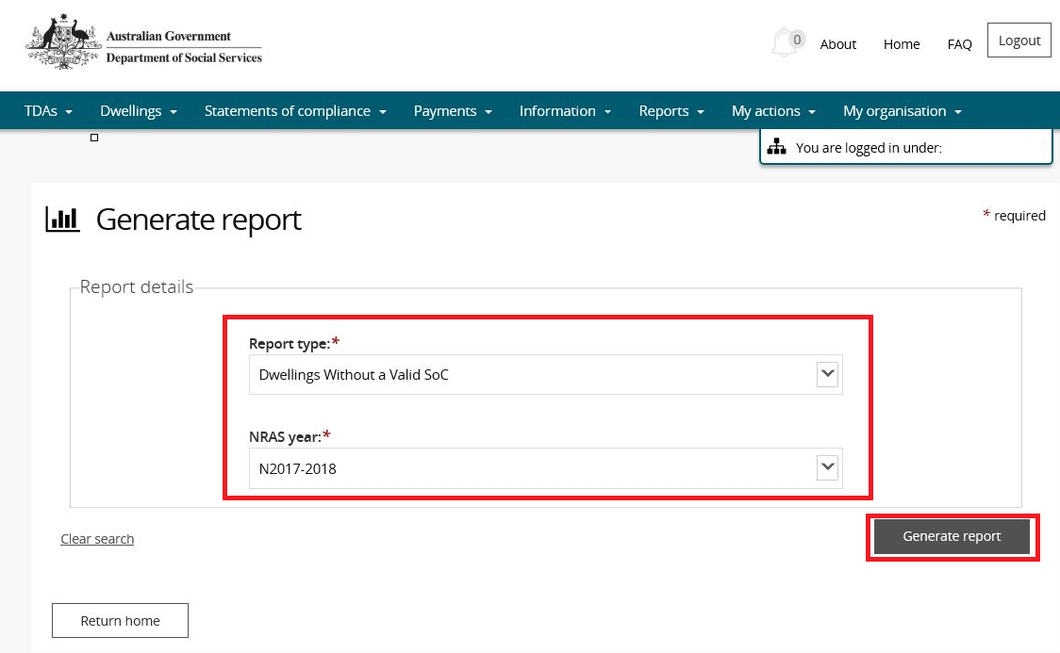

Results will appear in the lower half of the window.

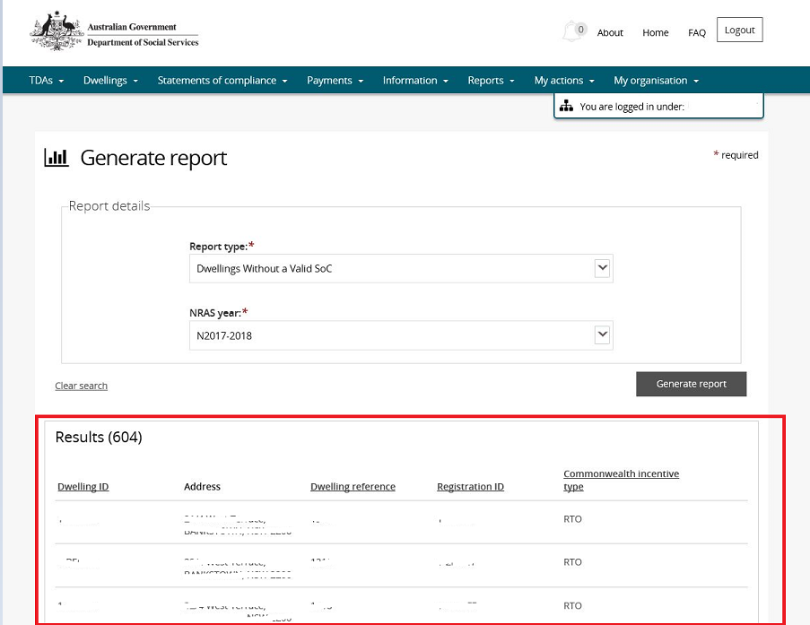

1. Click **Export** to export to Excel, or **Print** to print the report. To **Export**, select the type of file and then select **Export**. The recommended format is Tab Separated Values (TSV).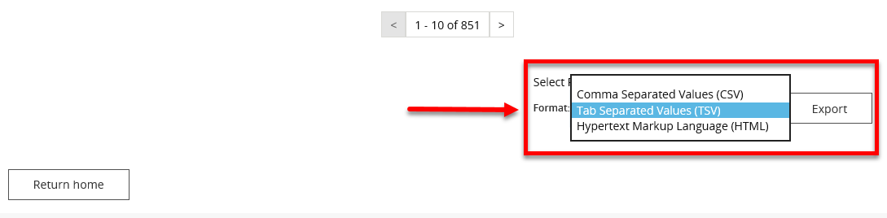
2. Where you are exporting data for more than one item, please allow the system time to process the request. Do not click **Export** again as this will override the request and only extract one line of data. To check if the export request is working the text on the browser tab changes to **Export**.

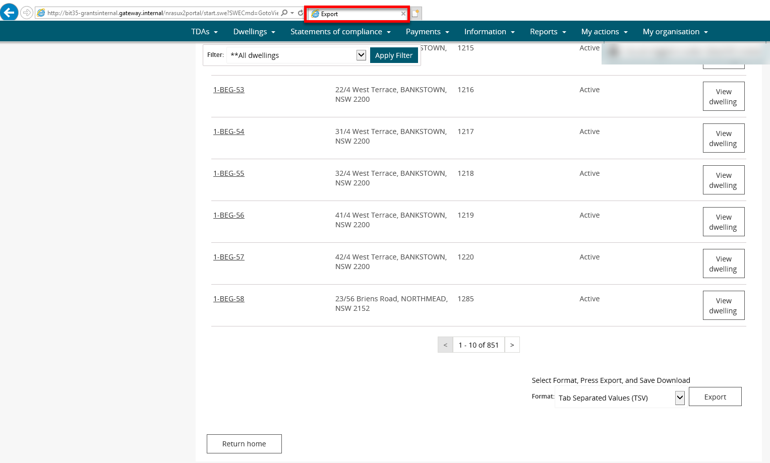

1. Once the Export process is complete, you will be prompted to either **Open** or **Save** the report.

Prompt to Open or Save the Report - Open or Save

1. Your report will either be opened or saved to the specified location.

Logging out of the NRAS Portal

1. To log out of the NRAS Portal click **Logout**.

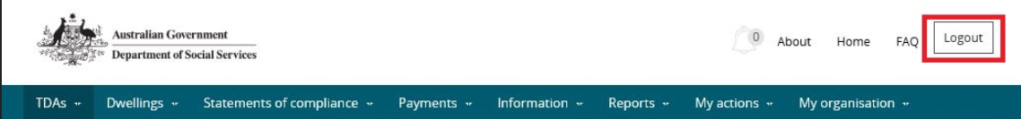

Note icon. For technical support enquiries, please contact [nrasithelpdesk@dss.gov.au](mailto:nrasithelpdesk@dss.gov.au) or 1300 911 235.