For further assistance please contact [nrasithelpdesk@dss.gov.au](mailto:nrasithelpdesk@dss.gov.au)

National Rental Affordability Scheme (NRAS) Portal

Quick Reference Guide

## How to Run a Report to Obtain Dwelling Details

This Quick Reference Guide (QRG) will take you through the process required to run a report in the NRAS portal to obtain dwelling details.

Access levels required to undertake this process:

* Participant Read Write User; or Participant Claims User.

Warning Do not use the navigation buttons on your web browser while working in the portal. Using the back, forward or refresh buttons on your browser will cause you to lose the information you have entered.

Use the **Back** and **Continue** buttons to move through the different sections.

1. Log in to the [NRAS Portal](https://nras.dss.gov.au/nrasportal/).
2. At the Disclaimer, click **I Agree**.
3. Click the **Dwellings** tile or select **Dwellings>Search Dwelling**.

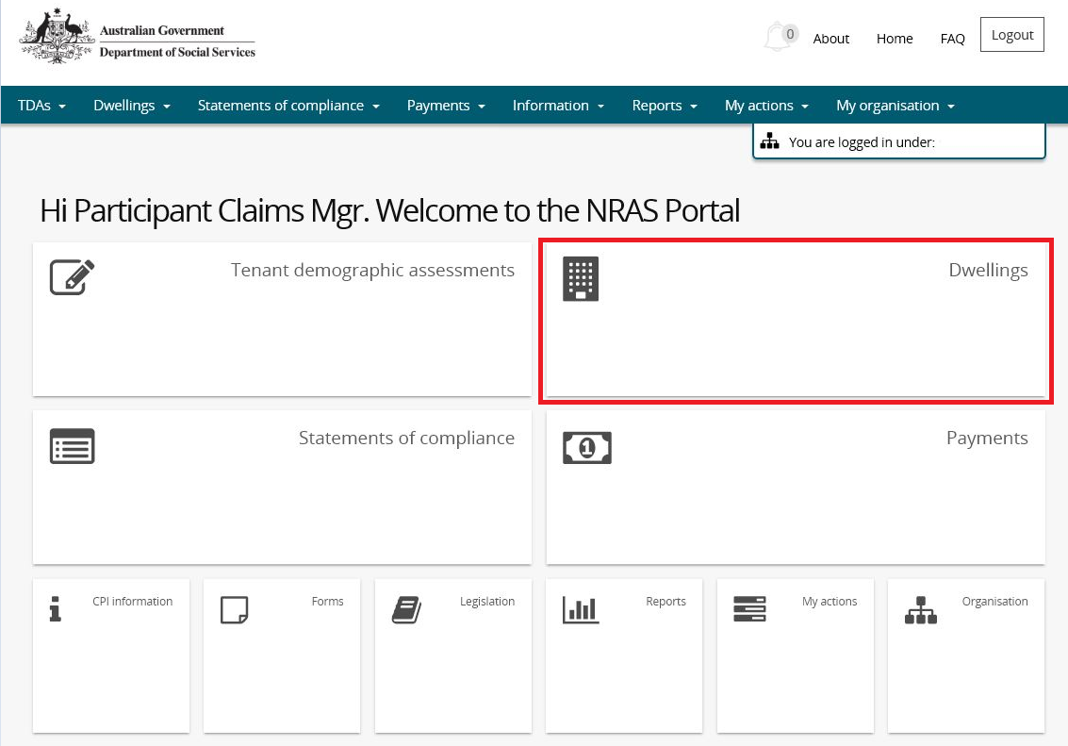

OR

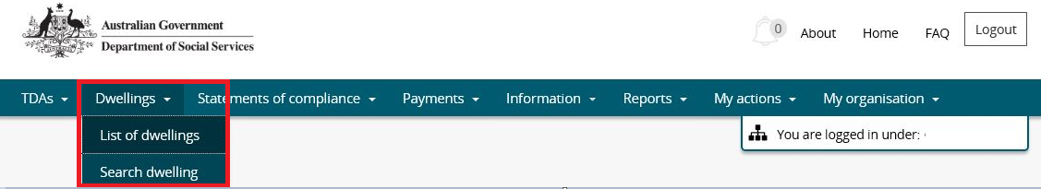

1. The Search dwellings window opens.

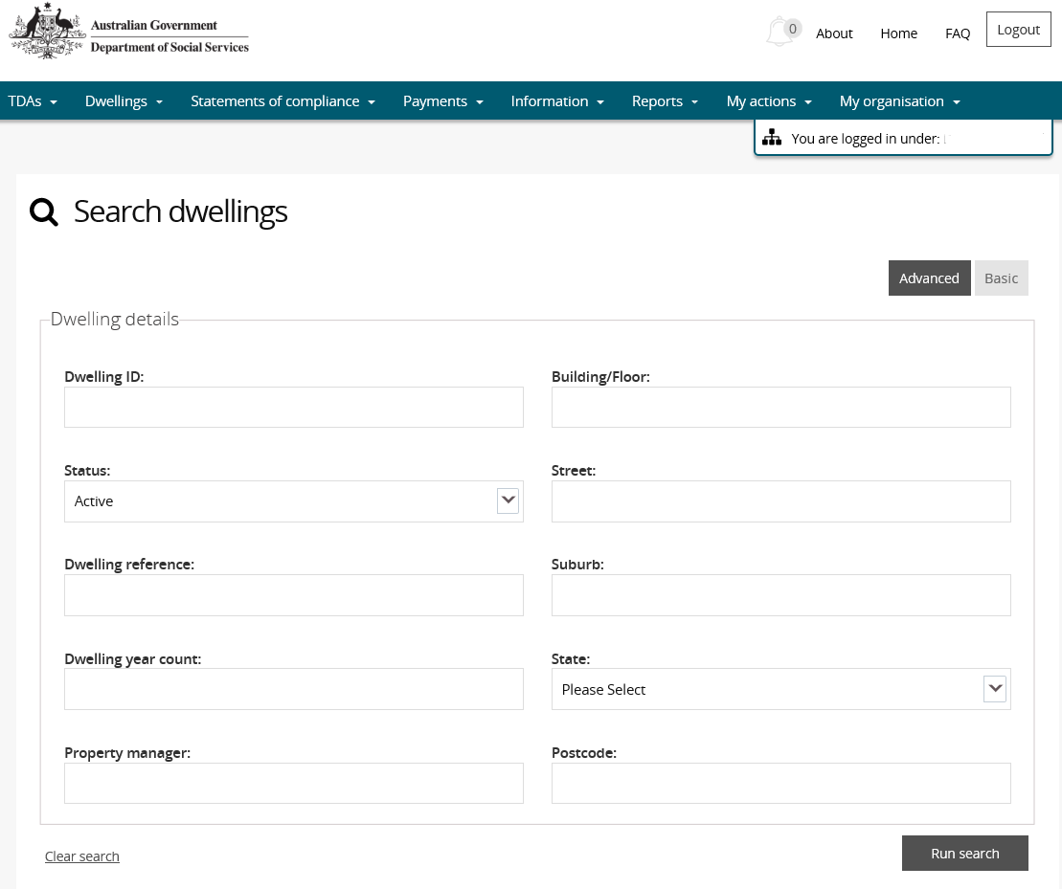

1. To search for a dwelling, select or enter search criteria in the **Dwelling details** search fields. If no search criteria is entered, the search results will default to all Dwellings with a Status of Active.
2. The available search criteria defaults to **Basic**, you can select **Advanced** to display additional search fields.

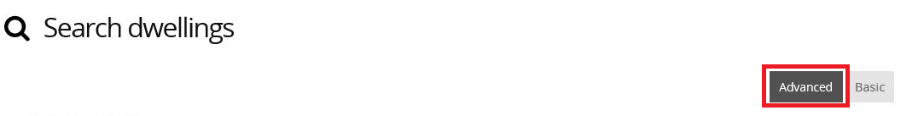

1. Once all search fields are entered Click **Run search**.

Search Dwellings - Run search

All dwellings that meet the search criteria will be displayed.

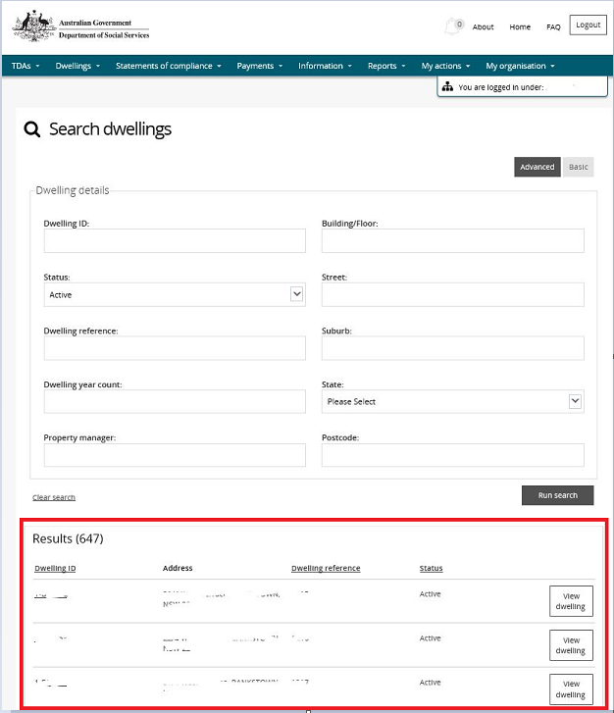

1. To **Export**, select the type of file and then select **Export**. The recommended format is Tab Separated Values (TSV).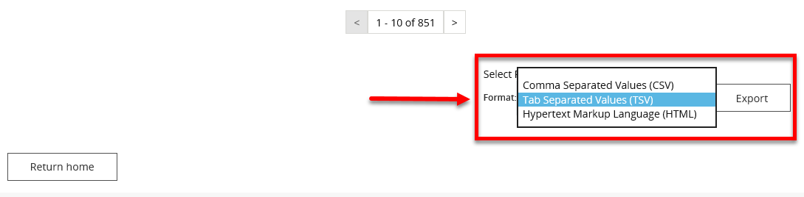
2. Where you are exporting data for more than one item, please allow the system time to process the request. Do not click **Export** again as this will override the request and only extract one line of data. To check if the export request is working the text on the browser tab changes to **Export**.

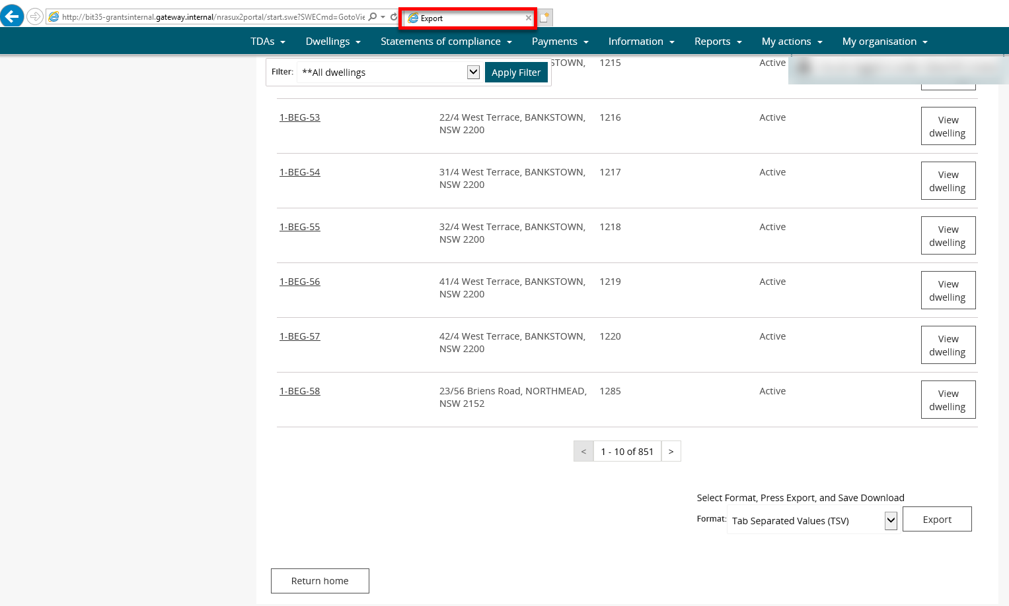

1. Once the Export process is complete, you will be prompted to either **Open** or **Save** the report.

Prompt for Open or Save the report - select Open or Save

1. Your Report will either be opened or saved to the specified location.

Additional Information Note All records in the report will be displayed or saved.

Logging out of the NRAS Portal

1. To log out of the NRAS Portal click **Logout**.

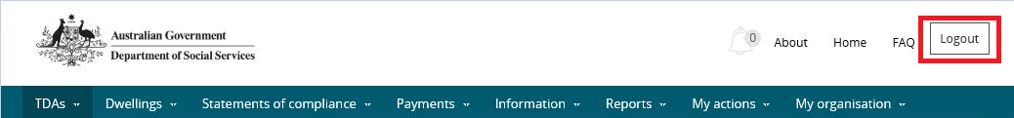

Additional Information NoteFor technical support enquiries, please contact [nrasithelpdesk@dss.gov.au](mailto:nrasithelpdesk@dss.gov.au) or 1300 911 235.