For further assistance, please contact [nrasithelpdesk@dss.gov.au](mailto:nrasithelpdesk@dss.gov.au)

## National Rental Affordability Scheme (NRAS) Portal

## Quick Reference Guide

View and print a RTO certificate

This Quick Reference Guide (QRG) will take you through the steps to view and print a Refundable Tax Offset (RTO) certificate in the NRAS Portal.

Access Required:

* Participant Read Write User; or Participant Claims User.

Warning Do not use the navigation buttons on your web browser while working in the portal. Using the back, forward or refresh buttons on your browser will cause you to lose the information you have entered.

Use the **Back** and **Continue** buttons to move through the different sections.

1. Log in to the [NRAS Portal](https://nras.dss.gov.au/nrasportal/).
2. At the Disclaimer, click **I agree**.
3. There are two ways to navigate to the **Search RTOs** screen from the main page: through the Payments tile (see step 4) or through the dropdown menu (see step 5).
4. Click the **Payments** tile.

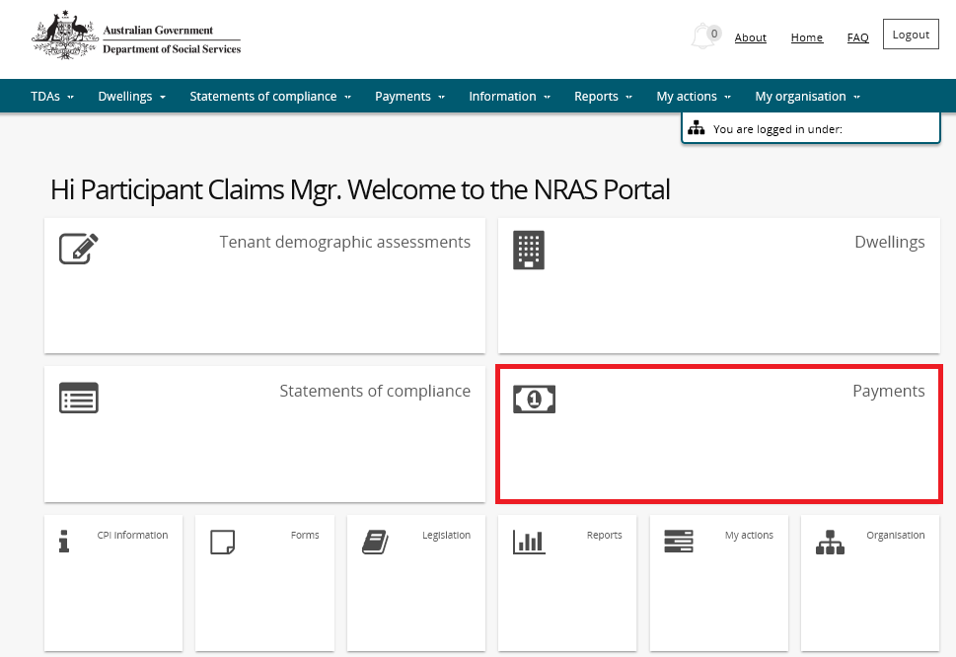

**OR**

1. At the Welcome screen, select **Payments>Search RTOs**.

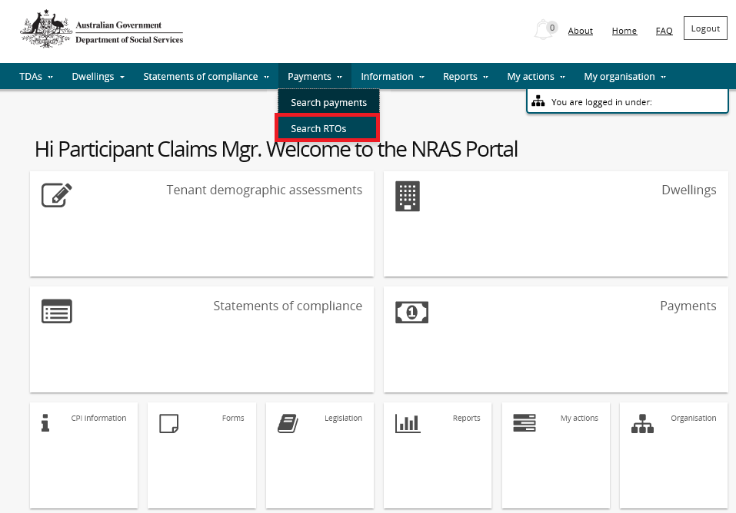

The **Search RTOs** page is returned enter required search criteria then select **Run search**.

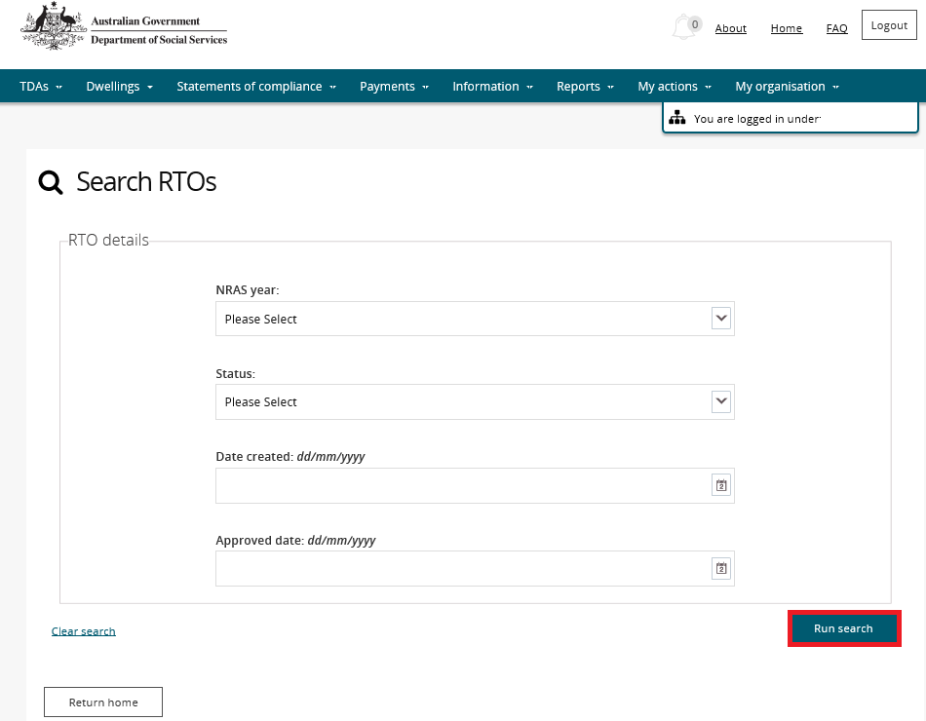

1. Search results appear in the lower half of the window. Select the **View RTO** button for the required RTO.

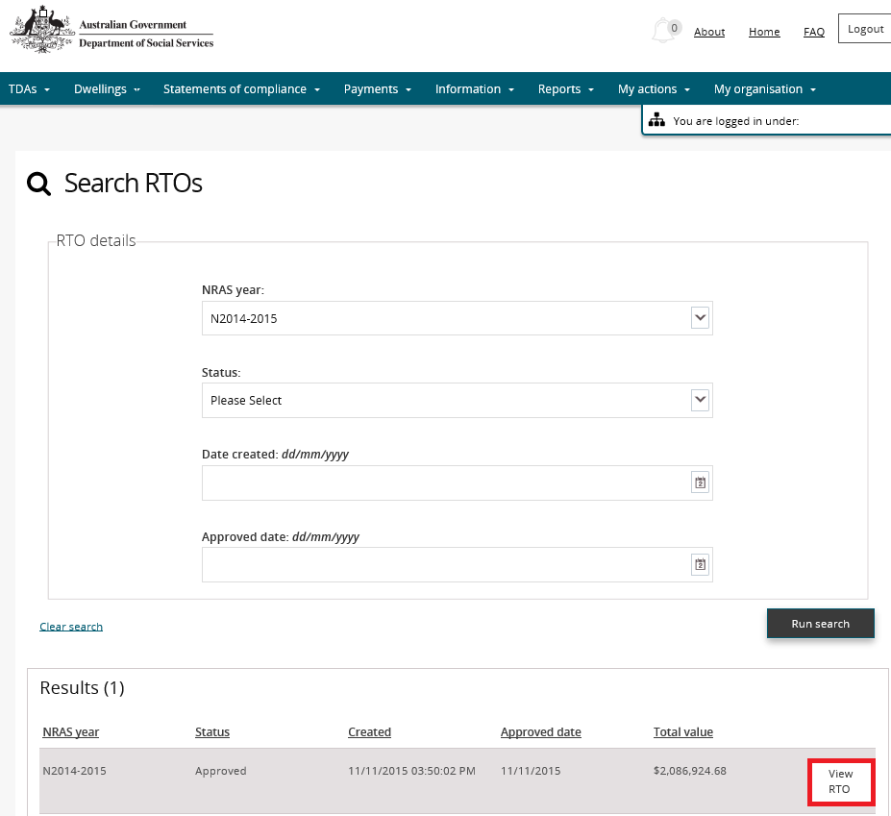

1. The **RTO Overview** page displays. To print the RTO, click the **Print RTO** button.

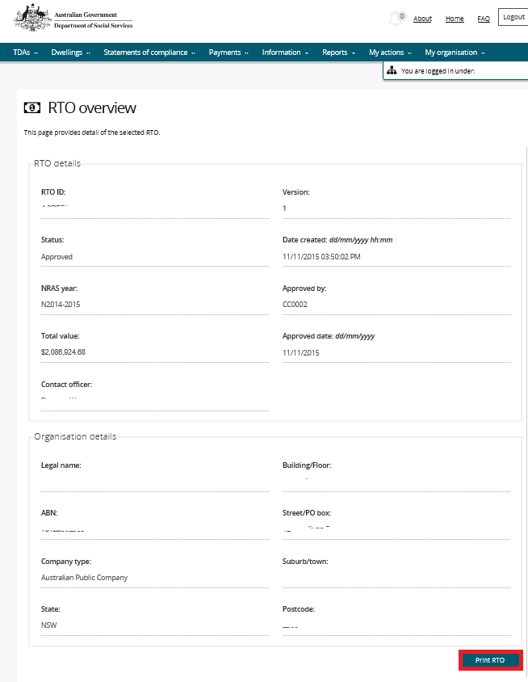

1. You will be prompted to either **Open** or **Save** the RTO.

Prompt for Open or Closing RTO - select option

1. Your RTO certificate will either be opened or saved to the specified location as a .pdf file.

Logging out of the NRAS Portal

1. To log out of the NRAS Portal click **Logout.**

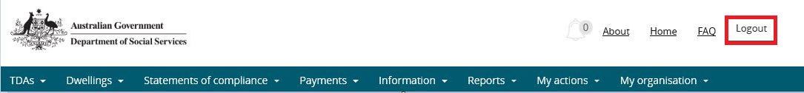

Note icon. For technical support enquiries, please contact [nrasithelpdesk@dss.gov.au](mailto:nrasithelpdesk@dss.gov.au) or 1300 911 235.