For further assistance please contact [nrasithelpdesk@dss.gov.au](mailto:nrasithelpdesk@dss.gov.au)

National Rental Affordability Scheme (NRAS) Portal

Quick Reference Guide

## Withdraw a Claim

This Quick Reference Guide (QRG) will take you through the process required to withdraw a claim in the NRAS Portal. Only Statements of compliance with a status of ‘Submitted’ can be withdrawn.

Access Required:

* Participant Claims User

Warning Do not use the navigation buttons on your web browser while working in the portal. Using the back, forward or refresh buttons on your browser will cause you to lose the information you have entered.

Use the **Back** and **Continue** buttons to move through the different sections.

1. Log in to the [NRAS Portal](https://nras.dss.gov.au/nrasportal/).
2. At the Disclaimer, click **I agree**.
3. There are two ways to navigate to the **Search Statement of compliance** screen from the main page: through the Statements of compliance tile (see step 4) or through the dropdown menu (see step 5).
4. Click the **Statements of compliance** tile. A list of Statements of compliance will be returned, then select the **Search SoCs** button.

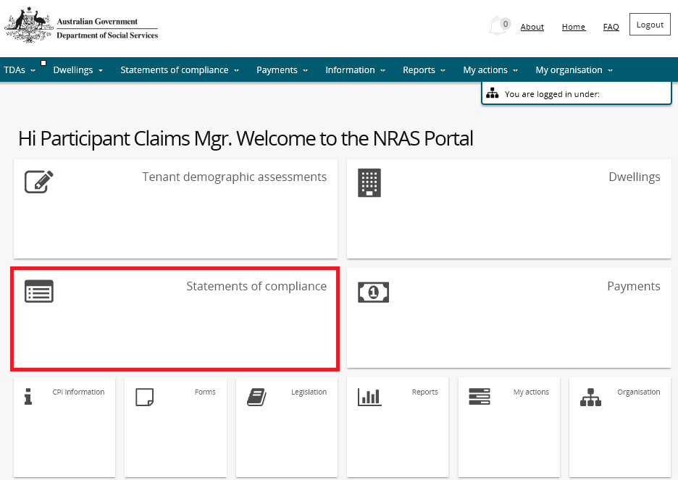

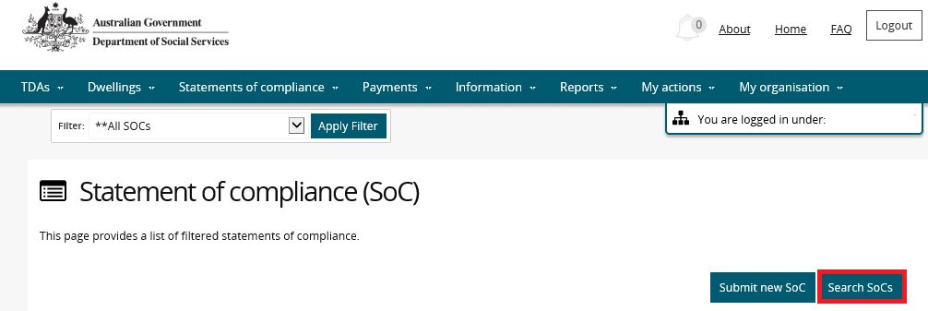

**OR**

1. At the **Welcome screen**, select **Statements of compliance>Search statements of compliance**.

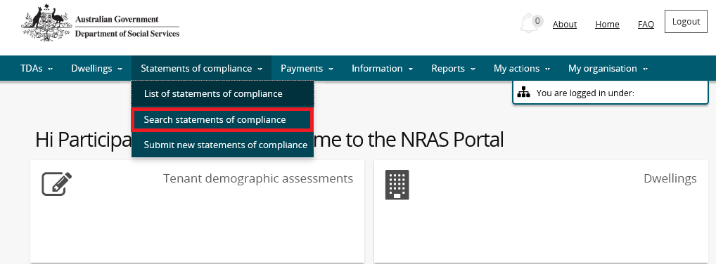

1. Select the relevant **NRAS Year** for the claim you are searching for and set the **Status** field to Submitted. You can further refine your search by typing in additional dwelling details.

Additional Information NoteClickthe **Advanced** buttonto display additional search fields**.**

Additional Information Note The **NRAS year** field will default to the current NRAS claiming year.

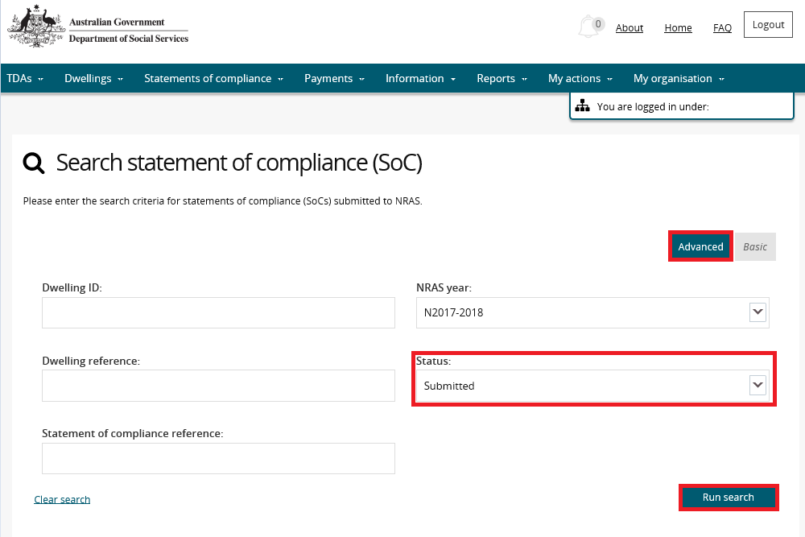

1. Click **Run search**. A list of Dwellings that meet the criteria are displayed.
2. Select the **View SoC** button for the Dwelling you which you wish to withdraw the claim.

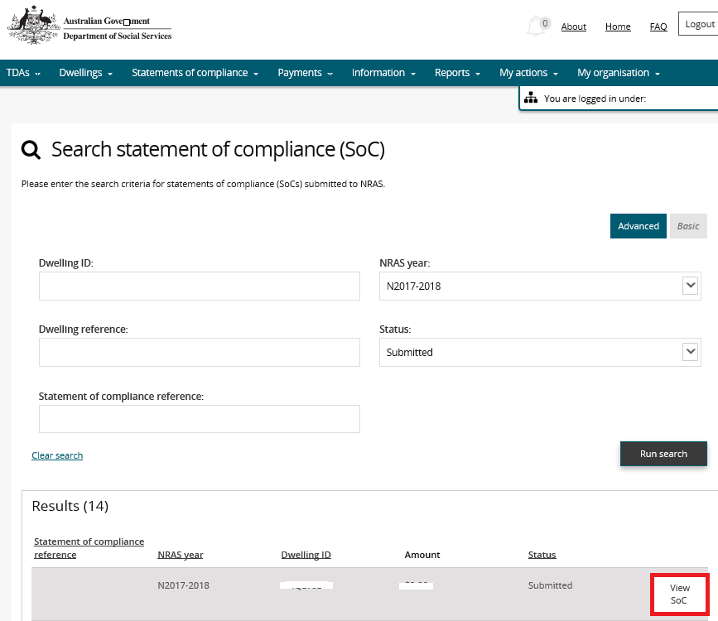

1. The **Statement of compliance details** screen displays. On the **Statement of compliance details** screen, click the **Withdraw SoC** button**.**
2. A message will appear on the screen, select the **Yes** button.

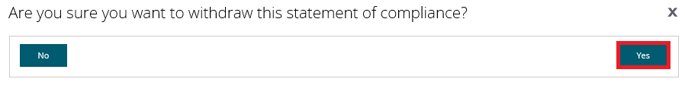

The claim is now withdrawn

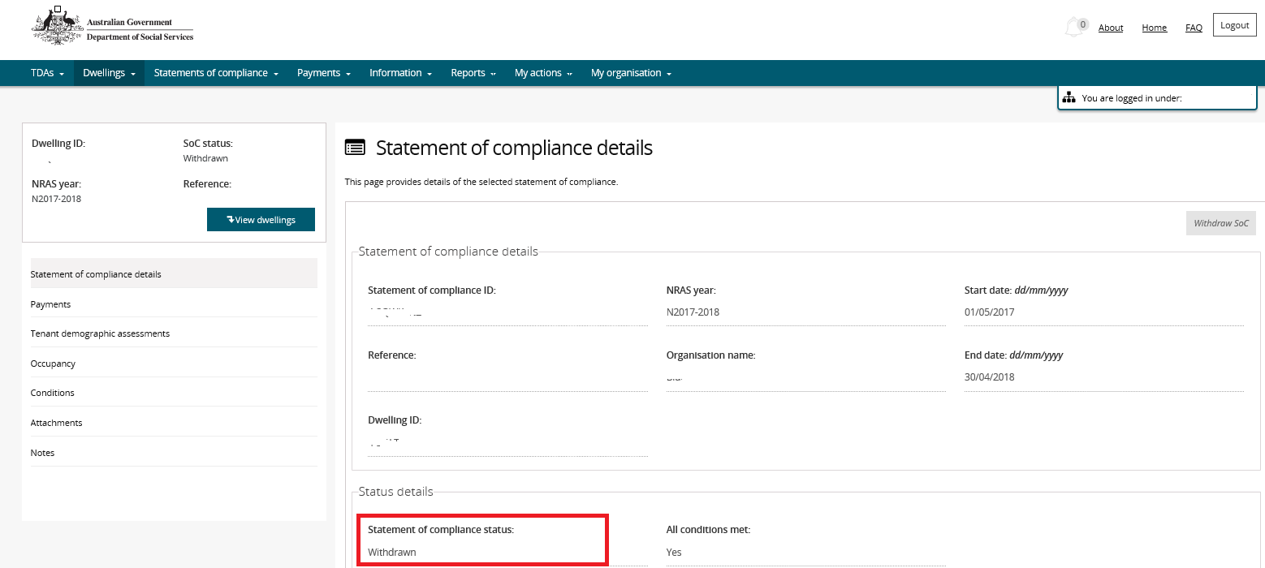

Logging out of the NRAS Portal

1. To log out of the NRAS Portal click **Logout**.

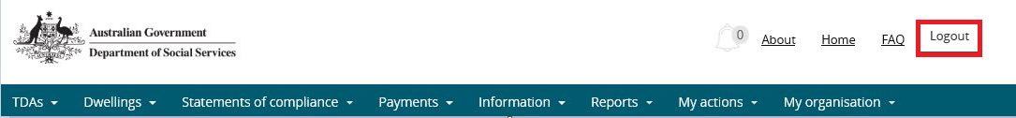

Note icon. For technical support enquiries, please contact [nrasithelpdesk@dss.gov.au](mailto:nrasithelpdesk@dss.gov.au) or 1300 911 235.