For further assistance please contact [nrasithelpdesk@dss.gov.au](mailto:nrasithelpdesk@dss.gov.au)

National Rental Affordability Scheme (NRAS) Portal

Quick Reference Guide

## Attaching a Document to an NRAS Dwelling

This Quick Reference Guide (QRG) will take you through the process required to attach a Document on an NRAS Dwelling.

Access Required:

* Participant Read Write User; or Participant Claims User.

Warning Do not use the navigation buttons on your web browser while working in the portal. Using the back, forward or refresh buttons on your browser will cause you to lose the information you have entered.

Use the **Back** and **Continue** buttons to move through the different sections.

1. Log in to the [NRAS Portal](https://nras.dss.gov.au/nrasportal/).
2. At the Disclaimer, click **I Agree**.
3. There are two ways to navigate to the Search Dwellings screen from the main page: through the Dwellings tile (see step 4) or the dropdown menu (see step 5).
4. Click the **Dwellings** tile. A list of Dwellings will be returned, then select the **Search Dwelling** button.

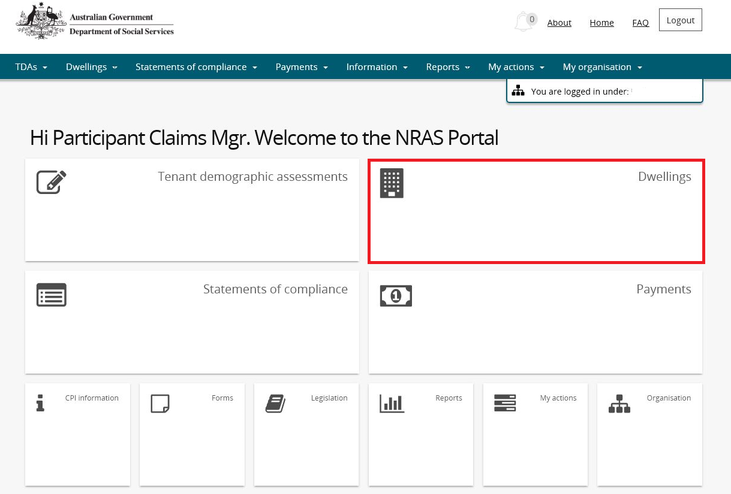

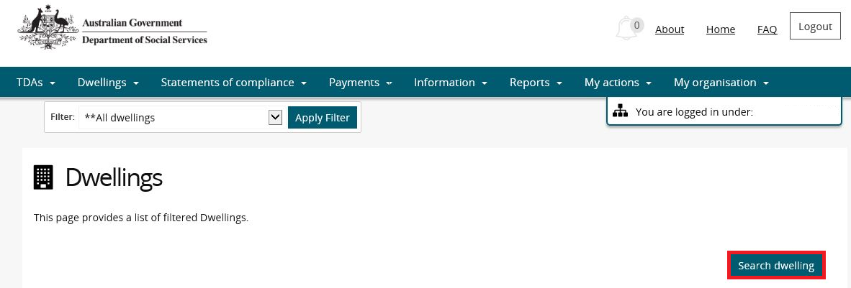

**OR**

1. At the **Welcome** screen, select **Dwellings>Search dwelling**.

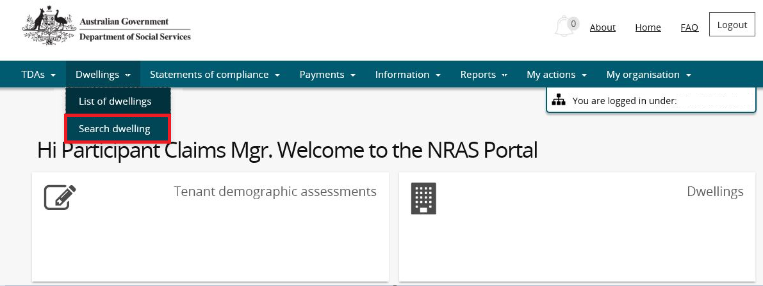

1. Enter required search criteria, then select the **Run Search** button.

Note icon.Click **Advanced** to display additional search fields.

Note icon. Search for a dwelling using any of the available search fields. All fields on the **Search dwellings** page are case insensitive for searching. If you wish to view all dwellings you have access to, leave the Dwelling search fields blank.

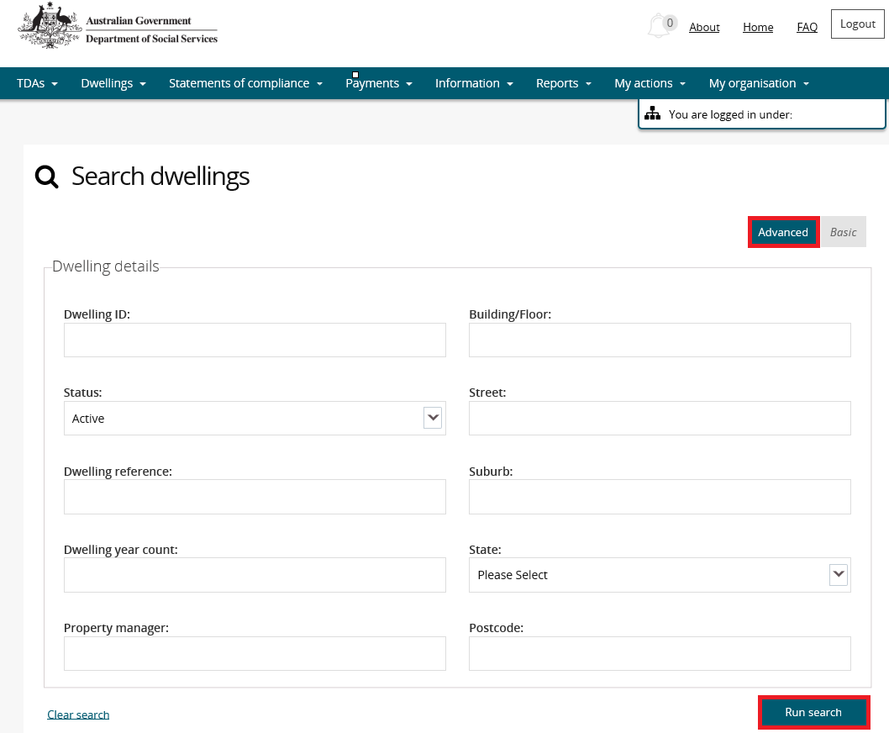

1. Results matching your entered search criteria will be returned.
2. Select the **View dwelling** button.

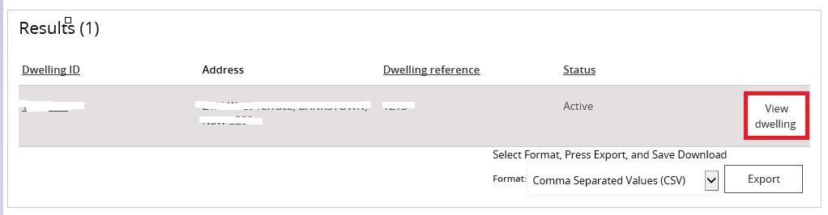

1. On the View dwelling page, select the **Attachments** link from the menu bar.

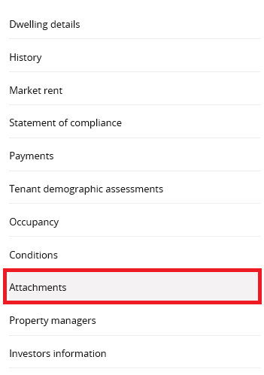

1. The Attachments page will be returned listing all existing attachments for the Dwelling. Select the **Add attachment** button and select the file you wish to upload.

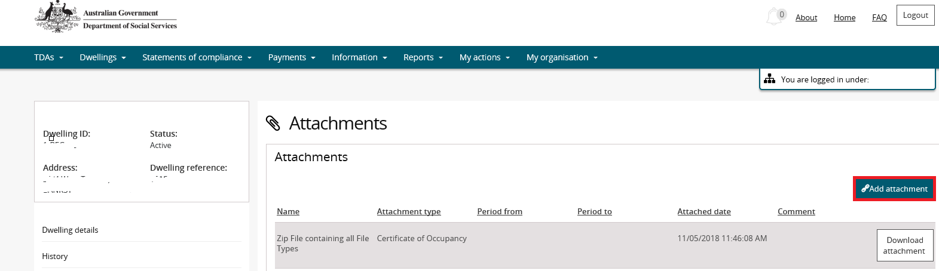

1. On the **Manage attachment details** screen, edit the file name (if required) and select an Attachment type.

Note icon. The Name and Attachment type fields are mandatory.

Note icon.You can also enter the Period From, Period to and any comments on the Manage attachment details screen.

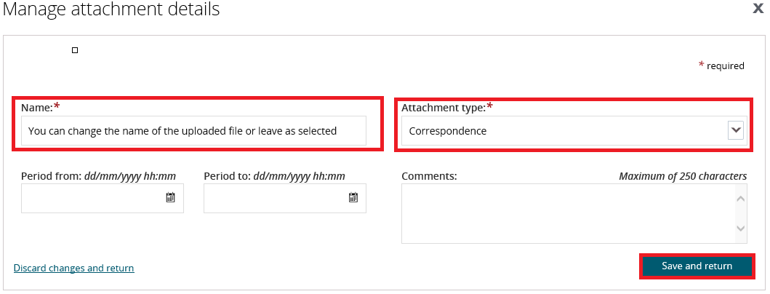

1. Select the **Save and return** button.

Your document will now be displayed in the Attachments section.

Note icon.Leases can also be attached when submitting a TDA, please check Quick Reference guides available for submitting a TDA:

* + New lease with New Tenants
  + New lease with Same Tenants
  + Same Lease

Logging out of the NRAS Portal

1. To log out of the NRAS Portal click **Logout**.

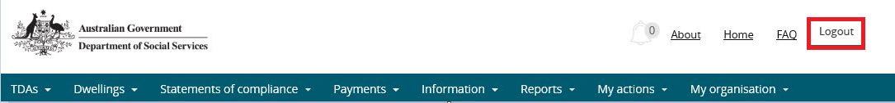

Note icon. For technical support enquiries, please contact [nrasithelpdesk@dss.gov.au](mailto:nrasithelpdesk@dss.gov.au) or 1300 911 235.