For further assistance please contact [nrasithelpdesk@dss.gov.au](mailto:nrasithelpdesk@dss.gov.au)

National Rental Affordability Scheme (NRAS) Portal

Quick Reference Guide

## Submit a Dwelling for Activation

This Quick Reference Guide (QRG) will take you through the process of submitting a dwelling for Activation in the NRAS Portal.

Access Required:

* Participant Read Write User or Participant Claims User.

Warning Do not use the navigation buttons on your web browser while working in the portal. Using the back, forward or refresh buttons on your browser will cause you to lose the information you have entered.

Use the **Back** and **Continue** buttons to move through the different sections.

1. Log in to the [NRAS Portal](https://nras.dss.gov.au/nrasportal/).
2. At the Disclaimer, click **I Agree**.
3. There are two ways to navigate to the Search Dwellings screen from the main page: through the Dwellings tile (see step 4) or the dropdown menu (see step 5).
4. Click the **Dwellings** tile. A list of Dwellings will be returned, then select the **Search dwelling** button.

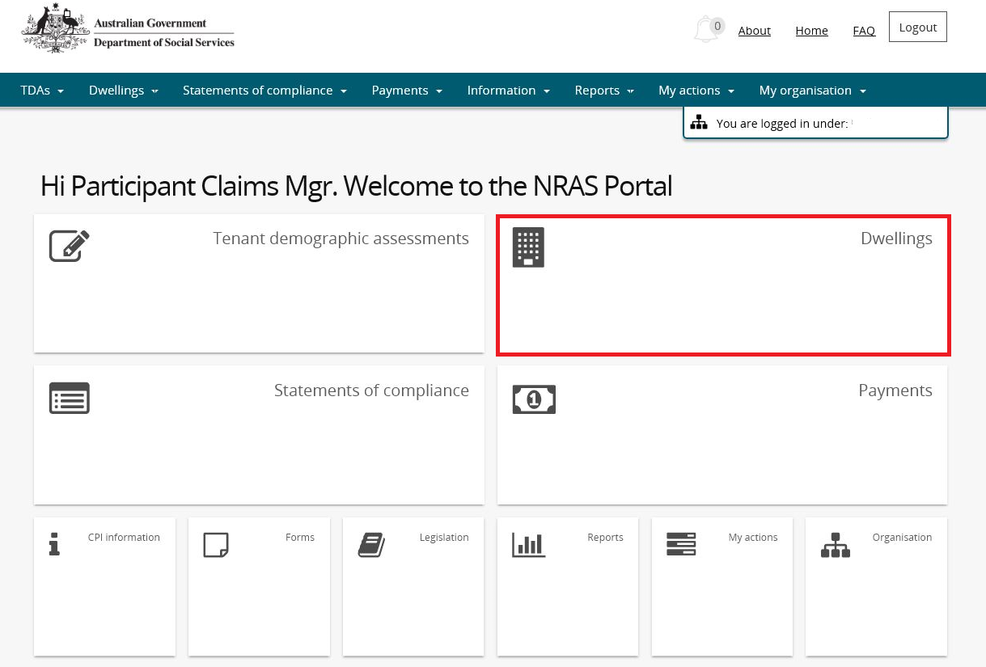

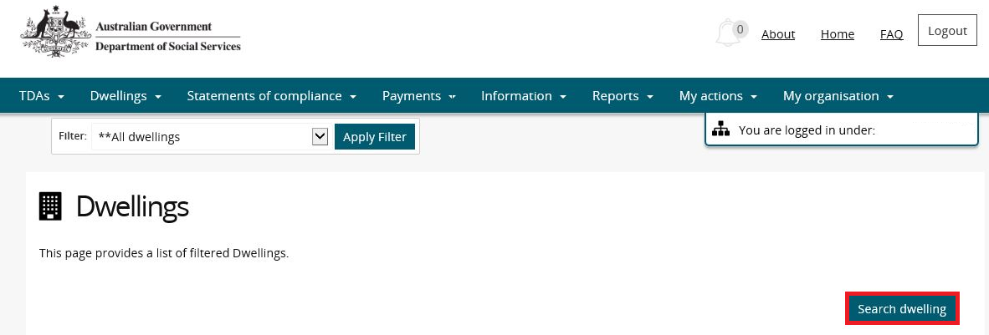

**OR**

1. At the **Welcome** screen, select **Dwellings>Search dwelling**.

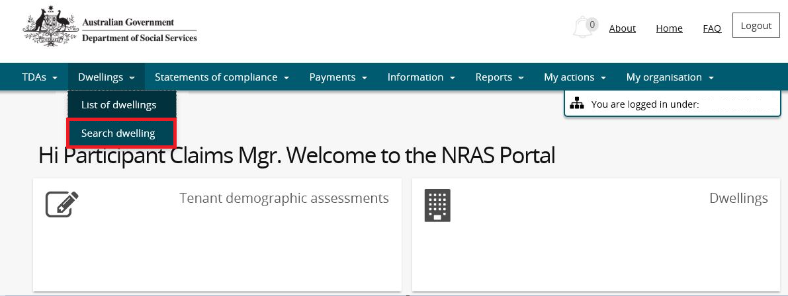

1. Enter required search criteria, then select the **Run search** button.

Note icon.Click **Advanced** to display additional search fields.

Note icon. Search for a dwelling using any of the available search fields. All fields on the **Search dwellings** page are not case sensitive for searching. If you wish to view all dwellings you have access to, leave the Dwelling search fields blank.

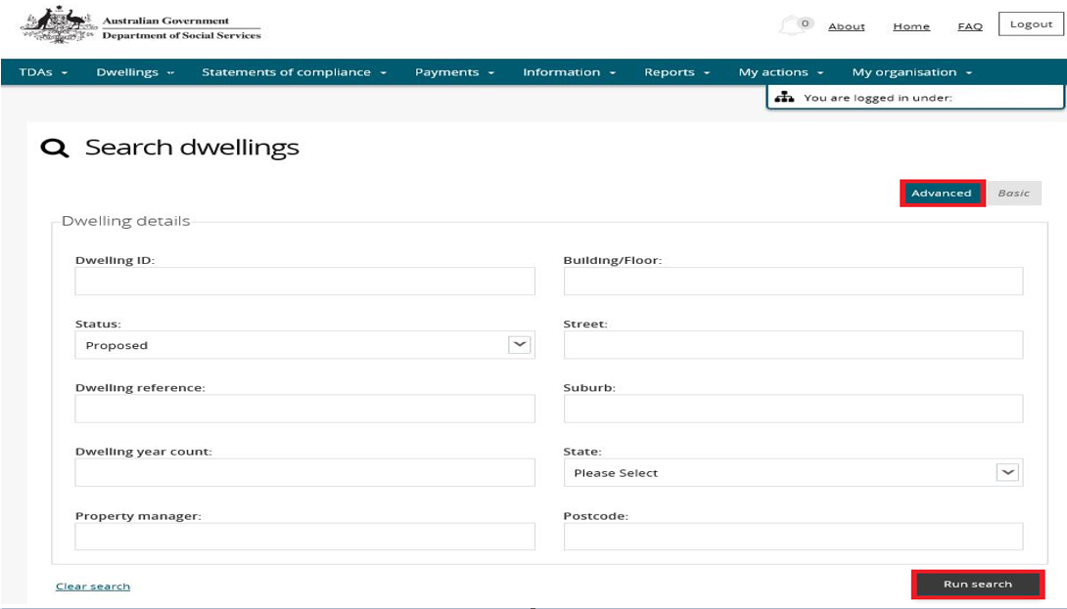

.Additional Information Note To successfully submit a dwelling for activation, the dwelling must have a Dwelling Attribute status of Approved.

1. Results matching your entered search criterial will be returned.
2. Click **View dwelling** to select the dwelling you wish to submit for activation.

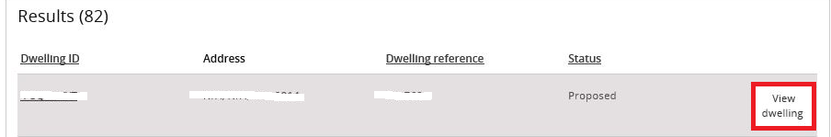

1. If all information has been completed the **Activate** button will be enabled on the ‘Dwelling details’ page. (skip to step 14).
2. If all information has not been completed the **Activate** button will be disabled and you will need to update the details.
3. On the **Dwelling details** page, select the **Update dwelling details** button.

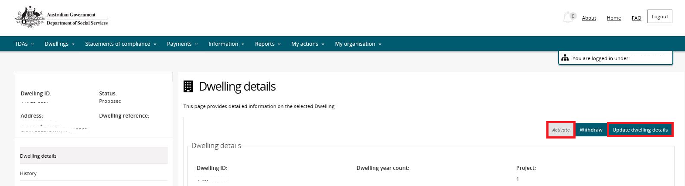

1. Ensure the following fields are complete:

Dwelling characteristics:

* Dwelling style and size; and
* Street address is complete, including all unit and street numbers.

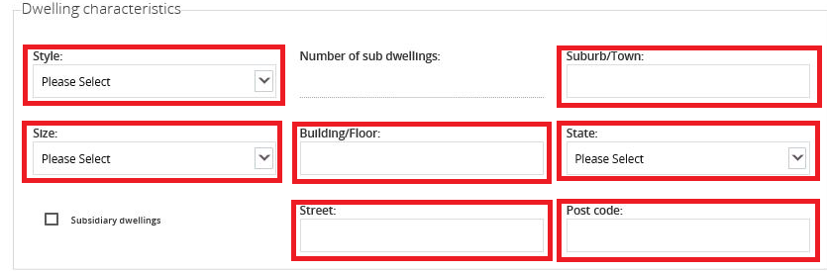

Dwelling approval details:

* Development approval;
* Construction commenced;
* Certificate of Occupancy issued;
* Approved for rent checkbox;
* Property Manager type; and
* Actual first available for rent.

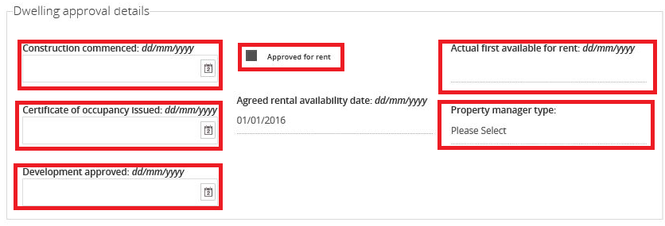

1. Click **Save and return**.
2. Select the **Attachments** menu item.

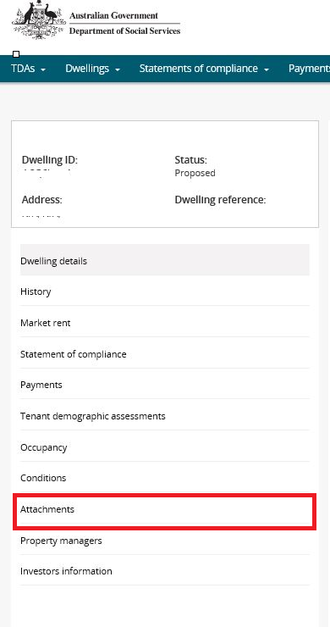

1. Select the **Add Attachment** button and add a **Certificate of Occupancy** and **Independent Rental Valuation** for the dwelling.

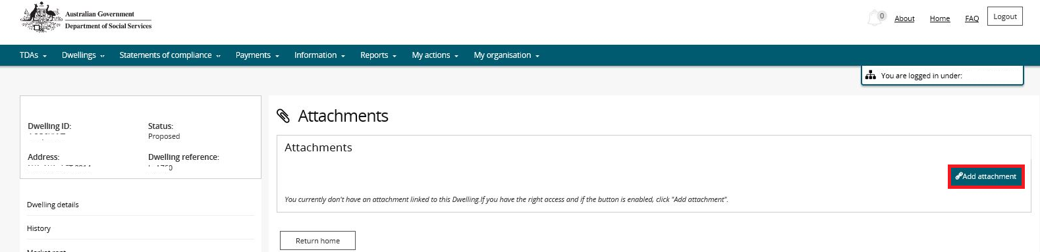

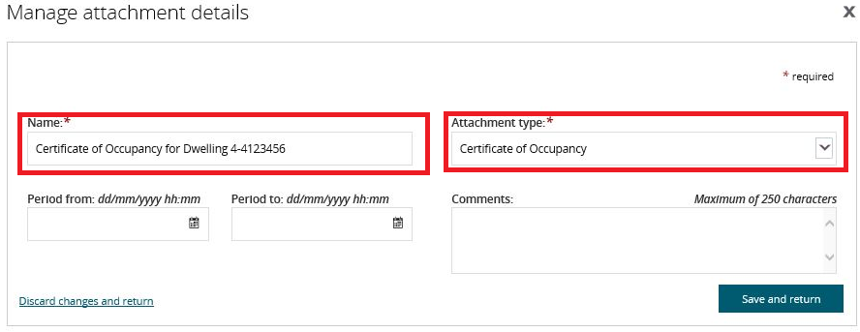

Additional Information NoteSelect the appropriate **Attachment type** for each attachment.

Additional Information NoteThe following is a list of accepted file types - BMP, DOC, DOCX, GIF, JPG, JPEG, PDF, PNG, PPS, PPT, RTF, TXT, XLS, XLSX, TIFF, TIF, ZIP, SVG, DDS, MDI, WDP, EMF, ICO, WMF, PPTX.

1. Once you have completed adding the attachments, select the **Dwelling details** menu item.

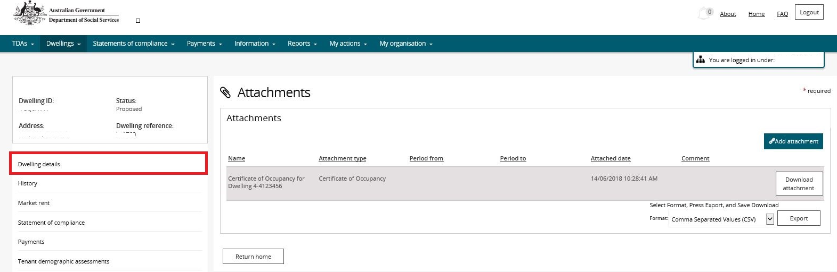

1. Select the **Activate** button.

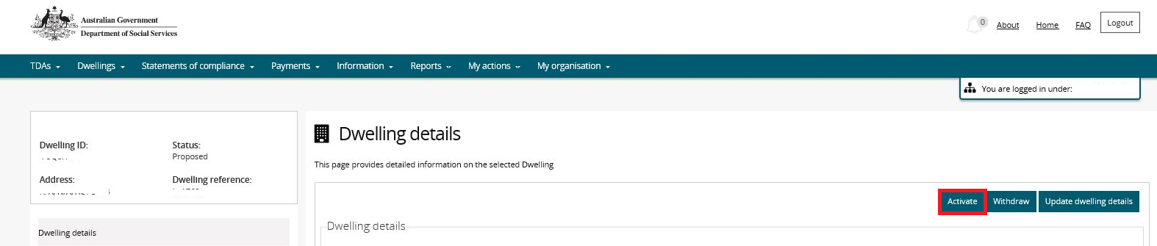

1. The **dwelling status** changes to **Submitted for Activation**.

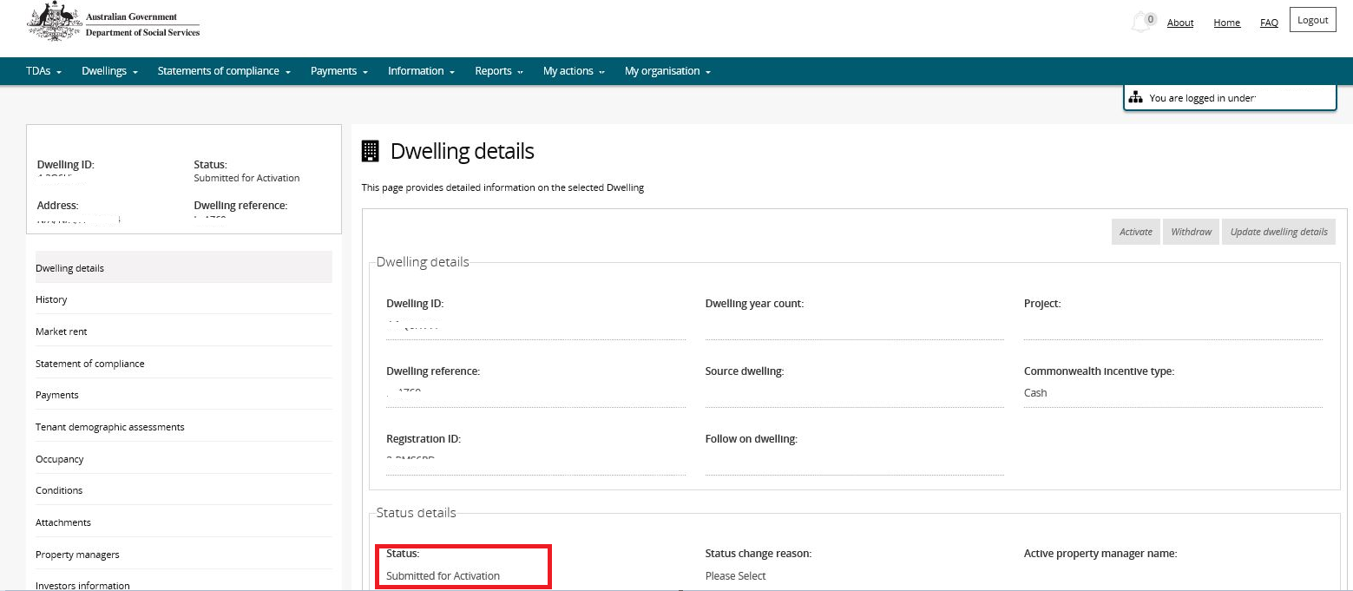

1. When the Department has reviewed the record for completion and accuracy, the Dwelling Status will change to **Active**.

Logging out of the NRAS Portal

1. To log out of the NRAS Portal click **Logout**.

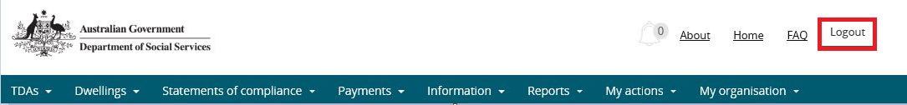

Note icon. For technical support enquiries, please contact [nrasithelpdesk@dss.gov.au](mailto:nrasithelpdesk@dss.gov.au) or 1300 911 235.