For further assistance please contact [nrasithelpdesk@dss.gov.au](mailto:nrasithelpdesk@dss.gov.au)

National Rental Affordability Scheme (NRAS) Portal

Quick Reference Guide

## Assign a Property Manager to a dwelling

This Quick Reference Guide (QRG) will take you through the process required to Assign a Property Manager to a dwelling.

Access Required:

* Participant Read Write User; or Participant Claims User.

Warning Do not use the navigation buttons on your web browser while working in the portal. Using the back, forward or refresh buttons on your browser will cause you to lose the information you have entered.

Use the **Back** and **Continue** buttons to move through the different sections.

1. Log in to the [NRAS Portal](https://nras.dss.gov.au/nrasportal/).
2. At the Disclaimer, click **I Agree**.
3. There are two ways to navigate to the Search Dwellings screen from the main page: through the Dwellings tile (see step 4) or the dropdown menu (see step 5).
4. Click the **Dwellings** tile. A list of Dwellings will be returned, then select the **Search Dwelling** button.

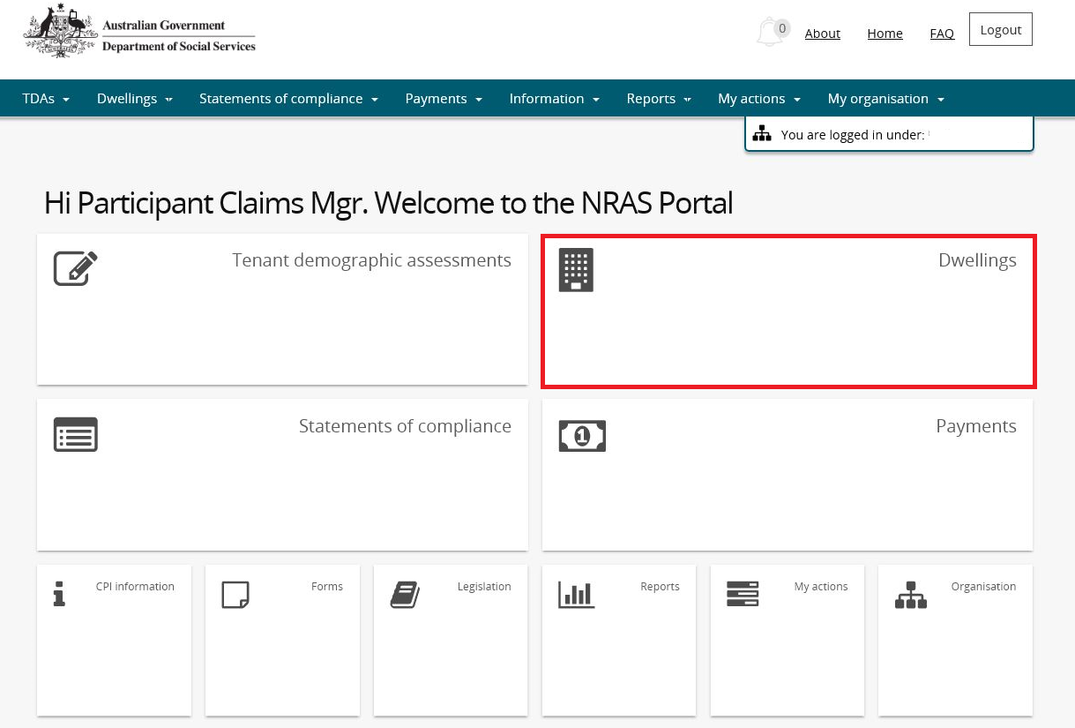

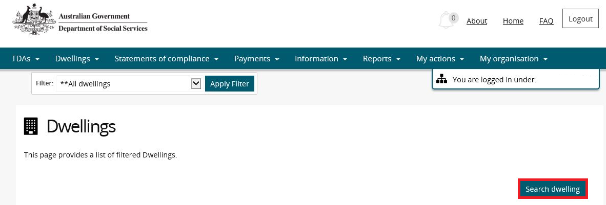

**OR**

1. At the **Welcome** screen, select **Dwellings>Search dwelling**.
2. Enter required search criteria, then select the **Run Search** button.

Note icon.Click **Advanced** to display additional search fields.

Note icon. Search for a dwelling using any of the available search fields. All fields on the **Search dwellings** page are case insensitive for searching. If you wish to view all dwellings you have access to, leave the Dwelling search fields blank.

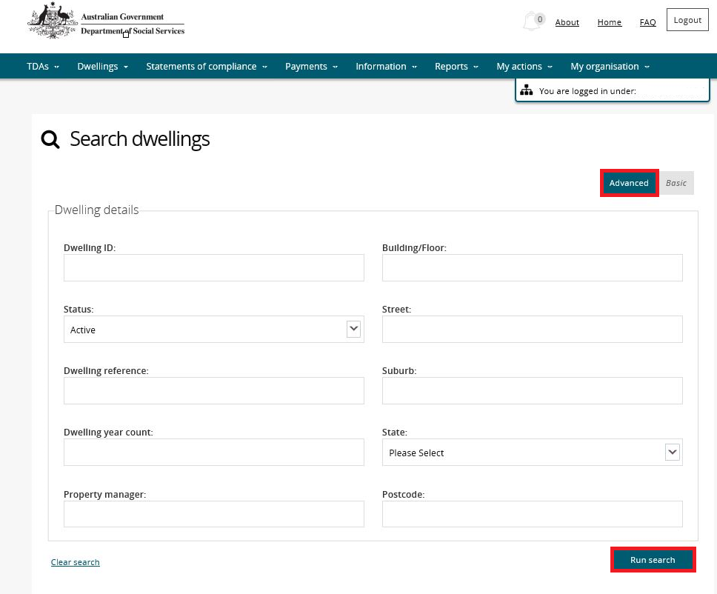

1. Results matching your entered search criteria will be returned.
2. Select the **View dwelling** button.

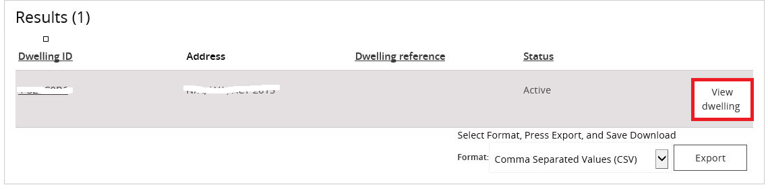

9. Select the **Property managers** menu item on the Dwelling details page.

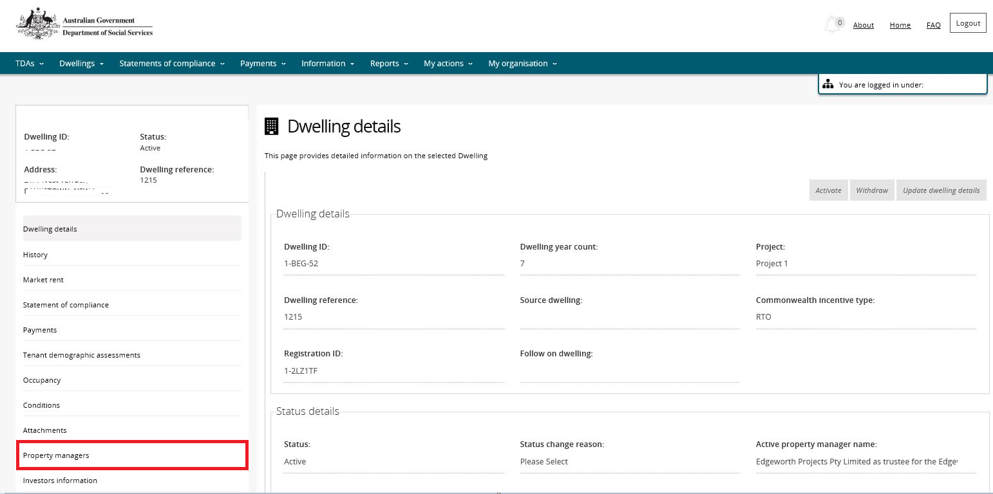

1. The Property Manager page will be displayed with any existing Property Managers for the dwelling.
2. Select the **Add property manager** button.

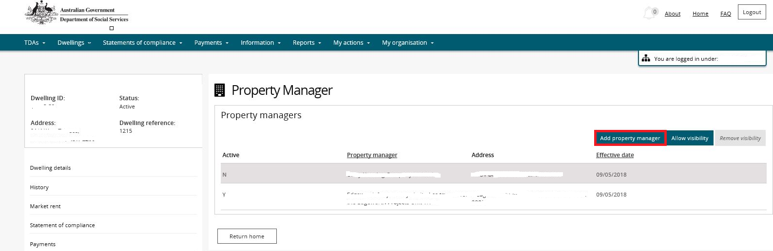

1. On the **Add property manager** page, select the Property Manager you wish to assign access to the dwelling and click the **Confirm Selection** button.

Note icon.You can also conduct a search for a Property Manager using the **Search Again** button.

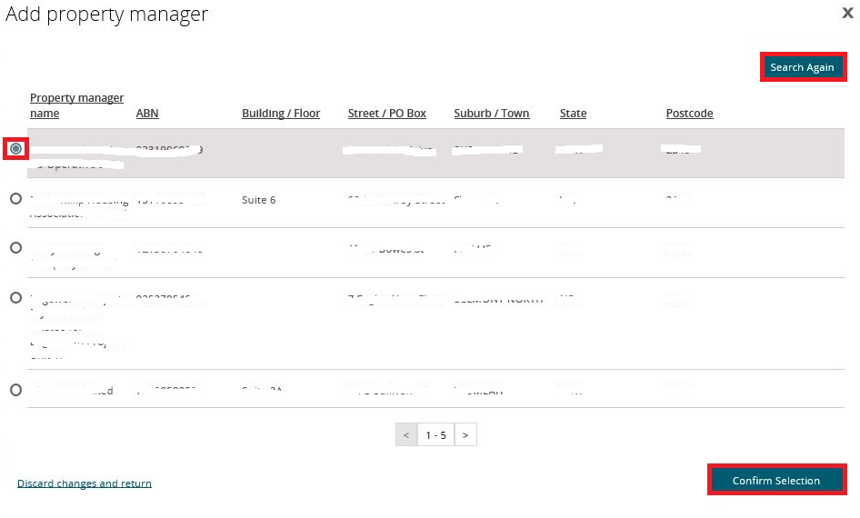

1. The selected Property manager will be added as the Active Property Manager for the Dwelling.

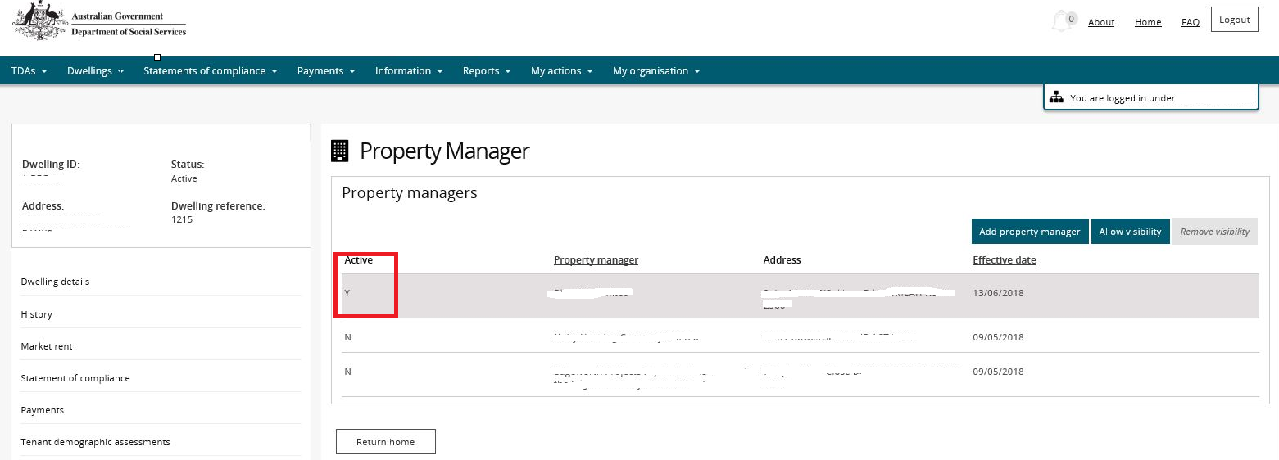

1. Click **Allow visibility** to make the dwelling visible to the Active Property Manager.
2. Click **Remove visibility** to remove the access of the Active Property Manager to a dwelling.

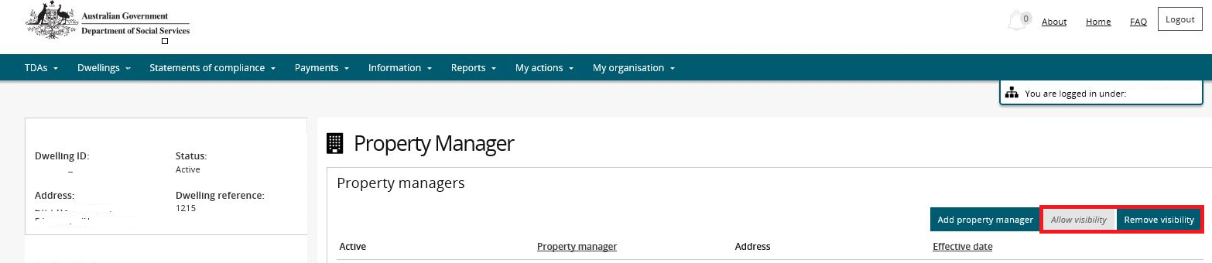

Note icon.This process must be undertaken for each dwelling that you want a Property Manager assigned to.

Logging out of the NRAS Portal

1. To log out of the NRAS Portal click **Logout**.

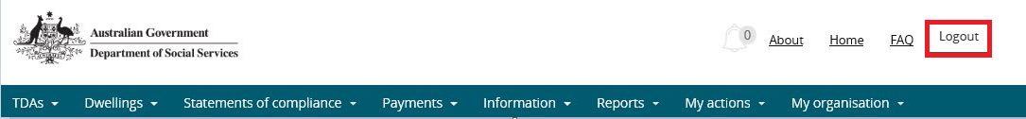

Note icon. For technical support enquiries, please contact [nrasithelpdesk@dss.gov.au](mailto:nrasithelpdesk@dss.gov.au) or 1300 911 235.