For further assistance please contact [nrasithelpdesk@dss.gov.au](mailto:nrasithelpdesk@dss.gov.au)

National Rental Affordability Scheme (NRAS) Portal

Quick Reference Guide

## Modify a Single Dwelling

This Quick Reference Guide (QRG) will take you through the process to modify a single dwelling.

Access Required:

* Participant Read Write User; or Participant Claims User.

Warning Do not use the navigation buttons on your web browser while working in the portal. Using the back, forward or refresh buttons on your browser will cause you to lose the information you have entered.

Use the **Back** and **Continue** buttons to move through the different sections.

1. Log in to the [NRAS Portal](https://nras.dss.gov.au/nrasportal/).
2. At the Disclaimer, click **I Agree**.
3. There are two ways to navigate to the Search Dwellings screen from the main page: through the Dwellings tile (see step 4) or through the dropdown menu (see step 5).
4. Click the **Dwellings** tile. A list of Dwellings will be returned, then select the **Search Dwelling** button.

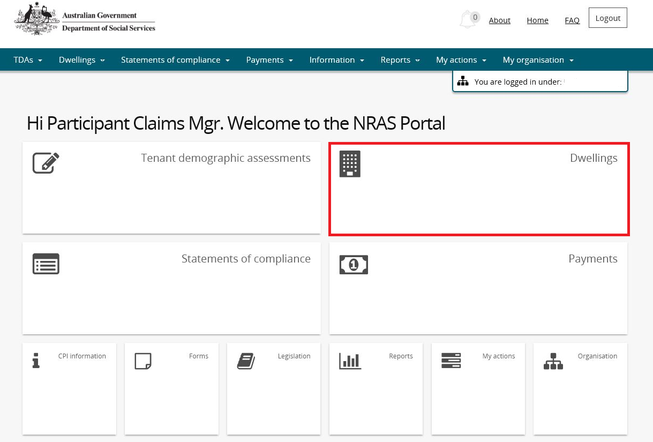

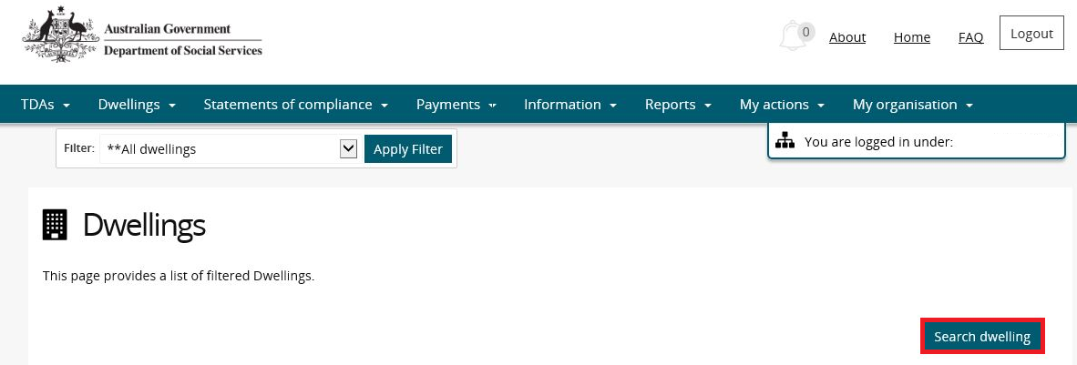

**OR**

1. At the **Welcome** screen, select **Dwellings>Search dwelling**.

How to select; "Search dwelling"



1. Enter required search criteria, then select the **Run Search** button.

Note icon.Click **Advanced** to display additional search fields.

Note icon. Search for a dwelling using any of the available search fields. All fields on the **Search dwellings** page are not case sensitive for searching. If you wish to view all dwellings you have access to, leave the Dwelling search fields blank.

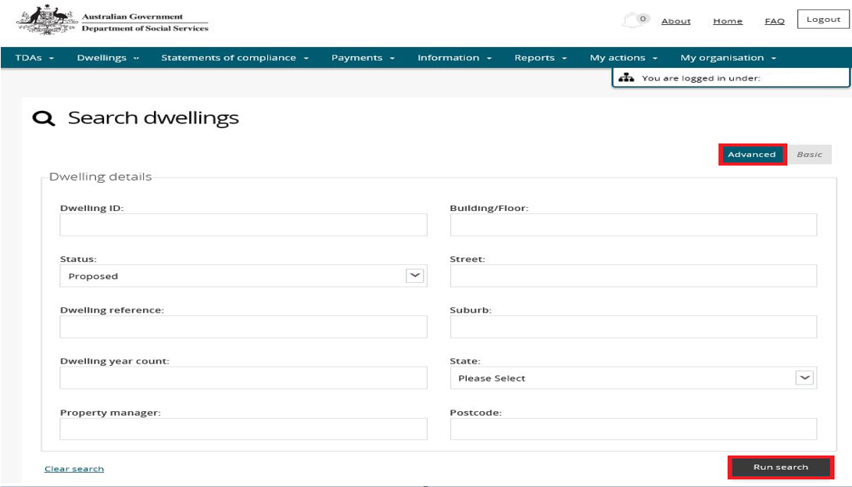

Note icon. Only Dwellings with a status of Proposed can be updated. Any changes to active dwellings will require a change request to be submitted to the Department.

1. Results matching your entered search criteria will be returned.
2. Select the **View dwelling** button.

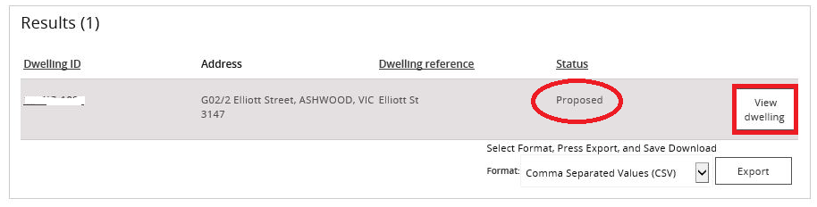

1. On the **Dwelling details** page, select the **Update dwelling details** button.

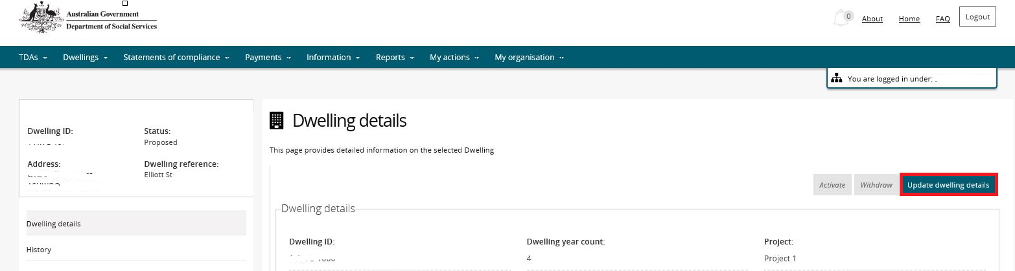

1. Make any required changes to allowed fields on the **Update dwelling details** page and then select the **Save and return** button.
2. Your changes will be saved and displayed on the Dwelling details page.

Logging out of the NRAS Portal

1. To log out of the NRAS Portal click **Logout**.

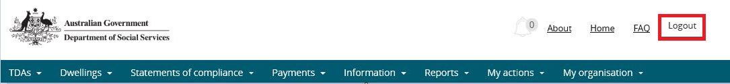

Note icon. For technical support enquiries, please contact [nrasithelpdesk@dss.gov.au](mailto:nrasithelpdesk@dss.gov.au) or 1300 911 235.