Department of Social Services

Forced Adoption Support Services Post Implementation Review

Final Report

January 2018



Table of Contents

1 Executive summary 13

1.1 Introduction 14

1.2 Review purpose 14

1.3 Methods 15

1.4 Key findings 15

1.5 Recommendations to enhance service delivery 22

1.6 Concluding remarks 24

2 Introduction 25

2.1 The Forced Adoption Support Services 26

2.2 Project background 30

2.3 Overview of methods 32

3 FASS implementation 36

3.1 Introduction 37

3.2 National 1800 number 38

3.3 Face-to-face services 40

3.4 Client diversity 41

3.5 Accessibility of services 42

3.6 Networking and collaboration 47

3.7 Trauma Informed approach to service delivery 48

3.8 Administration of Small Grants 53

3.9 Promotion of FASS 56

3.10 Data collection and reporting 57

4 Uptake and reach of FASS 60

4.1 Introduction 61

4.2 Uptake of FASS 61

4.3 Reach of FASS 67

4.4 Barriers to access: FASS provider perspectives 70

5 FASS target group perspectives 71

5.1 Introduction 72

5.2 Service user perspectives 73

5.3 Barriers to access 77

5.4 Service gaps 80

6 Other stakeholder perspectives 82

6.1 Introduction 83

6.2 Advocacy groups 83

6.3 State/territory and Australian Government representatives 85

6.4 Academics 87

7 Synthesis and recommendations 89

7.1 Introduction 90

7.2 Synthesis 90

7.3 Recommendations 104

Appendix A Services by jurisdiction 107

Appendix B National Practice Principles 109

Appendix C Operational Guidelines June 2014 111

Appendix D Service model snapshots Nov 2017 122

Appendix E Survey results 163

Appendix F Analysis of DEX data 188

Appendix G Summary of stakeholder engagement 199

Appendix H Cited references 202

List of Tables

Table 1‑1: Stakeholders consulted and mode of engagement 15

Table 2‑1: Forced Adoption Support Services provider by jurisdiction 28

Table 2‑2: Participation summary 33

Table 3‑1: Summary of services provided through FASS program, by provider 38

Table 3‑2: Estimated proportion of clients in need of therapeutic counselling services and mode by which these needs were met 40

Table 3‑3: Mode of client access to FASS 41

Table 3‑4: Estimated percentage of clients by FASS target group 42

Table 3‑5: Small Grant allocation 2015-16 53

Table 3‑6: Small Grant allocation 2016-17 54

Table 3‑7: Activities undertaken using Small Grants 55

Table 4‑1: Clients and sessions by reporting period 62

Table 4‑2: Cost by client and session, 2014-15 to 2016-17 63

Table 4‑3: FASS service types and examples clarifying their use 65

Table 5‑1: Informant profile 72

Table‑5‑2: Overall satisfaction with FASS by respondent category 73

Table A‑1: Government and non-government post-adoption services by jurisdiction 108

Table D‑1: RA (NSW) FASS profile 124

Table D‑2: Overview of RA (NSW) service model 125

Table D‑3: RA (NSW) FASS client profile 126

Table D‑4: RA (NSW) FASS staffing profile 127

Table D‑5: RA (NSW) Small Grants 128

Table D‑6: Other services in the post-adoption sector where RA (NSW) referred FASS clients 129

Table D‑7: RA (NSW) promotion and awareness activities 129

Table D‑8: RA (NT) FASS profile 130

Table D‑9: Overview of RA (NT) service model 131

Table D‑10: RA (NT) FASS client profile 132

Table D‑11: RA (NT) FASS staffing profile 132

Table D‑12: RA (NT) Small Grants 133

Table D‑13: Other services in the post-adoption sector where RA (NT) referred FASS clients 133

Table D‑14: RA (NT) promotion and awareness activities 134

Table D‑15: Jigsaw Qld FASS profile 135

Table D‑16: Overview of Jigsaw Qld service model 135

Table D‑17: Jigsaw Qld client profile 137

Table D‑18: Jigsaw Qld FASS staffing profile 137

Table D‑19: Jigsaw Qld Small Grants 138

Table D‑20: Other services in the post-adoption sector where Jigsaw QLD referred FASS clients 139

Table D‑21: Jigsaw Qld promotion and awareness activities 140

Table D‑22: RA (SA) FASS profile 141

Table D‑23: Overview of RA (SA) service model 142

Table D‑24: RA (SA) FASS client profile 143

Table D‑25: RA (SA) FASS staffing profile 144

Table D‑26: RA (SA) Small Grants 145

Table D‑27: Other services in the post-adoption sector where RA (SA) referred FASS clients 146

Table D‑28: RA (SA) promotion and awareness activities 146

Table D‑29: RA (Tas) FASS profile 147

Table D‑30: Overview of RA (Tas) service model 148

Table D‑31: RA (Tas) FASS client profile 149

Table D‑32: RA (Tas) FASS staffing profile 149

Table D‑33: Other services in the post-adoption sector where RA (Tas) referred FASS clients 150

Table D‑34: RA (Tas) promotion and awareness activities 150

Table D‑35: RA (Vic) FASS profile 151

Table D‑36: Overview of RA (Vic)service model 152

Table D‑37: RA (Vic) FASS client profile 153

Table D‑38: RA (Vic) FASS staffing profile 153

Table D‑39: RA (Vic) Small Grants 155

Table D‑40: Other services in the post-adoption sector where RA (Vic) referred FASS clients 157

Table D‑41: RA (Vic) promotion and awareness activities 158

Table D‑42: RA (WA) FASS profile 159

Table D‑43: Overview of RA (WA) service model 160

Table D‑44: RA (WA) FASS client profile 161

Table D‑45: RA (WA) FASS staffing profile 161

Table D‑46: RA (WA) Small Grants 162

Table D‑47: Other services in the post-adoption sector where RA (WA) referred FASS clients 162

Table D‑48: RA (WA) promotion and awareness activities 163

Table E‑1: Survey respondents by FASS target group and expanded target group 166

Table E‑2: Survey respondents by FASS target group and gender 166

Table E‑3: Survey respondents by FASS target group and age group 167

Table E‑4: Survey respondents by FASS target group and current place of residence 167

Table E‑5: Survey respondents by FASS target group and residential area 167

Table E‑6: Survey respondents by FASS target group and Aboriginal or Torres Strait Islander status 168

Table E‑7: Survey respondents by FASS target group and CALD background 168

Table E‑8: Survey respondents by FASS target group and disability status 168

Table E‑9: Survey respondents by FASS target group and country of birth 169

Table E‑10: Survey respondents by FASS usage and expanded target group 170

Table E‑11: Survey respondents by FASS usage and by gender 171

Table E‑12: Survey respondents by FASS usage and age group 171

Table E‑13: Survey respondents by FASS usage and current place of residence 171

Table E‑14: Survey respondents by FASS usage and residential area 172

Table E‑15: Survey respondents by FASS usage and Aboriginal or Torres Strait Islander status 172

Table E‑16: Survey respondents by FASS usage and CALD background 172

Table E‑17: Survey respondents by FASS usage and disability status 172

Table E‑18: Survey respondents by FASS usage and country of birth 173

Table E‑19: Which organisations do you/have you engaged with? 176

Table E‑20: Year of first engagement 176

Table E‑21: Frequency of engagement 177

Table E‑22: Primary mode of connecting with FASS 177

Table E‑23: Overall satisfaction of FASS by FASS target group 181

Table E‑24: Overall satisfaction of FASS by provider 182

Table E‑25: Additional services by FASS target group (n = 163) 183

Table E‑26: Referral to external services by FASS target group (n = 163) 183

Table E‑27: Assistance with and access to external referral by FASS target group 183

Table E‑28: Number and proportion of respondents accessing external services 184

Table E‑29: Willingness to use FASS now that respondent is aware 186

Table E‑30: Existence of external supports by FASS target group 187

Table E‑31: Existence of external supports by FASS usage 187

Table E‑32: National Archives of Australia Forced Adoption website viewing by FASS target group 188

Table E‑33: National Archives of Australia Forced Adoption website viewing by FASS usage 188

Table E‑34: Helpfulness of the National Archives of Australia Forced Adoption website 189

Table E‑35: Awareness of *‘Without Consent’* exhibition by FASS target group 190

Table E‑36: Awareness of *‘Without Consent’* exhibition by FASS usage 190

Table E‑37: Meaningfulness of the *‘Without Consent’* exhibition by FASS target group 191

Table E‑38: Meaningfulness of the *‘Without Consent’* exhibition by FASS usage 191

Table F‑1: Clients and sessions by state and reporting period 202

Table F‑2: Sessions per client by state and reporting period 202

Table G‑1: Focus groups, in-depth interviews and survey respondents by jurisdiction 205

List of Figures

Figure 2‑1: Timeline of key documents and events 27

Figure 2‑2: Methodology phases 33

Figure 4‑1: Total session count by service type and financial year 62

Figure 4‑2: Type of service provision by jurisdiction 65

Figure 5‑1: Satisfaction by type of service received 75

Figure E‑1: Distribution of clients by FASS – Comparison between FASS survey and DEX data 173

Figure E‑2: Comparison between FASS survey and DEX data by sex 174

Figure E‑3: Finding out about FASS 177

Figure E‑4: Main reason for first using the Forced Adoption Support Service 178

Figure E‑5: Additional reasons for accessing Forced Adoption Support Service 179

Figure E‑6: Reasons for not having used FASS 184

Figure E‑7: Viewed features of the National Archives of Australia Forced Adoption website 188

Figure F‑1: Total clients by state and reporting period 193

Figure F‑2: Total sessions by state and reporting period 194

Figure F‑3: Total clients by sex and reporting period 195

Figure F‑4: Total clients by age group and reporting period 196

Figure F‑5: Total clients by locality and reporting period 197

Figure F‑6: Type of service provision by state 199

Figure F‑7: Type of service provision by reporting year 200

List of abbreviations

| Abbreviation | Definition |
| --- | --- |
| AAISSA | Adoptee Advocacy and Information Services SA |
| ABS | Australian Bureau of Statistics |
| AIFS | Australian Institute of Family Studies |
| AHA | Australian Healthcare Associates |
| AIHW | Australian Institute of Health and Welfare |
| ALAS | Adoption Loss Adult Support Australia Inc |
| APP | Australian Privacy Principles |
| APS | Australian Psychological Society |
| ARMS | Association Representing Mothers Separated by adoption (formerly Association of Relinquishing Mothers (Victoria)) |
| ATAPS | Access to Allied Psychological Services |
| BDM | Registry of Births, deaths and Marriages |
| CALD | Culturally and Linguistically Diverse |
| CLO | Community Liaison Officer |
| DEX | DSS Data Exchange |
| DSS | Department of Social Services |
| FaRS | Family and Relationship Services |
| FASS | Forced Adoption Support Service |
| FTE | Full Time Equivalent |
| GAM | Grant Agreement Manager |
| Jigsaw | Jigsaw Queensland Inc |
| NGO | Non-Government Organisation |
| PASQ | Post Adoption Support Queensland |
| PASS | Past Adoption Support Services |
| PIR | Post Implementation Review |
| RA | Relationships Australia |
| SCORE | Standard Client/Community Outcomes Reporting |
| SES | Stakeholder Engagement Strategy |
| The Department | Australian Government Department of Social Services |
| VANISH | Victorian Adoption Network for Information and Self Help |

Glossary of terms

| Term | Definition |
| --- | --- |
| Client | An individual who receives a service as part of the funded activity / sub-activity that is expected to lead to a measurable individual outcome. |
| Compass | Relationships Australia (Vic) |
| Counselling | Two types of counselling are referred to in this report:   * Counselling and emotional support includes engagement with clients where informal general and emotional support is provided * Therapeutic counselling is formal counselling provided by a professional, typically informed by a therapeutic framework, e.g. cognitive behavioural therapy. |
| Data Exchange (DEX) | DEX reporting is a requirement of most Department client-based programs, including FASS. It comprises a mandatory data set and an extended data set which service providers can volunteer to participate in. The extended data set is known as the Partnership Approach. A key element of the Partnership Approach is reporting client outcome data using SCORE. |
| FASS target group | People affected by past forced adoption practices and policies in Australia. The group includes those who have used FASS services and those who have not. This may include mothers, the child from whom they were separated (adult adoptee), fathers, siblings, and other extended family members. |
| Family Reunion mediation | During this mediation process, the FASS provider makes initial contact with a client’s relatives on the client’s behalf and assists the client in managing expectations around family reunion. |
| Find and Connect | Find and Connect Support Services provide specialist trauma informed counselling; referral services; peer, education, and social support programs; assistance to locate and access records and reconnect with family members (where possible) for Forgotten Australians and Former Child Migrants. The Department funds these national services. |
| Forced Adoption | The term refers to unmarried mothers and fathers who were subject to past policies and practices and forced to give up their babies shortly after birth for adoption. Many of these adoptions were arranged without willing or informed consent, were unethical, dishonest and in many cases illegal and are therefore considered ‘forced’.  From the mid-20th century until the 1970s and 1980s, adoption practice in Australia reflected the concept of secrecy and the ideal of having a “clean break” from the birth parents. Closed adoption is where an adopted child’s original birth certificate is sealed, and an amended birth certificate issued that establishes the child’s new identity and relationship with their adoptive family. The experience of closed adoption included people being subjected to unauthorised or illegal separation from their child, which then resulted in what has been called “forced adoption”. |
| Forced Adoption Support Services (FASS) | Services funded by the Department of Social Services to provide coordinated specialist support services across Australia for people affected by past forced adoption policies and practices. |
| Informant | Collective term to describe survey respondents and members of the FASS target group who participated in in-depth consultations. |
| Lanterns | Relationships Australia (WA) |
| Peer support group | Groups which have formed amongst people with a shared experience. |
| SCORE | Refers to Standard Client/Community Outcomes Reporting which forms part of the extended data west within DEX. SCORE comprises a pre-SCORE (recorded at the beginnings of service delivery) and a post -SCORE (recorded at the end of that service delivery). Multiple post-SCOREs can be recorded at regular intervals to track client outcomes. |
| Small Grant | Most funded Forced Adoption Support Services are required to allocate between 5% and 10% of their annual DSS funding to fund peer support and advocacy groups, including existing groups, to help build their capacity and enhance support for people affected by forced adoptions. |
| Veto | A veto prevents the release of identifying information about one party to the other parties to an adoption. For example, a contact veto enables a birth parent or an adopted person to prevent another party to the adoption from contacting them. |

Acknowledgements

Australian Healthcare Associates (AHA) would like to thank the many people who provided their thoughts and views on the Forced Adoption Support Services (FASS). In particular, the FASS target group, who shared their shocking experiences of forced adoption with our team, so that we may be better able to gain an enriched understanding of their perspectives and service needs.

We also appreciate the time taken by all FASS providers to make available, on numerous occasions, details of delivered services, plus program success and challenges. Advocacy group representatives, post adoption service providers, academics, Department of Social Services, and state/territory government representatives also kindly took time from their busy days to assist with our review.

Listening to and learning from this diverse range of stakeholders helped us to gain an improved comprehension of the viewpoints of the FASS target group and how effectively FASS have been implemented and are progressing.

# Executive summary

## Introduction

From 1950 until the early 1970s approximately 150,000 adoptions occurred in Australia. Many of these adoptions were arranged without willing or informed consent, were unethical, dishonest and, in many cases, illegal and are therefore considered forced.

In 2012, a Senate Inquiry by the Community Affairs References Committee was conducted into the *Commonwealth Contribution to Former Forced Adoption Policies and Practices*. In March 2013 the former Prime Minister, The Hon. Julia Gillard MP, on behalf of the Australian Government, delivered a formal apology to those affected by forced adoption which “created a lifelong legacy of pain and suffering” (Parliament of Australia 2013a)*.*

In the Australian Government response to the Senate Inquiry, several key commitments were made, including provision of $5 million to improve access to specialist support services, peer and professional counselling support and records tracing support for those affected by forced adoption (Parliament of Australia 2013b).

Additional funding of $5.7 million was granted through the 2016-17 Mid-Year Economic and Fiscal Outlook to continue the FASS from 2017-18 to 2020-21.

The Department of Social Services (the Department) funds Forced Adoption Support Services (FASS) for adopted people, mothers, fathers, siblings, adoptive parents, and extended family members. FASS services are provided by Relationships Australia (RA) in seven jurisdictions across Australia, with Jigsaw responsible for service provision in Qld.

Further details of the FASS program are provided in *Section 2.1.*

## Review purpose

The Department appointed Australian Healthcare Associates (AHA) to conduct a Post Implementation Review (PIR) of FASS with a focus on a client needs assessment. The PIR considered the perspectives of FASS providers and clients as well as others affected by forced adoption to identify:

* How the program is progressing
* How effectively the services have been implemented.

Key evaluation questions covered seven areas of FASS:

1. Implementation of the FASS
2. Access
3. Working within the sector
4. Small grants
5. Promotion and awareness
6. Data
7. Successes, issues, and service gaps.

## Methods

A mixed-methods approach involving a combination of quantitative and qualitative data sources was used to conduct the Review. Information derived from multiple data sources was then triangulated to generate a synthesis of findings and recommendations.

The main stakeholders consulted, and the mode of engagement used in each case are summarised are shown in *Table 1‑1.* Consultations were undertaken between October and November 2017, with additional information sought from FASS providers and some other stakeholders in January 2018.

Table 1‑1: Stakeholders consulted and mode of engagement

| Stakeholder | Mode of engagement |
| --- | --- |
| Members of the FASS target group who had and had not used Services | * A national survey (n=338) * In-depth consultations (n=37) |
| FASS providers | * Site visits * Email and phone contact * Service model profiles and other information submitted by providers |
| Other stakeholders including:   * Representatives from the National Archives of Australia Forced Adoption History Project, advocacy groups and academics (n=15) * Departmental representatives including Grant Agreement Managers (GAMs) (n=8) * Representatives from state and territory post adoption services (n=5) | * Semi-structured phone interviews |

## Key findings

Key findings of the PIR have been summarised in relation to each of the seven key evaluation areas.

### Implementation of FASS

All providers reported delivering services via the 1800 number. In some cases, this number was operated by FASS staff while in others, non-FASS staff (described as being appropriately trained and/or experienced) did so. Funding and staffing differences between FASS providers influenced their capacity to make services accessible to clients. Total funding for each jurisdiction from March 2015 to June 2021 ranges from $258,787.65 to $3,524,289.53 (GST incl.) while staffing levels at November 2017 ranged from 0.2 FTE to 3.3 FTE. Those receiving greatest funding tended to have the highest staff FTE, and thus the greater capacity to provide services.

Instances of people with lived experience of forced adoption being involved in answering calls was also reported. This involvement yielded mixed results, ranging from empathic engagement to potential traumatisation, depending on the perspective people brought from their experiences. To illustrate, an example was cited where an operator over-identified with their forced adoption position and sought to proselytise the caller who had a different perspective to theirs.

All FASS indicated that face-to-face services were provided as required by their clients. However, details of how clients accessed services during the six months to June 2017 highlighted that service delivery was primarily through other modes (*Section 3.3).* Given that records searching was cited by service providers as a key reason why clients accessed FASS, much of this activity could be undertaken by phone or email. Clients often had a face-to-face meeting at the beginning of the records searching process.

**Accountability**[1]was evident through:

* A feedback and complaints systems (formal and/or informal) implemented by all providers
* Governance arrangements that included people affected by forced adoption on advisory/reference committees at three providers
* All FASS providers collected the standard DEX data requirements in line with their contractual agreements with DSS
* Quality assurance is not consistently monitored in the Small Grants program as not all funded projects are evaluated.

**Accessibility**[2] of FASS was variable and depended on:

* Rurality of service user - Face-to-face contact was more problematic for clients based in rural and remote areas
* Client cohort characteristics. In general, adoptees and mothers comprised the main client base
* Level of provider funding and therefore staffing levels
* The type of service being provided to and sought by clients as the range of services provided varied across FASS providers. While this was in part attributable to funding and staffing levels, it was also related to the extent of organisational experience in working in the forced adoption field, and staff turnover that resulted in a loss of expertise. For instance, skills in record searching capacity differed considerably across sites.
* Issues related to the promotion of FASS at jurisdictional and national level, particularly in RA sites, meant that accessibility of services may be limited by a lack of a separate identity for FASS and a perception among the cohort that RA only deals with family or marriage counselling
* The term ‘forced adoption’. Some people in the FASS target group may not identify with this phrase. During consultations, for example, some mothers were ambivalent as to whether the circumstances of their separation from their child was ‘forced’, using language such as ‘I gave my child up’ to describe their experience. Likewise, given that the number of forced adoptions is unknown, many adoptees in the cohort will be unaware of whether their adoption was forced or not. Issues of eligibility and identification have led to some delays in or failure to take up services because of confusion about eligibility.

Clear differences were evident in the **diversity of services** reported by the various FASS providers. However, these differences may reflect inconsistencies in how data is reported in DEX (*Section 3.10*).

The **effectiveness**[3] of FASS was not objectively measured by FASS providers. While DEX provided the facility to record outcomes data through SCORE, the non-mandatory nature of the Partnership Approach (Australian Government Department of Social Services 2014) meant that SCORE data was only recorded for 62 of the total 1,410 FASS clients reported for the PIR period. However, consultations with FASS users indicated high levels of satisfaction with the services being accessed. The absence of therapeutic counselling, albeit because of the ambiguity in the Grant Agreements and Operational Guidelines and FASS providers’ interpretation thereof, was seen as a key gap in the model by providers, clients and other stakeholders consulted.

The **primary difference between the AIFS FASS scoping study and implementation** was that therapeutic counselling was not provided by FASS staff in the funding period to June 2017, nor was brokerage available to cover the cost of counselling through external providers. The absence of therapeutic counselling stemmed from an understanding among FASS providers that this form of counselling was not a requirement of their funding agreements. Instead, provision of general counselling and emotional support was the norm.

**Variation in services delivered** largely arose from differences in funding and thus staffing levels, plus the experience level of providers. FASS providers (Jigsaw and RA (SA)) have been offering post adoption support services for 40 years and 12 years respectively and accounted for among the highest number of clients. Consistency in service provision across jurisdictions is viewed as largely unfeasible because of differences in demand, staffing and funding between jurisdictions.

DEX data indicates **the demand for services nationally** has increased over the program term growing from 22 client sessions in the first six-month reporting period (January-June 2015) to 412 in January-June 2017. A total 6,633 client sessions were delivered to 1,410 clients from program commencement to June 2017. This increase in demand for FASS services has occurred despite low levels of awareness of FASS among the FASS target group and the barriers to FASS uptake being generated by local tensions (*Sections 4.4* and *5.3*).

The length of client engagement varied between jurisdictions. Average duration of client engagement reported by FASS providers ranged from two to 12 months, except for RA (Vic) which reported one client that had been engaged for more than 900 days.

Providers reported **implementing a trauma-informed approach to service delivery.**  Most FASS staff in a client-facing role had undertaken trauma-informed training or have had specific training or experience in forced adoption or trauma. Those involved in records searching tended not to have completed this training and were not generally involved in client engagement. The extent to which the following auspice staff have received training related to trauma-informed practice and the needs of the FASS target group specifically is unknown:

* Administrative staff who engage with clients by telephone or through face-to-face contact when FASS staff are not available
* Counsellors to whom clients are referred for therapeutic counselling (*Section 3.5.2*).

### Access

The reporting by providers of **data on target subgroups and special needs groups** was variable although it was evident that predominantly adoptees and mothers were accessing FASS. Fewer than ten clients in each jurisdiction (in most cases less than five) were recorded in the DEX data as being from the following special needs groups:

* Aboriginal or Torres Strait Islander descent
* People with a disability
* People from a CALD background.

Analysis of the qualitative responses from survey respondents who identified as being from these special needs groups, found the following as their main reasons for not using FASS:

* Not knowing about FASS
* Prior negative experience of other services
* Already using another service
* Does not feel the need for services
* Ongoing concealment of their forced adoption secret.

In the case of mothers, being unsure of their eligibility to use FASS was cited for non-usage of FASS.

For the FASS target group overall, the key barriers to accessing services were:

* Lack of awareness of FASS was seen as the key barrier to access. This was true for those who had and had not used FASS.
* Societal pressures including feelings of guilt, shame, stigma, and the need to keep the past hidden (mothers) and anger, a sense of “divided loyalties” towards their adoptive families and a fear of being labelled “ungrateful” by society (for adoptees).
* Lack of trust in the system and the “red tape” involved in record searches was an obstacle to reaching out for assistance.
* In some jurisdictions referrals for counselling and record searching were made to organisations with a perceived history of facilitating forced adoption, or to providers which had limited understanding of the perspective of those with lived experience of forced adoption.
* Misconception about the scope of FASS services and what ‘forced adoption’ means was also cited.
* Competitive trauma was evident among the FASS target group that contributed to the absence of joint mother and adoptee groups in most cases, and a sense of exclusion by other FASS group members, especially fathers.

In many cases, these barriers cited above were most acute in the RA context because of the more generic nature of their service offering than their Jigsaw counterpart. While RA services span issues such as family/relationship problems, the majority, except for RA (SA), do not have a specific focus on post-adoption. In contrast, Jigsaw is a specialist post-adoption service with more than 40 years’ experience in this area.

Many adoptees are of working age and therefore may find it difficult to access services during the 9 am-5 pm window.

### Working within the sector

Overall, FASS providers reported strong collaborative working arrangements with their FASS colleagues in other jurisdictions, with relationship-building opportunities such as the FASS roundtable meetings being valued.

Collaboration largely occurred in relation to interstate clients. However, there was also evidence of other collaborations that drew on the skills and expertise of specific FASS providers.

FASS providers’ capacity to build and maintain effective relationships with other service providers was context dependent, with some FASS providers hindered by tensions related to the selection of the local FASS provider. Those with long-established roles in post adoption work, generally had networks that pre-dated FASS that they continued to nurture and develop.

Small Grants provided a key mechanism through which FASS providers worked with local groups, with these grants being used to fund peer support and advocacy groups at the jurisdictional level. In some cases, small grant funding availability exceeded the funding requested by all suitable applicants. This resulted in FASS providers directly approaching organisations and assisting them to complete an application. While this points to a non-competitive process at times, it also demonstrates the proactive relationship-building activities undertaken by FASS and the capacity building opportunity this assistance afforded to small organisations.

The Small Grants were also used by FASS providers as a step towards restoring relationships with local organisations that had been unsuccessful in their bid for FASS funding and/or to moderate local tensions related to the selection process. Nonetheless, these grants and activities were not always successful in dissipating anger and frustration among stakeholders.

Opinions differed in terms of whether duplication/overlap occurred between FASS and the services offered via state/territory government funding. The view was held by some members of the FASS target group and FASS providers, that having duplication/overlap was beneficial as it provided people with a choice of services. In contrast, most forced adoption advocacy groups considered FASS to:

* Be largely replicating what already existed in most jurisdictions (namely successful interagency referral systems, networking, and information provision)
* Not be meeting the service needs earlier identified and requested by advocacy groups, in particular, trauma-informed counselling, and in some cases, financial reparation.

### Small Grants

Nationally, from the commencement of FASS (March 2015) to June 2017, a total of 53 grants have been allocated, with a total value of $202,902 (GST excl.). Most FASS achieved or exceeded their target of Small Grants totalling between 5% and 10% of their funding (noting that RA (Tas) are exempt from this requirement and small grants are optional for RA (NT) due to their lower funding levels).

Small Grants are used for a range of purposes, with a broad focus on improving the capacity of the sector (including other service providers, advocacy groups and individuals), and to provide for group healing events.

FASS providers considered the capacity building potential of the grants to be particularly powerful, facilitating engagement with other services providers, peer support and advocacy groups in the sector. Some FASS providers reported that the grants have been an important way of improving collaboration with other groups.

A key risk related to Small Grants policy identified in the PIR is the lack of imperative to implement the scheme. Given that unused funds can be absorbed back into the organisation, this could potentially:

* Serve as a disincentive for FASS providers to engage in a scheme that is time consuming to administer
* Lead to inequalities in access to Small Grant funding across jurisdictions
* Reduce opportunities for capacity building at the local level.

### Promotion and awareness

The need to increase awareness of FASS was reported by those who use FASS and those who do not. Most informants stated that the FASS suffers from poor visibility and that more marketing was needed to ensure that it reaches the people who need it the most.

With the exception of Jigsaw and RA (SA), the other FASS providers were not as well-known and their links and networks with advocacy groups and other service providers in the jurisdiction were considered by informants to be inadequately developed.

Promotion of FASS was absent on RA-affiliated homepages, thus making it more difficult for the FASS target group to access information about FASS.

The FASS target group were generally of the opinion that online advertising is not sufficient, and services need to advertise through traditional channels such as GP waiting rooms, television, radio, and flyers. Survey responses highlighted the importance of word of mouth as a means for finding out about FASS, ranking as the most cited means (cited by with 18.7% of respondents who had used FASS (n=163)). Online media followed second (14.4%). Respondents were least likely to find out about FASS by print media (0.7%) and the Forced Adoption History Website (1.4%).

### Data

None of the FASS providers use DEX for client data management. Instead, in-house software packages are used for day-to-day data collection with the fields required to complete the Department’s reporting exported into the DEX system. Four of the seven FASS providers reported using outcome measurement tools, including the DEX Standard Client/Community Outcomes Reporting (SCORE) tool. However, SCORE data for only 62 clients was reported in DEX. The non-mandatory nature of the Partnership Approach is likely to account for the low uptake of SCORE data.

All FASS providers submitted mandatory DEX data up to June 2017. Consultations indicated that none of the FASS providers enter case data directly into DEX, instead using in-house software packages and exporting the required fields to DEX.

Inconsistencies may exist in terms of data entry because of ambiguities in and/or misinterpretation of the DEX data entry guidelines. Furthermore, DEX does not capture key elements of FASS activities. For example, service provision by client group (e.g. mother, adoptee) is not captured nor are non-client activities such as collaboration/ networking with other services, administration of small grants, and attendance at FASS Roundtable meetings. Likewise, data entry instructions mean that some FASS activities are conflated e.g. emotional support and referrals onto counselling services are grouped with counselling.

Clarifying the DEX data entry guidelines and further refining DEX categories to better reflect the range of activities undertaken by FASS would greatly improve the quality of data captured.

### Successes, issues, and service gaps

FASS users reported high levels of satisfaction with FASS services overall, with the highest levels of satisfaction evident for:

* Accessing general information (73.1% of survey respondents were satisfied/very satisfied)
* Emotional support and counselling provided by FASS (72.8% were satisfied/very satisfied).
* Considerably lower levels of satisfaction were reported with regards to access to peer support (52.7%) and referrals (56.1%).

Uptake of FASS by clients from CALD, disability and Indigenous Australian backgrounds is limited. Nonetheless, all providers sought to cater for clients from these groups and there was strong awareness of the need to provide a culturally competent service.

Therapeutic counselling services emerged as the most frequently cited service gap by informants, advocacy groups and other stakeholders. Record searching, DNA testing and peer support were also listed as gaps.

This increase in demand for FASS services has occurred despite low levels of awareness of FASS among the FASS target group and the barriers to FASS uptake being generated by local tensions (*Sections 4.4* and *5.3*).

### Summary of key issues for service delivery

The following key issues for service delivery have been identified:

* Small staff numbers mean that some FASS are unable to have FASS staff answer the 1800 number during the specified period. As a result, administrative staff (who may or may not have trauma training and knowledge of issues specific to forced adoption) answer calls from FASS clients
* Advocacy group tensions leading to some groups not referring clients to the FASS
* Lack of knowledge/understanding of forced adoption by some FASS staff
* Recruitment and retention of skilled staff; high staff turnover and lags in training
* Lack of qualified counselling professionals to accept referrals of FASS clients
* Lack of records searching expertise
* Management of the Small Grants (limited evaluation of funding, review of value for money, or review of alignment with FASS guidelines/grant requirements)
* Limited DSS oversight of Small Grants funding/projects.

## Recommendations to enhance service delivery

* **Greater advertising and promotion of FASS.** Given the success of the PIR in engaging members of the FASS target group who had not used services before based on one month’s social media outreach, this would suggest social media is potentially a cost-effective promotion medium. Greater promotion could also increase the transparency around what services are being provided by FASS and help to dispel some of the misconceptions about its client target group. Other suggested mediums included television and radio advertising, GP clinics, community centres and seniors’ publications. Promotional efforts need to consider that some of the forced adoption cohort may have low literacy levels due to interrupted education and may not have strong computer skills.
* **Greater online access to FASS** through the provision of direct links to FASS from the Department’s website, rather than to RA homepages where further searching needs to be undertaken to source FASS details.
* **Provision of therapeutic counselling.** Counselling emerged as the greatest gap in the current FASS offering as only general counselling and emotional support are provided. To ensure specialist services are provided to those affected by past adoption practices and policies, these services need to be provided by specialist counsellors either within FASS or through brokerage arrangements with external providers. To achieve this, more extensive training is required in the sector. While it is acknowledged that Australian Psychological Society (APS) training was specifically developed to increase awareness of forced adoption issues, uptake of this training was less than expected and, as of June 2017, access to this training changed. Furthermore, FASS providers are generally unaware of which counsellors have completed APS training as they rely on the counsellor to notify them of their interest (Section 3.7).

Develop a clear and distinguishable FASS profile through:

* + Revisiting the use of the term ‘forced adoption’ as this term is confusing for some people. This, in turn, has led to delays in or failure to take up services because of confusion about eligibility for services. This issue was raised by most of the stakeholder groups consulted. It should be noted that no alternative term was suggested during consultations and that, given the divergent views that exist in the FASS target group, finding an agreed alternative term is likely to be challenging.
  + Development of a distinct FASS identity. This is particularly needed for RA-affiliated providers where FASS is one of a broader suite of services provided. The unique contribution of FASS is often not known by the FASS target group, including those using services.
* **Review of funding allocation to ensure FASS providers have adequate resources** (including staff and training) to provide services. Discrepancies in the costs per client should be examined and funding decisions should be made based on cost of service provision and service mix per client.
* **Monitor training needs of FASS staff** to ensure a specialist service is being provided for the FASS target group; one that recognises and addresses the specific needs of the group and is not informed by generic trauma-informed principles.

**Refinement of the Small Grants guidelines.** Greater clarity is needed in terms of what the Small Grants can be used for. A key risk related to Small Grants identified in the PIR is the potential lack of imperative to implement the scheme. Given that unused funds can be absorbed back into the organisation, this could potentially:

* + Serve as a disincentive for FASS providers to engage in a scheme that is time consuming to administer
  + Lead to inequalities in access to Small Grant funding across jurisdictions
  + Reduce opportunities for capacity building at the local level.

**Improvements to DEX data.** The current DEX system:

* + Does not include provision for recording all activities being undertaken by FASS. These include non-client activities such as collaboration/networking with other services, and administration of Small Grants
  + Does not capture service provision by client group (e.g. mother, adoptee)
  + Data entry instructions are ambiguous and are likely to have caused data entry errors.
* Ensure greater access to peer support, particularly in rural and regional areas.

## Concluding remarks

This PIR covered the first three years of FASS operation. Many promising initial outcomes are evident including high levels of satisfaction among FASS users with the general information and emotional support/general counselling they have received to date.

As with any new service, a number of teething issues have emerged. Of particular note are:

* The difficulties being experienced by some FASS providers as a result of the local contexts in which they work
* The gaps that exist in the provision of therapeutic counselling services and data capture, both of which are largely attributable to unclear guidelines.

As FASS enter its next stage of funding, the Department is undertaking a review of the guidelines and the opportunity exists, based on the PIR findings, to optimise FASS operations and Government expenditure in this important area. By so doing, FASS will be in a better position to be the service which helps people affected by forced adoption to heal from the impacts of forced adoption by strengthening relationships and improving well-being.

# Introduction

## The Forced Adoption Support Services

### Background

In the past, adoption of children of unwed parents was common (Higgins et al. 2014). While separation by adoption continues, approximately 150,000 adoptions occurred in Australia during the peak period of 1951 to 1971 (Australian Institute of Health and Welfare 2011). During this period unwed pregnant women had little or no choice about what would happen to their babies (Higgins et al. 2016).

Many of these adoptions were arranged without willing or informed consent, were unethical, dishonest and in many cases illegal and are therefore considered forced.

In 2012, a Senate Inquiry led to the publication of the *Commonwealth Contribution to Former Forced Adoption Policies and Practices* report that highlighted the need for a national framework to include a national apology to people affected by forced adoption, and the provision of counselling and support services (Senate Community Affairs Reference Committee 2012). The then Prime Minister the Hon Julia Gillard, on behalf of the Australian Government, delivered a formal apology on 21 March 2013, taking responsibility and apologising for “the policies and practices that forced the separation of mothers from their babies, which created a lifelong legacy of pain and suffering” (Parliament of Australia 2013a). The effects of these policies on fathers, siblings, grandparents, partners, and extended family members were also acknowledged.

While the issue of forced adoption is being increasingly discussed in many countries around the world, Australia has ‘led the way’ in apologising for past practices (Fronek & Cuthbert 2012).

In the Australian Government response to the Senate Inquiry, several key commitments were made, including provision of:

* $5 million to improve access to specialist support services, peer and professional counselling support and records tracing support for those affected by forced adoption
* $5 million for the development of guidelines and training materials for mental health professionals to assist in the diagnosis, treatment, and care of those affected by forced adoption practices and increase the capacity of the Access to Allied Psychological Services (ATAPS) program to deliver psychological services to this target group in the immediate post-apology period, while specialist support and counselling services were being established
* $1.5 million to the National Archives of Australia to deliver a forced adoption experiences history project, to include an exhibition to increase awareness and understanding of the experiences of individuals affected by forced adoption practices and a website to identify and share their stories (Parliament of Australia 2013b).

Figure 2‑1: Timeline of key documents and events

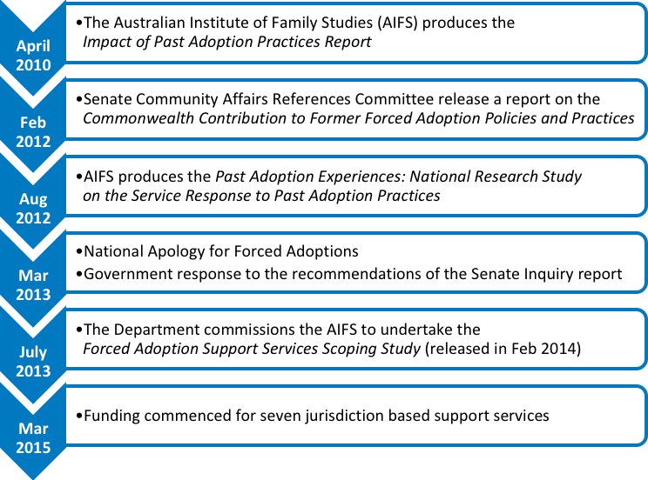

*Figure 2‑1* shows a timeline of key documents and events which led to the commencement of Forced Adoption Support Services in seven jurisdictions. In April 2010, the Australian Institute of Family Studies (AIFS) produced the “Impact of Past Adoption Practices Report”. This was followed by the “Commonwealth Contribution to Former Forced Adoption policies and Practices” report by the Senate Community Affairs Reference Committee in March 2012, and the AIFS report, “Past Adoption Experiences: National Research Study on the Service Response to Past Adoption Practices” in August 2012. March 2013 saw the National Apology for Forced Adoptions and the government response to the recommendations of the Senate Inquiry report. In July 2013, the DSS commissioned the AIFS to undertake the Forced Adoption Support Services Scoping Study (released in Feb 2014). These events culminated with the commencement of funding for seven jurisdiction-based support services in March 2015.

### The Forced Adoption Support Services

#### Overview

As part of the commitment made by the Australian Government to improve access to specialist support services, the Department of Social Services funds seven state and territory-based organisations to provide coordinated specialist support services across Australia for people affected by past forced adoption policies and practices.

Initial funding of $3.9 million was provided for Forced Adoption Support Services (FASS) over three years to 2016-17, followed by an additional $5.7 million over four years to 2020-21.

FASS aims to:

Enhance existing services funded by the state and territory governments

* Improve access to records, professional counselling, peer support and family tracing (Australian Government Department of Social Services 2017).

Services are available for adopted people, mothers, fathers, siblings, adoptive parents, and extended family members.

The organisations funded to provide these FASS are listed in *Table 2‑1*.

Table 2‑1: Forced Adoption Support Services provider by jurisdiction

| Jurisdiction | Organisation | Abbreviation | Also known as |
| --- | --- | --- | --- |
| NSW and ACT | Relationships Australia (NSW) | RA (NSW) | N/A |
| NT | Relationships Australia (NT) | RA (NT) | N/A |
| Qld | Jigsaw Queensland Inc | Jigsaw | N/A |
| SA | Relationships Australia (SA) | RA (SA) | N/A |
| Tas | Relationships Australia (Tas) | RA (Tas) | N/A |
| Vic | Relationships Australia (Vic) | RA (Vic) | Compass |
| WA | Relationships Australia (WA) | RA (WA) | Lanterns |

The design and implementation of FASS was guided by the findings of the AIFS *Forced Adoption Support Services Scoping Study* (Higgins et al. 2014), commissioned by the Department, and subsequently-developed National Practice Principles and Operational Guidelines specific to FASS.

#### Activity requirements under grant agreements and Operational Guidelines

The activity requirements pertaining to the FASS during the PIR period were specified in two key documents:

* DSS Streamlined Grant Agreement with FASS providers (grant agreements)
* Forced Adoption Support Services Operational Guidelines 2014.

In the grant agreements, the key activity objective of FASS is cited as being to:

Provide specialist support to people affected by forced adoptions to complement and enhance existing services funded by state and territory governments aiming to improve access to peer support, professional counselling and records and family tracing (p. 2).

While minor differences exist in language used to describe how these specialist services were to be provided, the following four mechanisms were listed in each document:

* The provision of a telephone information, referral, and support service via a national 1800 number for calls originating in each jurisdiction
* Face-to-face services where appropriate/possible
* The development of Local Networks of service providers – mainstream, post-adoption specific, professionals and peer support
* The administration of Small Grants totalling between 5% and 10% of funding to peer support and advocacy groups.

Exemptions applied to some FASS providers with regards to the latter two requirements during the PIR period. The RA (Tas) grant agreement did not contain reference to local networks or Small Grants while the RA (NT) Grant Agreement was qualified by the inclusion of ‘where appropriate/possible’ for each of the latter requirements.

### Contextualising FASS in terms of existing jurisdictional services

FASS are delivered in a jurisdictional context where a range of other governmental and non-governmental services are being provided for post-adoption clients. An overview of the main services by jurisdiction is provided in Appendix A*.*

#### Government services

State/territory adoption and community service departments predominantly assume an administrative role and assist with the release of historical records, in line with local legislation. Individuals (predominantly adoptees) can contact departments directly or work through a FASS (or another provider) to apply for family records. It is common for people with adoption experiences to contact their state/territory department for assistance in the first instance, before reaching out to other support services. When records are sent to the applicant by the department, a brochure is typically enclosed which details local post adoption support services, including the FASS and other post adoption service providers.

In Vic and Tas, it is a requirement for family records to be provided to the applicant in person unless extenuating circumstances prevent this. At this time, information about ongoing support options is provided. In Qld, the Department of Communities, Child Safety and Disability Services make face-to-face appointments with applicants when needed, for instance if it is thought the individual or information is highly sensitive.

In Vic and Tas, the Department of Health and Human Services also offer intermediary support such as making initial contacts with birth relatives on behalf of the applicant, or assuming a coordination role for ongoing written communication between family members.

In most jurisdictions, the state government department is well connected to the local post adoption community. There is communication between the department and the FASS provider in each jurisdiction, and representatives of each organisation typically attend stakeholders’ meetings a few times a year. In SA, the Department for Child Protection has a long-standing relationship with RA (SA) and is able to reach out to this provider to help communicate the result of the record search in the instance when records are viewed as potentially particularly sensitive.

#### Non-government services

In each jurisdiction, with the exception of Tas, a number of non-government organisations also operate. These organisations include a mix of post-adoption providers and advocacy groups.

Post adoption providers (such as Jigsaw WA[4] and VANISH[5]) offer counselling, record searching assistance and support group services. VANISH coordinates separate support groups in Melbourne and regional Victoria for adult adoptees, birth mothers and a mixed group for all adoptees and parents.  At the time of writing this report, group meetings occur monthly in Melbourne, bimonthly in large regional centres and less frequently in less populated areas.  Jigsaw WA arranges a monthly meeting for birth mothers and infrequent gatherings for adoptees.

A range of advocacy groups also exist whose membership/focus tends to be target-group specific, i.e. mothers or adoptees only.

## Project background

The Department appointed AHA to conduct a PIR of FASS with a focus on a client needs assessment.

The PIR considered the perspectives of FASS providers and clients as well as others affected by forced adoption to identify:

* How the program is progressing
* How effectively the services have been implemented.

### Key evaluation questions

The PIR addressed a range of evaluation questions that have been grouped into seven key areas:

#### Implementation of the FASS

* What progress has been made by FASS in implementing effective support services for those affected by forced adoption?
* How consistent has the implementation been with the design outlined in the AIFS scoping study?
* How successful are services in implementing the principles of accountability, accessibility and effective and diversity of services identified in the *Forced Adoption National Practice Principles*?
* How are the variations in the services delivered by FASS by jurisdiction explained, and should they be more consistent? If so, what changes would be required to achieve better consistency and allow for flexibility?
* How long are clients engaging with FASS and is this expected to change over time?
* How has demand changed for the services? How have FASS adapted to meet any changes in demand?
* How well are services implementing a trauma-informed approach to service delivery?

#### Access

* How well have FASS been accessed by the different target subgroups (mothers, adult adoptees, fathers, siblings and other extended family members, Indigenous Australians, people from CALD backgrounds, people with disabilities and other specific groups?)

Which of the services provided by FASS have the different subgroups used (i.e. counselling, advocacy/support, information/advice/referral, intake/assessment, records search, outreach, community capacity building) and what are the reasons for this breakdown?

* + Why have certain eligible client groups not accessed support from FASS?
  + How satisfied are clients with the services provided?

#### Working within the sector

* How well are FASS working with other services in the post-adoption sector and other relevant services (including use of warm referrals) to ensure a holistic and effective support system and to build capacity (including network opportunities)?
* Are services effectively complementing service offer of states/territories for this cohort or is there duplication/overlap?

#### Small grants

* How useful has the small grants component been to build sector capacity and enhance group healing activities?
* What are the small grants being used for, the key themes, gaps, pros/cons, changes needed and are they beneficial or not?

#### Promotion and awareness

* How effective are promotion and awareness activities in meeting the needs of people affected by forced adoption, including the Forced Adoption History website, the ‘*Without consent: Australia’s past adoption practices’* exhibition and anniversary events?

#### Data

* Do FASS collect other data than that is provided through the DEX? Would it be useful for FASS to share their approaches to collect additional data with each other to improve consistency?
* What outcome measurement tools are currently being used by FASS?
* Is DEX being used consistently by FASS and what (if any) support or improvements are required to ensure its timely and effective use?
* What service types are undertaken by each FASS and how are they reported in DEX?

#### Successes, issues, and service gaps

* What needs of mothers, adult adoptees, fathers, siblings, and extended families have been met so far through FASS?
* Is the program appropriate for Indigenous Australians, people from CALD backgrounds, people with disabilities and other specific groups?
* Are referrals working well for the clients’ needs?
* What gaps exist in meeting needs of these subgroups affected by forced adoption?
* What issues/gaps are being experienced in family search and reunion work, including accessing information?
* Do clients/the FASS cohort have any suggestions for improving the current FASS?

## Overview of methods

A mixed-methods approach involving a combination of quantitative and qualitative data sources was used to conduct the PIR. Findings were collated and triangulated to identify key findings and provide recommendations. Ethics approval to conduct the PIR was obtained from Bellberry Human Research and Ethics Committee.

Multiple data sources were used to address the review questions, as detailed in the following chapters.

A summary of participants and the mode(s) of engagement is provided in *Table 2‑2*.

There were five review phases (Figure 2‑2):

* Phase 1 – Project initiation
* Phase 2 – Development of data collection tools
* Phase 3 – Data collection
* Phase 4 – Analysis and synthesis
* Phase 5 – Reporting.

Table 2‑2: Participation summary

| Stakeholder | Mode of engagement | No. of Participants |
| --- | --- | --- |
| FASS target group | Survey respondents (n=338)  In-depth consultations with a subset of survey recipients who had:   * Used FASS (n=28) * Not used FASS (n=10) | 338 |
| FASS providers | Site visits to all FASS providers (n=7) | 23 |
| National Archives of Australia | Telephone interview | 2 |
| Support/advocacy groups | Telephone interview | 9 |
| Academics | Telephone interview | 4 |
| Departmental representatives | Telephone interview with:   * Policy and implementation representatives * GAMs | 1  7 |
| State and territory post adoption services | Telephone interview | 5 |

Figure 2‑2: Methodology phases

Description follows

This figure illustrates the five-phase methodology used to conduct this review.:

Phase 1: Project initiation is comprised of initial meeting, review of resources provided by Department, development of evaluation project plan, development of stakeholder communication strategy, and development of the evaluation fact sheet.

Phase 2: Development of data collection tools, which consists of a literature scan, development of data collection tools, submission of ethics application, and pilot testing of tools and finalisation of methodology.

Phase 3: Data collection, which consists of a national survey of the FASS cohort, in-depth consultations with the FASS cohort, consultations with FASS providers, consultations with other stakeholders, quantitative data collection (including FASS service usage), and input and feedback into FASS program logic.

Phase 4: Analysis and synthesis, which includes quantitative data analysis, qualitative data analysis, and triangulation and synthesis of findings.

Phase 5: Reporting, which consists of regular reporting arrangements, a draft final report, and the final report.

### Evaluability issues

A number of issues were identified that may impact on the results of the review. These included:

* **Survey respondent confusion.**  It became apparent during the in-depth consultations with survey respondents that some were unable to differentiate between RA and FASS services. Accordingly, responses provided may not always relate to FASS.

Selection bias:

* + Focus group attendees and phone interviewees nominated by FASS providers potentially represent those clients most satisfied with the service
  + Promotion of the review was undertaken via social media, links provided on the Department’s and FASS provider websites, promotion by FASS providers and advocacy groups. Members of the FASS target group who are not using FASS, who are not linked to an advocacy group or who do not regularly access the listed websites may not have had an opportunity to participate in the review
  + Members of the FASS target group may be unaware of the ‘forced adoption’ term and therefore any promotional material about the review is unlikely to reach them. Adoptees who are unsure if their adoption was forced may not participate
  + The PIR may have attracted responses from those who are most satisfied or dissatisfied with FASS.
* **Loss of corporate knowledge.** In a number of cases, key FASS or government personnel involved in the initial implementation of FASS had left the organisation and this resulted in a loss of corporate knowledge, particularly in relation to the development and implementation phases. The richness and depth of the information provided may have been compromised as a result.

**Quality and suitability of DEX data.** DEX reporting is not customised to reflect the full range of clients or activities that constitute the FASS program (see *Section 3.10*). As a result:

* + The type of forced adoption client (mother, adoptee, etc), is not collected. In the absence of this information, the PIR was reliant on FASS provider estimates of client sub-group numbers
  + The range of items included in DEX does not reflect all activities undertaken by FASS providers. Examples included administering small grants, attending meetings such as the FASS Practice Roundtable and local networks, and DSS reporting
  + Ambiguities and inconsistencies in DEX data entry guidelines related to FASS (Section 4.2.2) may compromise the quality and/or consistency of data captured.

Methodological constraints:

* + The short time frame of the PIR:
    - Limited promotion of the online survey, thus potentially compromising the ability of the FASS target group service users to provide feedback
    - Invitations to focus groups were delayed because of the ethics approval process and therefore, focus group consultations did not occur in all states
  + Submission of SCORE data by FASS providers was not compulsory during the PIR period. Score data was only reported for 62 people. The small number of cases involved meant that the DEX data could not be disaggregated by FASS subgroup, goals, or satisfaction categories because of identification risks. This limited the availability of outcome measures to compare FASS providers.
* **Differences in how responses are articulated by informants and stakeholders consulted.** These differences may influence the interpretability of findings particularly as inclusion or exclusion of factors may relate to informants’/stakeholders' narrative style rather than reflect true differences between stakeholders.
* **Recall bias.** FASS commenced service provision in 2015. Research studies indicate that 20% of critical details are irretrievable after one year and 50% after 5 years (Hassan 2005). This introduces the risk of recall bias in the information provided in the survey and during in-depth consultations with clients. All studies that rely on self-reported data are prone to this limitation.

# FASS implementation

## Introduction

This chapter provides an overview of the extent to which the FASS delivery models implemented to date align with the intended design of the FASS, as articulated in the National Practice Principles (Higgins et al. 2016), and the Operational Guidelines 2014 (Department of Social Services 2014a). Findings from the Scoping Study (Higgins et al. 2014) are referenced in discussions regarding service gaps in later chapters.

Information for this section is drawn from:

* Service model profiles completed and verified by service providers
* Consultations with FASS providers
* DEX data
* Funding information
* Review of FASS and the Department websites.

To avoid duplication, common elements of the National Practice Principles and the Operational Guidelines are reviewed together and a cross‑reference to the relevant element of these documents is provided (see Appendix B and Appendix Cfor full details of the National Practice Principles and the Operational Guidelines respectively).

Implementation findings are discussed under the following thematic areas in this chapter:

* National 1800 number
* Face-to-face services
* Client diversity
* Accessibility of services
* Networking and collaborations
* Trauma-informed approach
* Administration of Small Grants
* Staffing
* Promotion of FASS
* Data collection and reporting.

Use of this thematic approach has meant that elements of the National Practice Principles have been disaggregated and neither the National Practice Principles nor the Operational Guidelines are discussed in the sequence they are presented in Appendix B and Appendix C*.*

A summary of the services provided through the FASS program, by provider is provided in *Table 3‑1*.

Table 3‑1: Summary of services provided through FASS program, by provider

| Service | RA (NSW) | RA (NT) | Jigsaw (Qld) | RA (SA) | RA (Tas) | RA (Vic) | RA (WA) |
| --- | --- | --- | --- | --- | --- | --- | --- |
| 1800 information line | Yes | Yes | Yes | Yes | Yes | Yes | Yes |
| Referrals and information based on individual needs | Yes | Yes | Yes | Yes | Yes | Yes | Yes |
| Face-to-face support | Yes | Yes | Yes | Yes | Yes | Yes | Yes |
| Casework/case management | Yes | Yes | Yes | Yes | Yes | Yes | Yes |
| Intake/assessment | Yes | Yes | Yes | Yes | Yes | Yes | Yes |
| Outreach (for service accessibility) | Yes | No | Yes | No | Yes | Yes | Yes |
| Group activities | Yes | No | Yes | Yes | Yes | No | Yes |
| Records tracing | Yes | Yes | Yes | Yes | Yes | Yes1 | Yes |
| Dedicated records staff | Yes | Yes | No | No | No | No | Yes |
| Reunion mediation | Yes | Yes | Yes | Yes | Yes | No | No |
| Emotional support/counselling | Yes | Yes | Yes | Yes | Yes | Yes | Yes |
| Access to peer support | Yes | No | Yes3 | Yes | Yes | Yes3 | Yes3 |
| Advocacy | No | Yes | Yes | Yes | No | Yes | Yes |
| Small grants | Yes | Yes | Yes | Yes | No | Yes | Yes |
| SCORE reporting | Yes | Yes | No | No | No | Yes | Yes |

Notes:

1. Initially, RA (Vic) subcontracted VANISH to undertake records searching, and to provide support for people after the release of their records. RA (Vic) has advised that this arrangement ceased on 30 June 2017.
2. Emotional support/counselling does not include therapeutic counselling.
3. Access to peer support is provided through Small Grants funding and through referrals.

## National 1800 number

**Operational Guidelines:** Delivering a telephone information, referral, and support service via a national 1800 number for calls originating in their jurisdiction.

**National Design Principle 1:** Service providers are accountable and transparent in their service provision—as evidenced by…clear referral processes…and transparent information.

#### Telephone information

All services reported delivering services via the 1800 number. In some cases, this number was operated by FASS staff while in others, non-FASS staff within the auspice organisation (described as being appropriately trained and/or experienced), did so. In some cases, people with lived experience of forced adoption were involved in answering calls and this was found to yield mixed results.

Despite assertions that those answering calls were adequately trained, some examples of inappropriate responses by telephone staff were cited by service users, including:

* Instances where the empathy afforded by a person with lived experience of forced adoption involved in answering calls was marred by the operator’s over-identification with their own forced adoption position, and this interaction had the potential to traumatise callers who were from a different FASS subgroup to that of the operator
* A non-FASS staff member who answered a call and said to a mother: “So you’re one of those women who gave up their child.”

These examples highlight the importance of:

* Ongoing staff training, particularly in organisations where staff turnover is an issue
* Constantly monitoring client feedback to ensure interactions of this nature are identified and appropriate action is taken.

#### Referral and support

FASS providers reported that records searching and counselling were the main reasons why clients needed to be referred to other organisations.

As evidenced in the service model snapshots (Appendix D), referrals were made to local organisations such as government adoption services, Births, Marriages and Deaths registries, and institutions such as the Salvation Army at the jurisdictional level for the purpose of accessing adoption records and original birth certificates.

At the FASS provider level, between 18% and 70% of clients were estimated to need therapeutic counselling services. This wide range illustrates the considerable variation between jurisdictions in their estimations of the needs of their presenting clients *(Table 3‑2).*

Consultations indicated that FASS providers did not consider that the provision of therapeutic counselling services was included under their 2015-2017 FASS funding agreements. While the grant agreements required FASS providers “to improve access to peer support, professional counselling, and records and family tracing” (*Section 2.1.2*), it was not stipulated that improved access was to be achieved by direct provision of these services by the FASS providers. The FASS staff primarily provided general counselling and emotional support to clients and facilitated warm referrals to counsellors in their auspice agency when therapeutic counselling was needed.

This process of auspice referrals was facilitated by the complex nature of FASS clients and the multiplicity of services being provided by the auspice organisation. Many clients were eligible for other services (e.g. the Royal Commission into Institutional Abuse and/or Find and Connect[6]), which allowed FASS providers to address a large proportion of FASS needs using referrals to other areas within their organisation that were specifically funded to provide services to the cohorts in question. The remainder were addressed through referrals to external counselling and/or support organisations (e.g. Past Adoption Support Service (PASS), Origins, ARMS) or through services provided by clients’ private counsellors.

Table 3‑2: Estimated proportion of clients in need of therapeutic counselling services and mode by which these needs were met

| Jurisdiction | Clients who required counselling | Met within the auspice organisation | Met through an external referral | Met by client’s private counsellor | Met by other |
| --- | --- | --- | --- | --- | --- |
| NSW and ACT | 70% | 50% | 25% | 25% | 0% |
| NT | 50% | 100% | 0% | 0% | 0% |
| Qld | 18% | 85% | 8% | 7% | 0% |
| SA | 36% | 87% | 13% | 0% | 0% |
| Tas | 33% | 95% | 0% | 5% | 0% |
| Vic | 70% | 80% | 16% | 4% | 0% |
| WA | 26% | 80% | 0% | 20% | 0% |

Reaching out to family and family reunion mediation were among the supports offered by most FASS providers. Legislative restriction in WA prevented RA (WA) from engaging in reunion mediation work. All providers were aware of the risks of additional client trauma if information vetoes were found to be in place or if reunions were unsuccessful. For these reasons, clients were generally advised to have a face-to-face meeting for records release to ensure their emotional safety. FASS staff generally followed up with clients by phone after records release, “to check how they were doing”.

## Face-to-face services

**Operational Guidelines:** Delivering these services face-to-face where appropriate/possible

All FASS indicated that face-to-face services were provided as required. However, based on service delivery estimations provided by FASS providers in their service model profiles, details of how clients accessed services during the six months to June 2017 highlighted that service delivery was primarily through other modes (*Table 3‑3).* Given that records searching was cited by service providers as a key reason for clients accessing FASS, much of this activity could be undertaken by phone or email. Clients often had a face-to-face meeting at the beginning of the records searching process.

Table 3‑3: Mode of client access to FASS

| Jurisdiction | Face-to-face | Email/online | Phone | Post |
| --- | --- | --- | --- | --- |
| NSW | 6% | 0% | 90% | 4% |
| NT | 50% | 25% | 25% | 0% |
| Qld* | 1% | 97% | 98% | 3% |
| SA | 9.9% | 37.2% | 36.2% | 3.7% |
| Tas | 20% | 50% | 30% | 0% |
| Vic | 20% | 80% | 0% | 0% |
| WA | 35% | 5% | 60% | 0% |

*Note: Jigsaw have advised that there is substantial overlap between clients accessing FASS via phone and email/online, hence their figures do not add up to 100%

## Client diversity

**Operational Guidelines:** The target group for Forced Adoption Support Services is anyone who was affected by forced adoption policies and practices. Affected people include mothers, fathers, adopted people and extended family members. The priority for service delivery should be the people who were directly involved. Services to extended family members can also be achieved through effective warm referrals to other relevant providers.

The primary focus of the Forced Adoption Support Service is people directly affected by forced adoptions. However, family may be a key support for the primary client. Therefore, family of the primary client may need to be included in the support and services offered to the primary client.

Forced Adoption Support Services will have the most relevant knowledge and skills to respond to the family member’s request as appropriate.

**National Design Principle 1:**  Forced Adoption Support Services must provide flexible, culturally sensitive, and accessible service delivery models and practices that ensure accessibility to any people who face a real or perceived barrier to receiving assistance and have in place strategies to achieve this unless otherwise exempted by legislation…Forced Adoption Support Services must provide services equally, without bias or prejudgement about clients. Services must be accessible to all target groups, including Indigenous people and culturally and linguistically diverse communities.

Analysis of DEX data indicated that a total of 6,633 sessions have been delivered to 1,410 clients nationally from the commencement of FASS to June 2017 (*Chapter 4*). While the breakdown of clients by FASS target group is not available from DEX, FASS providers reported in the service model snapshots, that adoptees and mothers constituted the greatest proportion of clients, with adoptees representing the larger of the two groups (*Table 3‑4*).

Service usage by fathers was very low or non-existent, while extended family members affected by forced adoption were represented in the client profile in all FASS, except the Northern Territory.

Table 3‑4: Estimated percentage of clients by FASS target group

| Jurisdiction | Adoptees | Mother | Father | Extended family member | Other |
| --- | --- | --- | --- | --- | --- |
| NSW | 55% | 20% | 4% | 10% | 10% |
| NT | 75% | 25% | 0% | 0% | 0% |
| Qld | 69% | 17% | <1% | 6% | 6% |
| SA | 68% | 17% | 3% | 11% | 0% |
| Tas | 55% | 45% | 0% | 0% | 0% |
| Vic | 76% | 19% | 0% | 5% | 0% |
| WA | 46% | 28% | 4% | 4% | 15% |

Note: Figures may not add up to 100% because of rounding.

The number of Aboriginal or Torres Strait Islander people, people with a disability, and people from CALD background using FASS was very low in most jurisdictions. DEX data indicated that fewer than 10 clients in each jurisdiction (in most cases less than five) identified as Aboriginal and/or Torres Strait Islander people, during each six-month reporting period to June 2017. A similar reporting pattern occurred for clients with a disability. Across all jurisdictions and across all reporting periods, less than five clients have been recorded as being from a CALD background.

## Accessibility of services

Accessibility of services was examined in terms of:

* Barriers and facilitators to service access
* How FASS providers work with clients.

### Barriers and facilitators to service access

**National Design Principle 2:**

‘Within the parameters of resourcing and local circumstances, Forced Adoption Support Services should endeavour to make services accessible to clients and be flexible in the mode of service delivery in order to meet client’s needs.’

Accessibility of FASS depended on:

* **The mode of service delivery**. Irrespective of location in Australia, clients can access the 1800 number and avail of telephone services. Face-to-face contact is more problematic for clients based in rural and remote areas as not all FASS providers have face-to-face contact opportunities in these areas, instead having to rely on telephone, email, or Skype to communicate.
* **Client cohort characteristics**. In general, adoptees and mothers comprised the main client base. Other members of the FASS cohort (fathers, adoptive parents, and extended family members) represented a smaller proportion of clients, with few services specifically tailoring service delivery to include those who were not mothers or adoptees (*Chapter 4).*
* **Funding and staff levels.** Funding and staffing differences between FASS providers influenced their capacity to make services accessible to clients. Total funding for the period March 2015 to June 2021 ranges from $258,787.65 (GST incl.) to $3,524,289.53 (GST incl.) per organisation while staffing at November 2017 ranged from 0.2 FTE to 3.3 FTE. Those receiving greatest funding tended to have the highest staff FTE, and thus the greater capacity to provide services. Low staff numbers made it difficult to make FASS staff available in all FASS throughout the 9 am to 5 pm, Monday to Friday window specified in contractual arrangements. While services generally staggered staff working hours to provide coverage, where possible, continuity of care was nonetheless found to be an issue. Staff in the auspice organisations were often required to undertake telephone engagement.
* **The type of service being provided to and sought by clients**. The range of services provided varied across FASS providers. While this was in part attributable to funding and staffing levels, it was also related to the extent of organisational experience in working with those who had experienced forced adoption, and staff turnover that resulted in a loss of expertise. Skills in record searching differed considerably between FASS providers, ranging from those who had dedicated team members undertaking records searching to one who outsourced to an external agency because of an internal lack of expertise in this area. Legislative restrictions in WA mean that the FASS cannot undertake family reunification or mediation services. In general, telephone services were more accessible than face-to-face services.
* **Client location**. While some FASS providers had secondary sites in regional areas, FASS for clients living in rural and remote areas tended to be by telephone, rather than face-to-face. Some electronic modalities such as Skype were used.

**Promotion of services.** Issues related to the promotion of FASS at jurisdictional and national level (*Section* *3.9*), particularly in RA sites, meant that accessibility of services may be limited by:

* + The lack of separate identity for FASS. In all cases, FASS is one component of a broader suite of services being offered by the auspice organisation. Information about the FASS is difficult to find on the main organisational website. Jigsaw is a clear exception in this regard, because of its longevity in exclusively providing services to those affected by adoption. The lack of a separate FASS identity in many jurisdictions may serve as a barrier to service uptake.
  + A perception among the cohort that RA only deals with family or marriage counselling
  + Concerns among the cohort that RA is a church-based organisation. This perception is based on the fact that RA was founded by two ministers but does not acknowledge that RA no longer has religious affiliations[7].
* **Identification of cohort with the terminology of ‘forced adoption’.** The term ‘forced adoption’ is one that not all people in the sector identity with. This has led to delays in or failure to uptake services because of confusion about eligibility for services.
* **Lack of advocacy group endorsement of FASS**. As outlined in *Section 6.2*, some advocacy groups actively advised their membership to not use FASS because of the group’s perception that FASS was not appropriate to their members’ needs.

The barriers cited above were most acute in the RA context because of the more generic nature of their service offering than that of their Jigsaw counterpart. While RA services span issues such as family/relationship problems, the majority, except for RA (SA), do not have a specific focus on post-adoption. In contrast, Jigsaw is a specialist post-adoption service with more than 40 years’ experience in this area.

Also, many adoptees are of working age and therefore may find it difficult to access services during the 9 am to 5 pm window.

### How FASS providers work with clients

Operational Guidelines:

* Services support and empower people affected by forced adoptions
* The way services are offered should include that:  
  – Clients drive the type and direction of support  
  – Service delivery is flexible and tailored to the individual needs of each person  
  – Services are clear about what they do and how and  
  – Clients are the expert of their own life.
* Services are respectful of the different histories and needs of people affected by forced adoptions and:  
  – Promote self-determination, upholding client views that ‘nothing about us, without us’  
  – Give options so that people can make informed choices such as to access support that is independent from past adoptions providers  
  – Advocate for clients’ access to information past adoption organisations hold about them and  
  – Make referrals and advocate to mainstream services to create a common approach and understanding in delivering support.
* The services employ specialist skilled staff to deliver services based on:  
  – Developing trust and relationships and   
  – Take time to notice relevant information about clients, are curious, ask questions, are invitational to clients and do not tell clients what to do.
* Where service providers are either past or current providers of adoption services, they must:  
  – Make a strong and public commitment which acknowledges their past practices and  
  – Have appropriate policies and practices in place to ensure that any client who may or may not be comfortable with accessing the service, is referred to another service, preferably through a warm referral.
* No Wrong Door approach  
  – Identifying the most appropriate service to respond to a client’s needs is the role of the Forced Adoption Support Services’ staff.  
  –Generally, it is expected a client will receive support from the Forced Adoption Support Service in the jurisdiction in which they reside. However, clients should be able to receive a prompt response no matter which service they first approach for assistance, where they currently reside or where the adoption took place.

#### Services support and empower people affected by forced adoptions

Survey respondents and interviewees/focus group participants spoke of how disempowered they felt during the record tracing process prior to engaging with FASS. Many had sought to independently undertake records searching but were unsuccessful, sometimes resulting in years of frustration. Engagement with FASS meant they:

* Became aware of legislative changes that occurred between their earlier searching and present search (which facilitated greater access to information)
* Accessed skilled FASS personnel who could undertake records searching on their behalf and often progressed the search further than the client had been able to
* Obtained support related to records searching that they would not have otherwise accessed.
* While all FASS providers reported offering records tracing services, only three FASS had staff dedicated to records searching.

Within FASS, clients ultimately drove the direction and duration of the support they received. As evidenced in *Section 4.2.2*, the length of client engagement with services varied considerably, with many clients engaging intermittently or cyclically, as required. This contact pattern often signified that the client needed time to process information received, which could result in gaps in contact. While FASS providers advised clients on their preferred mode of engagement over matters such as release of records, family searching and reunification, the decisions always rested with the client.

The majority of survey respondents who had used FASS (62.9%) indicated they were either satisfied/very satisfied with the services they had received (*Table‑5‑2*). This figure increases to 71% when missing responses (i.e. no response was provided regarding overall satisfaction) are excluded. Highest levels of satisfaction were reported in relation to

* Accessing general information (73.1% of respondents were satisfied/very satisfied)
* The emotional support and counselling received (72.8% were satisfied/very satisfied).

#### Services are respectful of the different histories and needs of people affected by forced adoptions

All FASS provided client-centred processes with regards to supporting them in records searching. Accordingly, the extent of support was determined by clients’ needs and preferences and ranged from providing information to clients about where records could potentially be sourced, assistance with completing paperwork, to undertaking the entire search on a client’s behalf. In all circumstances, FASS providers were respectful of all parties to the mediation/reunion process.

FASS providers had different capacities in records searching. This capacity ranged from those who had dedicated team members undertaking records searching to one who outsourced to an external agency because of an internal lack of expertise in this area.

The services employ specialist skilled staff to deliver services

All staff involved in direct service provision within FASS were reported to have undertaken trauma-informed training or had either undertaken equivalent training and/or had extensive experience. Given the small number of staff in some FASS, responsibility for operating the 1800 number fell to administrative staff within the auspice organisations rather than to FASS-specific staff. The extent to which all administrative staff had specific training in the trauma associated with forced adoption is unknown. This is an area that requires further research and monitoring, particularly as poor initial engagement experiences with FASS were cited in the survey as a source of dissatisfaction with RA-auspiced FASS. This negative experience may reflect the more generic nature of RA services compared to Jigsaw, which is a specialist post-adoption service with more than 40 years’ experience in this area:

*“I found the initial contact with [the organisation] cold, not empathetic, awful experience, well below expectations*” (Father, survey respondent, FASS user)

Likewise, the extent to which FASS providers make referrals to their auspice organisations for therapeutic counselling (*Table 3‑2)* raises the issue of how well specialist general counsellors in the RA system are skilled/trained/experienced with issues specifically related to forced adoption. Again, this is an area that warrants further research.

#### Service providers that are either past or current providers of adoption services

RA’s origins as The National Marriage Guidance Council of Australia, established by church leaders, was not raised as an issue by RA-affiliated FASS providers. However, this historical linkage proved problematic for some members of the forced adoption cohort consulted (*Section 6.2*), particularly given the involvement of religious groups with past forced adoption practices. Consequently, some community members reported being opposed to engaging with organisations that have religious foundations.

Each FASS provider was required to develop an Adoption Provider Association Management Strategy which outlined how the provider will manage and maintain independence from those organisations who in the past, or currently, arranged adoptions.

#### No Wrong Door Approach

FASS providers worked closely together when required, particularly where interstate clients were concerned. Jurisdictional difference in legislation, as well as differences in service availability and skill sets provided the greatest challenges to providing seamless cross-jurisdictional services to clients.

## Networking and collaboration

National Design Principle 1:

Forced Adoption Support Service providers must work collaboratively with each other and with relevant government and non-government agencies that provide services to the target group. To ensure effective integration with appropriate services, Forced Adoption Support Service providers must build and maintain effective relationships with a broad network of relevant services, which may include:

* Peer support groups
* Counselling
* Mental health practitioners
* Advocacy groups
* Records tracing support.

**Operational Guidelines:**

* Develop Local Networks of service providers within their community area that includes mainstream, post-adoption specific, professionals and peer support services to enhance quality, coordination, flexibility and diversity of post-adoption support services.
* Collaborate with Forced Adoption Support Services in all states and territories to help provide ‘no wrong door’ assistance for clients, particularly for clients whose records may be located in a different state or territory to the one in which they reside.

The capacity of FASS providers to develop local networks was context dependent. Organisations such as Jigsaw and RA (SA) that had a long and recognised role in post adoption work, generally had networks that predated FASS. However, in other jurisdictions, the establishment of local networks with service providers and advocacy groups was often hindered by tensions related to the selection of the FASS providers. In situations where multiple organisations applied for FASS funding and/or local expectations regarding which organisation should be appointed were not met, factious relationships generally developed. Examples of how these tensions negatively impacted FASS activities included burnout among FASS staff (ultimately leading to staff resignations), the circulation of misinformation about FASS, and network members actively discouraging potential clients from using FASS. In one jurisdiction, these tensions escalated to such a point that FASS senior management had to circulate a letter to local organisations asking them to cease their disruptive actions.

Conflicts of interest existed at a local level because some local organisations in the sector who were potential Local Network members were also potential Small Grant recipients. This made it unfeasible for these organisations to be involved in determining how the Small Grants program would operate (*Section 3.8*)*.*

Overall, FASS providers reported strong collaborative working arrangements with their FASS colleagues in other jurisdictions, with relationship-building opportunities such as the FASS roundtable meetings being valued in this regard. In the early days of FASS implementation, the Relationship’s Australia National Office convened regular teleconferences with RA FASS providers and Jigsaw, which providers found very helpful. The Department of Social Services currently conducts annual FASS roundtable meetings. As an outcome of the 2017 roundtable, the Department has reinstated regular national teleconferences with the FASS.

Collaboration largely occurred in relation to interstate clients. However, there was also evidence of other collaborations that drew on the skills and expertise of specific FASS providers. Examples included FASS providers in SA and QLD assisting each other in the review of small grant applications, while FASS Victoria staff undertook a two-day training course with RA (SA) on records tracing.

Small Grants provided a key mechanism through which FASS providers worked with local groups, with these grants being used to fund peer support and advocacy groups at the jurisdictional level. In some cases, the number of small grant applicants did not exceed the supply of funding. While this points to a non-competitive process at times, it also demonstrates the proactive relationship-building activities undertaken by FASS and the capacity building to small organisations that assistance in developing grant applications provided. Some Small Grants have, at times, been allocated to certain peer support and advocacy groups with the hope of restoring relationships with local organisations that had been unsuccessful in their bid for FASS funding and/or to moderate local tensions related to the selection process. Nonetheless, these grants and activities were not always successful in dissipating anger and frustration among stakeholders.

## Trauma Informed approach to service delivery

Clients should be assessed and supported based on need. Trauma Informed principles should be applied.

All staff involved in direct service provision within FASS were reported to have undertaken trauma-informed training or had either undertaken equivalent training and/or had extensive experience. Given the small number of staff in some FASS, responsibility for operating the 1800 number fell to administrative rather than FASS-specific staff. The extent to which all administrative staff had specific training in the trauma associated with forced adoption is unknown.

Staff turnover in some FASS meant there may have been lags between staff appointment and provision of trauma-informed training. Upskilling of FASS staff was evident by the numbers reported to have engaged in training opportunities related to past forced adoption practices, the impacts of adoption, record searching and trauma informed care. Examples include:

Training provided to FASS staff by a number of other specialist organisations:

* + VANISH provided a two-day training about Working with Loss and Trauma Related to Past and Forced Adoption Practices. This training is aimed at a broad range of professionals in the health and community sector. Over 20 RA (Vic) staff completed the course.
  + Origins NSW provided training to RA (NSW) staff on past forced adoption practices and their lifelong impacts.
  + The Australian Psychological Society (APS) provided training to 18 FASS staff. These places were funded by the Department to ensure the FASS workforce were fully cognisant of past forced adoption practices and trauma informed care.
* The SA Department of Child Protection, Qld Department of Communities, Child Safety and Disability Services and other state/territory departments work with the local FASS to provide updates on changes to local Acts and Regulations.
* RA (SA) has delivered a two-day training course on records tracing to RA (Vic) staff to build internal capacity in this area. RA (Vic) subcontracted VANISH to undertake records searching on behalf of their clients.
* Informal training opportunities at FASS roundtables and regular teleconferences where FASS service providers share best practice, learnings, and challenges.

Recognition of the need to ensure trauma-informed approaches to client engagement informed the approach taken by FASS providers regarding the support provided around records searching, records release and family searching/reconnecting (*Sections 3.7.1, 3.7.2, and 3.7.3)*.

The capacity of FASS providers to refer externally to professionals that also shared a trauma-informed approach was limited by a lack of professionals, particularly in regional areas, who were able to effectively support individuals living with the lifelong impact of forced adoption. To help bolster workforce capabilities, the APS was engaged by the Department of Health in January 2015, to provide training to health and community professionals about forced adoption and trauma informed care. This training was delivered online through webinars and e-learning modules and commenced in March 2016. The development of the training materials was informed by a comprehensive scoping study, reference group and AIFS’s guide to Trauma-Informed Care.

The e-learning modules took around 10 hours to complete and gave rise to continuing professional education points. Around 1,200 individuals completed the first of three modules. The webinars were more frequently accessed as they were of shorter duration than the e-learning modules. In total, eight webinars were delivered. The highest number of course registrations were from NSW, Qld, and Vic.

Initially, the Department of Health funded the following seven health professional groups to undertake the training:

* General practitioners (GPs)
* Psychiatrists
* Psychologists
* Social workers
* Occupational therapists
* Mental health nurses
* Aboriginal and Torres Strait Islander health workers.

While strong participation by GPs was sought by the Department of Health, psychologists represented the highest number of participants. This was followed by social workers, mental health nurses, counsellors, occupational therapists, GPs, psychiatrists, and Aboriginal and Torres Strait Islander health workers.

FASS staff were not explicitly targeted or funded in the initial stages of the APS training delivery.

The APS is working with FASS providers to advise them of local professionals who have completed the APS online training in an effort to expand the FASS referral network. However, FASS providers reported an ongoing deficit at the local level in terms of their knowledge of, and access to, appropriate external professionals to whom they can refer.

The APS contract with the Department of Health ended in June 2017. The three e-learning modules and other material developed through the project, including the eight webinars, were then transitioned to the APS Institute website. These resources will be accessible by those who are doing or have done the training via the APS’ new website (scheduled for launch in February 2018). Training will be available as a user pays model. The APS is no longer promoting the training to professionals in the broader health and community service sector.

### Support for records searching

**Operational Guidelines:**

Searching for and releasing records will, in many situations, require the assistance of other support services. Forced Adoption Support Services are encouraged to seek advice and support from their colleagues in other services who are in closer proximity to where the records may exist or where the client lives as they prepare to search for interstate records and when providing a supported records release.

#### Overview

Record searching can be a lengthy and costly process. Once an applicant has received an adoption certificate from a state/territory department they are able to search for family members through Registries of Births, Deaths and Marriages (BDM) and other agencies. Australia does not have a centralised BDM records service and so applications for certificates and searches need to occur at a jurisdiction level. Applicants are charged fees by BDM for searches and certificates and these charges vary across the country. Each application for a marriage certificate takes around one month to be processed by the BDM office plus staff time at the post adoption organisation assisting (e.g. FASS, Jigsaw WA, VANISH). In the instance where family members have moved interstate this process is time consuming and costly as the search needs to be undertaken by jurisdiction, and in some instances, by decade. The process is then repeated for birth and death searches, with name changes for women (upon marriage) adding complexity.

Unsuccessful searches may result in the applicant seeking information though their state library, however records are not available online and therefore pages of microfiche need to be searched.

Electoral rolls are also a key source of information. This is straightforward when a full name is known however this is uncommon, and not everyone is enrolled to vote. Electoral rolls do not include year or decade of birth and therefore in the instance where an individual with a common name is sought, post adoption agencies have had to reach out to 20 or 30 potential matches individually.

DNA testing is expensive and time consuming, costing around $250 per application and often several people need to be tested. In the event the birth parents are deceased, extended family members can be DNA tested however this is more expensive.

### Supported release of records

**Operational Guidelines:**

A client’s right to exercise self-determination in receiving their records must be considered, and support and information provided so the client can make an informed decision. Clients are to be offered a supported release of their records if appropriate.

It is important that clients are not denied their right to receive information about them, and this must be balanced with ensuring the client’s wellbeing is safeguarded (considering duty of care responsibilities).

A supported release of records might be assisting the client to plan their supports (having a partner, friend, or family member with them) when they receive the records and how they will approach reading the records. Services could involve contracting with the client that they open records only when they next visit their therapist, or it might involve a series of face-to-face meetings with the client to gradually read through the records according to the client’s needs and wishes. The level of support will vary among the Forced Adoption Support Services.

The decision as to whether supported release of records occurred was also client-led. While clients’ needs and preferences were respected, FASS staff were vigilant to the potential of traumatisation of clients because of gaps or negative information presented in records. For this reason, caseworkers generally prepared people to receive their records prior to release, providing emotional support during this time, and undertaking an assessment of need/risk with possibility of continuing contact depending on need.

Face-to-face release of records was preferred so that the emotional safety of client could be ensured when reading the file. Where this was not possible, telephone support was provided.

In situations where record searching staff were employed by FASS, these staff generally met with case workers to explain the records received.

### Support for family searching and reconnecting

**Operational Guidelines:**

Forced Adoption Support Services may provide support to assist with family searching and reconnections. This support can be provided at all stages of the search and reunion process. However, Forced Adoption Support Services’ funding cannot be used to directly fund reunions.

The level of support provided to clients for family searching was dependent on the client’s wishes and their capacity to independently search. FASS use a range of online searching tools and the electoral rolls to search for relatives. If FASS are unable to locate the relative, clients are generally referred to other services for assistance.

Clients are prepared for searching and contacting through discussion about expectations and possible outcomes, and through the provision of information on support groups and information sheets.

Where available, FASS can act as an intermediary in this process. Legislative restrictions in WA prevent any intermediary work such as family mediation being undertaken. In most cases, the FASS intermediary role consists of FASS staff reaching out to family on behalf of the client.

Post-contact support is provided to clients and family members during the initial stages of contact and for as long as needed to deal with any post-contact issues, including the other party not wanting to engage.

Trauma-informed practices were found to be the norm among the FASS providers, with most FASS staff in a client-engagement role having undertaken trauma-informed training or having had specific training/experience in forced adoption or trauma generally. Those involved in records searching tended not to have completed this training and generally did not engage with clients.

Several services reported undertaking follow-up with clients at various interval to ‘check how they were going’. Clients favourably received this aspect of the service.

The capacity of FASS providers to provide a continuum of care was hampered, at times, by:

* FASS providers having to refer elsewhere for therapeutic counselling services and, in some cases, record searching
* Low staff numbers within the FASS limiting staff availability from 9 am to 5 pm, Monday to Friday. Therefore, for a client to engage with the same FASS staff member, a time lapse is likely between engagements because of limited staff availability.

## Administration of Small Grants

**Operational Guidelines:**

Forced Adoption Support Services are required and encouraged to work with peer support and advocacy groups who will be part of the planning and decision making regarding the allocation of Small Grants.

Peer support group activities for consideration of Small Grants funding can include, but are not limited to:

* Venue and group meeting costs
* Group facilitation costs
* Art therapy fees
* Retreats
* Production of memorials and
* Capacity building opportunities such as local or national training.

Small Grant recipients cannot use Small Grant funding for the employment of staff and/or provision of counselling services.

All FASS providers, with the exception of RA (Tas) which is exempt, administered small grants to peer support and advocacy groups. This included RA (NT) where Small Grants were optional. As illustrated in Table 3‑5 and Table 3‑6, most FASS achieved or exceeded their target of Small Grants totalling between 5% - 10% of their funding, largely through rollover of funds between financial years. FASS NSW was the only FASS that did not reach the target (due to some applications not meeting criteria in the grant approval process).

Table 3‑5: Small Grant allocation 2015-16

| State | Grants to build sector capacity | Grants for group healing activities | Grants for other/not specified activities | Total no of grants | Total value (GST excl.) | Grant range (GST excl.) | Within 5‑10% of total FASS funding? |
| --- | --- | --- | --- | --- | --- | --- | --- |
| NSW | 1 | 2 | n/a | 3 | $13,909 | $3,455-$7,273 | Below target |
| NT | 0 | 0 | 0 | 0 | 0 | 0 | n/a |
| QLD | 3 | 4 | n/a | 4 | $13,398 | $708-$8,913 | On target |
| SA | 0 | 4 | 0 | 4 | $8,012 | $1,090-$2,827 | On target |
| VIC | 5 | 4 | 2 | 10 | $46,776 | $2,376-$5,000 | Exceeded target |
| WA | 1 | 3 | 0 | 3 | $23,128 | $5,130-$12,727 | Exceeded target |
| Totals | 6 | 15 | 2 | 21 | $91,314.00 | $708-$12,727 | n/a |

Notes:

* Some grants were assigned to multiple categories, hence the number of grants by subcategory exceeds total grants.
* FASS Tas is not funded to offer the Small Grants scheme.
* Allocation of small grants can be influenced by factors such as the quality of applications/proposals received.

Table 3‑6: Small Grant allocation 2016-17

| State | Grants to build sector capacity | Grants for group healing activities | Grants for other/not specified activities | Total no of grants | Total value (GST excl.) | Grant range (GST excl.) | Within 5‑10% of total FASS funding? |
| --- | --- | --- | --- | --- | --- | --- | --- |
| NSW | 1 | 2 | 1 | 4 | $17,364 | $3,909-$4,545 | Below target |
| NT | 0 | 2 | 0 | 2 | $5,574 | $2,728-$2,846 | Exceeded target |
| QLD | 4 | 5 | 0 | 7 | $16,271 | $723-$4,716 | On target |
| SA | 3 | 3 | 0 | 5 | $8,423 | $600-$2,766 | On target |
| VIC | 3 | 4 | 2 | 9 | $39,484 | $2,460-$5,000 | Exceeded target |
| WA | 0 | 2 | 0 | 2 | $10,563 | $3,750-$6,813 | On target |
| Totals | 10 | 18 | 2 | 29 | $97,679.00 | $600-$6,813 | 5.1 |

Notes:

* Some grants were assigned to multiple categories, hence the number of grants by subcategory exceeds total grants.
* FASS Tas is not funded to offer the Small Grants scheme.
* Allocation of small grants can be influenced by factors such as the quality of applications/proposals received.

#### Planning and decision-making regarding the allocation of Small Grants

The Operational Guidelines specified that FASS providers ‘are required and encouraged to work with peer support and advocacy groups in the planning and decision making regarding the allocation of Small Grants.’ This proved challenging in many jurisdictions because of strained relationships between the FASS provider and local peer support and advocacy groups. Furthermore, some of these local groups were potential Small Grant recipients, thus generating a conflict of interest if they were to be involved in how the Small Grants program would operate.

While guidelines for the administration of Small Grants have been developed by the Department, some providers have developed their own guidelines and application packs. In several cases, the number of grant applications did not exceed the available grants, so the process was not competitive. In these cases, FASS providers approached an organisation with a concept or idea for the grant and supported the organisation to write the application.

Cross-jurisdictional support was provided in the review and selection of some Small Grant recipients. For example, FASS providers in SA and Qld engaged in a mutual review of applications.

#### Achievement of Small Grant targets

Under the Operational Guidelines, Small Grants funding was to be within 5 - 10% of total FASS funding for each provider. Nationally, from the commencement of FASS, March 2015, to June 2017, a total of 53 grants have been allocated, with a total value of $202,902 excluding GST (*Error! Reference source not found.*)*.* Tasmania does not receive funding for Small Grants and has therefore not been included.

A key risk related to Small Grants identified in the PIR is the lack of imperative to implement the scheme as un-used funds can be absorbed back into the organisation.

#### Use of Small Grants

Small Grants are used for a range of purposes, with a broad focus on improving the capacity of the sector (including other service providers, advocacy groups and individuals), and to provide for group healing events. Examples of each are provided in *Table 3‑7*. Further details on recipients and funding amounts are provided in the service model snapshots (Appendix D).

In most cases, the grants appear to have been used as intended. However, it is arguable whether some activities (e.g. digitisation of catalogued photos; workshops to explore how DNA testing can assist with searching for family of origin) neatly fit within the guidelines.

Table 3‑7: Activities undertaken using Small Grants

| Capacity building | Group healing |
| --- | --- |
| Book launches  Documentary filming  Travel to workshops/forums/training  Assisting organisations to become incorporated  Training (Mental Health First Aid, group facilitation) for members of advocacy/support groups | Mothers’ retreats  Support groups (mothers’, men’s, outreach)  Workshops (e.g. relationships, reconstructing identity, DNA, art therapy etc)  Art exhibitions  Art/writing activities (writing, poetry, printmaking)  Outings (cruises, Christmas celebrations)  Memorial/anniversary events  Construction of memorials |

There was broad agreement among FASS providers that the Small Grants were useful in engaging other service providers, peer support and advocacy groups in the sector. Some FASS providers reported that the grants have been an important way of improving collaboration with other groups. In these cases, they were also used by FASS providers as a step towards restoring relationships with local organisations that had been unsuccessful in their bid for FASS funding and/or to moderate local tensions related to the selection process.

The capacity building potential of the grants was considered by FASS providers to be particularly powerful, although the benefits may not be fully realised in the short term. Assisting small, grass-roots groups to become incorporated was seen as particularly beneficial. While some of the activities funded through Small Grants have been evaluated by FASS providers or funding recipients (e.g. participant satisfaction with retreats/healing workshops), this is not done routinely.

#### Challenges and limitations

While overall the Small Grants scheme was considered worthwhile, FASS providers commented that it was laborious and time-consuming to administer. Many individuals or organisations applying for funding needed support to prepare their applications, and some proposals had to be closely reviewed to ensure that risk mitigation strategies were in place (e.g. to minimise the risk of re-traumatisation arising from healing workshops).

The absence of public reporting on how Small Grants funding was used was a source of angst for advocacy groups (*Section 6.2).* Lack of transparency regarding the recipients, the amount of funding awarded, and the purpose of the Small Grant activities funded were raised as problematic.

## Promotion of FASS

### Promotion of FASS providers

#### At jurisdictional level

All FASS providers reported undertaking independent advertising of their service and did so through a variety of different mechanisms. Most advertised through their existing networks and relevant meetings. Several advertised through traditional means such as mail outs to clients, medical centres, nursing homes, psychological and associated services, and flyers in doctor’s surgeries. Others choose more contemporary means of communication, such as social media and websites. Presentations and attendance at local events were also used as promotion opportunities.

Despite the advertising efforts undertaken by FASS, being unaware of FASS was the highest-ranking reason survey respondents reported not having used FASS (Appendix E)*.* Furthermore, a review of FASS websites highlighted several issues that could contribute to this lack of awareness and/or serve as deterrents to exploring FASS service offerings through online searches:

* Jigsaw is the only FASS to directly advertise FASS on their homepage. All RA homepages require the user to search under the ‘services’ tab to find details of FASS, while the FASS component of RA (Tas) is listed as the Past Adoption Support Services in the services tab. ‘Forced adoption’ is not a valid search field on the RA (Tas) webpage. In Vic, the FASS service was titled: Compass Forced Adoption Support Service
* The situation in Victoria was further compounded by the acronym FASS also being associated with another service (Family Advocacy and Support Services), a service which is also delivered by RA (Vic) and is listed as the first entry when FASS Vic is used as a search term
* The imagery provided on some of the RA main websites may be problematic for the FASS target group, particularly when happy children and/or families are displayed, as was the case in three of the RA websites.

Advertising efforts may also have been countered by some advocacy groups actively discouraging people from accessing FASS (*Section 6.2*).

#### Nationally

In addition to the service promotion undertaken by individual FASS providers, a link to the seven support service organisations across Australia is provided from the Department’s forced adoption practices page of the Department’s website[8]. In the case of the RA providers, organisational details via this link do not include other names by which services may be locally known (i.e. Compass in Victoria and Lanterns in WA).

#### Anniversary events

Events to commemorate the Anniversary of the national or jurisdictional apologies were used by all FASS providers to promote awareness of the services. Mechanisms to do so included mail outs to clients, as well as flyers and promotion through other organisations in their networks.

### Promotion of other activities funded as part of the Senate Inquiry provisions

As outlined in *Chapter* *2*, the Commonwealth response to the 2012 Senate Inquiry included provision of $1.5 million to the National Archives of Australia to deliver a [Forced Adoption Experiences History Project](http://forcedadoptions.naa.gov.au/). This project included a website to identify and share stories of experiences (the National Archives Forced Adoption History Project) and an exhibition to increase awareness and understanding of the experiences of individuals affected by forced adoption practices *(‘Without Consent’*).

A link to FASS is embedded in the history project website which directs site visitors to the list of FASS providers on the Department’s website.

Conversely, three FASS providers reported advertising the National Archives Forced Adoption History Project, through word of mouth, links on websites and information on other FASS promotional material (e.g. bookmarks).

Four FASS providers reported advertising the Without Consent exhibition. Promotion was done directly to clients and stakeholders through the provision of the Without Consent booklet, word of mouth and social media. In some cases, uncertainty around the exhibition’s touring locations limited jurisdictional willingness to advertise the exhibition.

## Data collection and reporting

**Operational Guidelines:** Service providers must meet their data collection and reporting obligations and work in accordance with the requirements described in Sections 2.9 and 2.10 of the Families and Communities Programme, Families and Children Guidelines Overview.

**National Design Principle 1:** Service providers are accountable and transparent in their service provision—as evidenced by quality assurance measures…data collection and transparent information.’

#### Overview of DEX

DEX reporting is a requirement of most Department client-based programs. It was first introduced in 2014 to ensure more streamlined and automated program reporting processes as part of a shift from outputs to more meaningful information about service delivery outcomes (Department of Social Services 2014b). Through the simplification of reporting processes, fewer data items are reported by providers and reporting across programs is consistent. This is designed to reduce red tape for providers delivering multiple grants.

DEX is comprised of a mandatory data set and a voluntary component. The mandatory data set reports on how much is being done in terms of the number and profile of clients assisted and services delivered. The voluntary extended data requirements (the Partnership Approach) focusses on how well it is being done and whether what was expected has been achieved. This additional information is captured through Standard Client Outcomes Reporting (SCORE) [9]. Guidance is provided to assist providers in data entry (Department of Social Services 2017).

DEX reporting is not customised to reflect all the activities being undertaken by a program. In some cases, the standardisation used to reduce red tape had resulted in the loss of certain key performance information. For example, while the recording of client name, date of birth, gender, residential location, Indigenous status, CALD status and disability are mandatory requirements, the recording of other program-specific sub cohorts is not.

#### FASS reporting in DEX

FASS providers submit performance data to the Department at six-monthly intervals. Records indicate that all FASS providers have submitted reports to June 2017.

DEX does not capture key elements of FASS activities. For example, service provision by client group (e.g. mother, adoptee) is not captured nor are non-client activities such as collaboration/ networking with other services, administration of small grants, and attendance at FASS Roundtable meetings. Likewise, data entry instructions mean that some FASS activities are conflated e.g. emotional support and referrals onto to counselling services are grouped with counselling.

Ambiguities and inconsistencies in DEX data entry guidelines related to FASS (*Section 4.2.2*) are likely to be compromising the quality of data captured.

Consultations indicated that none of the FASS providers enter case data directly into DEX. In RA, administration and service staff enter case data into the organisation’s bespoke case management software (Penelope). Internal IT staff then extract items required for DEX reporting and make the submission to the Department. Jigsaw use the Service Record System (Infoxchange) to record client information and then transfer the required fields directly into DEX.

Client data collected by FASS providers is more detailed than that required by DEX and is used by some providers to drive improvements to service delivery.

From July 2017, SCORE is now part of new grant agreement requirements. Despite four of the FASS providers reporting having used this measurement tool during the PIR period, DEX data indicated that only 62 FASS clients had SCORE data reported. Over the seven providers, a total of 1,410 FASS clients were reported for the PIR period. Analysis of these 62 clients has not been included in this report.

#### Accountable and transparent data collection

All FASS providers collected the standard DEX data requirements in line with their contractual agreements with the Department. However, evaluation of activities funded under the Small Grants program was not routinely undertaken.

#### Accountable and transparent quality assurance measures

All FASS providers had feedback and complaints systems (formal and/or informal) in place to ensure accountability and quality of service provision.

Three of the seven FASS providers had governance arrangements that included people affected by forced adoption on advisory/reference committees.

Quality assurance is not consistently monitored in the Small Grants program as evaluation is not part of the funding system.

#### Feedback and complaints

**Operational Guidelines:**

* Service providers must have an ‘internal complaints procedure’ in place and it must be prominently displayed. The ‘internal complaints procedure’ can include the complaint being handled by the organisation running the service.
* A system for feedback loops is provided including:
* Consultation in groups and other accessible formats including for people living regionally and involved in support networks and activities:
* Consumer reference groups where people affected by forced adoption are included in governance and planning mechanisms
* Surveys and continuous feedback
* Options to inform and improve the service system

All FASS providers reported having internal complaints procedures in place.

Feedback mechanisms included a mix of formal and informal processes. Three of the seven FASS providers had an advisory/reference group whose membership comprised people affected by forced adoption. Others had informal engagement with the community and/or conducted a mix of client surveys and ongoing informal discussions with those affected by forced adoption to provide service input and feedback opportunities.

# Uptake and reach of FASS

## Introduction

This section examines the activities undertaken by each FASS provider over the program period and presents a profile of clients who accessed FASS. Barriers to service access, as perceived by the FASS providers, are also reviewed.

Findings in this section have been derived from three data sources:

* DEX reports submitted by FASS providers
* Interviews with providers performed during September and October 2017
* Service model profiles submitted to AHA by providers.

## Uptake of FASS

### Client and session numbers

DEX data to June 2017 was used to examine FASS uptake across Australia in terms of client and session numbers. Owing to the low number of FASS clients in NT and Tas, reporting for these jurisdictions have been combined in DEX for confidentiality reasons. The ACT service is subcontracted to FASS NSW and has been included in the NSW figures.

A total of 6,633 sessions were delivered to 1,410 clients from program commencement to June 2017 (Table 4‑1). Overall, the number of clients attending services increased over time, growing from 22 in the first six-month reporting period (January-June 2015) to 412 in January-June 2017. Likewise, the number of sessions increased nationally, from a total of 43 to 2025 in the same period.

The number of clients assisted through the program differed considerably by jurisdiction. Jigsaw consistently reported the highest number of clients and sessions during each reporting period except for the initial period (January to June 2015), and accounted for 43.7% of all clients and 47.3% of sessions to June 2017. NSW and WA ranked second and third in terms of client and session numbers. Activity levels in the remaining jurisdictions have been relatively consistent over time.

A review of the session count by service type and financial year (*Figure 4‑1*) indicated increased provision was reported for all service types except outreach and intake/assessment. Themain growth areas were information/advice/referral, records searching, advocacy/support and community capacity building. However, given that this data is derived from DEX reporting, the reliability of which may be compromised by definitional issues (*Section 3.10*), the findings related to session types need to be interpreted with caution.

Table 4‑1: Clients and sessions by reporting period

| Jurisdiction | Jan-Jun 2015 | Jul-Dec 2015 | Jan-Jun 2016 | Jul-Dec 2016 | Jan-Jun 2017 | Total clients (sessions) | Client: session ratio |
| --- | --- | --- | --- | --- | --- | --- | --- |
| NSW | 16 (35) | 42 (141) | 110 (296) | 114 (648) | 125 (516) | **407 (1,636)** | **4.0** |
| QLD | 6 (8) | 106 (380) | 186 (809) | 144 (877) | 174 (1,065) | **616 (3,139)** | **5.1** |
| SA | 0 | 38 (180) | 46 (290) | 48 (324) | 46 (239) | **178 (1,033)** | **5.8** |
| Tas/NT | 0 | 7 (9) | 13 (10) | 9 (7) | 12 (13) | **41 (39)** | **1.0** |
| VIC | 0 | 4 (30) | 23 (147) | 19 (166) | 14 (81) | **60 (424)** | **7.1** |
| WA | 0 | 11 (46) | 14 (87) | 42 (118) | 41 (111) | **108 (362)** | **3.4** |
| Total clients (sessions) | 22 (43) | 208 (786) | 392 (1,639) | 376 (2,140) | 412 (2,025) | 1410 (6,633) | n/a |
| Client: session ratio | 2.0 | 3.8 | 4.2 | 5.7 | 4.9 | n/a | 4.7 |

Figure 4‑1: Total session count by service type and financial year

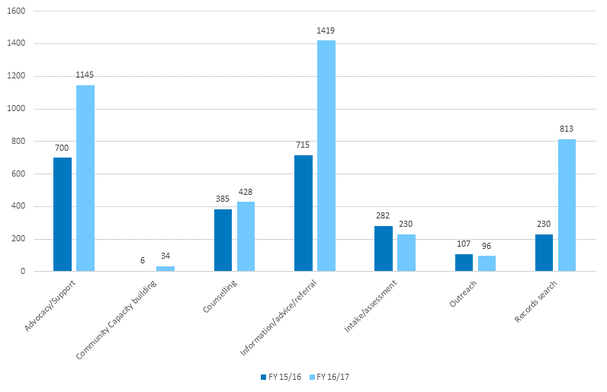

Figure 4‑1 shows the number of sessions provided for each service type for the financial years 2015-16 and 2016-17. For advocacy/support, 700 sessions were provided in 2015-16 and 1,145 sessions were provided in 2016-17. For community capacity building, 6 sessions were provided in 2015-16 and 34 sessions were provided in 2016-17. For counselling, 385 sessions were provided in 2015-16 and 428 sessions were provided in 2016-17. For, information/advice/referral, 715 sessions were provided in 2015-16 and 1,419 sessions were provided in 2016-17. For, intake/assessment, 282 sessions were provided in 2015-16 and 230 sessions were provided in 2016-17. For outreach, 107 sessions were provided in 2015-16 and 96 sessions were provided in 2016-17. For records search, 230 sessions were provided in 2015-16 and 813 sessions were provided in 2016-17.

While session numbers may be subject to interpretation, DEX data nonetheless shows **an increase in the number of clients over time**. This, in turn, points to an increase in demand for FASS services despite low levels of awareness of FASS among the FASS target group and the barriers to FASS uptake being generated by local tensions (*Sections 4.4* and *5.3*).

#### Service provision costs

Marked differences existed in the cost of providing services to clients by jurisdiction (Table 4‑2). Cost per client ranged from an average of $1,257 in Qld to $16,281 (GST incl.) in Vic. While these figures do not include time allocated to non-client activities such as the administration of small grants and sector capacity building, or the average number of sessions provided per client (Table 4‑1), they provide an insight into the return on investment in client number terms.

Table 4‑2: Cost by client and session, 2014-15 to 2016-17

| Jurisdiction | FASS funding (GST incl.) | Number of clients reported* | Average funding per client (GST incl.) |
| --- | --- | --- | --- |
| NSW | $1,340,813 | 407 | $3,294 |
| Qld | $774,401 | 616 | $1,257 |
| SA | $311,831 | 178 | $1,752 |
| Tas/NT | $160,629 | 41 | $3,918 |
| Vic | $976,908 | 60 | $16,282 |
| WA | $394,661 | 108 | $3,654 |
| Program total | $3,959,243 | 1,410 | $2,808 |

* Source: DSS DEX data

These discrepancies in costs may be attributable to factors such as:

The level of experience/longevity of FASS providers in the forced adoption sector. Established providers, namely Jigsaw and RA (SA) that have been offering post adoption support services for 40 years and 12 years respectively, have accounted for the greatest number of clients, and but also incurred the lowest costs per client. This experience and longevity in the field is likely to have increased these organisations’ capacity to:

* + Provide services more efficiently due to streamlined processes
  + Attract higher numbers of clients because of strong community awareness of the services they provide
  + Minimise tensions based on their appointment as a FASS
* Differences in how services are delivered (i.e. the proportion of client interaction that is face-to-face, by email or by phone (see *Table 3‑3*).

In contrast, small providers (NT and Tas) are constrained by funding allocation and staff numbers.

* Limitations to the DEX data. As indicated in Section 4.2.2, the provision of client sessions is one of the many activities performed by FASS providers. DEX data does not have the facility for FASS providers to capture time spent on activities such as community engagement or promoting and reviewing Small Grant applications (*Section*3.10). Consequently, some of the differences between jurisdictions may be related to non-client related factors, and the actual costs per client or by session may not accurately be reflected in Table 4‑2
* Local factors. Client numbers may be influenced by local factors, such as tensions that prevent people from using FASS (*Section*3.4).

Each of these factors needs to be considered when reviewing jurisdictional activity and cost differences.

### Type of services provided by jurisdiction

Clear differences were evident in the rates of service provision type reported in the DEX service data (*Figure 4‑2*). Advocacy/support emerged as the dominant activity in WA, SA and Vic, accounting for between 60-70% of service activities in WA and SA, and over 50% in Vic. In Qld and NSW, information, advice and referral services are more prominent than in the other jurisdictions (with the exception of Tas/NT). Only two states reported having provided both outreach services as well as community capacity building (Qld and SA).

Surprisingly, despite records searching being listed by FASS providers as one of the key reasons why clients accessed services, this activity accounted for a relatively small proportion of activities reported by FASS providers in their service model snapshots.

Figure 4‑2: Type of service provision by jurisdiction

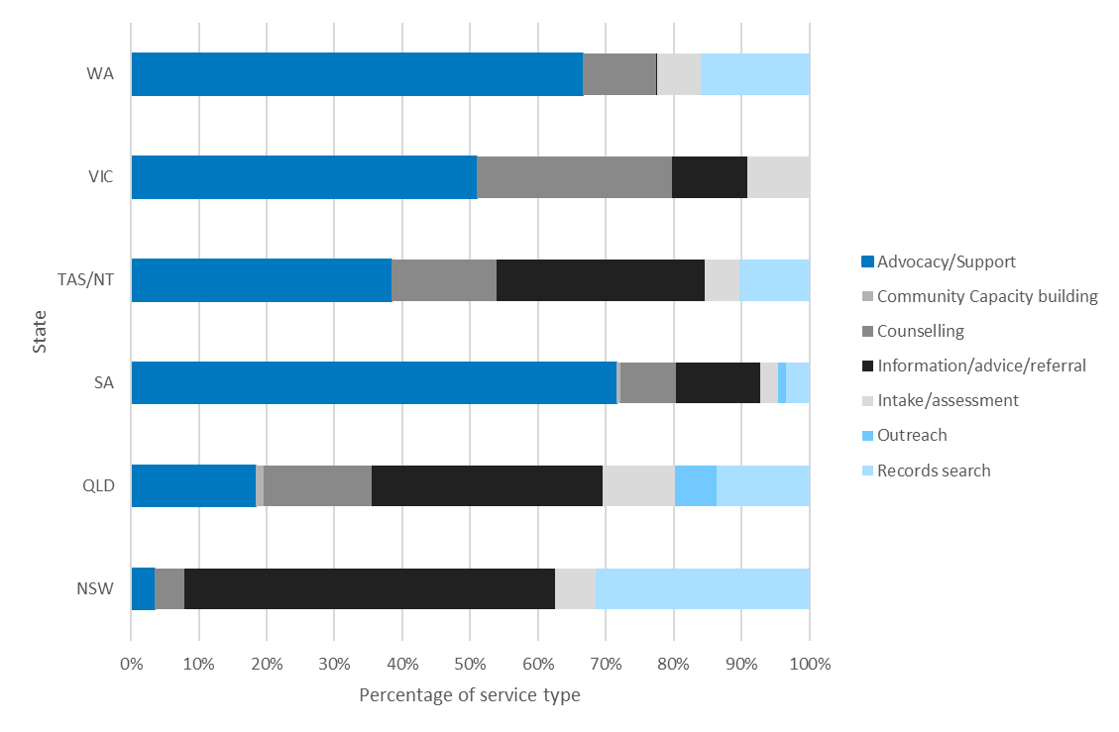

Inconsistency of data entry into DEX may account for some of the differences shown. These inconsistencies may, in turn, reflect ambiguities in and/or misinterpretation of the DEX data entry guidelines (Department of Social Services 2014b).

Reference to referrals is made in two separate service types. Given that referral for counselling may be classified as a ‘relevant service’ (Information/Advice/Referral), FASS providers may have been confused about which service type applied to their counselling referrals (Counselling). Multiple interpretations of the service type items may have occurred in the DEX data reporting, thus limiting comparability between FASS providers.

Table 4‑3: FASS service types and examples clarifying their use

|  |  |
| --- | --- |
| Service type | Example of service type use within this program activity |
| Information/advice/referral | Deliver information, *referra****l*** and support services, provide warm referrals to relevant services. |
| Counselling | General counselling and *referrals* onto counselling services – does not include therapeutic counselling as Forced Adoption Services are not expected to provide this service. |

Source: (Department of Social Services 2014b)

The Advocacy/Support service type refers to: ‘Advocacy on behalf of the client, particularly peer support and advocacy groups who will assist in planning allocation of small grants’. Consultations with FASS providers indicated that peer support and advocacy groups did not assist in the planning allocation of small grants, largely for reasons of conflict of interest (*Section 3.8*). If advocacy was not related to ‘peer support and advocacy groups who will assist in planning allocation of small grants’, FASS providers may have been confused as to how to record their support services and inadvertently added them to the Information/Advice/Referral; Service type which also included support services (see previous bullet point).

The Community Capacity Building service type, as described in the data entry guidelines:

* ‘Includes capacity building through *obtaining* [emphasis added] small grants, and using those grants for further group workshops to support persons affected by forced adoption and inspire a sense of community’.
* In the case of FASS, providers do not obtain small grants, rather they allocate them. Confusion between obtaining and allocating small grants may account for the low number of activities related to Community Capacity Building in DEX.

The Outreach service type is described as follows:

* ‘Where a session is delivered in a locality away from the outlet recorded against the case such as an alternative site, park, home or other nonstandard location.’

Reference to ‘a locality away from the outlet recorded against the case’ could be interpreted as only applying when providers have multiple locations for a client. This may explain why a FASS service like RA (Vic) reported no outreach services during the PIR period despite having multiple locations outside Melbourne where clients could access services.

Other possible explanations for the differences in service delivery profiles of each FASS include:

* Differences in local demand (brought about by the size and composition of the FASS target group in a jurisdiction)

Other reasons such as:

* + Promotional activities undertaken by the FASS providers
  + Staff capacity and capability to perform the services
  + Client usage of other post adoption support services in the jurisdiction.

#### Length of clients’ engagement with services

The length of client engagement with the service varied between jurisdictions. In the service model snapshots, the average duration of client engagement reported ranged from two to 12 months, except for RA (Vic) which reported one client had been engaged for more than 900 days.

Duration of client engagement was contingent on the type of services sought. For example, FASS providers reported during site visits that records searching was generally a lengthy process, sometimes taking many months. Likewise, where support was being provided through ongoing group involvement (e.g. through RA (Tas)), longer duration of engagement ensued.

Family tracing and reunion was also time consuming, and FASS providers reported that it is common for issues to arise in the reunion stage that necessitated provision of ongoing support, particularly if the reunion breaks down or is unsuccessful (*Section 3.7.3*).

Findings from the survey confirmed the variability in duration of engagement (Appendix E). Frequency of access to FASS was for most respondents intermittent (44.2%), followed by access on a monthly basis (14.1%). Weekly and fortnightly access to FASS were less common at 8.6% and 9.8% respectively. Respondents primarily interacted with FASS via phone (46.0%) followed by face-to-face (27.6%).

## Reach of FASS

The reach of FASS was examined in terms of the following client characteristics as identified in either DEX data or self-reported by FASS providers in the service model snapshots:

* Demographic characteristics
* Client subgroup
* Special needs groups
* Client location.

However, it should be noted that:

* The total number of people affected by Australia’s past forced adoption policies and practices is unknown (Senate Community Affairs Reference Committee 2012)
* Therefore, while the FASS program has assisted 1,410 clients from its commencement to June 2017, it is impossible to ascertain the proportion of the forced adoption community who have accessed FASS.

### Demographic characteristics

In each reporting period, DEX data showed that more than double the number of female clients were seen compared with males. Whilst female access to the service continued to increase, the number of male clients declined from a peak of 120 individuals in the reporting period of January to June 2016.

Given that DEX data does not capture details on forced adoption subgroups, the proportion of each gender category that comprises parents, adoptees, or other cohort members cannot be determined.

DEX data shows 45% of FASS clients were aged 45-59 years, followed by a further third aged 60­74 years. There was very low representation by clients aged below 30 years; fewer than 20 clients in this age group have accessed FASS.

These figures are consistent with expectations given the historical timeframe within which the forced adoption practices occurred. Those aged 45-59 years are likely to be adoptees, which in turn, corresponds to the FASS providers’ estimation of adoptees comprising their main clientele (*Section 3.5.2*).

### Subgroup usage of FASS

As outlined in Table 3‑4, self-reported data in the service model profiles indicated that adoptees and mothers were the two key groups which have primarily accessed the FASS.

Overall:

* In all jurisdictions except WA, adoptees represented more than half of service users.
* Tasmania listed the highest proportion of clients who were mothers (45%). Elsewhere, the proportion of FASS clientele comprised of mothers ranged from 17% to 28%.
* No fathers were listed in the clientele of NT, Tas or Vic. Elsewhere, the proportion of fathers ranged from 0.01% to 4%. The reasons for this under-representation is not fully known. Only one father provided feedback in the survey, stating that: “Being a birth father, I feel very private about it”. Interviews with fathers identified other possible reasons for lack of service usage, including being unaware that they were fathers and a lack of emotional intelligence/confidence to pursue services. It is also worth noting that men, in general, tend to have worse help-seeking behaviour than women, and this too may contribute to low uptake of FASS by fathers (Vogel et al. 2011).
* Service usage by extended family members, including adoptive parents, tended to be higher than fathers, except in NT where there were no clients in either group. Tas reported the highest proportion of extended family members, with almost one in three clients (30%) in this category. Elsewhere, extended family members accounted for between 4% and 11% of clients.

### Special needs groups

As indicated in *Section 3.7*, few clients from the following special needs groups were reported in the DEX data:

* **Clients identifying as Aboriginal or Torres Strait Islander**. In each jurisdiction, during each six-month reporting period to June 2017, fewer than 10 clients (in most cases less than five) were identified as being of Aboriginal and/or Torres Strait Islander descent
* **Clients with a disability**. In each jurisdiction, during each six-month reporting period to June 2017, fewer than 10 clients (in most cases less than five) were identified as having a disability
* **Clients from a CALD background**. Across all states and across all reporting periods, less than five clients have been recorded as being from a Cultural and Linguistically Diverse background.

It is unclear if this low uptake is because clients are not self-reporting or if they are not using FASS services because they are accessing other services such as Link-Up, NDIS, etc.

Analysis of the qualitative responses from survey respondents who identified as being from these special needs groups, found the following as their main reasons for not using FASS:

* Not knowing about FASS
* Prior negative experience of other services
* Already using another service
* Does not feel the need for services
* Ongoing concealment of their forced adoption secret
* In the case of mothers, being unsure of their eligibility to use FASS was cited for non-usage of FASS.

Nonetheless, all providers recognised the need to cater for clients with special needs and the need to provide a culturally competent service:

* Most RA staff undertook Aboriginal cultural fitness training to better understand the perspectives and experiences (such as intergenerational trauma and racism) of Aboriginal and Torres Strait Islander Australians
* Jigsaw and RA (SA) made referrals to, and consulted with Link Up, a service for Indigenous people wanting to trace and connect with their birth relatives. RA (NT) employs Aboriginal and Islander Cultural Advisers who can offer extra help to Indigenous clients and offers an Aboriginal interpreter service. RA (Tas) made efforts to acknowledge the Aboriginal community at all events
* RA (Vic) has established links throughout Victoria with Aboriginal Community Controlled Organisations and facilitates the referral of Indigenous clients into culturally specific services, where desired. RA (WA) offer to meet clients off site, at an Aboriginal service if requested by the client
* Providers were sensitive to the needs of disabled individuals. At intake, clients were typically asked if they had a disability and if so, whether any changes to service provision were needed. Flexible service delivery options were offered to help improve service access for those with a disability. Most providers highlighted that their premises were accessible for people with a physical disability and some used the TTY National Relay Service for hearing impaired clients
* All providers offered an interpreter service for CALD clients.

### Client location

DEX data indicated that the majority of FASS clients from March 2015 to June 2017 (70%) were based in major cities. A further 19.3% were from regional areas, 8.8% were from rural area and 1.8% from remote or very remote areas (see Appendix Ffor further discussion).

Self-reported data from the FASS provider service model profiles indicated that all services made provision for the inclusion of non-urban clients in their models. This was particularly the case in NT where the majority of clients resided in rural and remote areas.

Telephone based services were provided to cater for the needs of people living in rural and remote areas. Based on client preferences, this was supplemented by a range of other technologies including Skype, Zoom and email.

## Barriers to access: FASS provider perspectives

During consultations, FASS providers identified several potential barriers to access:

* Failure of potential clients to identity with the term ‘forced adoption’. This terminology was viewed as contentious; one that had the potential to cause re-traumatisation and/or fail to resonate with people within the cohort
* A lack of awareness of the FASS. National advertising of FASS was seen as a need, and TV advertising was suggested over online promotion, given the age profile of the target cohort

The negative impact of some advocacy/support groups:

* + Unconstructive actions/comments of some advocacy groups led to distrust of the FASS provider in some forced adoption communities and discouraged use of the service
  + Some community groups were unhappy with the FASS terms of reference. In particular:
    - the eligibility of adoptive parents and extended family for FASS
    - the absence of compensation or legal redress services
    - providers running combined support groups
    - the absence of therapeutic counselling in the suite of FASS offerings

Differences in service offerings across jurisdictions. For instance:

* + Some providers assist with family reunions and coordinate DNA testing whereas others do not
  + WA legislation[10] prevents the provider performing mediation activities. This is problematic because FASS clients who have an established rapport with RA (WA) staff must then be referred to another provider
* Limited pool of trauma-informed counsellors in some regions with awareness of and experience with forced adoption issues to whom FASS staff can refer
* Record searching being challenging, time consuming and costly for clients.

# FASS target group perspectives

## Introduction

This section reports on consultations undertaken with the people who have been affected by forced adoption practices and presents their voices on three main themes:

* What is and is not working well in FASS
* Barriers to accessing FASS
* Service gaps.

The viewpoints and experiences of individuals who have and have not used the FASS are presented in this section, using information captured from:

* A national online survey conducted in October 2017 which elicited 338 responses, with almost equal representation from those who had used FASS and those who had not

In-depth consultations with a sample of:

* + FASS clients (28)
  + Individuals who had not used FASS (10)

Approximately twice as many adoptees as mothers participated in the in-depth consultations. Two individuals identified as both a mother and an adoptee.

Table 5‑1: Informant profile

| Informant group | Characteristics |
| --- | --- |
| Survey respondents | * Most were female (79.9%) * Over a third (35.5%) were aged 56-65 years with overall strong representation from people aged 46-75 years (85.5%) * Responses were achieved from: * Each jurisdiction: Qld (34.6%), Vic (21.0%), NSW (14.8%), WA (12.4%), SA (8.9%), Tas (4.1%), ACT (1.8%), NT (0.6%) * Each location, predominantly urban (53.3%), followed by regional (31.1%), rural (11.2%), and remote (3.6%) * Each category of the forced adoption cohort, with the highest proportion of respondents being adoptees (60.7%) and mothers separated from a child through forced adoption (30.2%) * Almost equal proportions of those who used FASS and those who did not (48.2% and 47.3% respectively). |
| In-depth consultations | * Number who had used FASS: 28 * Number who had not used FASS: 10 * Approximately two thirds of these informants were adoptees and one third were mothers |

The profile of people who completed the online survey is broadly consistent with:

The client user profile presented in Section 4.3.

* Australian population distribution statistics, with the greatest number of respondents based in the most populated jurisdictions.

Full details of the analysis that supports the findings in this chapter can be found in Appendix E.

## Service user perspectives

### What is working well

#### Overall satisfaction among FASS users

The majority of survey respondents who had used FASS (62.9%) indicated they were either satisfied/very satisfied with the services they had received (Table‑5‑2). This figure increases to 71% when missing responses (i.e. no response was provided regarding overall satisfaction) are excluded. Satisfaction levels were not significantly different between adoptees and mothers.

Table‑5‑2: Overall satisfaction with FASS by respondent category

| Respondent category | Dissatisfied/ Very Dissatisfied | Neutral | Satisfied/ Very Satisfied | Missing | Total |
| --- | --- | --- | --- | --- | --- |
| Adoptee | 14 (12.8%) | 13 (11.9%) | 69 (63.3%) | 13 (11.9%) | **109 (66.9%)** |
| Mother | 8 (18.6%) | 4 (9.3%) | 27 (62.8%) | 4 (9.3%) | **43 (26.4%)** |
| Other | 3 (30.0%) | 0 | 6 (60.0%) | 1 (10.0%) | **10 (6.1%)** |
| Missing | 0 | 0 | 0 | 1 (100.0%) | **1 (0.6%)** |
| Total | 25 (15.3%) | 17 (10.4%) | 102 (62.6%) | 19 (11.7%) | 163 (100.0%) |

Source: Survey data

Most informants who had used FASS attributed their satisfaction with the service to:

* Their experiences with FASS staff. Some of the key themes that emerged were that FASS staff displayed “responsiveness to client needs and sensitivities” and engaged with clients with “compassion” and “sincerity”.
* FASS peer support groups and workshops. This was the second most common theme that emerged for users who were satisfied with FASS. Users reported that peer support groups were valuable as they fostered connections with people with similar experiences as them. These support groups and workshops were generally seen as being supportive and provided people with a safe space to discuss any issues that they might be working through.
* Records searching and family reunification services, where provided, were appreciated by users of FASS.

Statistically, there were no differences in the level of satisfaction reported by FASS users by year they first accessed FASS. Small numbers made comparisons by jurisdiction unviable.

#### Perspectives of users with special needs

Statistical analysis found that there were no differences in the level of satisfaction reported by FASS users who had a disability. However, statistically significant differences were observed from CALD and Aboriginal or Torres Strait Islander respondents, with respondents from these groups reporting lower levels of satisfaction with the service. Further details of this analysis are available in *Appendix E*.

#### Satisfaction by type of service accessed

Survey data *(Figure 5‑1)* indicated that:

* For every type of service used, more than half of all respondents were satisfied/very satisfied

Highest levels of satisfaction were reported in relation to:

* + Accessing general information (73.1% of respondents were satisfied/very satisfied)
  + The emotional support and counselling received (72.8% were satisfied/very satisfied)
* Over 60% of respondents reported being satisfied/very satisfied with assistance in records and family searching, relationship support about contacting family and assistance in contacting family

Highest levels of dissatisfaction were reported for:

* + Searching for records (22.2%)
  + Assistance contacting/connecting with family (22.5%)
  + Referrals (28.1%).

Figure 5‑1: Satisfaction by type of service received

This figure illustrates survey findings for level of satisfaction (dissatisfied/very dissatisfied to neutral to satisfied/very satisfied) in percentages by type of service. Details are given above.

Source: Survey data

### What is not working well

Among dissatisfied FASS users, the following reasons for their dissatisfaction were most commonly cited:

* A lack of understanding of forced adoption and adoption issues
* The quality of workshops
* Inconsistency in service provision across the country.

#### A lack of understanding of forced adoption and adoption issues

Lack of understanding was raised by FASS clients in relation to both FASS staff and counsellors external to the FASS program.

High staff turnover at some FASS sites has meant there is a continual need to train staff, a burden felt by some clients.

*“I’m happy with referral [to FASS] but staff turnover [at FASS] is an issue.”*  (Mother, survey respondent, FASS user)

Some FASS users reported that in their experience, counsellors to whom they were referred were not conscious of the complexities of adoption, past forced adoption practices, and the special needs of the cohort, which had led to re-traumatisation. It was reported by some that they were spoken to in a patronising way rather than with compassion, validation and understanding.

*“The person counselling me did not have an understanding of how adoption had affected me.”* (Adoptee, survey respondent, FASS user)

#### The quality of workshops

The quality of workshops was reported as being variable, depending on the facilitator. A lack of workshops that were meaningful and participant driven was also identified as an issue with the service. **It is not known if the workshops referenced were run by a FASS provider or Small Grant recipient.**

*“The workshops and events were too structured and rigid, I left halfway through my first one, and haven’t attended since.”* (Mother, in-depth interview, FASS user)

*“The workshop I attended was poorly run and the content was not relevant to adoption.”* (Adoptee, survey respondent, FASS user).

#### Consistency in service provision

Variability in the experience of the service providers in assisting people with lived experience of forced adoption also caused inconsistency in the of array services offered in each jurisdiction. FASS providers such as Jigsaw and RA (SA) have been offering post adoption support services for 40 years and 12 years respectively and were more likely to offer a broader range of service offerings within their auspice organisation compared to providers in other states and territories. In some jurisdictions, people from rural or remote areas cited a lack of outreach services.

Some FASS users also felt RA providers were restricted in the extent to which they could assist clients by the corporate policies of the organisation.

## Barriers to access

Survey respondents, focus group attendees and in-depth interviewees (collectively referred to as informants), were each asked to identify barriers to accessing FASS.

Lack of awareness of FASS was seen as the key barrier to access. This was true for those who had and had not used the service.

Other barriers cited were:

* Societal pressures
* Lack of trust in the system
* Counselling-related issues
* Perceptions regarding FASS scope
* Limited services in non-metropolitan areas.

#### Lack of awareness of FASS

The most commonly reported issue by users and those who had not accessed FASS alike was the lack of awareness of FASS. With the exception of Jigsaw and RA (SA), informants were of the view that FASS providers were not well-known and their links and networks with advocacy groups and other service providers in the jurisdiction were not inadequately developed.

Most informants stated that the **FASS suffers from poor visibility** and that more marketing was needed to ensure that it reaches the people who need it the most. The age profile of the target cohort may mean that online advertising would lack effectiveness. Other promotion suggestions made were television advertising (reiterated by providers), for instance, after adoption-focused programs, and pamphlets or posters in GP clinic waiting rooms.

Some informants reported that FASS was not well publicised by RA. FASS is not advertised on the homepages of the Relationships Australia website in each jurisdiction and potential clients are required to search for program details which may be challenging for some. FASS was advertised prominently on the Jigsaw website. However, FASS users across jurisdictions were of the opinion that online advertising is not sufficient, and services needs to advertise through traditional channels. Likewise, it was noted that the Department’s website does not connect people easily with information about FASS in their area, instead they have to navigate a complex series of menus or run special searches to access it. A closely related theme was that information about forced adoption (in general) was difficult to find online.

There was also confusion amongst people already accessing services provided by RA if they were explicitly receiving FASS. This was especially true of individuals who were also eligible for other services. For instance, some informants were not only an adoptee and a mother through forced adoption, but also fell under the remit of the Royal Commission into Institutional Responses to Child Sexual Abuse and/or Find and Connect Support Services for Forgotten Australians and Former Child Migrants.

*“Jigsaw is one support service in Brisbane that does wonderful things when people meet there for the support groups. However how well known is it? Are there flyers anywhere in health service environments?? Let's get this more out in the open and in public areas so that people affected by [forced] adoption can connect with others and get support.”* (Adult adoptee, survey respondent, FASS user)

*“Are they connected to Jigsaw [WA]? You tell me why FASS is a better option than Jigsaw? Who are FASS? What is their experience with forced adoptions? Why have I never heard of them before now?”* (Mother, survey respondent, had not used FASS)

*“Most people affected by adoption probably don't know the service exists - I found out about it by chance. I'm still not 100% sure what it provides in Tasmania, other than the opportunity to participate in an adoption support group once a month (which is extremely valuable but limited in scope). People in rural or remote areas may not get much benefit, other than through being able to read about the experiences of others affected by adoption. That at least should give them comfort that they are not alone.”* (Adult adoptee, survey respondent, FASS user).

#### Societal pressures

Various societal pressures emerged as the second most frequently reported barrier to access by informants whether or not they had accessed FASS and whether or not they were adoptees or mothers.

Feelings of guilt, shame, fear of rejection, the stigma experienced at the time of the adoption/separation, and the need to keep the past hidden emerged as major sub-themes for mothers. For adoptees, the main subthemes included feelings such as:

* Anger towards the system at the time of their adoption (both the health system and society at large) and mothers
* “Divided loyalties” towards their adoptive families
* Fear of being labelled “ungrateful” by society.

*“Social perception and the outdated view that the pregnant mother was less than acceptable in society.”* (Mother, survey respondent, had not used FASS)

*“If a person was bound to secrecy when young, it can still be hard to believe that you have the right to information - perhaps shame”* (Adoptee, survey respondent, had not used FASS).

#### Lack of trust in the system

Lack of trust in the system was an obstacle to reaching out for assistance for those who had used FASS and those who had not.

* This distrust of the system for mothers came from their experiences with health services and the clergy when they were separated from their child by forced adoption. For adoptees, this distrust came from a lack of transparency about the circumstances in which they were adopted, difficulties in obtaining this information, and the feeling of betrayal as this information was often concealed by adoptive families.

*“Missing birth records. Fear of Judgement. Anger towards the system and distrust.”* (Adoptee, survey respondent, FASS user).

The “red tape” or bureaucratic processes associated with record searches was also seen as a barrier.

#### Counselling-related issues

Some informants raised the issue that counselling is being provided in some jurisdictions by organisations connected or auspiced to an organisation with a history of facilitating forced adoption (e.g. Catholicare, Anglicare), or by providers which had limited understanding of the perspective of those with lived experience of forced adoption and trusting such an organisation was not possible. On occasion, this negative feedback applied to the therapeutic counselling being provided by RA auspice organisations (*Section 3.5.2*).

*“Counselling by the very people who took our child from us, not good.”* (Mother, survey respondent, had not used FASS)

*“Mothers don’t trust the Church or any organisations that are related to religious bodies which provide FASS. Not surprising given the Church’s role!”* (Mother, in-depth interview participant, FASS user)

*“There are no specialised services. Most counsellors I have been too (I have been to a lot) did not understand when I said I have a sense of profound grief. They just did not get it.... Most adoptees don't really understand (including me until recently) why they have the feelings they have as you have grown up under the secrecy and lies.”* (Adult adoptee, survey respondent, had not used FASS).

Prior negative experiences of counselling were also cited as a barrier.

#### Perceptions regarding FASS scope

* Adoptees reported feeling that services are still directed towards mothers, with limited resources and support available for adoptees.

*“I have never heard anything about it. Services have never been aimed at adopted children. Sorry was not said to adopted children. We have since before birth been denied rights. We do not exist.”* (Adoptee, survey respondent, had not used FASS).

* This perception runs contrary to the self-reported estimates made by FASS providers that indicated in all jurisdictions except WA, adoptees represented more than half of service users (Section *4.3.2*).
* Confusion also existed around the term ‘forced adoption’ which created uncertainty over people’s status and eligibility for the service. Some adoptees may not know the circumstance of their adoption and therefore, not realise they can access the service. Furthermore, the subgroups eligible for FASS were thought by some to differ from those perceived to be mentioned in the National Apology for Forced Adoptions.
* Not all eligible clients felt welcomed into the FASS. Certain providers were viewed as being adoptee advocates and not the place for mothers or adoptive parents to seek assistance. Tasmania was the only jurisdiction where focus groups membership included both mothers and adoptees. Elsewhere, separate groups were convened. In some cases, advocacy group were very vocal in their view that both groups could not be in the same room.

#### Limited services in non-metropolitan areas

* There was a lack of outreach services in most non-metropolitan areas, both face-to-face consultation opportunities with providers and support group options. People reported feeling uncomfortable talking about their issues with an unknown person on the phone and would prefer the opportunity for face-to-face consultation.

*“I really need a local support group with others in my situation.”* (Adoptee, survey respondent, had not used FASS)

*“I could only access the service by phone. It's not the best way to discuss such personal details.”* (Mother, survey respondent, FASS user).

## Service gaps

Informants were asked to identify any other services not currently offered through the FASS which would be of benefit to the forced adoption community. **Therapeutic counselling services emerged as the most frequently cited service gap**.

Other gaps were cited in relation to:

* Record searching
* DNA testing
* Peer support

Additionally, some people felt financial compensation should be part of FASS. Each service gap is discussed below.

#### Therapeutic Counselling

One third of survey respondents first accessed the FASS for emotional support or counselling. For those who first used the Service for other reasons (such as to search for records or family), the provision of emotional support or counselling was an important additional reason for accessing the Service, as was seeking general information (30% users, Appendix E). In-depth interviewees reinforced this viewpoint, as did FASS providers (*Section 4.4*).

Informants considered it critical that therapeutic counselling be provided by trained professionals who specialise in adoption issues and are trauma informed to reduce the risk of re-traumatisation. Some informants who are using FASS spoke of having to seek out trauma-informed therapeutic counsellors with limited guidance from FASS, and often paying out of pocket.

The general omission of funded trauma informed therapeutic counselling opportunities (*Section 3.2*), meant FASS did not meet the expectations of some FASS users who felt the need to access such services:

*“Speciality psychology support - not just councillors [sic] but psychiatrists or psychologists.”* (Adoptee, survey respondent, FASS user).

#### Record searching

Free or low cost and faster records searching services are called for. FASS users reported long wait times for retrieving records, especially in cases where the adoption occurred across state lines. Such services can be costly, which increased financial burden. There was a sense that adoptees and mothers separated from their children had no choice in their circumstance yet were forced to pay large sums of money to ‘untangle the past unlawful and unscrupulous practices to reconnect with their family’.

#### DNA testing

FASS does not provide DNA testing services. Free DNA testing was reported as a gap by people who had accessed DNA testing independently of FASS. FASS users who had accessed DNA testing had done so at their own expense and reported it to be effective additional means of records/family searching.

*“I need DNA [testing] but this requires payment. Father wants DNA [testing] because of [his] relationship with mother.”* (Adoptee, survey respondent, FASS user)

*“Full funding yearly to Australian DNA Hub [is needed], so we may assist Adopted people to [access] DNA testing”* (Adoptee, survey respondent, FASS user).

#### Peer support

More support groups and workshops were requested, especially by people in regional or remote areas, as phone support was reported as being inadequate for stories that were highly personal. Support groups were requested for the sense of community that they are perceived to bring. It was thought these groups should be run by trained counsellors.

*“[I need] Accessible face-to-face groups. Support groups [run in my capital city] are not accessible.”* (Adoptee, survey respondent, FASS user)

*“Adult adoptee ONLY support group.”* (Adoptee, survey respondent, FASS user).

# Other stakeholder perspectives

## Introduction

As part of this PIR, information was sought from a range of other stakeholders, to better understand the context of the FASS and the voice of individuals with lived experience of forced adoption. It was also important to contextualise the remit of state and territory post adoption services.

AHA consulted with:

* Advocacy groups
* State/territory and Australian Government representatives, including Grant Agreement Managers (GAMs)
* Academics.

A list of the stakeholders who contributed to this section are listed in Appendix F.

## Advocacy groups

A number of forced and post adoption advocacy groups and service providers were established in the 1970s, when forced adoption practices were abating. Since this time, these organisations have worked together or independently to serve the community impacted by forced adoption practices. Advocacy groups successfully lobbied the Federal Government to hold a senate inquiry into forced adoption practices in Australia and in turn, drove local and federal apologies.

Many of these advocacy groups are sub-group specific, focussing on mothers only, adoptees only, etc. For example, the Association of Relinquishing Mothers Victoria and Origins only advocate for mothers separated from their children whereas other groups are more focused on adoptees). Consultations highlighted a competitive trauma between sub-groups with some perceiving their trauma to be more intense than that of others within the cohort. For example, some mothers’ advocacy groups considered the trauma of their experiences to outweigh that of the children from whom they were separated. In many cases, advocacy groups discounted the experiences of fathers.

Some organisations (such as Adoption Research and Counselling Service WA) did however offer mixed support groups, for instance adoptive parents and separated mothers, or adoptees and mothers. It was obvious advocacy groups were passionate about the need to support the forced adoption community.

Most informants championed the peer led support model which reportedly promoted a sense of feeling validated and understood. Advocacy groups provided a range of services, some of which were supported by the FASS Small Grants scheme:

* Community awareness building
* Information provision
* Peer support groups
* Telephone support
* Retreats, lunches
* Art therapy classes.

Post adoption providers (such as Jigsaw WA and VANISH) also offered counselling, record searching assistance and peer support group services.

### Perspective on the FASS

The FASS initiative was viewed by most forced adoption advocates as a flawed and inadequate response for individuals who have been deeply hurt by past practices. This viewpoint was based on their opinion that FASS:

* Largely replicates what already existed in most jurisdictions (namely successful interagency referral systems, networking and information provision)
* Does not meet the service needs earlier identified and requested by advocacy groups, in particular, trauma-informed counselling, and in some cases, financial reparation.

Advocacy group representatives also expressed frustration that FASS providers received substantial funding to run, in their view, a referral service which is referring clients in some instances back to advocacy groups for ongoing (non-funded) support. It was clear that advocacy groups and experienced post adoption service providers felt funding to support and extend their ongoing work offered significantly greater cost benefit to the community over the implemented FASS.

There was widespread disappointment across advocacy groups with the selection of RA as the primary provider of the FASS across the country. This was primarily in light of the perceived limited experience of the organisation with the forced adoption community (compared with advocacy groups) and the longstanding efforts made by advocates to lobby for the funding prior to 2015. RA was thought to lack an understanding of forced adoption issues and the passion of long established groups.

Furthermore, the origins of RA from The National Marriage Guidance Council of Australia which was established by church leaders troubled some advocates. Given the involvement of religious groups in forced adoption practices, advocates mentioned being opposed to engaging with, and referring to, organisations which have religious foundations. This perception does not acknowledge that RA no longer has any religious affiliations.[11]

The ongoing anger and resentment felt by advocacy groups has significantly compromised the relationship between these groups and FASS providers in all jurisdictions except Qld where Jigsaw has been delivering post-adoption services for several decades. High FASS staff turnover in some states also made it difficult for groups to establish networks with the FASS provider.

Advocacy groups also reported a lack of transparency around the magnitude of funds received by FASS providers and the volume of services provided. The forced adoption community viewed this as ‘another example of the secrecy which has plagued their lives’. This lack of reporting has made it challenging to trust the FASS and in turn, some do not refer clients.

##### Small Grants

Some groups have found the Small Grants to be beneficial in terms of providing funding for retreats, art therapy and book launches. However, the following concerns were raised:

* Lack of transparency around the amount of funding issued by each FASS
* The guidelines were seen as complicated and too restrictive in terms of what activities can be funded (e.g. there was uncertainty about whether funding could be used for staff costs related to events/workshops, given that the guidelines state that funding cannot be used for employment of staff)
* Jurisdiction-specific requirements such as having to include logos on materials and invite a FASS provider representative to the funded event
* Amounts were perceived to be too small to be useful and considered insulting given the work done by advocacy groups to get due recognition and funding
* Lack of promotion by providers around Small Grants
* In some cases, Small Grants were being used to fund activities with national implications (e.g. funding for adoptees to attend a national meeting of adoptees). It was suggested that if Small Grants activities affect more than one jurisdiction, approval from all relevant jurisdictions should be sought.

There is a perception that some people in the forced adoption community would prefer to see Small Grants money used to compensate victims of forced adoption.

## State/territory and Australian Government representatives

AHA engaged with state and territory post adoption service departments to better understand the functions of these departments, referral pathways to FASS providers and current networking arrangements. A list of informants is at Appendix G*.*

GAMs and a Departmental representative were also consulted to better understand program development, provider selection criteria and implementation processes. GAMs also provided service improvement suggestions.

### State/territory post adoption service departments

FASS is considered by state/territory post adoption service departments to be a valuable offering for individuals impacted by forced adoption. Referrals are commonly made to FASS, as well as to other post adoption services. Collaboration between FASS and state/territory government departments is strong as evidenced through mutual attendance at quarterly or triannual post adoption sector meetings (in larger jurisdictions) plus ongoing case management discussions (all jurisdictions).

In Qld and NSW, while it was felt that there was an overlap between FASS and post adoption services, this overlap was seen as advantageous to the community as it affords choice to clients. For instance, in Qld both Jigsaw and Post Adoption Support Queensland (PASQ) coordinate support groups with Jigsaw predominantly operating closed, peer support groups whereas PASQ groups welcome all people impacted by adoption. Also, choice of services was seen to be particularly beneficial for individuals who had a strong aversion to seeking support from certain organisations, particularly religious groups which were seen to be perpetrators of forced adoption.

Duplication of services was acknowledged to be less likely in smaller jurisdictions (Tas, NT) where post adoption support services were limited.

Whilst the departments informed all relevant applicants of FASS and other post adoption services, they concurred that greater promotion of the service is needed to improve awareness, especially for people yet to reach out for support.

### The Department’s perspective

Following the national apology in 2013, the Australian Government released its response to the Senate Report and established a Forced Adoptions Implementation Working Group. This Group comprised individuals with lived experience of forced adoption and Members of Parliament. It provided a key advisory role to the Government on services and projects related to the implementation of the Government’s response to the recommendations of the Senate Inquiry into forced adoptions policies and practices.

A national approach to delivery of the FASS, including timing of commencement, was sought by the Department to ensure consistency in the service offering across the country. This mode of program delivery had also been used successfully for Find and Connect, the key support program for Forgotten Australians and Former Child Migrants.

The Department sought contracted organisations to offer multiple services to meet the needs of the diverse forced adoption population. Some advocacy groups were only willing or able to serve part of the target community. The Department also sought providers that could offer a wrap-around service and assist with complex clients such as individuals who were also experiencing other social issues (e.g. domestic violence, housing insecurity).

The capacity of FASS clients to receive counselling within or outside FASS arose from the Department’s desire to provide the community with choice and also in response to the recommendation (from stakeholders) for greater access to trauma informed services. A referral from a FASS provider for counselling could be made to a range of counsellors, psychologists, social workers, and mental health workers.

### GAMs

GAMs for all jurisdictions except Tas (staff changes at the time meant that an appropriate alternative representative could not be contacted) participated in the evaluation. GAMs have the direct relationship with the FASS provider in their jurisdiction. While not all were in their role when the FASS was introduced, most had considerable knowledge about the implementation of the FASS which was gained through telephone contact with managers, review of DEX data and, in some cases, site visits. The GAMs have limited visibility of how the FASS is implemented in other jurisdictions, so they were not in a position to comment on national consistency or cross-jurisdictional collaboration.

#### Implementation

GAMs noted that implementation of the FASS was largely consistent with the funding guidelines. They acknowledged that early implementation was difficult in jurisdictions where the FASS-funded organisation was not considered by other organisations within the jurisdiction to be best placed to deliver forced adoption services (due, for example, to a real or perceived lack of expertise). In some instances, ongoing resentment by organisations who were not successful in obtaining funding to deliver FASS made implementation difficult. Other comments in relation to implementation included:

* The FASS client group is varied, with complex and multiple needs. Many clients are highly traumatised, and FASS are working well to meet their needs; however more capacity for therapeutic counselling would be beneficial
* Within the forced adoption community there are diverse perspectives about how services should be delivered. This can lead to a sense of competition between organisations within jurisdictions, and hamper decision-making within organisations (e.g. where members of consumer consultative committees have opposing views)
* Views about the effectiveness of the Small Grants program were mixed. While they are considered useful, they are time-consuming to administer. In some instances, Small Grants have been used to support organisations that were unsuccessful in winning FASS funding (and have, to some extent, improved relationships with those organisations)
* GAMs noted that the DEX system is functioning well. It integrates well with services’ client management software; however, its capacity to capture information about outcomes or the effectiveness of services provided is limited unless FASS providers volunteer to participate in the Partnership Approach (*Section 3.10*).

#### Suggestions for improvement

Suggestions made by the GAMs for improving the FASS included:

* Increasing capacity for training of mainstream service providers (social workers, psychologists)
* More funding for therapeutic counselling
* GAMs could potentially play a role in supporting the assessment of Small Grants applications
* More opportunity for FASS providers to network with their counterparts in other jurisdictions. The existing Practice Roundtable is considered very valuable
* More funding to respond to increased demand for services, and more funding certainty.

## Academics

Four academics who specialise in the field of forced adoption research (listed in Appendix F) were consulted to garner a better understanding of the context for the FASS and to gain a stronger appreciation of the needs of the population (including special needs groups, and how to best promote FASS to those affected by forced adoption).

It was evident from discussions that Australia’s response to past forced adoption practices is ahead of comparable countries and therefore, cannot be guided by international best practice.

The experts highlighted some needs of those with lived experience of forced adoption, for instance, fathers’ names omitted from birth certificates, adoptees’ feelings of guilt when conducting birth family searches, and the strong need for many impacted by forced adoption to tell their story. This was reported to be especially evident when the AIFS scoping study was being undertaken. Differences across jurisdictions in terms of past adoption practices and also legislation related record release was also emphasised.

Forced adoption experiences will be an ongoing issue for some and lifelong counselling will be needed according to one expert. The value of face-to-face services was emphasised, as was the importance of continuity of care. As reiterated by FASS providers and the cohort, counselling from a therapist who has a strong understanding of adoption issues is vital.

Although a trauma informed approach is generally considered to be strengths-based (Wall et al. 2016), one academic was critical of this approach to care, arguing instead that it represented deficit model (i.e. is based on the presupposition of trauma being present) rather than a strengths-based approach.

Concern was voiced by one academic that (internal) referrals to RA counsellors may represent a conflict of interest for the organisation as there was a financial incentive for the organisation to do this. Informal support services (peer group, family, friends) were also felt to be valuable. Fathers were also identified as a group which is under-represented but needing assistance.

The additional needs of Aboriginal and Torres Strait Islander and CALD adoptees were emphasised. Adoptees in these cases, when separated from their family of origin, lost their culture and history which compounds the impact of adoption. Some Aboriginal Australians who were separated as children were fostered by non-Indigenous families and not adopted which brings about different challenges relating to family tracing.

The experts felt there was greater awareness now of past adoption practices in light of the apologies and also recent television shows. It was recognised though that better promotion of the FASS needs to occur and that these promotional efforts need to consider that the forced adoption cohort may have low literacy levels due to interrupted education and may not have strong computer skills. Promotion of the FASS through GP clinics, community centres and seniors’ publications was suggested. Embedding FASS in a Department of Social Services or Health ongoing funding stream was seen as a way to aid awareness of the service and confirm continuity of care was available to those who need it.

# Synthesis and recommendations

## Introduction

This section provides a triangulation of findings from the preceding chapters and presents these findings under each of the PIR’s key evaluation questions. Key successes and gaps in current delivery of FASS are highlighted. Recommendations for the future are also presented.

## Synthesis

For the purposes of discussion, key evaluation questions have been grouped under themes as follows:

* Implementation of FASS
* Access
* Working within the sector
* Small grants
* Promotion and awareness
* Data
* Successes, issues, and service gaps.

### Implementation of the FASS

#### What progress has been made by FASS in implementing effective support services for those affected by forced adoption?

All services reported delivering services via the 1800 number. In some cases, this number was operated by FASS staff while in others, non-FASS staff within the auspice organisation (described as being appropriately trained and/or experienced), did so. Funding and staffing differences between FASS providers influenced their capacity to make services accessible to clients. Total funding from March 2015 to June 2021 ranges from $258,787.65 to $3,524,289.53 (GST incl.) per organisation while staffing at November 2017 ranged from 0.2 FTE to 3.3 FTE. Those receiving greatest funding tended to have the highest staff FTE, and thus the greater capacity to provide services.

Instances of people with lived experience of forced adoption being involved in answering calls was also reported. This involvement yielded mixed results, ranging from empathic engagement to potential traumatisation, depending on the perspective people brought to their experiences. To illustrate, an example was cited there an operator over-identified with their forced adoption position, and sought to proselytise the caller who had a different perspective to theirs. All FASS indicated that face-to-face services were provided as required by their clients. However, details of how clients accessed services during the six months to June 2017 highlighted that service delivery was primarily through other modes (*Section 3.3).* Given that records searching was cited by service providers as a key reason why clients accessed FASS, much of this activity could be undertaken by phone or email. Clients often had a face-to-face meeting at the beginning of the records searching process.

#### How successful are services in implementing the FASS practice principles of accountability, accessibility and effective and diversity of services?

Accountability[12]

* Feedback and complaints systems (formal and/or informal) were in place at all FASS to ensure accountability and quality of service provision (*Section 3.7)*
* Three of the seven FASS providers had governance arrangements that included people affected by forced adoption on advisory/reference committees
* All FASS providers collected the standard DEX data requirements in line with their contractual agreements with DSS
* Quality assurance is not consistently monitored in the Small Grants program as not all funded projects are evaluated. The absence of public reporting on how Small Grants funding was used was a source of angst for advocacy groups (*Section 6.2*.). Moreover, lack of transparency regarding the recipients, the amount of funding awarded, and the purpose of the Small Grant activities funded were raised as problematic by advocacy groups.

Accessibility[13]

The accessibility of FASS depended on:

* **The mode of service delivery.** Irrespective of location in Australia, clients can access the 1800 number and avail of telephone services. Face-to-face contact is more problematic for clients based in rural and remote areas as not all FASS providers have face-to-face contact opportunities in these areas, instead having to rely on telephone, email, or Skype to communicate
* **Client cohort characteristics.** In general, adoptees and mothers comprised the main client base. Other members of the FASS cohort (fathers, adoptive parents, and extended family members) represented a smaller proportion of clients, with few services specifically tailoring service delivery to include those who were not mothers or adoptees (*Chapter 4)*
* **Funding and staffing levels.** Funding and staffing differences between FASS providers influenced their capacity to make services accessible to clients. Total funding from March 2015 to June 2021 ranges from $258,787.65 to $3,524,289.53 (GST incl.) while staffing at November 2017 ranged from 0.2 FTE to 3.3 FTE. Those receiving greatest funding tended to have the highest staff FTE, and thus the greater capacity to provide services. Low staff numbers made it difficult to make FASS staff available in all FASS throughout the 9 am to 5 pm, Monday-Friday window specified in contractual arrangements. While services generally staggered staff working hours to provide coverage, where possible, continuity of care was nonetheless found to be an issue. Staff in the auspice organisations were often required to undertake telephone engagement.

**The type of service being provided to and sought by clients.** The range of services provided varied across FASS providers. While this was in part attributable to funding and staffing levels, it was also related to the extent of organisational experience in working in the forced adoption field, and staff turnover that resulted in a loss of expertise

* + Skills in record searching capacity differed considerably between FASS providers, and ranged from those who had dedicated team members undertaking records searching to one who outsourced to an external agency because of an internal lack of expertise in this area within the FASS. While many of the FASS providers are also funded to undertake records searching under the Find and Connect program, it is important to remember that FASS and Find and Connect are different programs, with different funding streams. While many FASS clients are eligible for both FASS and Find and Connect funding, the utilisation of Find and Connect funding to meet the needs of FASS clients involves cost shifting between programs and is not how FASS was designed to operate. Legislative restrictions in WA meant that the FASS in that state could not undertake family reunification or mediation services (*Section 4.4)*.
  + FASS providers estimated that between 18% and 70% of clients were in need of therapeutic counselling services (*Section 3.2*). However, lack of clarity in the Funding Agreements and Operational Guidelines meant that FASS providers understood that the provision of such services is not included under FASS funding. While the grant agreements required FASS providers “to improve access to peer support, professional counselling, and records and family tracing” (*Section 2.1.2*), it was not stipulated that improved access was to be achieved by direct provision of these services by the FASS providers themselves. This viewpoint was reinforced by the DEX data entry guide in which it states that FASS provide: “General counselling and referrals onto counselling services – does not include therapeutic counselling as Forced Adoption Services are not expected to provide this service”. FASS staff generally provided emotional support to clients and facilitated warm referrals to counsellors in their auspice agency when therapeutic counselling was needed.
  + The complex nature of clients meant that many were also eligible for other services (e.g. the Royal Commission into Institutional Responses to Child Sexual Abuse and/or Find and Connect Support Services for Forgotten Australians and Former Child Migrants), which allowed RA FASS providers to provide access to counselling using internal referrals to other services in their organisation (where provided). This raises issues of cost-shifting and the accuracy of client reporting across multiple Department-funded programs. The remainder were addressed through referrals to external counselling and/or support organisations (e.g. Past Adoption Support Service (PASS), Origins, ARMS) or through services provided by clients’ private counsellors
  + To facilitate access to adoption records and original birth certificates, referrals were made to local organisations such as government adoption services, Births, Deaths and Marriages registries, and institutions such as the Salvation Army at jurisdictional level for the purpose of accessing adoption records and original birth certificates.
* **Client location.** While some FASS providers had secondary sites in regional areas, FASS for clients living in rural and remote areas tended to be by telephone, rather than face-to-face. Some electronic modalities such as Skype were used
* **Promotion of services.** Issues related to the promotion of FASS at jurisdictional and national level, particularly in RA sites, meant that accessibility of services may be limited by a lack of a separate identity for FASS and a perception among the cohort that RA only deals with family or marriage counselling
* **Identification of cohort with the terminology of ‘forced adoption’.** The term ‘forced adoption’ is one that many people in the FASS target group may not identify with.
* During consultations, for example, some mothers were ambivalent as to whether the circumstances of their separation from their child was ‘forced’, using language such as ‘I gave my child up” to describe their experience. Likewise, given that the number of forced adoptions is unknown, many adoptees in the cohort will be unaware of whether their adoption was forced or not. Issues of eligibility and identification have led some to delays in or failure to take up services because of confusion about eligibility.

Effectiveness and diversity of services[14]

The effectiveness of services was not objectively measured by FASS providers. While DEX provided the facility to record outcomes data through SCORE, the non-mandatory nature of the Partnership Approach meant that SCORE data was only recorded for 62 of the total 1,410 FASS clients reported for the PIR period. However, consultations with FASS users indicated high levels of satisfaction with the services being accessed. The absence of therapeutic counselling, albeit because of the ambiguity in the Grant Agreements and Operational Guidelines and FASS providers’ interpretation thereof, was seen as a key gap in the model by providers, clients and other stakeholders consulted.

Clear differences were evident in rates of service provision type reported in the DEX service data (*Section 4.2*). Advocacy/support emerged as the dominant activity engaged in by WA and SA, accounting for between 60-70% of service activities. Services delivered in Qld and NSW comprised less advocacy and support provision when compared with other jurisdictions, whilst information, advice and referral for these states are more prominent when compared to the other areas (with the exception of Tas/NT). Only two states reported providing outreach services and community capacity building provision (Qld and SA).

Diversity of services was related to several factors, including funding and staffing differences. The extent of organisational experience in working in the forced adoption field, and staff turnover that resulted in a loss of expertise were important. Ambiguities in the DEX data entry guidelines and the resultant variations in how FASS providers report activities in DEX may also have been factors (*Section 4.2.2*).

#### How consistent has the implementation been in the design outlined through the Australian Institute of Family Studies (AIFS) FASS scoping study?

The principles in the scoping study are broader than those eventually included in the National Practice Principles and Operational Guidelines for FASS. The scoping study discussed service affordability (i.e. low-cost or free services), stating "meeting the ongoing needs of those affected by forced adoption should not be contingent on their capacity to pay for services" (Higgins et al. 2014) page xii). However, the National Practice Principles state: “services delivered under FASS funding, and those recommended through case-management referral, should include low-cost options” (Higgins et al. 2014) p. 9). FASS achievements relative to the National Practice Principles and Operational Guidelines have been discussed above.

The scoping study highlighted the potential value of counselling, noting that "Counselling and mental health care services can perform a range of functions for those affected by forced adoptions” (Higgins et al. 2014) p. xi) by "addressing trauma and other mental health consequences through evidence-based therapeutic interventions" as a 'restorative justice' activity (Higgins et al. 2014) p. xii).

Implementation differed from the scoping study design in that therapeutic counselling was not provided by FASS staff in the funding period to June 2017, nor was brokerage available to cover the cost of counselling through external providers. The absence of such funding runs contrary to the model of low-cost or free services advocated by the scoping study to ensure that "meeting the ongoing needs of those affected by forced adoption should not be contingent on their capacity to pay for services" (Higgins et al. 2014) page xii).

#### How are the variations in services delivered by FASS per jurisdiction explained, and should they be more consistent? If so, what changes would be required to achieve better consistency and allow for flexibility?

Variations in the services delivered by FASS at jurisdictional level can be explained by factors such as:

* Differences in funding and staffing levels, noting that funding amounts for each jurisdiction were based on population demographics and a minimum funding amount

The level of experience/longevity of FASS providers in the forced adoption sector. FASS providers (such as Jigsaw and RA (SA)) have been offering post adoption support services for 40 years and 12 years respectively accounted for among the highest number of clients. This experience and longevity in the field is likely to have increased these organisations’ capacity to:

* + Provide services more efficiently due to streamlined processes, with service delivery being almost equally split between email/online and telephone modalities (*Section 3.3*).
  + Attract higher numbers because of strong community awareness of the services they provide
  + Minimise tensions based on their appointment as a FASS.
* In contrast, small providers (NT and Tas) are constrained by funding allocation and staff numbers
* Client numbers may be influenced by a mix of local and personal factors. Local factors include tensions generated by advocacy groups and other providers that prevent people from using FASS and/or client usage of other post adoption support services in the jurisdiction. Personal factors include client-related issues such as a reluctance to use service because of prior negative experience or a lack of awareness of the availability of FASS.

While, ideally, consistency in service provision across jurisdictions would be an optimal arrangement, this is largely unfeasible because of:

* The funding and skilled staff needed to do so
* The inequitable population distribution (and by extrapolation, the FASS target group) nationally
* Legislative differences between jurisdictions.

#### How long are clients engaging with the FASS and is this expected to change over time?

The length of client engagement varied between jurisdictions. The average duration reported ranged from two to 12 months, except for RA (Vic) where one client reportedly engaged for more than 900 days.

Duration of client engagement was contingent on the type of services sought. For example, FASS providers reported that records searching was generally a lengthy process, sometimes taking many months depending on the accessibility of the records. Likewise, where support was being provided through ongoing group involvement (e.g. through RA (Tas)), longer duration of engagement ensued.

Family tracing and reunion are time consuming, and FASS providers reported that it is common for issues to arise in the reunion stage that necessitated provision of ongoing support, particularly if the reunion is unsuccessful or breaks down.

Findings from the survey confirmed the variability in duration of engagement (Appendix E). Frequency of access to FASS was for most respondents intermittent (44.2%), followed by access on a monthly basis (14.1%). Weekly and fortnightly access to FASS were less common at 8.6% and 9.8% respectively. Respondents primarily interacted with FASS via phone (46.0%) followed by face-to-face (27.6%).

#### How has demand changed for the services? How have the FASS adapted to meet any changes in demand?

DEX data indicated that a total of 6,633 sessions were delivered to 1,410 clients from program commencement to June 2017 (*Section 4.2.1*). Overall, the number of clients attending services increased over time, growing from 22 in the first six-month reporting period (January-June 2015) to 412 in January-June 2017. Likewise, the number of sessions increased nationally, from 43 to 2,025 in the same period. This indicates that the demand for FASS services has increased over time, despite:

* Survey and consultation findings showing awareness of FASS was low among the target group
* Therapeutic counselling not being part of the service offering to June 2017 but being identified as a key gap/need for clients.

The nature of past forced adoption policies and practices makes it difficult to quantify the size of the cohort or how many of these people will require support services into the future. As awareness of FASS grows and more people identify as having been affected by past forced adoption policies and practices it is likely that demand will continue to grow, particularly if therapeutic counselling services are provided.

To date, FASS have been able to meet the demand without generating wait lists.

#### How well are services implementing a trauma-informed approach to service delivery?

Trauma-informed practices were found to be the norm among the FASS providers, with most FASS staff in a client-facing role having undertaken trauma-informed training or having had specific training/experience in forced adoption or trauma. Those involved in records searching tended not to have completed this training and were generally involved in client engagement. The extent to which the following auspice staff have received training related to trauma-informed practice and the needs of the FASS target group specifically is unknown:

* Administrative staff who engage with clients by telephone or through face-to-face contact when FASS staff are not available
* Counsellors to whom clients are referred for therapeutic counselling (*Section 3.5.2*).

A trauma-informed approach also underpinned the client-led processes regarding records/family searching and reunification. While clients’ needs and preferences were respected, FASS staff were vigilant to the potential for re-traumatisation of clients because of gaps or negative information presented in records, or issues related to family searching/reunion. For these reasons, caseworkers generally:

* Prepared people to receive their records prior to release, providing emotional support during this time, and undertaking an assessment of need/risk with possibility of continuing contact depending on need
* Prioritised face-to-face release of records, where possible, so that the emotional safety of the client could be ensured when reading the file
* Provided post-contact support to clients and family members during the initial stages of contact and for as long as needed to deal with any post-contact issues, including the other party not wanting to engage.

### Access

#### How well have FASS been accessed by the different target subgroups (mothers, adult adoptees, fathers, siblings and other extended family members, Indigenous Australians, people from CALD backgrounds, people with disabilities and other specific groups?

Self-reported estimates by FASS providers indicated that adoptees and mothers were the two key groups which have accessed the FASS. Overall:

* In all jurisdictions except WA, adoptees represented more than half of service users
* Tasmania listed the highest proportion of clients who were mothers (45%). Elsewhere, the proportion of mothers in the FASS clientele ranged from 17% to 28%
* No fathers were listed in the clientele of NT, Tas, or Vic. Elsewhere, the proportion of fathers ranged from 0.01% to 4%
* Service usage by extended family members, including adoptive parents, tended to be higher than fathers, except in NT where no clients were reported in either category. Tasmania listed the highest proportion of extended family members, with almost one in three clients (30%) falling into this category. Elsewhere, extended family members accounted for between 4% and 11% of clients.

Fewer than ten clients in each jurisdiction (in most cases less than five) were recorded in the DEX data as being from the following special needs groups:

Aboriginal and Torres Strait Islander descent

People with a disability

* People from a CALD background.

Analysis of the qualitative responses from survey respondents who identified as being from these special needs groups, found the following as their main reasons for not using FASS:

* Not knowing about FASS
* Prior negative experience of other services
* Already using another service
* Does not feel the need for services
* Ongoing concealment of their forced adoption secret.

In the case of mothers, being unsure of their eligibility to use FASS was cited for non-usage of FASS.

#### Why have certain eligible client groups not accessed support from FASS?

The key barriers to the FASS target group accessing services were:

* Lack of awareness of FASS was seen as the key barrier to access. This was true for those who had and had not used the service.
* Various facets of societal pressures emerged as the second most frequently reported barrier to access by all informants whether they were users or non-users of FASS, adoptees or mothers. These included feelings of guilt, shame, fear of rejection, the stigma experienced at the time of the adoption, and the need to keep the past hidden, emerged as major sub-themes for mothers. For adoptees, anger (towards the health system, society at large, and mothers), a sense of “divided loyalties” towards their adoptive families and a fear of being labelled “ungrateful” by society, were key barriers.
* Lack of trust in the system and the red tape involved in record searches was an obstacle to reaching out for assistance. This barrier was identified by those who had used FASS and those who had not.
* In some jurisdictions referrals for counselling and record searching were made to organisations with a perceived history of facilitating forced adoption, or to providers which had limited understanding of the perspective of those with lived experience of forced adoption.
* Misconception about the scope of FASS and what ‘forced adoption’ means was also cited.
* Competitive trauma was evident among the FASS target group. The view was expressed by some mothers that their trauma exceeded that of the child they were separated from, while some adoptees argued that the reverse was true. This contributed to the absence of joint mother and adoptee groups in most cases, and a sense of exclusion by other FASS group members, especially fathers.
* Many adoptees are of working age and therefore may find it difficult to access services during the 9 am to 5 pm window.

#### How satisfied are clients with the services provided?

High levels of satisfaction were reported in the survey by those who had used FASS.

### Working within the sector

#### How well are FASS working with other services in the post-adoption sector and other relevant services (including use of warm referrals) to ensure a holistic and effective support system and to build capacity (including network opportunities)?

Overall, FASS providers reported strong collaborative working arrangements with their FASS colleagues in other jurisdictions, with relationship-building opportunities such as the FASS roundtable meetings being valued. In the early days of FASS implementation, the RA’s national office convened regular teleconferences with RA FASS providers and Jigsaw, which providers have found very helpful. The National FASS teleconferences have recently been reinstated following an outcome from the 2017 FASS roundtable.

Collaboration largely occurred in relation to interstate clients. However, there was also evidence of other collaborations that drew on the skills and expertise of specific FASS providers.

FASS providers’ capacity to build and maintain effective relationships with other service providers was context dependent, with some FASS providers hindered by tensions related to the selection of the local FASS provider. Those with long-established roles in postadoption work generally had networks that pre-dated FASS that they continued to nurture and develop.

Small Grants provided a key mechanism through which FASS providers worked with local groups, with these grants being used to fund peer support and advocacy groups at the jurisdictional level. In some cases, small grant availability exceeded the number of applicants, which resulted in FASS providers directly approaching organisations and assisting them to complete an application. While this points to a non-competitive process at times, it also demonstrates the proactive relationship-building activities undertaken by FASS and the capacity building opportunity this assistance afforded to small organisations.

The Small Grants were also used by FASS providers as a step towards restoring relationships with local organisations that had been unsuccessful in their bid for FASS funding and/or to moderate local tensions related to the selection process. Nonetheless, these grants and activities were not always successful in dissipating anger and frustration among stakeholders.

#### Are services effectively complementing the states/territories service offer for this cohort or is there duplication/overlap?

The extent of complementarity/duplication (real or perceived) differed by jurisdiction. In some cases, like Tas, for example, FASS was the sole provider of support services for those affected by forced adoption. In others, multiple services existed (*Section 2.1.3*).

Opinions differed in terms of whether duplication/overlap occurred. The view was held by some members of the FASS target group, FASS providers, and GAMs that having duplication/overlap was beneficial as it provided people with a choice of services. In contrast, most forced adoption advocacy groups considered FASS to:

* Be largely replicating what already existed in most jurisdictions (namely successful interagency referral systems, networking and information provision)
* Not be meeting the service needs earlier identified and requested by advocacy groups, in particular, trauma-informed counselling, and in some cases, financial reparation.

### Small grants

#### What are the small grants being used for, the key themes, gaps, pros/cons, changes needed and are they beneficial or not?

#### How useful had the small grants component been to build sector capacity and enhance group healing activities?

All FASS providers, with the exception of RA (Tas) which is exempt, administered small grants to peer support and advocacy groups. Nationally, from the commencement of FASS to June 2017, a total of 53 grants have been allocated, with a total value of $202,902 (GST excl.). Most FASS achieved or exceeded their target of Small Grants totalling between 5% - 10% of their funding, in the latter case generally by rolling over funds from one financial period to the next. FASS NSW was the only FASS that did not reach that target. Some FASS providers reported that the grants have been an important way of improving collaboration with other groups. The Small Grants were also used by FASS providers as a step towards restoring relationships with local organisations that had been unsuccessful in their bid for FASS funding and/or to moderate local tensions related to the selection process. The lack of transparency about Small Grant funding amounts and recipients remained a source of angst for advocacy groups.

The capacity building potential of the grants was considered by FASS providers to be particularly powerful, although the benefits may not be fully realised in the short term. While some of the activities funded through Small Grants have been evaluated (e.g. participant satisfaction with retreats/healing workshops), this is not done routinely.

While overall the Small Grants scheme was considered worthwhile, FASS providers commented that it was laborious and time-consuming to administer. Many individuals or organisations applying for funding needed support to prepare their applications, and some proposals had to be closely reviewed to ensure that risk mitigation strategies are in place (e.g. to minimise the risk of re-traumatisation arising from healing workshops).

Evaluation of activities funded under the Small Grants program was not routinely collected for all funded projects. The usefulness of the Small Grants in building sector capacity and enhancing group healing activities is therefore, not fully known.

A key risk related to Small Grants identified in the PIR is the lack of imperative to implement the scheme. Given that unused funds can be absorbed back into the organisation, this could potentially:

* Serve as a disincentive for FASS providers to engage in a scheme that is time consuming to administer
* Lead to inequalities in access to Small Grant funding across jurisdictions
* Reduce opportunities for capacity building at local level.

### Promotion and awareness

#### How effective are promotion and awareness activities in meeting the needs of people affected by forced adoption, including the Forced Adoption History website, the ‘*Without consent: Australia’s past adoption practices’* exhibition and anniversary events?

The need to increase awareness of FASS was reported by those who use FASS and those who do not. Most informants stated that the FASS suffers from poor visibility and that more marketing was needed to ensure that it reaches the people who need it the most.

With the exception of Jigsaw and RA (SA), the other FASS providers were not as well-known and their links and networks with advocacy groups and other service providers in the jurisdiction were considered by informants to be inadequately developed.

FASS is not promoted on the homepages of the RA website in each jurisdiction where RA-affiliated services were provided, and potential clients are required to search for program details which may be challenging for some. Conversely, FASS was advertised prominently on the Jigsaw website.

The FASS target group were generally of the opinion that online advertising is not sufficient, and services need to advertise through traditional channels such as GP waiting rooms, television, radio, and flyers. Survey responses highlighted the importance of word of mouth as a means for finding out about FASS, ranking as the most cited means (cited by with 18.7% of respondents who had used FASS (n=163)). Online media followed second (14.4%).

Three FASS providers reported advertising the National Archives Forced Adoption History Project, through word of mouth, links on websites and information on other FASS promotional material (e.g. bookmarks).

Four FASS providers reported advertising the Without Consent exhibition. Uncertainty around the exhibition’s touring locations limited jurisdictional willingness to advertise the exhibition.

Survey respondents showed a minimal awareness of the Without Consent exhibition and the majority had not accessed the National Archives of Australia Forced Adoption website.

All FASS reported having anniversary events and, these events were listed a group healing activity funded under the Small Grants. Attendees were generally appreciative of these events particularly as, in some jurisdictions, anniversary events represented one of the few opportunities people had to engage in face-to-face group activities. Survey respondents who had used FASS indicated that attending memorial events were among the reasons why they had accessed FASS (Appendix E).

### Data

#### Do FASS collect other data than that is provided through the DSS Data Exchange (DEX)? Would it be useful for FASS to share their approaches to collect additional data with each other to improve consistency?

None of the FASS providers use DEX for client data management. Instead, in-house software packages are used for day-to-day data collection which capture additional information to that required under DEX. The fields required to complete DSS reporting exported into the DEX system.

Given that most of the FASS providers are RA-affiliated and therefore, all use the RA software system, there is little merit to sharing data collection approaches.

#### What outcome measurement tools are currently being used by FASS?

Four of the seven FASS providers reported using outcome measurement tools. All four used SCORE (or elements thereof). The Kessler-10 (K10), a validated measure of psychological distress, was also used for counselling clients in one of these services (which can be translated to SCORE outcomes[15]).

However, SCORE data for only 62 clients was reported in DEX. Analysis of these 62 clients has not been included in this report because:

* There is no way of establishing their representativeness of the broader client base (1,410 FASS client were reported for the PIR period)
* Small numbers meant that findings could not be disaggregated by indicators because of the risk of identifying clients.

The non-mandatory nature of the Partnership Approach is likely to account for the low uptake of SCORE data.

#### Is DEX being used consistently by FASS and what (if any) support or improvements are required to ensure its timely and effective use?

All FASS providers submitted mandatory DEX data up to June 2017. Consultations indicated that none of the FASS providers enter case data directly into DEX. In RA, administration and service staff enter case data into the organisations bespoke case management software (Penelope). Internal IT staff then extract items required for DEX reporting and make the submission to the Department. Jigsaw use the Service Record System (Infoxchange) to record client information and then transfer the required fields directly into DEX.

However, while data is consistently being submitted by FASS providers, the findings presented in *Section 4.2.2*, suggest that inconsistencies may exist in terms of data entry because of ambiguities in and/or misinterpretation of the DEX data entry guidelines. Furthermore, DEX does not capture key elements of FASS activities. For example, service provision by client group (e.g. mother, adoptee) is not captured nor are non-client activities such as collaboration/ networking with other services, administration of small grants, and attendance at FASS Roundtable meetings. Likewise, data entry instructions mean that some FASS activities are conflated e.g. emotional support and referrals to counselling services are grouped with counselling.

Clarifying the DEX data entry guidelines and further refining DEX categories to better reflect the range of activities undertaken by FASS would greatly improve the quality of data captured.

### Successes, issues, and service gaps

#### What needs of mothers, adult adoptees, fathers, siblings, and extended families have been met so far through FASS?

As DEX data does not differentiate between different types of FASS users, survey data was used to identify satisfaction levels as a measure of the extent to which needs of the different subgroups are being met.

FASS users reported high levels of satisfaction with FASS overall, with the highest levels of satisfaction evident for:

* Accessing general information (73.1% of survey respondents were satisfied/very satisfied)
* Emotional support and counselling received (72.8% were satisfied/very satisfied).

Considerably lower levels of satisfaction were reported with regards to access to peer support (52.7%) and referrals (56.1%).

The main groups of respondents were adoptees and mothers. Service usage by extended family members, including adoptive parents, tended to be higher than fathers, except in NT where there were no clients in either group. Tasmania reported the highest proportion of extended family members, with almost one in three clients (30%) fell in this category. Elsewhere, extended family members accounted for between 4% and 11% of clients.

No fathers were listed in the clientele of NT, Tas or Vic. Elsewhere, the proportion of fathers ranged from 0.01% to 4%. The reasons for this under-representation is not fully known. Only one father provided feedback in the survey, stating that: “Being a birth father, I feel very private about it”. Interviews with fathers identified only possible reasons for service usage, including being unaware that they were fathers and a lack of emotional intelligence/confidence to pursue services. It is also worth noting that men, in general, tend to have worse help-seeking behaviour than women (Vogel et al. 2011), and this too may contribute to low uptake of FASS by fathers.

While in each FASS target group category, the number of respondents with external supports outnumbered those who did not have external support, nonetheless, over a third of all respondents indicated that they did not have any external supports. This highlights a potentially unmet need, particularly as a greater number of those who had not used FASS indicated having no external supports when compared with those who had used FASS in the group.

#### Is the program appropriate for Indigenous Australians, people from culturally and linguistically diverse (CALD) backgrounds, people with disabilities and other specific groups?

Uptake of FASS by clients from these groups is limited. As indicated in Section 7.2.2, analysis of the qualitative responses from survey respondents who identified as being from these special needs groups, found the following as their main reasons for not using FASS:

* Not knowing about FASS
* Prior negative experience of other services
* Already using another service
* Does not feel the need for services
* Ongoing concealment of their forced adoption secret.

All providers sought to cater for clients from these groups and there was strong awareness of the need to provide a culturally competent service.

#### Are referrals working well for the clients’ needs?

Therapeutic counselling represented one of the main reasons client referrals were issued. The complex nature of clients meant that many were also eligible for other services (e.g. the Royal Commission into Institutional Abuse and/or Find and Connect), which allowed FASS providers to address a large proportion of these needs using internal referrals to other services in their organisation. The remainder were addressed through referrals to external counselling and/or support organisations (e.g. Past Adoption Support Service (PASS), Origins, ARMS) or through services provided by clients’ private counsellors.

Based on survey results (Appendix E), approximately half of all respondents who received referrals were provided with assistance with those referrals. Respondents were referred on to a variety of external services which included mental health organisations and services, a number of state-based Post Adoption support services, individual and couples counselling and highly specialised counselling services (e.g. Blue Knot, a sexual abuse service). While respondents reported satisfaction in excess of 70% for accessing general information (73.1% of respondents were satisfied/very satisfied) and the emotional support and counselling received (72.8% were satisfied/very satisfied), referrals were among the lowest satisfaction levels (56.1%).

The risk exists that internal referrals for therapeutic counselling will be used over external options because of the potential benefits to the organisations. Likewise, low numbers of appropriately trained external counsellors limit client choice. The need to avoid retraumatising is a key concern of the FASS target group and advocacy groups.

#### What gaps exist in meeting needs of these subgroups affected by forced adoption?

Therapeutic counselling services emerged as the most frequently cited service gap by informants, advocacy groups and other stakeholders. Record searching, DNA testing and peer support were also listed as gaps.

* Informants considered it critical that therapeutic counselling be provided by trained professionals who specialise in adoption issues and is trauma informed to reduce the risk of re-traumatisation. Some informants who are using FASS spoke of having to seek out trauma-informed counsellors with limited guidance from FASS, and often paying out of pocket expenses
* Free or low cost and faster records searching services are called for. FASS users reported long wait times for retrieving records, especially in cases where the adoption was across state lines. Such services can be costly, which increased financial burden on the client
* Free DNA testing was reported as a gap by people who had accessed DNA testing independently of FASS. FASS users who had accessed DNA testing had done so at their own expense, and reported it to be effective as an add-on to other means of records/family searching.

Those FASS users who expressed dissatisfaction with FASS did so for the following reasons:

* A lack of understanding of forced adoption and adoption issues by both FASS staff and therapeutic counsellors external to the FASS program
* High staff turnover at some FASS sites has meant there is a continual need to train staff, a burden felt by some clients
* Their assessment of the quality of workshops (it is not known if the workshops referenced were run by a FASS provider or Small Grant recipient)
* Inconsistency in service provision across the country when records searching across jurisdictions is needed or clients move between jurisdictions.

The PIR highlighted that fathers are often ‘absent’ in forced adoption stories and services. Evidence from the literature indicates that many fathers suffer lingering or enduring psychological and emotional issues, countering the stereotype of a disinterested or absent father. Many fathers were involuntarily excluded from their partners’ lives (e.g. by family members), and while birth and adoption records detail a mother’s information and, potentially, reflect her point of view, a father’s information may not have been captured, and his point of view never recorded (Clapton 2007).

The literature suggests that there may be more similarities than differences in mothers’ and fathers’ experiences of forced adoption, and that including birth fathers’ perspectives in policy-making and providing appropriate support services, and publicising these are important factors in meeting the needs of this group (Clapton 2007). Addressing the needs of fathers is a gap in the current FASS model.

## Recommendations

* **Greater advertising and promotion of FASS.** Given the success of the PIR in engaging members of the FASS target group who had not used services before based on one month’s social media outreach, this would suggest social media is potentially a cost-effective promotion medium. Greater promotion could also increase the transparency around what services are being provided by FASS and help to dispel some of the misconceptions about its client target group. Other suggested mediums included television and radio advertising, GP clinics, community centres and seniors’ publications. Promotional efforts need to consider that the forced adoption cohort may have low literacy levels due to interrupted education and may not have strong computer skills.
* **Greater online access to FASS** through the provision of direct links to FASS from the Department’s website, rather than to RA homepages where further searching needs to be undertaken to source FASS details.
* **Provision of therapeutic counselling.** Counselling emerged as the greatest gap in the current FASS offering as only general counselling and emotional support are provided. To ensure specialist services are provided to those affected by past adoption practices and policies, these services need to be provided by specialist counsellors either within FASS or through brokerage arrangements with external providers. To achieve this, more extensive training is required in the sector. While it is acknowledged that APS training was specifically developed to increase awareness of forced adoption issues, uptake of this training was less than expected and, as of June 2017, access to this training changed. Furthermore, FASS providers are generally unaware of which counsellors have completed APS as they rely on the counsellor to notify them of their interest (Section 3.7).

Developing a clear and distinguishable FASS profile through:

* + Revisiting the use of the term ‘forced adoption’ as this term is confusing for some people. This, in turn, has led to delays in or failure to take up services because of confusion about eligibility for services. This issue was raised by most of the stakeholder groups consulted. It should be noted that no alternative term was suggested during consultations and that, given the divergent views that exist in the FASS target group, finding an agreed alternative term is likely to be challenging.
  + Development of a distinct FASS identity. This is particularly needed for RA-affiliated providers where FASS is one of a broader suite of services provided. The unique contribution of FASS is often not known by the FASS target group, including those using services.
* **Review of funding allocation** to ensure FASS providers have adequate resources (including staff and training) to provide services. Discrepancies in the costs per client should be examined and funding decisions should be made based on cost of service provision and service mix per client.
* **Monitor training needs of FASS staff** to ensure a specialist service is being provided for the FASS target group; one that recognises and addresses the specific needs of the group and is not informed by generic trauma-informed principles.

**Refinement of the Small Grants guidelines.** Greater clarity is needed in terms of what the Small Grants can be used for. A key risk related to Small Grants identified in the PIR is the lack of imperative to implement the scheme. Given that unused funds can be absorbed back into the organisation, this could potentially:

* + Serve as a disincentive for FASS providers to engage in a scheme that is time consuming to administer
  + Lead to inequalities in access to Small Grant funding across jurisdictions
  + Reduce opportunities for capacity building at local level.

Improvements to DEX data. The current DEX system:

* + Does not include provision for recording all activities being undertaken by FASS. These include non-client activities such as collaboration/networking with other services, and administration of Small Grants
  + Does not capture service provision by client group (e.g. mother, adoptee)
  + Data entry instructions are ambiguous and are likely to have caused data entry errors.
* **Ensure greater access to peer support**, particularly in rural and regional areas.

Services by jurisdiction

The information provided in the following tables has been compiled from discussions with key jurisdictional personnel and represents an overview of the main services available in each jurisdiction.

Table A‑1: Government and non-government post-adoption services by jurisdiction

| **Jurisdiction** | **Government dept** | **Services receiving funding** | **Services not receiving funding** |
| --- | --- | --- | --- |
| **NSW** | Department of Family and Community Services | Post Adoption Resource Centre - Benevolent Society  Link Up (NSW)  Catholicare  Anglicare  Salvation Army Special Search Service | Origins NSW |
| **ACT** | Family Information Service, Child and Youth Protection Services | Post Adoption Resource Centre - Benevolent Society | Data not available |
| **Vic** | Family Information Networks & Discovery, DHHS | VANISH Inc (Victorian Adoption Network for Information and Self Help)  Catholicare  Anglicare  Uniting Care Connections  Link-Up | Independent Regional Mothers Group of Victoria  Origins Victoria Inc  Association Representing Mothers Separated (ARMS) by adoption |
| **Qld** | Department of Communities, Child Safety and Disability Services Queensland | PASQ Benevolent Society  Salvation Army Special Search Service  Link-Up | Origins Qld  ALAS Australia Inc (previously ALAS Qld: Adoption Loss Adult Support) |
| **SA** | Department for Child Protection | Post Adoption Support Services (PASS), RA  Link-Up  Aboriginal Legal Rights Movement Inc. | Data not available |
| **WA** | Fostering and Adoption Services, Department for Child Protection and Family Support | Adoption Jigsaw (WA)  Adoption Research and Counselling Service (ARCS) | Association Representing Mothers Separated (ARMS) from their children by adoption  International Social Service - Life Works (federally funded) |
| **Tas** | Adoptions Information Service, Department of Health and Human Services | Data not available | Data not available |
| **NT** | Territory Families Adoption Unit | Link-Up | n/a |

National Practice Principles

Key features of the National Practice Principles

There are three overarching FASS principles (Higgins et al. 2016):

* **Accountability:** services to be accountable to clients, network partners, referral and funding agencies as evidenced through quality assurance measures, formal referral processes, data-collection processes, and transparent information
* **Accessibility:** services to be accessible and adaptable to clients’ needs within the parameters of resourcing and location
* **Effectiveness and diversity:** services are to use trauma-informed best practice and be delivered in ways that are high quality, holistic and provide a continuum care for a diversity of client needs.

Operational Guidelines June 2014

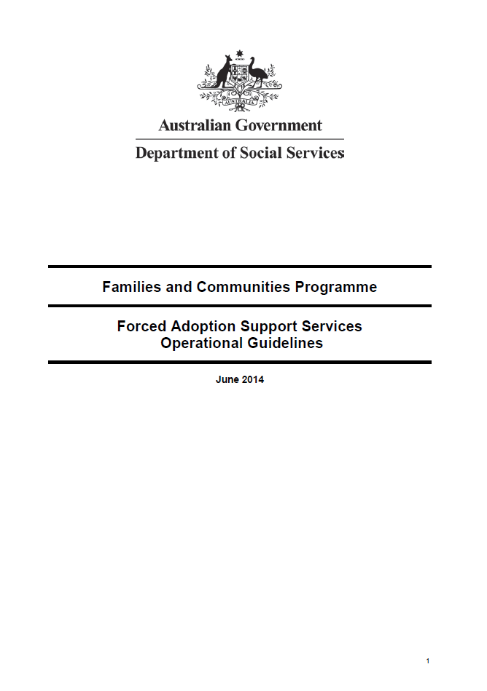

Download a Word document version of the [Forced Adoption Support Services Operational Guidelines](https://www.dss.gov.au/sites/default/files/forced_adoption_-_operational_guidelines.docx)

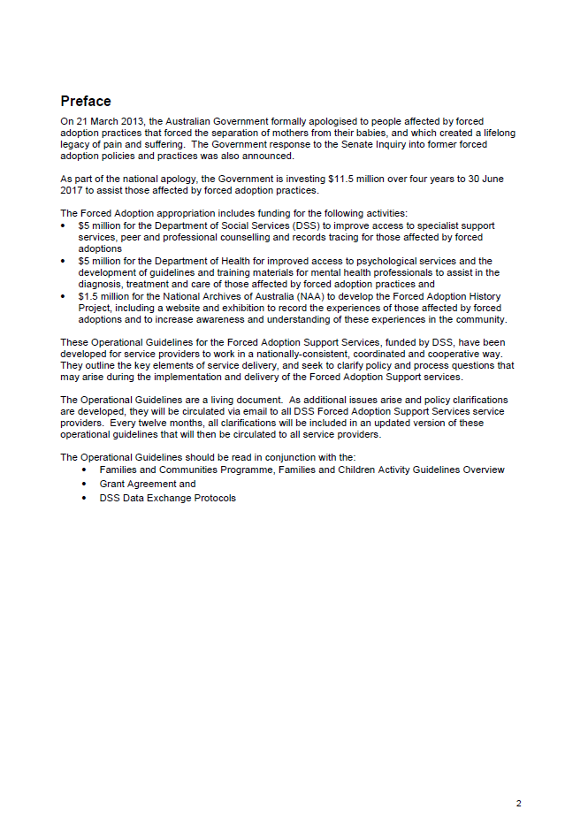

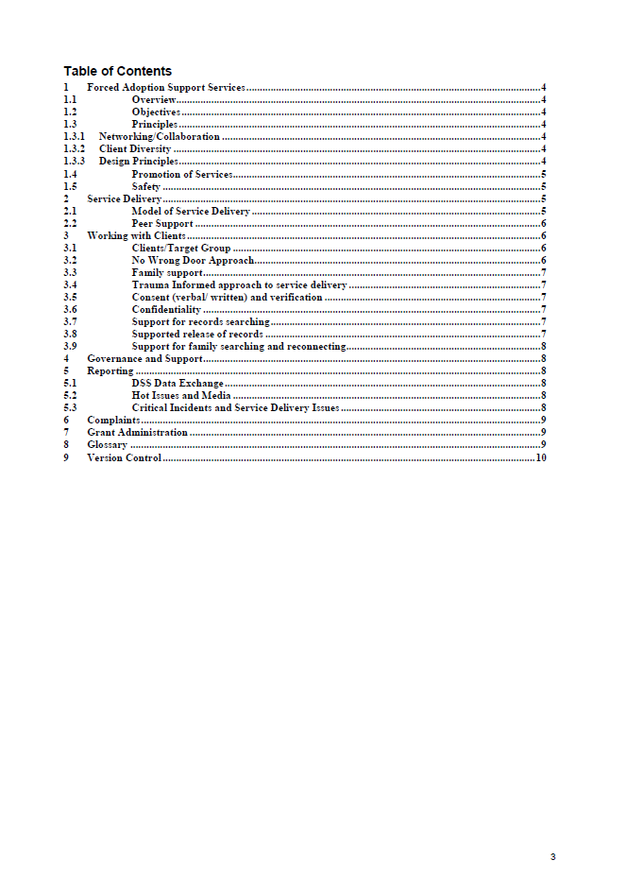

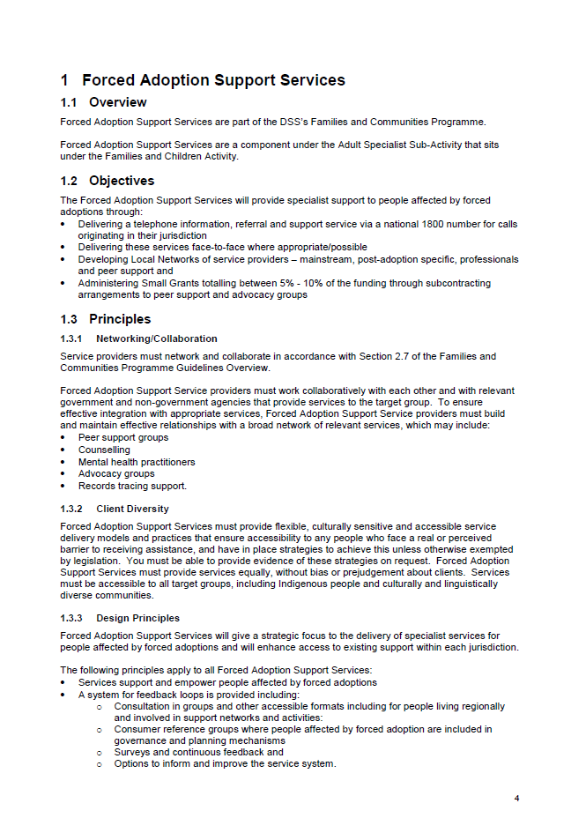

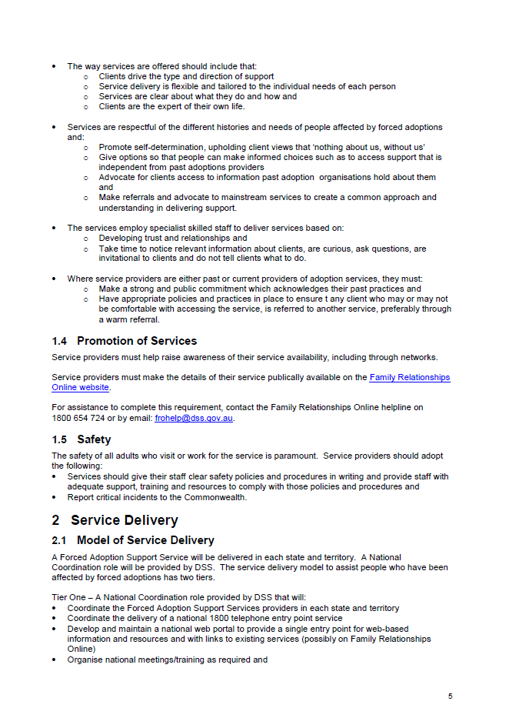

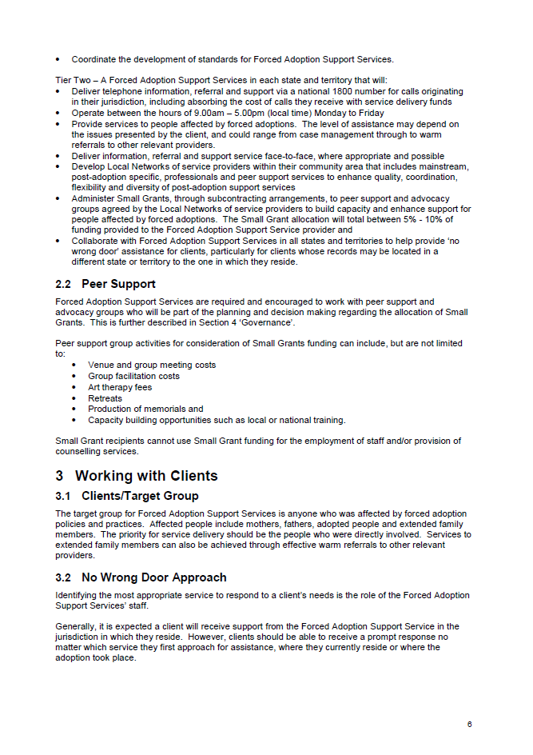

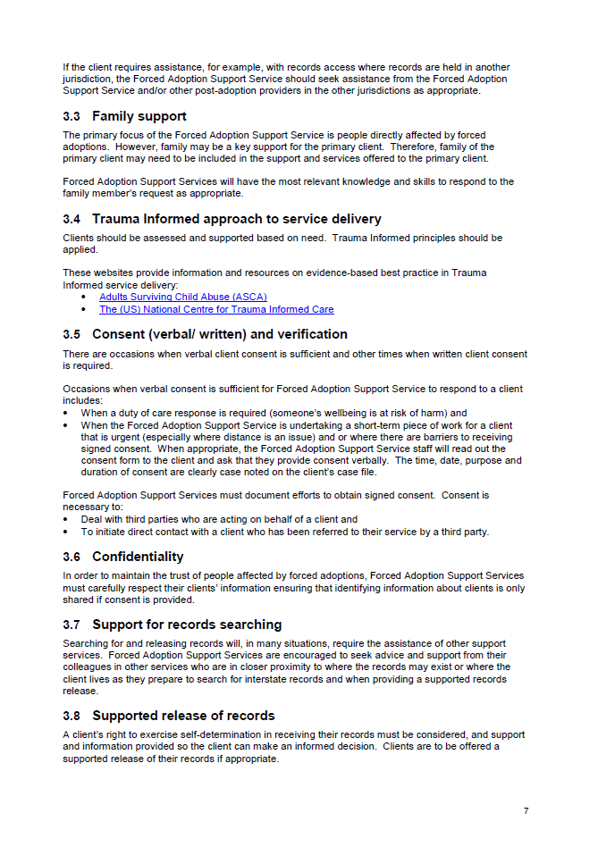

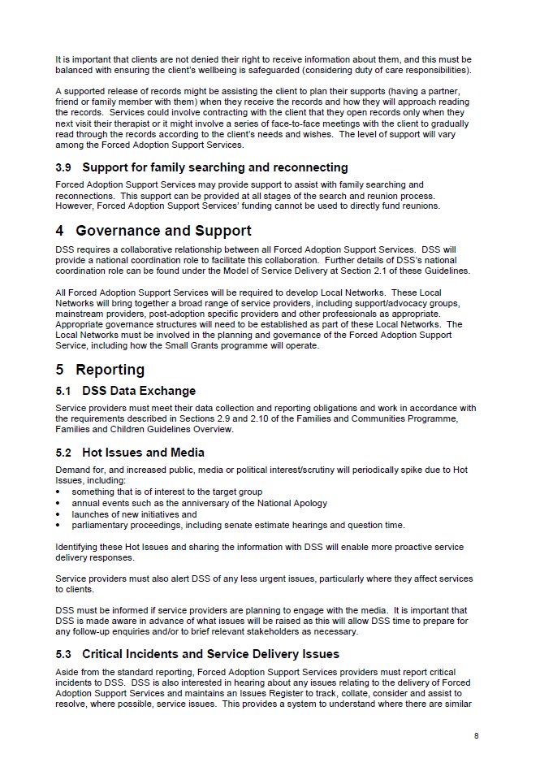

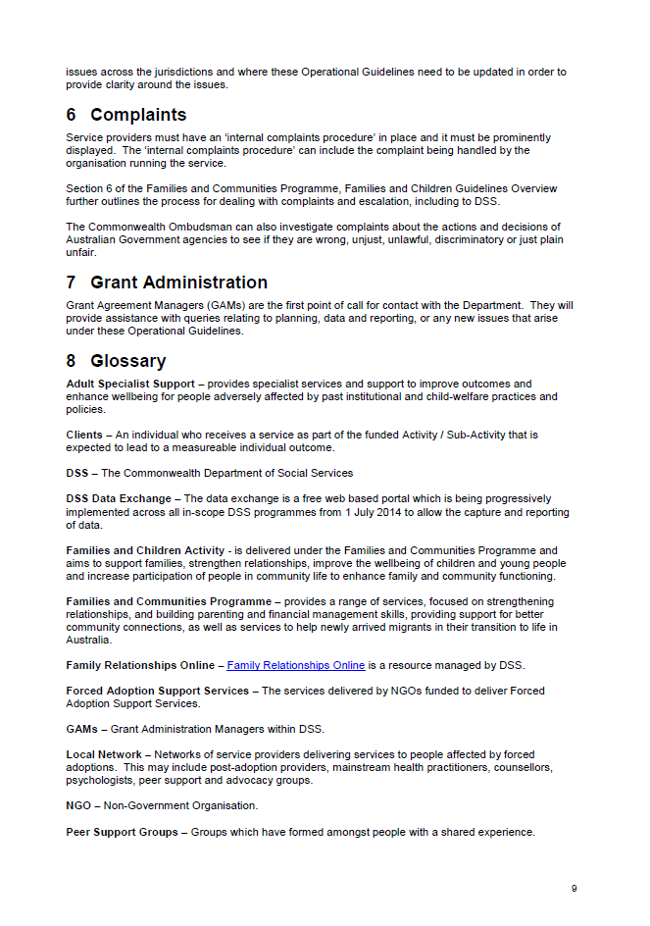

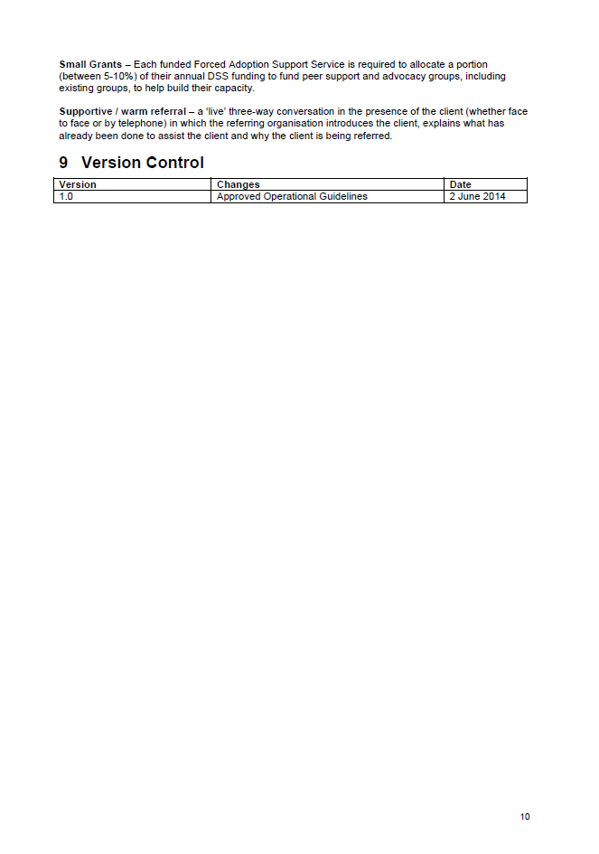

Service model snapshots Nov 2017

Relationships Australia New South Wales

Service provider details[16]

Relationships Australia New South Wales (RA (NSW)) is an independent, not-for profit organisation that provides support for families by providing counselling, mediation and dispute resolution, relationship education, and information and referral.

The FASS provided by RA (NSW) forms part of the suite of ‘Wattle Place’ services that include support for Forgotten Australians and those affected by the Royal Commission into Institutional Responses to Child Sexual Abuse.

Table D‑1: RA (NSW) FASS profile

| Funded organisation name | Relationships Australia New South Wales |
| --- | --- |
| Date service provision commenced | March 2015 |
| Location(s) | Parramatta |
| Additional outlets | Harris Park  Canberra and region |
| Total funding 1 March 2015 to June 2021[17] | $3,524,289.53 (GST incl.) |
| Funding from other sources | No |
| In-kind support | Yes |

Service context

The FASS provided by RA (NSW) receives referrals from other relevant organisations, specifically the Benevolent Society’s Post Adoption Resource Centre (PARC) and the NSW Government’s Adoption Information Unit (AIU). Origins and CLAN (Care Leavers Australasia Network) are also active in the forced adoption area.

RA (NSW) contracts to Relationships Australia Canberra and Region to provide FASS in the ACT.

The NSW government formally acknowledged the traumatic effects of past forced adoption processes and apologised on 20 September 2012.

Table D‑2: Overview of RA (NSW) service model

| Service | Details |
| --- | --- |
| 1800 information line | The 1800 line is staffed by an intake worker who covers all the Wattle Place services. |
| Referrals and information based on individual needs | Provided as required. |
| Face-to-face support | Provided as required. |
| Casework/case management | Casework is provided to support clients as they move through the records searching/tracing process. RA (NSW) has dedicated casework/counselling staff to support the release of clients’ information, preparing them to receive their records prior to release, providing information psycho-education and emotional support and follow up with post-release support. |
| Intake/assessment | The intake process is shared across Wattle Place services.  A minimal waitlist exists for services. |
| Outreach (for service accessibility) | Rural and remote clients are supported primarily through telephone support and also by retreats (see below). Services are also offered via Skype. |
| Group activities | Separate retreats for mothers and adoptees are held in partnership with PARC. Events are also organised for activities; to commemorate the Federal Apology to those affected by Forced Adoption. |
| Records tracing | Tracing is completed by the records management team.  Processes are in place to provide information and access information from the Adoption Information Unit and other providers (e.g. mothers’ and babies’ homes for social and medical information). The organisation has a strong relationship with Births, Deaths and Marriages and is working towards the development of an MOU regarding the information provided. A professional records team is headed by a Records Management Officer. Records searching can take an average of six months. |
| Emotional support/ counselling | RA (NSW) estimate that 80% of FASS clients would have benefited from casework practice in the past six months, noting that the majority did not request counselling. Five per cent of clients received counselling provided by RA (NSW), and a further 15% received counselling via an external referral or the client’s private counsellor.  Counselling has recently been integrated into the service model, with recruitment of a 0.6 FTE counsellor. Where required, RA (NSW) staff who provide counselling through other programs can provide counselling for FASS clients, on a salary transfer arrangement. Counselling is offered as required through the stages of family tracing. Some brokered counselling is also provided. |
| Reunion mediation (outreach to family on behalf of client) | Support includes discussion of the process and agreement regarding who facilitates contact. It is generally recommended that the FASS make initial contact with confirmed and potential family members.  RA (NSW) provides information to clients about the challenges and difficulties that can emerge when reunion is attempted. FASS workers support and follow up the general wellbeing of all parties, and continue to support clients through the process.  If the search yields a ‘do not contact’ veto, the client is informed and offered support at that time. The FASS worker is also there to support the client if the reunion fails. |
| Access to peer support | RA (NSW) is planning to do some training for peer group leadership. |
| Advocacy | RA (NSW) does not undertake advocacy activities. |
| Small grants | In the period 1 March 2015 to 30 June 2017, RA (NSW) issued seven Small Grants, ranging from $3,182 to $7,273 in value. The total amount disbursed to June 2017 was $31,273 (GST excl.). |

Client profile

From January 2015 to June 2017, RA (NSW) provided a total of 1,636 sessions to 407 FASS clients.[18]

Table D‑3: RA (NSW) FASS client profile

| Type of client | Percentage of recent clients |
| --- | --- |
| Adult adoptee | 55%* |
| Mother | 20% |
| Father | 5% |
| Adoptive mother | 0% |
| Adoptive father | 0% |
| Extended family member through forced adoption (e.g. siblings, grandparents, etc.) | 10% |
| Adoptive extended family member separated through forced adoption (e.g. siblings, grandparents, etc.) | 10% |
| Professionals | 0% |
| Other | 0% |

* Includes 10% who are ‘late discovery’ adult adoptees

Note: FASS providers were asked to consider ‘recent’ clients, i.e. in the most recent six-month reporting period.

How clients access services

* The majority (90%) of RA (NSW)’s FASS clients access the service via phone.
* Less than 10% of clients make only one or two contacts with FASS in NSW/ACT. For ongoing clients, the average length of time a client is involved with FASS is 12 months.
* Family tracing is a specific need/service used by longer-term clients, and this process takes an average of six months.

Staffing and volunteer profile

All FASS staff are paid workers with a total staff equivalent of 3.3 FTE.

Table D‑4: RA (NSW) FASS staffing profile

| Position | FTE | Completed 1+ days of trauma-informed practice training |
| --- | --- | --- |
| Team Leader | 0.5 | Yes |
| Caseworker | 1 | Yes |
| Casework/counsellor | 0.6 | Yes |
| Records Management Officer | 0.3 | No |
| Intake/admin | 0.3 | Yes |
| Group work/Community Engagement | 0.1 | Yes |
| Manager | 0.2 | Yes |
| Clinical Supports | 12 hrs per month | Yes |

Client feedback

RA (NSW) collects client feedback via an annual survey (new in 2017), informal feedback and evaluation of retreats.

Initial results from the first annual survey appear positive, but had not been collated during the consulting period. Feedback from retreats is over 90% positive.

Client involvement in governance arrangements

RA (NSW) established a FASS consultative group to ensure that people who use the service have an ongoing, formal role in providing feedback to FASS staff to improve the service. This group is designed to provide a forum for ideas and discussion, identify issues for consideration of service providers and make recommendations (although decisions are ultimately made by FASS management). RA (NSW) provides significant support to the consultative group (e.g. development of terms of reference, inviting new members).

Small grants

In the period 1 March 2015 to 30 June 2017, RA (NSW) issued seven Small Grants. RA (NSW) calls for funding applications in March and September each year.

The selection and allocation process involve group consideration of the merit of a proposal measured against criteria and risks as follows:

* Description and demonstrated ability to deliver the project (40%)
* Partnerships (20%)
* Risk and safety (20%)
* Evaluation (10%)
* Value for money (10%).

Projects are to be completed and evaluated within a six-month period.

Table D‑5: RA (NSW) Small Grants

| Organisation or recipient | Grant amount (GST excl.) | Funded period | Description | Build sector capacity | Group healing activities | Status |
| --- | --- | --- | --- | --- | --- | --- |
| Origins | $7,273 | Mar- Sep 16 | Symposium, book launch – Sanctioned evil. Forum to discuss issues as a result of forced adoption | Y | N | Complete |
| Mushroom Mothers | $3,182 | Sep 15- Mar 16 | Harbour cruise | N | Y | Complete |
| Mushroom Mothers | $3,909 | Sep 16- Mar 17 | Christmas activity | N | Y | Complete |
| Soulology | $4,545 | Mar 17 | Self-help workshop | N | Y | Complete |
| Kerrie Small | $4,545 | Mar 17- Sep 17 | DNA Workshop | N | N | In progress |
| Benevolent Society | $3,455 | Sep 15- Mar 16 | Men’s Group | N | Y | Complete |
| Adoptees Rights | $4,364 | Sep 16- Mar 17 | Documentary filming | Y | N | In progress |

Working with other services

The FASS provided by RA (NSW) receives a small number of referrals (with four external referrals received in the most recent six-month reporting period) from the Benevolent Society’s Post Adoption Resource Centre (PARC) and NSW Government’s Adoption Information Unit (AIU) Conversely, FASS clients are referred to these same providers, as well as Origins, as appropriate.

Table D‑6: Other services in the post-adoption sector where RA (NSW) referred FASS clients

| Organisation | Type of support |
| --- | --- |
| PARC | Adoption support – counselling offered |
| AIU | Records |
| Origins | Legal assistance |

Working with other FASS providers

Interagency meetings and relevant networking include:

* Sharing knowledge and supporting record searching
* DSS practice roundtables
* Joint projects with state-based services (including through Small Grants)
* Interagency attendance
* Connecting other services with APS counsellors who have done adoption units
* Providing knowledge around legislative differences
* Networking with other providers supporting the Without Consent exhibition.

Promotion and awareness activities

Table D‑7: RA (NSW) promotion and awareness activities

| Service/activity | Details of promotion and awareness activities |
| --- | --- |
| FASS | * Presentation to broader organisation * Wattle Place Team Meeting * Interagency promotion * Documentary being produced * Handbooks * Session in Newcastle (Dr Rickaby main speaker) |
| The National Archives Forced Adoption History Project | * Word of mouth |
| The *Without Consent* exhibition | * Provide training to staff * Word of mouth * Inform stakeholders – peer groups advertise through their newsletters |
| Anniversary events | * Websites * Invite PARC * Mail out to clients * Facilitating the federal anniversary event |

Relationships Australia Northern Territory

Service provider details[19]

In the Northern Territory, FASS is provided by Relationships Australia Northern Territory RA (NT) and is based in Darwin. RA (NT) has been providing relationship support and other services since 1973. As well as the FASS, RA (NT) also provides a range of other support services including Royal Commission support services, Find and Connect support services (for Forgotten Australians and Former Child Migrants), and specific support services for youth, Aboriginal and Torres Strait Islander people.

Table D‑8: RA (NT) FASS profile

| Funded organisation name | Relationships Australia NT |
| --- | --- |
| Date service provision commenced | March 2015 |
| Location(s) | Darwin |
| Additional outlets | Alice Springs and Katherine |
| Total funding 1 March 2015 to June 2021[20] | $258,787.65 (GST incl.) |
| Funding from other sources | None |
| In-kind support | None |

Service context

There are currently no other similar support services specifically for those affected by forced adoption in the NT. The NT Stolen Generation Aboriginal Corporation (also referred to as Link-Up) is a support service that assists Aboriginal and Torres Strait Islander people separated from their families under the past laws, practices and policies of Australian governments, to undertake family tracing and family reunions with counselling support, however this service is for Stolen Generation clients only.

RA (NT) works with the NT Department of Children and Families Adoption Unit for records tracing.

To date, the NT Government has not made a public apology for past forced adoption practices. The NT did not have self-government during the period of forced adoptions and is covered by the Commonwealth Apology

Table D‑9: Overview of RA (NT) service model

| Service | Details |
| --- | --- |
| 1800 information line | The 1800 number is staffed by RA (NT) reception staff |
| Referrals and information based on individual needs | Provided as required. |
| Face-to-face support | Provided as required. |
| Casework/case management | Provided as required. |
| Intake/assessment | Provided by RA (NT) intake and reception team. In some cases, clients may be referred to other RA services (e.g. Find and Connect or Royal Commission). |
| Outreach (for service accessibility) | No outreach activities are provided. However, clients can engage with the service by telephone. |
| Group activities | No group activities are provided. |
| Records tracing and release of records | RA (NT) offers supported release of records; a process that includes giving clients the choice on how they would like to receive their records and what support they would prefer. Generally, the Records Searcher and Family Tracing Worker meets with the counsellor to explain the records received for the client, after which the client attends a session with a counsellor for supported release. There is a two-month waitlist for clients requesting record searching. |
| Family searching | Records, family tracing and mediation is a new service to RA (NT) and is provided as required. |
| Reunion mediation (outreach to family on behalf of client) | RA (NT) does not provide financial support for reunions. |
| Emotional support/ counselling | Professional counselling is a new service to RA (NT) and they are currently promoting the availability of FASS counselling via stakeholders, clients, business contacts and social media. The Family and Relationship Services (FaRS) counsellors provide counselling to clients, with no limit to the number of counselling sessions clients are eligible to receive. |
| Access to peer support | No peer support groups are available. |
| Advocacy | Provided as required. |
| Small grants | RA (NT) has administered two Small Grants in 2016-17, providing a total of $5,574 in funding (GST excl.) |
| Other | Each year RA (NT) organises an apology anniversary event to which clients and stakeholders are invited. |

Client profile

The total number of FASS sessions (based on DEX data) are unavailable because, due to small numbers, sessions for Tasmania and NT were combined in the DEX reporting.

Table D‑10: RA (NT) FASS client profile

| Type of client | Percentage of recent clients |
| --- | --- |
| Adult adoptee | 75% |
| Mother | 25% |
| Father | n/a |
| Adoptive mother | n/a |
| Adoptive father | n/a |
| Extended family member through forced adoption (e.g. siblings, grandparents, etc.) | n/a |
| Professionals | n/a |

Note: FASS providers were asked to consider ‘recent’ clients – i.e. in the most recent six-month reporting period.

How clients access services

Half of the NT FASS clients access services face-to-face, and the remaining half access through phone or email/online (25% for each).

About 50% of clients make only one or two contacts with FASS in the NT. For ongoing clients, the average length of time a client is involved with FASS is three and a half months, with most ongoing clients requesting records searching and counselling.

Staffing and volunteer profile

All RA (NT) staff are paid workers with a total staff equivalent of 0.53 FTE. The Records Searcher and Family Tracing Worker position is currently vacant.

Table D‑11: RA (NT) FASS staffing profile

|  |  |  |
| --- | --- | --- |
| Position | FTE | Completed 1+ days of trauma-informed practice training |
| Coordinator of Adult Specialist Support Services | 0.33 | Yes |
| Records Searcher and Family Tracing Worker | 0.2 | N/A – currently vacant |

Client feedback

Clients having counselling with the in-house counselling team can provide feedback on their counselling via RA (NT)’s counselling feedback process. A feedback process for records searching services is currently being completed.

Currently all complaints received by RA (NT) are directed to the Coordinator of Adult Specialist Support Service. The complaint is subsequently discussed with the Director of Early Intervention service, and a rectification decision is discussed and approved.

RA (NT) is currently implementing a formal complaints process, in which a ‘Quality Service, Client Rights, Feedback and Complaints’ brochure will be given to each client.

Client involvement in governance arrangements

People affected by past practices and policies are included in planning FASS client engagement via the following stakeholders:

* The Alliance for Forgotten Australians
* Northern Territory Stolen Generation Aboriginal Corporation
* NT Find and Connect Consumer Reference Group.

Small grants

RA (NT) has administered two Small Grants in 2016-17, providing a total of $5,574 (GST excl.) in funding.

Table D‑12: RA (NT) Small Grants

| Organisation or recipient | Grant amount (GST excl.) | Funded period | Description | Build sector capacity | Group healing activities | Status |
| --- | --- | --- | --- | --- | --- | --- |
| Corporation | $2,846 | 2016-17 | Therapeutic support retreat | N | Y | In progress | |
| Corporation | $2,728 | 2016-17 | 2 x support and advocacy gatherings | N | Y | Complete | |

Working with other services

Table D‑13: Other services in the post-adoption sector where RA (NT) referred FASS clients

| Organisation | Type of support |
| --- | --- |
| NT Department of Children and Families Adoption Unit | Records searching |
| NT Stolen Generation Aboriginal Corporation | Records searching |

RA (NT) networks with the NT Department of Children and Families Adoption Unit and the NT Stolen Generation Aboriginal Corporation. These stakeholders are invited to RA (NT) events, and reciprocal invitations are provided to RA (NT).

RA (NT) engages in local service networking through training opportunities, service networking functions such as expos and community events, and RA (NT) networking functions as such the FASS anniversary events.

Working with other FASS providers

RA (NT) provides services to interstate clients and has experienced no issues in doing so.

Promotion and awareness activities

Table D‑14: RA (NT) promotion and awareness activities

| Service/activity | Details of promotion and awareness activities |
| --- | --- |
| Your FASS | Mail out of brochures and information to all medical centres, nursing homes, psychological and associated services in the NT. |
| The *Without Consent* exhibition | Provide the *Without Consent* booklet to clients and stakeholders. |
| Anniversary events | Each year RA (NT) organises an apology anniversary event to which clients and stakeholders are invited. |

Jigsaw Queensland Inc

Service provider details[21]

In Qld, FASS is provided by Jigsaw. Jigsaw is a non-profit, member-based organisation that has assisted people affected by adoption for 41 years. It commenced FASS provision in March 2015, funded by the Department of Social Services.

Table D‑15: Jigsaw Qld FASS profile

| Funded organisation name | Jigsaw Queensland Inc (Jigsaw) |
| --- | --- |
| Date service provision commenced | March 2015 |
| Location | Sands House, 505 Bowen Tce, New Farm Qld 4005 |
| Additional outlets | Nil |
| Total funding 1 March 2015 to June 2021[22] | $2,035,824.69 (GST incl.) |
| Funding from other sources | No |
| In-kind support from your organisation | No |

Service context

Jigsaw works with other key organisations including: Adoption Services (QLD Government), ALAS Australia, Association for Adoptees, Origins Qld, PASQ Benevolent Society, Salvation Army, Link-up Qld and Find and Connect (MICAH Projects).

Jigsaw has established links with Adoption Services and Births Death and Marriages (BDM) Queensland who can help with advice and accessing records in more complex cases. Jigsaw also has contacts in the State Library of Queensland family history unit and Australian DNA Hub for advice and more advanced searching assistance.

An apology to the people affected by forced adoption was given on behalf of the Qld community in Parliament on 27 November 2012.

Table D‑16: Overview of Jigsaw Qld service model

| Service | Details |
| --- | --- |
| 1800 information line | The 1800 number is staffed by FASS team members. |
| Referrals and information based on individual needs | Provided as required |
| Face-to-face support | Provided as required |
| Casework/case management | Provided as required |
| Intake/assessment | Provided by a FASS team member. There is currently no wait list for services. |
| Outreach (for service accessibility) | If required, FASS provides services at the client’s home e.g. for frail elderly or at other sites e.g. for reunions |
| Group activities | Clients are referred to Jigsaw’s peer support groups. FASS staff provide client support at workshops and retreats funded under the Small Grants program. |
| Records tracing and release of records | Jigsaw provides clients with information on how to access their adoption records and BDM records in the state (or country) they were adopted in.  Some clients have difficulty obtaining records, e.g. from Salvation Army archives or hospitals, and Jigsaw offers to contact these agencies and advocate on their behalf to obtain access to the records for the client. |
| Family searching | Jigsaw provides clients with a range of levels of searching support, according to need, from advice on how to search to doing extensive searching for them  Jigsaw prepares clients for outreach/contact by discussing expectations and possible outcomes with the client. Discussions include being sensitive to the other party’s confidentiality and the potential role of Jigsaw as an intermediary |
| Reunion mediation (outreach to family on behalf of client) | If a client chooses to use the Jigsaw intermediary service, Jigsaw identifies what information the client is happy to share in the initial contact and any vital questions that they may have, should the other party not want any contact. Jigsaw conducts the outreach via a letter asking the relative to make contact.  Post contact support is also offered to both parties for a long as needed. |
| Emotional support/counselling | FASS staff provide emotional support as needed when offering other types of client services. Jigsaw also provides short term (maximum six sessions) supportive counselling in-house (face-to-face, phone or skype) and also makes referrals to PASQ or private professionals for longer term therapeutic counselling. |
| Access to peer support | Jigsaw has a pool of trained peer support volunteers who facilitate support groups and also offer one-to-one support. FASS staff provide assistance in training the peer support volunteers. |
| Advocacy | Jigsaw is active in promotion and awareness activities. Jigsaw participated in the 2016 review of the Qld Adoption Act (2009) which resulted in amendments to the Act. |
| Small grants | In the period 1 March 2015 to 30 June 2017 Jigsaw has administered 11 Small Grants, ranging from $708 to $8,913 in value. The total amount disbursed to June 2017 was $29,669 (GST excl.). |
| Other | FASS supports clients at memorial/anniversary events. |

Client profile

From January 2015 to June 2017, Jigsaw provided a total of 3,139 sessions to 626 FASS clients.[23]

Table D‑17: Jigsaw Qld client profile

| Type of client | Percentage of recent clients | Notes |
| --- | --- | --- |
| Adult adoptee | 69% | n/a |
| Mother | 17% | n/a |
| Father | 0.01% | 1 father |
| Adoptive mother | 1% | n/a |
| Adoptive father | 0% | n/a |
| Extended family member through forced adoption (e.g. siblings, grandparents, etc.) | 6% | n/a |
| Professionals | <0.01% | 1 professional |
| Partner | 1% | n/a |
| Friend or relative | 4% | n/a |

Note: FASS providers were asked to consider ‘recent’ clients – i.e. in the most recent six-month reporting period.

How clients access services

Approximately 30% of clients make one or two contacts with Jigsaw. For ongoing clients, the average length of time a client is involved with Jigsaw is six months. A small number of clients require ongoing intermittent emotional support. There is currently no wait list for services, although the search process may take longer when client numbers are higher.

Staffing and volunteer profile

All Jigsaw FASS staff are paid workers with a total staff equivalent of 2.2 FTE. One casual administrative staff is also employed.

Table D‑18: Jigsaw Qld FASS staffing profile

| **Position** | FTE | **Completed 1+ days of trauma-informed practice training** |
| --- | --- | --- |
| Manager | 0.4 | No, but has extensive experience in post adoption work |
| Team leader | 0.6 | Yes |
| Information, support and referral worker | 2 x 0.6 | Yes |
| Admin support | Casual | No, but has done APS training as well as a social work student placement at FASS |

Client feedback

Jigsaw collects client experience and satisfaction data by:

* Collating any written feedback that is received
* Obtaining written feedback after workshops/retreats.

Jigsaw has a client feedback form which is available on the Jigsaw website. From time to time, (approximately half yearly) it is also mentioned in newsletters and/or Facebook. The form is also available in hard copy at support group meetings and in the counselling support room.

Written feedback from workshops/retreats suggested that 99% of the clients surveyed reported that they were satisfied. Jigsaw reported that they do not have any other data on the percentage of clients who are satisfied with FASS, but intend to work on this.

Client involvement in governance arrangements

People with lived experience of forced adoption are part of the Jigsaw management committee.

FASS communicates regularly with other forced adoption stakeholder groups such as ALAS Australia, Association for Adoptees and Origins Qld through quarterly meetings with stakeholders and ongoing contact between meetings.

Small grants

In the period 1 March 2015 to 30 June 2017 Jigsaw has administered 11 Small Grants, ranging from $708 to $8,913 in value. The total amount disbursed to June 2017 was $29,669 (GST excl).

Table D‑19: Jigsaw Qld Small Grants

| Organisation or recipient | Grant amount (GST excl.) | Funded period | Description | Build sector capacity | Group healing activities | Status |
| --- | --- | --- | --- | --- | --- | --- |
| Origins Qld | $8,913 | 2015-16 | Mother’s retreat | Y | Y | Complete | |
| ALAS | $2,342 | 2015-16 | Anniversary event | Y | Y | Complete | |
| Pat Zuber (artist) | $1,435 | 2015-16 | Printmaking workshops for adopted people | N | Y | Complete | |
| Qld State Apology 3rd anniversary | $708 | 2015-16 | Banners for Anniversary event | Y | Y | Complete | |
| Australian DNA Hub | $2,037 | 2016-17 | DNA workshops (2) | Y | Y | Complete | |
| Qld stakeholders group | $3,382 | 2016-17 | 4th Anniversary event costs – banners, catering, guest speaker | Y | Y | Complete | |
| Pat Zuber (artist) | $723 | 2016-17 | Co-ordinator/ curator for My Adoption Experience Exhibition | N | Y | Complete | |
| Jo Sparrow (group facilitator) | $939 | 2016-17 | Constructing Identity after Adoption workshop | N | Y | Complete | |
| Trish Purnell-Webb (group facilitator, Psychologist) | $3,403 | 2016-17 | Relationship workshop for adopted people | N | Y | Complete | |
| Individual adoptees | $1,071 | 2016-17 | Funding for airfares for 3 people to attend ARTTT meeting in Victoria | Y | N | Complete | |
| Qld stakeholders group for Memorial Plaques Project | $4,716 | 2016-17 | Funding for project worker to complete stage 1: engage and consult with stakeholders, develop design brief, obtain quotes, approach proposed sites | Y | Y | Stage 1 complete  Stage 2 in progress | |

Working with other services

Table D‑20: Other services in the post-adoption sector where Jigsaw QLD referred FASS clients

| Organisation | Type of support |
| --- | --- |
| State Government Adoption Services | Access to adoption records |
| Birth, Deaths and Marriages | Access to original birth certificates, and marriage and death searches for relatives |
| Salvation Army | Searching for relatives |
| PASQ | Counselling or support group in regional areas |
| Link Up | Family tracing and reunion for Aboriginal and Torres Strait Islander clients |
| Find and Connect (MICAH projects) | Records searching and support for Forgotten Australians |

Jigsaw receives referrals from other parts of their organisation, with four referrals from Jigsaw Support Groups in the last six-month reporting period. Jigsaw also receives referrals from three main organisations: Adoption Services (Qld Government Department of Communities), Salvation Army and PASQ. In the last six-month reporting period, 14 referrals were received from these organisations.

Working with other FASS providers

Jigsaw networks with other FASS though the annual FASS roundtable and telephone conferences when these are organised by the Department. Jigsaw also networks more regularly with Nikki Hartmann, from RA (SA) because of her level of experience and expertise. Jigsaw assists RA (SA) with FASS SA Small Grant application selection and are currently also working with RA (SA) on a video project for the 5th Anniversary of the Apology.

Jigsaw also attends quarterly meetings with Qld post adoption service providers and bi-monthly meetings with PASQ.

Promotion and awareness activities

Table D‑21: Jigsaw Qld promotion and awareness activities

| **Activity** | **Details of promotion and awareness activities** |
| --- | --- |
| FASS | * Presentations to public groups, student groups * Media releases and media interviews. * Jigsaw Facebook, website and newsletter. |
| The National Archives Forced Adoption History Project | * Link on Jigsaw webpage * Promotion at annual Apology Anniversary events using bookmarks/catalogues. |
| The Without Consent exhibition | * Jigsaw Facebook promotion of Canberra and Sydney exhibitions * Plans to promote more when exhibition comes to Brisbane/Qld. |
| Anniversary events | * Email flyer sent to all FASS clients * Promote via other organisations e.g. PASQ, Salvation Army * Promote on Facebook and in Jigsaw newsletters. |

Relationships Australia South Australia

Service provider details[24]

In SA, FASS are provided by RA (SA). RA (SA) is a not-for-profit, secular, community organisation that has provided family support services for the past 50 years. It has been the South Australian provider of Post Adoption Support Services (PASS) since 2006, funded by the state government. Its services include Find and Connect support services (for Forgotten Australians and Former Child Migrants), and specific support services for youth, Aboriginal and Torres Strait Islander people, people from a CALD backgrounds, people affected by domestic violence and gambling.

RA (SA) commenced FASS provision in 2015, funded by the Department of Social Services.

Table D‑22: RA (SA) FASS profile

| Funded organisation name | Relationships Australia South Australia |
| --- | --- |
| Date service provision commenced | March 2015 |
| Location | 49A Orsmond St, Hindmarsh SA 5007 |
| Additional outlets | Nil |
| Total funding 1 March 2015 to June 2021[25] | $675,115.14 (GST incl.) |
| Funding from other sources | Yes |
| In-kind support from your organisation | Yes |

Service context

Currently, there are no other similar support services available specifically for those affected by forced adoption in SA. PASS, the state funded adoption support service provides support to all individuals affected by adoption, including forced adoption. Some small, grassroots support and advocacy services exist and RA (SA) is well engaged with these community groups and other related support services.

All requests for adoption information and documents, for adoptions that took place in SA, are through the SA Department of Child Protection (DCP), which charges no fee for this service. A veto system applies in SA, meaning that an adoption completed before 17 August 1989 may have a restriction placed on the release of information about one of the parties of the adoption. In such a case, the DCP only provides non-identifying information. For people who are or believe that they may be of Aboriginal descent, the DCP refers them to Nunkuwarrin Yunti (Link-Up SA) for specific searches. However, the FASS also responds to and supports Aboriginal people who are affected by forced adoption. SA became the second state in Australia to apologise to people affected by forced adoption, with its apology delivered on 18 July 2012.

Table D‑23: Overview of RA (SA) service model

| Service | Details |
| --- | --- |
| **1800 information line** | The 1800 number is staffed by FASS team members. |
| **Referrals and information based on individual needs** | Provided as required. |
| **Face-to-face support** | Face-to-face support is often provided to individuals before they join FASS. |
| Casework/ case management | Provided as required. |
| Intake/assessment | Provided by a FASS team member. In some cases, clients may be referred to other RA services (e.g. Find and Connect, PASS).  The wait list for a client to receive their first appointment is between two and four weeks, depending on service demands. |
| Outreach (for service accessibility) | As FASS in SA is a small service, provision of regular outreach services is not possible but may be negotiated in exceptional circumstances. |
| Group activities | FASS practitioners at RA (SA) facilitate Mothers’ and Adoptee group support programs which meet every month. Mothers and adoptees meet separately in these groups.  RA (SA) has identified that fathers need support, and are planning to include them in existing ad-hoc groups comprised of other FASS cohort members which meet intermittently.  RA (SA) does not provide retreats through the FASS program. |
| Records tracing and release of records | Clients accessing FASS for records searching are advised by RA (SA) about the avenues available, and the processes that need to be undertaken. RA (SA) has a relationship with the Registrar of Births, Deaths and Marriages which allows them to attend the Registrar’s office for record searching. |
| Family searching | Family searching is provided and is the most common reason clients seek assistance from FASS. |
| Reunion mediation (outreach to family on behalf of client) | Provided on request. When undertaking family searching, FASS practitioners ensure clients are kept up to date with any developments and assists clients in establishing connections and communications with each other. FASS also provides support prior to, during and after reunion which also includes links and referrals to appropriate services. |
| Emotional support/ counselling | Counselling is provided in-house via FASS, RA (SA)’s generic counselling program or to external agencies as appropriate. All RA (SA) counsellors are trained in trauma-informed counselling approaches and external providers are assessed for these skills when making referrals.  In total, 23 of RA (SA)FASS clients have required counselling in the past six months. This was provided primarily through the FASS (20), with the remainder accessing these services by referral to other RA (SA) counselling services or by external referral. RA (SA) does not store data about clients utilising private services. |
| Access to peer support | Peer support is provided through the monthly group meetings and other ad-hoc meetings held in Adelaide. |
| Advocacy | RA (SA) provides this through direct service provision to clients and indirectly at a policy/service/program level as appropriate or through its relationship with a range of external agencies and community groups e.g. Department for Child Protection, the Salvation Army, Nunkuwarrin Yunti (SA Linkup), IdentityRites and the Adoptee Advocacy and Information Services SA (AAISSA) – (formerly Adoption SA) |
| Small grants | In the period 1 March 2015 to 30 June 2017, RA (SA) issued nine Small Grants, ranging from $600 to $2,827. The total amount disbursed to June 2017 was $16,435 (GST excl.). |
| Other | FASS clients participate in memorial/anniversary events |

Client profile

From FASS commencement to June 2017, RA (SA) provided a total of 1,033 sessions to 178 FASS clients.[26]

Table D‑24: RA (SA) FASS client profile

| Type of client | Percentage of recent clients |
| --- | --- |
| Adult adoptee | 63% |
| Late discovery adult adoptee (unaware of being adopted until over 16 years of age) | 5% |
| Mother | 17% |
| Father | 3% |
| Adoptive mother | 0% |
| Adoptive father | 0% |
| Extended family member through forced adoption (e.g. siblings, grandparents, etc.) | 11% |
| Professionals | 0% |

Note: FASS providers were asked to consider ‘recent’ clients –i.e. in the most recent six-month reporting period.

How clients access services

The majority of clients access RA (SA) FASS primarily through email (37.2%). The average length of time a client is involved with RA (SA) differs depending on the needs of clients: if records/family search takes a long time, or if the reuniting parties require support in exchanging letters etc, RA (SA) provides this until such time as parties are ready to have direct contact. A small number of these clients require ongoing intermittent emotional support. New enquiries to the services are responded to generally within 48 hours. Depending on service demands at the time, clients are usually offered a first appointment within 2-4 weeks.

Staffing and volunteer profile

All FASS staff are paid workers with a total staff equivalent of 0.7 FTE.

Table D‑25: RA (SA) FASS staffing profile

| Position | FTE | Completed 1+ days of trauma-informed practice training |
| --- | --- | --- |
| Case Worker/Counsellor | 0.4 | Yes |
| Program Manager and case worker | 0.3 | Yes |

Client feedback

RA (SA) clients provide qualitative feedback regarding the service through the FASS practitioners which is then fed back to the Manager for Post Adoption and Forced Adoption Support Services.

Clients are also encouraged to provide feedback through regular Client Snapshot Surveys that RA (SA) conducts. RA (SA) have an explicit commitment to continuous improvement through adjustments to their practice based on client feedback. Clients also complete feedback forms for the groups and workshops provided by RA (SA).

Client involvement in governance arrangements

Community groups are engaged to provide regular input/suggestions to the service and this is welcomed. RA (SA) has other key community connections, with specific adoption experience and knowledge who can be contacted to seek advice as needed. RA (SA) has a client advisory group for its Post Care Services and Find and Connect Services and engages community members on committees as appropriate e.g. the SA Adoption Memorial Steering Committee.

Small grants

In the period 1 March 2015 to 30 June 2017, RA (SA) issued nine Small Grants, ranging from $600 to $2,827. The total amount disbursed to June 2017 was $16,435 (GST excl.).

Ideas for Small Grant applications are identified through discussions with stakeholders and through RA (SA) staff identifying needs that could be met through the grants program. RA (SA)’s community knowledge and PASS experience allowed them to readily identify the key groups / people most likely to be interested in the Small Grants Scheme, and allowed them to identify the gaps in SA.

RA (SA) reports that the idea of Local Networks to form an assessment panel for Small Grants cannot work in SA, as some potential members would also apply for grants, leading to a conflict of interest. As a result, a number of the other FASS assist RA (SA) in making the Small Grants assessments. this has been working well. There is an assessment matrix form that all assessors complete, which is followed by a teleconference to discuss each application and make approvals

Table D‑26: RA (SA) Small Grants

| Organisation or recipient | Grant amount (GST excl.) | Funded period | Description | Build sector capacity | Group healing activities | Status |
| --- | --- | --- | --- | --- | --- | --- |
| Adoptee IdentityRites | $1,091 | Oct 2015 | Writers Group | N | Y | Complete |
| Adoptee IdentityRites | $2,827 | Apr 2016 | Writing and production of book of adoptees poetry and prose | N | Y | Complete |
| Adoption SA | $2,619 | Apr 2016 | DNA HUB Workshop | N | Y | Complete |
| Sherry Hearn | $1,475 | Apr 2016 | Healing workshop | N | Y | Complete |
| Adoption SA | $2,765 | Oct 2016 | Assist the organisation in becoming incorporated | Y | N | Complete |
| Adoptee Advocacy and Information Services SA (AAISSA) (formerly Adoption SA) | $600 | Apr 2017 | Travel interstate for National Adoptee Think Tank | Y | N | Complete |
| Adoptee Support Group | $1,700 | Apr 2017 | Art Therapy workshop(s) for adoptees | N | Y | In progress |
| Mothers Support Group | $988 | Apr 2017 | Art workshop | N | Y | Complete |
| Adoptee IdentityRites | $2,370 | Apr 2017 | Publication and Launch of book | Y | Y | In progress |

Working with other services

RA (SA) reports that in SA, every person receiving their adoption file from the DCP is provided with information about both the PASS and the FASS. The majority of clients that access the FASS come in this way, however these are not counted as ‘direct referrals’. Over the last six-month reporting period, they received three warm referrals from the PASS service, two from external NGOs, and two from a GP.

It was reported that RA (SA) made three referrals to mainstream services in the last six-month reporting period all of which were warm referrals. Two were referred to psychologists and one to housing services. Other services in the post-adoption sector that RA (SA) refers clients to are:

Table D‑27: Other services in the post-adoption sector where RA (SA) referred FASS clients

| **Organisation** | **Type of support** |
| --- | --- |
| PASS | Therapeutic counselling and support groups |
| Births Deaths and Marriages | Relevant certificates |
| Adoptions departments | Adoption files |

RA (SA) also network with the other FASS through the Practice Roundtable, regular teleconferences, and for particular other needs as they arise. Other FASS providers are also on FASS SA Small Grants Assessment Panel.

RA (SA)’s Nikki Hartmann, regularly communicates with Jigsaw and lends her expertise. Jigsaw assists RA (SA) with FASS SA Small Grant application selection and are currently also working with RA (SA) on a video project for the 5th Anniversary of the apology.

Working with other FASS providers

Where RA (SA) have engaged with another FASS provider in collaborative client work, clients have received well rounded support.

Different jurisdictional laws and slight differences in service configurations have presented challenges which can pose coordination issues when trying to ensure a nationally integrated service.

Promotion and awareness activities

RA (SA) has been actively promoting the FASS provider through their extended network and via the following specific channels:

Table D‑28: RA (SA) promotion and awareness activities

| Service/activity | Details of promotion and awareness activities |
| --- | --- |
| FASS | RA (SA) promotes the service through existing networks. |
| The National Archives Forced Adoption History Project | Details about each state FASS provider is available through the National Archives Forced Adoption History Project. |
| The *Without Consent* exhibition | RA (SA) still does not know if the exhibition is coming to SA and have found it difficult to get concrete information about it. |
| Anniversary events | RA (SA) has held anniversary events in the past  In 2016 there has been a lack of interest from the community which led to a cancellation of the proposed event. |

Relationships Australia Tasmania

Service provider details[27]

In Tasmania, FASS is provided by RA (Tas). RA (Tas) is a community-based, not-for-profit organisation that has been providing relationship support and other services for more than 60 years. Its services include Find and Connect Support Services (for Forgotten Australians and Former Child Migrants), and specific support services for youth, Aboriginal and Torres Strait Islander people, disability carers and gamblers among others.

The FASS was preceded by a state government-funded ‘Past Adoption Support Service’’ that ceased when FASS funding became available.

Table D‑29: RA (Tas) FASS profile

| Funded organisation name | Relationships Australia Tasmania |
| --- | --- |
| Date service provision commenced | March 2015 |
| Location(s) | Hobart |
| Additional outlets | Launceston |
| Total funding 1 March 2015 to June 2021[28] | $449,033.57 (GST incl.) |
| Funding from other sources | No |
| In-kind support | No |

Service context

There are currently no other similar support services specifically for those affected by forced adoption in Tasmania. Some small, grassroots support services were previously available, but reportedly ceased operation when Commonwealth FASS funding commenced.

The Tasmania Department of Health and Human Services provides an Adoption Information Service (AIS) and maintains an Adoption Information Register. The AIS offers a counselling interview for residents of Tasmania seeking information and can assist with search and contact on request.

CatholicCare also provides counselling.

An apology to the victims of forced adoptions was given on behalf of the Tasmanian community in Parliament on 18 October 2012.

Table D‑30: Overview of RA (Tas) service model

| Service | Details |
| --- | --- |
| 1800 information line | The 1800 number is staffed by FASS team members. |
| Referrals and information based on individual needs | Provided as required. |
| Face-to-face support | Face-to-face support is often provided to individuals before they join the support group. |
| Casework/case management | Provided as required. |
| Intake/assessment | Provided by a FASS team member. In some cases, clients may be referred to other RA services (e.g. Find and Connect).  There is currently no wait list for services. |
| Outreach (for service accessibility) | FASS staff will visit clients in their homes where required. |
| Group activities | RA (Tas) provides a monthly group support program facilitated by a FASS practitioner. This group successfully combines mothers and adoptees.  There are plans in the North (Launceston) to set up a monthly peer support group, but in the past, this has been unsuccessful due to low numbers.  RA (Tas) does not provide retreats through the FASS program. |
| Records tracing and release of records | RA (Tas) provides assistance with records searching through its close relationship with the DHHS AIS. FASS practitioners assist in completing paperwork and ensuring that all clients are supported when the records are released, and offer counselling if required. |
| Family searching | Family searching is provided on request. |
| Reunion mediation (outreach to family on behalf of client) | Provided on request. When undertaking family searching, FASS practitioners ensure clients are kept up to date with any developments and provide links to appropriate services. |
| Emotional support/counselling | Counselling is provided by referral to RA (Tas)’s generic counselling program. All counsellors are trained in trauma-informed counselling approaches.  It is estimated that a third of FASS clients have required counselling in the past six months. This was provided primarily through RA (Tas)’s counselling, with some clients in the South (around 10%) utilising private services. |
| Access to peer support | Peer support is provided through the monthly meetings held in Hobart. |
| Advocacy | RA (Tas) does not undertake advocacy activities. |
| Small grants | RA (Tas) is not funded to offer Small Grants. |
| Other | FASS clients participate in memorial/anniversary events. |

Client profile

The total number of FASS sessions (based on DEX data) are unavailable because, due to small numbers, sessions for Tas and NT were combined in the DEX reporting.

Table D‑31: RA (Tas) FASS client profile

| Type of client | Percentage (%) of recent clients |
| --- | --- |
| Adult adoptee | 50-60% |
| Mother | North: 10%  South: 40% |
| Father | 0% |
| Adoptive mother | 0% |
| Adoptive father | 0% |
| Extended family member through forced adoption (e.g. siblings, grandparents, etc.) | North: 30% |
| **Professionals** | 0% |

Note: FASS providers were asked to consider ‘recent’ clients – i.e. in the most recent six-month reporting period.

How clients access services

Approximately half of FASS clients in Tas access the service via email or online means, with the exception of clients in the South where 90% of attend the group support sessions.

About 10% of clients make only one or two contacts with FASS in Tas. For ongoing clients, the average length of time a client is involved with FASS was reported to be six months, although individual support needs tend to be ‘cyclical’, and a number of members of the Hobart support group have been attending since it began.

Staffing and volunteer profile

All FASS staff are paid workers with a total staff equivalent of 0.2 FTE.

Table D‑32: RA (Tas) FASS staffing profile

| Position | FTE | Completed 1+ days of trauma-informed practice training |
| --- | --- | --- |
| Counsellor/case manager (including group facilitation) | 0.1 | Yes |
| Counsellor/case manager | 0.1 | Yes |

Client feedback

RA (Tas) has a formalised method for regular collection of client satisfaction data both at six-monthly intervals and at the conclusion of the service for a client. Feedback can also be provided via the website or at f RA (Tas) offices.

Over 95% of clients in all client groups report satisfaction with the service.

Client involvement in governance arrangements

FASS provided by RA (Tas) does not have a consultative group in place. Program governance is provided through the broader RA structures and processes.

Small grants

RA (Tas) is not funded to offer Small Grants

Working with other services

Table D‑33: Other services in the post-adoption sector where RA (Tas) referred FASS clients

| **Organisation** | **Type of support (e.g. mental health, housing etc.)** |
| --- | --- |
| Department of Health and Human Services (Tasmania) | Adoptions and permanency agency – access to adoption records |
| Know More | Legal information |

Networking with other services is undertaken through presence at events such as Neighbourhood House community expos and Mental Health Week expos, with FASS information available at these types of events.

Working with other FASS providers

Liaison occurs with interstate FASS providers when necessary (e.g. when a client was affected by adoption that took place in another jurisdiction) and networking occurs through the FASS roundtable.

Promotion and awareness activities

Table D‑34: RA (Tas) promotion and awareness activities

| Service/activity | Details of promotion and awareness activities |
| --- | --- |
| FASS | * Presence at relevant events – e.g. speaking at provider forums, stall at the Neighbourhood House state-wide conference. * Distribution of fliers through any relevant opportunity (e.g. doctors’ surgeries). |
| The National Archives Forced Adoption History Project | * Supplied clients with web address. * Utilised book marks as promotional materials |
| Anniversary events | * Promotion of awareness with staff at anniversary events, highlighting the apology and timeline of forced adoptions in Australia. |

Relationships Australia Victoria

Service provider details[29]

In Victoria, FASS is provided RA (Vic) through their Compass Forced Adoption Support Service. RA (Vic) is a community-based, not-for-profit organisation, with no religious affiliations. RA (Vic) provides services from 13 centres in metropolitan Melbourne and regional Victoria, two of which focus on FASS. Its services include specific support services for youth, Aboriginal and Torres Strait Islander people, mental health and family support, as well as the FASS.

Table D‑35: RA (Vic) FASS profile

| Funded organisation name | Compass Forced Adoption Support Service |
| --- | --- |
| Date service provision commenced | March 2015 |
| Location(s) | Ballarat and Sunshine |
| Additional outlets | Boronia, Cranbourne, Greensborough, Kew, Shepparton, Traralgon |
| Total funding 1 March 2015 to June 2021[30] | $2,563,985.80 (GST incl.) |
| Funding from other sources | None |
| In-kind support | None |

Service context

There are currently no other similar support services specifically for those affected by forced adoption in Victoria. Many advocacy groups exist however, several of which are highly active and vocal in the support of their members and those affected by past forced adoption practices. Particularly active advocacy groups in Victoria are Origins Victoria Inc, Association for Relinquishing Mothers (ARMS), Victorian Adoption Network for Information and Self Help (VANISH) and Independent Regional Mothers Group (IRM) (although this is not an exhaustive list).

Family Information, Networks and Discovery (FIND) is a unit within the Department of Health & Human Services (DHHS) that assists persons who were born or adopted in Victoria to access information and records about their adoption. FIND also offers the supported release of records to those persons who are applying or who have received their former ward, child protection or "out of home care" records.

On 25 October 2012, the Victorian Parliament formally apologised to the mothers, fathers, sons, and daughters affected by past forced adoption practices in Victoria.

Table D‑36: Overview of RA (Vic)service model

| Service | Details |
| --- | --- |
| 1800 information line | The 1800 number is staffed by Ballarat reception staff. |
| Referrals and information based on individual needs | Provided as required |
| Face-to-face support | Provided as required |
| Casework/case management | Provided as required |
| Intake/assessment | The Therapeutic Case Manager is primarily responsible for ensuring the delivery of intake and assessment. While there is currently no wait list, projections indicate there will be a wait list within six months. |
| Outreach (for service accessibility) | The Therapeutic Case Manager provides outreach services to Ballarat one day per week, and can provide outreach from other RA offices as required. |
| Group activities | RA (Vic) do not provide group activities |
| Records tracing and release of records | RA (Vic) subcontracted to VANISH to undertake records searching, and provide support for people after the release of their records and by accompanying them to appointments where records are being handed over. In the future RA (Vic) plan to provide records searching for clients, RA (SA) provided some in-house training for RA (Vic) staff on records searching. |
| Family searching | RA (Vic) provide family searching as required. |
| Reunion mediation (outreach to family on behalf of client) | RA (Vic) do not provide reunion mediation |
| Emotional support/ counselling | RA (Vic) provide emotional support to clients, and refer people to internal counselling as a ‘fee-for-service’ client. |
| Access to peer support | RA (Vic) provide access to peer support as part of the Small Grants funding and through referrals. |
| Advocacy | RA (Vic) provide advocacy and also fund advocacy groups/activities as part of the Small Grants funding. |
| Small grants | In the period 1 March 2015 to 30 June 2017, RA (Vic) issued 19 Small Grants, ranging from $2,376 and $5,000. The total amount disbursed to June 2017 was $86,260 (GST excl.). |
| Other | RA (Vic) held their first anniversary event on 25 October 2017 to commemorate the 5th Anniversary of the Victorian Parliament State Apology. |

Client profile

From FASS commencement to June 2017, RA (Vic) provided a total of 424 sessions to 60 clients.[31]

Table D‑37: RA (Vic) FASS client profile

| Type of client | Percentage of recent clients |
| --- | --- |
| Adult adoptee | 76% |
| Mother | 19% |
| Father | 0% |
| Adoptive mother | 0% |
| Adoptive father | 0% |
| Extended family member through forced adoption (e.g. siblings, grandparents, etc.) | 5% |
| Professionals | 0% |

Note: FASS providers were asked to consider ‘recent’ clients – i.e. in the most recent six-month reporting period.

How clients access services

The majority of clients access RA (Vic) services by phone (80%), with the remaining 20% accessing face-to-face support.

For ongoing clients, the average length of time a client is involved with FASS is 306 days, with duration of involvement ranging from 44 to 911 days.

Staffing and volunteer profile

All RA (Vic) staff are paid workers with a total staff equivalent of 2.2 FTE.

Table D‑38: RA (Vic) FASS staffing profile

| Position | FTE | Completed 1+ days of trauma-informed practice training |
| --- | --- | --- |
| Therapeutic Case Manager x 2 | 0.6 x 2 | Yes |
| Program Coordinator | 1.0 | Yes |

Client feedback

RA (Vic) obtains continuous feedback from clients using the DSS SCORE Client Satisfaction Survey. An informal record of positive feedback received is also maintained.

RA (Vic) maintains a client complaint process, and employ a Complaints Officer to undertake formal reviews of complaints received. Numbers, trends and issues are monitored, and corrective action taken when required, to ensure continuous improvement in the quality of services.

Client involvement in governance arrangements

FASS provided by RA (Vic) does not formally engage clients in governance arrangements.

Small grants

In the period 1 March 2015 to 30 June 2017, RA (Vic) issued 19 Small Grants, ranging from $2,376 to $5,000. The total amount disbursed to June 2017 was $86,260 (GST excl.).

Table D‑39: RA (Vic) Small Grants

| Organisation or recipient | Grant amount (GST excl.) | Funded period | Description | Build sector capacity | Group healing activities | Other | Status |
| --- | --- | --- | --- | --- | --- | --- | --- |
| Auspiced Individual (Group Facilitator) | $5,000 | Round 1 (closed 23.02.16) | Understanding Adoption Peer Support Group | Y | Y | Information sharing | Complete |
| VANISH & ARMS | $5,000 | Round 1 | Victorian Regional Outreach Support Groups | Y | N | N | Complete |
| ARMS | $5,000 + $400 honorarium | Round 1 | Mildura Outreach and Advocacy Project | Y | N | N | Complete |
| Anglicare | $5,000 | Round 1 | Digitising of Anglicare’s Victoria’s catalogued photographs | N | N | Y | Complete |
| Independent Regional Mothers | $5,000 | Round 1 | “Cherished” Memorial | N | Y | N | Complete |
| Adoptions Origins Victoria | $5,000 | Round 2 (closed 17.06.17) | Origins Victoria Retreat | N | Y | N | Complete |
| VANISH | $4,000 | Round 2 | Metro and Regional Group Facilitator Training | Y | N | N | Not stated |
| Anglicare | $5,000 | Round 2 | Digitising of Anglicare’s Victoria’s catalogued photographs (Continued) | N | N | Y | Complete |
| Connections UnitingCare | $2,376 | Round 2 | Mental Health First Aid Training | Y | N | N | Complete |
| Independent Regional Mothers | $5,000 | Round 2 | “Cherished” Memorial (Continued) | N | Y | N | Complete |
| Independent Regional Mothers | $5,000 | Round 3 (closed 25.11.16) | “Cherished” Memorial (Continued) | N | Y | N | Complete |
| VANISH | $5,000 | Round 3 | Art Therapy Course “Creative Expressive Program” | N | Y | N | Complete |
| ARMS | $5,000 | Round 3 | Self-healing Event | N | Y | N | Complete |
| ARMS | $3,440 | Round 3 | ARMS IT & Social Media Capacity Building | Y | N | N | Complete |
| ARMS | $2,460 | Round 3 | Support Group Facilitation Training | Y | N | N | Complete |
| ARMS | $3,584 | Round 3 | ARMS Publication | N | N | Y | Complete |
| Adoptee Round Table Think Tank (ARTT) Organising Committee | $5,000 | Round 3 | A two-day gathering of adoptees to discuss their particular support needs for the future. Event run June 2­4 2017 | N | N | N | Not reported |
| VANISH | $5,000 | Round 4 (closed 24.04.17) | Art Therapy Course Creative Expressions Two | N | Y | N | Complete |
| ARMS | $5,000 | Round 4 | Mildura Outreach and Advocacy Project (Continued) | Y | N | N | Ongoing |

Working with other services

RA (Vic) received approximately five referrals from other organisations in the adoption space in the last six months. RA (Vic) reported that some organisations have also dispensed misinformation about the program, thus raising false expectations of what RA (Vic) can provide to FASS clients and creating tension within the sector.

RA (Vic) refer clients to a broad range of other services both internally and externally, generally through a warm referral with client consent. Some examples are listed below.

Table D‑40: Other services in the post-adoption sector where RA (Vic) referred FASS clients

| Organisation | Type of support (e.g. mental health, housing etc.) |
| --- | --- |
| Origins | Support for those affected by adoption |
| The Victorian Genealogical Society | Records searching |
| Salvation Army Family Tracing Service | Assisting with reuniting family |
| Government services (e.g. Centrelink, Housing, DHHS, Royal Commission) | Access to a range of government payments and services |
| VANISH | For people affected by adoptions |
| ARMS | Support for women who have lost a child or children to adoption |
| LinkUp | A national network of Stolen Generations services across Australia |
| Family Information Networks and Discovery (FIND) | Assistance for people who were born or adopted in Victoria to access information and records about their adoption |
| Mental health services | A broad range of mental health services are available |
| Open Place | Services, support and brokerage for Forgotten Australians |
| Organisations who provide records searching | Family Court, Magistrates Court, NSW Adoptions Unit, AEC |
| Family Violence | RA (Vic) liaise with a number of services, networks and supports |
| Financial Aid | RA (Vic) liaise with a number of services, networks and supports |

Networking

When the FASS initially received funding, the nationwide group of FASS providers met fortnightly to develop a shared approach, response, and framework to the Operational Guidelines. This was an opportunity to share expertise, challenges, and resources. RA (Vic) attend a number of external meetings with stakeholders, including AGMS and occasionally attend conferences.

Working with other FASS providers

Compass consults with FASS organisations regarding best practice, sharing information and up skilling workers.

Promotion and awareness activities

Table D‑41: RA (Vic) promotion and awareness activities

| Activity | Details of promotion and awareness activities |
| --- | --- |
| Stakeholder Engagement Strategy (SES) | Compass program stakeholders are engaged via phone call, email or service visit with varying levels of frequency during the year. |
| RA (Vic) Community Liaison Officers (CLO) | As part of the SES RA (Vic) also engage with the RA (Vic) CLO’s to visit a number of community groups and Aboriginal and Torres Strait Islander groups within the state.  Most recently RA (Vic) has attended:   * Aboriginal Family Violence Prevention and Legal Service Victoria Sister’s Day Out Program. This is a one-day workshop that engages with Koori women, and in particular, young Koori women, for the purpose of preventing family violence. * Deadly Kitchen Elders Gathering, a healthy cooking group held for the Indigenous community. |
| Compass Roadshow | As part of the SES, the Compass Program will be showcased to other RA (Vic) offices to promote the service, highlight FASS and encourage referrals. |
| Relevant advertising | RA (Vic) FASS is currently advertised in The Senior magazine. |
| Anniversary events | RA (Vic) held their first anniversary event on 25 October 2017 to commemorate the 5th Anniversary of the Victorian Parliament State Apology. |

Relationships Australia Western Australia

Service provider details[32]

In Western Australia (WA), FASS is provided by Relationships Australia Western Australia (Lanterns House). Lanterns House is a community-based, not-for-profit organisation that has been providing relationship support and other services for more than 60 years. Lanterns House services include Find and Connect support services (for Forgotten Australians and Former Child Migrants), the Royal Commission Support Service and specific support services for youth, Aboriginal and Torres Strait Islander people, family support services, mental health services and a support service for survivors of sexual assault or sexual abuse at Port Hedland.

Table D‑42: RA (WA) FASS profile

| Funded organisation name | Relationships Australia Western Australia (Lanterns) |
| --- | --- |
| Date service provision commenced | 1 March 2015 |
| Location(s) | Lanterns House, 23 Southport Street West Leederville WA 6007 |
| Additional outlets | Nil |
| Total funding 1 March 2015 to June 2021[33] | $1,071,270.38 (GST incl.) |
| Funding from other sources | No |
| In-kind support | Yes |

Service context

WA was the first state in Australia to issue an apology to the victims of forced adoptions, which was delivered on 19October 2010.

The WA Government Department of Communities, Child Protection and Family Support (DCP) administers the Past Adoption Register and Outreach Service. In June 2005, the information veto system which was designed to protect people’s privacy if they did not want to be contacted, was abolished. As a result, a birth parent, adoptee, or adoptive parent can apply for information that identifies or has the potential to identify a party to an adoption.

In WA, the adoption support services sector is very diverse, comprised of multiple services and advocacy groups. Support service for those affected by forced adoption in WA is also provided by Jigsaw WA, which was established before Lanterns, along with Association Representing Mothers Separated from their children by adoption (ARMS) and the Adoption Research & Counselling Service (ARCS). Ideological and funding issues have caused friction within the sector.

Table D‑43: Overview of RA (WA) service model

| Service | Details |
| --- | --- |
| 1800 information line | Lanterns receives a substantial number of enquiries, but only about a third of callers register. |
| Referrals and information based on individual needs | Provided as required. |
| Face-to-face support | Face-to-face support is often provided to individuals before they join the support group and when they join FASS. |
| Casework/case management | Provided as required. |
| Intake/assessment | Provided by a FASS team member. In some cases, clients may be referred to other RA services (e.g. Find and Connect).  There is currently no wait list for services. |
| Outreach (for service accessibility) | Outreach services are available as required (e.g. off-site meetings for people with disability). |
| Group activities | Lanterns facilitates third party peer support by providing Small Grants for group healing activities to organisations such as ARMS and Jigsaw.  Some of the FASS clients also come under the Find and Connect category and can participate in the Thursday social group for Find and Connect/FASS. |
| Records tracing and release of records | Lanterns search for records on behalf of clients and also assist clients who want to conduct their own search, discussion, and internet facilities are available at Lanterns House that clients can use. |
| Family searching  Reunion mediation (outreach to family on behalf of client) | Lanterns does not provide support for family searching and reconnecting because family reconnection in WA requires a mediator by law. Any such cases are referred to Jigsaw if they are from WA, or to another inter-state service provider if applicable. |
| Emotional support/counselling | Counselling is provided by referral to RA (WA)’s generic counselling program. It is estimated that a fourth of FASS clients have required counselling in the past six months. This was provided primarily through RA (WA)’s in-house counselling (80%), with the remaining clients (20%) utilising private services. |
| Access to peer support | Lanterns facilitates third party peer support by providing Small Grants to organisations such as ARMS. Access to Lanterns’ premises and facilities is provided for peer support meetings. |
| Advocacy | Lanterns is active in client advocacy as well as through its association and support of community advocacy organisations such as ARMS, and through its support of initiatives such as the FASS memorial. |
| Small grants | In the period 1 March 2015 to 30 June 2017, Lanterns issued five Small Grants, ranging from $3,750 to $12,727 in value. The total amount disbursed to June 2017 was $33,691 (GST excl.). |

Client profile

From FASS commencement to June 2017, Lanterns provided a total of 362 sessions to 108 FASS clients[34].

Table D‑44: RA (WA) FASS client profile

| Type of client | Percentage of recent clients |
| --- | --- |
| Adult adoptee | 42% |
| Late discovery adult adoptee (unaware of being adopted until over 16 years) | 4% |
| Mother | 28% |
| Father | 4% |
| Adoptive mother | 15% |
| Adoptive father | 0% |
| Extended family member through forced adoption (e.g. siblings, grandparents etc.) | 4% |
| Professionals | 0% |
| Other | 4% |

Note: FASS providers were asked to consider ‘recent’ clients – i.e. in the most recent six-month reporting period.

How clients access services

Approximately 60% of Lantern’s FASS clients access the service via phone. About 25% of clients make only one or two contacts with FASS in WA. For ongoing clients, the average length of time a client is involved with FASS was reported to be two months if they were contacting just for Department of Child Protection records. However, this length of engagement extends to several months if they engage with FASS for accessing emotional support or records searching. Engagement can also be “cyclical”, and a number of clients go through cycles of intense engagement followed by gaps. Those who stay with the service are those requiring ongoing case management and or counselling/support.

Staffing and volunteer profile

All FASS staff are paid workers with a total staff equivalent of 1.0 FTE, with no volunteers.

Table D‑45: RA (WA) FASS staffing profile

| Position | FTE | Completed 1+ days of trauma-informed practice training |
| --- | --- | --- |
| Customer Service Officer | 0.2 | Yes |
| Records and Research Officer | 0.2 | Not yet - new staff member |
| Case Worker | 0.3 | Yes |
| Manager | 0.3 | Yes |

Client feedback

Lanterns undertakes regular collection of client satisfaction data using a formal survey at the conclusion of service for a client (closing the file) and ongoing informal feedback. Feedback can also be provided via the website or at the Lanterns office via a Comments Feedback Box in the common area.

Client involvement in governance arrangements

Lanterns does not have a consultative group in place. Informal consultations and meetings are undertaken with people affected by forced adoption.

Small grants

In the period 1 March 2015 to 30 June 2017, Lanterns issued nine Small Grants, ranging in value from $3,750 to $12,727 (GST excl.). The total amount disbursed to June 2017 was $33,691 (GST excl.).

Table D‑46: RA (WA) Small Grants

| Organisation or recipient | Grant amount (GST excl.) | Funded period | Description | Build sector capacity | Group healing activities | Status |
| --- | --- | --- | --- | --- | --- | --- |
| ARMS | $5,130 | 2015-16 | Emotional Healing & Personal Development for Mothers | N | Y | Complete |
| Jigsaw | $5,271 | 2015-16 | Workshop: Write your story | N | Y | Complete |
| ARMS | $12,727 | 2015-16 | Memorial  Consultations and Construction | Y | Y | Complete |
| ARMS | $3,750 | 2016-17 | Memorial Installation | N | Y | In progress |
| Jigsaw | $6,813 | 2016-17 | Mothers Retreat | N | Y | Complete |

Working with other services

Table D‑47: Other services in the post-adoption sector where RA (WA) referred FASS clients

| Organisation | Type of support (e.g. mental health, housing etc.) |
| --- | --- |
| Association Representing Mothers Separated from their children by adoption (ARMS WA) | Peer support |
| Jigsaw | Family tracing and reunion |
| Adoption Research and Counselling Service (ARCS WA) | Family tracing and reunion |

90% of all referrals made by Lanterns to other services in the post-adoption sector are warm referrals.

Networking with other organisations

Lanterns participate in the Adoption Sector Network meetings who meet every three months to coordinate efforts (other attendees include ARMS, ARCS, Jigsaw, the Department of Child Protection (WA)).

Working with other FASS providers

Interstate FASS providers

Lanterns engages with FASS providers in other states/territories, and it has a good experience working with other FASS providers. No issues were identified.

Liaison occurs with interstate FASS providers when necessary (e.g. if a client was affected by adoption that took place in another jurisdiction). Networking with other services and FASS providers occurs through the National FASS roundtable, National Relationships Australia network, Adoption Sector Network meetings. Workshops, and individual meetings with other service providers and FASS providers regarding service provision are also an important means of networking.

Promotion and awareness activities

Table D‑48: RA (WA) promotion and awareness activities

| Service/activity | Details of promotion and awareness activities |
| --- | --- |
| FASS | Sharing information about FASS and program promotion at sector meetings and networking opportunities. |
| The *Without Consent* exhibition | Provided training to museum staff and provided support to members of the public (3 events/locations). |
| Anniversary events | State:   * 19th October 2016 – High Tea at the Duxton Hotel * 2017 – currently planning a joint event (lunch in the park) with ARMS.   Federal:   * 21March 2016 Morning Tea – Formal agenda with speakers including, RA CEO, Senator, and people affected by forced adoption. * 2017 Morning Tea |

Survey results

Profile of participants

Introduction

A total of 338 surveys were completed with varying levels of missing data throughout. To maintain consistency, missing data has been reported within tables.

Throughout the analysis of the survey, respondents are grouped as follows:

FASS target group category:

* + Adoptee
  + Mother (separated from a child through forced adoption)
  + Other FASS target group members comprised adoptive mothers, fathers, adoptive fathers, family members who had been separated from a child through forced adoption, adoptive family members and others. These groups were collapsed into a single category as there were insufficient respondents to perform meaningful analysis on each separate group. Any analysis that is conducted by FASS target group category includes all 338 survey respondents.
* FASS usage status (whether the individual had accessed FASS or not).

Profile of survey respondents

A sociodemographic profile of the survey respondents split by FASS target group category can be found in Table E‑1*.* As shown:

The majority of respondents were:

* + Adoptees (60.7%) with a further 30.2% identifying as mothers
  + Female (79.9%)
  + Aged 46 years or greater (86.7%)
  + Australian-born (91.4%)
* Highest responses were from those who resided in Qld (34.6%), and Vic (21.0%).
* Over half of the sample lived in a capital city (53.3%) whilst a third resided in a regional centre (approximately three-hour drive from the nearest capital city), with 11.2% living in a rural area and finally 3.6% residing in remote areas
* Only 24 respondents (7.1%) identified as having a CALD background
* Almost one-fifth (18.3%) identified as living with a disability
* A total of 13 respondents identified as Aboriginal and Torres Strait Islander (3.8%). Of those 13, two respondents identified as being part of the Stolen Generation.

Six respondents who had not identified as being of Aboriginal and Torres Strait Islander identified as being part of the Stolen Generation. This anomaly may be explained by respondents not understanding the Stolen Generation terminology, instead identifying as being ‘stolen’ in the sense of having experienced forced adoption.

A much larger proportion of Aboriginal and Torres Strait Islander identified as adoptees (84.6%), compared with those who identified as mothers (7.7%), with similar patterns observed for CALD and those living with a disability.

Table E‑1: Survey respondents by FASS target group and expanded target group

| Expanded target group | Adoptee | Mother | Other | Missing | Total |
| --- | --- | --- | --- | --- | --- |
| Adult adoptee | 178 (100.0%) | 0 | 0 | 0 | **178 (52.5%)** |
| Late discovery adult adoptee | 27 (100.0%) | 0 | 0 | 0 | **27 (8.0%)** |
| Mother (who was separated from child through forced adoption) | 0 | 102 (100.0%) | 0 | 0 | **102 (30.2%)** |
| Adoptive mother | 0 | 0 | 2 (100.0%) | 0 | **2 (0.6%)** |
| Father (who was separated from child through forced adoption) | 0 | 0 | 6 (100.0%) | 0 | **6 (1.8%)** |
| Family member separated | 0 | 0 | 8 (100.0%) | 0 | **8 (2.4%)** |
| Adoptive family member | 0 | 0 | 1 (100.0%) | 0 | **1 (0.3%)** |
| Other | 0 | 0 | 6 (100.0%) | 0 | **6 (1.8%)** |
| Missing | 0 | 0 | 0 | 8 (100.0%) | **8 (2.4%)** |
| Total | 205 (60.7%) | 102 (30.2%) | 23 (6.8%) | 8 (2.4%) | 338 (100.0%) |

Table E‑2: Survey respondents by FASS target group and gender

| Gender | Adoptee | Mother | Other | Missing | Total |
| --- | --- | --- | --- | --- | --- |
| Female | 149 (55.2%) | 102 (37.8%) | 14 (5.2%) | 5 (1.9%) | **270 (79.9%)** |
| Male | 55 (85.9%) | 0 | 9 (14.1%) | 0 | **64 (18.9%)** |
| Missing | 1 (25.0%) | 0 | 0 | 3 (75.0%) | **4 (1.2%)** |
| Total | 205 (60.7%) | 102 (30.2%) | 23 (6.8%) | 8 (2.4%) | 338 (100.0%) |

Table E‑3: Survey respondents by FASS target group and age group

| Age group | Adoptee | Mother | Other | Missing | Total |
| --- | --- | --- | --- | --- | --- |
| 18-25 years | 0 | 0 | 1 (100.0%) | 0 | **1 (0.3%)** |
| 26-29 years | 1 (50.0%) | 0 | 1 (50.0%) | 0 | **2 (0.6%)** |
| 30-45 years | 32 (82.1%) | 2 (5.1%) | 5 (12.8%) | 0 | **39 (11.5%)** |
| 46-55 years | 81 (91.0%) | 6 (6.7%) | 1 (1.1%) | 1 (1.1%) | **89 (26.3%)** |
| 56-65 years | 69 (57.5%) | 41 (34.2%) | 9 (7.5%) | 1 (0.8%) | **120 (35.5%)** |
| 66-75 years | 22 (27.5%) | 50 62.5%) | 5 (6.3%) | 3 (3.8%) | **80 (23.7%)** |
| Over 75 years | 0 | 3 (75.0%) | 1 (25.0%) | 0 | **4 (1.2%)** |
| Missing | 0 | 0 | 0 | 3 (100.0%) | **3 (0.9%)** |
| Total | 205 (60.7%) | 102 (30.2%) | 23 (6.8%) | 8 (2.4%) | 338 (100.0%) |

Table E‑4: Survey respondents by FASS target group and current place of residence

| Current place of residence | Adoptee | Mother | Other | Missing | Total |
| --- | --- | --- | --- | --- | --- |
| ACT | 3 (50.0%) | 3 (50.0%) | 0 | 0 | **6 (1.8%)** |
| NSW | 32 (64.0%) | 13 (26.0%) | 5 (10.0%) | 0 | **50 (14.8%)** |
| NT | 0 | 2 (100.0%) | 0 | 0 | **2 (0.6%)** |
| QLD | 72 (61.5%) | 34 (29.1%) | 9 (7.7%) | 2 (1.7%) | **117 (34.6%)** |
| SA | 22 (73.3%) | 5 (16.7%) | 3 (10.0%) | 0 | **30 (8.9%)** |
| Tas | 10 (71.4%) | 4 (28.6%) | 0 | 0 | **14 (4.1%)** |
| VIC | 47 (66.2%) | 18 (25.4%) | 3 (4.2%) | 3 (4.2%) | **71 (21.0%)** |
| WA | 17 (40.5%) | 22 (52.4%) | 0 | 0 | **42 (12.4%)** |
| Outside Australia | 2 (66.7%) | 1 (33.3%) | 0 | 0 | **3 (0.9%)** |
| Missing | 0 | 0 | 0 | 3 (100.0%) | **3 (0.9%)** |
| Total | 205 (60.7%) | 102 (30.2%) | 23 (6.8%) | 8 (2.4%) | 338 (100.0%) |

Table E‑5: Survey respondents by FASS target group and residential area

| Residential area | Adoptee | Mother | Other | Missing | Total |
| --- | --- | --- | --- | --- | --- |
| Capital city | 111 (61.7%) | 52 (28.9%) | 15 (8.3%) | 2 (1.1%) | **180 (53.3%)** |
| Regional centre | 65 (61.9%) | 32 (30.5%) | 6 (5.7%) | 2 (1.9%) | **105 (31.1%)** |
| Rural area | 22 (57.9%) | 14 (36.8) | 1 (2.6%) | 1 (2.6%) | **38 (11.2%)** |
| Remote area | 7 (58.3%) | 4 (33.3%) | 1 (8.3%) | 0 | **12 (3.6%)** |
| Missing | 0 | 0 | 0 | 3 (100.0%) | **3 (0.9%)** |
| Total | 205 (60.7%) | 102 (30.2%) | 23 (6.8%) | 8 (2.4%) | 338 (100.0%) |

Table E‑6: Survey respondents by FASS target group and Aboriginal or Torres Strait Islander status

| Aboriginal or Torres Strait Islander status | Adoptee | Mother | Other | Missing | Total |
| --- | --- | --- | --- | --- | --- |
| Yes | 11 (84.6%) | 1 (7.7%) | 1 (7.7%) | 0 | **13 (3.8%)** |
| No | 194 (58.7%) | 101 (31.1%) | 22 (6.8%) | 8 (2.5%) | **325 (96.2%)** |
| Total | 205 (60.7%) | 102 (30.2%) | 23 (6.8%) | 8 (2.4%) | 338 (100.0%) |

Table E‑7: Survey respondents by FASS target group and CALD background

| CALD background | Adoptee | Mother | Other | Missing | Total |
| --- | --- | --- | --- | --- | --- |
| Yes | 18 (75.0%) | 4 (16.7%) | 2 (8.3%) | 0 | **24 (7.1%)** |
| No | 184 (59.9%) | 98 (31.9%) | 20 (6.5%) | 5 (1.6%) | **307 (90.8%)** |
| Missing | 3 (42.9%) | 0 | 1 (14.3%) | 3 (42.9%) | **7 (2.1%)** |
| Total | 205 (60.7%) | 102 (30.2%) | 23 (6.8%) | 8 (2.4%) | 338 (100.0%) |

Table E‑8: Survey respondents by FASS target group and disability status

| Disability status | Adoptee | Mother | Other | Missing | Total |
| --- | --- | --- | --- | --- | --- |
| Person with a disability | 41 (66.1%) | 17 (27.4%) | 4 (6.5%) | 0 | **62 (18.3%)** |
| Person who does not have a disability | 163 (60.6%) | 82 (30.5%) | 19 (7.1%) | 5 (1.9%) | **269 (79.6%)** |
| Missing | 1 (14.3%) | 3 (42.9%) | 0 | 3 (42.9%) | **7 (2.1%)** |
| Total | 205 (60.7%) | 102 (30.2%) | 23 (6.8%) | 8 (2.4%) | 338 (100.0%) |

Table E‑9: Survey respondents by FASS target group and country of birth

| Country of birth | Adoptee | Mother | Other | Missing | Total |
| --- | --- | --- | --- | --- | --- |
| Australia | 195 (63.1%) | 88 (28.5%) | 21 (6.8%) | 5 (1.6%) | **309 (91.4%)** |
| Canada | 1 (100.0%) | 0 | 0 | 0 | **1 (0.3%)** |
| England | 3 (25.0%) | 9 (75.0%) | 0 | 0 | **12 (3.6%)** |
| Guyana | 0 | 0 | 1 (100.0%) | 0 | **1 (0.3%)** |
| Holland | 0 | 0 | 1 (100.0%) | 0 | **1 (0.3%)** |
| Kenya | 0 | 1 (100.0%) | 0 | 0 | **1 (0.3%)** |
| New Zealand | 1 (25.0%) | 3 (75.0%) | 0 | 0 | **4 (1.2%)** |
| Scotland | 1 (50.0%) | 1 (50.0%) | 0 | 0 | **2 (0.6%)** |
| USA | 1 (100.0%) | 0 | 0 | 0 | **1 (0.3%)** |
| Vietnam | 1 (100.0%) | 0 | 0 | 0 | **1 (0.3%)** |
| Missing | 2 (40.0%) | 0 | 0 | 3 (60.0%) | **5 (1.5%)** |
| Total | 205 (60.7%) | 102 (30.2%) | 23 (6.8%) | 8 (2.4%) | 338 (100.0%) |

Profile of survey respondents by FASS usage status

In Table E‑10, the sociodemographic characteristics of survey respondents is disaggregated by those who had and had not used FASS.

* Overall there was an almost even split of respondents between FASS usage groups, with 48.2% having used FASS and 47.3% having not used FASS
* Proportionally, more males had used FASS when compared with females (64.1% and 44.8% respectively), however this contrasts with DEX service data showing a greater number of females accessing FASS (Table E‑11)
* FASS usage was higher among respondents in the ACT, QLD, SA and Tasmania, whereas Victoria and WA had a greater proportion of respondents who had not used FASS
* For the sociodemographic variables of Aboriginal and Torres Strait Islander, CALD or those living with a disability there were similar proportions of those who had and those who had not used FASS.

Table E‑10: Survey respondents by FASS usage and expanded target group

| Expanded target group | Used FASS | Had not used FASS | Don’t know | Missing | Total |
| --- | --- | --- | --- | --- | --- |
| Adult adoptee | 96 (53.9%) | 78 (43.8%) | 4 (2.3%) | 0 | **178 (52.5%)** |
| Late discovery adult adoptee | 13 (48.1%) | 14 (51.9%) | 0 | 0 | **27 (8.0%)** |
| Mother (who was separated from child through forced adoption) | 43 (42.2%) | 53 (52.0%) | 4 (3.8%) | 2 (2.0%) | **102 (30.2%)** |
| Adoptive mother | 1 (50.0%) | 1 (50.0%) | 0 | 0 | **2 (0.6%)** |
| Father (who was separated from child through forced adoption) | 4 (66.7%) | 2 (33.3%) | 0 | 0 | **6 (1.8%)** |
| Family member separated | 1 (12.5%) | 3 (37.5%) | 1 (12.5%) | 3 (37.5%) | **8 (2.4%)** |
| Adoptive family member | 1 (100.0%) | 0 | 0 | 0 | **1 (0.3%)** |
| Other | 4 (66.7%) | 2 (33.3%) | 0 | 0 | **6 (1.8%)** |
| Missing | 0 | 0 | 0 | 8 (100.0%) | **8 (2.4%)** |
| Total | 163 (48.2%) | 160 (47.3%) | 10 (3.0%) | 5 (1.5%) | 338 (100.0%) |

Table E‑11: Survey respondents by FASS usage and by gender

| Gender | Used FASS | Had not used FASS | Don’t know | Missing | Total |
| --- | --- | --- | --- | --- | --- |
| Female | 121 (44.8%) | 136 (50.4%) | 9 (3.3%) | 4 (1.5%) | **270 (79.9%)** |
| Male | 41 (64.1%) | 22 (34.4%) | 1 (1.6%) | 0 | **64 (18.9%)** |
| Missing | 1 (25.0%) | 2 (50.0%) | 0 | 1 (25.0%) | **4 (1.2%)** |
| Total | 163 (48.2%) | 160 (47.3%) | 10 (3.0%) | 5 (1.5%) | 338 (100.0%) |

Table E‑12: Survey respondents by FASS usage and age group

| Age group | Used FASS | Had not used FASS | Don’t know | Missing | Total |
| --- | --- | --- | --- | --- | --- |
| 18-25 years | 0 | 1 (100.0%) | 0 | 0 | **1 (0.3%)** |
| 26-29 years | 1 (50.0%) | 1 (50.0%) | 0 | 0 | **2 (0.6%)** |
| 30-45 years | 20 (51.3%) | 17 (43.6%) | 1 (2.6%) | 1 (2.6%) | **39 (11.5%)** |
| 46-55 years | 49 (55.1%) | 37 (41.6%) | 3 (3.4%) | 0 | **89 (26.3%)** |
| 56-65 years | 56 (46.7%) | 63 (52.5%) | 0 | 1 (0.8%) | **120 (35.5%)** |
| 66-75 years | 37 (46.3%) | 35 (43.8%) | 6 (7.5%) | 2 (2.5%) | **80 (23.7%)** |
| Over 75 years | 0 | 4 (100.0%) | 0 | 0 | **4 (1.2%)** |
| Missing | 0 | 2 (66.7%) | 0 | 1 (33.3%) | **3 (0.9%)** |
| Total | 163 (48.2%) | 160 (47.3%) | 10 (3.0%) | 5 (1.5%) | 338 (100.0%) |

Table E‑13: Survey respondents by FASS usage and current place of residence

| Current place of residence | Used FASS | Had not used FASS | Don’t know | Missing | Total |
| --- | --- | --- | --- | --- | --- |
| ACT | 4 (66.7%) | 2 (33.3%) | 0 | 0 | **6 (1.8%)** |
| NSW | 29 (58.0%) | 20 (40.0%) | 1 (2.0%) | 0 | **50 (14.8%)** |
| NT | 1 (50.0%) | 0 | 1 (50.0%) | 0 | **2 (0.6%)** |
| QLD | 68 (58.1%) | 44 (37.6%) | 3 (2.6%) | 2 (1.7%) | **117 (34.6%)** |
| SA | 20 (66.7%) | 8 (26.7%) | 2 (6.7%) | 0 | **30 (8.9%)** |
| Tas | 10 (71.4%) | 4 (28.6%) | 0 | 0 | **14 (4.1%)** |
| VIC | 17 (23.9%) | 52 (73.2%) | 1 (1.4%) | 1 (1.4%) | **71 (21.0%)** |
| WA | 13 (31.0%) | 27 (64.3%) | 2 (4.8%) | 0 | **42 (12.4%)** |
| Outside Australia | 1 (33.3%) | 1 (33.3%) | 0 | 1 (33.3%) | **3 (0.9%)** |
| Missing | 0 | 2 (66.7%) | 0 | 1 (33.3%) | **3 (0.9%)** |
| Total | 163 (48.2%) | 160 (47.3%) | 10 (3.0%) | 5 (1.5%) | 338 (100.0%) |

Table E‑14: Survey respondents by FASS usage and residential area

| Residential area | Used FASS | Had not used FASS | Don’t know | Missing | Total |
| --- | --- | --- | --- | --- | --- |
| Capital city | 84 (46.7%) | 90 (50.0%) | 5 (2.8%) | 1 (0.6%) | **180 (53.3%)** |
| Regional centre | 61 (58.1%) | 39 (37.1%) | 3 (2.9%) | 2 (1.9%) | **105 (31.1%)** |
| Rural area | 14 (36.8%) | 22 (57.9%) | 2 (5.3%) | 0 | **38 (11.2%)** |
| Remote area | 4 (33.3%) | 7 (58.3) | 0 | 1 (8.3%) | **12 (3.6%)** |
| Missing | 0 | 2 (66.7%) | 0 | 1 (33.3%) | **3 (0.9%)** |
| Total | 163 (48.2%) | 160 (47.3%) | 10 (3.0%) | 5 (1.5%) | 338 (100.0%) |

Table E‑15: Survey respondents by FASS usage and Aboriginal or Torres Strait Islander status

| Aboriginal or Torres Strait Islander | Used FASS | Had not used FASS | Don’t know | Missing | Total |
| --- | --- | --- | --- | --- | --- |
| Yes | 6 (46.2%) | 6 (46.2%) | 1 (7.7%) | 0 | **13 (3.8%)** |
| No | 157 (48.3%) | 154 (47.4%) | 9 (2.8%) | 5 (1.5%) | **325 (96.2%)** |
| Total | 163 (48.2%) | 160 (47.3%) | 10 (3.0%) | 5 (1.5%) | 338 (100.0%) |

Table E‑16: Survey respondents by FASS usage and CALD background

| CALD background | Used FASS | Had not used FASS | Don’t know | Missing | Total |
| --- | --- | --- | --- | --- | --- |
| Yes | 11 (45.8%) | 12 (50.0%) | 1 (4.2%) | 0 | **24 (7.1%)** |
| No | 150 (48.9%) | 145 (47.2%) | 8 (2.6%) | 4 (1.3%) | **307 (90.8%)** |
| Missing | 2 (28.6%) | 3 (42.9%) | 1 (14.3%) | 1 (14.3%) | **7 (2.1%)** |
| Total | 163 (48.2%) | 160 (47.3%) | 10 (3.0%) | 5 (1.5%) | 338 (100.0%) |

Table E‑17: Survey respondents by FASS usage and disability status

| Disability status | Used FASS | Had not used FASS | Don’t know | Missing | Total |
| --- | --- | --- | --- | --- | --- |
| Person with a disability | 31 (50.0%) | 27 (43.5%) | 4 (6.5%) | 0 | **62 (18.3%)** |
| Person who does not have a disability | 128 (47.6%) | 133 (49.4%) | 6 (2.2%) | 2 (0.7%) | **269 (79.6%)** |
| Missing | 4 (57.1%) | 0 | 0 | 3 (42.9%) | **7 (2.1%)** |
| Total | 163 (48.2%) | 160 (47.3%) | 10 (3.0%) | 5 (1.5%) | 338 (100.0%) |

Table E‑18: Survey respondents by FASS usage and country of birth

| Country of birth | Used FASS | Had not used FASS | Don’t know | Missing | Total |
| --- | --- | --- | --- | --- | --- |
| Australia | 155 (50.2%) | 143 (46.3%) | 8 (2.6%) | 3 (1.0%) | **309 (91.4%)** |
| Canada | 0 | 1 (100.0%) | 0 | 0 | **1 (0.3%)** |
| England | 4 (33.3%) | 6 (50.0%) | 1 (8.3%) | 1 (8.3%) | **12 (3.6%)** |
| Guyana | 1 (100.0%) | 0 | 0 | 0 | **1 (0.3%)** |
| Holland | 0 | 1 (100.0%) | 0 | 0 | **1 (0.3%)** |
| Kenya | 0 | 1 (100.0%) | 0 | 0 | **1 (0.3%)** |
| New Zealand | 1 (25.0%) | 3 (75.0%) | 0 | 0 | **4 (1.2%)** |
| Scotland | 1 (50.0%) | 1 (50.0%) | 0 | 0 | **2 (0.6%)** |
| USA | 0 | 1 (100.0%) | 0 | 0 | **1 (0.3%)** |
| Vietnam | 0 | 1 (100.0%) | 0 | 0 | **1 (0.3%)** |
| Missing | 1 (20.0%) | 2 (40.0%) | 1 (20.0%) | 1 (20.0%) | **5 (1.5%)** |
| Total | 163 (48.2%) | 160 (47.3%) | 10 (3.0%) | 5 (1.5%) | 338 (100.0%) |

Demographic comparison of FASS survey and DEX data

A comparison of those who indicated they had used FASS in the survey and DEX data related to FASS organisation usage is presented below in Figure E‑1*.*

* When NSW and ACT survey responses were combined they represent a lower proportion of survey respondents (18.1%) when compared with DEX data (28.9%)[35]
* QLD and SA organisations had similar proportions of FASS survey respondents when compared with DEX data
* Tasmania and VIC appear to be over-represented in the FASS survey.

Figure E‑1: Distribution of clients by FASS – Comparison between FASS survey and DEX data

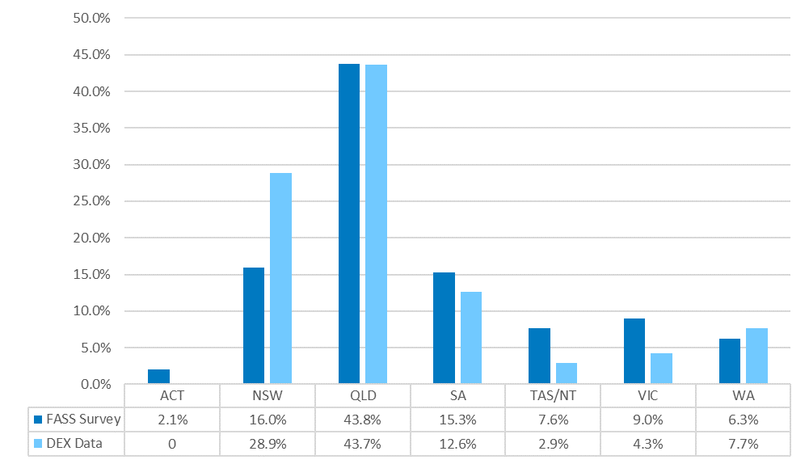

A comparison between those who indicated they had used FASS in the survey and DEX data on respondent/client sex revealed a close alignment of male and female respondents/clients (Figure E‑2)between the two sets of data*.* This suggests that the FASS survey was reasonably representative of the split between male and female users of FASS services.

Figure E‑2: Comparison between FASS survey and DEX data by sex

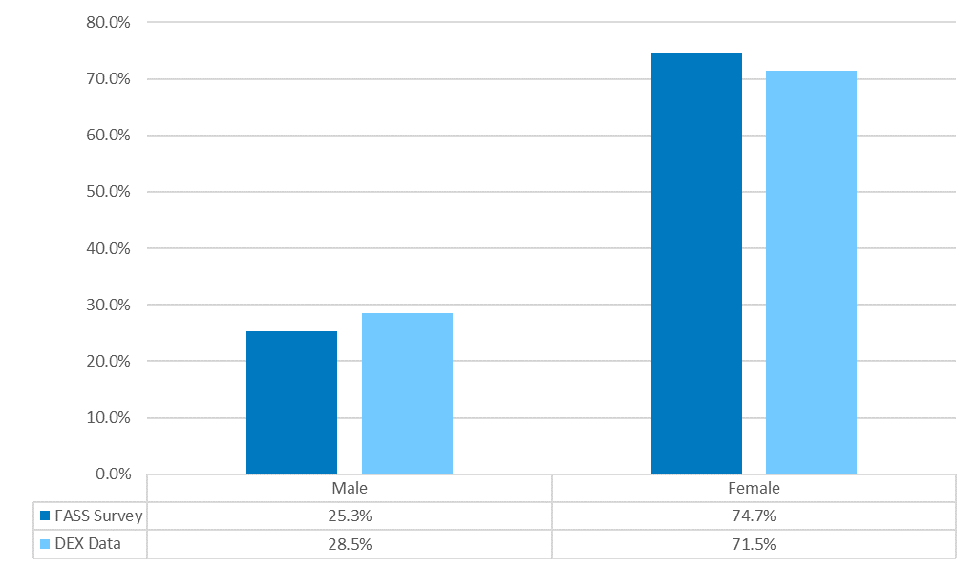

Perspectives of respondents who had used FASS

Usage of FASS varied widely by jurisdiction. The highest proportion of the 163 respondents who had used FASS accessed Jigsaw (38.7%), followed by 14.1% and 13.5% respectively in NSW and SA (Table E‑19). At least one respondent from each state or territory indicated they had used FASS. Additionally:

* The majority of respondents had first engaged with FASS in 2015 (49.1%), followed by 23.9% in 2016 and 12.9% in 2017
* Frequency of FASS usage was primarily intermittent (44.2%), followed by access on a monthly basis (14.1%)
* Weekly and fortnightly access to FASS were less common at 8.6% and 9.8% respectively
* Respondents primarily interacted with FASS via phone (46.0%) followed by face-to-face (27.6%).

Table E‑19: Which organisations do you/have you engaged with?

| Organisation | Adoptee | Mother | Other | Missing | Total |
| --- | --- | --- | --- | --- | --- |
| ACT – Relationships Australia | 2 (66.7%) | 1 (33.3%) | 0 | 0 | **3 (1.8%)** |
| NSW – Relationships Australia | 14 (60.9%) | 7 (30.4%) | 2 (8.7%) | 0 | **23 (14.1%)** |
| NT – Relationships Australia | 0 | 1 (100.0%) | 0 | 0 | **1 (0.6%)** |
| QLD – Jigsaw | 47 (73.4%) | 13 (20.6%) | 3 (4.8%) | 0 | **63 (38.7%)** |
| SA – Relationships Australia | 18 (81.8%) | 2 (9.1%) | 2 (9.1%) | 0 | **22 (13.5%)** |
| Tas – Relationships Australia (Past Adoption Support Service) | 7 (70.0%) | 3 (30.0%) | 0 | 0 | **10 (6.1%)** |
| VIC – Relationships Australia (Compass) | 9 (69.2%) | 4 (30.8%) | 0 | 0 | **13 (8.0%)** |
| WA – Relationships Australia (Lanterns House) | 2 (22.2%) | 7 (77.8%) | 0 | 0 | **9 (5.5%)** |
| Missing | 10 (52.6%) | 5 (26.3%) | 3 (15.8%) | 1 (5.3%) | **19 (11.7%)** |
| Total | 109 (66.9%) | 43 (26.4%) | 10 (6.1%) | 1 (0.6%) | 163 (100.0%) |

Table E‑20: Year of first engagement

| Year | Adoptee | Mother | Other | Missing | Total |
| --- | --- | --- | --- | --- | --- |
| 2015 | 51 (63.8%) | 26 (32.5%) | 3 (3.8%) | 0 | **80 (49.1%)** |
| 2016 | 24 (61.5%) | 11 (28.2%) | 4 (10.3%) | 0 | **39 (23.9%)** |
| 2017 | 18 (85.7%) | 2 (9.5%) | 1 (4.8%) | 0 | **21 (12.9%)** |
| Missing | 16 (69.6%) | 4 (17.4%) | 2 (8.7%) | 1 (4.3%) | **23 (14.1%)** |
| Total | 109 (66.9%) | 43 (26.4%) | 10 (6.1%) | 1 (0.6%) | 163 (100.0%) |

Table E‑21: Frequency of engagement

| Frequency | Adoptee | Mother | Other | Missing | Total |
| --- | --- | --- | --- | --- | --- |
| Once Only | 9 (75.0%) | 3 (25.0%) | 0 | 0 | **12 (7.4%)** |
| Weekly | 11 (78.6%) | 1 (7.1%) | 2 (14.3%) | 0 | **15 (8.6%)** |
| Fortnightly | 12 (75.0%) | 4 (25.0%) | 0 | 0 | **16 (9.8%)** |
| Monthly | 10 (43.5%) | 12 (52.2%) | 1 (4.3%) | 0 | **23 (14.1%)** |
| Intermittently | 51 (70.8%) | 16 (22.2%) | 5 (6.9%) | 0 | **72 (44.2%)** |
| Rarely | 6 (60.0%) | 3 (30.0%) | 1 (10.0%) | 0 | **10 (6.1%)** |
| Missing | 10 (62.5%) | 4 (25.0%) | 1 (6.3%) | 1 (6.3%) | **16 (9.8%)** |
| Total | 109 (66.9%) | 43 (26.4%) | 10 (6.1%) | 1 (0.6%) | 163 (100.0%) |

Table E‑22: Primary mode of connecting with FASS

| Mode | Adoptee | Mother | Other | Missing | Total |
| --- | --- | --- | --- | --- | --- |
| Phone | 50 (66.7%) | 20 (26.7%) | 5 (6.7%) | 0 | **75 (46.0%)** |
| Face-to-face | 28 (62.2%) | 16 (35.6%) | 1 (2.2%) | 0 | **46 (27.6%)** |
| Email | 20 (76.9%) | 3 (11.5%) | 3 (11.5%) | 0 | **26 (16.0%)** |
| Missing | 11 (64.7%) | 4 (23.5%) | 1 (5.9%) | 1 (5.9%) | **16 (10.4%)** |
| Total | 109 (66.9%) | 43 (26.4%) | 10 (6.1%) | 1 (0.6%) | 163 (100.0%) |

How FASS users found out about the service

Figure E‑3displays the various ways those who had used FASS found the service. A total of 139 survey respondents out of the 163 who had used FASS answered this question.

* Word of mouth was the most cited means of finding out about FASS (18.7%)
* Online media followed with 14.4%
* Respondents were least likely to find out about FASS by print media (0.7%) and the Forced Adoption History Website (1.4%).

Commonly cited ‘other’ sources of finding out about FASS included: State and National Government apologies for forced adoption practices, a national archives event and from the Department of Births, Deaths and Marriages.

Figure E‑3: Finding out about FASS (n = 139)

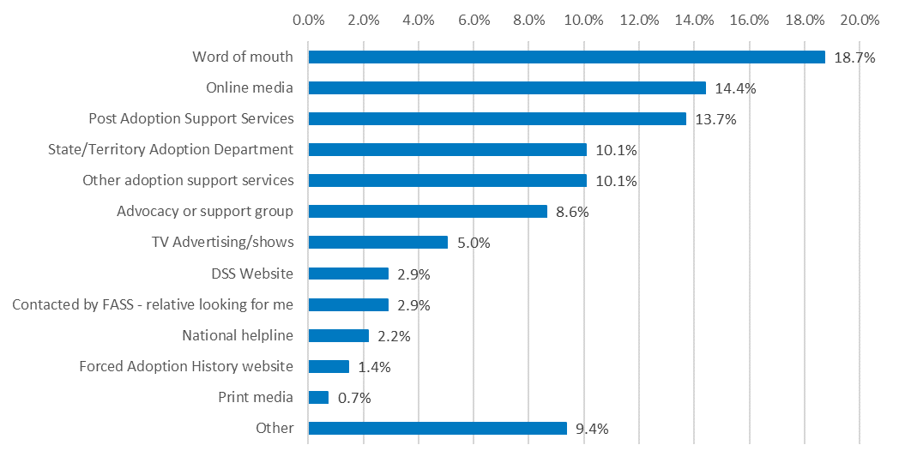

A total of 145 out of the 163 respondents who had indicated having used FASS (88.9%) listed their main reasons for first using FASS (Figure E‑4).

* Emotional support/counselling was cited as the main reason respondents used FASS (33.1%)
* This was followed by searching for family (17.2%) and assistance with contacting/connecting with family (10.3%) and searching for records (10.3%)
* Respondents were least likely to cite referral (1.4%), relationship support about contacting family (1.4%) and attending memorial services (0.7%) as the main reason for first using FASS.

Those who specified an ‘other’ reason for accessing FASS had varying responses including accessing information about funding, family contact mediation, and accessing a DNA workshop.

Figure E‑4: Main reason for first using the Forced Adoption Support Service (n = 145)

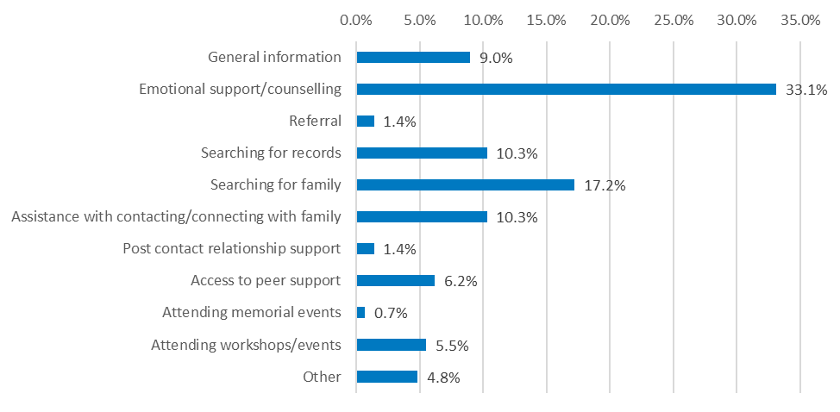

Total counts (respondents could select more than one item) detailing additional reasons for using FASS are displayed in Figure E‑5. Emotional support/counselling was again the most cited reason (59) for using FASS, followed closely by accessing general information (58). For the remaining items, there was an even spread across all services except for referrals and other.

Those indicating an ‘other’ response cited ‘DNA workshop’, ‘enquiring about birth certificate issued with my original birth name’ and attending the State Government apology.

Figure E‑5: Additional reasons for accessing Forced Adoption Support Service

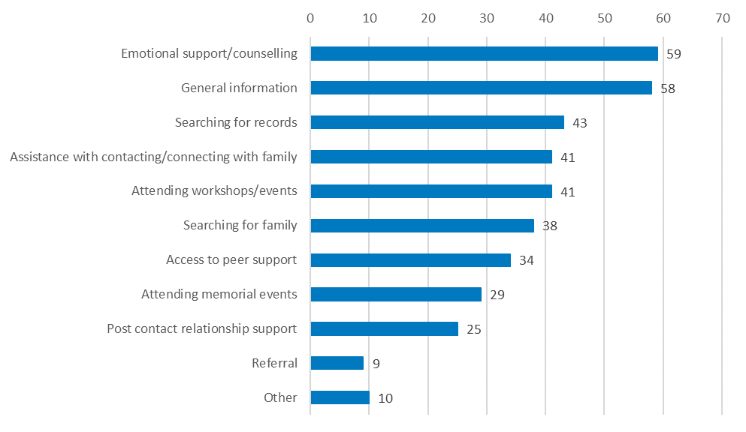

Experience of using FASS

This section details analysis on the experience of those who had used FASS (n = 163). Analysis has been conducted on this group’s experience overall, whilst sub-groups including those with a disability, those identifying as Culturally or Linguistically Diverse, those identifying as Aboriginal and Torres Strait Islander, sex, and the year in which the individual first accessed FASS have been compared on their levels of satisfaction with the service overall.

The cohort was split into groups based on FASS target subgroup category. This includes adoptees, mothers, and others (adoptive mothers, fathers, adoptive fathers, family members who had been separated from a child through forced adoption, adoptive family members and others).

In Table E‑23*,* overall satisfaction with FASS is displayed. Responses ranged from very dissatisfied to very satisfied.

* Overall satisfaction with FASS was largely positive (62.6%)
* When missing responses are removed, a total of 70.8% of those who had used FASS were satisfied or very satisfied
* More than 60% of mothers and adoptees were either satisfied or very satisfied with the service, while a Mann Whitney U test revealed that satisfaction levels between mothers and adoptees did not significantly differ
* There was a small cohort who were dissatisfied with their experience of FASS (15.3%).

Table E‑23: Overall satisfaction of FASS by FASS target group

| FASS target group | Dissatisfied/ Very Dissatisfied | Neutral | Satisfied/ Very Satisfied | Missing | Total |
| --- | --- | --- | --- | --- | --- |
| Adoptee | 14 (12.8%) | 13 (11.9%) | 69 (63.3%) | 13 (11.9%) | **109 (66.9%)** |
| Mother | 8 (18.6%) | 4 (9.3%) | 27 (62.8%) | 4 (9.3%) | **43 (26.4%)** |
| Other members | 3 (30.0%) | 0 | 6 (60.0%) | 1 (10.0%) | **10 (6.1%)** |
| Missing | 0 | 0 | 0 | 1 (100.0%) | **1 (0.6%)** |
| Total | 25 (15.3%) | 17 (10.4%) | 102 (62.6%) | 19 (11.7%) | 163 (100.0%) |

Respondents who indicated a positive experience were satisfied with the attentiveness, empathy and understanding of FASS staff. Importantly, respondents felt they had autonomy over the process of locating family whilst still being adequately supported throughout the process.

In contrast, respondents who reported dissatisfaction with their experience with FASS provided the following rationale for their response:

* Some respondents indicated that FASS administrative and counselling staff had treated them poorly, with little knowledge concerning forced adoption or regard for the respondents’ sensitivities
* Other respondents noted a feeling of wasting time by accessing FASS and had not received adequate follow-up from staff.

Satisfaction by FASS provider is displayed in Table E‑24.[36] Given the small number of respondents who had used FASS in several jurisdictions, interpretation of overall satisfaction for these services should be treated with caution.

* FASS organisations in WA and NSW had an even spread across satisfaction levels
* FASS organisations in SA, QLD and Tasmania all returned high levels of satisfaction with those respondents who had used FASS.

Table E‑24: Overall satisfaction of FASS by provider

| Jurisdiction | Very Dissatisfied/ Dissatisfied | Neutral | Very Satisfied/ Satisfied | Missing | Total |
| --- | --- | --- | --- | --- | --- |
| ACT | 1 (33.3%) | 1 (33.3%) | 1 (33.3%) | 0 | **3 (1.8%)** |
| NSW | 8 (34.8%) | 3 (13.0%) | 11 (47.8%) | 1 (4.4%) | **23 (14.1%)** |
| NT | 0 | 1 (100.0%) | 0 | 0 | **1 (0.6%)** |
| QLD | 3 (4.8%) | 5 (7.9%) | 55 (87.3%) | 0 | **63 (38.7%)** |
| SA | 3 (13.6%) | 1 (4.5%) | 17 (77.4%) | 1 (4.5%) | **22 (13.5%)** |
| Tas | 2 (20.0%) | 0 | 8 (80.0%) | 0 | **10 (6.1%)** |
| VIC | 3 (23.1%) | 6 (46.2%) | 4 (30.7%) | 0 | **13 (8.0%)** |
| WA | 4 (44.4%) | 0 | 4 (44.4%) | 1 (11.2%) | **9 (5.5%)** |
| Missing | 1 (5.3%) | 0 | 2 (10.5%) | 16 (84.2%) | **19 (11.7%)** |
| Total | 25 (15.3%) | 17 (10.4%) | 102 (62.6%) | 19 (11.7%) | 163 (100.0%) |

Several non-parametric tests were conducted to determine whether any significant differences existed between sub-groups of the survey regarding overall satisfaction of FASS. Significant differences were observed in overall satisfaction between:

* Members of the CALD community (Mdn = 3) and non-CALD respondents (Mdn = 5), *U* = 352, *p* < .01. Non-CALD respondents were more satisfied with the service.
* Aboriginal and Torres Strait Islander respondents (Mdn = 2.5) and non-Aboriginal and Torres Strait Islander respondents (Mdn = 5) regarding overall satisfaction, *U* = 232.5, *p* < .05. Non-Aboriginal and Torres Strait Islander respondents were more satisfied with the service.
* No significant differences were observed between those who were and those who were not living with a disability, nor by year of first using FASS.

Service gaps

Respondents were asked whether there were any services not provided by FASS that would benefit the FASS user (Table E‑25*).* A total of 40% of those who had used FASS felt there were gaps in services provided, the majority of whom were adoptees.

Respondents identified specialised counselling services and financial support/increased access to DNA testing as additional beneficial services. Respondents also cited a need for greater funding for the services to promote their activities to the general community.

Table E‑25: Additional services by FASS target group (n = 163)

| Could other services be provided? | Adoptee | Mother | Other | Missing | Total |
| --- | --- | --- | --- | --- | --- |
| Yes | 47 (71.2%) | 17 (25.8%) | 2 (3.0%) | 0 | **66 (40.5%)** |
| No | 47 (68.1%) | 15 (21.7%) | 7 (10.1%%) | 0 | **69 (42.3%)** |
| Missing | 15 (53.6%) | 11 (39.3%) | 1 (3.6%%) | 1 (3.6%) | **28 (17.2%)** |
| Total | 109 (66.9%) | 43 (26.4%) | 10 (6.1%%) | 10 (0.6%) | 163 (100.0%) |

Referral and assistance with access to other support services external to FASS were assessed for this cohort. The majority of respondents were not referred to external services (69.9%), and this was the case across all three FASS target subgroups (Table E‑26*).*

Table E‑26: Referral to external services by FASS target group (n = 163)

|  |  |  |  |  |  |
| --- | --- | --- | --- | --- | --- |
| Referral to external services | Adoptee | Mother | Other | Missing | Total |
| Yes | 22 (66.7%) | 9 (27.3%) | 2(6.1%) | 0 | **33 (20.2%)** |
| No | 77 (67.5%) | 30 (26.3%) | 7 (6.1%%) | 0 | **114 (69.9%)** |
| Missing | 10 (62.5%) | 4 (25.0%) | 1 (6.3%%) | 1 (6.3%) | **16 (9.8%)** |
| Total | 109 (66.9%) | 43 (26.4%) | 10 (6.1%%) | 1 (0.6%) | 163 (100.0%) |

A total of 33 respondents (20.2%) were referred on to an external service. Of these, 16 (48.5%) were assisted with making an appointment with the external service, 15 were not, and 2 had missing responses (Table E‑27).

Table E‑27: Assistance with and access to external referral by FASS target group

|  |  |  |  |  |
| --- | --- | --- | --- | --- |
| Assistance with referral | Adoptee | Mother | Other | Total |
| Yes | 12 (75.0%) | 4 (25.0%) | 0 | **16 (48.5%)** |
| No | 8 (53.3%) | 5 (33.3%) | 2 (13.3%) | **15(45.5%)** |
| Missing | 2 (100.0%) | 0 | 0 | **2 (6.1%)** |
| Total | 22 (66.7%) | 9 (27.3%) | 2 (6.1%) | 33 (100.0%) |

Of the 33 respondents who had been referred to external services, the majority (63.6%) had accessed that external service (Table E‑28).

Table E‑28: Number and proportion of respondents accessing external services

|  |  |  |  |  |
| --- | --- | --- | --- | --- |
| External service access | **Adoptee** | **Mother** | **Other** | **Total** |
| Yes | 13 (61.9%) | 6 (28.6%) | 2 (9.5%) | **21 (63.6%)** |
| No | 7 (70.0%) | 3 (30.0%) | 0 | **10 (30.3%)** |
| Missing | 2 (100.0%) | 0 | 0 | **2 (6.1%)** |
| Total | 22 (66.7%) | 9 (27.3%) | 2 (6.1%) | 33 (100.0%) |

Respondents were referred on to a variety of external services which included mental health organisations and services, a number of state-based Post Adoption support services, individual and couples counselling and highly specialised counselling services (e.g. Blue Knot, a sexual abuse service).

Respondents who had not used FASS

Almost half of the sample (160, 47.3%) indicated that they had not used FASS. It should be noted that during PIR consultations, it became clear that some respondents may have experienced confusion between auspice organisation names and the term FASS. For example, a respondent may identify the service through its auspice organisation name (Relationships Australia) rather than the FASS. Furthermore, in two states, the FASS service within the auspice organisation had an additional name (i.e. Lanterns House, SA; Compass, VIC). Qualitative responses by some respondents indicated this confusion, evidenced by the following response:

*“Are they connected to Jigsaw [WA]? You tell me why FASS is a better option than Jigsaw? Who are FASS? What is their experience with forced adoptions? Why have I never heard of them before now?”* (Mother, survey respondent, non-user of FASS).

Findings and conclusions from the following data should therefore, be treated with caution.

Reasons for not using FASS

Total counts (respondents could select more than one item) of reasons for not using FASS are displayed in Figure E‑6*.* In rank order, the following reasons dominated:

* 87 respondents indicated that they had not heard about FASS until they had started this survey
* 33 respondents indicated that they had accessed other support services
* 19 respondents felt they did not need the support provided by FASS.

Those who responded with ‘other’ did not detail why they had not accessed FASS.

Figure E‑6: Reasons for not having used FASS

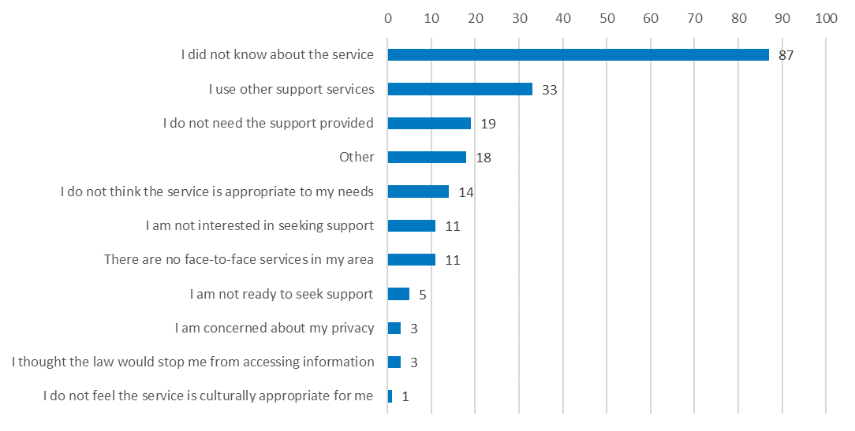

Those who had not accessed FASS (n = 160) were asked whether they would consider accessing FASS now that they were aware of the service (Table E‑29*).*

* 13.1% indicated they would access FASS now that they were aware of the service
* Half of the respondents indicated they might access FASS (50.0%)
* Mothers had the highest proportion of respondents who would not access FASS (41.5%), however this difference was not statistically significant.

Reasons given as to why this subgroup would not access FASS included a distrust of services that had not been operating for as long as other providers and respondents were already successfully receiving support from another organisation.

Specific qualitative responses from mothers included:

*“I prefer to access a service that has 30+ years of experience”*

*“Prefer talking to people that know what they are talking about. Jigsaw has been doing this for 30 years or more.”*

Table E‑29: Willingness to use FASS now that respondent is aware

|  |  |  |  |  |  |
| --- | --- | --- | --- | --- | --- |
| Respondent | Yes | No | Maybe | Missing | Total |
| Adoptee | 16 (17.4%) | 24 (26.1%) | 49 (53.3%) | 3 (3.3%) | **92 (57.5%)** |
| Mother | 5 (9.4%) | 22 (41.5%) | 22 (41.5%) | 4 (7.5%) | **53 (33.1%)** |
| Other | 0 | 3 (25.0%) | 8 (66.7%) | 1 (8.3%) | **12 (7.5%)** |
| Missing | 0 | 0 | 1 (33.3%) | 2 (66.7%) | **3 (1.9%)** |
| Total | 21 (13.1%) | 49 (30.6%) | 80 (50.0%) | 10 (6.3%) | 160 (100.0%) |

General questions

Survey questions within this section were relate to all 338 survey participants.

External supports

Just over half of all respondents (55.3%) indicated they had external supports outside of FASS *(Table E‑30)*. Adoptees reported having more external supports than mothers (57.8% vs 33.7% respectively. However, no statistically significant differences were observed between mothers, adoptees, and others.

These supports consisted primarily of family and friends, or a mental health practitioner. In each FASS target group category, the number of respondents with external supports outnumbered those who did not have external support. Despite this finding, over a third of all respondents indicated that they did not have any external supports, highlighting a potentially unmet need in the group.

Table E‑30: Existence of external supports by FASS target group

| External supports? | Adoptee | Mother | Other | Missing | Total |
| --- | --- | --- | --- | --- | --- |
| Yes | 108 (57.8%) | 63 (33.7%) | 15 (8.0%) | 1 (0.5%) | **187 (55.3%)** |
| No | 78 (68.4%) | 29 (25.4%) | 6 (5.3%) | 1 (0.9%) | **114 (33.7%)** |
| Missing | 19 (51.4%) | 10 (27.0%) | 2 (5.4%) | 6 (16.2%) | **67 (10.9%)** |
| Total | 205 (60.7%) | 102 (30.2%) | 23 (6.8%) | 8 (2.4%) | 338 (100.0%) |

A similar proportion of respondents who had and had not used FASS indicated the presence of external supports (Table E‑31*).* A greater number of those who had not used FASS indicated having no external supports when compared with those who had used FASS, though the difference was not statistically significant.

Table E‑31: Existence of external supports by FASS usage

|  |  |  |  |  |  |
| --- | --- | --- | --- | --- | --- |
| External supports? | Have accessed | Have not accessed | Don’t know | Missing | Total |
| Yes | 93 (49.7%) | 88 (47.1%) | 6 (3.2%) | 0 | **187 (55.3%)** |
| No | 48 (42.1%) | 62 (54.4%) | 4 (3.5%) | 0 | **114 (33.7%)** |
| Missing | 22 (59.5%) | 10 (27.0%) | 0 | 5 (13.5%) | **37 (10.9%)** |
| Total | 163 (48.2%) | 160 (47.3%) | 10 (3.0%) | 5 (1.5%) | 338 (100.0%) |

Access to National Archives website

The majority of the online survey sample (n = 196, 58.0%) had not accessed the National Archives of Australia Forced Adoption website (Table E‑32*).* A chi-square test revealed that female respondents were proportionately more likely to have accessed the National Archives of Australia Forced Adoption website when compared with males, χ2 (1, *N* = 305) = 7.84, *p* < .01, a difference that was statistically significant. There were no significant differences in National Archives of Australia Forced Adoption website access for other sociodemographic variables.

Table E‑32: National Archives of Australia Forced Adoption website viewing by FASS target group

| Viewed Forced Adoption website? | Adoptee | Mother | Other | Missing | Total |
| --- | --- | --- | --- | --- | --- |
| Yes | 69 (62.7%) | 34 (30.9%) | 5 (4.5%) | 2 (1.8%) | **110 (32.5%)** |
| No | 120 (61.2%) | 59 (30.1%) | 16 (8.2%) | 1 (0.5%) | **196 (58.0%)** |
| Missing | 16 (50.0%) | 9 (28.1%) | 2 (6.3%) | 5 (15.6%%) | **32 (9.5%)** |
| Total | 205 (60.7%) | 102 (30.2%) | 23 (6.8%) | 8 (2.4%%) | 338 (100.0%) |

The majority of those who had viewed the National Archives of Australia Forced Adoption website had also used FASS (60.0%) (Table E‑33).

Table E‑33: National Archives of Australia Forced Adoption website viewing by FASS usage

| Viewed Forced Adoption website? | Have accessed | Have not accessed | Don’t know | Missing | Total |
| --- | --- | --- | --- | --- | --- |
| Yes | 66 (60.0%) | 40 (36.4%) | 4 (3.6%) | 0 | **110 (32.5%)** |
| No | 79 (40.3%) | 111 (56.6%) | 6 (3.1%) | 0 | **196 (58.0%)** |
| Missing | 18 (56.3%) | 9 (28.1%) | 0 | 5 (15.6%) | **32 (9.5%)** |
| Total | 163 (48.2%) | 160 (47.3%) | 10 (3.0%) | 5 (1.5%) | 338 (100.0%) |

For the 110 respondents who had accessed the National Archives of Australia Forced Adoption website (Figure E‑7), the two main reasons for doing so was to:

* Read about others, or contribute their own experiences of forced adoption (n = 91)
* Learn about the impact on adopted persons, mothers, fathers, and families (n = 69).

Figure E‑7: Viewed features of the National Archives of Australia Forced Adoption website

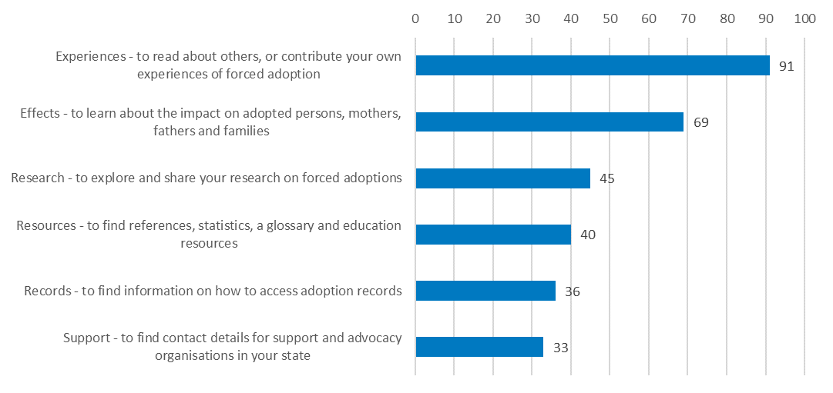

The majority of those who had accessed the National Archives of Australia Forced Adoption website found it helpful to some degree (86.9%, Table E‑34), with 38.2% rating it either very or extremely helpful. There were no statistically significant differences between adoptees and mothers, however mothers had a greater proportion of respondents finding the website to be very helpful.

Table E‑34: Helpfulness of the National Archives of Australia Forced Adoption website

| Respondent | Not at all helpful | Slightly helpful | Somewhat helpful | Very helpful | Extremely helpful | Missing | Total |
| --- | --- | --- | --- | --- | --- | --- | --- |
| Adoptee | 6 (8.7%) | 6 (8.7%) | 31 (44.9%) | 15 (21.7%) | 8 (11.6%) | 3 (4.3%) | **69 (62.7%)** |
| Mother | 1 (2.9%) | 7 (20.6%) | 10 (29.4%) | 11 (32.4%) | 3 (8.8%) | 2 (5.9%) | **34 (30.9%)** |
| Other | 0 | 0 | 1 (20.0%) | 2 (40.0%) | 2 (40.0%) | 0 | **5 (100.0%)** |
| Missing | 1 (50.0%) | 0 | 0 | 1 (50.0%) | 0 | 0 | **2 (100.0%)** |
| Total | 8 (7.3%) | 13 (11.8%) | 42 (38.2%) | 29 (26.4%) | 13 (11.8%) | 5 (4.5%) | 110 (100.0%) |

Exhibition awareness

Respondents’ awareness of the ‘Without Consent: Australia’s past adoption practices’ exhibition by FASS target group category is shown in Table E‑35 and FASS usage status is shown in Table E‑36.

While 40.2% of the sample were aware of the exhibition, almost half (48.8%) had not.

A greater proportion of mothers knew about the exhibition when compared with adoptees, a difference that was statistically significant, χ2 (2) = 11.38, *p* < .01.

Table E‑35: Awareness of *‘Without Consent’* exhibition by FASS target group

| Exhibition awareness | Adoptee | Mother | Other | Missing | Total |
| --- | --- | --- | --- | --- | --- |
| Yes | 72 (52.9%) | 54 (39.7%) | 9 (6.6%) | 1 (0.7%) | **136 (40.2%)** |
| No | 115 (69.7%) | 36 (21.8%) | 12 (7.3%) | 2 (1.2%) | **165 (48.8%)** |
| Missing | 18 (48.6%) | 12 (32.4%) | 2 (5.4%) | 5 (13.5%) | **37 (10.9%)** |
| Total | 205 (60.7%) | 102 (30.2%) | 23 (6.8%) | 8 (2.4%) | 338 (100.0%) |

Those who had used FASS were proportionately more likely to have heard of the ‘Without Consent: Australia’s past adoption practices’ exhibition (χ2 (2) = 7.60, p < 0.05) than those who had not *(Table E‑36).*

Table E‑36: Awareness of *‘Without Consent’* exhibition by FASS usage

| Exhibition awareness | Have used FASS | Have not used FASS | Don’t know | Missing | Total |
| --- | --- | --- | --- | --- | --- |
| Yes | 76 (55.9%) | 55 (40.4%) | 5 (3.7%) | 0 | **136 (40.2%)** |
| No | 67 (40.6%) | 93 (56.4%) | 5 (3.0%) | 0 | **165 (48.8%)** |
| Missing | 20 (54.1%) | 12 (32.4%) | 0 | 5 (13.5%) | **37 (10.9%)** |
| Total | 163 (48.2%) | 160 (47.3%) | 10 (3.0%) | 5 (1.5%) | 338 (100.0%) |

Of the 41 respondents who attended the ‘Without Consent: Australia's past adoption practices’ exhibition (Table E‑37 and Table E‑38):

* 58.5% felt the exhibition was either very meaningful or extremely meaningful
* Mothers had a greater proportion of those who found the exhibition meaningful (85.6%) when compared with adoptees (70.5%), though this difference was not statistically significant
* Only two respondents (4.9%) felt the exhibition was not meaningful at all (one respondent each from mothers and adoptees, both of whom had used FASS)
* Those who had used FASS had two respondents who felt the exhibition was not meaningful to them at all (7.7%).

Table E‑37: Meaningfulness of the *‘Without Consent’* exhibition by FASS target group

| Respondent circumstance | Not at all meaningful | Slightly meaningful | Somewhat meaningful | Very meaningful | Extremely meaningful | Missing | Total |
| --- | --- | --- | --- | --- | --- | --- | --- |
| Adoptee | 1 (5.9%) | 4 (23.5%) | 1 (5.9%) | 4 (23.5%) | 3 (17.6%) | 4 (23.5%) | **17 (41.5%)** |
| Mother | 1 (4.8%) | 0 | 4 (19.0%) | 7 (33.3%) | 7 (33.3%) | 2 (9.5%) | **21 (51.2%)** |
| Other | 0 | 0 | 0 | 2 (66.7%) | 1 (33.3%) | 0 | **3 (7.3%)** |
| Total | 2 (4.9%) | 4 (9.8%) | 5 (12.2%) | 13 (31.7%) | 11 (26.8%) | 6 (14.6%) | 41 (100.0%) |

Table E‑38: Meaningfulness of the *‘Without Consent’* exhibition by FASS usage

| FASS usage status | Not at all meaningful | Slightly meaningful | Somewhat meaningful | Very meaningful | Extremely meaningful | Missing | Total |
| --- | --- | --- | --- | --- | --- | --- | --- |
| Had used FASS | 2 (7.7%) | 2 (7.7%) | 5 (19.2%) | 8 (30.8%) | 6 (23.1%) | 3 (11.5%) | **26 (63.4%)** |
| Had not used FASS | 0 | 1 (7.7%) | 0 | 4 (30.8%) | 5 (38.5%) | 3 (23.1%) | **13 (31.7%)** |
| Don’t know | 0 | 1 (50.0%) | 0 | 1 (50.0%) | 0 | 0 | **2 (4.9%)** |
| Total | 2 (4.9%) | 4 (9.8%) | 5 (12.2%) | 13 (31.7%) | 11 (26.8%) | 6 (14.6%) | 41 (100.0%) |

Analysis of DEX data

DEX Data

DEX is an online performance reporting tool which captures data from Department of Social Services organisations across Australia. Services can submit performance and service usage information to DEX and subsequently access self-service reports on service provision. As part of the current project FASS organisations provided aggregate client and service data by several variables including reporting period (e.g. January to June 2016), reporting year, age group, sex. Tasmania and Northern Territory were provided as a combined group due to low numbers of clients.

InFigure F‑1*,* total clients by state and reporting period are displayed. As illustrated, Qld consistently have reported the highest number of clients during each reporting period except for the initial period in January to June 2015, whereby NSW had reported the greatest numbers of clients. The remaining states began reporting in the July to December reporting period, and unlike NSW or Qld have remained relatively flat over time regarding client numbers. In the most recent reporting period of January to June 2017 Victoria had similar client levels as Tas and NT combined.

In Figure F‑2, total sessions by state over time are displayed. It should be noted that total client numbers will not match those reported in the state-based figures above due to records being withheld if there were less than five individual clients in a sex or age category. The figure tracks in a similar fashion to total number of clients, with Qld and NSW having the greatest number of sessions, steadily increasing over the time. The remaining states are relatively flat over time with respect to their total sessions. In the latest reporting period of January to June 2017, Qld had reported over double the total session count of the next highest session count from NSW.

Figure F‑3displays total clients by sex over the five reporting periods. In each reporting period females have had more than double the amount of access to FASS organisations. Male access to FASS peaked at 120 in the reporting period of January to June 2016 whereas female access continues to increase, with the highest number of female clients reported in the January to June 2017 reporting period. Most clients were aged 45-59 years (n = 592) and 60-74 years (n = 441) (Figure F‑4*).* As expected, younger age groups had less representation in the DEX service reports. Those aged 45-59 years have continued to increase, with the reporting period of January to June 2017 seeing the highest number of clients for this age group (n = 187).

Figure F‑5 displays location of FASS clients across reporting periods.

* In each reporting period, most FASS clients lived in major cities
* Inner regional clients increased dramatically between the July-December 2015 and January to June 2016 reporting periods
* Outer regional and remote/very remote clients represent a small proportion of service provision

It should be noted that due to the presence of less than five clients in outer regional and remote/very remote areas in 2015, data has not been reported for these localities

Figure F‑1: Total clients by state and reporting period

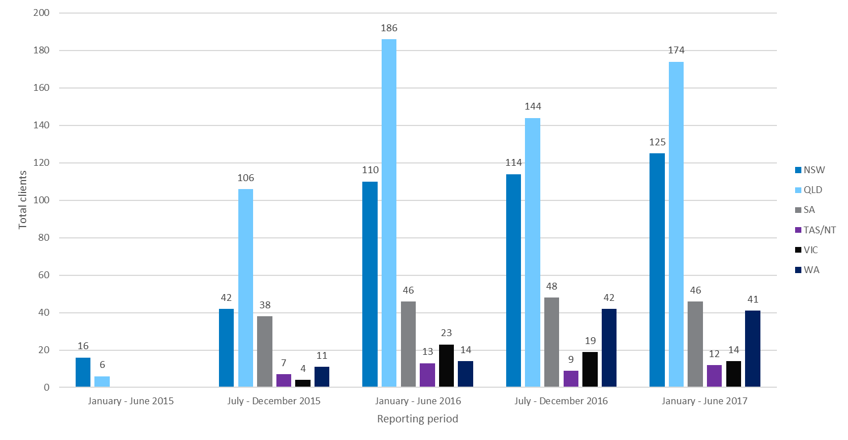

Figure F‑2: Total sessions by state and reporting period

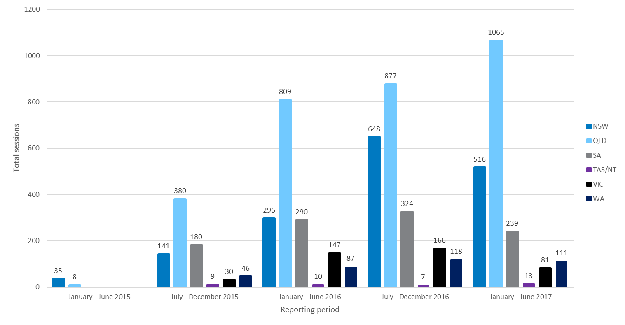

Figure F‑3: Total clients by sex and reporting period

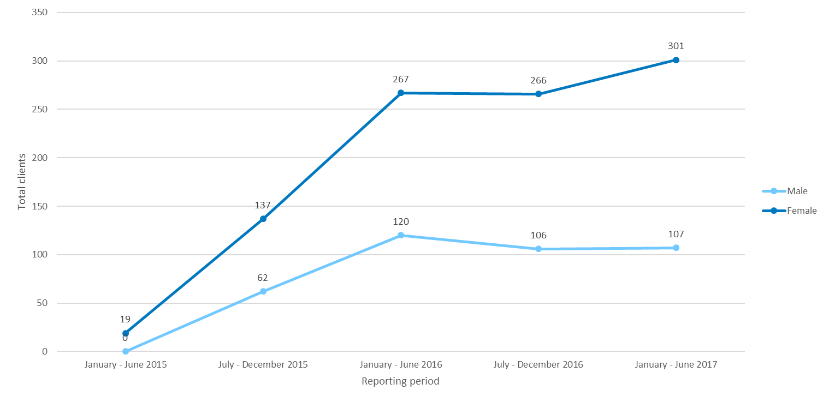

Figure F‑4: Total clients by age group and reporting period

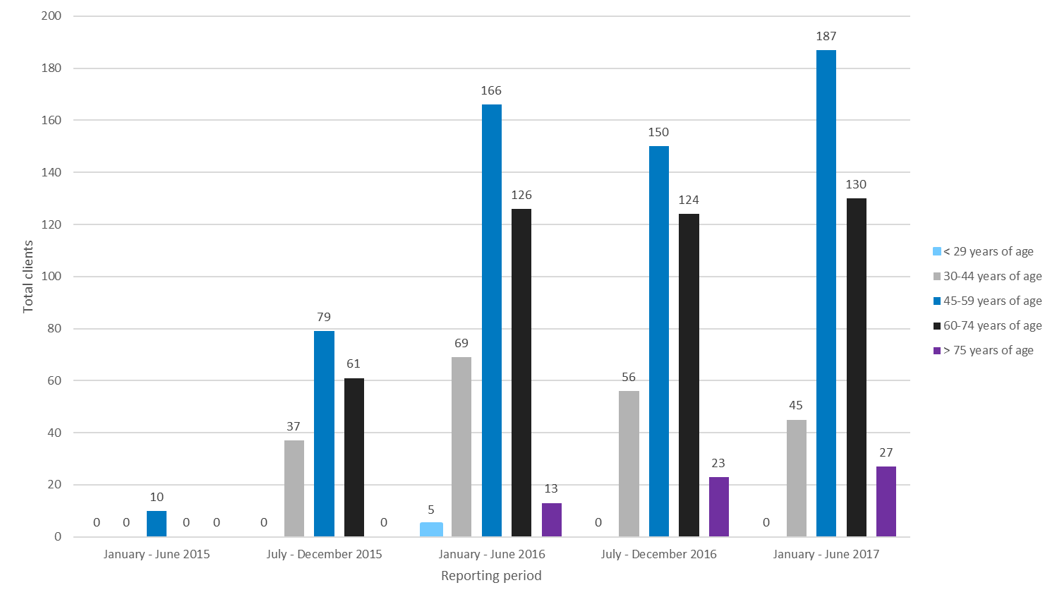

Figure F‑5: Total clients by locality and reporting period

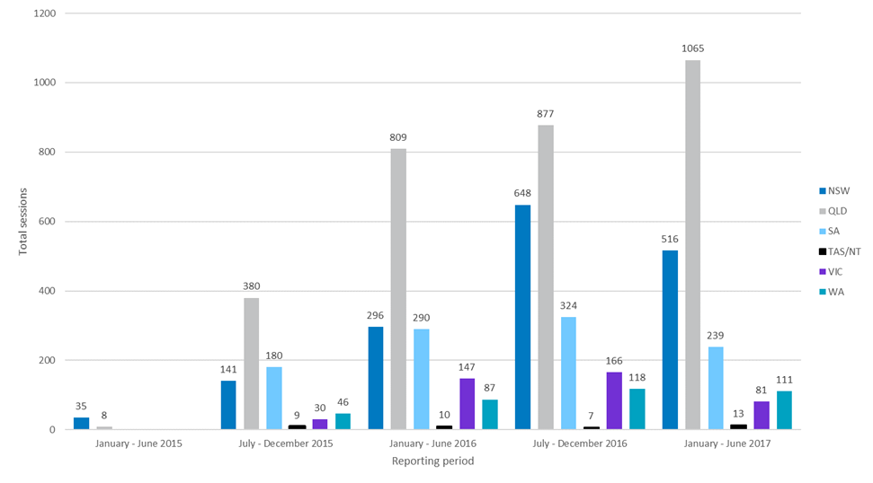

In Figure F‑6, the type of service provision is displayed by each state. There are clear differences in the types of services provided by each state FASS organisation. Services in QLD and NSW consist of less advocacy and support provision when compared with other states, whilst information, advice and referral for these states are more prominent when compared to the other states (with the exception of Tasmania/NT). Only two states provided outreach services and community capacity building provision, Qld and SA. Other more sparsely populated states with rural and remote populations such as NSW and WA did not report providing any outreach services to clients.

Figure F‑7 displays the proportion of service types by reporting year. The proportion of service types has remained relatively steady across the three reporting years of the FASS program. Key changes over time relate to provision of outreach services, whereby services increased dramatically in the second reporting year but became almost non-existent in 2017. Intake and assessment as a proportion of all services provided has decreased over the reporting period, as have counselling services. Finally, *Table F‑1* displays client and session count by state, and Table F‑2 shows the client to session ratio data. Victoria had the highest ratio with 7.1 sessions per client on average.

Figure F‑6: Type of service provision by state

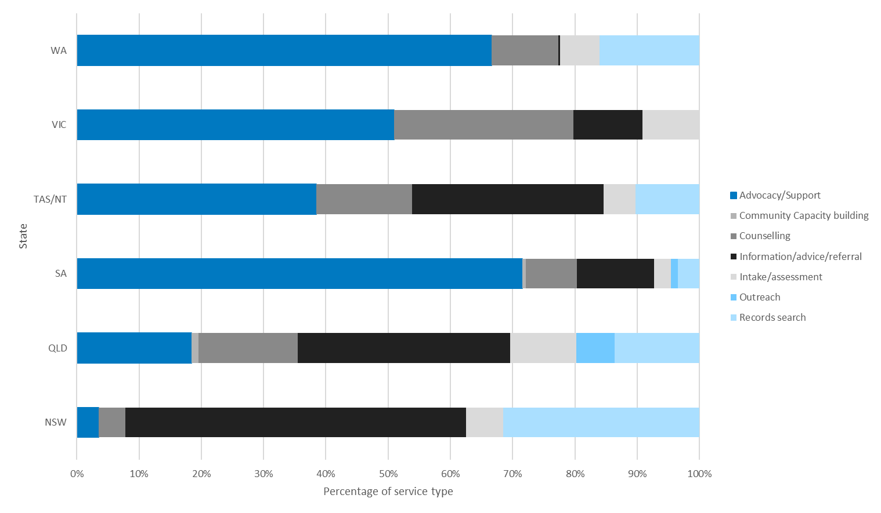

Figure F‑7: Type of service provision by reporting year

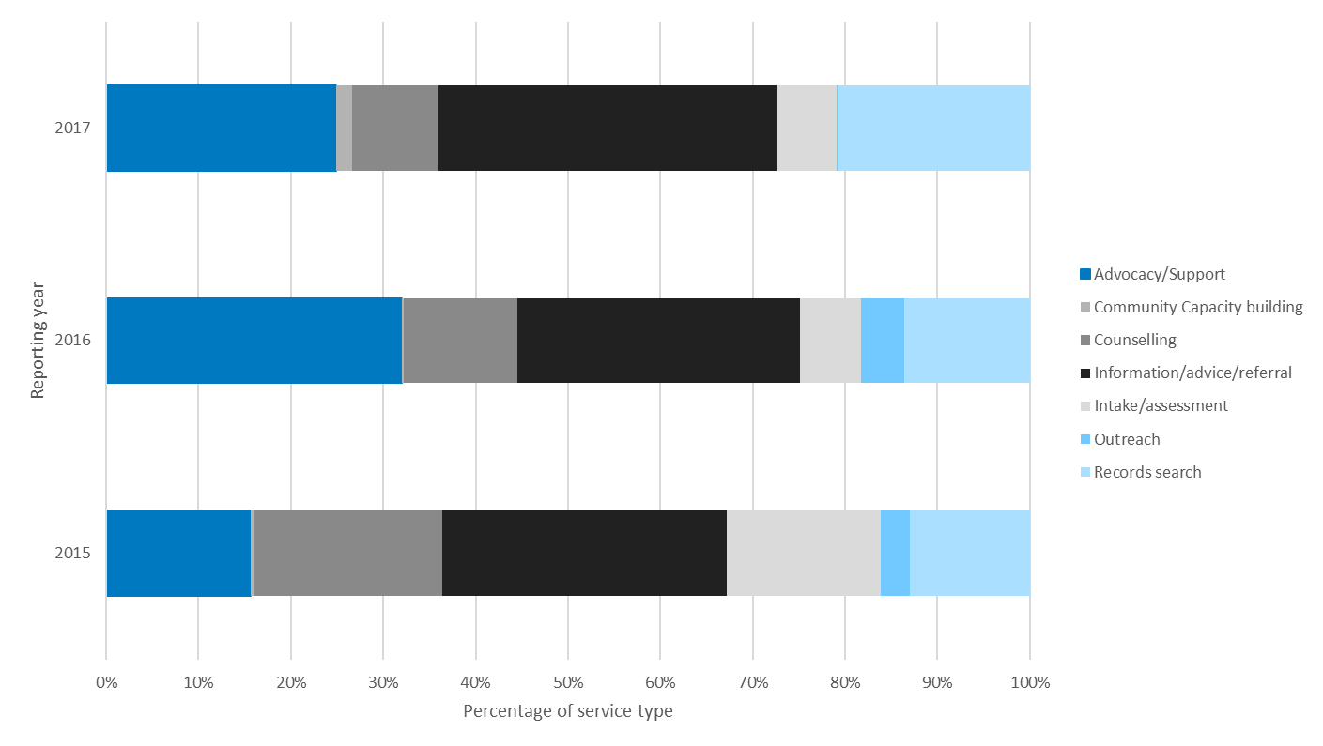

Table F‑1: Clients and sessions by state and reporting period

|  |  |  |  |  |  |  |
| --- | --- | --- | --- | --- | --- | --- |
| State | Jan-Jun 2015 | Jul-Dec 2015 | Jan-Jun 2016 | Jul-Dec 2016 | Jan-Jun 2017 | Total |
| NSW | 16 (35) | 42 (141) | 110 (296) | 114 (648) | 125 (516) | **407 (1,636)** |
| QLD | 6 (8) | 106 (380) | 186 (809) | 144 (877) | 174 (1,065) | **616 (3,139)** |
| SA | 0 | 38 (180) | 46 (290) | 48 (324) | 46 (239) | **178 (1,033)** |
| Tas/NT | 0 | 7 (9) | 13 (10) | 9 (7) | 12 (13) | **41 (39)** |
| VIC | 0 | 4 (30) | 23 (147) | 19 (166) | 14 (81) | **60 (424)** |
| WA | 0 | 11 (46) | 14 (87) | 42 (118) | 41 (111) | **108 (362)** |
| Total | 22 (43) | 208 (786) | 392 (1639) | 376 (2140) | 412 (2025) | 1,410 (6,633) |

Table F‑2: Sessions per client by state and reporting period

|  |  |  |  |  |  |  |
| --- | --- | --- | --- | --- | --- | --- |
| State | Jan-Jun 2015 | Jul-Dec 2015 | Jan-Jun 2016 | Jul-Dec 2016 | Jan-Jun 2017 | Total |
| NSW | 2.2 | 3.4 | 2.7 | 5.7 | 4.1 | **4.0** |
| QLD | 1.3 | 3.6 | 4.3 | 6.1 | 6.1 | **5.1** |
| SA | 0 | 4.7 | 6.3 | 6.8 | 5.2 | **5.8** |
| Tas/NT | 0 | 1.3 | 0.8 | 0.8 | 1.1 | **1.0** |
| VIC | 0 | 7.5 | 6.4 | 8.7 | 5.8 | **7.1** |
| WA | 0 | 4.2 | 6.2 | 2.8 | 2.7 | **3.4** |
| Total | 2.0 | 3.8 | 4.2 | 5.7 | 4.9 | 4.7 |

Summary of stakeholder engagement

Summary of stakeholder engagement

Advocacy groups

AHA spoke with the following advocacy groups:

* Origins, NSW
* Origins, QLD
* ARMS, Vic
* Independent Regional Mothers Group, Vic
* Origins, Vic
* Post Adoption Resource Centre (PARC) - Benevolent Society
* VANISH, Vic
* Adoption Jigsaw, WA
* Adoption Research and Counselling Service, WA
* ARMS, WA.
* NT Adoption Unit, Operational Support, Territory Families
* Adoption Information Unit, Family and Community Services NSW

GAMs

AHA consulted with all GAMs, except for Tasmania, where there had been a recent change in staff and an appropriate alternative representative could not be contacted.

State/territory adoption departments

AHA spoke with the following state/territory adoption departments:

* Adoption Services, Qld Government
* Department for Child Protection, SA
* Adoptions Information Service, Department of Health and Human Services, Tasmania
* Family Information Networks and Discovery (FIND), Department of Human Services, Vic
* Fostering and Adoption Services, Department for Child Protection and Family Support, WA.

Experts/Academics

AHA spoke with the following experts/academics:

* Professor Shurlee Swain
* Dr Patricia Fronek
* Professor Daryl Higgins
* Professor Denise Cuthbert.

Other stakeholders

* Representatives from the National Archives of Australia
* Australian Psychological Society

Focus groups and in-depth interviews

In addition to the online survey (some of which were conducted over the phone), AHA also spoke to FASS users and those who had not accessed FASS through in-depth telephone interviews and focus groups during site visits.

Survey respondents who were interested in providing more detail around their experience with the FASS could opt into participating in in-depth telephone interviews. Some of these in-depth interviews occurred when people phoned in to do the survey and provided further detail at the time of the call.

Focus groups were organised by a number of the FASS providers. Unfortunately, in some jurisdictions the timeframes for scheduling these were insufficient, due to the timing of ethical approval being granted for the project.

The following table outlines the numbers by state of people who participated in focus groups, in-depth interviews, and the survey.

Table G‑1: Focus groups, in-depth interviews and survey respondents by jurisdiction

| Jurisdiction | Focus group participants | In-depth telephone interviews | Survey respondents |
| --- | --- | --- | --- |
| ACT | 0 | 0 | 6 |
| NSW | 7 | 3 | 50 |
| NT | 0 | 0 | 2 |
| QLD | 0 | 7 | 117 |
| SA | 0 | 1 | 30 |
| Tas | 7 | 1 | 14 |
| VIC | 0 | 1 | 71 |
| WA | 3 | 2 | 42 |
| Outside Australia | 0 | 0 | 3 |
| Not stated | 0 | 5 | 3 |
| Total | 17 | 20 | 338 |

Cited references

Australian Government Department of Social Services 2014, *A Partnership Approach to Reporting Outcomes*.

Australian Government Department of Social Services 2017, Document 2 Forced Adoption Support Services - Draft Operational Guidelines.

Australian Institute of Health and Welfare 2011, *Adoptions Australia 2010–11. Child Welfare Series No. 52. Cat. No. CWS 40.*

Department of Social Services 2014a, Forced Adoption Support Services Operational Guidelines.

Department of Social Services 2014b, *The DSS Data Exchange Framework*.

Department of Social Services 2017, Program Activity Guidance for the Data Exchange All Programs.

Fronek, P & Cuthbert, D 2012, An Apology to Forced Adoption Birth Mothers: It’s about Time, *The Conversation*.

Hassan, E 2005, Recall Bias Can Be a Threat to Retrospective and Prospective Research Designs, *The Internet Journal of Epidemiology*, vol. 3, no. 2.

Higgins, D, Kenny, P, & Morley, S 2016, *Forced Adoption National Practice Principles Guidelines and Principles for Specialist Services*.

Higgins, D, Kenny, P, Sweid, R, & Ockenden, L 2014, *Forced Adoption Support Services Scoping Study*, Canberra.

Parliament of Australia 2013a, National Apology for Forced Adoptions, viewed 30 May 2017, <https://www.ag.gov.au/About/ForcedAdoptionsApology/Documents/Nationalapologyforforcedadoptions.PDF>.

Parliament of Australia 2013b, *Australian Government Response to the Senate Community Affairs References Committee Report: Commonwealth Contribution to Former Forced Adoption Policies and Practices*.

Senate Community Affairs Reference Committee 2012, Commonwealth Contribution to Former Forced Adoption Policies and Practices.

Vogel, DL, Heimerdinger-Edwards, SR, Hammer, JH, & Hubbard, A 2011, ‘Boys Don’t Cry’: Examination of the Links between Endorsement of Masculine Norms, Self-Stigma, and Help-Seeking Attitudes for Men from Diverse Backgrounds, *Journal of Counseling Psychology*, vol. 58, no. 3, pp. 368–382.

Wall, L, Higgins, D, & Hunter, C 2016, Trauma-Informed Care in Child/family Welfare Services, *Child Family Community Australia*, , no. 37, pp. 1–19.

1. As defined in the National Practice Principles (*Appendix B*)
2. As defined in the National Practice Principles (*Appendix B*)
3. As defined in the National Practice Principles (*Appendix B*)
4. Jigsaw WA is a not-for-profit organisation that provides counselling and support services, search and mediation services, and a support group for birth mothers.
5. VANISH is located in Melbourne with members in all parts of Australia and is funded by the Victorian State Government through the Department of Health and Human Services. Its services are available to, among others, people affected by adoption (domestic and intercountry) - mothers, fathers, adopted persons, adoptive parents and family members of all these people. Services are free if the adoption and/or ‘out of home care’ took place in Victoria, and to persons from interstate and overseas for a small fee. Costs associated with obtaining relevant certificates, files and records are fee based.
6. Find and Connect Support Services provide specialist trauma informed counselling; referral services; peer, education, and social support programs; assistance to locate and access records and reconnect with family members (where possible) for Forgotten Australians and Former Child Migrants. The Department funds these national services.
7. [Relationships Australia website](http://www.relationships.org.au/)
8. [DSS Forced Adoption Practices website](https://www.dss.gov.au/our-responsibilities/families-and-children/programs-services/forced-adoption-practices)
9. SCORE enables four different type of client and community outcomes to be measured and can be used to demonstrate what has been achieved.
10. Under the WA Adoption Act 1994 - Sect 105, contacting a party to an adoption in relation to the adoption or negotiating such contact must be undertaken by a contact and mediation licensee.
11. [Relationships Australia website](http://www.relationships.org.au/)
12. As defined in the National Practice Principles (*Appendix B*)
13. As defined in the National Practice Principles (*Appendix B*)
14. As defined in the National Practice Principles (*Appendix B*)
15. <https://dex.dss.gov.au/policy-guidance/dex_score_translation_matrix/>
16. All information presented in this appendix was self-reported and verified by the FASS provider.
17. Source: [DSS grants funding](https://www.dss.gov.au/grants/grants-funding)
18. Source: DSS Data Exchange (DEX)
19. All information presented in this appendix was self-reported and verified by the FASS provider.
20. Source: [DSS grants funding](https://www.dss.gov.au/grants/grants-funding)
21. All information presented in this appendix was self-reported and verified by the FASS provider.
22. Source: [DSS grants funding](https://www.dss.gov.au/grants/grants-funding)
23. Source: DSS Data Exchange (DEX)
24. All information presented in this appendix was self-reported and verified by the FASS provider.
25. Source: [DSS grants funding](https://www.dss.gov.au/grants/grants-funding)
26. Source: DSS Data Exchange (DEX)
27. All information presented in this appendix was self-reported and verified by the FASS provider.
28. Source: [DSS grants funding](https://www.dss.gov.au/grants/grants-funding)
29. All information presented in this appendix was self-reported and verified by the FASS provider.
30. Source: [DSS grants funding](https://www.dss.gov.au/grants/grants-funding)
31. Source: DSS Data Exchange (DEX)
32. All information presented in this appendix was self-reported and verified by the FASS provider.
33. Source: [DSS grants funding](https://www.dss.gov.au/grants/grants-funding)
34. Source: DSS Data Exchange (DEX).
35. NSW and ACT data are combined in DEX data.
36. As overall satisfaction was skewed toward respondents being positive about their experience with FASS, comparative group tests have been conducted using non-parametric statistical analysis.