New Enterprise Incentive Scheme Concurrency with Disability Employment Services Guidelines
V 1.0
Disclaimer
This document is not a stand-alone document and does not contain the entirety of Disability Employment Services Program Providers' obligations. It should be read in conjunction with the Disability Employment Services Grant Agreement and any relevant Guidelines or reference material issued by the Department of Social Services and the Department of Jobs and Small Business under, or in connection with, the Disability Employment Services Grant Agreement.

Table of Contents
New Enterprise Incentive Scheme Concurrency with Disability Employment Services Guidelines 1
Table of Contents 2
Document Change History 3
Summary 3
Additional Information 3
Disability Employment Services Grant Agreement Clauses 4
Reference documents relevant to these guidelines 4
Explanatory Note 4
Flow Chart: Concurrent servicing in DES and NEIS 5
Table: Concurrent servicing in DES and NEIS 6

New Enterprise Incentive Scheme Concurrency with Disability Employment Services Guidelines

Document Change History
Version | Effective Date | EndDate | Change & Location
1.0 | 1 July 2018 | 1 July 2018 | Original version of document

Summary
Disbaility Employment Services (DES) Participants may be eligible to access the New Enterprise Incentive Scheme (NEIS) while receiving concurrent servicing by their DES Provider. NEIS helps eligible people to start a small businesses. NEIS is delivered by a national network of NEIS Providers.
These Guidelines set out the role of DES Providers in checking a Participant’s eligibility for NEIS, referring them to a NEIS Provider and providing DES assistance concurrently to the Participant while they are engaged in NEIS.

Additional Information
For more information please visit Program Information> New Enterprise Incentive Scheme in the Disability Employment Services Provider Portal.

Disability Employment Services Grant Agreement Clauses
Clause 93 – Contact services
Clause 117 – Entry into Ongoing Support
Clause 113 – Suspensions
Clause 143 – Outcome Fees
Clause 156 – New Enterprise Incentive Scheme

Reference documents relevant to these guidelines
How people access NEIS and participate in NEIS Training Guidelines
Outcomes Guidelines
Ongoing Support Guidelines
Period of Services Guidelines
Job Plans Guidelines
Contacts Guidelines
Comprehensive Compliance Assessments and Compliance Activities Guideline
Documentary Evidence Guidelines

Explanatory Note
All capitalised terms have the same meaning as in the Disability Employment Services Grant Agreement.
In this document, “must” means that compliance is mandatory and “should” means that compliance represents best practice.

Flow Chart: Concurrent servicing in DES and NEIS
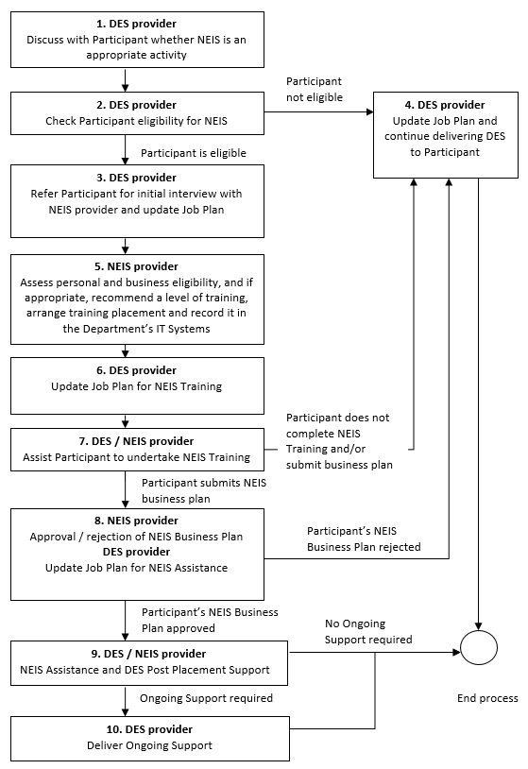
Note: This should not be read as a stand-alone document, please refer to the Disability Employment Services Grant Agreement.

Table: Concurrent servicing in DES and NEIS
Who is Responsible: | What is Required:
- DES Provider  Discuss with Participant whether NEIS is an appropriate activity  Disability Employment Services Grant Agreement Clause References:  - Clause 156 | Where a Participant shows interest in self-employment, the DES Provider should discuss with the Participant the option of participating in NEIS. This would usually be done as part of the initial negotiation or update of the Participant’s Job Plan.  - proceed to Step 2
- DES Provider  Check Participant’s eligibility for NEIS | Where the DES Provider decides through discussions with the Participant that NEIS is an appropriate activity, the DES Provider must check whether the Participant is Eligible for NEIS. The Participant must be in the DES Employment Assistance phase to be eligible for NEIS.  Participant eligibility criteria  ‘Eligible’ means that a Participant:  - is at least 18 years of age at the time of commencing NEIS Assistance  - is available to participate in NEIS Training and work full-time# in the proposed NEIS Business  - is not prohibited by law from working in Australia  - is not an overseas visitor on a working holiday visa or an overseas student studying in Australia  - has not received NEIS Assistance in the past year  - is not an undischarged bankrupt and  - is any other person or persons identified to the NEIS Provider by the Department in writing from time to time.  #The number of hours as a minimum that a NEIS Participant must work in their NEIS Business. The NEIS Provider will assess the hours a Participant is required to work each week to ensure the NEIS Business is Commercially Viable. Full-time participation is generally 35 hours per week but where the Participant has a Partial Capacity to Work this will be taken into account.  - If the Participant meets the eligibility criteria proceed to Step 3  - If the Participant does not meet the eligibility criteria proceed to Step 4
- DES/NEIS Provider  Refer Participant for initial interview with NEIS Provider | Where the DES Provider determines that the Participant meets NEIS Eligibility Criteria, the DES Provider should check for available NEIS Providers in Employment Region where the Participant proposes to operate their NEIS business. The Participant will choose a NEIS Provider from those available. The DES Provider should contact the chosen NEIS Provider and arrange an appointment for an initial interview, advise the Participant of the interview details and update the Participant’s Job Plan (activity code AI01-Attend Appointment).  The NEIS Provider will check whether the Participant is Eligible for NEIS and will assess whether the Participant’s Business Idea meets NEIS Business Eligibility Criteria. If the Participant’s Business Idea does not meet NEIS Eligibility Criteria, the Participant will not be eligible for NEIS. The NEIS Provider will explain the reasons to the Participant in writing within 10 Business Days of the decision. The NEIS Provider will then refer the Participant back to their DES Provider.  - If the Participant is not Eligible for NEIS proceed to Step 4  - If the Participant is Eligible for NEIS and their Business Idea meets the NEIS Business Eligibility Criteria proceed to Step 5
- DES Provider  Continue delivering DES to Participant | The DES Provider should update the Participant’s Job Plan and continue delivering DES Employment Assistance to the Participant.  - End Process
- NEIS Provider  Recommend level of training and arrange training placement | Where a Participant is Eligible for NEIS and their Business Idea meets NEIS Business Eligibility Criteria, the NEIS Provider must recommend to the DES Provider whether the Participant should undertake either:  - a Certificate III in Micro Business Operations, or  - a Certificate IV in New Small Business.  This decision should be made in consultation with the DES Provider and should take into account the Participant’s ability to benefit from and complete the training.  Once the NEIS Provider has arranged the training placement with the Participant, the NEIS Provider will update the Activity Management screen in the Department’s IT system and should advise the DES Provider of the training details and refer the Participant back to the DES Provider to update their Job Plan.  - proceed to Step 6
- DES Provider  Update Job Plan | The DES Provider must update the Participant’s Job Plan (activity code ET58-NEIS Training) indicating that NEIS Training will be undertaken, the Certificate level and the expected start and end dates. The Participant must sign the Job Plan.  In the event that NEIS Training is not immediately available, the DES Provider should review and negotiate interim activities in the Participant’s Job Plan and explain to the Participant their obligations until NEIS Training commences.  - proceed to Step 7
- DES/NEIS Provider  Assist Participant to undertake NEIS Training | NEIS Training is a Centrelink approved activity and is for a period of up to 13 weeks. While participating in NEIS Training, Participants will continue to receive Centrelink Income Support payments and will satisfy their Mutual Obligation Requirements during this period.  Where a Participant has part-time participation requirements or is unable to participate full-time in NEIS Training, the NEIS Provider and the DES Provider should explore flexible delivery options for the Participant.  While undertaking NEIS Training the Participant will remain in DES Employment Assistance and the DES Provider should continue delivering contacts in accordance with the DES Contacts Guidelines.  The NEIS Provider will monitor the Participant’s attendance in NEIS Training. Where attendance is unsatisfactory, the NEIS Provider will contact the DES Provider to discuss the issue. For Participants with Mutual Obligation Requirements, the DES Provider may take compliance action in the form of a ‘No Show No Pay’ failure if deemed appropriate. See the DES Comprehensive Compliance Assessment and Compliance Activity Guidelines.  Alternatively the DES Provider may decide, in consultation with the NEIS Provider that the Participant should not continue with NEIS Training.  - Participant does not complete NEIS Training proceed to Step 4  - Participant completes NEIS Training proceed to Step 8  Note:  - Participants do not need to fully complete their Certificate to proceed to Step 8.
- DES/NEIS Provider  Approval/rejection of NEIS Business Plan | The Participant must develop a NEIS Business Plan and have this approved by their NEIS Provider.  Approval of Business Plan  Where a Participant’s NEIS Business Plan has been approved, the Participant will move to NEIS Assistance to commence their NEIS business. The Participant will sign the NEIS Participant Agreement which sets out their rights and obligations. The NEIS Provider will refer the Participant back to their DES Provider to update their Job Plan (Activity code EM52-NEIS) indicating that NEIS Assistance will be undertaken, the start and expected end date for the activity and the organisation who will deliver the NEIS Services to the Participant.  The DES Provider must update the Participant’s Job Plan prior to the Participant commencing NEIS Assistance.  NEIS Allowance  Participants commencing in NEIS Assistance are eligible to receive NEIS Allowance for up to 39 weeks in place of their usual Centrelink or Department of Veterans Affairs (DVA) payment. NEIS Allowance is paid by the Department of Jobs and Small Business and it is not an allowance or benefit paid under the Social Security Act 1991. The NEIS Provider will inform Participants about their options, however it is the responsibility of the Participant to determine the income support arrangements that best meets their needs. If a Participant is unsure about their circumstances, for example, the loss of Disability Support Pension and Health Care Card benefits, they should be encouraged to discuss their circumstances with Centrelink or DVA prior to making a decision.  Any Participant in receipt of NEIS Allowance is a Volunteer (Non-Mutual Obligation requirements) for the purpose of DES and may be suspended or exited in accordance with the Period of Service Guidelines.  Rejection of Business Plan  Where a Participant’s NEIS Business Plan has been rejected, the NEIS Provider will refer the Participant back to their DES Provider and advise the Participant of the reasons for the NEIS Business Plan rejection.  - Participants NEIS Business Plan rejected proceed to Step 4  - Participants NEIS Business Plan approved proceed to Step 9
- DES/NEIS Provider  NEIS Assistance and DES Post Placement Support  Disability Employment Services Grant Agreement Clause References:  - Clause 93.1  - Clause 93.2  - Clause 143 | Participants will receive NEIS Assistance for 52 weeks.  DES Contacts  The DES Provider should maintain ongoing, productive engagement throughout the period of NEIS Assistance. The DES Provider should work with the Participant and the NEIS Provider to agree on an appropriate level of DES assistance that is required during this time, taking into account the Participant’s NEIS Business Mentoring and NEIS monthly contact requirements.  Post Placement Support  The DES Provider may select an Anchor Date for the Participant’s employment by moving the Participant into the Post Placement Support phase of DES, once the Participant is likely to meet the requirements of an Outcome. A Job Placement Fee is not available for Participants self-employed through NEIS, however, the Provider may be eligible to claim Outcome and Bonus Fees in accordance with the DES Outcome Guidelines.  NEIS Business Mentoring Contacts  Participants will receive a minimum of five NEIS Business Mentoring visits during this time. The first visit will occur in the first month and then one visit each Financial Quarter. The NEIS Provider will arrange the NEIS Business Mentoring, which is provided by a person with business skills and experience to maximise the potential success of the NEIS Business.  NEIS Monthly Contacts  During NEIS Assistance, the NEIS Provider will also maintain regular monthly contact with the Participant to offer advice and mentoring and to ensure that the business is operating in accordance with the NEIS Business Plan.  - Participant’s employment ceases or Participant does not meet the requirements of an Outcome proceed to Step 4  - Participant achieves a 26 week outcome and moves to the Ongoing Support phase of DES proceed to Step 10  - Participant achieves a 26 week outcome and is exited from DES as an Independent Worker End of process
- DES Provider  Deliver Ongoing Support  Disability Employment Services Grant Agreement Clause References:  - Clause 117 | Where the Participant achieves a 26 Week Employment Outcome, the DES Provider should determine whether the Participant requires Ongoing Support in accordance with the Ongoing Support Guidelines.  Note: The 26 Week Employment Outcome may fall at any time during or after the Participant receives NEIS Assistance and will be dependent on the Anchor Date selected by the DES Provider.  Ongoing Support can continue in accordance with the Ongoing Support Guidelines after the Participant has exited from NEIS Assistance.  - End Process

