Kantar Public logo

Building Employer Demand

Research report

October, 2017

Commissioned by Australian Government

Department of Social Services

# Contents

1. Introduction 6

2. How does commitment to disability employment vary? 10

3. What motivates ‘open’ employers to hire people with disability? 19

4. What deters open employers from hiring people with disability? 24

5. How does the business environment influence employers’ hiring decisions? 30

6. What are the perspectives of CALD and Indigenous employers? 35

7. What information and support do employers want? 37

# Executive summary

People with disability are considerably under-represented in the Australian labour market, are less likely than those without disability to be employed full-time and typically face longer periods of both underemployment and unemployment. While there are a multitude of complex factors underpinning this picture, previous studies have outlined a series of persistent and prevalent barriers deterring many employers from employing people with disability[1].

In order to further quantify and unpack the drivers and barriers different employers and businesses in Australia face to employing people with disability, the Department of Social Services (DSS) commissioned Kantar Public to undertake a program of research with employers. Both qualitative and quantitative methodologies were implemented, involving seven group discussions, 5 ‘workplace visits’ (each involving three in-depth interviews with staff on site), 4 in-depth interviews and a survey of n=1200 employers. Key findings and outcomes from this research are outlined below.

How ‘open’ are employers to taking on someone with disability?

While the overwhelming majority of employers indicate openness to hiring people with disability, only around a third of businesses show behavioural commitment to doing so. **Overall, medium and larger employers may be more committed than smaller businesses.**

What motivates medium and large employers to hire people with disability?

* At an individual level, many employers demonstrate a **moral conviction** towards the treatment and employment of people with disability and displayed empathy with them and their situation. In some cases employers indicated they might favour people with disability – providing they meet key recruitment and role requirements – as they wanted to give them a ‘fair go’. They were also potentially driven by a sense of self-gratification around giving them this opportunity.
* The large majority of employers tended to **support the concept of diversity and inclusion** in the business and did not necessarily see the employment of people with disability as a poor business decision. In fact, for some, the employment of people with disability was viewed as something that can enhance corporate image and reputation and potentially adds to the ‘bottom line’.
* There was some sentiment that people with disability can bring **valuable attributes to the workplace** (e.g. a ‘good attitude’, resilience, loyalty), however this was very much felt to be on an individual case-by-case basis and may not differ in this respect to other employees.
* Perceptions of **wage subsidies** as an incentive were somewhat divergent. They could ‘tip the balance’ if deemed to offset any costs of employing someone with disability (again as long as this person was suitable for the role); however, their efficacy was questioned through a lack of awareness, uncertainty as to amounts and what is covered, perception of bureaucracy to administer, and some stigma associated with people on a subsidy.

What are the key attitudes and beliefs that get in the way?

For many large and medium employers, the barriers to hiring people with disability relate less strongly to overt prejudice than they do to **low levels of confidence** around the process of employing people with disability, and the potential need for adjustment both within the workplace (management approaches, inclusion/ integration, job requirements), and to the physical working environment.

* Overall, the most prominent barriers tended to cluster around perceived **suitability and fit** of people with disability to the role and their **integration** within the workforce.
* Other notable concerns included a perception of people with disability requiring **greater supervision and support** and an increased safety risk associated with their employment.
* There was also strong evidence of **low self-efficacy** among business in relation to the employment of people with disability. This manifested both in terms of considerable levels of uncertainty around many aspects of disability employment.

What is the role of the workplace environment in facilitating or impeding disability employment?

* In some businesses, **workplace supports** appeared to alleviate many of the concerns that surround disability employment. The presence of HR departments, diversity policies, and accessible workplaces support disability employment both implicitly and explicitly.
* In many medium workplaces, however, such supports do not exist. Instead, inaccessible workplaces, a challenging culture and the dissenting views of others presented additional barriers.

How do different business audiences differ?

* The research suggests that **business owners and leaders** in smaller sized business are most risk averse and likely to show poor understanding, bias and prejudice in their attitudes towards people with disability.
* **HR staff** appear the most positive cohort overall, being most committed to workplace diversity, more convinced about the benefits of hiring people with disability, and least likely to see this as a risky undertaking.
* **Line managers** and supervisors are also typically positive about hiring people with disability, but display greater concern around the potential that staff with disability may require greater supervision.
* Employers in **manual industries** (e.g. construction, manufacturing, primary industries, services and trades) tend to show a wider range and weight of concerns, extending from uncertainty around the suitability of the work or the working environment for people with disability, to concern around workplace health and safety, staff supervision, and employee integration.
* **Culturally and Linguistically Diverse** (CALD) employers often exhibit more negative attitudes and concerns around disability employment, while the research suggests **Indigenous employers** are largely undifferentiated in their beliefs and behaviours to ‘mainstream’ employers.

What information and support needs do businesses have?

* There is a clear need and interest from employers in receiving **greater guidance, advice and information** pertaining to employing people with disability.
* The type of information needed is not necessarily highly sophisticated, with some fundamental resources around different types of disability, supported by **practical advice and strategies for workplace integration and management likely to have appeal.**
* Nonetheless, there is favourability towards **information and advice which can be tailored and specific** to employer situations and contexts, pointing towards support mechanisms that can be more personalised, proactive and provided ‘on the ground’.
* There is also appetite for support which provides a **practical and / or financial incentive to employers** and motivates or empowers them to increase exposure to people with disability in workplace settings. This includes wage subsidies, about which little is currently known.
* Many of the reported needs in information content and support mechanisms may already be in place, suggesting strategies to **promote and raise awareness** of them, along with optimising them to better engage with employers could be beneficial.

# Introduction

## Background and objectives

As part of its remit to improve the wellbeing of people and families in Australia, the Department of Social Services (DSS) provides support to people with disability through a range of initiatives.

People with disability are considerably under-represented in the Australian labour market. Of the 2.1 million Australians aged between 15-64 years who identify as having a disability, 53.4% are actively seeking work or already in employment: a proportion that contrasts markedly with the 83% of Australians without a disability participating in the labour market. Moreover, people with disability in the labour market are less likely than those without disability to be employed full-time, and typically face longer periods of both underemployment and unemployment.[2] As a result, many people with disability are denied the personal, social and financial benefits of work, with negative impacts on both the individual, and for the economy more broadly.

The Australian Government is committed to improving employment outcomes for people with disability.

**DSS engaged Kantar Public to conduct primary research in order to elicit a more robust understanding of the relationship between business characteristics and attitudes/ behaviours; the relative weight of individual prejudicial beliefs for different cohorts of employers and for different decision makers within organisations; as well as the communications needs and preferences of the priority target segment/s.**

This report details the findings of this research.

## Methodology

### Quantitative research

In order to provide robust measures and enable interrogation and analysis of the attitudes, behaviours, preferences and needs of different employer audiences, the research involved a large **quantitative survey with n=1200 employers** (which has a margin of error of approximately ±3% at the 95% confidence level). The survey was conducted via telephone as this is a more proven methodology (than, for instance, online) in terms of ensuring a representative and inclusive sample, as well as attaining higher response rates amongst a business audience.

For this stage of the research, a survey questionnaire was developed by Kantar Public, with input and approval from the Department. The questionnaire was programmed and tested for interviewing, with fieldwork undertaken by a team of skilled business interviewers at Q&A Research. Fieldwork took place between 18-29 September 2017, with the questionnaire taking on average 15 minutes to administer.

Once contacted, individual respondents were screened during the early stages of the interview to ensure that they had responsibility for hiring practices and were active in the recruitment market (i.e. have recruited in the past 18 months or intend to recruit in the next 18 months).

To ensure representativeness of the survey sample, target quotas were set on business size, location and industry type according to business population statistics from the ABS. These quotas were put in place for n=1000 respondents. An additional ‘boost’ of n=200 respondents was introduced for achieving extra interviews with employers in medium and large business. Since medium and large businesses represent a small proportion of the total population, the boost ensures sufficient sample to be able to analyse and interrogate data for these audiences at an individual level. Subsequent post-survey weighting ensured the total n=1200 sample was corrected to be representative of the Australian business population.

All research was conducted in accordance with ISO20252 standards.

### Qualitative research

Qualitative research was undertaken with people responsible for making hiring decisions in small, medium and large businesses, who were attitudinally ‘open’ to employing people with disability. The primary focus of this stage of the study was on building understanding of the drivers and barriers to employing people with disability, by exploring the knowledge, perceptions and attitudes of this ‘open’ cohort of employers.

The qualitative research comprised:

* **7 x group discussions with managers/ owners/ HR managers**: each group included 4-6 participants and was 1.5 hours in duration;
* **5 x workplace visits**: each involved a researcher conducting in-depth interviews with a business leader, HR staff and manager/s on site;
* **4 x individual in-depth interviews** with Indigenous employers, each of which was 60 minutes in duration.

The structure of fieldwork is detailed below.

| Audience | Large business  (200+ employees) | Medium business  (20-199 employees) | Small business  (1 – 19 employees) | TOTAL |
| --- | --- | --- | --- | --- |
| Group discussions with business owners/ managers | 1 x group discussion | 2 x group discussions | 2 x group discussions | 6 x group discussions |
| Group discussions with HR managers | 1 x group discussion | 1 x group discussion | - | 2 x group discussions |
| Workplace visits (each including IDIs with leader, HR and manager) | 5 x workplace visits |  | - | 5 x workplace visits |
| Business owners/ managers from Indigenous backgrounds | 4 x in-depth Interviews |  |  | 4 x in-depth Interviews |

Fieldwork was conducted in Sydney, Shepparton and Brisbane in September 2017.

The recruitment of participants was conducted by a professionally accredited recruiter from our approved supplier panel. Screening questionnaires, along with other materials for recruitment, were developed in conjunction with DSS. Once finalised, recruiters received a verbal briefing and written instructions and guidelines from the project team before commencing recruitment via telephone. An appropriately sized thank you payment was offered to participants to incentivise participation.

A discussion guide for all sessions was developed in consultation with DSS and is appended to this report.

## About this report

The report draws on both the quantitative and qualitative sources of data concurrently in order to provide hard figures, subgroup analyses and a richness of detail and insight behind these.

One of the key objectives of the research is to better understand what **‘open’ employers** think and feel and the processes and preferences they have in terms of recruitment, workplace management, communication and message resonance. Therefore, in reporting measures from the survey, data is largely presented based on those employers who expressed some openness to employing someone with disability[3]. In total n=918 (weighted n=945) employers met this criteria, which provides a highly robust sample for analysis and subgroup comparison. Reflecting this aim, the qualitative sample was also structured to engage and consult with employers who self-identified as ‘open’ to employing someone with disability.

There are other ways to define and establish openness (and varying degrees of this) including the level of ‘commitment’ that employers demonstrate to disability employment. This was further examined via a commitment-based segmentation of employers (See Section 2). This demonstrated that commitment was lower than stated openness, and some of the attributes, attitudes and preferences of different ‘committed’ and ‘uncommitted’ segments are detailed here.

The remainder of this report is structured thematically in relation to key research objectives and contains the following sections:

* **Commitment-based segment of employers** (Section 2), where an approach to categorise and identify key employer segments in order to inform future strategies and messaging based on their levels of commitment is presented.
* **Motivations for hiring people with disability** (Section 3), which identifies the beliefs and attitudes that prompt employers to consider hiring people with disability.
* **Barriers and concerns around disability employment** (Section 4), which examines the beliefs and attitudes which may deter employers from hiring a person with disability.
* The influence of the **business environment** in shaping hiring decisions (Section 5), where environmental and external influences are explored.
* The perspectives and attitudes of **Indigenous and CALD employers** (Section 6), where differences between these groups are the ‘mainstream’ employers are identified.
* **Information and support needs** (Section 7), where the type of information and advice and the support mechanisms employers need are examined and discussed.

# How does commitment to disability employment vary?

In considering future strategies, interventions and communication to employers with the aim of increasing openness to employing someone with disability, the research sought to further unpack the business population into segments, using a commitment-based model. The latest evolution in behaviour change thinking indicates a need to move away from self-reported intentions towards a more accurate behaviour predictor – commitment. Strong or weak levels of commitment are better at explaining why people do or do not act as they intend, or stick with intentions. The commitment model helps to understand how to bridge the intention-action gaps, and convert target segments to committed states, and ultimately predict and generate sustained behavioural change.

## Creation of the commitment segmentation

Measuring commitment is not a single construct, since commitment is a complex human concept with multiple dimensions. The measurement involves behaviour-specific contextualised questions on four dimensions: cognitive dissonance, external influence, ambivalence, and involvement/ importance.

Six segments are created through the analysis of responses to customised, contextualised questions on the four dimensions:

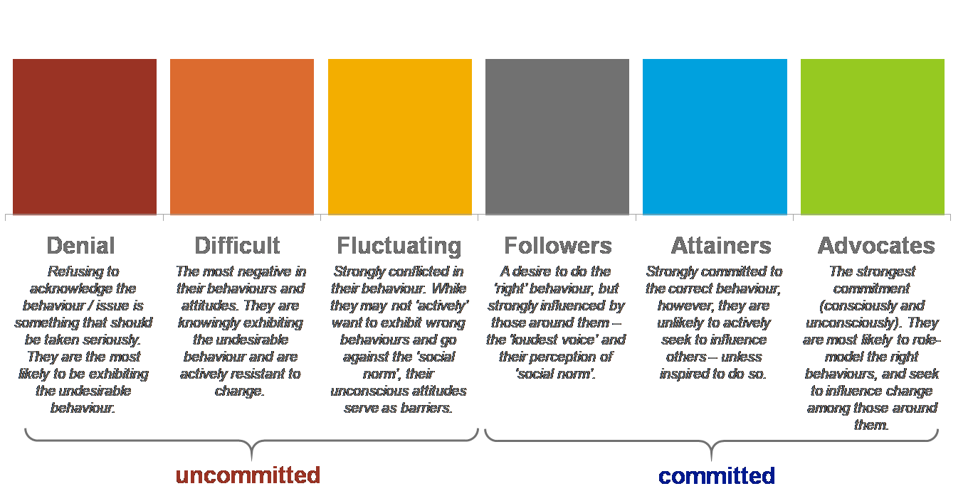

### The commitment segmentation of employers

The distribution of employer segments is depicted in Figure 1. A number of points emerge here which have implications for potential approaches and interventions:

* **Currently, almost two thirds of employers are largely uncommitted to employing someone with disability.** This is split fairly evenly between those in ‘Denial’ (31%) and those who are ‘Fluctuating’ (34%) in their beliefs and behaviour. While the Denial segment will require significant (and almost certainly, long-term, sustained) effort to ‘convert’ towards being more open in their attitudes and behaviour towards employees with disability, the Fluctuating segment are more conflicted in this regard and are more amenable to influence in the medium term, particularly if attitudinal barriers and norms can be challenged).
* **There are no (0%) employers represented in the uncommitted, ‘Difficult’ segment.** This can be explained by the nature of the behaviour that is being sought, since this segment would be diametrically opposed to, and indeed vocally reject, the concept that *anyone* should employ people with disability. Often, this segment is described as the ‘vocal minority’. And while they are often small in their size (within any population group or behaviour of interest), they can be powerful in generating broader negativity and confusion around the issue they oppose. It is therefore considered positive this potentially ‘opposing force’ does not exist.
* Most of the committed employers feature in the ‘Followers’ segment – indeed one quarter of employers (25%) are considered a potential opportunity in this regard. Their ‘Follower’ status likely stems from the nature of relationships and influences within workplaces, as well as potential constraints associated with workplace settings and environment. That is, while these employers express a desire to do ‘the right thing’, they are often constrained and influenced by others around them and perceptions and biases built on dominant norms and values. Converting such employers towards the desired behaviour may require supporting changes to workplace settings and culture, and helping them ‘walk the walk’ rather than just ‘talk the talk.’
* **‘Advocates’ (8%) and – to a greater extent – ‘Attainers’ (3%) represent only a small proportion of the employer population**, and this reflects the weight of research in this area. Advocacy and attainment is influenced by ‘individual’ in addition to ‘business’ factors – i.e. a personal or vested interest or strongly passionate, moral viewpoint on the issue.

Figure 1: Commitment-segmentation of employers

Bar chart showing commitment segmentation of employers. 31 were categorised in denial, 0 difficult, 34 fluctuating, 25 followers, 3 attainers, and 8 advocates.

### How do these segments align with business size?

It was evident across this research (and reflective of much previous research) that employer attitudes and behaviours towards employing people with disability is frequently correlated with business size. That is, larger businesses are typically more likely to report openness to employing someone with disability, express positive attitudes and fewer barriers, and actually employ people with disability. This is replicated through the commitment segmentation model in that **large and, to a lesser extent, medium-sized businesses are less likely to contain employers who are in the Denial segment**. However, beyond this the pattern is far more nuanced and complex than one might initially conceive, and suggests that other factors are influencing the genuine commitment of larger business in this area, even if they have people with disability within their workforce.

As noted above, the strongest levels of commitment come from those individuals who are passionate and actively advocating and promoting the issue of disability employment. Such attitudes are as likely to be **influenced by individual motivations and** **beliefs** as they are business characteristics. Thus, while large business is marginally more likely to contain Advocates and Attainers than other businesses, this difference is not substantial. Indeed, it was apparent in the qualitative research that there were individual advocates for disability employment within smaller as well as larger business.

Large businesses are more likely than other business to comprise of the Follower and Fluctuating segments (71% of large business fit into these segments, as opposed to 59% of all business). They essentially sit somewhere in the middle – able to see positive and negatives, facilitators and barriers. They are not closed to **the prospect of employing someone with disability**, and do not dismiss it as a topic or area of business focus. One influencer of this is that large businesses are more likely to have structures and mechanisms – such as policies and resources – to promote diversity and, in theory, facilitate the employment of people with disability. Essentially, **it is something which is on their workplace policy agenda** (or, is at least not absent from workplace policy). However, influences of others within the business and prevalent attitudes and norms around disability can undermine individual commitment to this (both positively, and negatively), even if they do enact the desired behaviours.

Differences in segment composition are less pronounced for medium-sized business and are largely in line with the segment composition of the total business population. This seems reflective of the wide band and divergence in what constitutes a medium-sized business and one could hypothesise that ‘upper-medium’ businesses are more likely to be similar to larger business, while ‘lower-medium’ are more likely to be like small; indeed, such observations were apparent in some of the qualitative discussions whereby ‘upper-medium’ business exemplified similar structures and attitudes to large business while ‘lower-medium’ appeared often, attitudinally and behaviourally, in a similar position to small business employers.

### What else can the segments tell us?

The segments provide a framework from which to consider the prioritisation and development of initiatives and strategies that can be more targeted and resonate with employers based on their situation, openness, attitudes and needs. It can also point to commonalities across different audiences which may validate more universal approaches to impact and effect change in different contexts. In theory, the aim of strategies would be to shift or ‘convert’ segments upwards in terms of their commitment, so that they are more inclined to exhibit the desired behaviours. Understanding what motivates them and – critically – what barriers stand in the way can be a useful starting point from which to do this.

A ‘snapshot’ of the profile and key attitudes of the four most prominent segments: Advocates, Followers, Fluctuating, and Denial appears below.

# ADVOCATES

|  |
| --- |
| 8%  of employer population |

Advocates are the most committed segment, viewing the employment of people with disability as a highly important issue, feeling highly enthused about and likely to do it, and confident and equipped to do so. They are, essentially, standard bearers and, given this, could be valuable to harness in challenging preconceptions and biases relating to the issue and promoting positive messages through both informal and formal networks

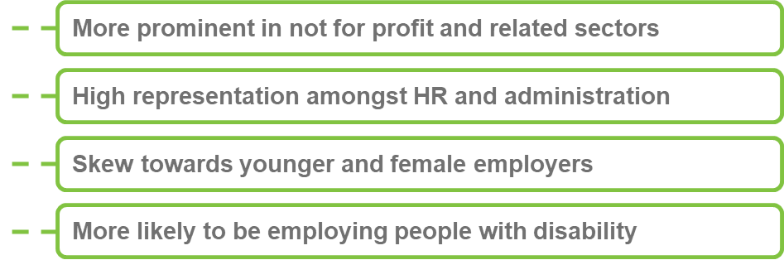

## How do their beliefs and attitudes compare?

* Strongly recognise the importance that their workforce reflects the diversity in the community by including people with disability, and most likely to identify benefits of employing people with disability in terms of loyalty and attitude to work.
* Less likely to demonstrate negative attitudes towards employing people with disability or to attach risk to employing people with disability.
* Barriers focus on the suitability and fit of people with disability to be able to integrate and operate effectively within the workplace.

# FOLLOWERS

|  |
| --- |
| 25%  of employer population |

Followers see the issue as important, but hold some reservations around the perceived complexity of hiring people with disability, and can be influenced by prevailing norms. Nonetheless, they are attitudinally open and supportive of disability employment and so represent a key target group for attention, particularly if structural and attitudinal barriers can be addressed or alleviated.

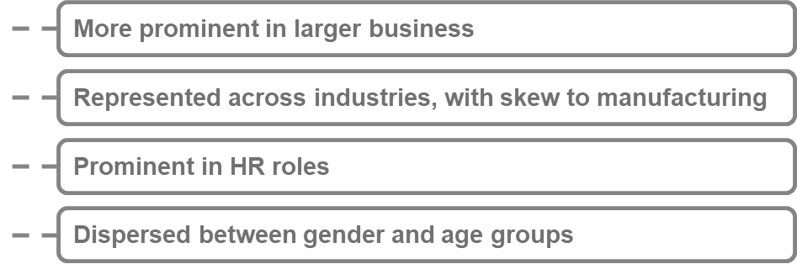

## How do their attitudes and beliefs compare?

* Recognise the importance of employing people with disability to reflect the diversity in the community.
* Most likely segment to express interest in wage subsidies and consider these more likely to have an influence on their decision.
* Limited self-efficacy and concern around convincing others to support hiring a person with disability.
* Areas of concern relate to integration into the workplace and suitability for roles, with associated perceptions regarding safety and the need for increased support and supervision.

# FLUCTUATING

|  |
| --- |
| 8%  of employer population |

On face value, the Fluctuating cohort place importance on the issue of disability employment, feel they are reasonably equipped to employ people with disability and indicate some motivation to do so. However, this does not always transpire into their behaviour, suggesting some subconscious biases and / or other environmental barriers are likely to come into play.

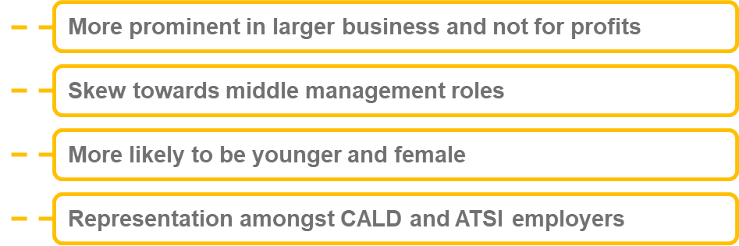

## How do their attitudes and beliefs compare?

* Supportive of diversity in the workplace and less likely than average to believe that employing someone with disability represents a commercial risk.
* Perceive difficulties regarding cost associated with employing a person with disability, and the extent to which their business is equipped to employ people with disability.
* Concerns focus on suitability and fit, supervision and support required.
* Self-efficacy to manage and deal with issues related to the employment of people with disability is also a barrier,

# DENIAL

|  |
| --- |
| 31%  of employer population |

The Denial segment are the most closed group to disability employment, often lacking any enthusiasm towards it nor seeing it as a particularly important issue. While some might consider themselves able to take on someone with disability, it is not something which they deliberately contemplate. As such, they are the segment least likely to be influenced by initiatives in this area.

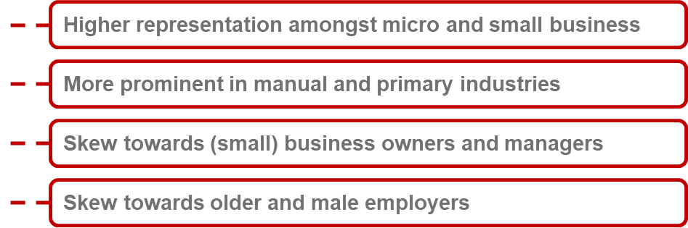

## How do their attitudes and beliefs compare?

* Most likely to hold prejudicial views of employees with disability
* Substantial uncertainty and ambivalence towards the pros and cons of employing someone with disability.
* Greater tendency to view people with disability as unsuitable for their business
* More likely to question whether their business is equipped and prepared for the employment of people with disability in the workplace

|  |
| --- |
| The remaining sections of the report focus on findings pertaining to medium and large employers who express openness to employing people with disability. |

# What motivates ‘open’ employers to hire people with disability?

For ‘open’ employers across the medium and large business cohorts, the motivation to employ a person with disability is underpinned by a sense of moral imperative. They show strong empathy towards people with disability and the obstacles they are likely to face in gaining employment. They are also, however, appreciative of the benefits that people with disability can offer workplaces, particularly in terms of corporate image and attitude to work. The role and impact of wage subsidies as incentives for employers in these cohorts is uncertain.

## Employing a person with disability is the ‘right’ thing to do

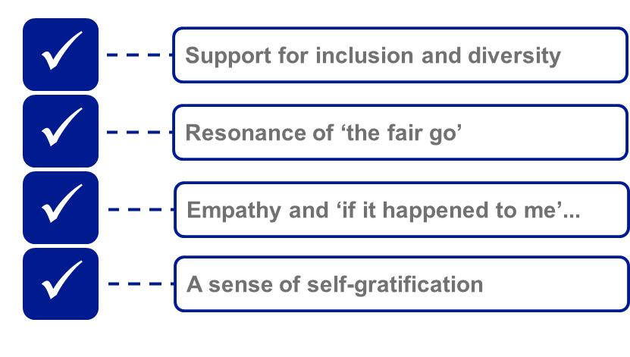

The research clearly demonstrates the significance of **morality and emotion** in motivating employers to hire people with disability. The overwhelming majority of the ‘open’ employer cohort regarded this as an issue that was personally important to them (93% of large businesses; 89% of medium sized businesses), while the moral imperative of hiring people with disability also emerged as a resonant factor during the qualitative discussions. For both large and medium sized businesses, there was a **strong personal conviction around giving someone with disability an opportunity, tapping into progressive values around equality and a ‘fair go’**.

“It makes the business feel like they’re doing their bit’ (Manager, medium business, Shepparton)

‘It makes you feel good. It gives you the warm and fuzzies. It makes you think that you’re socially responsible and you’re progressive.’ (Manager, medium business, Sydney)

Many ‘open’ employers showed a **great degree of empathy** with people with disability, often drawing on their personal experiences and familiarity with people with disability (e.g. family members, friends). The disposition of some employers led them to feel that – *if circumstances were right* – they might favour candidates with disability, perhaps over others who did not have a disability. In several of the discussions employers alluded to the potential for them to ‘positively discriminate’ towards people with disability, out of a desire to give them an opportunity to work.

“Sometimes you can have a bit more empathy with that person I think. And you can think this person deserves a chance more than others.” (Middle Management, Medium business, Brisbane)

## Employing a person with disability can also be a ‘good' thing for the business

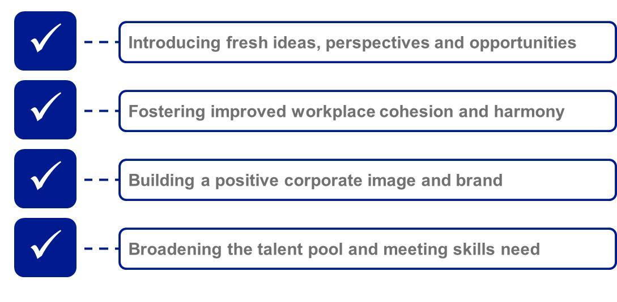

While for many open employers, the moral drivers to employing someone with a disability are powerful, on a more rational level, there is also recognition of the business benefits in terms of both corporate image and reputation, as well as the desirable personal attributes that employees with disability often bring to businesses.

### Perceived benefits: Business image

While fostering workplace diversity was considered important from an ethical perspective, there was cognisance of the **positive impact of diversity on the bottom line**. Among the benefits associated with a diverse workplace – including representation of people with disability – were:

* The introduction and inclusion of different perspectives and ideas within the workplace potentially fostering greater **innovation and business opportunity**;

“When you are looking for new ideas and everything else, they have so much of a different experience they can bring to the organisation.” (HR, Medium business, Brisbane)

* Improved workplace **cohesion and harmony**, understanding of and respect for individuality and difference;

‘It can change the culture, it can change people’s thinking. It can break stereotypes.’ (Manager, medium business, Sydney)

* Building a **positive external image**, both in terms of attracting potential future employees and projecting an inclusive, diverse brand to clients and customers; and

‘If you see a business is employing someone with a disability, you think – good on them – they’re doing their bit!’ (Manager, medium business, Shepparton)

‘It’s being a good example to other companies that are out there as well. It’s showing them that you’ll accept anyone as long as they’re right for the job. And I feel like more companies need to be more accepting of that as well.’ (Manager, medium business, Shepparton)

* Opening up a **broader labour pool** than may have traditionally been the case, which may help to fill vacancies in areas of skills shortage.

### Perceived benefits: Positive attributes of staff

The research also revealed perceptions that people with disability might bring valuable qualities that are often sought by employers. As Figure 2 below shows, there was widespread agreement that employees with disability have a good attitude to work, and are loyal to the business.

Figure 2: Positive attributes associated with people with disability

Bar chart. Employees with disabilities have a good attitude to work. For medium business, 3% disagree, 28% neutral and 69% agree. For large business, 2% disagree, 35% neutral and 63% agree. Employees with disabilities are loyal to the business. For medium business, 3% disagree, 21% neutral and 76% agree. For large business, 2% disagree, 30% neutral and 69% agree.

 

QC7. Using a scale of 0 to 10 where 0 is strongly disagree and 10 is strongly agree, to what extent do you agree or disagree that...

Base: Employers ‘open’ to employing someone with disability (medium business, n=151; large business, n=102)

The findings were also reflected in the qualitative research, during which participants made mention of the **resilience, strong motivation and commitment** often shown by employees with disability. To some extent, there was a perception that these employees could ‘outshine’ other staff and proved to be some of the most productive workers.

“For want of a better word, they work their arses off...because they’re proud of the opportunity. One of the individuals that works for us, he’s so grateful to have the opportunity for a role here, he’s one of the best guys we’ve got.” (HR, Large business, Brisbane)

## What role do wage subsidies play in motivating employers?

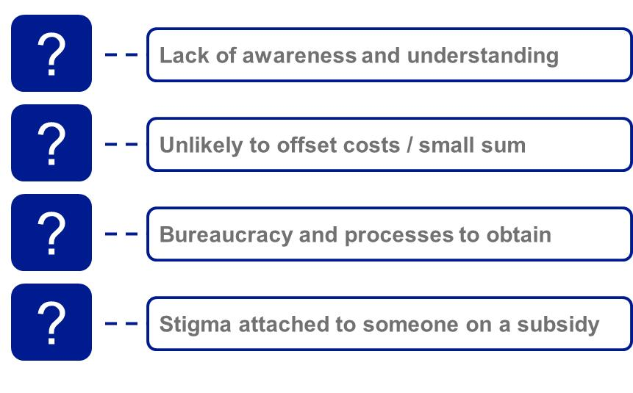

The research suggests that, while wage subsidies are of interest to some employers (particularly smaller businesses), the extent to which they motivate employers to engage people with disability is uncertain.

As demonstrated in Figure 3, around a quarter of ‘open’ employers in medium sized business (26%), and around one in five ‘open’ employers in large business (19%) agreed that a wage subsidy would encourage them to hire a person with a disability, with the remaining 74% - 81% either uncertain or unconvinced that a wage subsidy would influence them in this way.

Figure 3: Influence of wage subsidies

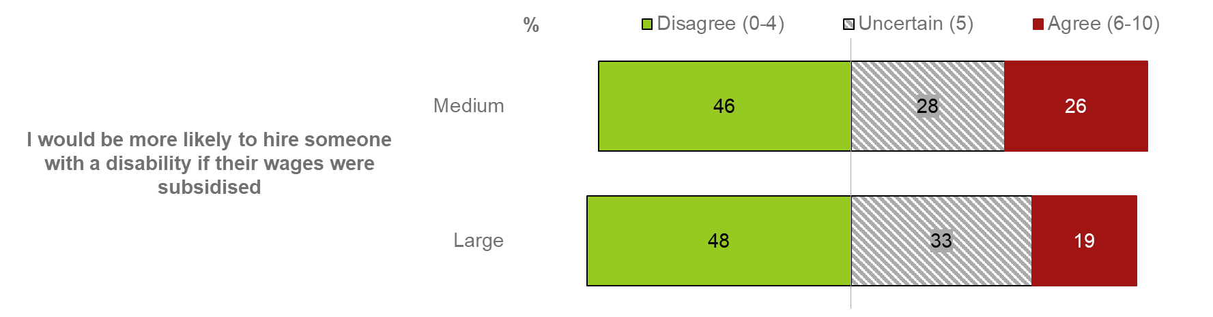

QC7. Using a scale of 0 to 10 where 0 is strongly disagree and 10 is strongly agree, to what extent do you agree or disagree that...

Base: Employers ‘open’ to employing someone with disability (medium business, n=151; large business, n=102)

The qualitative research revealed both a lack of nuanced understanding of wage subsidies (in terms of amounts, what is covered, how you access them etc.) and conflicting views on the topic. There was some assertion that a subsidy might ‘tip the balance’ in terms of taking on an employee with a disability. For the most part, this came down to a financial **cost-benefit calculation** in terms of whether the subsidy provided would positively offset perceived costs or not (i.e. from such things as workplace adjustments, lower productivity, and training). However, this was frequently tempered by the caveat that the candidate was suitable for the role and met other recruitment considerations – i.e. most employers would not take on someone with disability *solely or predominantly* because they came with a wage subsidy.

‘If it’s $20 grand a year on a $60k salary, you’ve just dropped the cost of that person by 30% - that’s not small.’ (Middle manager, Medium business, Sydney)

Other employers were more sceptical and dismissive of wage subsidies and indicated that they would do little, if anything, to impact their propensity to employ someone with disability. This stemmed from a number of beliefs including:

* A calculation that **subsidies would be insufficient** to offset the perceived financial and ‘other’ costs of employing someone with disability;
* **Stigma associated with candidates attached to a wage subsidy** – i.e. connoting that such a candidate has inferior skills, experience, capacity etc. and needed a financial incentive to be ‘employable’;
* **Uncertainty regarding the process** for attaining subsidies and a negative perception of process, burden and bureaucracy involved; and
* The **relatively small sum** assumed available for subsidies which, in the context of larger turnover businesses in particular, was deemed fairly insignificant and ‘not worth bothering with’.

# What deters open employers from hiring people with disability?

Despite recognising the benefits of hiring people with disability, many employers put caveats in place for the employment of people with disability that appear more likely to act as barriers to their employment**. Unlike smaller sized businesses, medium and larger sized businesses largely do not show extensive bias or prejudicial beliefs** around the productivity of people with disability, likelihood of absenteeism, or the negative reaction of staff or clients.Rather, their concerns related more strongly to a **lack of awareness and understanding of disability employment** in terms of job suitability, supervision and integration into the workplace, and, associated with this, the belief that employing a person with disability was going to be in some sense complex or difficult.

## Employers lack awareness and understanding of disability employment

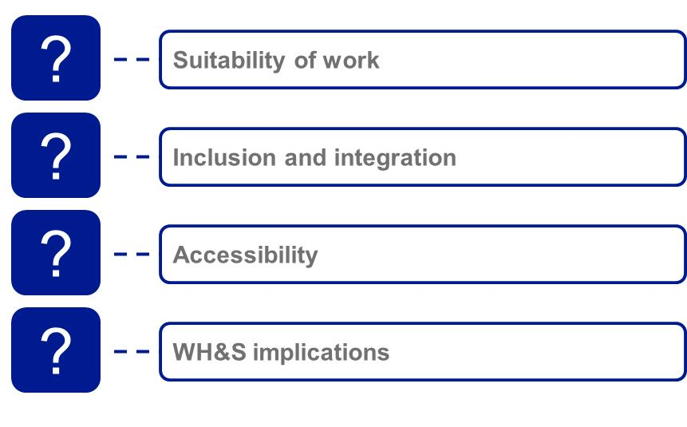

A lack of awareness and understanding was evident in relation to many aspects of disability employment: from work suitability, inclusion and integration, to accessibility and safety risks. These were not in themselves considered reasons not to hire a person with disability. They did, however, contribute to a perception of **‘extra effort’** required in hiring a person with disability, which made the decision to do so slightly more complicated and involved than it might be for a person without a disability. The concern that employing someone with disability in the workforce would require extra work, time for adjustment, and potentially be more disruptive to team cohesiveness and culture acted as an implicit barrier to their employment.

“It’s just too hard. All of it. It’s like I don’t want to go through the process. What am I going to have to change, what am I going to tell the staff, how am I going to have to manage the other staff, am I going to have to train all the other staff? ...Make sure there’s no bullying, what’s appropriate, what’s not. Can we talk openly, do we have to have separate meetings now, is that discriminating and isolating?” (HR, Medium business, Brisbane)

‘if you’ve actually done that (hired someone with a disability) – that is really putting your money where your mouth is – this is a big deal. It’s not just something you can play with academically. You’re going to have to accommodate someone and your team accordingly. You’re going to do something that is going to require you to rethink your workflows, how things are set out, how things are laid out – and work it out according to what his needs are – it requires you to be serious about it.

It’s a commitment.

A commitment to the community.’ (Middle manager, Medium business, Sydney)

The areas of greatest concern and confusion for medium and large employer are described in more detail below.

### How well suited are people with disability to the work that we do?

Some of the most prominent hurdles to the employment of people with disability relate to employer concerns regarding suitability and fit into the role and business environment. Employers often explained their viewpoint in relation to the physicality of roles and tasks and / or accessibility of work environments, usually reflecting first and foremost on people with physical disabilities. A few considered intellectual, sensory and mental disabilities and noted potential restrictions these could place on the roles and tasks that an individual can undertake. Essentially there was an assessment that employment of people with disability would be treated on a case-by-case basis and very much depended on the match between candidate skills, aptitudes and perceived capabilities (or, more commonly, restrictions) and the type and nature of the role in question.

“I suppose disability is such a broad term. It’s hard to say what’s a strength or weakness because it’s such a variety. I don’t feel I can… it would be a weakness if someone’s in a wheelchair because they can’t perform the job I need them to do.” (HR, Large business, Sydney

Despite the acknowledgement that suitability is contingent on the type of role, tasks involved and the disability in question, around six in ten medium (61%) and large ‘open’ employers (65%) placed caveats on the roles and responsibilities they could offer to people with disability.

Figure 4: Suitability and fit to workforce

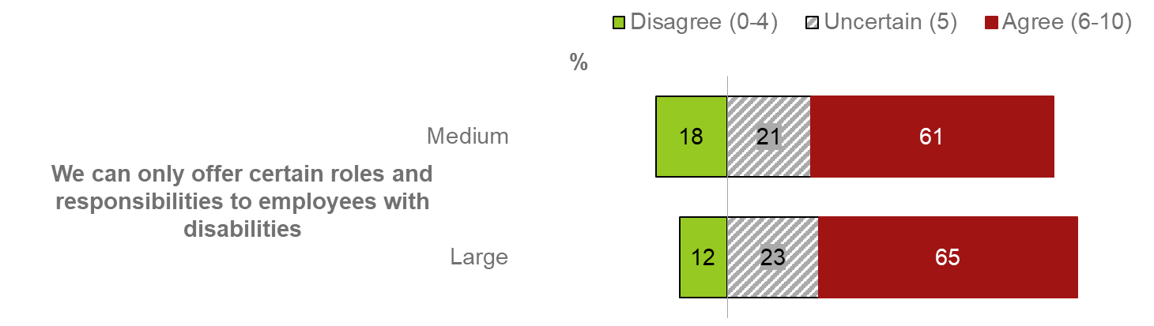

QC7. Using a scale of 0 to 10 where 0 is strongly disagree and 10 is strongly agree, to what extent do you agree or disagree that...

Base: Employers ‘open’ to employing someone with disability (medium business, n=151; large business, n=102)

### How do I include and integrate people with disability into the workplace?

The research also revealed considerable uncertainty around the **inclusion and integration** of people with disability within the workplace, and their needs in terms of supervision and management. As Figure 5 below shows, around four in ten medium (41%) and large (46%) ‘open’ employers were of the view that a person with disability would require extra support or supervision, while a third of medium employers (34%) and 41% of large businesses were of the view that integrating a person with disability would be difficult.

Figure 5: Supervision and integration

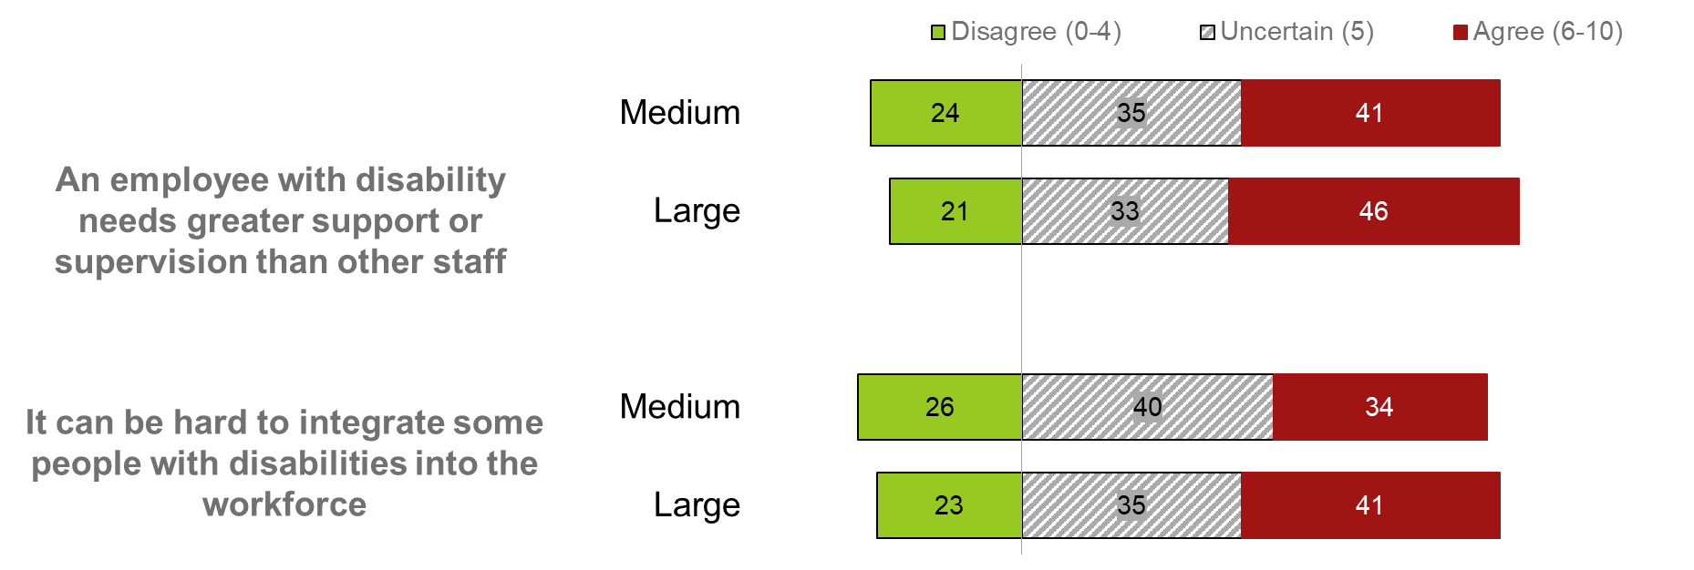

QC7. Using a scale of 0 to 10 where 0 is strongly disagree and 10 is strongly agree, to what extent do you agree or disagree that...

Base: Employers ‘open’ to employing someone with disability (medium business, n=151; large business, n=102)

In the qualitative research, this type of concern was particularly raised by line managers and team leaders, who were unfamiliar with people with disability, and wanted guidance around the most appropriate and effective ways to work with them on an every-day basis. Concern was voiced, in particular around how to manage the reactions of other staff, so as to ensure that the person with disability was not excluded or bullied.

‘If we make the decision on who we hire – the things that we care about are the things that affect us on a day to day basis – how do we make sure this person doesn’t feel excluded and is happy at work – all that sort of stuff.’ (Middle manager, Large business, Sydney)

### How equipped is my workplace?

The perceived inaccessibility of workplaces was a recurring theme in the research, as employers pointed to the difficulty of accommodating a person with disability in their working environment. While this was most commonly a concern for smaller businesses, around four in ten medium ‘open’ employers (43%) and a third of larger ‘open’ employers (32%) were either uncertain that their business was equipped to employ someone with a disability or of the view that it was not equipped to employ someone with a disability.

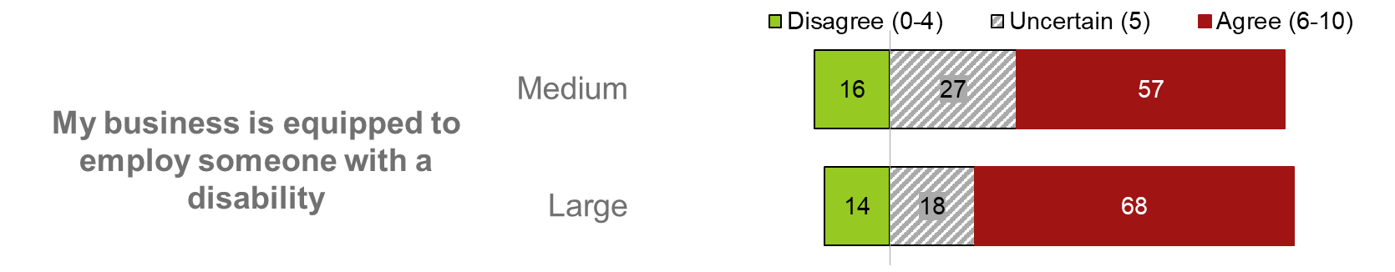

QC7. Using a scale of 0 to 10 where 0 is strongly disagree and 10 is strongly agree, to what extent do you agree or disagree that...

Base: Employers ‘open’ to employing someone with disability (medium business, n=151; large business, n=102)

Allied with this, was a great deal of uncertainty around the extent to which adjustment would be required, with many participants tending to assume that **extensive adjustment would be necessary,** likely at great cost. There was generally **limited awareness of government subsidies, and poor knowledge of what they might cover.**

‘You’re thinking this guy or this guy, and if you have to go with this guy, you have to make all those changes: will it cost me? You’d just steer towards one who is pretty close to the mark anyway.’ (Middle manager, Medium business, Shepparton)

### What are the implications for WH&S?

While medium and larger employers tended not to have the same degree of concern around safety or legal risks associated with hiring people with disability, there was some uncertainty about the implications of employing a person with disability from a WH&S perspective. As illustrated in Figure 6 below, around a quarter of ‘open’ employers in medium (28%) and large (22%) sized businesses were of the view that hiring someone with disability could increase health and safety risks in the workplace.

Nonetheless, this tended not to be identified as a reason not to hire a person with disability, as it was on occasion for smaller employers. Indeed, some ‘open’ employers in medium sized businesses viewed this as something which could motivate business to make improvements to the environment, which in turn would have positive flow on effects for all staff members. Thus, while this belief persists, it can be viewed as surmountable and lead to beneficial change.

Figure 6: Workplace safety and legal risk to the business

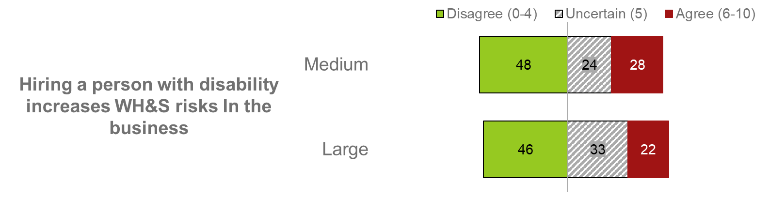

QC7. Using a scale of 0 to 10 where 0 is strongly disagree and 10 is strongly agree, to what extent do you agree or disagree that...

Base: Employers ‘open’ to employing someone with disability (medium business, n=151; large business, n=102)

Concerns around disabilty employment are strongest for manual industries

Greater openness in service, office-based industries. Stronger misgivings in manual industrial sectors. Perceptions correlate with exposure to people with disability.

The research suggests that **employers in traditionally manual industries may have the widest range of misgivings about employing people with disability** – extending from uncertainty around the suitability of the work or the working environment for people with disability, to concern around workplace health and safety, staff supervision, and employee integration. By contrast, employers in service industries appear to have far fewer concerns about role suitability or WH&S risk, though, to some degree, are also apprehensive about integration and supervision.

A synopsis of the key drivers and barriers for employers in six major industry groups appears below:

* **Employers in the services industries** (business and professional services) appear to hold the most supportive attitudes to hiring people with disability. They are notably less likely than employers in other industries to be concerned about the integration of employees with disability into the workforce, or to believe that they will require more supervision or support. They do not appear to have the same reservations about role suitability as employers in other industries, and are less likely to identify risks to hiring people with disability in term of WH&S or discrimination claims.
* **Employers in retail and accommodation and food services** are also largely positive about hiring people with disability and, like those in the services industries, tend neither to be as concerned as employers in other industries about role suitability, nor to perceive significant risks with hiring people with disability. They show slightly greater concern, however, about impacts in terms of workplace supervision and integration.
* **Employers in social/ healthcare/ education services** are amongst the least likely to attach risk to hiring people with disability. While they also show low levels of concern about supervision, they do seem to be wary of integration, and are somewhat more concerned than other employers about how their customers will react to staff with disability.
* **Employers in the construction industry** appear to be most concerned about hiring people with disability in a variety of ways. The research suggests that they have greatest reservations about role suitability, feel poorly equipped to accommodate staff with disability, are most explicit in attaching WH&S and discrimination risks to employing people with disability, and are most likely to believe that people with disability will take more time off work. They also show high levels of concern about supervision and integration.
* **Employers in manufacturing** are less likely to see role suitability as problematic, but share high levels of concern around integration and supervision, and WH&S risks. Interestingly, they are also the employer cohort most likely to believe that hiring people with disability may be unfair on other staff, though this is a relatively low level concern overall.
* **Employers in other primary industries** show high levels of concern about role and workplace suitability, and are also likely to see employing people with disability as a WH&S risk. As for other employers, supervision and integration are also concerning for this cohort of employers.

It is important to note that the difference in attitudes between employers in service and manual industries also reflects the extent of their experience in employing people with disability. Many more of the employers in service industries were employing people with disability than their counterparts in manual sectors. This again, points to the impact of experience and familiarity in driving positive perceptions of disability.

# How does the business environment influence employers’ hiring decisions?

The research also demonstrated the role of a range of **workplace influences** in shaping the perspectives and attitudes of employers around disability recruitment. For open employers, workplace influences were often very significant in facilitating the employment of people with disability. This was apparent in subtle and implicit ways through the design of buildings, policies and processes; as well as more explicitly through advocacy, support or assistance available to hirers within the organisation. The workplace can have a powerful impact on employers: in some cases helping to normalise disability employment, while in others, making it exceptionally difficult.

## For larger business, HR support drives acceptance and normalisation

For many ‘open’ employers in large businesses, hiring people with disability is entirely **normal**. Larger businesses are typically both supportive of employing people with disability and well set-up to do so, offering accessible workplaces and flexible working arrangements. For many employers in large businesses, hiring people with disability is not considered anything new or exceptional, and largely not a cause for concern in the way that it is for many smaller sized businesses.

‘For most big businesses, I don’t think it would be a big conversation point or a pro or a con one way or the other – all buildings are fully accessible. I can’t see how it would make a difference in terms of someone coming to work. I don’t see why it would make a difference…’ (Middle manager, large business, Sydney)

This normalisation of disability in larger workplaces appears to have been driven to a great degree by the often **sizeable HR teams** who support both recruitment and ongoing employment of staff. HR in larger organisations often have considerable knowledge of and commitment to workplace diversity and accessibility, and have designed workplace policies and procedures, and working environments around this. This appears to take a lot of the ‘guess-work’ out of employing people with disability from a practical perspective, offsetting many of the perceived barriers and obstacles, and helping to create a largely accepting and inclusive workplace culture. These processes and policies implicitly support and encourage the employment of people with disability, in far-reaching ways:

* **Recruiting processes**: the recruitment process at larger businesses is often specifically designed to control against unconscious bias, with input from several people, and the use of standardised recruitment tools to ensure transparency, and hold decision makers to account.

“Every time we have an interview it’s a panel. Absolute minimum of two people which is generally the hiring manager and someone who is outside of the area – so is the objective person with an unbiased opinion. But generally it’s three or four people. We’ve had up to ten people in a panel before.” (HR, large business, Brisbane)

* **Explicit focus on diversity**: Larger businesses often espouse a commitment to Corporate Social Responsibility, and are conscious of the importance of this for their public profile and reputation. While this is likely to be most pertinent for leaders and HR within the business, it may help to reinforce a culture within the organisation that is explicitly ‘pro-diversity’, driving positive views and attitudes amongst staff at all levels. A corporate expression of commitment to diversity was thought to send an important message, demonstrating that diversity is something to be encouraged and endorsed through the workplace. While not necessarily motivating for employers in an active sense, the existence of formal policies around diversity were considered significant in raising the profile of the issue within organisations, shaping perceptions of organisational support, and helping to establish an inclusive workplace culture. Over a third of ‘open’ employers in large businesses (36%) have a diversity policy, compared with 22% of employers in medium businesses.

*‘Our recruitment process means that there has to be some evidence – not just a disability – to demonstrate why you don’t want to hire them.’ (Middle manager, large business, Sydney)*

* A commitment to diversity was also aligned with the provision of opportunity for **flexible working arrangements or role adaptability**. Such allowances were also significant in demonstrating to hirers that recruiting a person with disability who had special requirements would be feasible within the business.
* Readily available **support and guidance for employers**: Employers in larger businesses can access guidance and assistance from HR if need be, contributing to a greater sense of self-efficacy around hiring people with disability. They therefore do not appear to share the confusion or uncertainty about employing people with disability observed amongst employers in smaller sized businesses.

Overall, therefore, workplace supports have a significant bearing on the outlooks and experiences of larger employers around disability employment. Essentially, they mean that ‘open’ employers in larger businesses avoid many of the significant obstacles and constraints that make employing a person with disability a somewhat intimidating proposition for others.

‘In a large business – all the rest of it is covered off by the process within the organisation. The workers’ comp and the accessibility – that would have been covered through the recruitment process – so it’s not really my concern. All that sort of stuff…accessibility just wouldn’t come into it. It’s all done. It’s not part of our thought process… ‘(Middle manager, Large business, Sydney)

## Medium businesses lack the knowledge and support available to large business and are not aware of government support in this area

On an attitudinal level, **employers from medium sized businesses are very similar to employers from larger businesses**: they see this as a morally important issue, they are appreciative of the skills that people with disability can bring to an organisation, and more supportive of workplace diversity broadly. Nonetheless, employers in this cohort of businesses may lack the knowledge, experience, policies and - potentially – physical environment that make hiring people with disability a far easier proposition for larger businesses.

Part of the difference between the two business cohorts is that **medium sized businesses typically lack the HR function of larger sized businesses,** and the implicit and explicit support for hiring people with disability that a strong HR presence may provide. The research suggests that businesses at the lower end of the medium sized businesses range[4] may approach fairly informally, but with considerable input from directors or senior leaders, supported by ‘administrative staff’ (e.g. payroll/ book-keepers) who commonly assume an HR role. Employers at the upper end of the medium sized business range may be more likely to have more formalised recruitment processes, a diversity policy and, for some, a few dedicated HR staff to provide support and guidance. Overall, however, for most medium businesses, the HR function and associated policies and services are notably less sophisticated than in larger businesses.

This is a significant barrier for medium sized businesses: while they recognise the importance of hiring people with disability, there is a **low level of understanding of disability generally, and a high degree of uncertainty and confusion about ‘where to start’**. More than a third of ‘open’ employers in medium sized businesses not currently employing people with disability agreed that they ‘wouldn’t know how to prepare my workplace for a person with disability’ (35%). This sense of uncertainty around the issue was also evident in the qualitative research with this cohort:

‘When I worked at [large business], you could hire anyone, knowing that they’d be support for it, there’s an OH&S manager – they’d love to make a case study… whereas (in a medium sized business) there have to be some practicalities. It makes us uncomfortable to think that it would affect our decision making but…’ (Middle manager, Medium business, Sydney)

‘In our companies, we don’t have an HR person – so I would want to know what I should read to make sure I’m doing this correctly. I would want to be sure that I wasn’t going to ask the wrong question or say the wrong thing. I haven’t forgotten to do something I needed to do. I don’t have that kind of training... ’ (Middle manager, Medium business, Sydney)

## The hiring process may exacerbate barriers for people with disability

Variation in the perspectives of individual members of staff, tension between those inputting into hiring decisions can present an additional challenge for people with disability in some businesses.

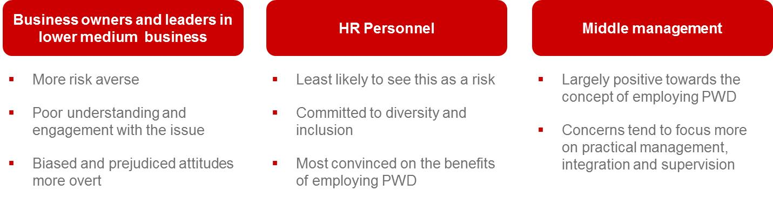

The research revealed notable variation in the views and perspectives of different hiring decision makers:

* Overall, the research suggests that **business owners and leaders in lower- medium sized business are most conservative,** and most likely to show poor understanding in their attitudes towards people with disability and their suitability for employment across a range of measures. By contrast, while there were relatively few **business leaders from large organisations** represented in this study, the findings suggest that they are attitudinally quite different from owners/ leaders at smaller organisations: They are not as involved either in the day-to-day operations of the business, or the recruitment process, so lack the same degree of engagement in issues such as integration or supervision. They are also operating along-side an extensive HR team, who are more likely to be steering strategies and approaches to staffing and recruitment. They are however, far more attune to the importance of CSR to the business and presenting a positive corporate image. As a result, they may be more likely to endorse rather than oppose the employment of people with disability at the business – albeit in a generally detached ‘conceptual’ way.
* HR staff are potentially the most positive cohort overall – most committed to workplace diversity, most convinced about the benefits of hiring people with disability, and least likely to see this as a risky undertaking. Their greatest concern relates to integration, with 44% agreeing ‘it can be hard to integrate some people with disabilities into the workforce’.

“Okay, say a person with a disability goes in there, can’t perform the role and all these people that have got that bias already are just so, it’s just confirming it. You’ve got to be so careful managing that culture and supporting them to be able to succeed. It might be a very small percentage, but what that does to the organisational culture and the acceptance of anything going forward from there is quite harmful.” (HR, medium business, Brisbane)

* Though committed to workplace diversity to a slightly lesser degree, **line managers and supervisors are also typically positive about hiring people** with disability. Their concerns relate more to the potential that staff with disability may require greater supervision (44%), with lower proportions expressing apprehension about integration (35%).

The diversity of views and attitudes of those inputting into hiring decisions can create additional hurdles for people with disability. This appears to be particularly pronounced in lower-medium sized businesses, most prominently because of the propensity for business owners and leaders to weigh into hiring decisions in businesses of this size. While HR or administrative staff are generally tasked with placing initial recruitment advertisements and screening applicants, and line managers are often responsible for interviewing candidates, they often make the final decision in collaboration with the business owner/ leader.

“I don’t usually do the initial interviews, but I come in with the second interview and I supervise the test. And I’m part of the final process. They kind of bring me in when they’ve got one or two candidates and I make the call.” [Leader, medium business, Sydney]

This means that even in cases where one individual, such as the HR or line manager, is supportive of the idea of hiring people with disability, another individual can raise risks and concerns within the meeting, leaving the HR/ line manager in the position of advocating on the candidate’s behalf. This is a perilous position as the HR/ line manager might decide not to pursue the application in favour of an “easier” candidate to sell to the senior manager. In addition, if the person with veto is a person in senior management, they might not have attended the interview, and might therefore have not met the candidate in question. In this case, heuristics might mean that their prejudices override the “rational” arguments of the individual advocating for the person with disability.

‘Managers are pretty careful about who they put in front of those people, because if it goes badly, people start to question their judgment.’ (HR, large business, Brisbane)

This poses a significant barrier for people with disability, as they must not only convince the person who conducts their interview, but also other individuals in the business – potentially, individuals they have not even met. In one of the qualitative case studies, it was stated that the managing director would be likely to veto employing someone with disability; in another, there was concern that individuals within the team would find working with someone with disability difficult. This was felt to be reasonable and appropriate; **team cohesion** was seen as important and the concerns of team members and managers were not to be dismissed.

# What are the perspectives of CALD and Indigenous employers?

The research suggests employers from culturally and linguistically diverse backgrounds may be less accepting of disability employment than non-CALD employers, showing greater concern around engaging people with disability, across a range of areas. The attitudes of Indigenous employers broadly approximate the mainstream view.

## CALD and Indigenous employers

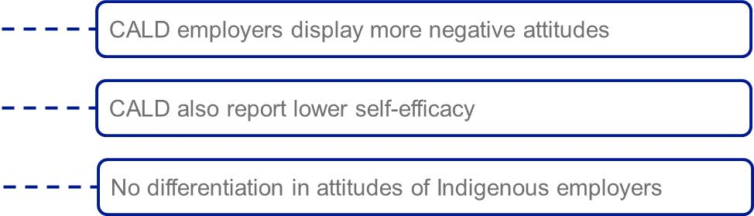

### CALD employers often exhibit more negative attitudes and concerns around disability employment

Results from the survey show significant variation between the attitudes of CALD and non-CALD employers who express openness to hiring people with disability. This manifests in terms of this cohort of CALD employers:

* Being more likely to question the **suitability and fit** of employees with disability in their workplace than attitudinally ‘open’ non-CALD employers. CALD employers were more likely to agree that a person with disability will be unsuitable for a role in their organisation (50% as opposed to 33% among non-CALD employers) and that they can only offer certain roles or responsibilities to employees with disability (73% v 57%). They were also more concerned with the extent the business is equipped to employ someone with a disability (35% disagreeing this was the case v 25% for non-CALD employers).
* Displaying **stronger negative attitudes and prejudices** towards employees’ capacity and capabilities in the workplace and the impact this will have on others in the business. This included the perception that employees with disability are more likely to take time off work (24% agree v 16%), increase safety risks (53% agree v 34%) and need extra support and supervision (19% strongly agreeing with this, as opposed to 9% of non-CALD employers). Subsequently they were also more likely to agree that employing people with disability could be unfair on other staff (13% v 6%).
* Demonstrating **lower self-efficacy and influence in the workplace** around this area. CALD employers were more likely than non-CALD to believe that employing someone with disability is a step into the unknown (47% agree v 35%), legislation and policies around disability are too complex (34% v 23%), and they would be worried about saying or doing the wrong thing (41% v 15%). They were also more likely to express the view that it would be difficult to convince other decision makers to hire a person with disability (47% agree v 19% for non-CALD employers)

Given the more negative views and attitudes of CALD employers in relation to disability employment, the research suggests that communications are unlikely to elicit positive attitudinal or behavioural change with this employer cohort.

### Employers from Indigenous backgrounds appear to have attitudes more similar to the mainstream employer cohort

The research also examined the perceptions and behaviours of employers who reported being **Aboriginal or Torres Strait Islander (ATSI),** both through qualitative and quantitative approaches. While sample sizes are relatively low, indications were that this cohort of employers were largely undifferentiated in their beliefs and behaviours to ‘mainstream’ employers. If anything, both the qualitative and quantitative consultation suggests a trend in ATSI employers being more positive in terms of attitudes and beliefs, but this difference is not statistically significant. The research thus indicates that ATSI employers will be receptive to the same communications and strategies to ‘mainstream’ audiences.

# What information and support do employers want?

## Promoting and building on what is already out there?

There is a clear need and appetite among many large and medium employers for greater information and support in relation to employing people with disability. The extent of uncertainty and limited self-efficacy (e.g. being a step into the unknown, not knowing how to prepare the workplace) indicates an influential role for information and support in engendering greater contemplation *and* facilitation of disability employment. For medium-sized employers in particular, support channels, tools and resources could offer possible solutions to tackle some of the practical and structural barriers associated with employing people with disability in the workplace.

It is important to note that much of the information and support needs raised by large and medium employers in the research may already be available from a variety of sources (including for example, state and federal government agencies, disability employment service providers, disability peak bodies, other employers etc.). In which case, it is clear that:

1. **Awareness-raising and promotion** of this and
2. **Greater alignment of information and support to employer communication and engagement preferences** would be warranted.

For instance, this might include better collation and consistency of information into a ‘one-stop shop’, more proactive engagement and outreach so employers are not having to expend additional time and energy seeking this, and more personalised and tailored support to better reflect employer situations and answer the specific issues that they have.

## Providing practical content which can empower employers to ‘make it happen’

The vast majority of large (89%) and medium (88%) employers reported a need for some further information and advice regarding employing someone with a disability. Principally this coalesced into:

* Practical and pragmatic **information to ‘operationalise’** the employment of someone with disability within the workplace (i.e. workplace settings, integration, management, and how this might differ depending on the nature of the disability), and
* Information and advice on **what support is available** to help them to do this, including any financial incentives.

Being typically more wary of risk and cost, employers in medium sized business were slightly more likely than large business to seek reassurance around the cost implications of employing someone with disability, as well as more detail regarding subsidies and incentives available. They also raised stronger demand for information that addressed issues of managing and supervising people with disability, perhaps reflecting a relative lack of confidence and experience in this area as opposed to large business.

Large business expressed marginally greater interest in information regarding different disability types, though this was also a resonant issue for medium-sized employers. This type of content was often considered in the context of specifics around what this disability means for the employee’s capacity, how they can fit into roles and workplace environments, and what the employer needs to do to support someone with this disability so that they can operate and integrate into their business.

“What is this disability? What do I need to be aware of? Say, this guy is 5% hearing in the one ear and has a speech impediment because of that, what do I need to do to be able to engage him in a manufacturing environment?” (HR, Medium business, Brisbane)

Notably, there was little desire emerging for information and content selling the benefits of employing people with disability, with the focus heavily skewed towards practical advice and guidance to make this happen and overcome any perceived obstacles in the way.

Figure 7: Main information content needs identified by medium and large employers

Bar chart. Accessibility & workplace adjustments - 25% medium business and 23% large business. How to integrate PWD into workplace - 24% medium business and 24% large business. Info about different disability types - 21% medium business and 25% large business. Rights & responsibilities as an employer - 20% medium business and 20% large business. Available support for employing PWD - 18% medium business and 21% large business. Managing and supervising PWD - 17% medium business and 13% large business. Subsidies & incentives for hiring PWD - 12% medium business and 9% large business. Likely costs involved in hiring PWD - 9% medium business and 3% large business. None - 12% medium business and 11% large business. Don't know - 8% medium business and 10% large business.

QE5. If you were considering employing someone with a disability, what type of information or advice would you like to receive?

Base: Employers ‘open’ to employing someone with disability (medium business, n=151; large business, n=102)

## Filling in the practical support gaps, especially for medium-sized business

Beyond the content areas sought, the research pointed towards a preference for support and advice that could be more personalised and specific in nature. While some of this came down to delivery and the channels through which information could be conveyed and obtained, there was a perception that universal ‘blanket’ approaches and ‘generic’ information had limited efficacy in supporting large and medium business to change behaviour. Instead, during discussions, employers often reported value in more **customised and tailored support and advice**, which had specific and direct practical relevance to the situation they were in.

While consideration of such options emerged across different sized businesses, there was strongest enthusiasm among those who had limited capacity and efficacy in managing recruitment and workforce practices and policy. That is, **medium-sized business** that did not have dedicated HR teams, internal legal professionals, and / or personnel dedicated to dealing with workplace culture or diversity or similar. Essentially, these organisations were more open to support which could **act as surrogate** in absence of such structures and personnel, providing them with specific practical resource and ‘hand-holding’ in terms of employing someone with a disability.

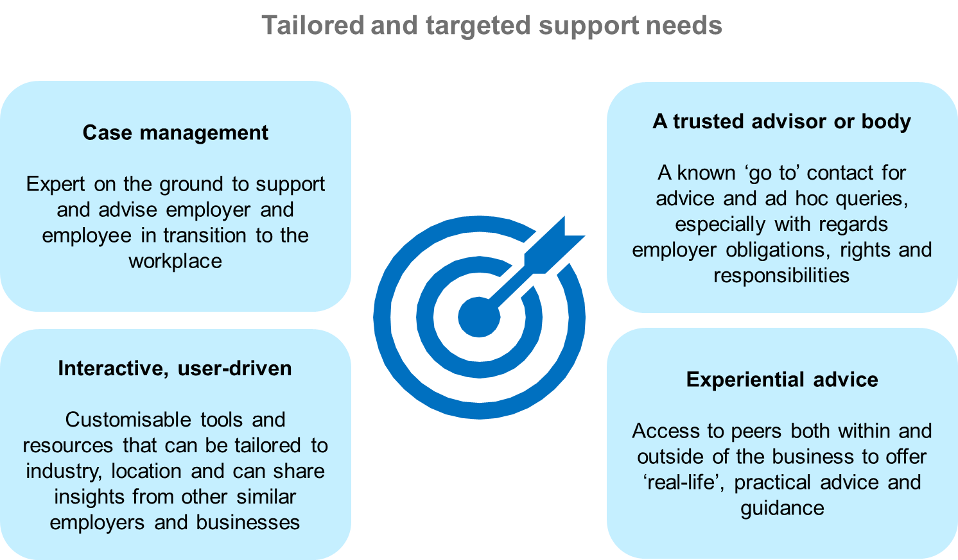

## Leveraging other support to motivate employers to act

A number of other potential support mechanisms and levers motivating large and medium employers to consider and take on (more) people with disability were raised in the discussions. It should again be noted that some of these options may already exist and therefore greater promotion and engagement with business so that they are aware of and can have access to such support would be a priority.

Potentially influential support levers centred on **additional** **financial incentives** to mitigate against some of the concerns with costs and risks of employing a person with disability, as well as more proactive **steps taken to expose employers to people with disability** in the workplace. Notably, many employers, especially in medium-sized business, highlighted how they were rarely or never knowingly exposed to candidates with disability, and that they simply ‘did not come across’ such candidates in the course of recruitment; thus there was an expectation that they would be unlikely to take on people with disability because of this, even though they were attitudinally open to the prospect.

Helping with costs: Tax rebates and incentives - Can be more emotionally motivating than wage subsidies, and foster a market-driven approach to disability employment. Workplace assessments and equipment - 
Offsetting some concerns employers have around cost and burden of making change. Training provision - Content and delivery which can be provided to all staff to aid integration. 
Broadening Exposure: ‘No obligation’ trials and placements - Allowing employers to ‘try out’ employees with disability without any obligation or penalisation if they are not retained.  Proactive approaches to ‘bring in’ people with disability - Increased activity and greater advocacy from employment providers, disability organisations and employer associations to help bring in people with disability into the workplace.

1. Van Bueren, D., Elliott, S., Tatarynowicz, R. (2017). Building Employer Demand: Literature Review. Kantar Public report prepared for Department of Social Services
2. Australian Bureau of Statistics, *Disability, Ageing and Carers, Australia: First Results, 2015* (Cat. No. 4430.0.10.001). At <http://www.abs.gov.au/ausstats/abs@.nsf/mf/4430.0.10.001>.
3. Overall openness based on rating 6-10 on a scale of 0 to 10, where 0 is ‘we would never employ someone with a disability regardless of their skill level’ and 10 is ‘we would definitely employ someone with a disability regardless of their skill level’.
4. Medium businesses are defined as businesses employing 20-199 staff